


Remote Sensing and Satellite Imagery Project
AI-powered Cloud Masking

Names | Sec | BN
Ahmed Samy | 1 | 8
Kareem Samy | 2 | 2
Nancy Ayman | 2 | 27
Yara Hisham | 2 | 31

Delivered to:
Dr. Sandra Wahid
Eng. Noran Hany
Table of Contents
Exploratory Data Analysis 3
Data Preprocessing 4
Manual Discard 4
Normalization 5
Data Augmentation Experiments 5
Band Selection 5
Data Split 5
Models Trials 6
Classical Models 6
Deep Learning Models 6
Loss Function Analysis 8
Thresholding 9
Selection Criteria and Results 9
Final Pipeline 10
Training Protocol 10
Workload Distribution 11

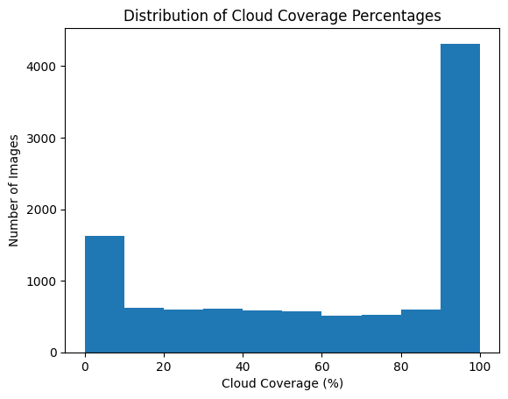

Exploratory Data Analysis
The dataset contains 10573 images of size 512x512 where each image has 4 spectral bands (channels) which are Red, Green, Blue, and IR.
We computed the cloud coverage percentage for each image and visualized the distribution. The data is heavily skewed with a strong bias toward fully overcast images (100% coverage).
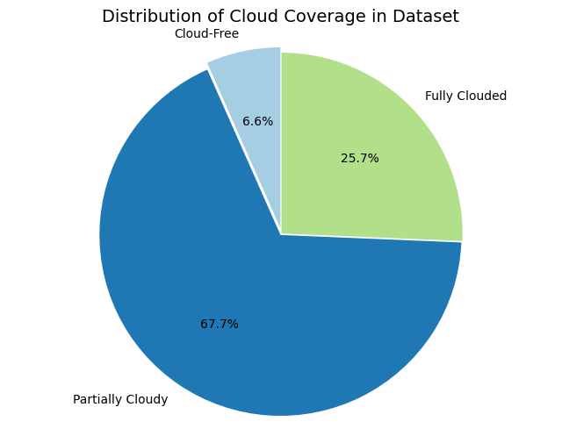

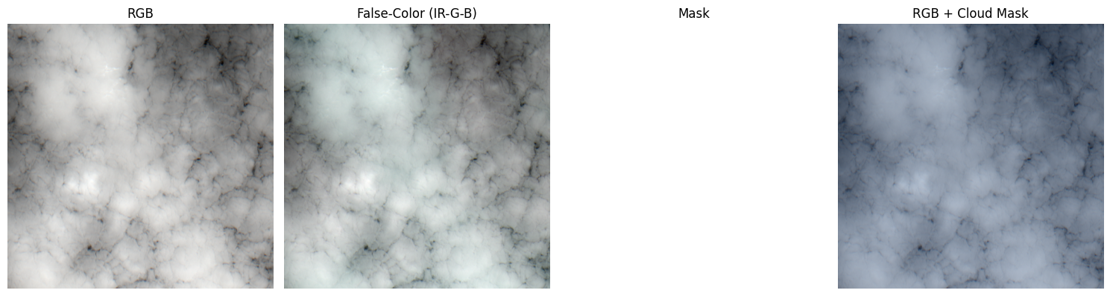
However, uponinspecting images labeled as 100% cloud coverage, we found instances of missegmented masks, for example:
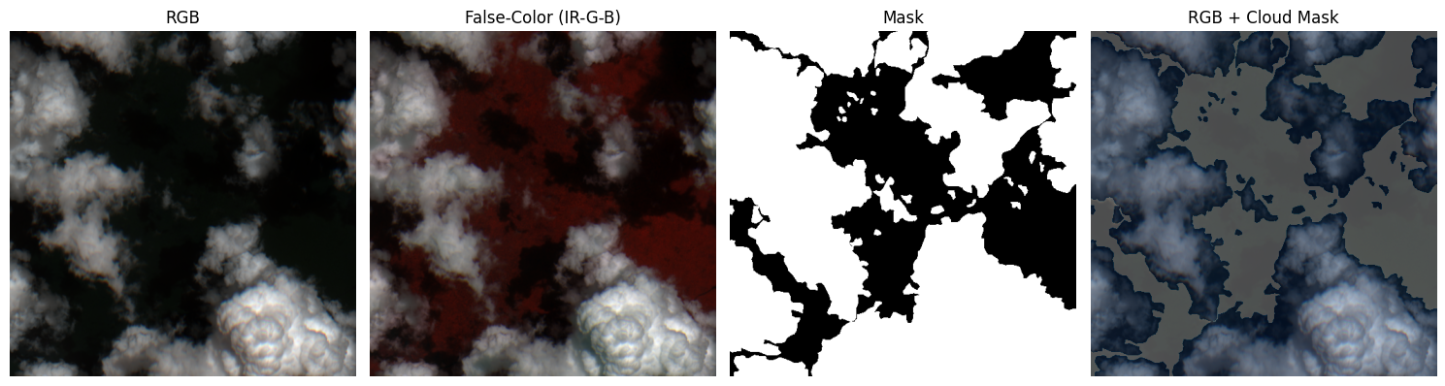
The segmentation masks were mostly releable for patially clouded, for example:
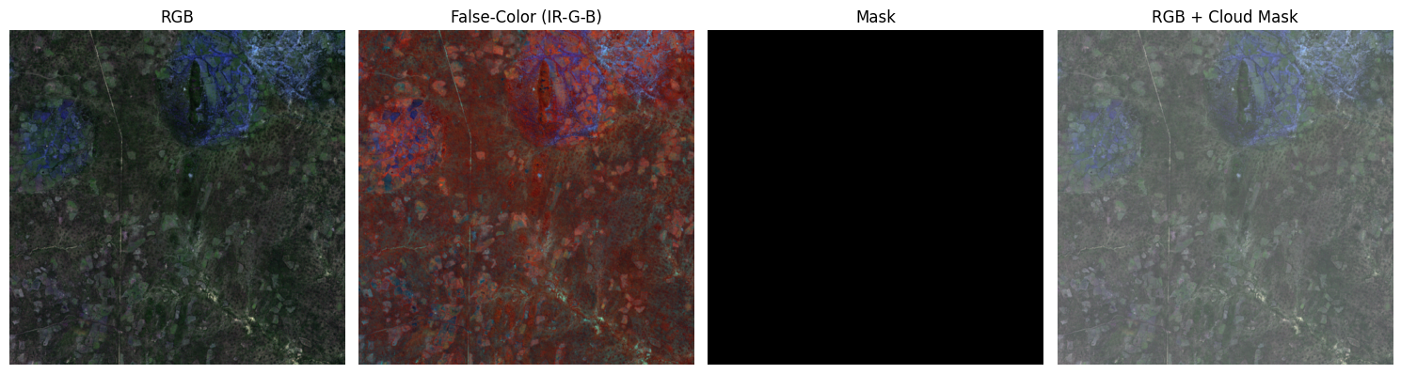
and clear-sky cases, for example:
We computed per-channel statistics across the entire dataset to enable proper normalization during preprocessing. The results are:
 | Red | Green | Blue | IR
Mean | 2855.27820701 | 2845.4572077 | 2747.33356059 | 3662.23889358
Std deviation | 3161.46447944 | 2903.18784174 | 2793.4662976 | 2427.58756888

Data Preprocessing

Manual Discard
We did a manual selection of images with missegmented masks to be excluded from the dataset and we excluded 864 images from the dataset, for example 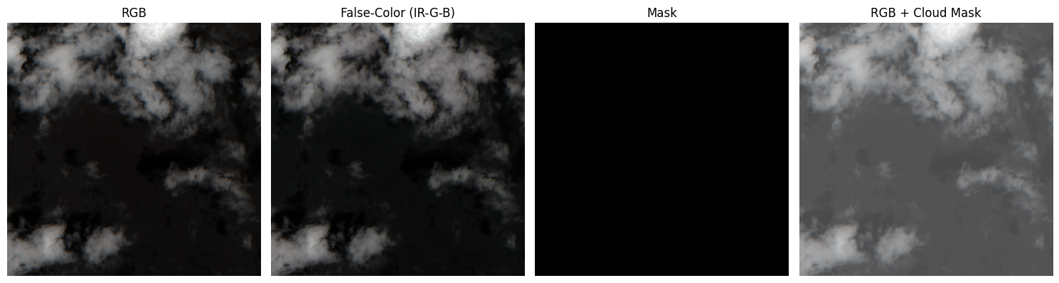

Normalization
To standardize the input data and improve model convergence, we applied z-score normalization to each channel independently. The normalization was computed as:
$$value=\frac{pixel value- μ_{channel}}{σ_{channel}}$$
where $μ_{channel}$ and $σ_{channel}$​ represent the mean and standard deviation of each spectral band, respectively.

Data Augmentation Experiments
After experimentation, the following augmentation pipeline yielded the best model performance by enhancing generalization while preserving critical spatial features:
- Geometric Transformations (Training Only)
  - Random Flips: Horizontal and vertical flips (50% probability each).
  - 90° Rotations: Applied randomly (50% probability).
  - Arbitrary Rotations: Limited to ±30° (30% probability) with nearest-neighbor interpolation to prevent mask distortion.
  - Random Crops: 448×448 patches resized back to 512×512 (30% probability), encouraging scale invariance.
- Validation Protocol
  - No augmentations were applied to validation data beyond tensor conversion, ensuring fair evaluation on unmodified samples.
The selected transformations diversified the training set without introducing destructive noise

Band Selection
The model was trained using all four available spectral channels to maximize the utilization of spatial and spectral information.

Data Split
We split the data to train, validation, and test datasets with the following sizes
Train | Validation | Test
7189 images | 1798 images | 1586 images

Models Trials

Classical Models
- Implementation Challenges
  - Traditional models faced significant limitations with full-resolution multispectral data
  - Memory Constraints Unable to process full 512×512×4 images (16MB per sample)
  - Computational Limits Training on entire dataset exceeded available RAM
- Logistic Regression (SGD-optimized)
  - Trained on the whole train set with batch size = 1000
  - With resizing the images, dice score = 0.84
  - Without resizing, dice score = 0.85
- Random Forest
  - Trained only on a sample with size 1000 from the data
  - We made a grid search to get the best parameters
  - Obtained dice score = 0.88

Deep Learning Models
1. CloudNet (Encoder-Decoder Architecture)
We began with straightforward U-Net style architecture as our baseline model. The architecture was adapted from the work of Mo et al. (GitHub repository)(paper), with key modifications to accommodate our multi-spectral input data and computational constraints.
- U-Net Inspired Design:
  - Symmetric encoder-decoder structure with skip connections
  - Four-stage down sampling/up sampling pipeline (512px → 32px bottleneck)
  - Double convolutional blocks with BatchNorm and ReLU activations
- Original Contributions:
  - Input channel adaptation (3-channel RGB → 4-channel multispectral)
  - Adjusted kernel dimensions for our 512×512 input resolution
  - Modified output head for binary segmentation (cloud vs. background)
- Model Summary:
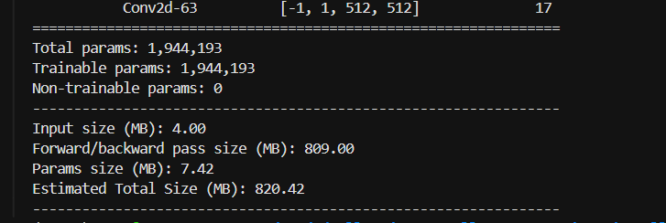
2.CloudNet Improved (Hybrid attention-residual architecture)
Building on the baseline, we introduced:
- Residual Blocks:
  - Replaced plain convolutions with residual connections
  - Added dropout (p=0.3) for regularization
- Attention Gates:
  - Implemented between decoder and skip connections
  - Dynamic feature refinement using gated attention
- Advanced Components:
  - Bilinear upsampling instead of transposed convolutions
  - Dilated convolutions in bottleneck (dilation=2)
  - Increased channel dimensions (32→512)
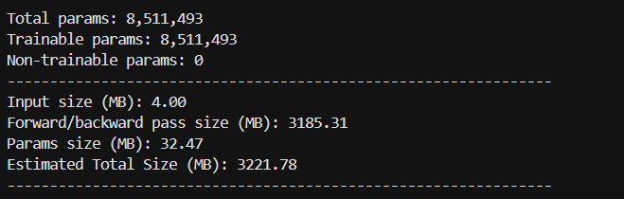
- Model Summary:

3. CloudNet Deep Supervision
To further enhance learning, we implemented:
- Deep Supervision:
  - Auxiliary outputs at multiple decoder levels
  - Multi-scale upsampled predictions (64px, 128px, 256px)
- Training Optimization:
  - Combined loss from all supervision heads
  - Progressive feature refinement through the network
- Architectural Refinements:
  - Balanced channel growth (16→256)
  - Dedicated upsampling layers for each supervision head
- Model Summary:
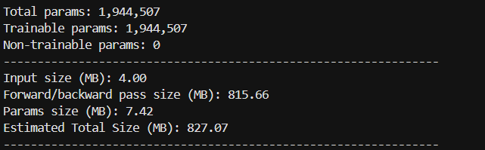

Loss Function Analysis
We conducted extensive experiments with multiple loss functions to optimize model convergence and segmentation performance
1. Dice Loss
- Advantages:
  - Achieved best final metrics (Dice: 0.90 on validation)
  - Naturally handles class imbalance in cloud coverage
- Challenges:
  - Exhibited training instability (loss oscillations ±15%)
  - Required careful learning rate scheduling
2.Combination of Dice Loss and Focal Loss
- Formulation:
  - loss = α*dice_loss + (1-α)*focal_loss , where α=0.7
- Behavior:
  - Improved training stability
  - Smoother gradient flow during early epochs
- Performance Tradeoff:
  - 5-7% lower Dice scores versus pure Dice loss

Thresholding
To get if the predicted pixel in the mask = 1 (contains cloud) we applied a certain threshold other than the typical 0.5 threshold
We made a function to run analysis on the validation dataset to determine the optimal decision boundary for cloud pixel classification

Selection Criteria and Results
We evaluated all variants using dice score on test set
Model Variant | Test Dice
CloudNet (Baseline) | 0.85
CloudNet Improved | 0.87
CloudNet Deep Supervision | 0.90

Final Pipeline
We split the data only to train (7779 images) and validation (1945 images)
Augmentation
Normalization
Raw Images

Final Prediction
Threshold Analysis
CloudNet Deep Supervision

Training Protocol
- Model Pipeline

Decoder
Ds4 branch
Ds3 branch
Ds2 branch
Input 4x512x512
Encoder
Bottleneck
Final Output

- Optimization:
  - Adam optimizer (lr=1e-3)
  - ReduceLROnPlateau scheduler (factor=0.5, patience=2 epochs)
- Loss Function:
# Weighted sum of losses
loss = (1.0 * loss_main +
0.6 * loss_ds2 + 0.3 * loss_ds3 + 0.1 * loss_ds4)
- FLOPs: 27,977,228,288
- Threshold Analysis: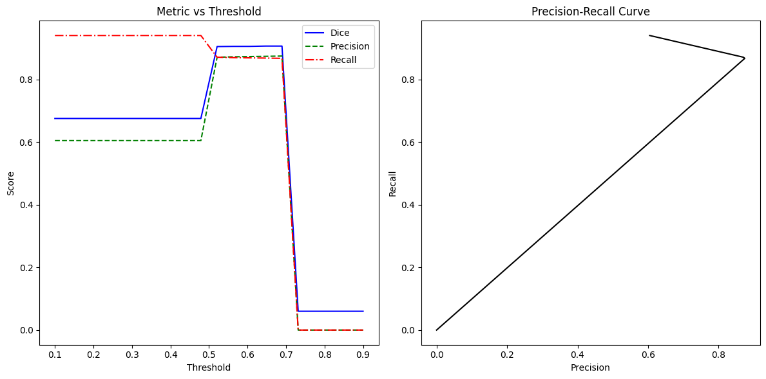
  - The curve shows that the max dice is obtained at threshold = 0.647

Workload Distribution
Names | Responsibility
Ahmed Samy | EDA & Preprocessing
Kareem Samy | Classical models
Nancy Ayman | Deep models
Yara Hisham | Deep models

