**Overnight_Test_2305_2215**

Start: 23.5.2025 22:15

End: 24.5.2025 08:01

Duration: 09:46:19 = 35179 s

Rate: 40 Hz

Bytes: 120

Bandwidth at start: 42.2-42.7 %

Setup: Ground floor, IMU connected to Laptop, weighed down by mass (394 g), covered by glass bowl

Output data: .bin file, saved in LunarLeaper > IMUs > VN100, however not as many measurements noted as expected

Nr of Outputs: 12441, Expected Nr: 35179 s * 40 Hz = 1407160

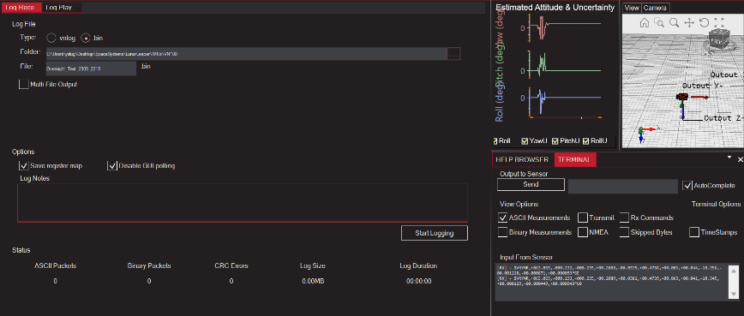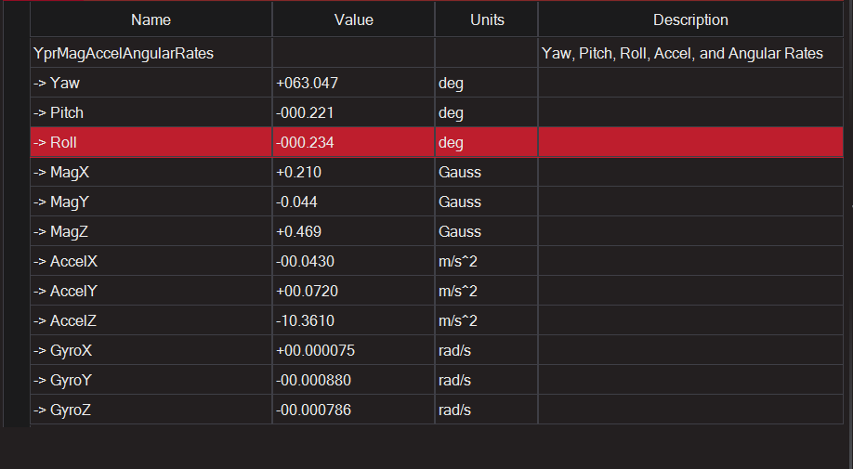

**Overnight_Test_2405_2215**

Start: 24.5.2025 22:15

End: 25.5.2025 08:05

Duration: 09:53:11 = 35591 s

Everything else the same as before

Nr of outputs: 1423700, Expected nr: 1423640

**Overnight_Test_2505_2340**

Start: 25.5.2025 23:35

End: 26.5.2025

Duration: 7:33:07 = 27187 s

Everything else the same as before but different room

Nr of outputs: 1087430, Expected nr: 1087480

**Overnight_Test_2705_2355**

Start: 27.5.2025 23:55

End: 28.05.2025 06:38

Duration: 6:41:48

Rate: 40 Hz (Ascii + binary)

Bytes: 120 (Ascii), 40 (binary)

Bandwidth at start: 42.3-42.5 % (ascii), 14.1 % (binary)

Setup: as always

Output data: .bin file, two packages; ascii (output as always) and binary (timestamps + temperature + pressure)

**Drop_Test_2605**

Start: 08:27

Duration: 1 min 25 sec

Setup/Measurement: Same as before

Method: Dropping 1kg at distances 0.5 m to 4.5 m from a height of 50 cm with a delta_s of 50 cm (9 peaks should be detected)

Output: Same as before + sound file to check timing of drops

**Drop_Test_2605_2**

Start: 08:39

Duration: 1:08

Setup/Measurement: same setup but now 50 Hz rate (max possible), bandwidth at 50-54 %

Method: drop from 50 cm

Output: same as Drop_Test_2605

**Drop_Test_2605_3**

Start: 08:45

Duration: 1:04

Repeat of Drop_test 2

**Drop_Test_2605_4/5**

Start: 10:52/10:53

Duration: 20 s / 15 s

Setup/Measurement: Same as always, 50 Hz

Method: Walking from the device away and back again (twice), 50cm steps from 0.5 m to 4.5 m