Before :
file:///C:/Users/padil/eclipse-workspace/CS%20305%20Module%20Six%20Code%20Base%20(1).zip_expanded/CS%20305%20Module%20Six%20Code/rest-service/target/dependency-check-report.html#l1_991c96a4e31e6c19e2b9136c8955bd423f2dc4c7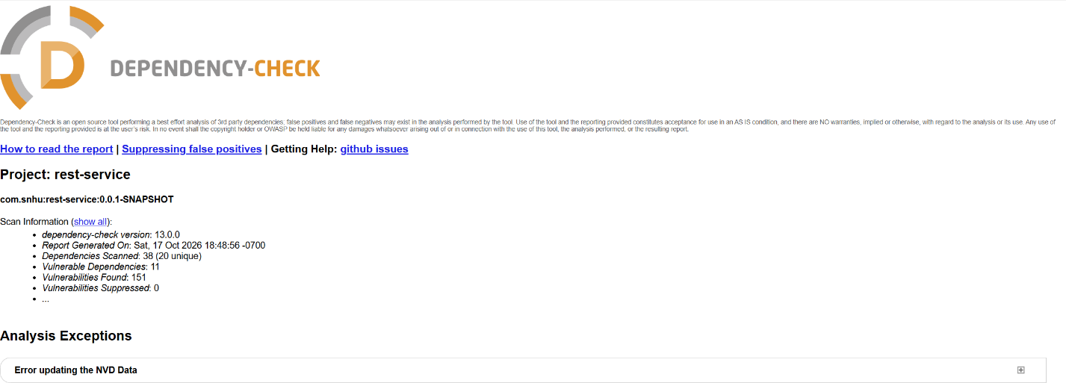
After:
file:///C:/Users/padil/eclipse-workspace/CS%20305%20Module%20Six%20Code%20Base%20(1).zip_expanded/CS%20305%20Module%20Six%20Code/rest-service/target/dependency-check-report.html#header-suppressed
