


University of Jordan
King Abdullah II School of Information Technology

Project Title: I Travel
Supervisor: Dr. Hamad Alsawalqah
Date:28th October 2022
Names | ID
Ghaliah Samer Taiser AbuHejleh  (Team Supervisor) | 0202565
Lana Amjad ghaleb Jabrieh | 0189759
Lara salamh Abdul Kareem alqaisi | 0204879
Yara Sameer Hussain Abu Sammour | 0202841
Besan Mousa Ali Ghanem | 0194643

Contents
1.0 Introduction 7
1.1 Project Overview 7
1.2 Purpose of the project 7
Background 7
Problem Definition 7
Issues 7
Objectives 8
1.3 Scope of the Work and Project Deliverable 8
Requirements 8
Constrains 9
Proposed Solution 9
1.4 Naming conventions and definitions 9
2.0 Project management Plane 9
2.1 Project Organization 9
2.2 Software Process Model 10
2.3 Roles and Responsibilities 10
2.4 Tools and techniques 10
2.5 Project Tasks 10
2.5.n. Task Description 10
2.5.n. Deliverables and Milestones 10
2.5.n. Resources needed (Skills, HW and SW) 10
2.5.n. Dependencies and Constraints 11
2.6 Assigning Team Members to Tasks 11
2.7 Project Schedule (Grant diagram) 11
2.8 Monitoring, Reporting, and Controlling 12
2.9 Risk Analysis and Plans 12
2.10 Local and Global Impact of the Proposed Solution 13
3.0 Feasibility Study 13
3.1 Technical Feasibility 13
3.2 Operational Feasibility 14
3.3 Economic Feasibility 14
3.4 Schedule Feasibility 17
3.5 Legal feasibility 18
4.0 Software Requirements Specifications (SRS) 18
4.1 System Stakeholders and Requirements Sources 18
4.2 User Requirement Definition 20
4.3 System Functional Requirement Specification (you can use user stories and requirements scenarios) 20
4.4 Non-Functional Requirements (you must ensure that your requirements can be tested) 22
4.5 Data Requirements 24
5.0 Analysis and Design 25
5.1 Use case Diagrams 25
5.2 Textual Description for Each Use Case 25
5.3 Activity diagram 31
5.4 Sequence diagram 31
5.5 class diagram 34
5.6 database design 34
5.7 Architecture design 36
5.8 Classes and Component Design 37
5.9 Graphical User Interface Design 37
6.0 User Manual 40
7.0 Implementation 43
8.0 References 45

Table of Figure
Figure 1 Roles & Responsibilities 10
Figure 2 Grant chart 13
Figure 3 questionnaire 20
Figure 4 questionnaire - 20
Figure 5: use case diagram 26
Figure 6: activity diagram 32
Figure 7:sign up sequence diagram 32
Figure 8: log in sequence diagram 33
Figure 9: view content sequence diagram 33
Figure 10: join chat sequence diagram 34
Figure 11 Classdiagram 35
Figure 12 firebase authentication 36
Figure 13 firebase firestore data 36
Figure 14 architecture design 37
Figure 15 component design 38
Figure 16 home screen design 39
Figure 17 welcome screen design 39
Figure 18 event screen design 40
Figure 19 chat screen design 40
Figure 20: welcome screen 41
Figure 21: log in screen 41
Figure 22: sign up screen 41
Figure 23: home page 42
Figure 24: event screen 42
Figure 25: add button 42
Figure 26 home screen implementation 44
Figure 27 welcome screen implementation 44
Figure 28 chat screen implementation 45
Figure 29event screen implementation 45

List of Tables
Table 1 Expenses Development Registration 15
Table 2 personnel Development Costs 15
Table 3 Hardware and Software Development Costs 15
Table 4 Cost-benefit Analysis - Hardware and Software Operating Costs 16
Table 5 Project Tangible Benefits 16
Table 6 Total of Development and Operating Cost 16
Table 7 Playback Analysis 17
Table 8 Project Schedule 18
Table 9 user Requirement 21
Table 10 non-functional requirement 24
Table 11:sign up description 27
Table 12:log in description 28
Table 13: join chats description 29
Table 14:join trip description table 29
Table 15:add place description table 30
Table 16: search trip description 31

Introduction

Project Overview
Being in love with adventure and experience new places are a passion for millions of people around the world. Having fun, meeting new people, trying new dishes, climbing, meeting different cultures, learning, traveling to escape reality, traveling to relax, traveling for humility, all of these reasons could make people would like to spend their money on traveling! It's our job to offer for them a safe planned journey, so we are here giving you our application to pick and choice the place you would like to go to!

Purpose of the project

Background
Most people love to travel around the world to see nature and meditate, create memories and explore new places, therefore there are people who like to travel as group whom share the same interests and favorite places. In this project, we will have an application that includes individuals who want to go to a certain area or town by providing them with the time, prices, people who are interested to join, not to mention the chat to interact with people all that in an organized and safe way.

Problem Definition
One of the problems facing travel lovers is their inability to credibly discover distinctive places nominated by others, in addition to not finding suitable companions to go with them and to secure safe travel requirements. In this application, you will find the solution to these problems.

Issues
Here are a number of issues:
- The ability to cancel the booking will cost the company if many users cancel … because the plan will fly with few travelers.
- Uncontrolled plan as mentioned in description of booking due to the unpredictable weather conditions.
- Canceling the flight before short period of time is not allowed and the money not return back.
- Leak in number of travels for all country due to the ability of company to make a plan is limited with the most visited countries.

Objectives
- The application helps book trips with a group of people and create new experiences.
- Give details about the trip before booking which increase users satisfied.
- Maintain a high level of security and privacy for the customer and the application.
- User friendly and easy to use application.

Scope of the Work and Project Deliverable

Requirements
Product teams will manage multiple types of requirements that are important to stakeholders:
- Identify most requested places to target.
- Multiple languages ​​support to deal with different customer cultures for chats .
- The application should be maintainable according to the changes in payment way and customer needs.
- The application should be user friendly, they need only 1 hour of training to use without any errors.
- The user shall be able to see all available trips to book in one of them.
- The application must be secure (data about users, trips and flights must be confidential).
- The pages of this app must load within 5 seconds.
- The application must be available 14/January 2.
- Regularly change the users’ interface to accommodate changing offers.
- Check users' information and block them after 5 attempts to enter wrong data.

Constrains
Here are some of the constrains:
- Lack of team experience with Mobil Application.
- We’re Limited with three months’ deadline due mid of January.
- Software costs must be between $35,000 to $60,000.
- We’re required to use the waterfall process.

Proposed Solution
Versatile apps are portion of the travel and tourism industry and 2023 will be a huge year for the travel portable app advancement. As the utilization and infiltration of versatile are at an all-time tall, this empowers travel industry proprietors and versatile app advancement companies to construct apps with the most recent patterns or advances. A few vital highlights like travel arranging, settlement booking, cab, and ticket booking, finding seeing and so on are created by versatile app advancement companies to provide multi-benefits for clients and travel companies. It offers speedier and solid administrations to the end-user and we are the one who give travel app advancement administrations for Android and iOS stages that benefits travel business.

Naming conventions and definitions

Conventions: Snake Case (word files, txt files naming), camel Case(programming)
- Acronyms:
ROI (return on investment)
NPV (net present value)
- Definition:
ROI: calculation of the monetary value of an investment versus its cost.
NPV: present value of the cash flows at the required rate of return of your project compared to your initial investment,

Project management Plane

Project Organization
Dealing with Multidivisional Type.
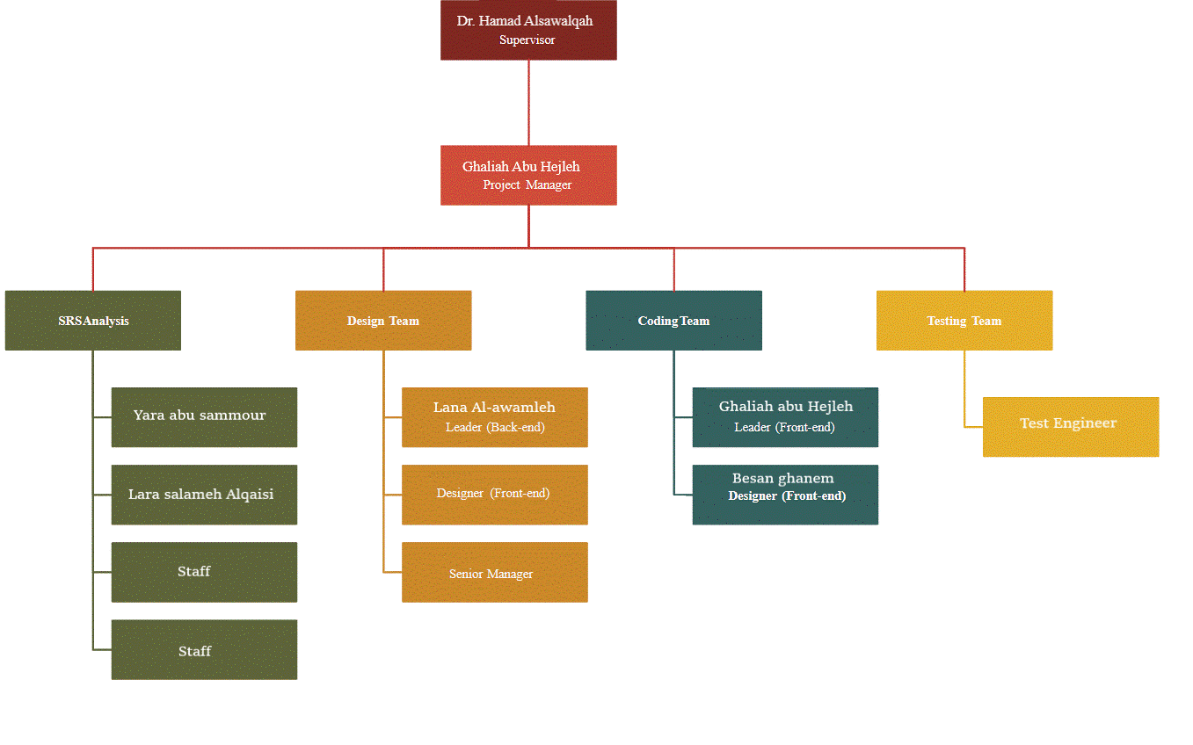
Figure 1 project organization

Software Process Model
We will be using the waterfall process model due to the client request even though the Incremental model is the best choice ability to obtain feedback from experts and clients on the application and fix mistakes immediately. It is easier, cheaper, and safer to make changes when using the incremental model. Therefore, providing the clients and customers with exactly what they want.

Roles and Responsibilities
the projects manager: Ghaliah Samer,
roles: The Project Manager is responsible for the planning, procurement, execution and completion of a project. The project manager is in charge of the entire project and handles everything involved, such as the project scope, managing the project team, as well as the resources assigned to the project
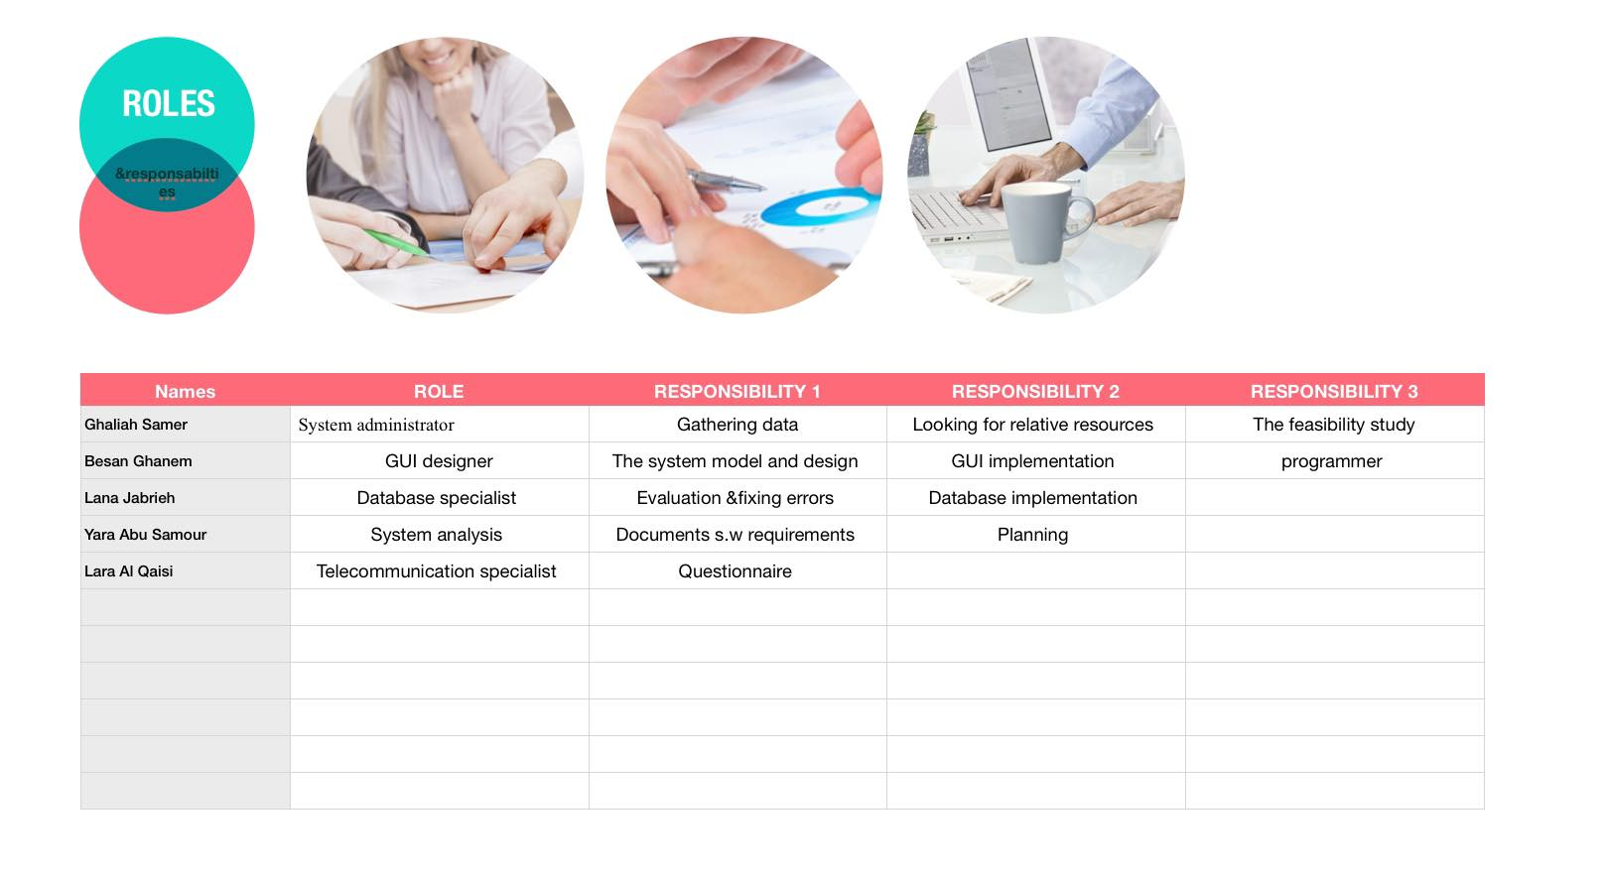
Figure 2 Roles & Responsibilities

Tools and techniques

Project Tasks
- Requirement (4 weeks)
- Design (2weeks)
- Implementation (4weeks)
- Validation (1week)
- Evaluation (1week)

Task Description
Requirement:
Gathering data & Looking for relative Resources(4days),
Project planning and structuring (2Week),
the feasibility study (3days),
Document software requirements (3 days).
Questioner (4 days).
Design:
Design software architecture (1Week),
Design database(4days),
Create The System models(3days)
Implementation:
GUI Implementation(2Week),
Database Implementation(2Week).
Validation: fix issues in the released patches (1Week).
Evaluation: test the system (1Week).

Deliverables and Milestones
Document is the output of the requirement, software architecture is the output of Design, initial software is the output of implementation but Since the system used is Waterfall, the whole project will be delivered after its completion, according to the agreement, on January 14th.
As for Milestone There will be Two Milestones the first on 19th November 2022, the second is on 3rd December 2022

Resources needed (Skills, HW and SW)
- Skills: object oriented programming skills, problem solving skills, Work under pressure, Mathematical aptitude, Excellent organizational and time management skills.
- Hardware: Server, Laptops, Mobiles ,4 Gb of available RAM ,250GB of free disk space to check out the code and an extra 150GB to build it.
- Software: DBMS Client Software, DBMS Server Software, android studio, Firebase, lucid chart, Adobe Photoshop.

Dependencies and Constraints
- Dependencies: We’re working on “Finish to Start” type each task depends on the task before,
- Constraints:
Cost: The project should be with total budget 45,070 including development cost and operating cost
Delivery time: The software should be ready for download and operation as agreed on January 14th. Others time

Assigning Team Members to Tasks
Requirement:
Gathering data & Looking for relative Resources(4days), (Ghaliah)
Project planning and structuring (2Week), (Lara) (yara)
the feasibility study (3days), (Ghaliah)
Document software requirements (3 days). (yara) (Lara)
Questioner (4 days). (Lana)
Design:
Design software architecture (1Week), (Besan), (Ghaliah)
Design database(4days), (Besan), (Ghaliah)
Create The System models(3days) (Besan), (Ghaliah)
Implementation:
GUI Implementation(2Week), (Besan), (Ghaliah)
Database Implementation(2Week). (Lana)
Validation: fix issues in the released patches (1Week). (Lara)
Evaluation: test the system (1Week). (Lana)

Project Schedule (Gant diagram & pert diagram)
This project will take three months to be released, So The project’s schedule is:
- 1st Milestone date is on 19th November 2022.
- 2nd Milestone is on 3rd December 2022.
- Submission of the final version is on the 14th January 2023.
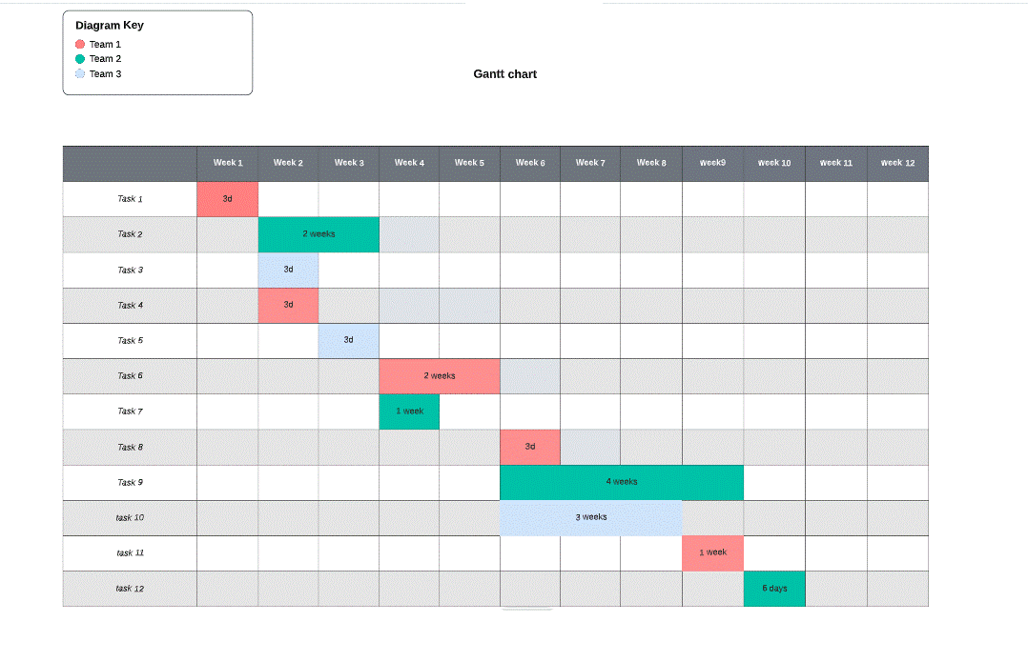
Schedule in Grant chart:
Figure 3 Grant chart
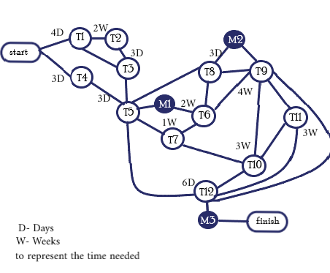
Figure 4 pert diagram

Monitoring, Reporting, and Controlling
Using the Grant as monitoring techniques.
weekly progress Reporting addition to a Status Reports through team meetings.
milestones to Track project’s cost and deadline to assure that the project is on the right path to achieving the expected result.

Risk Analysis and Plans
We have some risks that will face us while developing the software program and we have insert a table include the risks and their probabilities and effects on travel software as coming:
Risk | Probability | Effects
Changes to requirements that require major design rework is not easy if proposed. | Moderate | Serious
The time required to develop the software is little. | High | Serious
Required training for staff is not available. | Moderate | Tolerable
The rate of defect repair is underestimated. | Moderate | Tolerable
The size of the software may be bigger than expected. | Moderate | Serious
Code generated by code generation tools is inefficient. | Moderate | Insignificant
The database used in the system has many information which will make high request from client on server. | Moderate | Serious

We have some plans and strategies to reduce the risks and other to minimize them:
Risk | Strategy
Staff training | Trying to organize some courses training to the staff leaded by local high experiment employee or by specialize company.
Software size | Increase the time of working in each day as extra time to accomplish more processes to ensure deliver the software on time.
High Database size | Use high powerful server able to deal with big data connected to high database performance.
Underestimated development time | Investigate buying-in components; investigate use of a program generator.
Requirements changes | Derive traceability information to assess requirements change impact; maximize information hiding in the design.

Local and Global Impact of the Proposed Solution
Solutions that mention in the plan will impact on our environment software development in many way such a as:
- Our team will have more experience in software development also will give more comfortable getting the job done.
- Enable extra time system will able the employee to work and make more money.
- Powerful server will give the software system more sustainable for use in longer years and flexibility.

Feasibility Study

Technical Feasibility
The resources and technologies that the application needs are:
Programmers who are proficient in Flutter framework and Firebase.
A suitable integrated development environment (IDE).
The application is convenient and user-friendly and does not need any additional training for the users.
In conclusion, Travelers application is technically feasible.

Operational Feasibility
There is no specific problem, but the project's goal is to help travelers choose a destination and travel there with a group of individuals in a comfortable and safe manner, while also allowing them to become acquainted with and communicate with members of the group.

Economic Feasibility
development Cost
- Expenses
Table 1 Expenses Development Registration
Smalltalk Training registration | (JD 1500/Client ) | 6,000 JD

- Personnel:
Table 2 personnel Development Costs
 | employee | Cost per hour | Total hours | Total cost per hour
1 | System analysts | 15 | 400 | 6,000 JD
2 | System administration | 19 | 20 | 380 JD
3 | programmer | 23 | 300 | 6,900 JD
4 | GUI Designer | 20 | 200 | 4,000 JD
5 | Telecommunication Specialist | 25 | 50 | 1,250 JD
6 | Database Specialist | 22 | 20 | 440 JD
Total = 18,970 JD

- New Hardware & Software:

Table 3 Hardware and Software Development Costs
Hardware | Costs
Development Server | 6,200 JD
Storage Device (hard disk, Ram ) | 300JD
Software(adobe Photoshop, Firebase ) | 2,500JD
Server Software (OS, misc.) | 800 JD
DBMS Server Software | 3,500 JD
DBMS Client Software (400 per client) | 2,800 JD
Total = 16,100 JD

Total Development Cost =41,070
Operating Cost
Table 4 Cost-benefit Analysis - Hardware and Software Operating Costs
Name | Cost
Hosting server | 300 JD
Programmer | 2,000 JD
System Update and Enhancements | 1,000 JD
Device Maintenance | 700 JD
Total = 4,000 JD

- Tangible benefits: year (1-5)

Table 5 Project Tangible Benefits
Tangible Benefit (1-5) Years | Cost
Cost Reduction (reduce spending) | 1,500 JD
Increased Revenue | 2,500 JD
Increased Flexibility | 3,000 JD
Total = 7,000 JD

- Intangible Benefits:
- Improve user satisfaction.
- Good reputation and image.
- decreases in the amount of employee time needed to complete specific tasks.

Payback Analysis
Table 6 Total of Development and Operating Cost
Year | Development costs | Operating Costs | Total
Year 0 | 41,070 | 0 | 41,070
Year 1 | 0 | 6,000 | 6,000
Year 2 | 0 | 6,500 | 6,500
Year 3 | 0 | 4,000 | 4,000
Year 4 | 0 | 3,750 | 3,750
Year 5 | 0 | 5,300 | 5,300

Table 7 Playback Analysis

Year | Costs | Benefits | Discount Factor  Rate (12%) | Accumulated |  | NPV  Total
 |  |  |  | Cost | Benefits | NPV  Total
Year 0 | 41,070 | 0 | 0.89 | 36,552.3 | 0 | -36,552.3
Year 1 | 6,000 | 5,000 | 0.79 | 4,740 | 3,950 | -790.0
Year 2 | 10,500 | 25,000 | 0.71 | 7,455 | 17,750 | 10,295.0
Year 3 | 4,000 | 36,000 | 0.63 | 2,520 | 22,680 | 20,160.0
Year 4 | 3,750 | 55,000 | 0.56 | 2,100 | 30,800 | 28,700.0
Year 5 | 5,300 | 64,000 | 0.5 | 2,650 | 32,000 | 29,350.0
SUM ∑ | 70,620 | 185,000 | ---

Since the present value of accumulated benefits in the third year of operation (17,750) exceeds the present value of the accumulated costs (7,455), this project has payback period of slightly less than five (5) years.
- Payback Year = The third Year
- Lifetime ROI = (estimated lifetime benefits - estimated lifetime costs) / estimated lifetime cost = (185,000 – 70,620) /70,620
= 1.619654
- Annual ROI = Lifetime ROI / Lifetime of The System
= 1.619654/5
= 0.323931
- Net Present Value = Total Present value of benefits – Total Present value of costs
=32,000-2,650= 29,350.0

Schedule Feasibility
Table 8 Project Schedule
Tasks | Description | Start Time | End Time | Duration | Dependency
T1 | Gathering data &  Looking for relative  Resources | 20/10/2022 | 24/10/22022 | 4 Days | None
T2 | Project planning and structuring | 24/10/2022 | 7/11/2022 | 2 Week | T1
T3 | the feasibility study | 8/11/2022 | 10/11/2022 | 3 Days | T1&T2
T4 | Questioner | 11/11/2022 | 13/11/2022 | 3 Days | none
T5 | Document software requirements | 14/11/2022 | 17/11/2022 | 3 Days | T3,T4
First Milestone 19th November 2022
T6 | Design software architecture and GUI | 20/11/2022 | 33/12/2022 | 2 Week | T5
T7 | Design database | 20/11/2022 | 27/11/2022 | 1 week | T5,T6
T8 | Create The System models | 30/11/2022 | 2/12/2022 | 3 Days | T5,T6
Second Milestone 3rd December 2022
T9 | GUI Implementation | 4/12/2022 | 31/12/2023 | 4 Weeks | T6,T8
T10 | Database Implementation | 3/12/2022 | 23/12/2023 | 3Weeks | T7,T9
T11 | fix issues in the released patches | 1/1/2023 | 7/1/2023 | 1 Week | T9,T10
T12 | Test the system | 8/1/2023 | 13/1/2023 | 6 days | T5,T9,T10,T11
Submission of latest version 14th January 2023

Legal feasibility
proposed project confirms the legal and ethical requirement and the proposed system is completely fine with the legal and ethical terms. However, there’s some point that needs to be clarified:
- The development team Own the rights of The Source Code, in addition to that any new feature will be considered as a new version that has its cost.
- Dealing with any other company during the process or any leakage of the code leads to us to press legal charges.

Software Requirements Specifications (SRS)

System Stakeholders and Requirements Sources
Stakeholders:
System manager, IT staff(developers), Adventurers.
Requirements sources:
Observation: The direct approaches of interviewing and questionnaires provide valuable user feedback based on the questions asked of them.
User observation is helpful in assisting the analyst by getting a full grasp of how the user interacts with the system.
Brainstorming: a method design teams use to generate ideas to solve clearly defined design problems.
Questionnaire: is a research instrument that consists of a set of questions or other types of prompts that aims to collect information from a respondent.

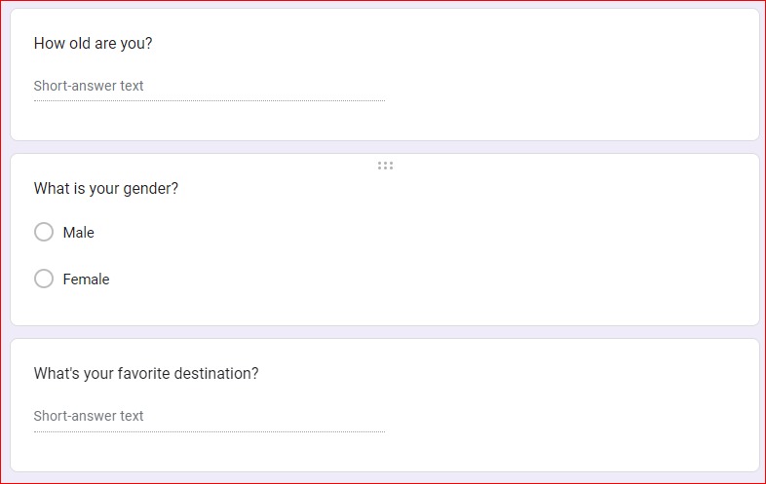
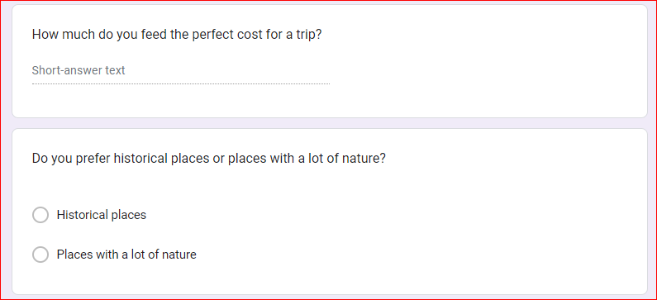
Figure 5 questionnaire
Figure 6 questionnaire -

User Requirement Definition
Table 9 user Requirement
Requirement .No | Description
1 | Users create account to log in.
2 | Employees should be able to view the costumers’ requests.
3 | Users should be able to add new trip.
4 | Users can search any distinction they want go to
5 | Users should be able to see the recent event in specific destination
6 | Users can access the app through devices any time, any place and should be connected to the internet.
7 | User can join chat with other users .

System Functional Requirement Specification (you can use user stories and requirements scenarios)
1.view contents:
  - when opening the application will has the ability to show the home page of the app that will contain the guidelines buttons.
  - if you are not logged in and pressed the reservations then the app will show you that you have to login to show your reservations
  - if you pressed the event the app will show the table of the next week to next and you can see their details like time and cost for 1 traveler and the airport and the destination country … etc.
  - if you pressed the national travels the app will show the table of the day to end of this week and you can see their details like time and cost for (1 traveler ) and the destination province and places (contains tourist places) … etc.
2.login system:
- Enter the app firstly … it will open the home page by default .
- On the right corner in this page there is an login button, click on it to go to login page.
- Enter your email and password and check the re-captcha button.
- Click “Sign in” button. it might take a few minutes until the system validates User-ID and password from database of server.
- if the system doesn’t sign in successfully due to incorrect information, the pop-up message “invalid username or password “ will appear and the user will r-enter them again. If the user enter incorrect information more than three times an alert will send to his email on system and the account will lock for 3 hours or if user click on the validation email the delivered in email.
- If the previous fields were entered correctly , the home page will be opened and new session will start.
3.logout system:
- If the user wants to logout from system it he will access the logout button in the right corner of any page in the system.
- If pressed, a pop up message from the system will appear to confirm the logout, if confirmed, the session will destroyed.
- if not, the system will return to the last page before clicking on the button.
4. View event:
- If the employee wants to show the request, he must go to the request page(work zone) to show all request came to the website.
- Request page will displayed and all request will be showed with all it’s details such as : the date, the desired country to travel, cost of trip, username, accept button, deny button, show details bar to show all related details,.
- If the employee chooses accept request it will be added to accepted request page and the app will send a message to user that his request accpeted .
- If the employee chooses deny it will disappears and the app will send a message to user that his request denied.
- If the employee chooses show details the request will appear with more details and like user email, phone number, time with hours and more details, also with accept and deny buttons.
5.update info:
- In home page of users account, there will be account button with man icon.
- When pressed, it will open all info of user, and in every input will be a edit button.
- From update button can change any info user want taking into consideration that the app will ask for password of user.
6.Search technique:
- In home page of users account, there will be a search bar.
- If user click on it, a keyboard opens and user can write the name of destination country.
- After that when user write a country name it will search for all country that contain this country in even destination or location on the route with briefly details of the trips like time of it and it’s cost…etc.
7. join chats
- In home page of users account, there will be a chat icon.
- If user click on it, users join a chat room.
- After that when user write a message all users can see it and interact with each others.

Non-Functional Requirements (you must ensure that your requirements can be tested)

  - Performance Requirements

Table 10 non-functional requirement
property | Description
speed | the application should be as fast as possible to achieve the purpose  the app won’t take more than 5 seconds to load the pages
size | 40.17MB
Ease of use | The time frame should include all human and system's processes. In addition, it should be easy for the user to learn how to use the application.  It will take the users 3 hours training to use the app ,a 10 minute quiz with a score out of 10 about the icons ,buttons will get a an average of 8.5
Reliability | extent which it works as and when needed  the system should be back within 2 hours in case of crash and
Efficiency | the users must be able to access the services which are provided by the system at any time The application should get information at any time; and should be able to retrieve it at the same time without delay  the system should provide the admin full access 24/7 therefor in case anything happen a backup user call will be received with one of the technical team within 1 hour
Portability: | the system must be compatible with various popular operating system  the system can be used in web ,Android and iOS devices and will be responsive

  - Dependability Requirements
- Software should not cause physical or economic damage in the event of system failure.
- The app should be able to retrieve information whenever it is needed and should be able to do so simultaneously and without delay. Also, it will be used whenever it is needed.
  - Security Requirements
- It shall be ensured that the system provided is secure against unauthorized access.
- All users shall be able to log-on to the system using a “User-Id” and “password”
- The app shall have the ability to restrict access to anyone that failed 3 attempt in logging in the system.
- An email shall be sent for authentication purposes.
  - Usability Requirements
The application should be easy to understand by anyone, easy to access, having a good error handling, effective navigation and good UI
  - Operational and Environmental Requirements
the app will work with devices that use API version 29 and higher .
  - Maintainability Requirements
The mean time to restore the system (MTTRS) following a system failure must not be greater than 10 minutes. MTTRS includes all corrective maintenance time and delay time. Mean preventative maintenance time: The mean preventative maintenance time on applying routine plug-in updates to the RQ Website shall be less than 30 minutes every 2 weeks.

Data Requirements
Ensures that data produced and consumed satisfies business objectives, is understood by all relevant stakeholders, and meets the needs of the business processes that create and use the data.
It is not uncommon for an IT project team to quickly design a database during software development, without reference to business terms, data standards (names, metadata, allowed values, ranges, lengths, etc.), or quality rules. Organizations are much better served by ensuring that selection of and specifications for data used to satisfy business objectives, are prioritized, validated by stakeholders, and well documented through a repeatable process.
Data requirements definition establishes the process used to identify, prioritize, precisely formulate, and validate the data needed to achieve business objectives. When documenting data requirements, data should be referenced in business language, reusing approved standard business terms if available. If business terms have not yet been standardized and approved for the data within scope, the data requirements process provides the occasion to develop them. For patient demographic data, governance should be engaged in validating data requirements, with representation from supplying and consuming business areas across the lifecycle to ensure that their requirements are met.

Analysis and Design

Use case Diagrams
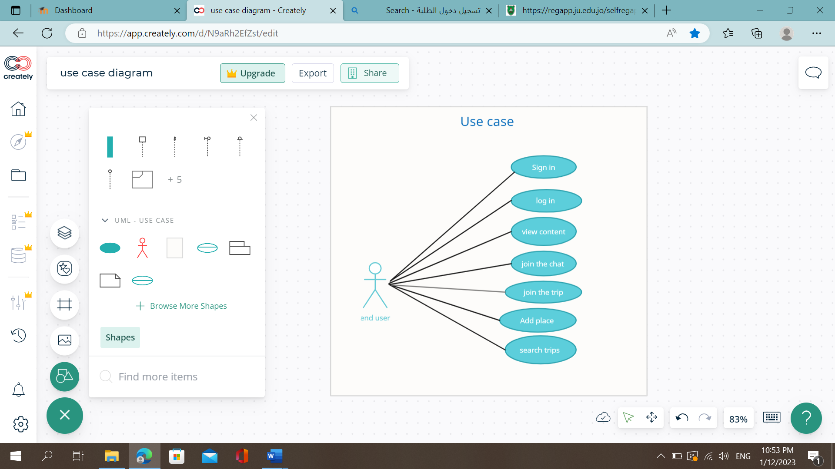
Figure 7: use case diagram

Textual Description for Each Use Case
- Sign up:
Initial assumption:
The application is not loaded on user’s device before.
Normal:
The user opens Google play then types for “iTravel” in search place, chooses the application by clicking on the install icon. Each user should fill his data (email, password, and password confirmation). If you entered the valid data in fields then send it to database to check it to storage it in it, that gives a message to users’ successful registration and give them authorization then take the user to profile page.

What can go wrong:
If the user enter a password consists of less than six characters then the password is invalid.
If the user used not correct email.
Table 11:sign up description
Sign up

Actors | Trip Participants, trip organizer
Description | Allow users to create their own account in “iTravel”, they have to use valid password and email the password must consists of 6 letters or higher, the email must be exist.
Data | Unique new email and password for the user.
Precondition | The Application must be available in app store and installed in users’ devices.
Post condition | Users sign in information must be saved in database. And give the user an authentication so he can log into the app.
Response | User account information saved in database.

- Log in:
Initial assumption:
The user already has an account saved in database and has the application downloaded on his device.
Normal:
The user opens “iTravel”, chooses logging by clicking on the log in icon. The user should fill his stored data (email, and password). If he entered the correct data in fields then send it to database to check it, then he could be in his home page.

What can go wrong:
If the user enter a wrong password or email he could not reach his home page .
If the user forget his password he could not get his account again .
Table 12:log in description
Log in

Actors | Trip Participants, trip organizer
Description | The users enter their own information in “iTravel”, they must use the same information that they used when they sign up. Then authenticity.
Data | Users’ email and password
Precondition | The account is already existing. And check his accessibility.
Post condition | Enter the user to home page with correct role.
Response | User get application ready to use .

- View content:
Initial assumption:
The user has successfully log in in his account.
Normal:
The user can see the home page and can do several activities within.
What can go wrong:
The home page not loaded for user.
- Join the chats:
Initial assumption:
The user already has signed in his account and viewed home page correctly.
Normal:
The user clicks “chats” icon, then he can talk to all other users in the app.
What can go wrong:
If the user does not connect to an internet network the messages sending fails.
Table 13: join chats description
Join the chats

Actors | Trip Participants, trip organizer
Description | Each user can send and receive messages with knowing email of sender.
Data | The users communicate with each other as text messages.
Precondition | The user has an account and signed in.
Postcondition | Make a link between users to get to each other.
Response | Chat room available for user.

- Join the trip:
Initial assumption:
The user already has signed in his account and viewed home page correctly. And there are available coming trips.
Normal:
The user opens “iTravel”, clicking event icon to view available trips the click on + in the event he interested on to be a participant on it.
Table 14:join trip description table
Join trips

Actors | Trip Participants.
Description | Join the event that he wants to go and enjoy with other people on it
Data | The date of event and the participants
Precondition | Log in .
Postcondition | The number of interested people is increased by one .
Response | The data of participant reach for trip organizer.

- Add place
Initial assumption:
The user already has an account saved in database and has the application downloaded on his device.
Normal:
The user opens “iTravel”, clicking on event if the users want to organize new trip he click on add button that let him to make it .
What can go wrong:
the page could not load .
Table 15:add place description table
Add place

Actors | Trip organizer
Description | The users enter information about his trip (place ,date) , then publish the event to all other users.
Data | Trip information , user that would like to join.
Precondition | Users logged in. Internet connection .
Postcondition | Publish the new trip for other users .
Response | New event added

- Search trips :
Initial assumption:
The user already has an account and log in without issues
Normal:
The user opens “iTravel”, click on search panel and type the place name that he want to search for available coming event in it. Maybe users want to organize trip and search to check there is no conflict or to join.
What can go wrong:
No results shown.
Table 16: search trip description
Search trip

Actors | Trip Participants, trip organizer
Description | The user type in search panel the place name that he want to know for available coming event in it.
Data | Place name or date.
Response | All result is shown for user.

Activity diagram
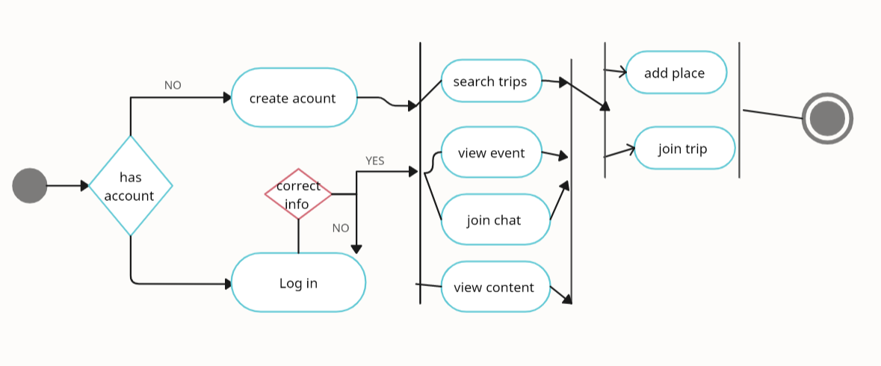
Figure 8: activity diagram

Sequence diagram
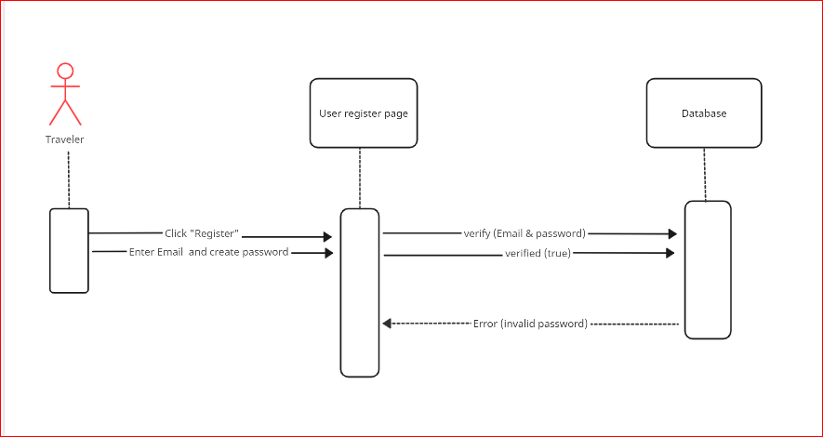
Figure 9:sign up sequence diagram
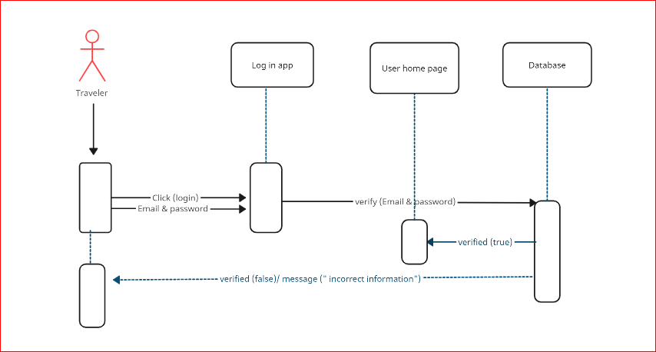
Figure 10: log in sequence diagram

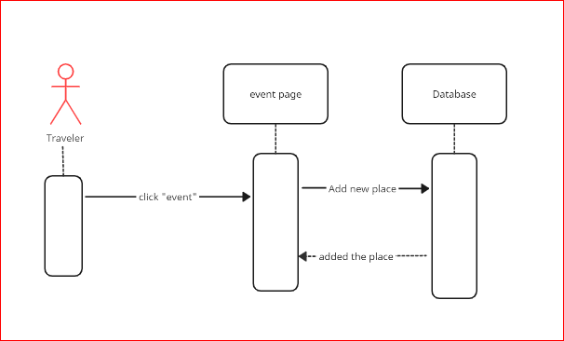
Figure 11: view content sequence diagram
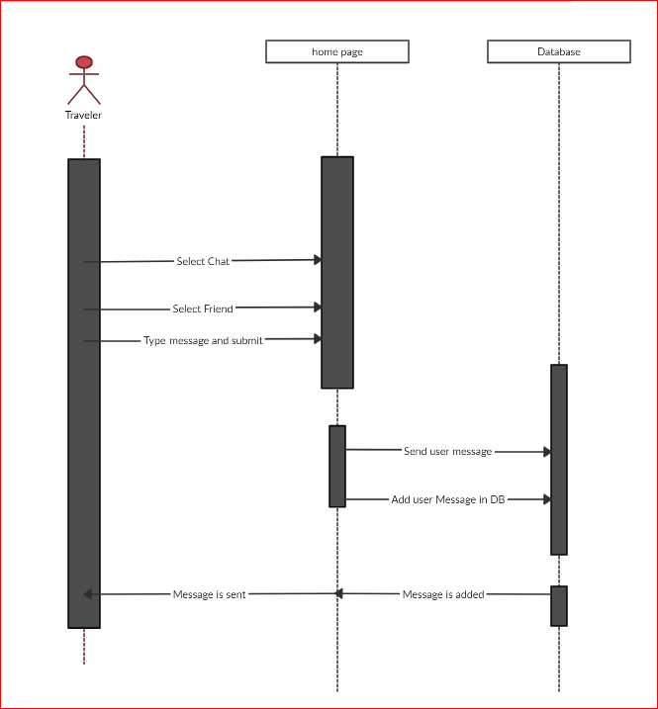
Figure 12: join chat sequence diagram

class diagram
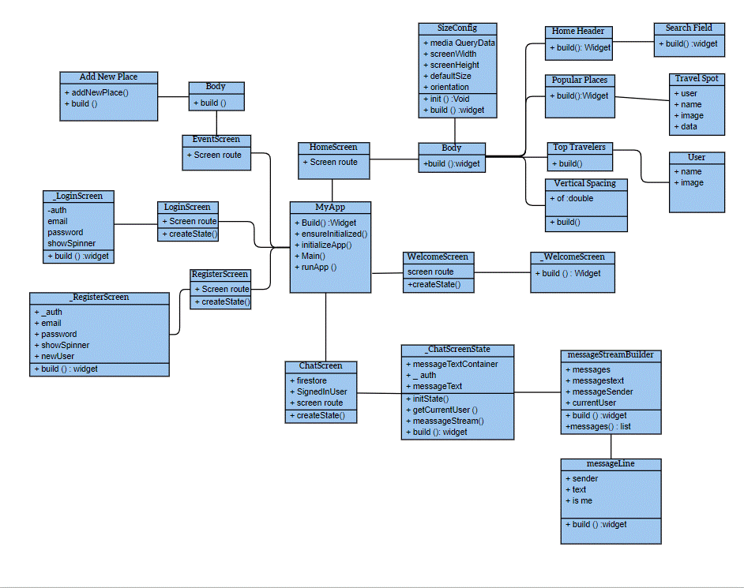
Figure 13 Class diagram

database design
Since we used a no SQL database server (firebase)
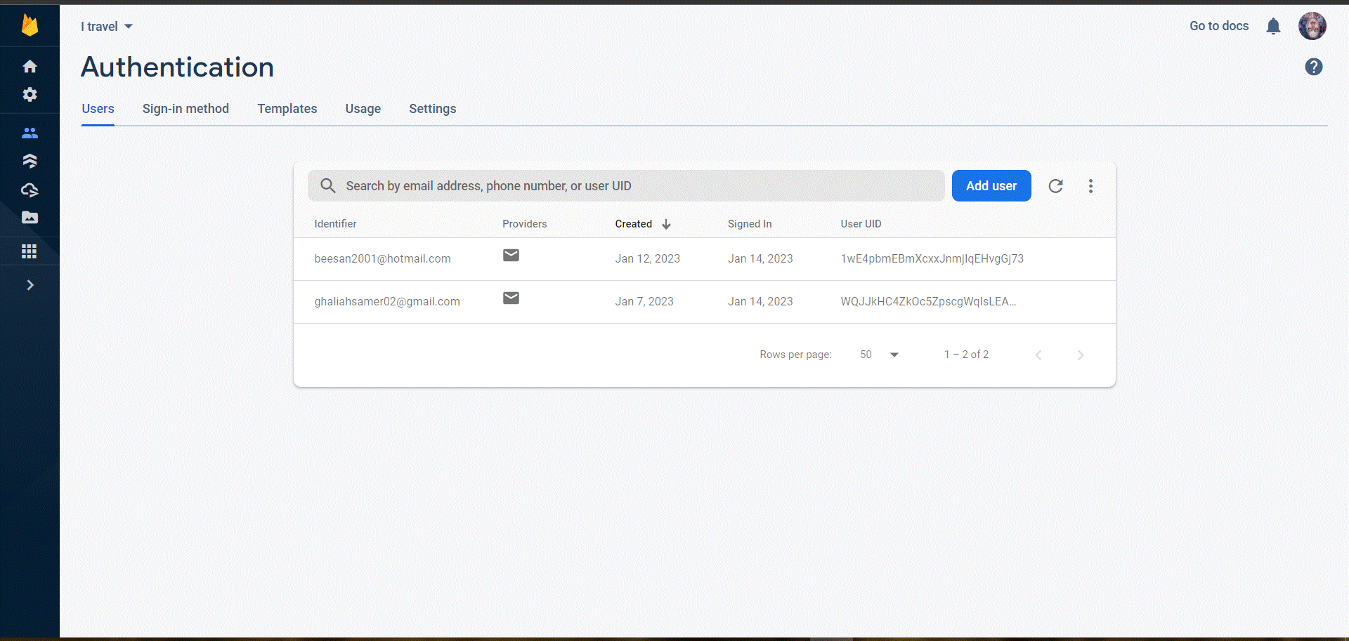
Figure 14 firebase authentication
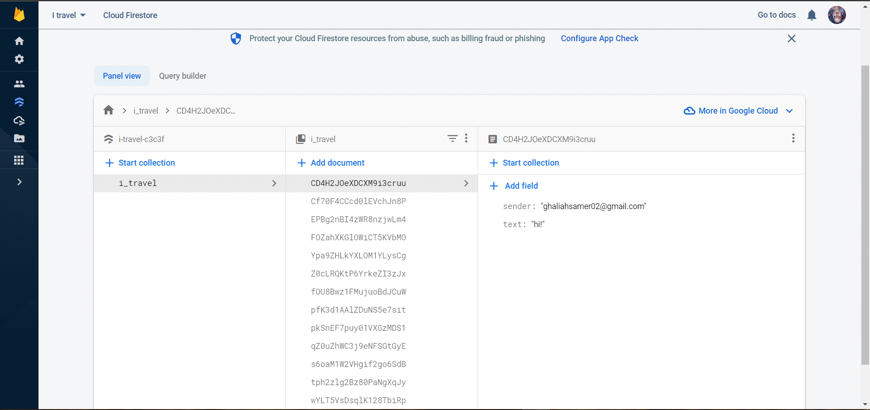
Figure 15 firebase firestore data

Architecture design
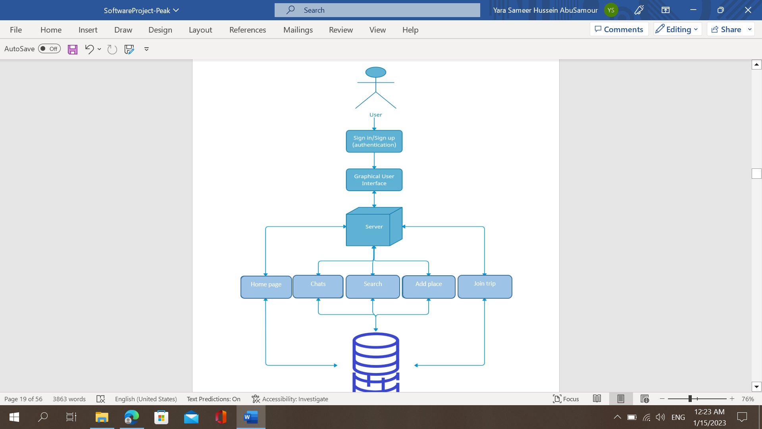
Figure 16 architecture design

Classes and Component Design
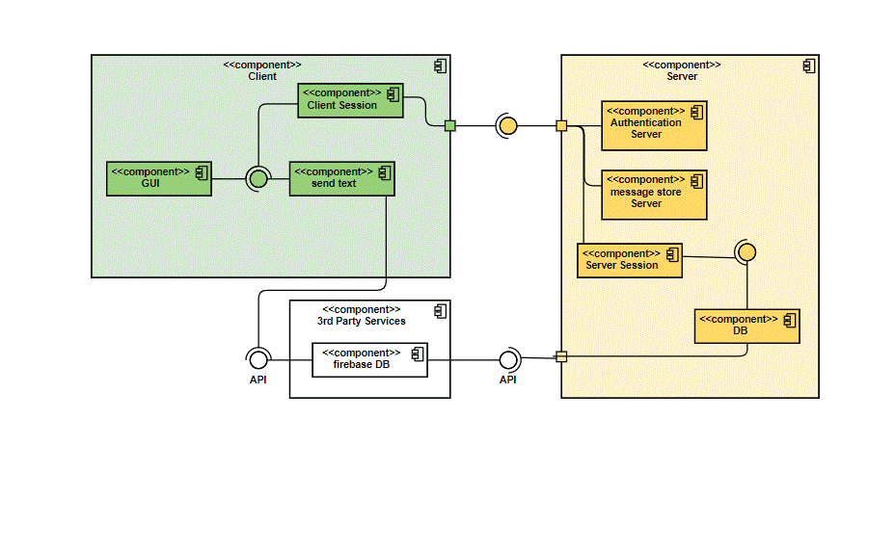
Figure 17 component design

Graphical User Interface Design

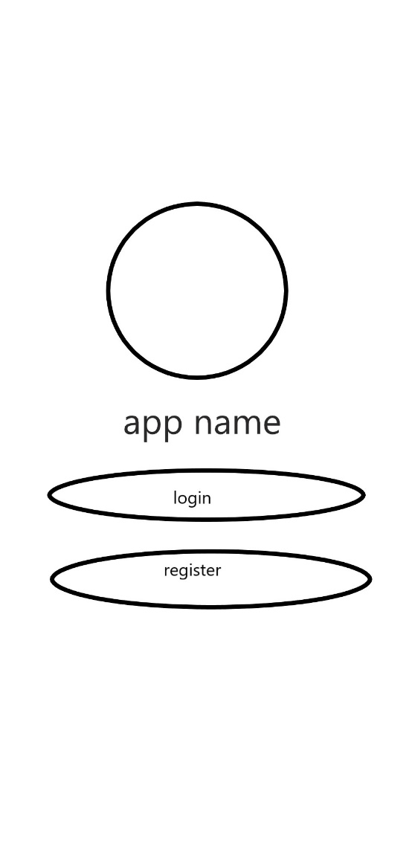
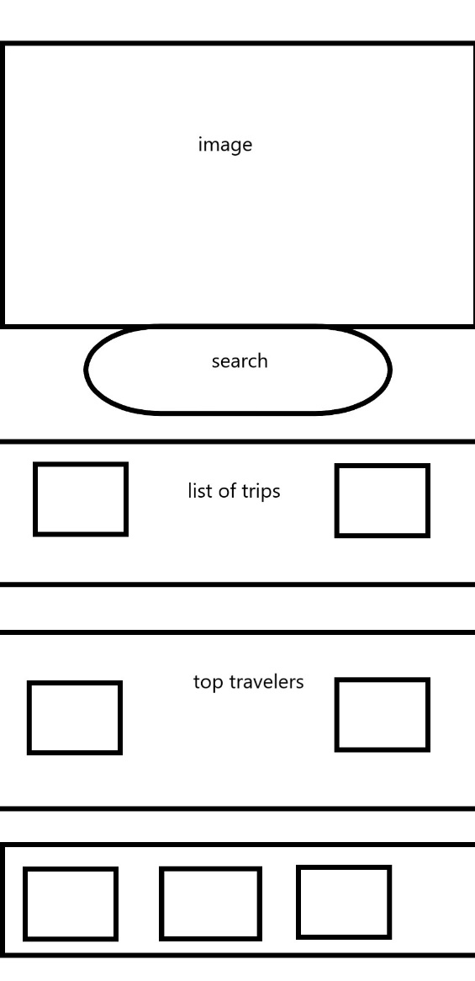
Figure 19 welcome screen design
Figure 18 home screen design

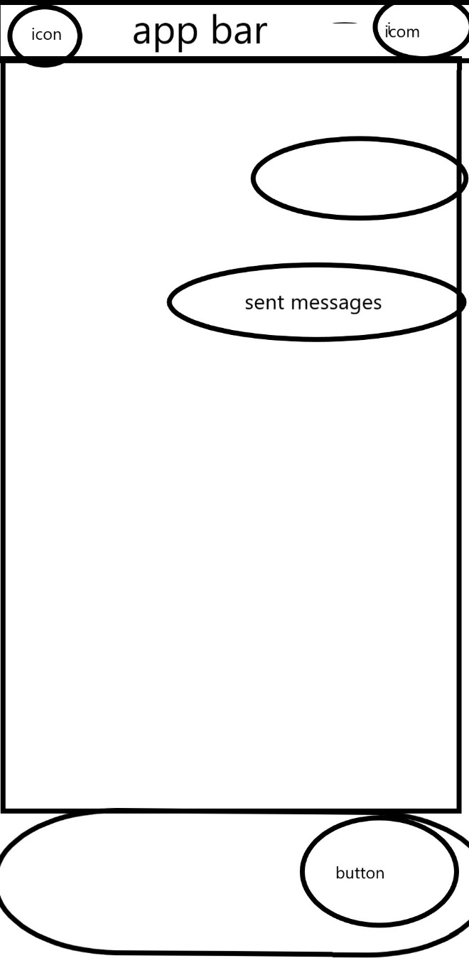

Figure 21 chat screen design
Figure 20 event screen design

User Manual
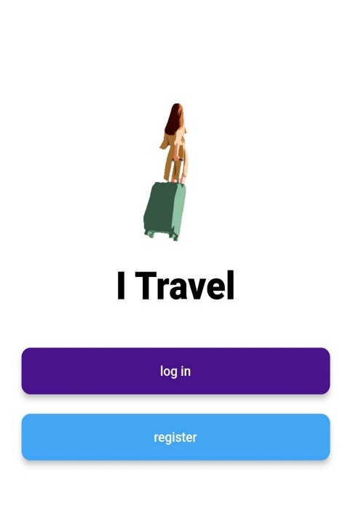
This is where the user can log in to start using the application if the user already has an account.
Figure 22: welcome screen

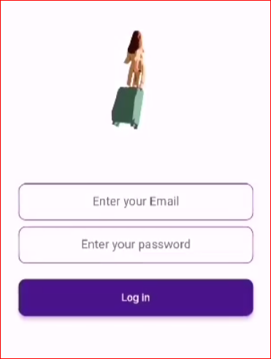
If the user doesn't have an account, the user should press the register button and the password must be at least six characters
Figure 23: log in screen

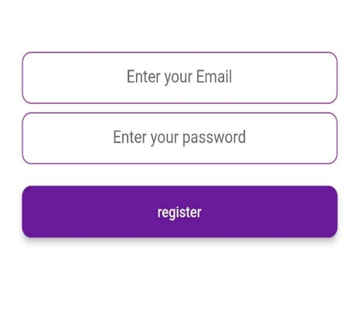
Figure 24: sign up screen

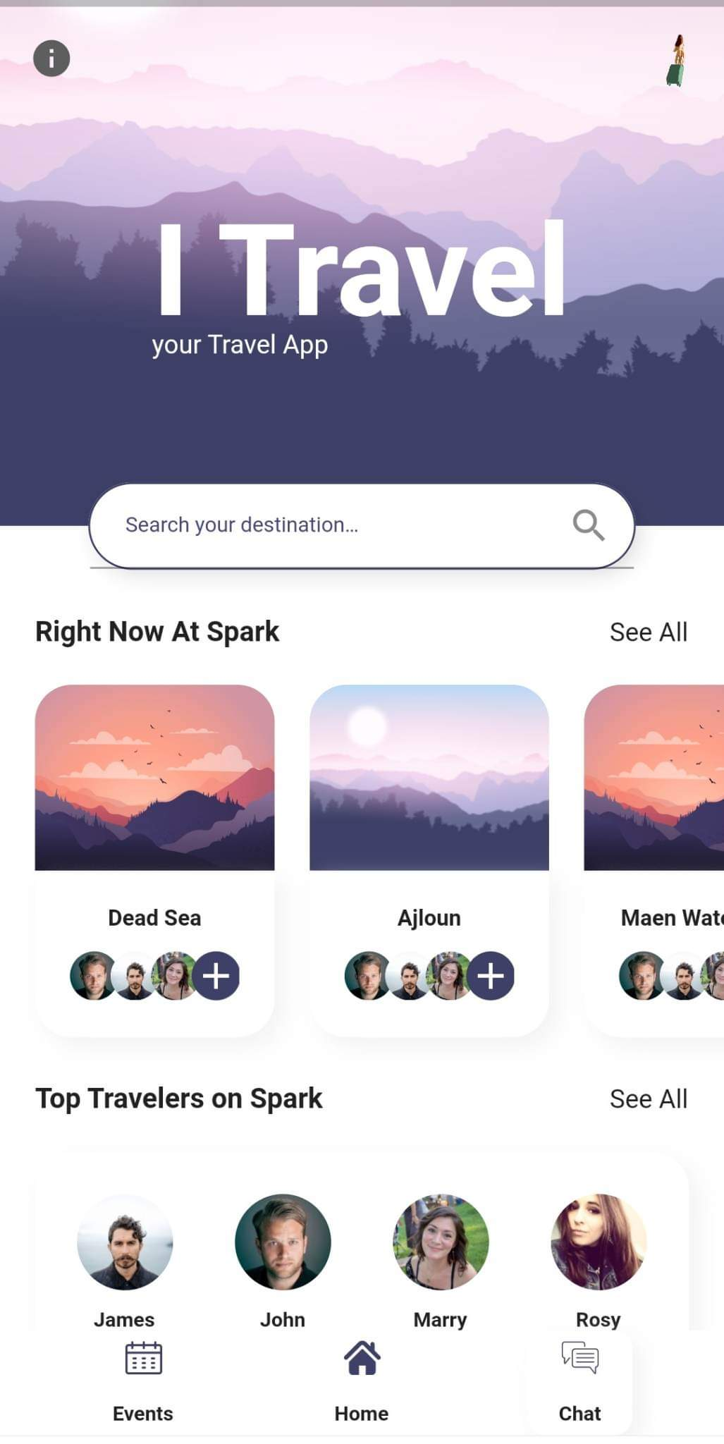
Figure 25: home page
when you press this button, you will go to a website have an information about the Tourist cities on wide

After logging in, the home page will appear where the user is allowed to find destinations of the trips

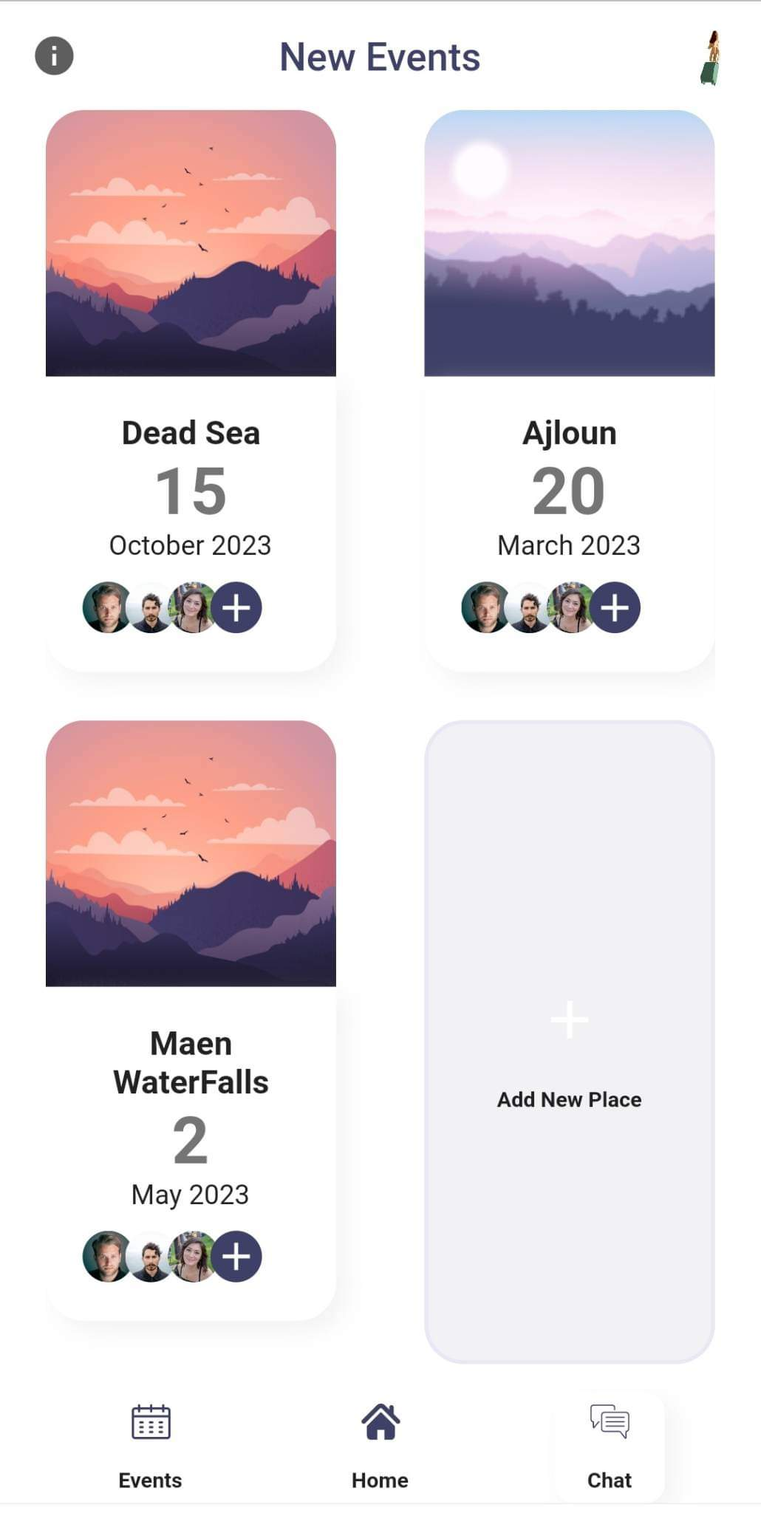
Figure 26: event screen

Figure 27: add button
For communication between travelers
Go to the home page
View the event information
You can add new trip (to be the organizer

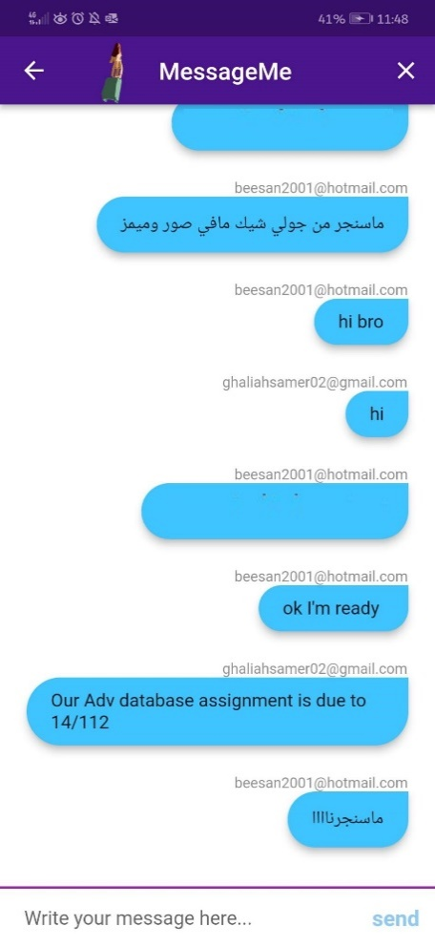
Send data to server to be viewed in the chat

Implementation
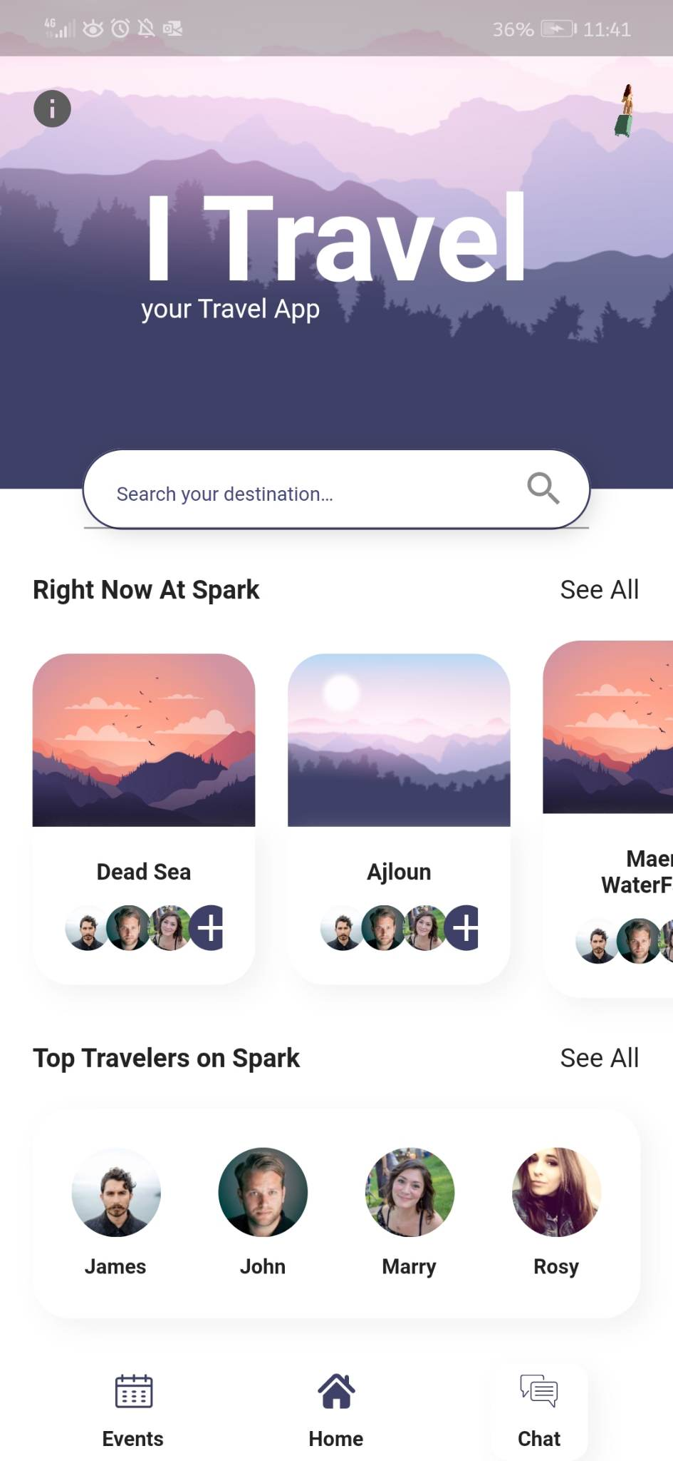
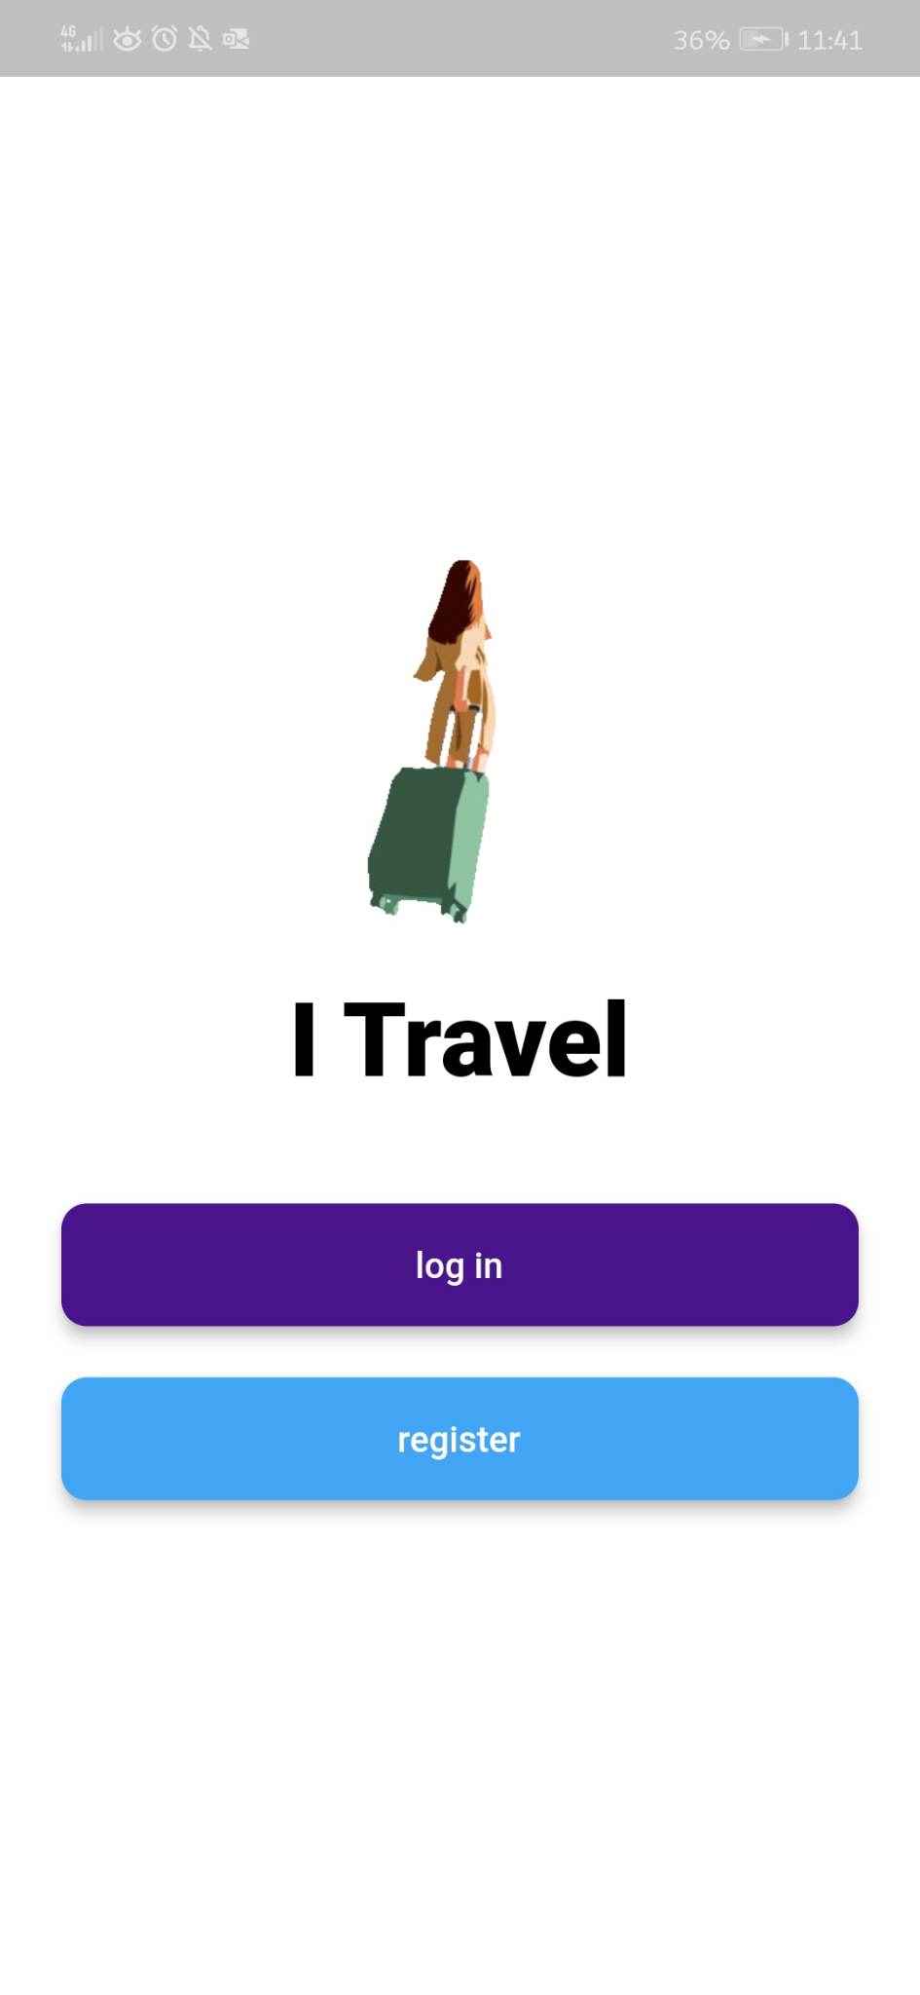
Figure 28 home screen implementation
Figure 29 welcome screen implementation

Figure 31event screen implementation
Figure 30 chat screen implementation
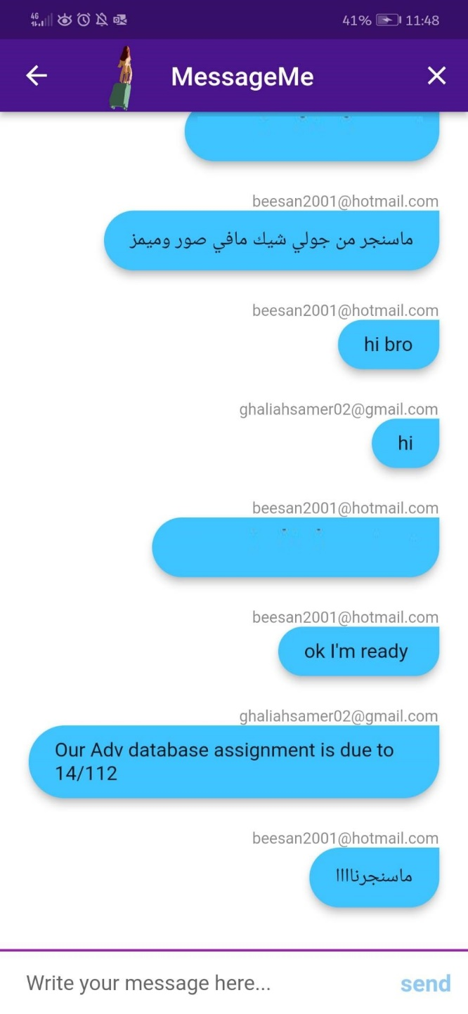
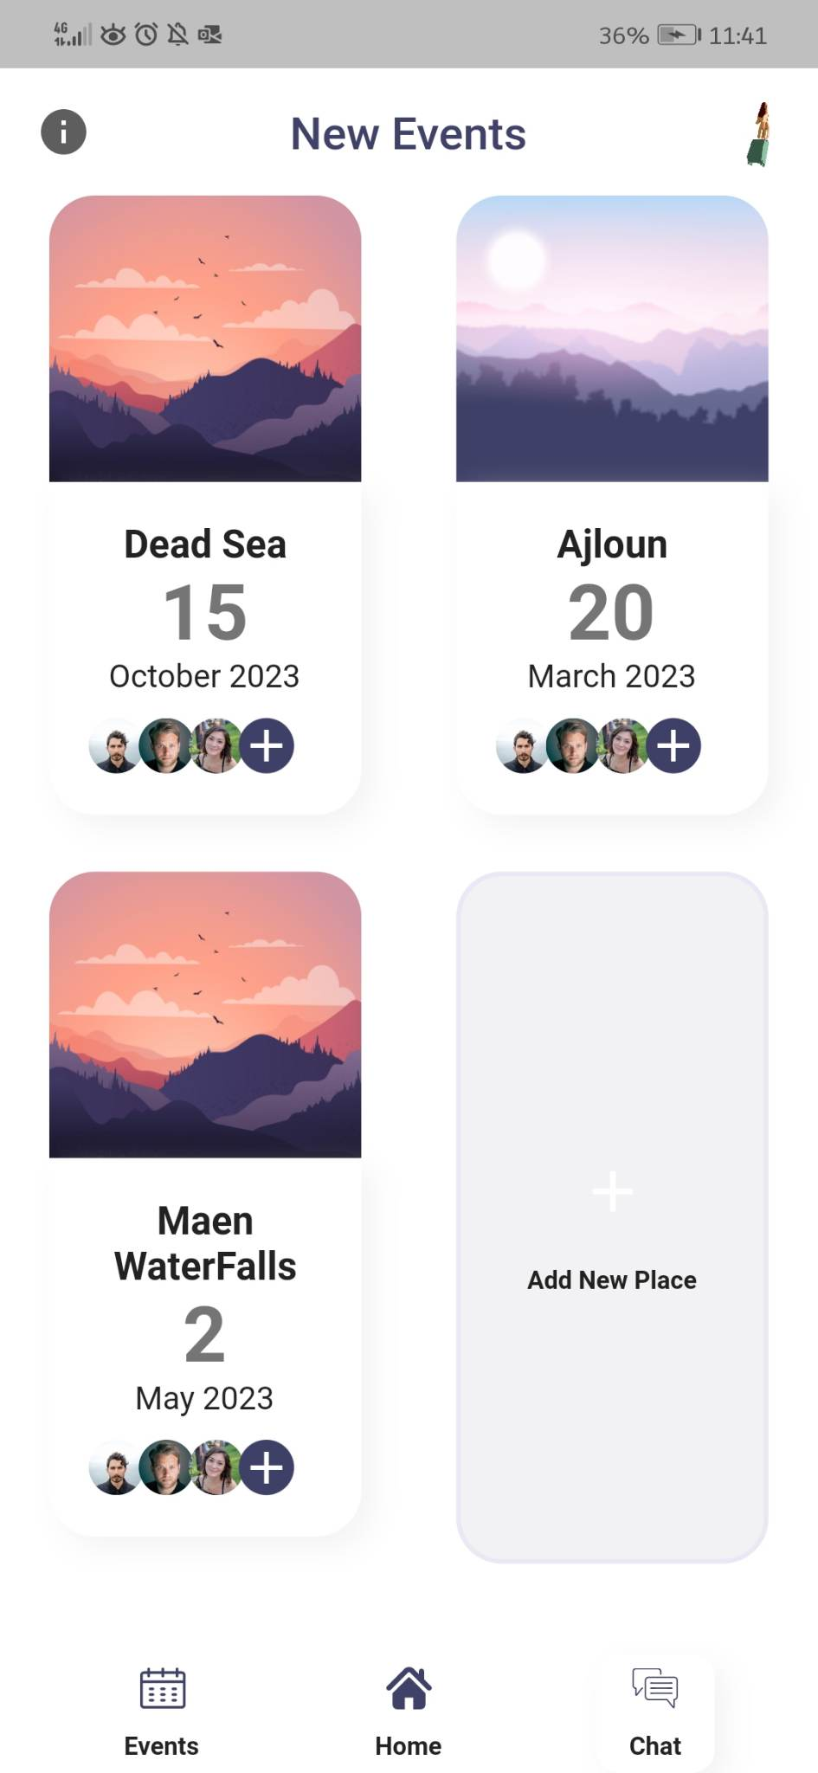

References
- https://creately.com/
- https://app.diagrams.net/
- https://www.figma.com/
- https://www.google.com/
- https://www.wikipedia.org/
- https://innovate.ieee.org/ieee-software-engineering-standards/

