**ASSIGNMENT-4**

Name: - Yaragalla Kusuma

Roll No: - 20NN1A12C5

Email: - yatagallakusuma.2002@gmail.com

College Name: - Vignan’s Nirula Institute of Technology and Science for Women

**DATASET -SAMPLE-SUPERSTORE.XLS**

Task 1:- Create one fixed and one exclude LOD expression.

Task 2: Create any 2 map visualizations using geographical data.

Task 3: Create Top N and/or Dynamic dimension parameters and utilize those in your workbook.

Explain LOD Expression, Map Visualizations using geographical data and Top N, Dynamic dimension Parameters

LOD Expression :- **Level of Detail (LOD) expressions** are used to run complex queries involving many dimensions at the data source level instead of bringing all the data to Tableau interface.

Different types of LOD functions: -

There are three types LOD functions: -

1. Fixed
2. Include
3. Exclude

Map Visualization using geographical data: -

Tableau is a tool for analyzing geographical data. It can automatically turn location data into interactive maps.

ZOOM Levels :- 16

In Map Visualization, Geographical fields are double click on the field the data pane and tableau will create a map using generated latitude and longitude fields.

Top N Parameter:-

Top N parameter uses a value selected by the user, where N is a value. The value can be static or controlled by a parameter.

Top N parameter is also known as Bottom N.

Tableau allows users to filter and display a certain percentage of their data.

Dynamic Dimension Parameters:-

Create a Parameter. Create a new Parameter that lists your dimensions.

Create a Calculated field that will be used as a dimension in your worksheet. Dimension to display when a particular parameter value is selected.

Add the calculated fields to the canvas.

1. Colours
2. Filters
3. Select any ratings or price ranges.

Tableau Starting: -

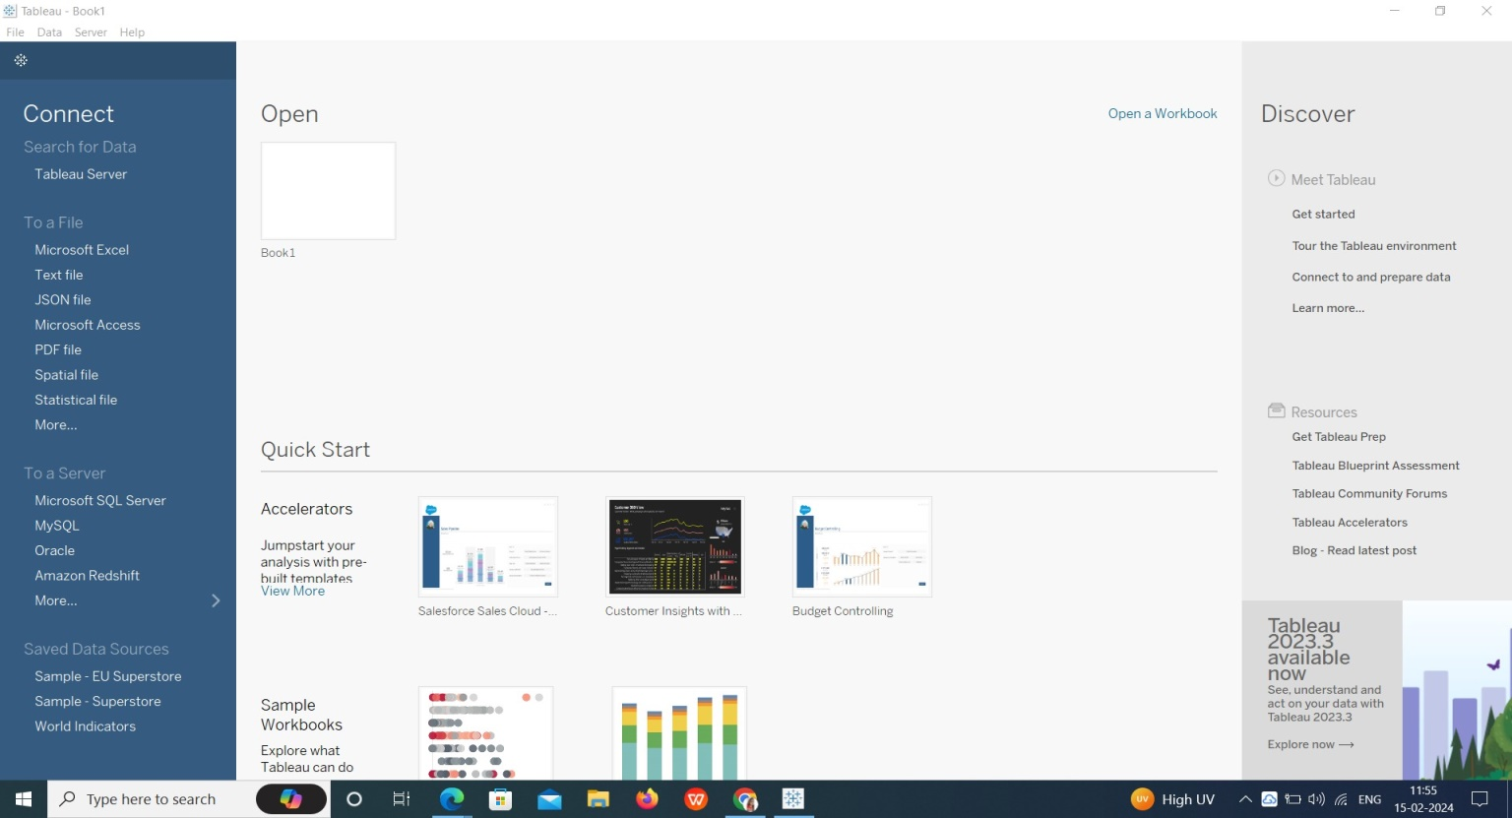

Upload the DataSet in Tableau:-

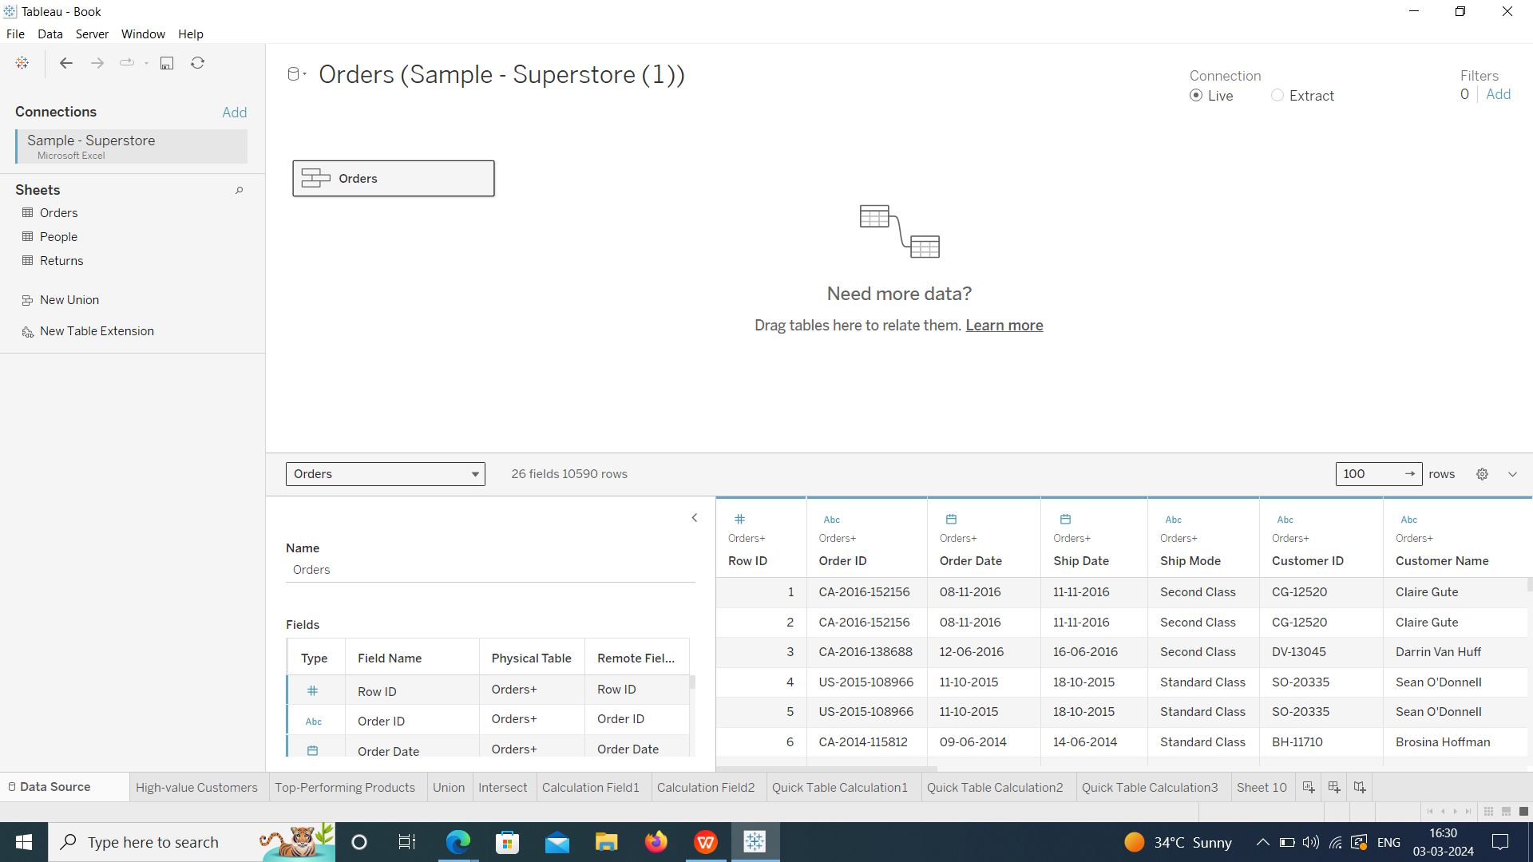

Create One Fixed LOD Expression and one exclude LOD expression: -

One Fixed LOD:-

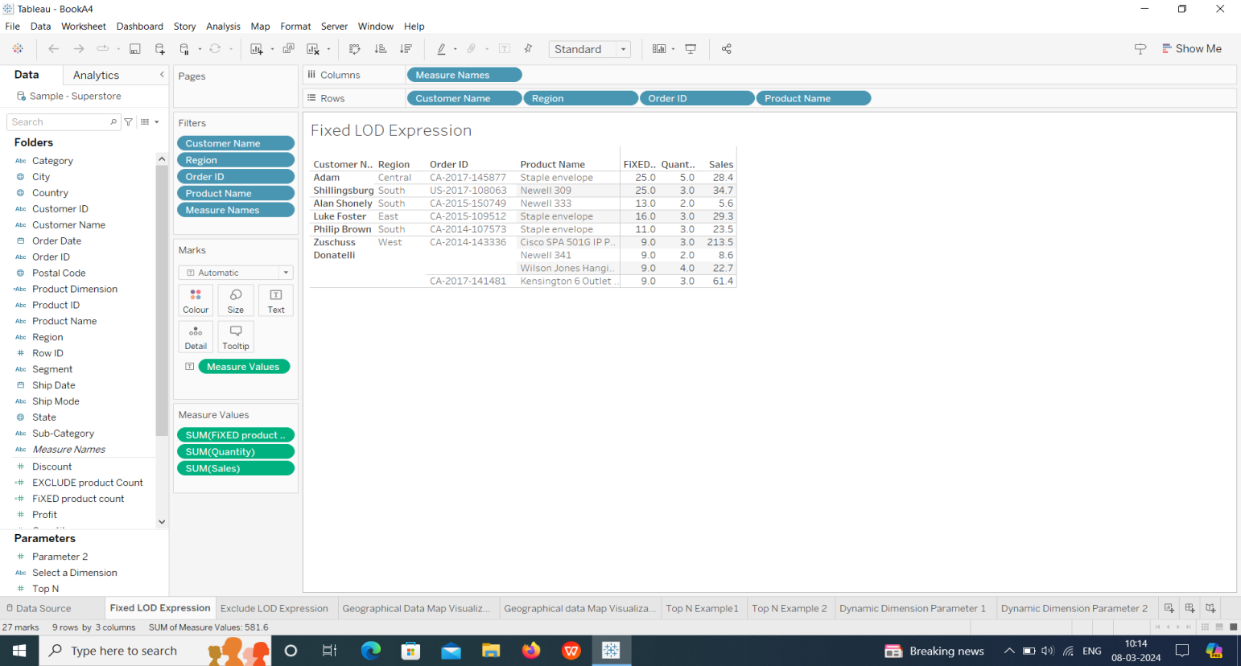

One Exclude LOD Expression:-

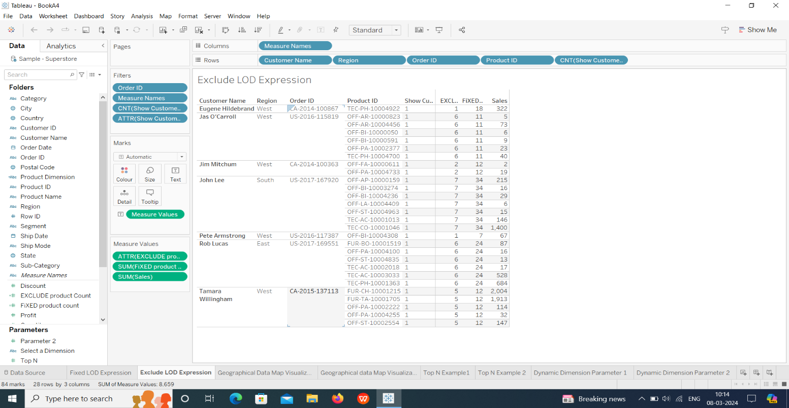

Create any 2 map visualizations using geographical data: -

Map visualization 1:-

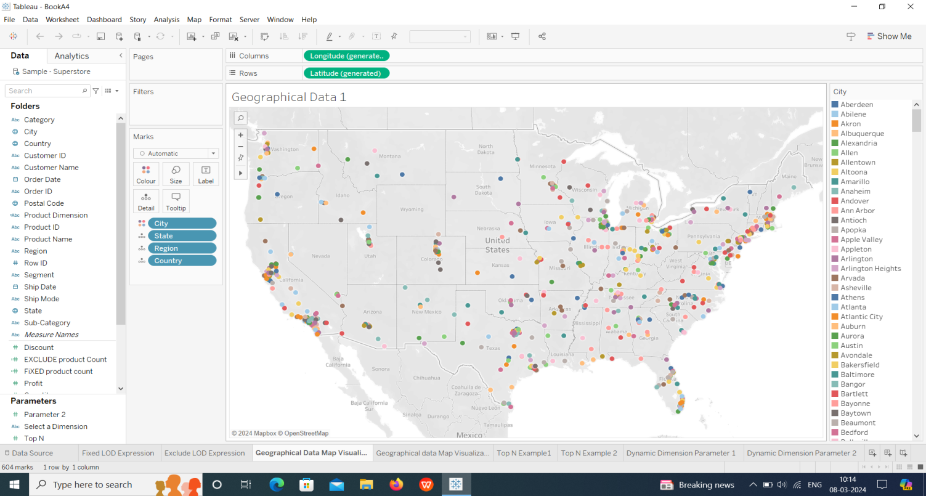

Map visualization 2:-

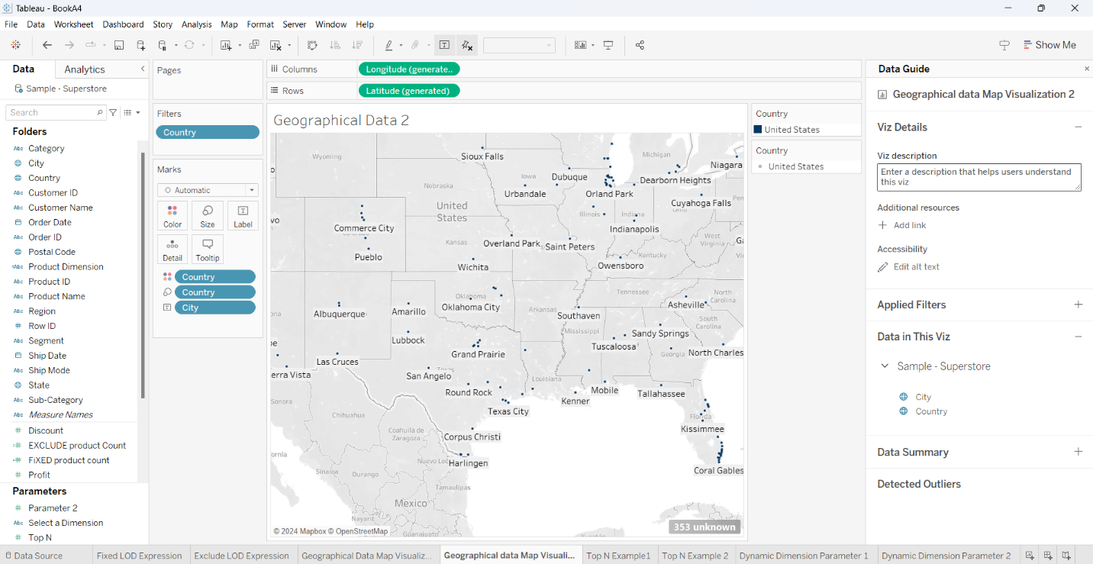

Create Top N and/or Dynamic dimension parameters and utilize those in your workbook: -

Top N Parameters: -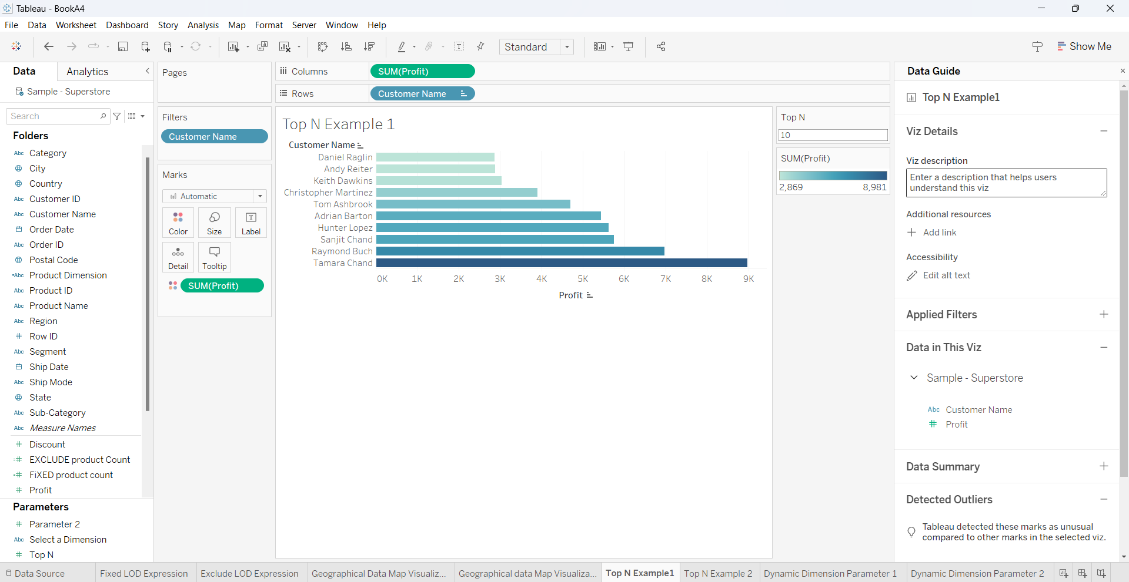

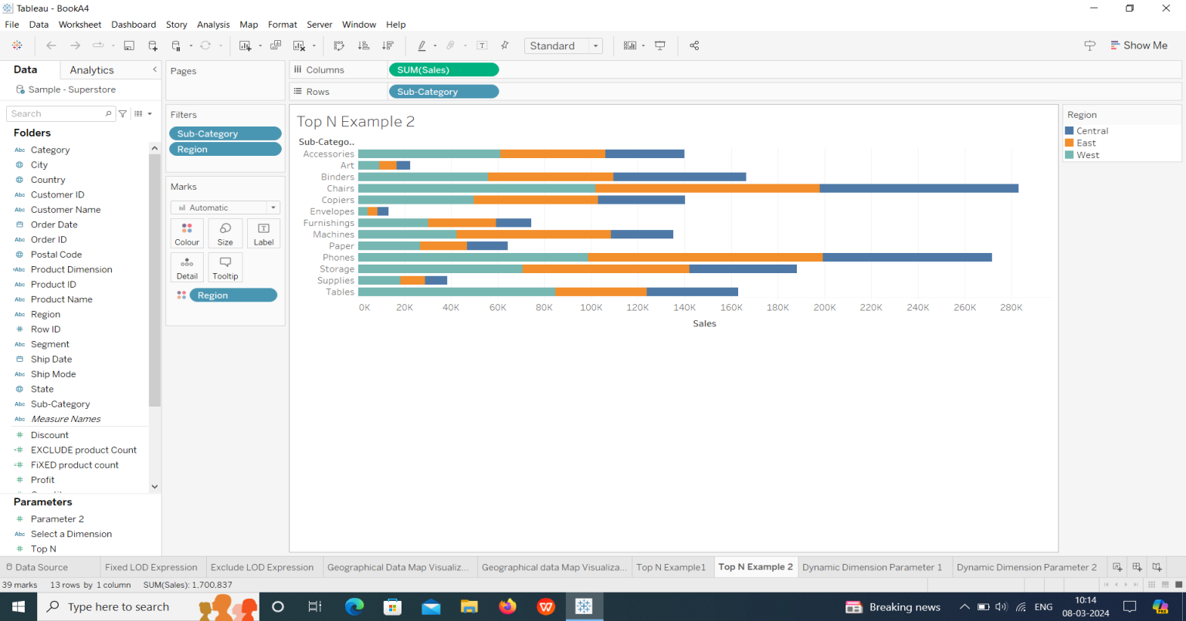

Dynamic Dimension Parameters: -

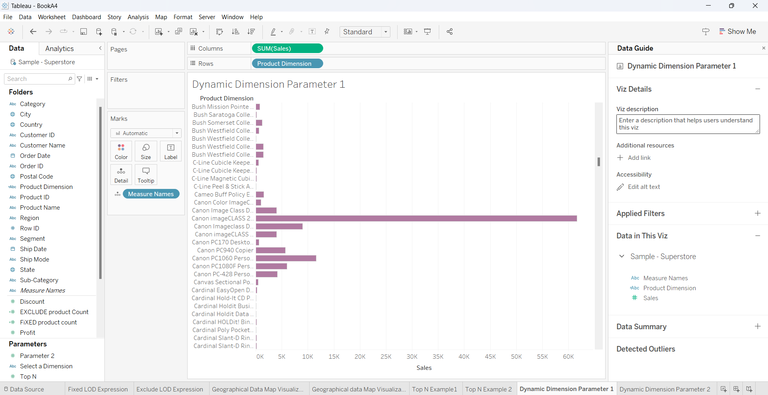

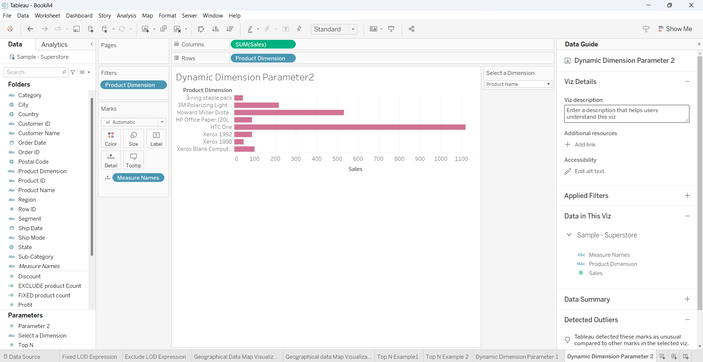

THANK YOU!

Email: -yaragallakusuma.2002@gmail.com