1-20, Certificate of Eligibility for Nonimmigrant Student StM »> OMB NO. 1653-0038

##### GIVEN NAME

Sai Kumar

##### PASSPORT NAME

##### COUNTRY OF CITIZENSHIP

INDIA

##### DATE OF BIRTH

29 JULY 1998

##### ADMISSION NUMBER

639816632A2

Class of Admission



ACADEMIC AND  
LANGUAGE

SCHOOL INFORMATION

##### SCHOOL NAME

Northwest Missouri State University Northwest Missouri State University

##### SCHOOL OFFICIAL TO CONTACT UPON ARRIVAL

Erika Lees

Assistant Director, International Involvement Center

##### SCHOOL ADDRESS

Northwest Missouri State University, 800 University Drive, Maryville, MO 64468

##### SCHOOL CODE AND APPROVAL DATE

KAN214F00394000 24 JANUARY 2003

PROGRAM OF STUDY

|  |  |  |  |  |  |
| --- | --- | --- | --- | --- | --- |
| ESTIMATED AVERAGE COSTS FOR: 9 MONTHS |  |  | STUDENT'S FUNDING FOR: 9 MONTHS |  |  |
| Tuition and Fees | $ | 8, 922 | Personal Funds | S | 0 |
| Living Expenses | $ | 5,400 | CS/IS Graduate Achievement Scholarship | s | 500 |
| Expenses of Dependents (0) | $ |  | Family | $ | 15,147 |
| Health Insurance | $ | 1,325 | On-Campus Employment | $ | 0 |
| TOTAL | $ | 15,647 | TOTAL | s | 15,647 |

REMARKS

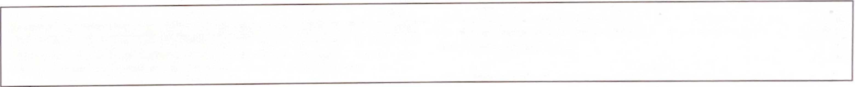

SCHOOL ATTESTATION

I certify under penalty of penury that all information provided above was entered before I signed this form and is true and correct. I executed this form in the United States after review and evaluation in the United States by me or other officials of the school of the student's application, transcripts, or other records of courses taken and proof of financial responsibility, which were received at the school prior to the execution of this form. The school has determined that the above named student’s qualifications meet all standards for admission to the school and the student will be required to pursue a full program of study as defined by 8 CFR 214,2(0(6). I am a designated school officiqhtjf the above named school and am authorized to issue this form.

x **r M ltyfY** (jTc 0 **hate issued place issued**

18 May 2022

SIGNATURE OF: Erika Lees, Assistant Director, International Involvement Center

Maryville,MO

STUDENT ATTESTATION

I have read and agreed to comply with the terms and conditions of my admission and those of any extension of stay. I certify that all information provided on this form refers specifically to me and is true and correct to the best of my knowledge. I certify that I seek to enter or remain in the United States temporarily, and solely for the purpose of pursuing a full program of study at the school named above. I also authorize the named school to release any information from my records needed by DHS pursuant tirlfCFR/214 3(f) to determine my nonimmigrant status. Parent or guardian, and student, must sign if student is under 18.

# *oefn I s. x*

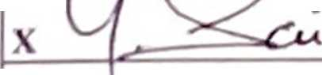

SIGNATURE OF: Sai Kumar Yaramasu

##### I) VTE

##### NAME OF PARENT OR GUARDIAN

##### SIGNATURE

##### ADDRESS (city/state or prosincc/eountry) D \TF.

ICE Form 1-20 (04/30/2021)

Page I of 3

Department of Homeland Security

U.S. Immigration and Customs Enforcement

SEVISID: **N0031830855**

surname/primary name

Yaramasu

PREFERRED name

Sai Kumar Yaramasu

##### COUNTRY OF BIRTH

INDIA

##### CITY OF BIRTH

Bollavarapadu

##### FORM ISSUE REASON

CONTINUED ATTENDANCE

|  |  |  |
| --- | --- | --- |
| EDUCATION LEVEL | MAJOR 1 | MAJOR 2 |
| MASTER'S | Computer Science 11.0701 | None 00.0000 |
| PROGRAM ENGLISH PROFICIENCY | ENGLISH PROFICIENCY NOTES | EARLIEST ADMISSION DATE |
| Required | Student is proficient |  |
| START OF CLASSES | PROGRAM START/END DATE |  |
| 18 AUGUST 2021 | 11 AUGUST 2021 - 18 AUGUST 2023 |  |

Department of Homeland Security

U.S. Immigration and Customs Enforcement

1-20, Certificate of Eligibility for Nonimmigrant Student Status OMB NO 1653-0038

NAME: Sai Kumar Yaramasu

SEVISID: N0031830855 (F-l)

employment authorizations

TYPE

CPT

FUL [./PART-TIME

PART TIME

STATUS

APPROVED

START DATE

18 MAY 2022

END DATE

10 AUGUST 2022

EMPLOYER INFORMATION

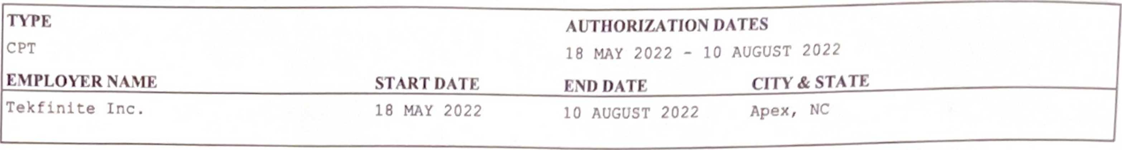

CHANGE OF STATUS/CAP-GAP EXTENSION



AUTHORIZED REDUCED COURSE LOAD



CURRENT SESSION DATES

CURRENT SESSION START DATE

12 JANUARY 2022



This page, when properly endorsed, may be used for re-entry of the student to attend the same school after a temporary absence from the United States. Each endorsement is valid for one year.

TRAVEL ENDORSEMENT

Designated School OfTicial TITLE SIGNATURE DATE ISSUED PLACE ISSUED

X

ICE Form 1-20 (04/30/2021)

Page 2 ofJ