**ASSIGNMENT-12**

**Screen shot 4 of Postman with URL and the result for the instance of your collection**

**Screen shot 5 showing your resource listing all elements in the collection**

**Screen shot 6 of Page for detailed display of one instance on a browse**

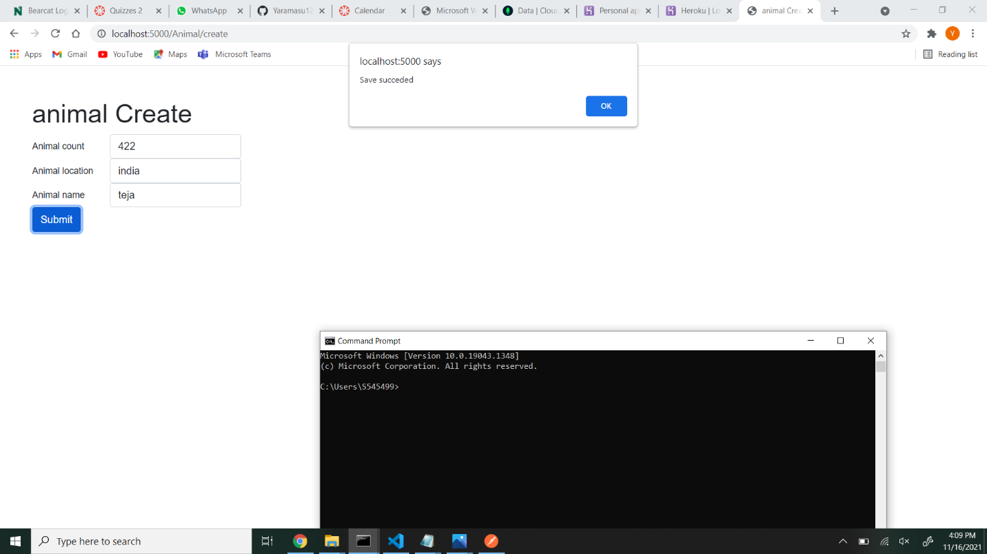

**Screen shot 7 of Page for detailed display of one instance on a browser**

**Screen shot 8 of Page for update of one instance on a browser**

Screen shot 9 of your delete page on a browser.

BONUS

**Provide a** **before and after screen shot of your browsers for the improved page. Screen shot from VSCode of the pug view for Detail and Update**