**The Indoor Game Reservation**

**Team member names**: Ajay, Makkena (S545449)

Sai Kumar, Yaramasu (S545499)

# Komali Priyadarshini, Myla (S545256)

For this project the firebase database and Core Data. For storing the games list and the slot timings.

**Screen – 1**

In this screen we must enter the email and password to Login with the help of Sign In button and below the Create Account button is helpful to create an Account.

**Screen - 2**

In this Screen, we must enter the details like Name, Email, Password and Then click the signup button to create an account.

**Screen – 3**

In this Screen, we have five games with five Buttons. Once we click on each button it will go to the respective game.

**Screen - 4**

In This Screen, we have two selections of Grounds and time slots. Once we click on the downside arrow it will show the available grounds. And other for time slot click on the downside arrow it will show the available time slots. Then click on the Book Ground it will book the ground.

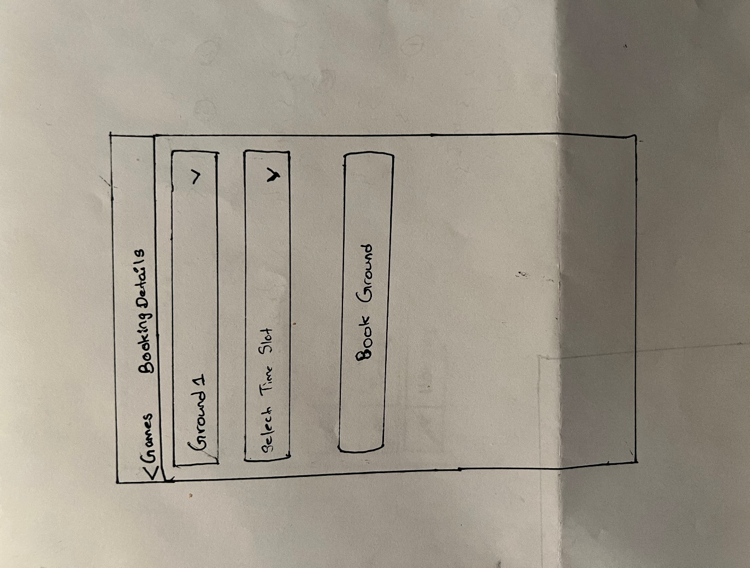

**Screen – 5**

Finally, Last Screen should be the confirmation page with image of Tick mark gesture.

