SparkLink Alliance
SLB-mmW Technical Report
Date: 2025-03-01
Author(s):
Affiliation | Name | Email
Huawei Technologies, Co. Ltd, Tommi Jämsä Consulting Oy | Tommi Jamsa (Editor) | tommi.jamsa@huawei.com, tommi.jamsa@jamsacon.com
University of Thessaly | Theodoros Tsiftsis | tsiftsis@uth.gr
WWRF | Vinod Kumar | ramukdoniv@outlook.com
Huawei Technologies Co., Ltd. | Xu Li | lixu11@huawei.com
Huawei Technologies Co., Ltd. | Dor Chay

Introduction

Use of SparkLink technology continues to grow and diversify over many market segments including residential, enterprise, and industrial. More stringent requirements are emerging to meet the demands of new applications (e.g. augmented reality/virtual reality, kiss connectivity Communications, proximity ranging and sensing) both in terms of throughput, latency bounds and accuracy. The very large bandwidth available in the short range mmWave bands, combined with the widely used 2.4, 5 and 6 GHz bands, is a great opportunity to help meet these requirements even in the densest environments. Enabling non-standalone operation in the short range mmWave bands in a cost-effective manner is required so that as many devices can benefit from it.

Revisions:
- Rev 0: Initial version of the document.
- Rev 1: Updated during the Malaga meeting in January 2025.
- Rev 2: Updated content for the Barcelona meeting in March 2025.

© Copyright Notification: By no means can any part of this document can be reproduced or used without prior written permission of the International SparkLink Alliance. Copyright © 2020-2025 The International SparkLink Short-range Communications Alliance. All Rights Reserved.

Contents
1 Definitions, symbols and abbreviations 4
1.1 Definitions 4
1.2 Symbols 4
1.3 Abbreviations 4
2 Scope 5
3 Use cases and requirements 5
3.1 Summary of Use Cases 5
3.2 Use Case 1 (UC1) 6
4 Operating bands candidates 7
4.1 mmWave Communication in the EU 7
4.1.1 Regulatory Framework: 7
4.1.2 Country-Specific Regulations: 7
4.1.3 Technical Parameters for 60 GHz Band: 7
4.1.4 Deployment Scenarios for SRC & Key Challenges 7
5 Channel Models 8
5.1 Channel Model Requirements 8
5.2 Propagation Scenarios 9
5.3 Evaluation of available channel models 9
5.4 Recommended channel model for SparkLink system simulations 12
6 Technical Solutions 12
6.1 2.56 GHz and more channel 12
6.2 PHY based-band sharing between SLB operating on sub-7 GHz bands and mmWave bands 12
6.3 Multi-carrier fusion between sub-7 GHz and mmWave bands 12
6.4 Numerology 12
6.4.1 For example: upclock SLB by 16 times. That would lead to the parameters shown in Table 1. 13
6.4.2 Example 2: Uplocking SLB by 8 times. 14
6.4.3 Super Frame 16
6.4.4 Radio Frame Structures 16
6.5 Spatial Streams 17
6.6 Modulation and Coding 18
6.7 Association 20
6.8 Beam Management and Beamforming 20
6.8.1 Beam Sweeping 20
6.8.2 Beam Measurement 22
6.8.3 Beam Reporting 23
6.8.4 Beam Determination 23
6.8.5 Beam Maintenance 24
6.8.6 Beam Recovery 24
6.8.7 Beam Correspondence 24
6.9 Power saving 24
7 Conclusion 24
8 References 24

Definitions, symbols and abbreviations

Definitions
For the purposes of the present document, the following definitions apply:
Beam determination: a process where a node selects its operating beams towards a specific receiver or towards a group of receivers.
Beamforming: transmission of a directional signal, i.e. concentrating the signal energy towards a specific direction.
Note: Beamforming can be either analog, digital or hybrid.
Beam management: a set of processes for scanning, reporting, and maintaining of Tx/Rx beams for optimal performance

Beam measurement: a process where the receiver measures the characteristics of a received beamformed signal.
Spatial Streams: several streams transmitted on multiple spatial dimensions by using multiple antennas at communications link.
Transmit Chains: several chains for transmitting signals

Symbols
For the purposes of the present document, the following symbols apply:
[|| Concatenation (Example)]

Abbreviations
For the purposes of the present document, the following abbreviations apply:
CP: Cyclic Prefix

MAC: Medium Access Control
MCS: Modulation and Coding Scheme
mmW, mm-Wave: millimeter-wave (a radiowave that has a wavelength of about 1 ~ 10 mm.
MU: Multi-user
OFDM: Orthogonal Frequency Division Multiplexing
PHY: Physical Layer
PPDU:
SU: Single User

Scope

This Technical Report will identify technical solutions in order to provide the necessary mechanism to both the SparkLink physical layer (PHY) and the SparkLink Medium Access Control (MAC) that allows SparkLink non-standalone operation in mmWave bands using single-user (SU) OFDM based transmissions.
The selected solutions should
- require that an SparkLink device supporting the mmWave bands also supports at least one of the sub-7 GHz bands.
- define the multi-carrier operation defined in the sub-7 GHz band specifications to support non-standalone operation in the mmWave bands.
- leverage or reuse existing PHY and MAC specifications defined for the operation in sub-7 GHz bands, e.g. SU transmission PPDU format and MAC frames
- help an SparkLink device supporting the mmWave bands reduce power consumption, without significant increment compared to the operation in sub-7 GHz bands.

Use cases and requirements
[input from Vinod Kumar / AHG1]

Summary of Use Cases

Several Use Cases have been proposed for mmW SparkLink: XR, etc.

Table summarizes the Use Cases, and the subsections below describe them in detail.

Use Case | Brief Description
UC1 XR | Extended Reality (XR) for Industrial, eHealth and entertainment applications, requires low latency and high bit rate.
UC2 | Short Range Wireless Connectivity Solutions for harsh environments
UC3 | Fiber to the Room (FTTR)
UC4 | Kiss connectivity Communications
UC5 | Video/Mass-Data Distribution/Video on Demand (VOD) System
UC6 | Mobile Fronthauling
UC7 | Office Docking
UC8 | Child Presence Detection & Seat Occupancy Detection
UC9 | Driver/Passenger Vital Sign Monitoring
UC10 | Gesture Recognition

Use Case Template (UCx)

SparkLink mmWave
Use Case Description Format & Version Management Proposal
Front page to be used after the introduction of version 1.0.0
Title / Number | Use case title
UC introduced in meeting no. | Date and place where the USE Case was first introduced.
Presenting Member/ individual Ver 0.0.0 | Company presenting the Use Case for the first introduction (ver 0.0.0)
Sponsoring Members (Optional) | Supporting Companies / Individuals  Once approved, who will be main drivers of this use case.  Same as “Supporting Companies or individuals”.  Remove one of the two
Intended Market Segments | Consumer, Medical, Automotive, IT Infrastructure, Industrial, Military. Etc.
Ecosystems | Chipset, modules, device manufacturers, network operators involved (to be clarified)

Objective | Short description of the objective for this Use Case – A few lines
Description | Use Case description – A few lines
Technical Specs related. Moved below “Description” | What technical specs or working groups will be affected, what the inclusion of this use case will have in the existing tech spec and test specs will have in them. May run into a few paragraphs/pages
Technical Feasibility / Complexity – Critical path and any Roadblocks | If this can be demonstrated to be feasible and if there are some methods already available – Hopefully only a few bullet points
Dependencies | What relationship has with other industry alliances or regulatory schemes.  Major aspects affected by regulation – Spectrum availability, EIRP and interference considerations.
Innovation | Is there any other SDO working on it? Performance advantage of the proposed solution wrt the existing or upcoming solution from other SDO’s
Justification and benefits | Why market needs this, what will be the benefits for that market and what problems the use case will solve.
Priority | Defined by the SparkLink Alliance

Use Case 1 (UC1)

SparkLink mmWave
Use Case Description Format & Version Management Proposal
Front page to be used from ver 0.0.0 till ver 1.0.0
Title / Number | XR (Extended Reality) for Industrial, eHealth and entertainment applications / UC1_XR
UC introduced in meeting no. | 15th January 2025; Meeting no.2 Malaga, Spain
Presenting Member/ individual Ver 0.0.0 | Vinod Kumar, WWRF representative
Sponsoring Members (Optional) | Huawei, Lenovo, Chipset Vendors, XR Vision Equipment Vendors
Intended Market Segments | Consumer, Medical, Automotive, IT Infrastructure, Industrial, Military
Ecosystems | Chipset, modules, device manufacturers  network operators involved (to be clarified)

Place Holder for managing the Use Case evolution in the TG Meetings
TG Meeting No | Input version Ver 0.a.b | Output Version  Ver 0.c.d | Updates Introduced
 | Ver 0.0.0 | Ver 0.1.2 | “Deployment Scenarios” Paragraph
 | Ver 0.1.2 | Ver 0.2.3 | Further details on  - XR parameters, bit rate, Latency, FoV  - LBT Categories suitable for XR

Objective | Design of wireless transmission mechanisms for satisfying bit rate and latency requirements of different applications of XR concepts.
Description | XR englobes AR (Augmented Reality), MR (Mixed Reality) and VR (Virtual Reality). Existing, usually tethered, XR devices offer a limited user mobility and reduced QoE (Quality of Experience). Implementation of (sometimes asymmetrical) bi-directional transmission, at speeds ranging from a few kb/sec to several Gb/sec (even a few Terabits/sec) is required for the operation of XR devices.  Wireless XR is realizable in the high GHz mmWave spectrum (e. g 60 GHz). Depending on the application domain, XR radio transmission would be deployed the in the licensed or unlicensed band. 4G, 5G (NR), WiFi 6 standards for mid-rate (upto <100 Mb/sec) transmission already exist and WiGig and 6G have the objective of standardizing the transmission technologies for multi-gigabit XR implementations.
Technical Specs related. Moved below “Description” | XR is a generic term used to designate separately or a combination of AR (Augmented Reality), MR (Mixed Reality) and VR (Virtual Reality). AR/MR images/videos are realized by super-imposing virtual objects on top of real images/videos. AR displays passive virtual contents only whereas MR allows users to interact with active virtual objects. VR does not require videos of the real environment since all the presented contents are virtual. Applications based on immersive and non-immersive XR experience exist. AR and MR are mainly used for assistance, training, tourism (guides) whereas VR is essential for gaming and immersive video (movies) experience. Smart phones, tablets and other handheld devices with cameras are suitable for non-immersive AR/MR experience whereas an immersive VR experience requires an Optical Head mounted device.  (N.B In AV (Augmented Virtuality) surrounding Virtual Environment is enriched with real objects).  A typical XR set-up consists of one or multiple XR devices (e.g Head mounted glasses with translucent screen (for AR and MR), Occulent glasses (for VR), tablets, portable PC) interacting with a central or an edge server through an air interface. The end application and the required resolution of the XR device and the connectivity scenario determine the UL (Device to Server) and the DL (Server to Device) transmission rates. For AR/MR applications the UL/DL transmission rates are quite symmetrical. The VR implementation usually requires very widely different UL (rather low) and DL (much higher) transmissions rates.  Characteristic parameters of XR devices are some of the other factors affecting the UL/DL Data rates. Such parameters include FoV (field of View), PPD (Pixels per degree), resolution and (frame) referesh rate. For a given resolution large FoV results in a small PPD and VR displays providing large FoV for immersive experience use a small PPD. The Refresh Rate (the number of frames displayed per second) determines the level of comfort (or discomfort) for an XR experience. Minimum refresh rate of 90 is a basic XR requirement.  Further, it can be noted, as an example, that 8K resolution VR demands 1.2 Gb/sec transmission rate to satisfy the 20ms photon to motion latency requirement.  More numerical details related to these parameters may be provided in an annexe.  Information (rendering) latency is another parameter to be considered for good QoE in XR. More specifically, it is the time required to display a new frame (say frame B) which was generated after some modification provoked by e. g new sensor information in the presently being displayed frame A.  The latency tolerance requirements for MR are more strict than for AR due to the fact that MR needs to interact with “dynamic” virtual objects. The latency tolerance in VR application dependent. For highly interactive gaming the latency tolerance is quite low and ultra-low latency is required whereas for VR applications (movies, immersive videos involving low user interaction quite high latency tolerance is acceptable.  Some of the typical values in (present day) XR are  AR – UL-Data Rate: 0.02 to 1Gb/sec; DL-Data Rate: 0.02 to 1Gb/sec; Latency – 20ms; Refresh Rate: 90; PPD: 30 to 60; FoV 20° - 50°;  MR – All same as above except Latency: 10ms  VR - UL-Data Rate: 150 kb/sec; DL-Data Rate: 0.02 to 1Gb/sec; Latency – 20 - 1000 ms; Refresh Rate: 90; PPD: 10 to 15; FoV 100° - 150°  These values related to Stage 1 implementation of XR where wireless is replacing tethered connections. The ultimate (Stage 3) XR will be based on air-interface capable to ensure several Terabit/sec data and 1ms latency.  Energy Efficiency and Physical Constraints of XR equipment  The QoE is limited by power consumption and weight of the head-mounted XR devices. High power consumption of wireless communication and computation not only drains the battery fast but also generates heating which affects the user experience.  Connectivity scenarios in XR applications  - One to One  Simplest case where an XR device connects to an edge server for each session  - One to Many  The case where a single server is talking simultaneously multiple XR nodes with UL in Multiple Access and DL in Broadcast (same information content for all XR nodes) or DL in multi-cast mode.  - One to clustered many (Head and Followers)  The case where one XR node acting as a cluster head would be communicating with an XR server in one to one in DL and relaying DL information to other cluster nodes (followers). Typically the case where a group of visitor on together on a museum visit.  - One to multiple clustered many (Heads and Followers)  Could be a combination of 2 and 3.  Other connectivity scenarios from XR applications in eHealth, Automotive and Industrial control should be appended to this list of scenarios mainly applicable in “Entertainment” related applications.
Technical Feasibility / Complexity – Critical path and any Roadblocks | If this can be demonstrated to be feasible and if there are some methods already available – Hopefully only a few bullet points
Dependencies | Most of the “Entertainment” related XR applications would be implemented in the un-licensed band. Bandwidth availability in the high GHz range is listed below. The values listed below are Frequency Range, centre frequency and available bandwidth.  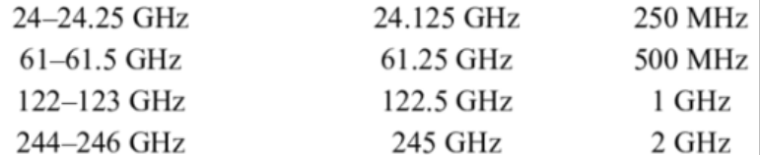  Despite the availability of rather large BWs, the release of such spectrum is under strict governmental control. The 9 GHz and 14 GHz spectrum recently released in the 60 GHz range, in Europe and in the USA, respectively, would provide 10× and 16× times more unlicensed spectrum as compared to sub-7 GHz bands in the respective countries. Its benefit in the implementation of high end XR applications would thus be available within these geographically limited markets.  The implementations in unlicensed bands are prone to several types of interference namely  - Geographically collocated networks for different usages operating in the same band for the existing technologies. Example IEEE 802.11ad (WiGig) affecting..  - Geographically collocated networks for different usages operating in the same band from the upcoming technologies. A recent example is the approval of 3GPP Study Item to extend the NR operation up to 71 GHz that means including in the 60 GHz licensed band.  - Mutual interference between the nodes belonging to the same network  - Interference due to the situations of Primary User against or along with the Secondary User. The case of a SU trying to operate in same geography as a security/defence related PU would be quite critical.  However, interference combating mechanisms to ensure the specified QoE which is a function of frame resolution, frame continuity and rebuffering time, need to be carefully selected. Adaptive Bit Rate (ABR) transmission, one of the simple methods, can introduce additional latency jitter.  The most commonly deployed interference avoidance mechanisms – suitable (?) for XR - are  - CSMA/CA  - LBT – Listen before talk  - Duty Cycle based operation not requiring the Clear Channel Assessment (CCA)  Regulatory requirements on LBT, maximum Channel Occupancy Time (COT), Occupied Channel Bandwidth (OCB) and power limits need due consideration.  Several variants of LBT have been deployed. The LBT can be based on “server-initiated COT” or “XR initiated COT”. Four Categories of LBT derived from WiFi CSMA/CA and LTE-LAA, are  - Cat1- LBT: immediate transmission (i.e., no LBT).  - Cat2 - LBT: LBT without random back-off.  - Cat3 - LBT: LBT with random back-off and fixed contention window.  - Cat4 - LBT: LBT with random back-off and exponential contention window.  As a general rule, the latency performance with degrade as we go from Cat 2 to Cat 4.  LBT and MAC interaction is another factor to be considered. Starting LBT before the data has been scheduled for transmission may generate in-efficiency in spectrum usage and starting LBT before the data had been scheduled may result in data loss due to a phenomenon called “side clipping”.  Additionally, information latency performance is known to be adversely affected by LBT and CSMA/CA.  Example Deployment Scenarios:  a) Indoors – Residential or office  - Server to XT node Distance: 1m to 10m  - Interference types: Multiple access interference, WiFi and Indoors 5G private networks.  b) Indoors – Industrial workshops and transport sites  - Server to XT node Distance: 5m to 50m  - Interference types: Multiple access interference, WiFi and Indoors 5G private networks for access and industrial control and CV related deployments.  c) Outdoors – Dense urban business areas and suburban industrial zones  - Server to XT node Distance: 20m to 100m  - Interference types: Multiple access interference, WiFi and Indoors 5G private networks and other incumbent users for the mmWave Spectrum  d) Outdoor deployments for Server to XT node distance of > 100m distance appear to be out of scope this use case at the first glance.
Innovation | Is there any other SDO working on it? Performance advantage of the proposed solution wrt the existing or upcoming solution from other SDO’s
Justification and benefits | Why market needs this, what will be the benefits for that market and what problems the use case will solve.
Priority | Defined by the SparkLink Alliance

Use Case 2 (UC2)

SparkLink mmWave
Use Case Description Format & Version Management Proposal
Front page to be used from ver 0.0.0 till ver 1.0.0
Title / Number | Short Range Wireless Connectivity Solutions for harsh environments
UC introduced in meeting no. | 13th February 2025; Meeting no.3 Online meeting
Presenting Member/ individual Ver 0.0.0 | Vinod Kumar, WWRF representative
Sponsoring Members (Optional) | Huawei, Lenovo, Chipset Vendors, XR Vision Equipment Vendors
Intended Market Segments | Consumer, Medical, Automotive, IT Infrastructure, Industrial, Military
Ecosystems | Chipset, modules, device manufacturers  network operators involved (to be clarified)

Place Holder for managing the Use Case evolution in the TG Meetings
TG Meeting No | Input version Ver 0.a.b | Output Version  Ver 0.c.d | Updates Introduced
 | Ver 0.0.0 | Ver 0.1.2 | - Some typos  - Editing the “Dependcies” chapter for spectrum selection and Sparklink co-existence with other technologies in unlicensed band  - Details on Xon/Xoff protocol in “Innovation" chapter

Objective | Design of protocols and end node architecture for very low latency variable bit rate (raw) data transmission
Description | There is an identified requirement of end nodes capable of exchanging information bi-directionally at random intervals, and at symmetrical or un-symmetrical bit rates variable in time.  Very often such nodes shall be installed pairwise in confined but harsh (interference-wise) environments. Multiple node pairs may have to be installed in a same confined environment and/or in closely spaced separate confined environments. The case of one node of pair A talking “simultaneously” to multiple nodes of pairs B, C and D etc would also have to be foreseen.  The typical distance of separation between the two ends of a communicating pair would be in the range of a few centimeters to a few meters. The usually present LoS channel between a node pair in communication may sometimes be obstructed due to the physical distortion of the space between them.  Strict requirements of reliability and integrity of data are expected to apply. Additionally, quick node wake-up, very fast link establishment and very low latency of exchanged data would need to be respected.
Technical Specs related. | This use case would bring multiple technical challenges like  - Design of a quickly reacting XON/XOFF or RTS/CTS Protocols based on the exchange of short information packets  - Design of error correction mechanisms for reliable transmission of short packets  - Selection of suitable numerologies for short packets during initial link establishment and then for very high bit rate transmission after the initial link establishment.  - Design of interference detection/evaluation mechanisms capable of driving the resource allocation for variable bit rate transmission in presence of a single one to one link, multiple one to one links and multiple one to many links. Ref remark about confined links above.  - Identification of suitable channel models in view of the fact that the near field propagation mechanisms (applicable here) are totally different from the usual outdoor propagation mechanisms for mmWave frequencies  - Design of node DRx/DTx and sleep mechanisms offering the best tradeoff between wake-up time, information latency, energy dissipation and information integrity. Remark: Side Clipping introduced by delayed wake-up results in information loss.  - Checking the need and usefulness of a central controller for controlling resource allocation in case of multiple closely spaced node pairs.  - ……
Technical Feasibility / Complexity – Critical path and any Roadblocks | If this can be demonstrated to be feasible and if there are some methods already available – Hopefully only a few bullet points
Dependencies | In the first step, it is suggested that a “focussed” piece of ISM spectrum be considered for the design of mechanism mentioned above. The following text reproduced from the XR Use case seems to be relevant for this use case as well. It will have to be adapted to fit the requirements and technical challenges listed above for the present use case.  The available spectrum in unlicensed band is listed in the table below  The availability of this spectrum is usually under strict government control. At the first instance, it is suggested that the 61 to 61.5 GHz spectrum band be considered for the implementation of the present use. The IEEE 802.11ad is largely deployed in the 60 GHz band and substantial amount of information related to channel models and path loss models for different deployment environments is available in the reports of WiFi Alliance. (Ref. xxx)  It is true that the co-existence of networks using existing and upcoming technologies like WiGig and 5G NR can be source of interference for Sparklink use case. Multiple studies on co-existence of such networks and dealing with the design of interference avoidance mechanisms like LBT are available. (Ref yyy).  In view of the relatively stringent specifications on transmission reliability and latency the situations of Primary and Secondary Users should be avoided for this particular use case.
Innovation | Design of Xon and Xoff or RTS/CTS protocols for the “initial handshake” in wireless links is very challenging.  Multiple considerations for high importance need attention namely  - time and frequency synchronization between the Tx and Rx and interaction with the native synch mechanisms for the air interface,  - node energy dissipation wrt the selection between “always on” and use of DTx/DRx.  - Inclusion of channel quality parameters in protocol header format useful for the Adaptive Bit Rate transmission. The channel coherence time in implementations of this use case would be more a function of the inter-system interference rather than on the relative Tx/Rx mobility.  - Inclusion of parameters related to the native air interface – e.g in case of OFDM symbols at the beginning of each slot can be reserved for the exchange of handshake messages.  - …..
Justification and benefits | Why market needs this, what will be the benefits for that market and what problems the use case will solve.
Priority | Defined by the SparkLink Alliance

Use Case 1 (UC1)

Operating bands candidates
mmWave bands includes [45 GHz, ]60 GHz bands, and the Sub-7GHz bands includes 2.4 GHz, 5 GHz and 6 GHz bands [To be clarified. Further input from T1.]

mmWave Communication in the EU
The regulatory landscape and deployment scenarios for millimeter-wave (mmWave) communication in the European Union (EU), focusing on both licensed and unlicensed bands is briefly provided below. The mmWave technology, operating in the 30-300 GHz range, is pivotal for 5G networks, enhanced mobile broadband (eMBB), fixed wireless access (FWA), and short-range communications (SRC).

Regulatory Framework:
- Unlicensed Bands: The 57-66 GHz range (V-band) is harmonized across the EU under CEPT ECC Decision (ECC/DEC/(09)01). Key regulations include power transmission limits (up to 40 dBm EIRP), adaptive spectrum allocation, and compliance with the Radio Equipment Directive (RED) 2014/53/EU.
- Licensed Bands: The 24.25-27.5 GHz band is allocated for 5G services under Decision (EU) 2019/784. Licensing methods include auctions, beauty contests, and direct assignments, with interference management guided by ECC Recommendation (19)01.

Country-Specific Regulations:
Each EU member state has specific rules for unlicensed mmWave bands, with national regulatory authorities (NRAs) overseeing compliance. For example, Germany applies ECC/DEC/(09)01 with additional restrictions, while France follows CEPT recommendations.

Technical Parameters for 60 GHz Band:
- Frequency Range: 57-71 GHz
- Power Restrictions: EIRP ≤ 40 dBm (indoor/outdoor), with higher limits for fixed outdoor installations (EIRP ≤ 55 dBm).
- No DFS or TPC requirements, but interference mitigation techniques must comply with Directive 2014/53/EU.

Deployment Scenarios for SRC & Key Challenges
- Industrial 5G Networks: Enhance connectivity in smart factories and logistics.
- V2X Systems: Support autonomous vehicles with ultra-low latency communication.
- Public Wi-Fi and FWA: Provide high-speed wireless access in urban and remote areas.
- Immersive AR/VR: Utilize mmWave's high bandwidth for virtual reality applications.
Key Challenges:
- Regulatory Compliance: Adherence to EU and national standards is essential.
- Signal Attenuation: Advanced techniques like MIMO and beamforming are required to mitigate path loss.
- Spectrum Sharing: Dynamic allocation strategies improve coexistence between users.

Channel Models

This Section describes the channel models for SparkLink mmW performance evaluation and system design.

Channel Model Requirements

Channel model is needed for SparkLink mmW performance evaluation and system design is needed. At this phase of the study, the main focus is on mmW band (60 GHz), but the scalability of the channel model to lower frequencies (e.g. 24 and 45 GHz) is considered as well.
In case of Non-Stand-Alone (NSA) mmW SparkLink, lower frequency (below 7 GHz) is used for, e.g. control signals. Channel model for lower frequencies can be simplified in simulations due to the main focus in performance evaluation such as throughput is on higher frequencies.

High frequency (mmW) performance differs from low frequency (below 7 GHz) significantly:
- Path loss is much higher,
- Penetration loss is much higher,
- Reflection loss is almost equal
- Diffraction loss is much higher
- Scattering depends on the material roughness and size
Therefore, low frequency channel models are not directly scalable up. The channel model should be base on measurements at the frequency range of interest. Other requirements for channel model are:
- Standardized and Mature (no need to invent the wheel again)
- Support SparkLink Use Cases
- Propagation Scenarios: [Indoor office, Indoor home, Large hall, Ultra-short range, Open area]
- Reasonable Complexity
- Support mmW (at least 60 GHz, preferably 10 – 100 GHz)
- Support wide bandwidth (up to 2 GHz)
- Include path loss, fast fading, and MIMO.
The available standardized channel models at around 60 GHz are 3GPP TR38.901, IEEE 802.11ad/ay.]

Propagation Scenarios

The propagation scenarios are deducted from the use cases as shown in below.

Use Case | Propagation Scenario
UC1 XR | Indoor
UC2
UC3
UC4
UC5

Evaluation of available channel models

The available channel models
Table 1. Feature comparison.
Feature | IEEE 802.11ad | IEEE 802.11ay | METIS Model |  |  | 3GPP TR 38.901 |  | ITU M.2412
Feature | IEEE 802.11ad | IEEE 802.11ay | stochastic | map-based hybrid | map-based | stochastic | map-based hybrid | stochastic | map-based hybrid
Random Cluster Model | no | no | yes | no | no | yes | no | yes | no
Ray Based Model | yes | yes | no | yes | yes | no | yes | no | yes
Support Phased Arrays | yes | yes | yes | yes | yes | yes | yes | yes | yes
Support MIMO | no | yes | yes | yes | yes | yes | yes | yes | yes
Support massive-MIMO | no | yes | limited | yes | yes | yes | yes | yes | yes
Support spherical waves | no | yes | no | no | yes | no | no | no | no
Support extremely large arrays beyond stationarity interval | no | no | idea | no | yes | no | no | no | no
Support dual mobility | no | no | limited | yes | yes | limited | yes | limited | yes
Support Mesh networks | no | no | no | yes | yes | No | yes | No | yes
Support 3D (elevation) | yes | yes | yes | yes | yes | yes | yes | yes | yes
Support mmW | yes | yes | limited | yes | yes | yes | yes | yes | yes
Dynamic modelling | limited | limited | no | no | yes | limited | no | limited | no
Spatial consistency | no | no | limited | yes | yes | partial | yes | partial | yes

Table 2. Maturity comparison.
Channel Model | Maturity | Complexity
IEEE 802.11ad | Mature | Medium
IEEE 802.11ay | Mature | Medium
IEEE 802.11bq | Under development | N/A
METIS stochastic | Mature | Medium
METIS map-based hybrid | Medium | High
METIS map-based | Low | Very high
3GPP TR38.901 | Mature | Medium
ITU-R M.2412 | Mature | Medium

Table 3. Scenario comparison.
Channel Model | Scenarios
IEEE 802.11ad | Conference Room, Cubicle Environment, Living Room
IEEE 802.11ay | MIMO extension to 11ad; Open Area Outdoor Hotspot, Outdoor Street Canyon, Large Hotel Lobby, NLOS, Ultra-Short Range, Data center, D2D Communications
METIS | Dense urban, Urban Micro, Urban Macro, Rural, Office, Shopping Mall, Highway, Open Air Festival, Stadium
3GPP TR38.901 | UMi – Street Canyon, UMa, RMa, InO, InF
ITU-R M.2412 | InH, UMa, UMi, RMa

Table 4. Numerical comparison.
Feature | IEEE 802.11ad | IEEE 802.11ay | METIS Model |  |  | 3GPP TR 38.901 |  | ITU M.2412
Feature | IEEE 802.11ad | IEEE 802.11ay | stochastic | map-based hybrid | map-based | stochastic | map-based hybrid | stochastic | map-based hybrid
Frequency Range (GHz) | 60 – 66 | 60 – 66 | up to 70 GHz |  | up to 100 GHz | 0.5 – 100GHz |  | 0.5 – 100GHz
Bandwidth (MHz) | 2000 | 2000 | 100 MHz < 6 GHz,  1 GHz @ 60 GHz |  | 10 % of the centre frequency | 10 % of the centre frequency, but less than 2 GHz |  | 10 % of the centre frequency, but less than 2 GHz
Number of Scenarios | 3 | 10 | 3* | 3* | unlimited | 5 | 5 | 4 | 4

Recommended channel model for SparkLink system simulations

Based on the brief analysis among SparkLink mmW standardization experts, the recommended channel model is IEEE 802.11ad/ay model [Working Assumption].

Technical Solutions

2.56 GHz and more channel

PHY based-band sharing between SLB operating on sub-7 GHz bands and mmWave bands

Multi-carrier fusion between sub-7 GHz and mmWave bands

SparkLink mmW is assumed to be working as non-standalone (NSA) mmW. It means that there is always a lower frequency radio communication installed to operate at the same time with the mmW band communication. One of the main reasons is the severe propagation conditions at 60 GHz. Very directive channel and high absorption may lead to lost connections that are backed up by the low frequency communications. Low frequency may also be used for reconnection and giving time for beam sweeping.

Numerology

The PHY numerology is based on SparkLink standard 1.0 bis. Some parameters are scaled due to the frequency difference between low-frequency (below 7 GHz) and mmW (60 GHz).
- mmWave shares the PHY components of SLB，including Coding: Polar code, Sync sequence: FTS and STS (update), Demodulation reference signal, Phase adjustment signal, HARQ block.

For example: upclock SLB by 16 times. That would lead to the parameters shown in Table 5.

Table 5. mmWave PHY numerology.
 | 320 | 640 | 1280 | 2560
N_{DFT} | 256 | 512 | 1024 | 2048
ΔF | 1.92 MHz
T_{DFT} | 0.5208 μs
T_{s} | 2.03 ns | 1.02 ns | 0.51 ns | 0.25 ns
T_{GI}=18T_{s,320M} | 36.54ns | 36.54ns | 36.54ns | 36.54ns
T_{GI}=39T_{s,320M} | 79.17ns | 79.17ns | 79.17ns | 79.17ns
T_{GI}=64T_{s,320M} | 129.92ns | 129.92ns | 129.92ns | 129.92ns
T_{GI}=93T_{s,320M} | 188.79ns | 188.79ns | 188.79ns | 188.79ns
T_{GI}=128T_{s,320M} | 259.84ns | 259.84ns | 259.84ns | 259.84ns
‘
mmWave shares the PHY components of SLB，including Coding: Polar code, Sync sequence: FTS and STS (update), Demodulation reference signal, Phase adjustment signal, HARQ block.
Other PHY parameters are shown in

Table 6. Other PHY parameters.
 | 320 M | 640 M | 1280 M | 2560 M
N_{DFT} | 256 | 512 | 1024 | 2048
ΔF | 1.92 MHz
T_{DFT} | 0.5208 μs
Nst | 38*4 | 76*4 | 152*4 | 304*4
Ndc | 1*4-1 | 3*4 | 3*4 | 3*4

A limited set of bandwidth (choosing a set of BWs between 160 and 2560 MHz for instance)

Table 7.Bandwidth options.
 | 320 | 640 | 1280 | 2560
N_{DFT} | 256 | 512 | 1024 | 2048
ΔF | 1.92 MHz
T_{DFT} | 0.5208 μs
T_{s} | 2.03 ns | 1.02 ns | 0.51 ns | 0.25 ns
T_{GI}=18T_{s,320M} | 36.54ns | 36.54ns | 36.54ns | 36.54ns
T_{GI}=39T_{s,320M} | 79.17ns | 79.17ns | 79.17ns | 79.17ns
T_{GI}=64T_{s,320M} | 129.92ns | 129.92ns | 129.92ns | 129.92ns
T_{GI}=93T_{s,320M} | 188.79ns | 188.79ns | 188.79ns | 188.79ns
T_{GI}=128T_{s,320M} | 259.84ns | 259.84ns | 259.84ns | 259.84ns

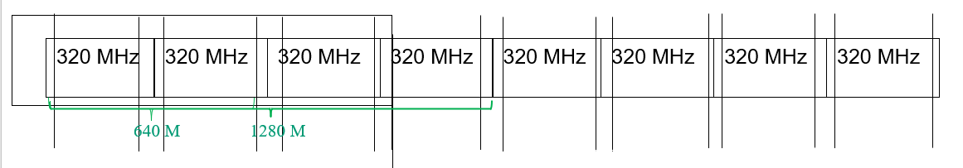

Example 2: Uplocking SLB by 8 times.

Upclocking SLB by 8 timeswould lead to the parameters shown in Table 5.

 | 160 | 320 | 640 | 1280 …
N_{DFT} | 256 | 512 | 1024 | 2048
ΔF | 960 kHz
T_{DFT} | 1.0416 μs
T_{s} | 4.07 ns | 2.03 ns | 1.02 ns | 0.51 ns
T_{GI}=18T_{s,320M} | 73.26ns | 73.26ns | 73.26ns | 73.26ns
T_{GI}=39T_{s,320M} | 77.33ns | 77.33ns | 77.33ns | 77.33ns
T_{GI}=64T_{s,320M} | 260.48ns | 260.48ns | 260.48ns | 260.48ns
T_{GI}=93T_{s,320M} | 378.51ns | 378.51ns | 378.51ns | 378.51ns
T_{GI}=128T_{s,320M} | 520.96ns | 520.96ns | 520.96ns | 520.96ns

 | 160 | 320 | 640 | 1280 …
N_{DFT} | 256 | 512 | 1024 | 2048
ΔF | 960 kHz
T_{DFT} | 1.0416 μs
Nst | 38*4 | 76*4 | 152*4 | 304*4
Ndc | 1*4-1 | 3*4 | 3*4 | 3*4

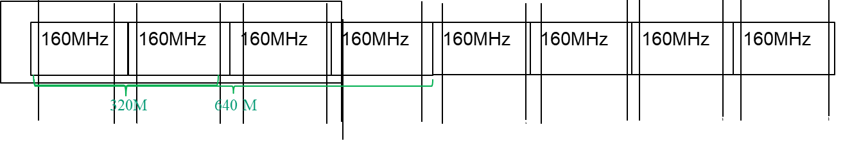
Figure 1. Maximum bandwidth is 2560 MHz in case of 8 times upclocking.

Super Frame
- Super frame (1 ms, 8*8 radio frame)
  - Super frame, half a frame, one quarter?
  - Radio frame: 320Ts*12=3840Ts=15.629 μs,
  - CP: 64Ts=0.260μs, OFDM: 256Ts=1.042μs, CP-OFDM: 320Ts=1.302μs
  - First switching interval (GAP1): 320Ts=1.302μs, GAP2: 320Ts=1.302μs

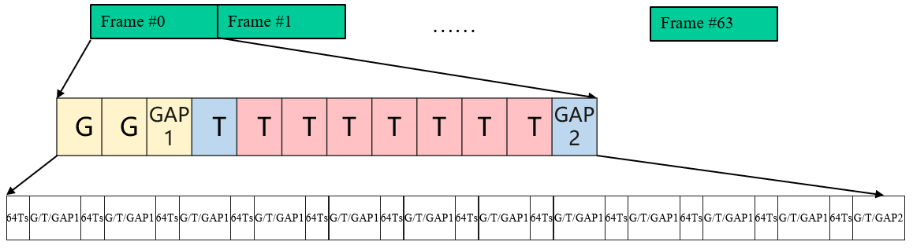

Radio Frame Structures

Symbol # | CP | CP-OFDM  (GAP1) | GAP2
14 | 18Ts，73.26ns | 274Ts，1.115μs | 278Ts，1.131μs
13 | 39Ts，158.37ns | 295Ts，1.201μs | 300Ts，1.221μs
12 | 64Ts，260.48ns | 320Ts，1.302μs | 320Ts，1.302μs
11 | 93Ts，378.51ns | 349Ts，1.420μs | 350Ts，1.425μs
10 | 128Ts，520.96ns | 384Ts，1.563μs | 384Ts，1.563μs

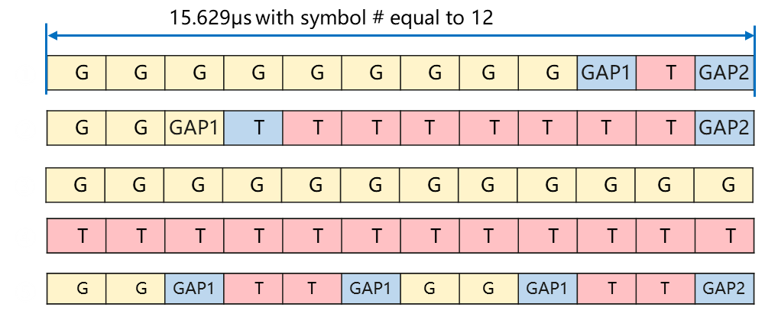

Spatial Streams

The term Spatial Streams means that several data streams are transmitted on multiple spatial dimensions by using multiple antennas at a communications link. There might be Transmit Chains, i.e. several chains for transmitting signals.

There are two alternative structures for the Spatial Streams. In Structure 1 (Figure 2), Spatial Stream Parser divides the output of the modulation mapper into several groups of bits. These sequences of the bits are different spatial streams. In Structure 2 (Figure 3), Spatial Stream Parser divides the output of the scrambling into several groups of bits. These sequences of the bits are different spatial streams. After precoding, different spatial streams are mapped to different transmit chains in both cases.

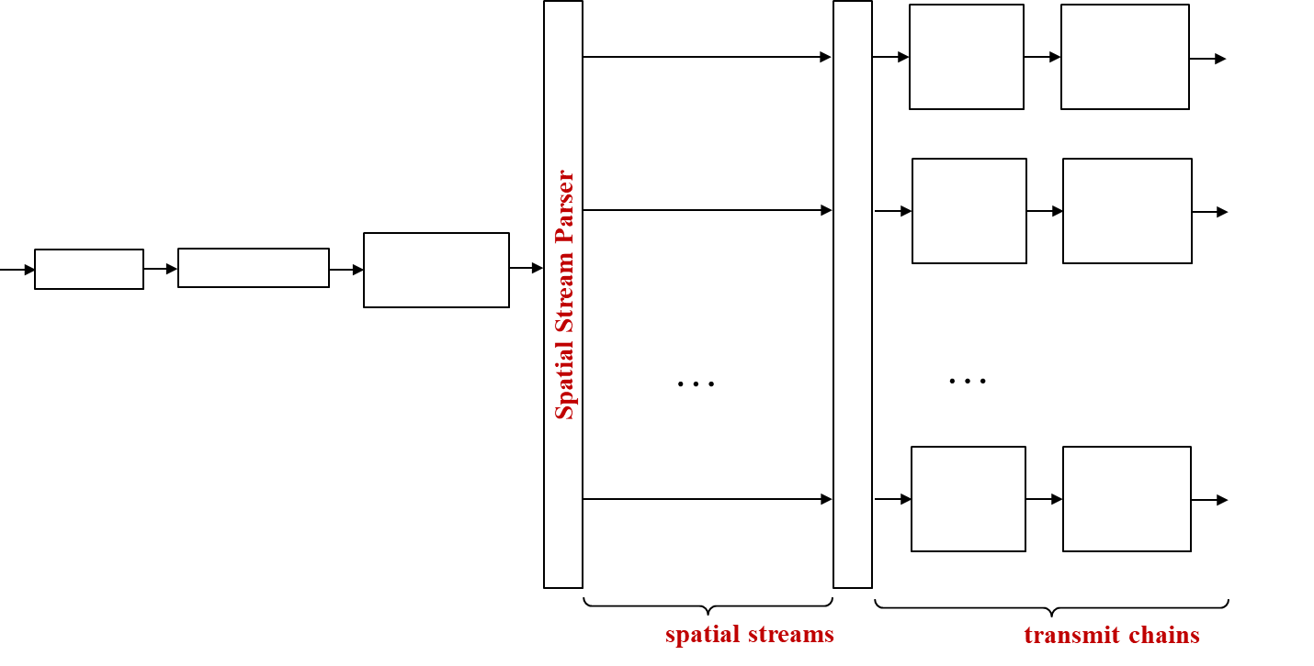
Figure 2. Spatial Streams structure 1.

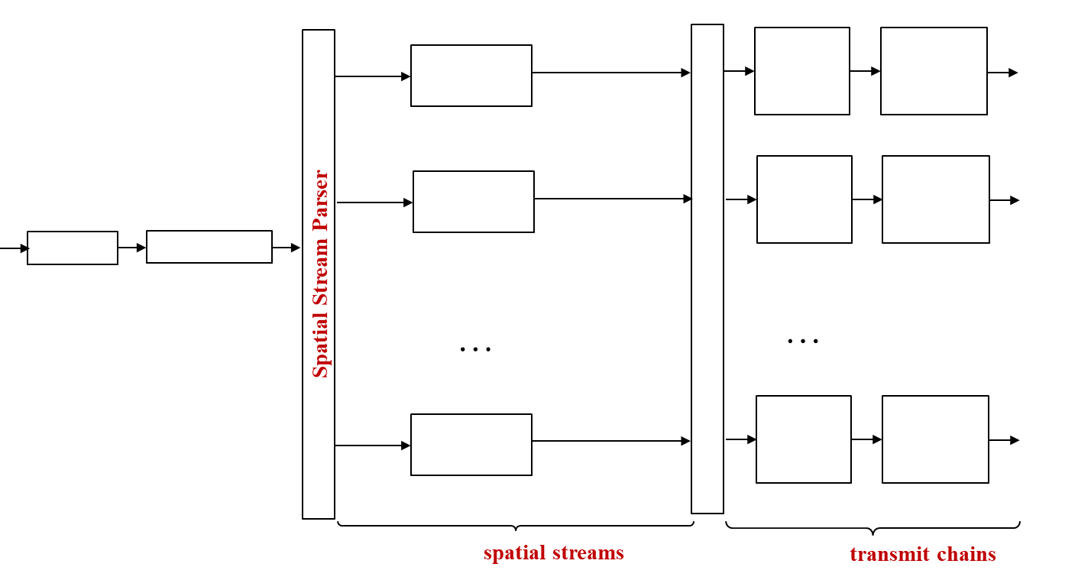
Figure 3. Spatial Streams structure 2.

Modulation and Coding

Modulation and Coding Scheme (MCS) determines the modulation and coding.
- Common modulations include BPSK, QPSK, 16-QAM, etc.
- Common codes include Polar code, etc.
- Considering the SNR imbalance over spatial streams, MCSs or modulations over different spatial streams could be different.
- Equal Modulation
- Unequal Modulation
- Equal MCS
Unequal MCS
- The suggested MCS table includes four modulation types, namely, BPSK, QPSK, 16-QAM, 64-QAM modulations.
- 64-QAM modulation needs to be supported.
Higher-order modulations and different code rates need to be discussed.

Table 8. MCS Table
MCS index | Modulation | Number of Bits Per Symbol | Code rate
1 | BPSK | 1
2 | BPSK | 1
3 | BPSK | 1
4 | BPSK | 1
5 | BPSK | 1
6 | QPSK | 2
7 | QPSK | 2
8 | QPSK | 2
9 | QPSK | 2
10 | QPSK | 2
11 | 16-QAM | 4
12 | 16-QAM | 4
13 | 16-QAM | 4
14 | 16-QAM | 4
15 | 16-QAM | 4
16 | 64-QAM | 6
17 | 64-QAM | 6
18 | 64-QAM | 6
19 | 64-QAM | 6
20 | 64-QAM | 6

Association

- Association (aka initialization/initial attachment/connection setup etc.) is the initial flow required in order to connect a G-node and a T-node.
- The FB2 mmWave association is expected to be different than that of FB1 due to:
  - mmWave vs. Sub-7GHz characteristics – mmWave isotropic (aka omnidirectional) transmission with decent range is usually impractical due to the high frequency values
  - FB1 presence – we can choose to assume a Non-standalone solution and use FB1 connection as an anchor to FB2 association
- We would like to define a new fast, secure and efficient association flow that will leverage all of the existing SparkLink specification & implementation
- Power consumption is a key consideration in deciding to activate/de-activate the FB2 mmWave link

Beam Management and Beamforming

- Beam management is a set of processes for scanning, reporting, and maintaining of Tx/Rx beams for optimal performance
- Beamforming is the transmission of a directional signal, i.e. concentrating the signal energy towards a specific direction
  - Beamforming can be either analog, digital or hybrid (both)

Beam Sweeping

Beam sweeping is the process of directions with beam transmission or reception (Figure 4). In this technique, the transmitter scanning several spatial /receiver simply transmits/receives towards a specific direction at a specific time, and repeats this process until it covers all required directions. All transmissions should be equal in their PHY characteristics (e.g. Tx power) for fair comparison.

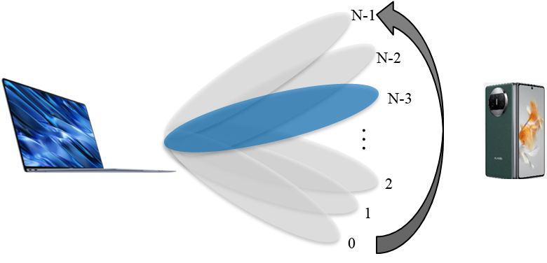
Figure 4. Beam Sweeping.

As a design goal, this process should consume as little overhead as possible, i.e. the transmitter/receiver should cover as much area with as little time as possible
  - This means the transmitter may use a limited number of relatively wide beams when latency is in high priority
We divide beam sweeping into 3 procedures:
  - Procedure 1: G-node & T-node joint beam sweeping
  - Procedure 2: G-node beam sweeping
  - Procedure 3: T-node beam sweeping

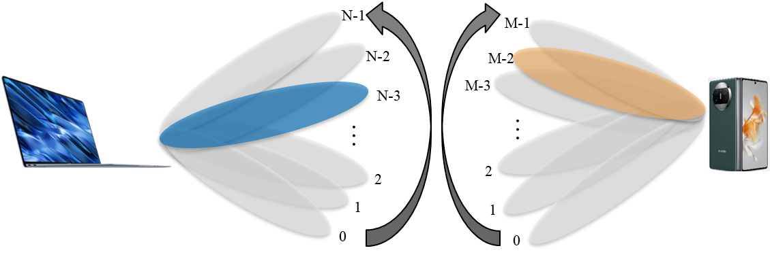

Figure 5. Procedure 1: G-node & T-node joint beam sweeping (Tx & Rx).

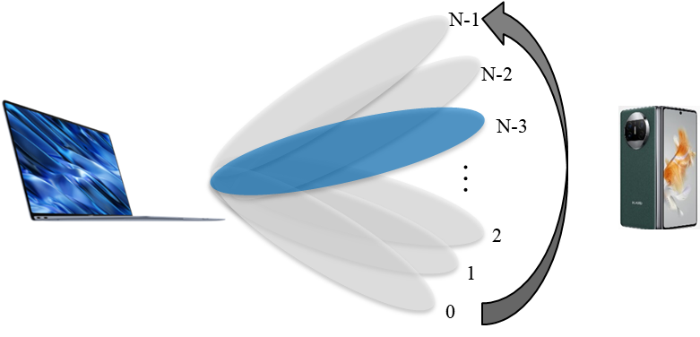
Figure 6. Procedure 2: G-node beam sweeping.

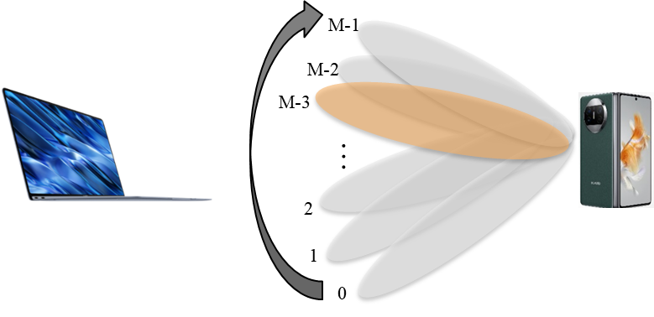

Figure 7. Procedure 3: T-node beam sweeping.

Beam Measurement

Beam measurement is a process where the receiver measures the characteristics of a received beamformed signal. Typically, this will be performed by the receiver during beam sweeping process by the transmitter.

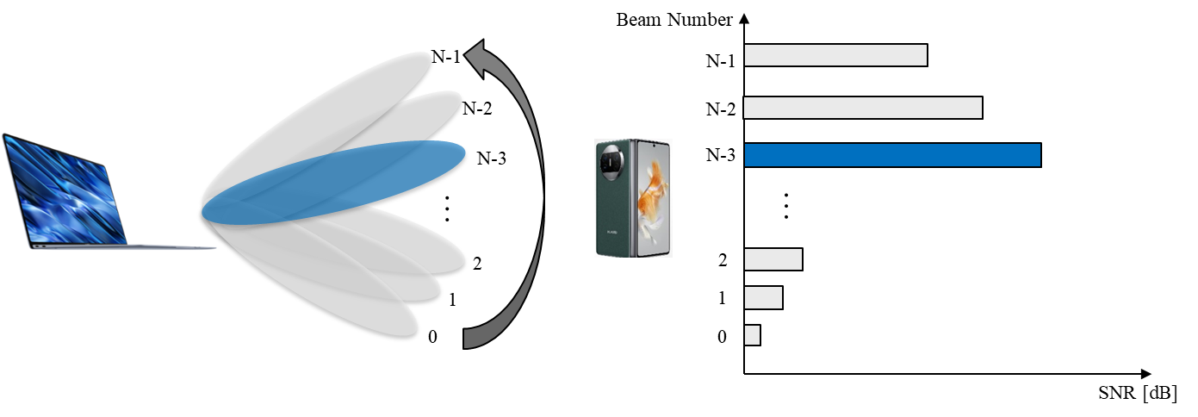
Figure 8. Beam Measurement.

Beam Reporting

Beam reporting is a process where the receiver of a beamformed signal reports back information to the transmitter about the signal. Typically, the reporting will include Reference Signal Received Power (RSRP) or Signal-to-Noise Ratio (SNR). The transmitter and receiver should have an agreed signal ID method so the transmitter could match the reporting with specific reference signals (and beam) transmitted.

Beam Determination
Beam determination is a process where a node selects its operating beams towards a specific receiver or towards a group of receivers. Typically, this process should be performed by the G-node after beam reporting from the T-node. Typically, the decision will be based on Reference Signal Received Power (RSRP) or Signal-to-Noise Ratio (SNR)

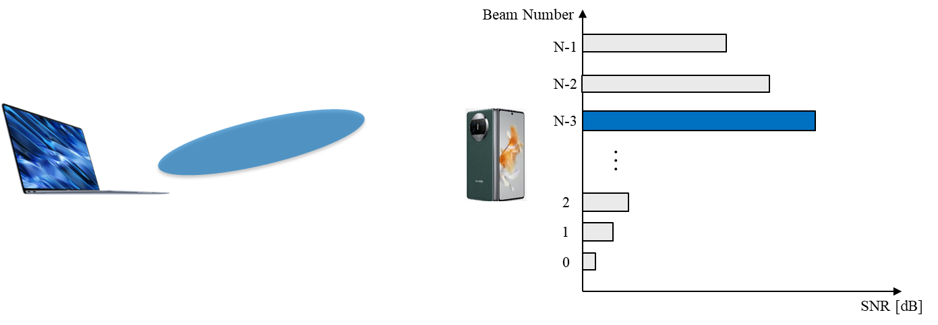

Beam Maintenance

Beam Recovery

Beam Correspondence

Power saving

Conclusion
[Do we need Conclusion here?]

References
The following documents contain provisions which, through reference in this text, constitute provisions of the present document.
- 3GPP TR 21.905: "Vocabulary for 3GPP Specifications". (example)
- 3GPP TSG RAN, Study on channel model for frequencies from 0.5 to 100 GHz (Release 17), 3GPP TR 38.901 V17.1.0 (2023-12).
- ITU-R, Guidelines for evaluation of radio interface technologies for IMT-2020, Report ITU-R M.2412-0 (10/2017).
- IEEE P802.11 Wireless LANs, Channel Model for 60 GHz WLAN Systems, IEEE 802.11-09/0334r8, May 2010.
- IEEE P801.11 Wireless LANs, Channel Models for IEEE 802.11ay, IEEE 802.11-15/1150r9, May 2016.

