**Homework 1**

**Programming Languages Principles and Implementation**

**JAVA**

**Name:**

**Homework 1 will permit you to review Java.**

**Instructions**

* This homework assignment is to be done alone or in a group of 2 students (not 3).
* Your written solution must be integrated in this document. Do not change the order and do not remove text. This part will be submitted through Classes.
* The code will be posted in GitHub. We will cover Git / GitHub this week. You can keep it on your computer until we cover GitHub.

All your code must be available on GitHub under the csS361 repository eventually.

* All Java code must be written and tested in an IDE. We recommend at this time the Eclipse IDE (<http://www.eclipse.org>). All my code for hw1 is written in Eclipse!
* Code that does not compile will be graded as 0.
* In case of problems with this homework, post your questions in Piazza.
* Part 1 - HackerRank: 110 points
* Part 2 – 100 pts

**Part 1 – HackerRank 110 pts**

A HackerRank test was sent to you by email. You have to do it in one sitting of 3 hours. The time suggested by HackerRank is 69 minutes. Please check the instructions in your email.

You should do Part 2 of this homework before Part 1! You will review Java before doing the homework.

**Part 2 – Java - 100 points**

**Exercise 1: Join Discord. 0 pts**

We will use Discord for direct communications. Join ASAP.

You can use it from the web site or from a mobile or desktop app. Download the mobile app! Be sure to opt-in for notifications!

**Exercise 2: GitHub. 5 pts**

The course has a GitHub repository with the code that we will cover in class: <https://github.com/scharffc/cs361>.

Create a GitHub account (if you do not have one). <https://github.com>.

Create a repository called cs361.

During the course, you will submit your work in GitHub. It will need to be organized. It is up to you but I must not have problems to find your work!

You will learn Git and GitHub in different lectures and assignments.

Post your GitHub cs361 link in the management spreadsheet.

**Exercise 3: Lecture notes. 5 pts**

Read the Java lecture notes posted in BlackBoard.

What is the title of slide n?

n is the number corresponding to the first letter of your first name.

For example, for me, n is 3 as my first name is Christelle.

My first name is Yared and the title for page Y is Listing.

**Exercise 4: Setting up. 0 pts**

Download Eclipse for Java Developers (We do not need the Java EE version). Download the latest version or update / upgrade your current version.

<https://www.eclipse.org/downloads/packages/>

Download the code at <https://github.com/scharffc/cs361>. You can download a zip file.

If you are more comfortable with another IDE it is fine but I may sometimes ask you to have EXACTLY the same organization of files as me for automated grading.

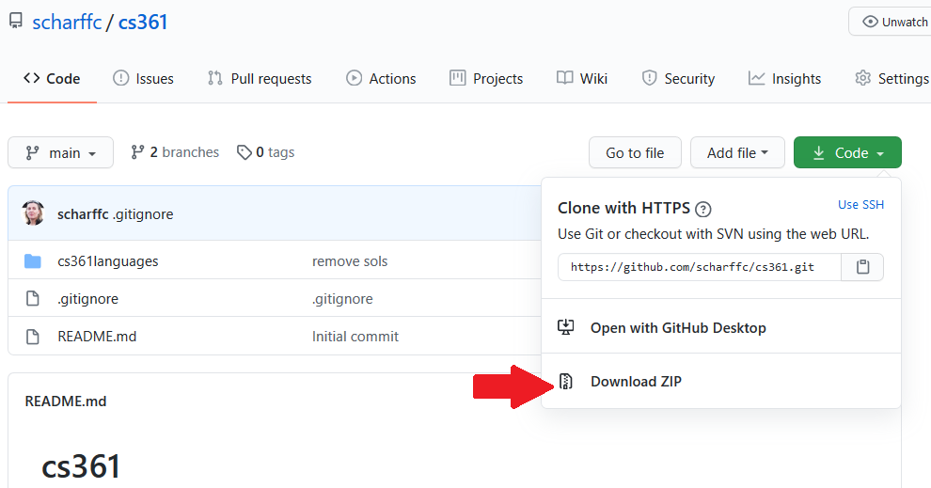

Open the file in Eclipse. The code in cs36languages was written with Eclipse.

In Eclipse, add the View Tasks.

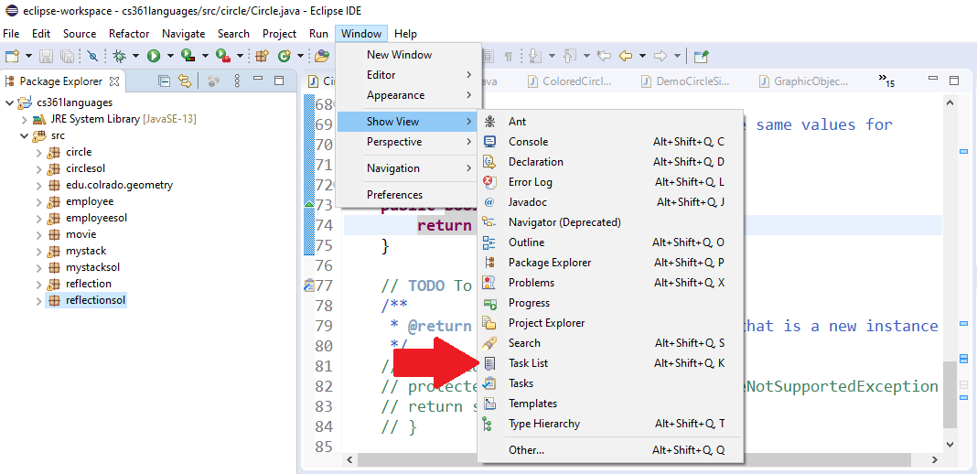

You should now see 22 TODO tasks.

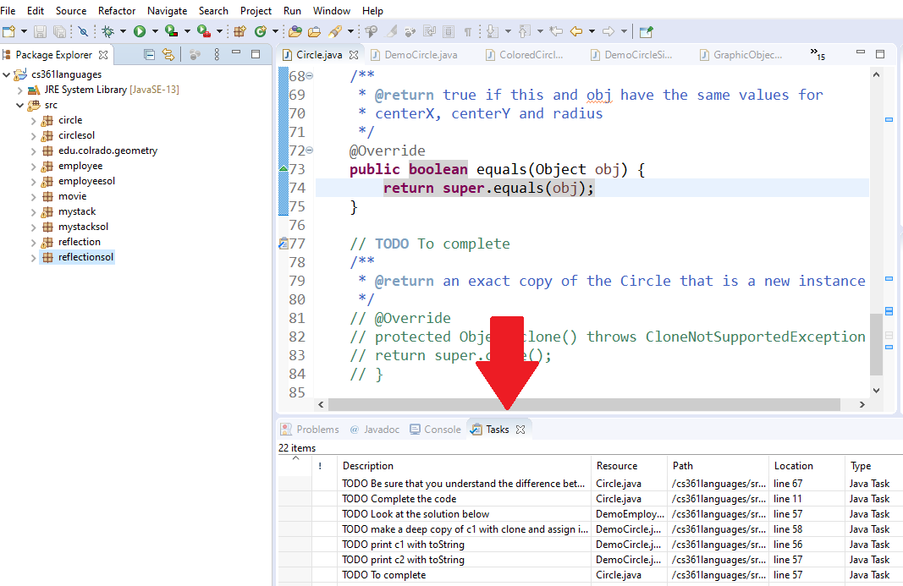

**Exercise 5: Do the 22 TODO tasks. 66 pts**

Do not remove the TODO such that I can go through them when correcting your work.

Code is provided to you. In real life, you often have to go through code written by someone else. You will have to read all the code in each package to do the required work.

The code corresponds to the lecture notes. There are explanations in the PDF.

22 TODO tasks may sound a lot but some of them are short!

* Circle package
  + This package will make you review polymorphism and crucial Object methods: toString, clone and equals.
* Employee package
  + This package will make you review polymorphism.
* Stack package
  + This package will make you review generics.
* Reflection package
  + This package will make you practice with Reflection.

**Exercise 6: Java Bytecode – 24 pts**

In the past, I was using an Eclipse plugin such that we look at Java bytecode. The plugin does not work for latest version of Eclipse.

The infos about the plugin are here:

<http://andrei.gmxhome.de/bytecode/index.html>

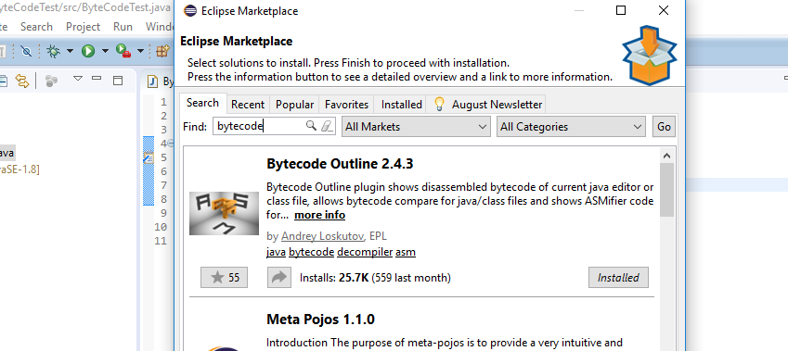

You may want to install it but it is not required…

You will find below the Java bytecode generated for the following Java code below.

**public** **static** **int** sum_for(**int** n) {

**int** i = 0, sum = 0;

**for** (i = 0; i <= n; i++) {

sum += i;

}

**return** sum;

}

1 to 39 are the line numbers that you can use to explain the code.

// access flags 0x9 1

public static sum_for(I)I 2

L0 3

LINENUMBER 4 L0 4

ICONST_0 5

ISTORE 1 6

L1 7

ICONST_0 8

ISTORE 2 9

L2 10

LINENUMBER 5 L2 11

ICONST_0 12

ISTORE 1 13

GOTO L3 14

L4 15

LINENUMBER 6 L4 16

FRAME APPEND [I I] 17

ILOAD 2 18

ILOAD 1 19

IADD 20

ISTORE 2 21

L5 22

LINENUMBER 5 L5 23

IINC 1 1 24

L3 25

FRAME SAME 26

ILOAD 1 27

ILOAD 0 28

IF_ICMPLE L4 29

L6 30

LINENUMBER 8 L6 31

ILOAD 2 32

IRETURN 33

L7 34

LOCALVARIABLE n I L0 L7 0 35

LOCALVARIABLE i I L1 L7 1 36

LOCALVARIABLE sum I L2 L7 2 37

MAXSTACK = 2 38

MAXLOCALS = 3 39

Use the references to explain the following bytecode commands:

* ILOAD
* IINC
* GOTO

Explain how this bytecode corresponds to the Java code. In particular, explain how assignments, loops etc. are implemented.

Loops are implemented by using an IF_ICMPLE code so that if the value loaded reaches 0 or less it would jump back to l4. This acts as a way to loop and go back to the start of the looped code. Assignments are stored to locations by using ISTORE. IRETURN is used as a way of finishing the code, similar to return in Java.

**References**

* The Java Virtual Machine Specification <https://docs.oracle.com/javase/specs/jvms/se8/html> (Java 8 SE) (2020)
* Java Bytecode Basics <http://www.javaworld.com/javaworld/jw-09-1996/jw-09-bytecodes.html> (1996)
* <http://www.beyondjava.net/blog/java-programmers-guide-java-byte-code/> (2015)