Establishment of animal model for Opisthorchis felineus liver fluke infection
Проблема выбора экспериментальной модели на примере O. felineus инвазии.

Introduction
One of the main problems of biology is investigation of pathogenesis of different diseases its control and developing therapy methods against them. Choosing the correct model that reproduces key features of morbidity is crucial for solving this task. The alignment of a model with the objectives at hand determines the validity of interpreting its results and the feasibility of applying them in clinical practice.
Validity of animal model is evaluated with several basic criterion: phenotypic similarity to a human disease (face validity), the correspondence of the mechanisms of its origin and development (construct validity) and ability to predict clinical response to the treatment (predictive validity) (https://doi.org/10.1186/2045-5380-1-9). These criteria reflect different aspects of correspondence of the model to disease and should be evaluated separately according to the purpose of the investigation.
Food-borne trematodes represent global health problem. Human infection occurs after consumption fresh water fish containing parasite larvae, known as metacercariae (WHO, 2015). Four species of food borne trematodes are epidemiologically important. Liver flukes of opisthorchiidae family and lung trematodes are among them. These parasites make significant contribution to disability of the population and, according to estimations, resulting in more than 2 million disability-adjusted life years (DALYs) globally (WHO, 2015).
Investigation of liver flukes commonly conducted on rodent models. For opisthorchiasis Syrian hamsters (Mesocricetus auratus) commonly used [Mordvinov et al., 2021; Pakharukova et al., 2019]. However, there is still debate on how well this model reflects human disease. This discussion also occurs due to modelling of different trematodoses on other rodent models. For instance, pathogenesis of schistosomiasis predominantly investigated on mice (Mahmoud et al., 2024; Liang et al., 2025; Agnew et al., 1988, Chala et al., 2017; Song et al., 2011). Fasciola hepatica another food borne trematode species, is predominantly investigated on Sprague Dawley strain of rats and rabbits (Fang et al., 2022). Clonorchis sinensis, which is refers to opisthorchiidae family as well as O. felineus and O. viverrini can be modeled on both Syrian hamsters (Woo et al., 2017), and Sprague Dawley strain of rats (Qi et al., 2022; Li et al., 2025).
Why do investigations of O. felineus infection predominantly conducted using Syrian hamster animal model? Several reasons explain it. Syrian hamsters M. auratus are close relative to muskrat (Ondatra zibethicus, семейство Cricetidae) – reservoir mammalian definitive host in natural environment in Western Siberia (Pakharukova & Mordvinov, 2016; Schuster et al., 2021). Phenotypically, adult worms are close to ones recovered from foxes, cats and other animals that infected naturally (Беэр, 2005). Pattern of infection development in Syrian hamsters similar to one in humans. In the liver of infected hamster, we can detect all characteristic signs of the disease (Lvova et al., 2012).
Despite usability of Syrian hamsters as experimental model several limitations exist. Investigation of molecular and cell mechanisms of pathogenesis is more difficult comparing to mouse model due to limited availability specific reagents and genetic resources. A classic example is absence of knockdown strains that are necessary for estimation of the role of specific genes in pathogenesis of disease. Limited number of validated antibodies and immunological tests, genetic instruments and fully annotated genomic resources also bring complications for investigation of opisthorchiasis. These limitations make more difficult characterization of immune cells, analysis of signal pathways and establishment of interconnections between molecular changes and development of pathological processes.
The aim of this was to compare several vide spread animal models of rodents and answer the question: can we use mice and rats as alternative experimental models of O. felineus infection. In this study we investigated the ability of mice and rats to be infected with opisthorchiasis with development of all characteristic liver changes.

Materials and methods
Collection of O. felineus metacercariae and experimental animals

O. felineus metacercariae were collected from naturally infected cyprinid freshwater fish caught in the Ob River near Novosibirsk City on May 2024. Metacercariae were isolated from muscle tissue with enzymatic digestion method as previously reported (Pakharukova et al., 2019). In brief, muscle tissue was incubated in pepsin-HCl solution, followed by at least 10 washes in 0.9% NaCl. Viable metacercariae were then identified under light microscope and collected for further use. Metacercariae collection was conducted by trained personnel.

Wistar rats, inbred BALB/c mice and C57Bl/6j mice, and Syrian hamsters were used as experimental models (Figure 1) Each animal was infected with 100 O. felineus metacercariae through an esophagogastric tube. Each experimental group included 15 animals: 5 animals were euthanized at 1 month post infection (m.p.i.), another 5 animals were euthanized at 3 m.p.i., and 5 animals were uninfected and used as control group.

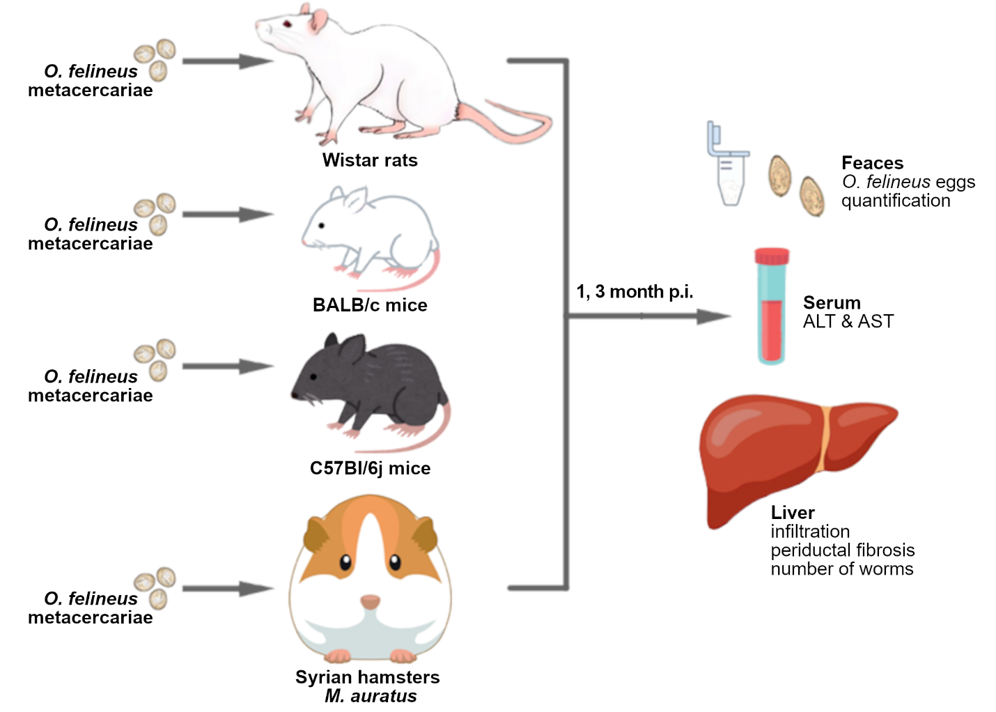
Figure 1. Design of experiment. Experimental animals (Wistar rats, BALB/c and C57Bl\6j mice and Syrian hamsters M. auratus) were infected with 100 metacercariae O. felineus. In 1 and 3 months of infection feces were collected for calculation number of O. felineus eggs. Liver was collected for both histological examination and calculation number of flukes. ALS & AST were measured in blood serum.

Animals were obtained from the conventional vivarium of the Institute of Cytology and Genetics. Infection was performed in the vivarium under sterile conditions. Each animal was kept in individual cage. The experiment was conducted in series: mice were infected first, followed by hamsters and then rats, the latter after a 2-week quarantine period. Euthanasia was performed by CO₂ in accordance with humane principles for laboratory animals. Blood was collected by cardiac puncture immediately after euthanasia. The liver was removed in its entirety and carefully freed from adjacent tissues. The experiment was approved by the Ethics Committee of the Institute of Cytology and Genetics (protocol extract № 221) and conducted in accordance with ARRIVE guidelines and GLP principles.

Biochemical analysis
Serum biochemical analysis was performed using commercially available ready-to-use kits for alanine aminotransferase (ALT; Vector-Best, Russia) and aspartate aminotransferase (AST; Vector-Best, Russia) according to the manufacturer’s protocol. Measurements were carried out using an Eppendorf BioPhotometer Plus spectrophotometer (Eppendorf, Germany).

Histological examination
Liver samples were fixed in 10% formalin solution. The samples were dehydrated through a graded series of ethanol and xylene and embedded in paraffin using a spin tissue processor (STP-120, Thermo Scientific, USA). The tissue blocks were prepared using an embedding station (EC-350, Thermo Scientific, USA). 5 μm histological sections were obtained using a Microm HM 355S microtome (Thermo Scientific, USA). Sections were stained with hematoxylin and eosin, PASM, and Masson’s trichrome. Ready-to-use staining kits were applied according to the manufacturer’s protocol.

Assessment of the intensity of infestation
To evaluate intensity of O. felineus infestation among laboratory animals counting of helminth recovered from the liver was conducted as well as counting of helminth eggs in feces 1 and 3 month post infection (m.p.i.). Counting of eggs was conducted with Mini Parasep 15ml Intestinal Parasite Concentrator (Apacor, Great-Britan) on light microscope Lacopa with Lacopa PC3-HI20M camera. Three specimens were analyzed per one animal. After that number of eggs was normalized per one gram of feces (Katz et al., 1972).

Statistical analysis
Statistical analysis was performed using Python (version 3.13.5). Data preprocessing was carried out with the pandas package (version 2.3.1). The Shapiro-Wilk test (scipy package, version 1.16.0) was used to assess the normality of data distribution in each group. For multiple comparisons, the Kruskal-Wallis test (scipy package, version 1.16.0) was applied, followed by pairwise Wilcoxon tests (scikit_posthocs package, version 0.11.4) with Benjamini-Hochberg correction for p-value adjustment. Statistical significance was defined as P < 0.05. Data visualizations were generated using Matplotlib package (version 3.10.3) and Seaborn package (version 0.3.12).

Results
Intensity of O. felineus infection among different species
Figure 2A shows that the median number of flukes recovered from M. auratus was 25 per animal at 1 m.p.i. and 39 per animal at 3 m.p.i. In C57Bl/6j mice, only several flukes were detected at 1 m.p.i.; however, the median number of recovered parasites increased to 7 per animal at 3 m.p.i. In BALB/c mice, the mean number of worms was lower. No flukes were detected at 1 m.p.i., and only one worm per animal was recovered at 3 m.p.i. No flukes were recovered from rat livers at either 1 or 3 m.p.i.

O. felineus egg counts in feces
Number of parasite eggs, detected in feces, reflecting the intensity of infection and maturation of trematode (Figure 2B). In Syrian hamsters egg production was relatively low at 1 m.p.i. increasing by 3 m.p.i. reflecting activation of reproductive activity of parasites. Same pattern was detected among C57Bl/6j mice, however number of eggs was relatively negligible. No eggs were detected in Balb/c mice at 1 m.p.i. and only in feces of two animals eggs were detected at 3 m.p.i. No eggs were detected in Wistar rat feces at either 1 or 3 m.p.i.
At 3 m.p.i median number of eggs per one parasite was 40 eggs/worm among Syrian hamsters, 10 eggs/worm in C57Bl/6j mice and 4 eggs/worm in Balb/c mice (Figure 2C).

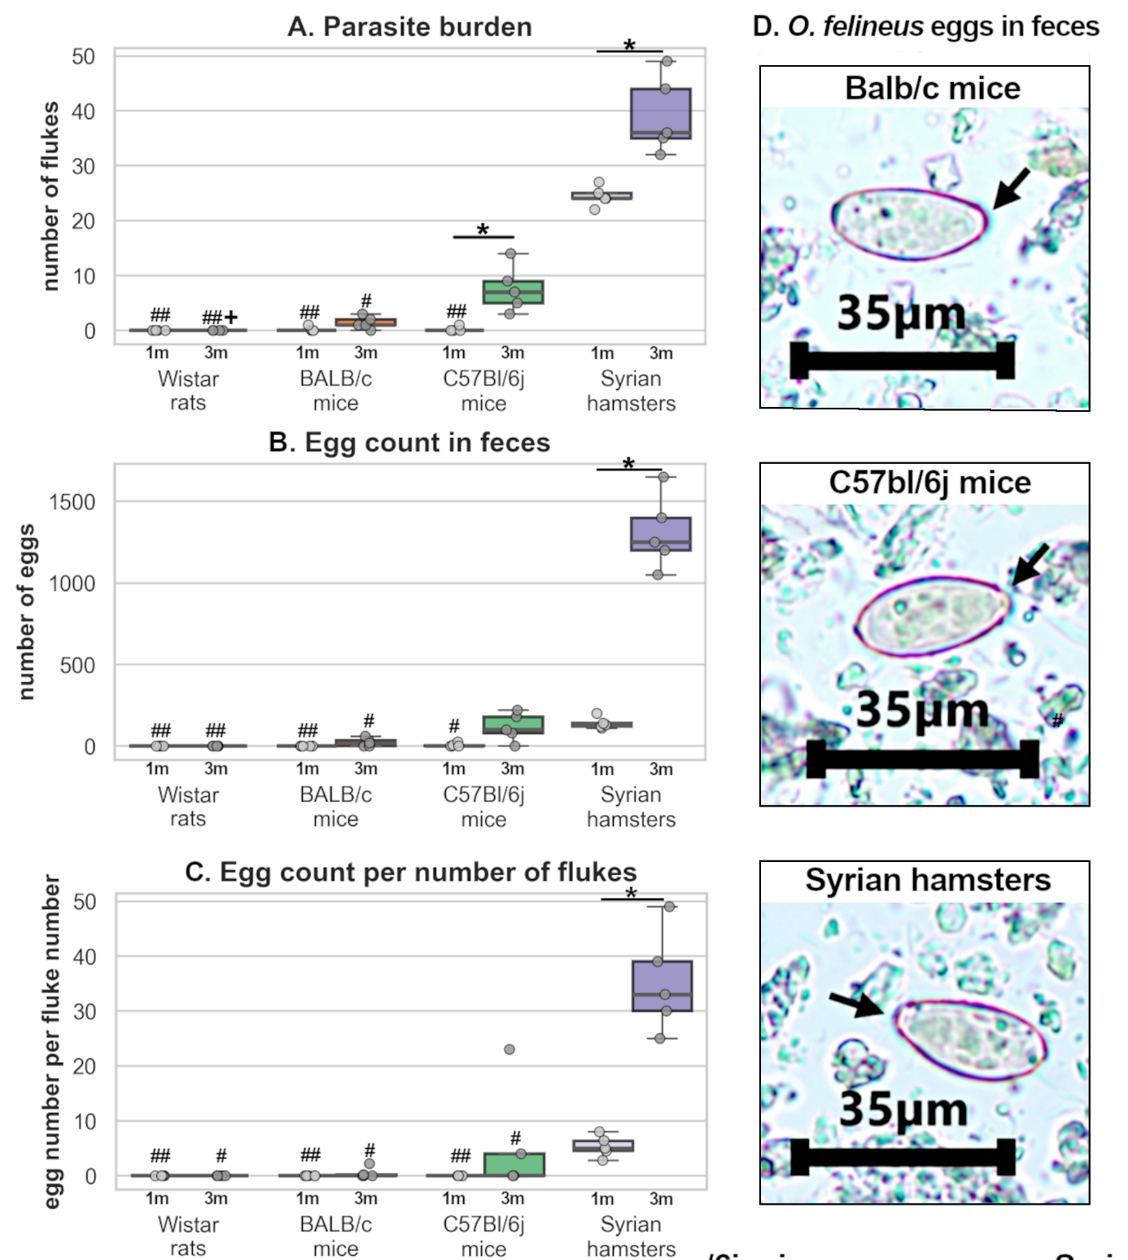
Figure 2. Estimation of parasite burden among experimental animal*P<0.05 in the same animal group; +P<0.05, ++P<0.01 vs C57Bl/6j mice of the same age; #P<0.05, ##P<0.01 vs Syrian hamster of the same age.. Arrows point operculum

ALT and AST estimation in serum
To assess liver state of infected animals, ALT and AST activities were measured in serum. The activity of both enzymes was increased in Syrian hamsters at 3 m.p.i. against control group AST was also upregulated in C57Bl/6j and BALB/c mice both 1 and 3 m.p.i., however no ALT upregulation was detected. No increase in transaminase activity was detected in rats.

Morphological changes in the liver of experimental animals
Figure 3 represents histological examination of liver in different hosts. Epithelial hyperplasia was close among laboratory animals, however most prominent in Syrian hamsters and increased from 1 to 3 months post infection (median values were 6.4 and 8.4 respectively); it was less severe in mice. In Balb/c mice level of hyperplasia was 4.1 at 1 m.p.i. and 5.6 at 3 m.p.i. In C57Bl/6j mice level of hyperplasia was 4.1 at 1 m.p.i. and 3.2 at 3 m.p.i.

Inflammatory infiltration was also most prominent in Syrian hamsters. Median value was 6.7 at 1 m.p.i. and 11.0 at 3 m.p.i. In mice inflammation was lower. In Balb/c mice median values were 4.7 and 3.9 at 1 and 3 m.p.i. respectively. In C57Bl/6j mice median values were 1.8 and 1.4 at 1 and 3 m.p.i. respectively. No inflammatory infiltration or epithelial hyperplasia were detected in Wistar rats
Egg granulomas were detected only in Syrian hamsters’ liver. No egg granuloma were detected ether mice or rats (Chi-Square Tests: χ2=20, P<0.001).
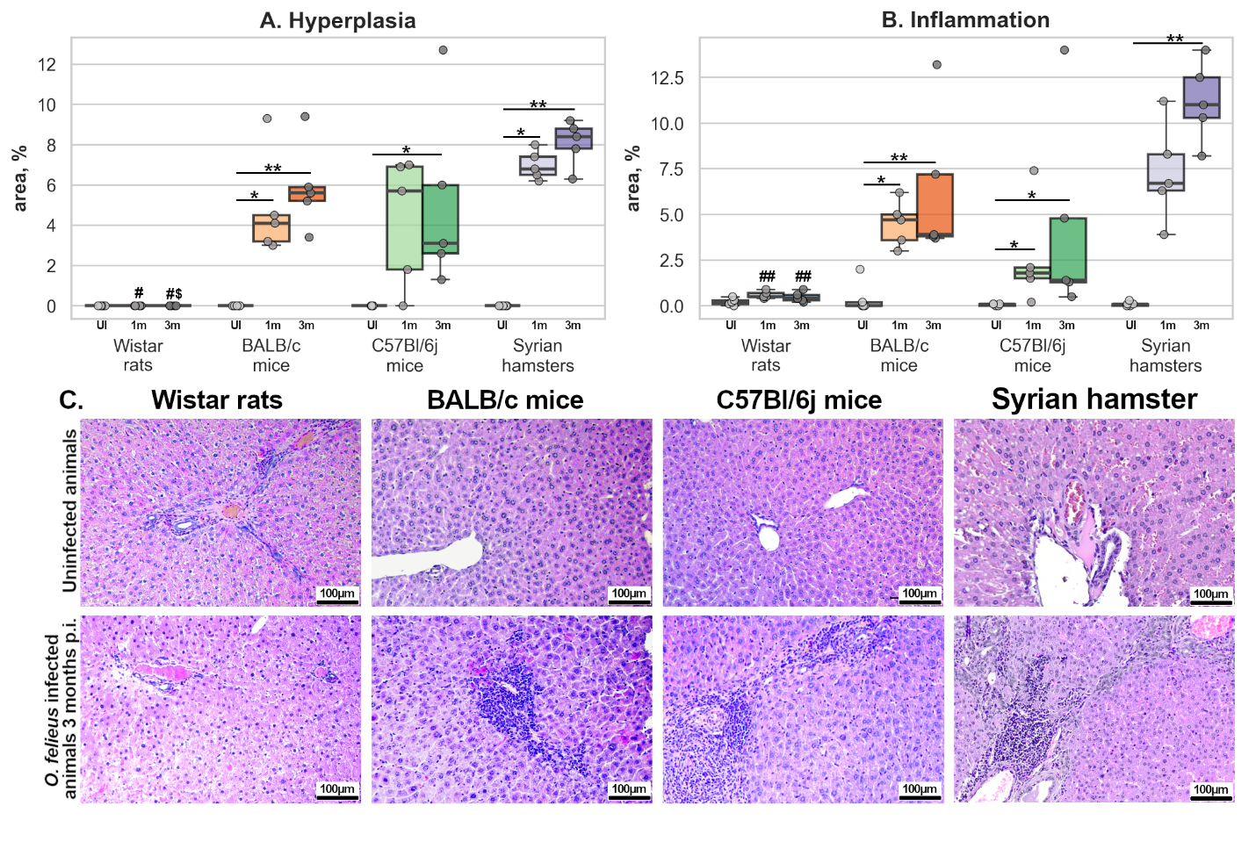
Figure 3. Histological manifestations of O. felineus infection among different experimental animals. *P<0.05; **P<0.01 in the same animal group; $P<0.05 vs BALB/c mice of the same age; #P<0.05 vs Syrian hamster of the same age. Arrows point inflammatory infiltration.

Masson trichrome staining was conducted to evaluate liver fibrosis (Figure 4A, B). Fibrosis was detected among all laboratory animals except rats. In Balb/c mice median level of fibrosis was 9.8% at 1 m.p.i. (P=0.029 vs uninfected control) and 7.7% at 3 m.p.i. (P=0.029 vs uninfected control). In C57Bl/6j mice median level of fibrosis was 9.9% at 1m.p.i. (P=0.042 vs uninfected control) and 14.9% at 3 m.p.i. (P=0.05 vs uninfected control, P=0.012 vs Wistar rats 3 m.p.i.). Liver fibrosis in Syrian hamsters was most prominent both at 1m.p.i. (median=29.7%, P=0.014 vs uninfected control, P=0.003 vs Wistar rats 1 m.p.i.) and 3 m.p.i. (median=24.8%, P=0.014 vs uninfected control, P=0.003 vs Wistar rats 3 m.p.i). No fibrosis was detected in rats’ liver. PASM silver staining (figure 4C) was performed to support Masson trichrome staining. More intense staining indicated more pronounced fibrosis. The strongest silver impregnation was observed in Syrian hamsters and C57Bl/6j mice, whereas in BALB/c mice staining was less pronounced.

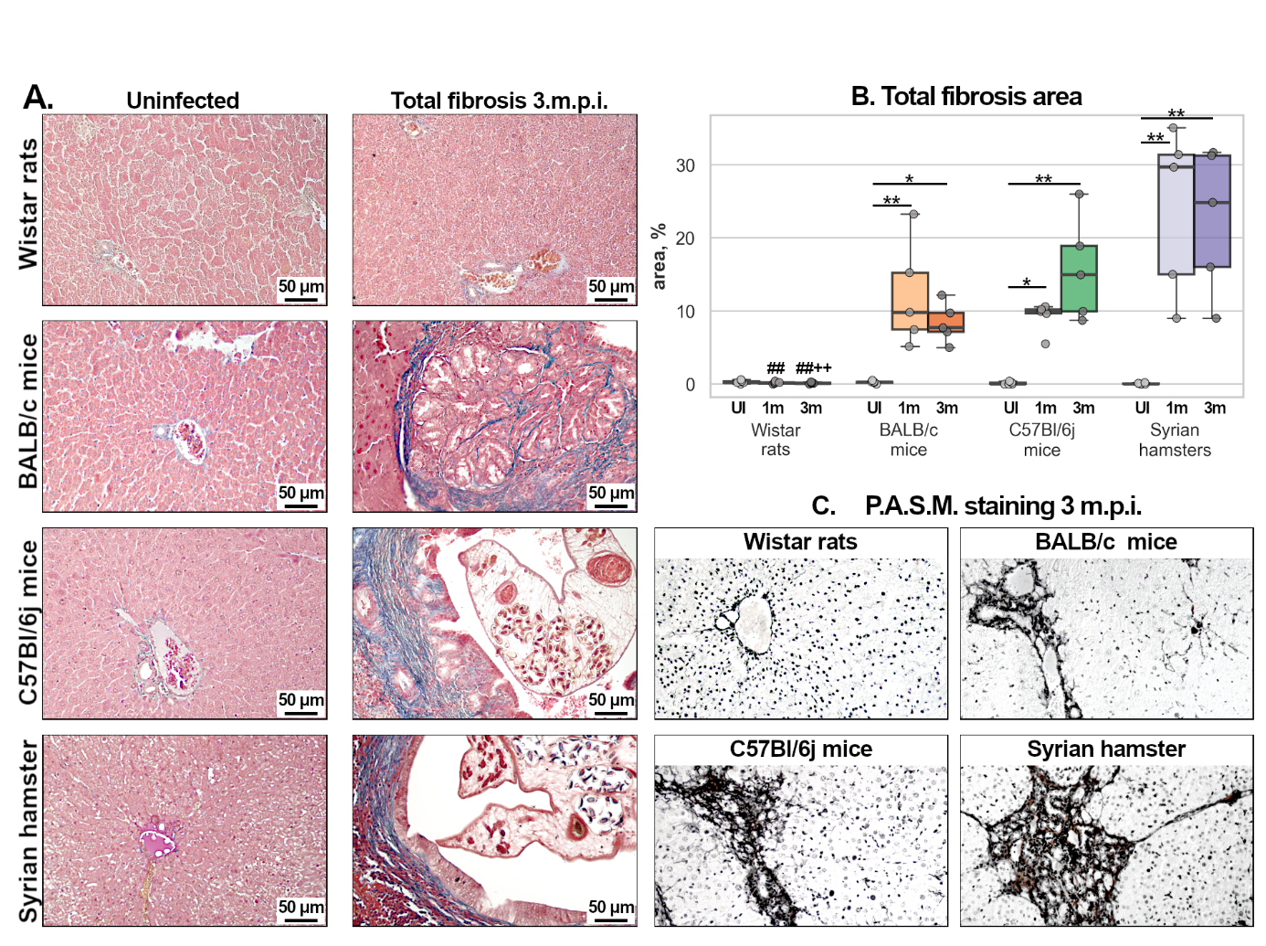
Figure 4. Fibrosis representation while O. felineus infection among different experimental animals. *P<0.05; **P<0.01 in the same animal group; $P<0.05 vs BALB/c mice of the same age; +P<0.05 vs C57Bl/6j mice of the same age; #P<0.05, ##P<0.01 vs Syrian hamster of the same age. A. Thickness of periductal fibrosis thickness; B Cholangiofibrosis area; C. Masson’s trichrome staining. Arrows point fibrosis; D. P.A.S.M-silver staining. Fibrosis reveals with black color.

Additionally, whole slide liver tissue imagination was conducted among all laboratory animals at 3m.p.i. and human (Figure 5). Among Balb/c mice more prominent neoplastic changes of biliary epithelium were detected. Among Syrian hamsters neoplastic changes were lower, representing early chronic period of infection. In C57Bl/6j mice biliary neoplastic changes were close to one in hamsters. However, liver fibrosis in mice were less prominent in mice of both strains comparing to hamsters and humans.

Figure 5. Whole slide images of liver tissue. Образцы печени экспериментальных животных окрашены по Массону на соединительную ткань. Срезы печени были сфотографированы при увеличении 100Х. В красных рамках представлен желчный проток (увеличение 200Х)

Discussion
Selecting of appropriate animal research model is crucial for correct interpretation and extrapolation of results obtained on humans. Modelling of pathology on animals is the most common approach, however with several limitations. While modeling, the disease should be phenotypically close to one in humans (face validity) and mechanisms underlying disease development must be similar (construct validity). If the investigation incudes development of therapeutic approaches, response to the treatment must also be similar in model and human (predictive validity) (Belzung et al., 2011). It is also crucial that model must be sensitive to the pathogen especially in context of infection diseases investigation.
The development of medicinal drugs has a long history marked by the failure of animal modeling. Most of drugs against cancer which have shown effectiveness on animal model were ineffective in humans (Mak et al., 2014). In early 2000th anticancer effect of inhibitors of metalloproteinases – group of enzymes, playing important role in remodeling of connective tissue and facilitating invasiveness of tumor. The most widely known drug, inhibiting metalloproteinases, was marimastat, which showed high effect on laboratory animals (Maekawa et al., 2002; Skipper et al., 2008). However, when marimastat was decided to implement as anti-tumor treatment in humans, it showed no favorable effect while caused severe joint pain (Sparano et al., 2004). Inhibitors of hedgehog signaling pathway is another example. Normally, this pathway is responsible for many processes like embryonic development, differentiation of cells and regeneration of tissue. In tumors hedgehog pathway facilitate invasiveness of tumor. IPI-926 (Saridegib), which blocks SMO receptor of hedgehog pathway was developed as anti-tumor therapy. Results, obtained on animal model were promising, however no effect was detected in patients (Mak et al., 2014)
Research of statins can be cited as counterexample. Lovastatin, one of the first drugs for lowering low density lipoproteins, was highly toxic in animal which is why clinical trials of this drug were suspended. However, Lovastatin was tested on small group of patients with hereditary hypercholesterinemia who were refractory to other therapy. Drug showed its high effectiveness with relatively low side effects and gave rise to extensive group of drugs for treatment hypercholesterinemia (reference).
There are other ways for modelling pathological states besides animal modelling. One of the most humane methods is modelling on cells culture. This method is widely used in context of investigation of different kinds of treatments on specific cell lines. Cell culturing methods are very useful for investigating specific mechanisms of cytotoxic or stimulating cell proliferation agents (Segeritz and Vallier, 2017). For instance, cell proliferating properties of Opisthorchis felineus excretory- secretory product were detected in human immortalized cholangiocytes through EGFR signaling pathway (Ponomarev et al., 2025). Besides, cell cultures are widely used for production of viral particles for vaccine development (Demirden et al., 2024). However, cell culturing method have its obvious limitations. Organism is a very complex system. While investigating response of one type of cells is widely accessible, investigating response of treatment or pathologic agent on tissue, which includes several types of cells can be difficult. Investigation on cultures are mostly conducted on a monolayer in 2D which is badly represents real human tissue. Several approaches exist for 3D culturing like organoids (Suarez-Martinez et al., 2022; Leisengang S, 2024) or scaffold-based culturing (Abuwatfa et al., 2024). They better reflect physiology of real tissue in vitro but can be unavailable and need specifically trained personnel. Besides, even the most advanced culture-based methods can’t reproduce the organism as a whole.
Accounting up mentioned limitations, modeling of pathology on animals can be the only available option. It is crucial to use correct model especially in context of infection diseases like O. felineus infection, if our aim is to extrapolate obtained results on humans. Resistant animal species, partly or totally, could not fully reproduce pathogenesis of disease. This can lead us to incorrect conclusions with poor translation of results on human (Tangkawattana et al., 2024).
This challenge is particularly relevant to the study of the pathological response to O. felineus infection, for which Syrian hamsters serve as the primary animal model. If we want to investigate potential effect of opisthorchiasis on different systems of organs we can find out that lots of methods are not adapted for this animal. Data exists supporting that O. felineus can lead to development of neurological disorders. However, methods evaluating the neurological state are developed for mice and rats and poorly adapted for Syrian hamsters. Different types of reagents, like commercially available antibodies, are well tested on mice and rats but can perform poorly on Syrian hamsters. Several methods can be adapted for hamsters; however, this may reduce the potential for comparation with data, presented in literature.
Another reason, why most of investigators prefers rats and mice is availability of different transgenic and knock-out mouse and rat strains for investigation diseases separately or in comorbidity (Wong et al., 2016). Coronavirus disease-19 pushed hamster modeling to the forefront due to its advantages over mice in recapitulating human pathology and transmission (Reyna et al., 2025), however mice and rats remain the primary laboratory animals for studying various pathological states. In this context, choosing an optimal experimental model appears fundamentally important for the correct study of pathogenesis of different diseases including opisthorchiasis.
In current study we focused our attention on estimation of face validity of O. felineus infection on several widely used laboratory animals: rats, mice and hamsters.
First of all, we estimated infectivity of animals with O. felineus. Egg production among Syrian hamsters was mostly detected in chronic period of infection (3 m.p.i.) which is normal for this animal model. This is related to sexual maturations of parasitic worms. C57Bl/6j and BALB/c have similar dynamics, however number of eggs in feces was much lower. No egg granulomas formation, another important feature of opisthorchiasis, were detected in mice liver unlike hamster liver. It seems that in mice O. felineus development of parasitic worms is much slower with no maturation by the 3rd month. Unfortunately, we have no information on longer dynamics of O. felineus infection in mice and can’t say how much time does it takes for worm maturation.
Number of adult parasitic worms, recovered from liver tissue, was also highest in hamsters. BALB/c and C57Bl/6j mice were less sensitive to opisthorchiasis while Wistar rats were refractory to infection.
Among laboratory rodents O. felineus infection morphological features like infiltration fibrosis and hyperplasia were most prominent in Syrian hamsters. This consistent with the changes in humans with chronic form of opisthorchiasis. All morphological changes were similar between mice strains yet less pronounced than ones in hamsters.
O. viverrini shows a host-range pattern similar to that of O. felineus. Syrian hamsters are a susceptible model, whereas BALB/c mice are relatively resistant (Tangkawattana et al., 2024; Srisai et al., 2024). Rats are refractory to O. viverrini infection, as they are to O. felineus (Boonmars et al., 2009). However, rat strains can be susceptible to C. sinensis infection. C. sinensis has been reported to infect Sprague-Dawley and Wistar rats, with biliary epithelial hyperplasia and periductal fibrosis development (Qian et al., 2024; Wang et al., 2009).
Differences in host susceptibility to trematode infections among mouse strains are not well established but possibly related to immune response (Tangkawattana et al., 2024; Srisai et al., 2024). BALB/c mice typically exhibit a more pronounced Th2 response, characterized by elevated IgE and IL-5 mediated eosinophil recruitment, which may protect against trematodes during early infection. In contrast, C57Bl/6j are characterized by stronger Th-1 response with relatively weaker anti-parasite activity, which may underlie their greater susceptibility to opisthorchiasis (Watanabe et al., 2004).

In humans infected with opisthorchiasis liver fibrosis development (Kovner et al,. year; Kovner et al,. year), biliary neoplasia and inflammation (Yablokov, 1973) are common features of opisthorchiasis. Aminotransferases (AST and ALT) often upregulated in humans (Kovner et al., year; Yablokov, 1973) and hamsters with no visible change in mice. Another important feature is egg granulomas which were presented in hamsters but not in mice. Summarizing the data we can conclude that character of disease in hamster and human is similar with all key features development unlike mice who have less pounced fibrosis and inflammation and no egg granulomas formation.

Table 1. Summarizing table represent infectivity and histological findings among different animal models and humans.
Estimation of construct validity of Syrian hamsters was beyond the scope of current investigation; however, it is currently actively taking place. Key problem is estimation of pathological processes in humane due to deficit of biological material. Biopsy of liver tissue is invasive, potentially risky procedure which can lead to complications. It is also unnecessary for establishment of opisthorchis diagnosis. Alternatively, cadaver material can be used, but it often unavailable for research groups and complicated with patient’s comorbidities, which can obscure the picture of infection process. However, several publications point out that infection development in humans and hamsters share similar mechanisms. It was shown that biliary neoplasia in Syrian hamster interconnected with ROS damage of DNA, chronic inflammation and mechanic damage of epithelium (Pakharukova et al., 2019). Same mechanism was proposed for humans (Grigorieva 2012).
Predictive validity estimation is also presented in literature. Data presented show that praziquantel, the only drug for treatment opisthorchiasis, highly effective in Syrian hamsters as well (Pakharukova et al., 2015).
The results of this study are consistent with previous reports and indicate that M. auratus is the optimal model for studying opisthorchiasis. If a mouse model is essential for experiment, C57Bl/6j mice may be used, but with several important limitations. Even with a high infective dose, the number of established flukes was very low: we administered 100 metacercariae per animal but recovered no more than fifteen adult flukes. May be infection should be performed in series at several timepoints. Sexual maturation is another constraint; fecal egg counts in C57Bl/6j mice remained low at 3 m.p.i., suggesting that a longer interval between infection and tissue collection may be necessary to capture later stages of parasite development. If a study requires use of a mouse strain whose susceptibility to O. felineus is uncharacterized, an initial evaluation of infectivity is essential. Finally, Wistar rats were completely resistant to O. felineus infection and are therefore unsuitable for studies of this species.

Comparative evaluation of Syrian hamsters, mice, and rats as experimental models of Opisthorchis felineus infection
Host susceptibility and hepatic pathology in experimental Opisthorchis felineus infection: A comparison of Syrian hamsters, mice, and rats
Experimental Opisthorchis felineus infection in rodent hosts: Differences in parasite establishment, egg output, and hepatic pathology

Abstract
Selecting an appropriate animal model is essential for investigating the pathogenesis of opisthorchiasis and interpreting the relevance of experimental findings to human disease. This study compared host susceptibility and hepatic pathological changes in Syrian hamsters, BALB/c mice, C57BL/6J mice, and Wistar rats to assess their suitability as experimental models of Opisthorchis felineus infection. For each host group, 10 animals were orally administered 100 metacercariae each, and five animals served as uninfected controls. Infected animals were examined at 1 and 3 months post-infection. Assessments included fluke recovery, fecal egg counts, serum ALT and AST activities, and histological examination of the liver. Syrian hamsters showed the highest parasite recovery, with median fluke counts of 25 and 39 per animal at 1 and 3 months post-infection, respectively. Parasite recovery was lower in both mouse strains, and no flukes were recovered from Wistar rats. Fecal egg counts increased between the two time points in hamsters and mice but remained substantially lower in mice. Hepatic epithelial hyperplasia, inflammatory infiltration, and fibrosis were generally most pronounced in Syrian hamsters, and egg granulomas were detected only in this host. Both serum aminotransferase activities were elevated in hamsters at 3 months post-infection, whereas mice showed increased AST activity without a corresponding increase in ALT activity. Wistar rats showed no infection-associated hepatic changes. These findings support Syrian hamsters as the most suitable of the hosts tested for reproducing the assessed features of O. felineus infection. C57BL/6J mice may provide an alternative when mouse-specific experimental resources are required, although limited parasite establishment, low egg output, and less pronounced hepatic pathology constrain their use. Wistar rats did not support detectable infection under the conditions tested.

