Establishment of rodent models for experimental opisthorchiasis

Introduction
Opisthorchiasis is a food-borne zoonosis caused by the liver flukes Opisthorchis felineus, Opisthorchis viverrini, and Clonorchis sinensis. O. felineus is endemic in Russia, with the highest prevalence in Western Siberia. O. felineus–induced opisthorchiasis represents a major public-health problem in this region, particularly in rural communities where infection rates may exceed 40% (Fedorova et al., 2020).
Infection follows consumption of undercooked cyprinid fish containing metacercariae. O. felineus infects a broad range of fish-eating mammals, including humans. Parasite localize in the hepatobiliary system, where it causes biliary obstruction, intense inflammatory infiltration, and progressive fibrosis. Biliary neoplasia is among the most serious complications of opisthorchiasis and can progress to cholangiocarcinoma. Although the carcinogenicity of O. felineus has not been definitively established (IARC, 2012), emerging data suggest that O. felineus may act as a potential risk factor for cholangiocarcinoma development (Fedorova et al., 2023). In addition to hepatobiliary pathology, renal injury has been reported in both experimental model and human cases (Zaparina et al., 2024; Kapushchak et al., 2022; Kovner et al., 2026). Russian clinical literature further documents a wide spectrum of syndromes, including neurological manifestations, indicating that O. felineus infection can be a systemic disease with diverse clinical presentations (ссылка на клинреки).
Appropriate experimental models are required to investigate disease pathogenesis especially systemic response. Traditionally, the Syrian hamster (Mesocricetus auratus) has been used as an animal model of opisthorchiasis for several reasons. M. auratus is closely related to Ondatra zibethicus, a natural definitive host of O. felineus (Pakharukova & Mordvinov, 2016); both species belong to the family Cricetidae. Adult flukes recovered from M. auratus are phenotypically similar to those obtained from naturally infected mammals such as foxes or cats (Беэр, 2005). Besides, the course of infection in hamsters reproduces many features characteristic of human disease (Lvova et al., 2012).
Nevertheless, several limitations of M. auratus animal model exist. Many molecular and behavioral methods have been optimized for mice and rats and are not readily transferable to hamsters. For example, common behavioral tests such as grip strength test, Morris water maze or open field test are not well adapted to M. auratus. Numerous ready-to-use molecular reagents and protocols validated for mice, rats, or humans may perform poorly in hamsters.
The aim of this study was to compare the susceptibility of mice, rats, and hamsters to O. felineus infection and to assess which species develops the characteristic features of human opisthorchiasis.
Materials and methods

Design of experiment
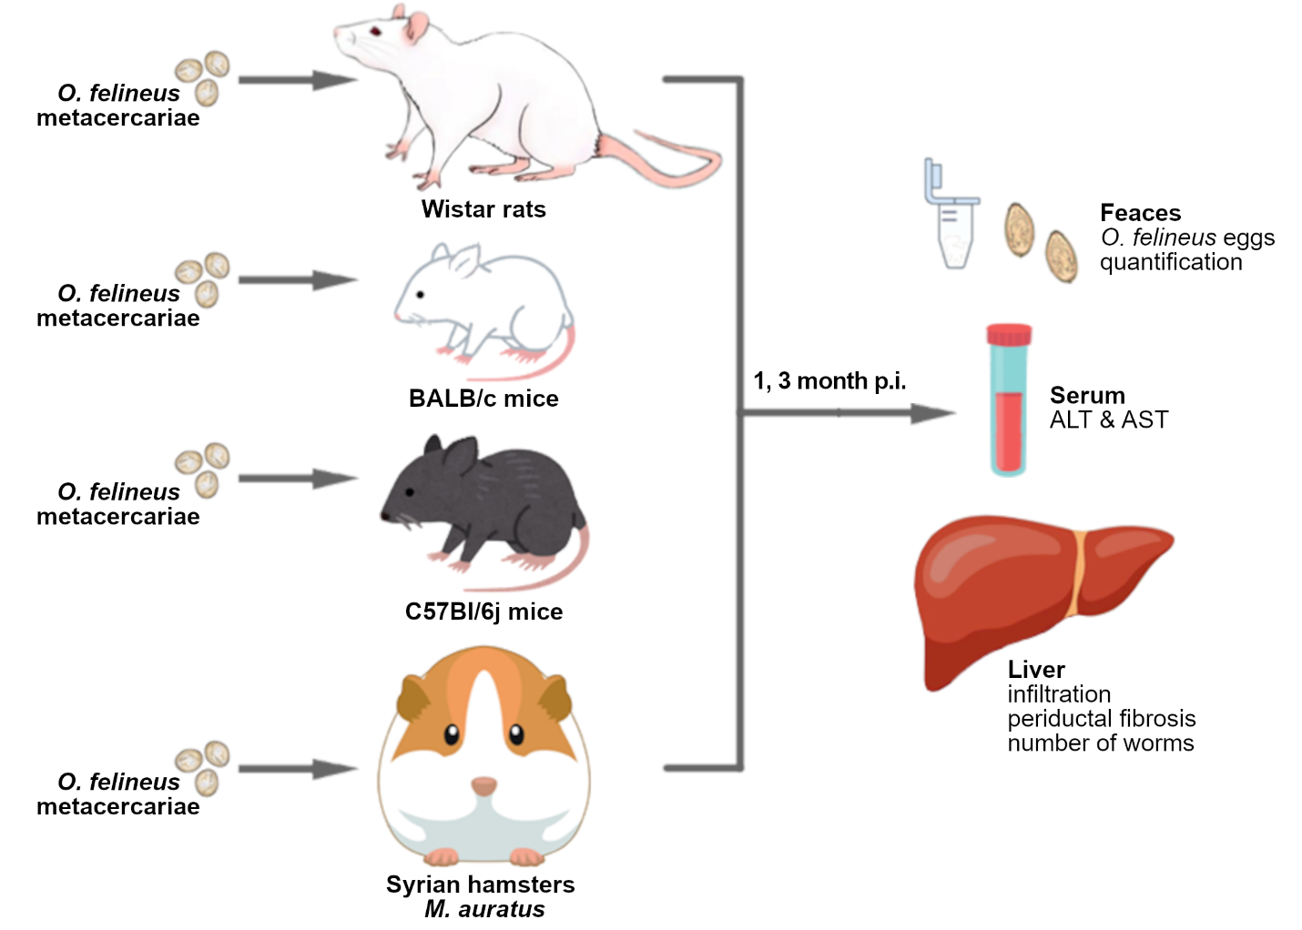
Figure 1. Design of experiment. Experimental animals (Wistar rats, BALB/c and C57Bl\6j mice and Syrian hamsters M. auratus) were infected with 100 metacercariae O. felineus. In 1 and 3 months of infection feces were collected for calculation number of O. felineus eggs. Liver was collected for both histological examination and calculation number of flukes. ALS & AST were measured in blood serum.

O. felineus metacercariae were collected from naturally infected cyprinid freshwater fish caught in the Ob River near Novosibirsk City on May 2024. Metacercariae were isolated from muscle tissue as described previously (Lishai et al., 2025). In brief, muscle tissue was incubated in pepsin-HCl solution for 30 min, followed by at least 10 washes in 0.9% NaCl. Metacercariae were then identified under light microscope and collected for further use. Animal infection was performed two months after metacercariae collection by trained personnel.
Wistar rats, BALB/c mice, C57Bl/6j mice and Syrian hamsters were used as experimental models (Figure 1). Animals were obtained from the conventional vivarium of the Institute of Cytology and Genetics. Infection was performed in the vivarium under sterile conditions. Each animal was kept in individual cage. The experiment was conducted in series: mice were infected first, followed by hamsters and then rats, the latter after a 2-week quarantine period. Each experimental group included 15 animals: 5 animals were euthanized at 1 month post infection (m.p.i.), another 5 animals were euthanized at 3 m.p.i., and 5 animals were uninfected and used as control group. Animals were infected with 100 O. felineus metacercariae through an esophagogastric tube. Euthanasia was performed by CO₂ in accordance with humane principles for laboratory animals.
Liver weight was measured using an LA1200S balance (Sartorius AG, Germany). Blood was collected by cardiac puncture immediately after euthanasia. The experiment was approved by the Ethics Committee of the Institute of Cytology and Genetics (protocol extract № 221) and conducted in accordance with ARRIVE guidelines and GLP principles.

Katz egg count
To assess the intensity of infection and sexual maturation of trematodes, egg counts were performed in feces using a Mini Parasep 15 mL Intestinal Parasite Concentrator (Apacor, Great Britain). Fecal samples were placed in tubes containing 10% formalin and mixed until a homogeneous suspension was obtained. The samples were centrifuged for 2 min at 400g using a 5810R centrifuge (Eppendorf, Germany). After removal of the supernatant, 300 µL of 0.9% NaCl was added to the sediment and mixed thoroughly. Then, 30 µL of the final suspension was transferred to a microscope slide and examined under a light microscope. The number of eggs was normalized per 1 g of feces (Katz et al., 1972).

Biochemical analysis
Serum biochemical analysis was performed using commercially available ready-to-use kits for alanine aminotransferase (ALT; Vector-Best, Russia) and aspartate aminotransferase (AST; Vector-Best, Russia) according to the manufacturer’s protocol. Measurements were carried out using an Eppendorf BioPhotometer Plus spectrophotometer (Eppendorf, Germany).

Histological examination
Liver samples were fixed in 10% formalin solution. The samples were dehydrated through a graded series of ethanol and xylene and embedded in paraffin using a spin tissue processor (STP-120, Thermo Scientific, USA). The tissue blocks were prepared using an embedding station (EC-350, Thermo Scientific, USA). 5 μm histological sections were obtained using a Microm HM 355S microtome (Thermo Scientific, USA). Sections were stained with hematoxylin and eosin, PASM, and Masson’s trichrome. Ready-to-use staining kits were applied according to the manufacturer’s protocol.

Statistical analysis
Statistical analysis was performed using Python (version 3.13.5). Data preprocessing was carried out with the pandas package (version 2.3.1). The Shapiro-Wilk test (scipy package, version 1.16.0) was used to assess the normality of data distribution in each group. For multiple comparisons, the Kruskal-Wallis test (scipy package, version 1.16.0) was applied, followed by pairwise Wilcoxon tests (scikit_posthocs package, version 0.11.4) with Benjamini-Hochberg correction for p-value adjustment. Statistical significance was defined as P < 0.05. Data visualizations were generated using Matplotlib package (version 3.10.3) and Seaborn package (version 0.3.12).

Results

Intensity of O. felineus infection among different species
To evaluate the intensity of O. felineus infection in different laboratory animals, the number of flukes recovered from the liver was counted. Figure 2A shows that the median number of flukes recovered from M. auratus was 24 per animal at 1 m.p.i. and 39 per animal at 3 m.p.i. In C57Bl/6j mice, only several flukes were detected at 1 m.p.i.; however, the median number of recovered parasites increased to 7 per animal at 3 m.p.i. In BALB/c mice, the mean number of worms was lower. No flukes were detected at 1 m.p.i., and only one worm per animal was recovered at 3 m.p.i.
The resulting number was normalized to liver mass (Fig. 2B), because liver size was different among host species. The number of worms recovered from Syrian hamsters was highest among the species examined and was similar at 1 and 3 m.p.i. (median level was 3.6 and 4.7 respectively). Median number of trematodes per liver mass was close to zero in both BALB/c and C57Bl/6j mice. However, at 3 m.p.i. number of flukes per mass raised to 0.9 and 3.9 respectively. This may reflect differences in parasite development among definitive hosts. Flukes recovered from mice at 1 m.p.i. were likely too small and immature to be clearly detected. No flukes were recovered from rat livers at either 1 or 3 m.p.i.

O. felineus egg counts in feces
Number of parasite eggs in feces is another marker reflecting the intensity of infection and maturation of trematode (Figure 2C, D, E). Egg counts were calculated per 1g (Supl. Table 3) of feces and then divided by the number of flukes recovered from the liver of each animal. The highest median number of eggs was observed in M. auratus. Egg production increased from 1 (median=5) to 3 m.p.i. (median=33), reflecting fluke maturation and activation of the reproductive system. C57Bl/6j mice showed a similar pattern, but the median number of eggs per worm was close to zero. However median number of recovered eggs (with no adjustment for liver mass) was 99 for C57Bl/6j mice and 19 for Balb/c mice at 3 m.p.i. No eggs were detected in Wistar rat feces at either 1 or 3 m.p.i. (Supl. Table 3)
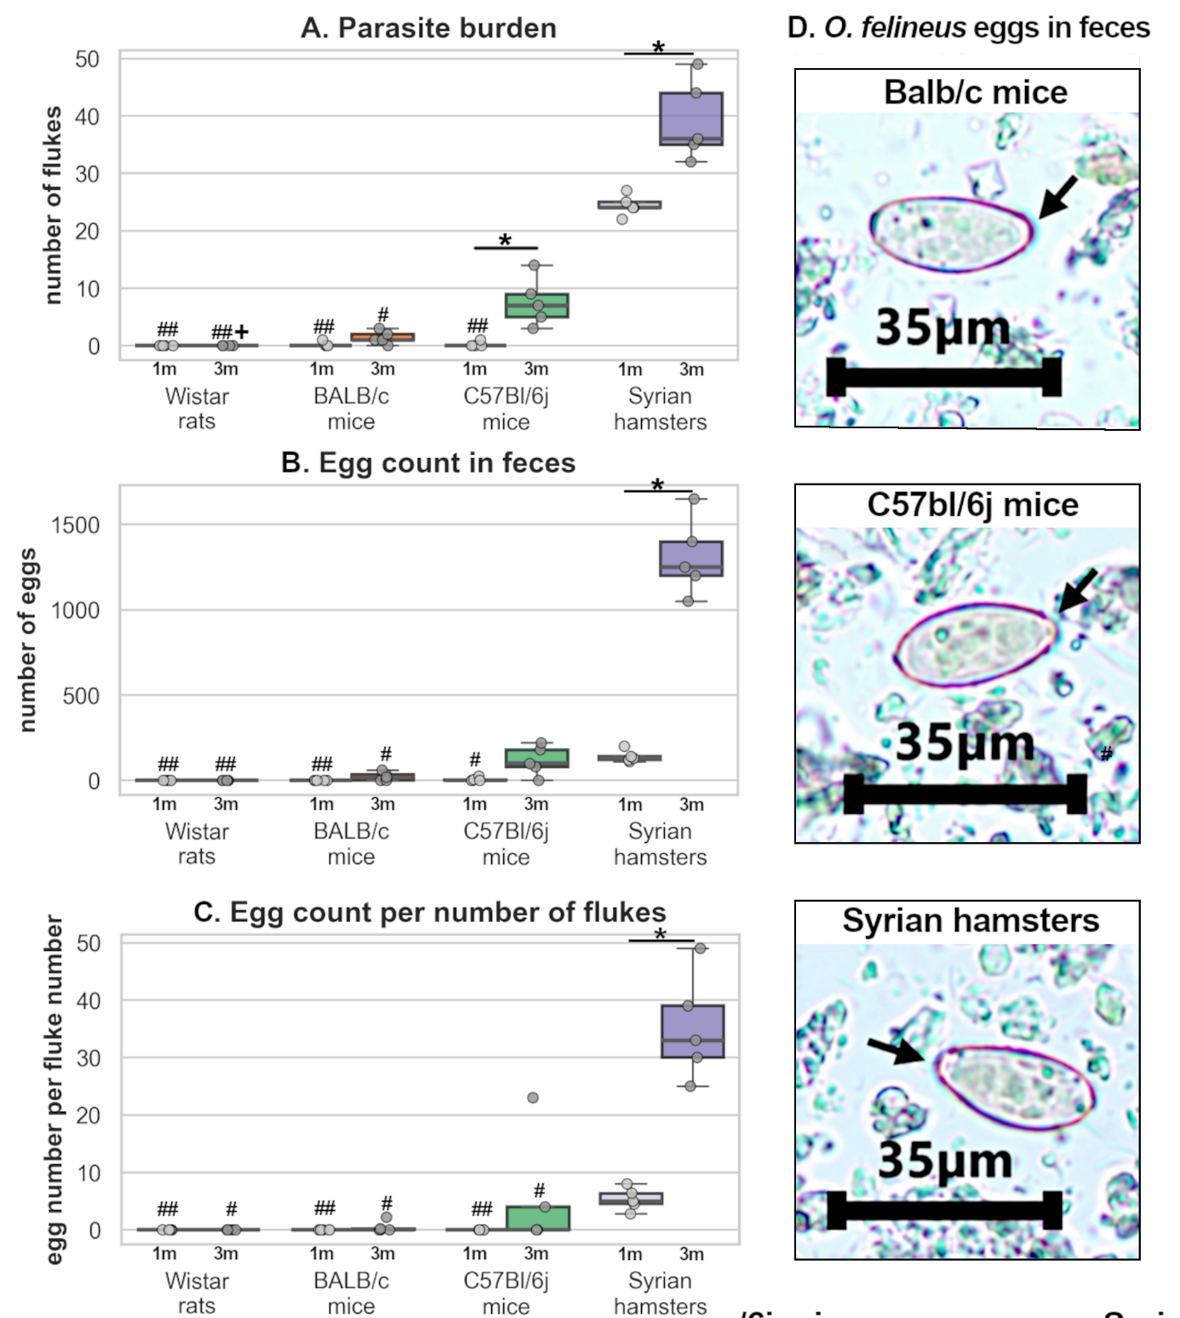
Figure 2. Estimation of parasite burden among experimental animal*P<0.05 in the same animal group; +P<0.05, ++P<0.01 vs C57Bl/6j mice of the same age; #P<0.05, ##P<0.01 vs Syrian hamster of the same age.. Arrows point operculum

ALT and AST estimation in serum
To assess liver state of infected animals, ALT and AST activities were measured in serum. The activity of both enzymes was increased in Syrian hamsters at 3 m.p.i. against control group AST was also upregulated in C57Bl/6j and BALB/c mice both 1 and 3 m.p.i. No increase in transaminase activity was detected in rats. (Supl. Table 2).
Morphological changes in the liver of experimental animals
Figure 3 represents histological examination of liver in different hosts. Epithelial hyperplasia was most prominent in Syrian hamsters and increased from 1 to 3 months post infection (median values were 6.4 and 8.4 respectively); it was less severe in mice. In Balb/c mice level of hyperplasia was 4.1 at 1 m.p.i. and 5.6 at 3 m.p.i. Inflammatory infiltration was also most prominent in Syrian hamsters. Median value was 6.7 at 1 m.p.i. and 11.0 at 3 m.p.i. In mice inflammation was lower. In Balb/c mice median values were 4.7 and 3.9 at 1 and 3 m.p.i. respectively. In C57Bl/6j mice median values were 1.8 and 1.4 at 1 and 3 m.p.i. respectively. No inflammatory infiltration or epithelial hyperplasia were detected in Wistar rats (Supl. Table 2).

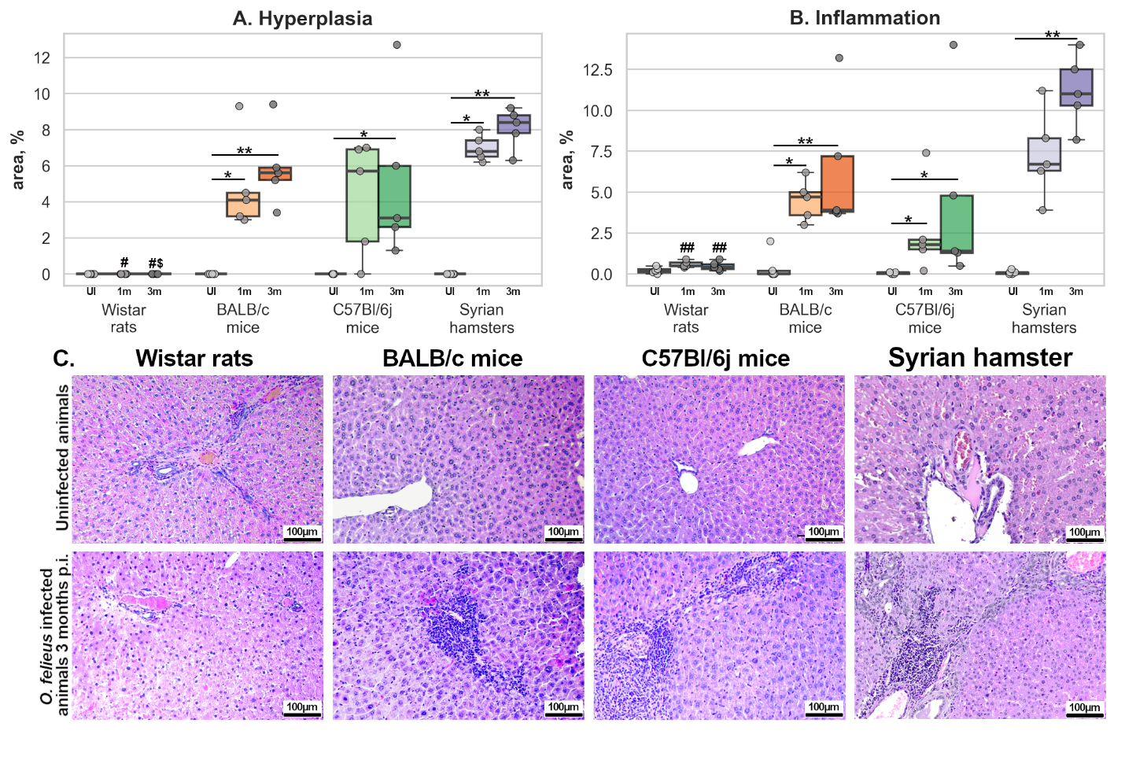Figure 3. Histological manifestations of O. felineus infection among different experimental animals. *P<0.05; **P<0.01 in the same animal group; $P<0.05 vs BALB/c mice of the same age; #P<0.05 vs Syrian hamster of the same age. Arrows point inflammatory infiltration.

Figure 4 shows fibrosis development in different host animals. The median thickness of periductal fibrosis in Syrian hamsters was 140 µm at 1 m.p.i. and 126 µm at 3 m.p.i. In mice, both BALB/c and C57Bl/6j , the median thickness of periductal fibrosis did not exceed 75 µm (Balb/c mice median value was 50 µm at 1 m.p.i. and 40 at 3 m.p.i.; C 57Bl/6j mice median value was 55 µm at 1 m.p.i. and 70 at 3 m.p.i.). Almost no periductal fibrosis was detected in Wistar rats.
Assessment of cholangiofibrosis area showed a similar pattern to that observed for periductal fibrosis. The highest values were observed in M. auratus, accounting for 15% of the assessed area at 1 m.p.i. and 12% at 3 m.p.i. In both mouse strains, the mean area of cholangiofibrosis was lower than in Syrian hamsters, although it increased from 1 to 3 m.p.i. (Balb/c mice median value was 5.5 µm at 1 m.p.i. and 3.2 at 3 m.p.i.; C 57Bl/6j mice median value was 2.0 µm at 1 m.p.i. and 5.0 at 3 m.p.i.). No cholangiofibrosis was detected in Wistar rats.
PASM silver staining (figure 4D) was performed only in hamsters and mice, due to their susceptibility to O. felineus infection. More intense staining indicated more pronounced fibrosis. The strongest silver impregnation was observed in Syrian hamsters and C57Bl/6j mice, whereas in BALB/c mice staining was less pronounced.

Discussion
The use of an appropriate animal model is essential for correct interpretation of experimental results. Partially or totally resistant models may exhibit infection dynamics that differ from those in humans, potentially leading to erroneous conclusions (Tangkawattana et al., 2024). This issue is particularly important when investigating systemic responses to O. felineus infection.
Although the Syrian hamster is the most commonly used model for opisthorchiasis (Boonmars et al., 2009), it has several limitations. For example, many classical methods for assessing nervous-system function were developed and validated for mice and rats and lack standardized alternatives for hamsters. Coronavirus disease-19 pushed hamster modeling to the forefront due to its advantages over mice in recapitulating human pathology and transmission (Reyna et al., 2025). However, findings obtained in hamsters may not be readily extrapolated to murine models. Likewise, genetically modified hamster strains are largely unavailable, which complicates studies of comorbidity, for instance, opisthorchiasis together with metabolic syndrome. In contrast, numerous transgenic and knock-out mouse strains exist and commercially available (Wong et al., 2016). While some methods can be adapted for M. auratus, extrapolation of these adaptations may be limited. Thus, selecting the optimal experimental model is crucial for accurate investigation of opisthorchiasis pathogenesis, especially outside hepatobiliary system.
Consistent with expectations, M. auratus exhibited the most pronounced manifestations of O. felineus infection. Inflammation, fibrosis, and serum activities of ALT and AST reached their highest values in hamsters, a pattern that corresponds to observations in chronically infected humans (Lvova et al., 2012). The number of adult flukes per gram of liver tissue was also highest in M. auratus. By contrast, BALB/c and C57Bl/6j mice were substantially less susceptible to infection, although a limited number of adult worms were recovered from mouse livers as well. BALB/c and C57Bl/6j strains showed similar degrees of hepatic inflammation and fibrosis, despite difference in number of recovered eggs and flukes. However, both markers were markedly less severe than in Syrian hamsters. Wistar rats were refractory to infection: no flukes were recovered from their livers and no eggs were detected in their feces.
Fecal egg counts peaked in M. auratus, predominantly at 3 m.p.i., reflecting the onset of sexual maturation of the liver fluke. In hamsters, maturation by 3 months is common. C57Bl/6j and BALB/c mice showed similar temporal dynamics, but the average egg production per worm was substantially lower than in hamsters, indicating slower development of flukes in mice and incomplete sexual maturation by 3 m.p.i.
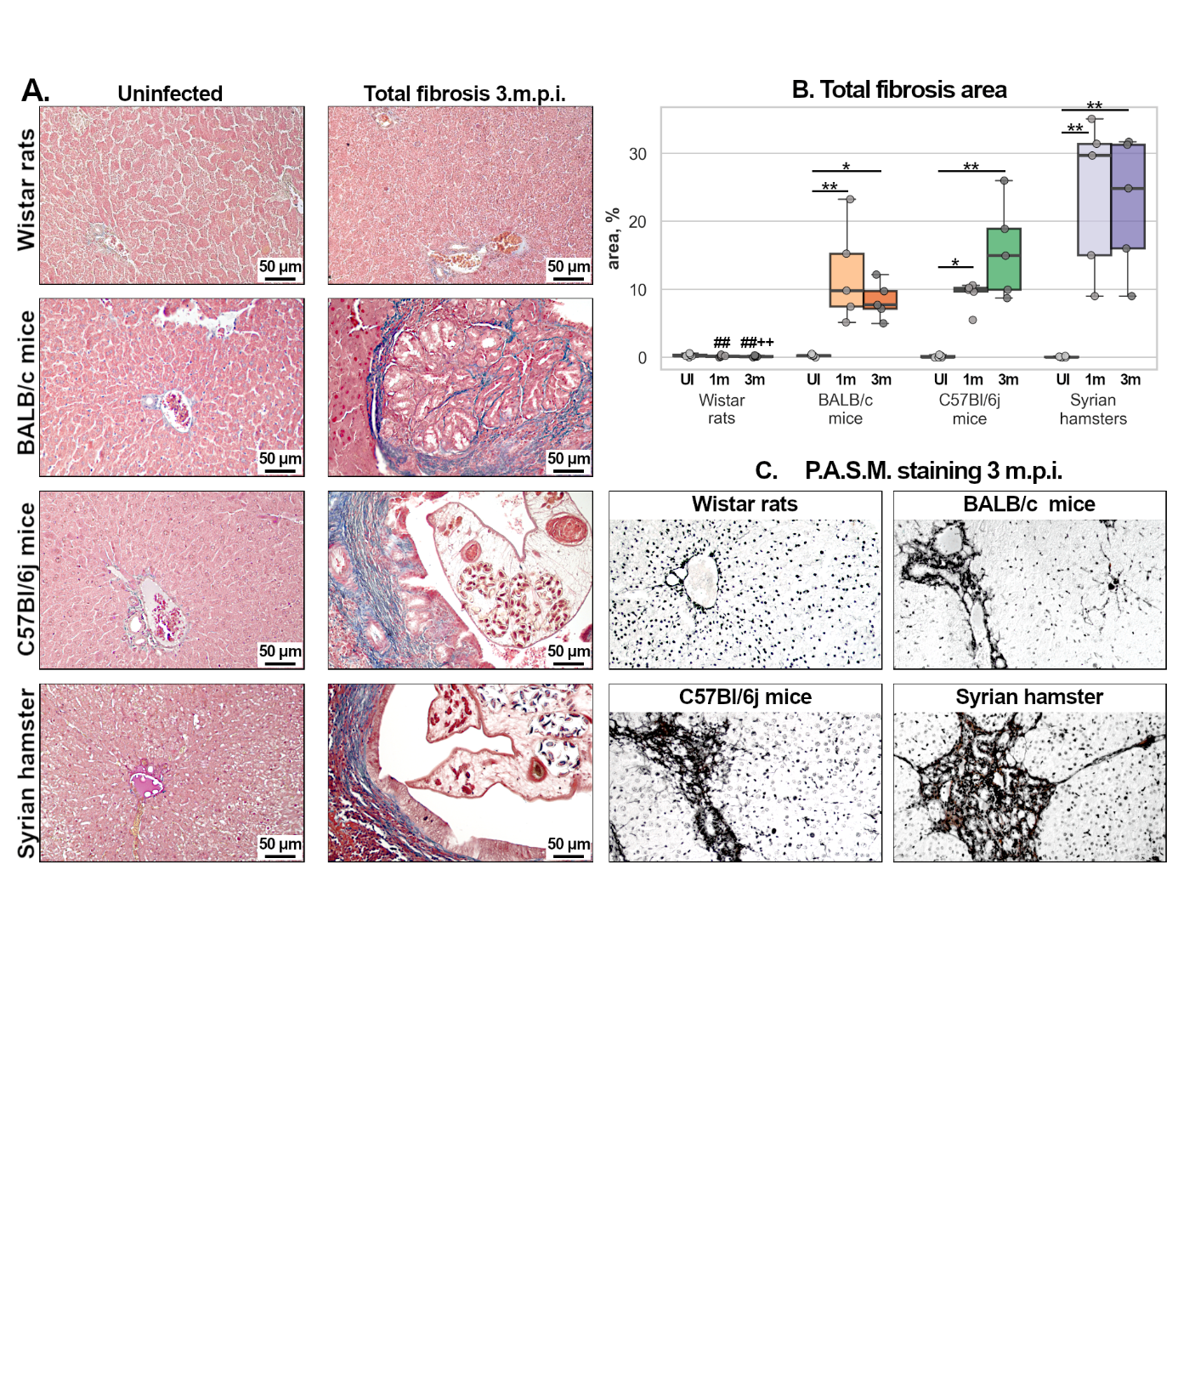
Figure 4. Fibrosis representation while O. felineus infection among different experimental animals. *P<0.05; **P<0.01 in the same animal group; $P<0.05 vs BALB/c mice of the same age; +P<0.05 vs C57Bl/6j mice of the same age; #P<0.05, ##P<0.01 vs Syrian hamster of the same age. A. Thickness of periductal fibrosis thickness; B Cholangiofibrosis area; C. Masson’s trichrome staining. Arrows point fibrosis; D. P.A.S.M-silver staining. Fibrosis reveals with black color.

O. viverrini shows a host-range pattern similar to that of O. felineus. M. auratus is a susceptible model, whereas BALB/c mice are relatively resistant (Tangkawattana et al., 2024; Srisai et al., 2024). Rats are refractory to O. viverrini infection, as they are to O. felineus (Boonmars et al., 2009). However, rat strains can be susceptible to C. sinensis infection. C. sinensis has been reported to infect Sprague-Dawley and Wistar rats, with biliary epithelial hyperplasia and periductal fibrosis development (Qian et al., 2024; Wang et al., 2009).
Differences in host susceptibility to trematode infections among mouse strains are not well established but possibly related to immune response (Tangkawattana et al., 2024; Srisai et al., 2024). BALB/c mice typically exhibit a more pronounced Th2 response, characterized by elevated IgE and IL-5 mediated eosinophil recruitment, which may protect against trematodes during early infection. In contrast, C57Bl/6j are characterized by stronger Th-1 response with relatively weaker anti-parasite activity, which may underlie their greater susceptibility to opisthorchiasis (Watanabe et al., 2004).
The results of this study are consistent with previous reports and indicate that M. auratus is the optimal model for studying opisthorchiasis. If a mouse model is essential for experiment, C57Bl/6j mice may be used, but with several important limitations. Even with a high infective dose, the number of established flukes was very low: we administered 100 metacercariae per animal but recovered no more than fifteen adult flukes. May be infection should be performed in series at several timepoints. Sexual maturation is another constraint; fecal egg counts in C57Bl/6j mice remained low at 3 m.p.i., suggesting that a longer interval between infection and tissue collection may be necessary to capture later stages of parasite development. If a study requires use of a mouse strain whose susceptibility to O. felineus is uncharacterized, an initial evaluation of infectivity is essential. Finally, Wistar rats were completely resistant to O. felineus infection and are therefore unsuitable for studies of this species.

