Article

From experimental infection to human disease: Assessing the pathological relevance of rodent models of opisthorchiasis
Yaroslav Kapushchak^{a,*}, Veronika Romanukovaª, Anna Kovnerª and Maria Pakharukova^{,b}
a Institute of Cytology and Genetics (ICG), Siberian Branch of Russian Academy of Sciences (SB RAS), 10 Ak. Lavrentiev Ave., Novosibirsk 630090, Russia
b Department of Natural Sciences, Novosibirsk State University, 2 Pirogova Str., Novosibirsk 630090, Russia
* Correspondence: yarikkaps@yandex.ru; Tel.: +79537742462 (Yaroslav Kapushchak)

Abstract
Translating experimental findings to human disease requires animal models that reproduce relevant pathological features. Syrian hamsters are widely used to study Opisthorchis felineus infection, but limited reagents and genetic resources encourage the use of alternative hosts. We compared susceptibility and hepatic pathology in Wistar rats, BALB/c mice, C57BL/6J mice, and Syrian hamsters. Animals received 100 metacercariae each and were examined at 1 and 3 months post-infection alongside uninfected controls. Assessments included fluke recovery, fecal egg counts, serum aminotransferase activities, and liver histology. Human autopsy liver material provided a qualitative comparison. Parasite recovery and egg counts were highest in hamsters and lower in mice; neither flukes nor eggs were detected in rats. Both ALT and AST activities increased in hamsters, whereas only AST increased in mice. Fibrosis, inflammatory infiltration, and epithelial hyperplasia were generally most pronounced in hamsters, and egg granulomas occurred only in this host. Fibrotic changes in hamsters more closely resembled those in the examined human material. Syrian hamsters were the most suitable of the hosts tested for reproducing the assessed disease features. C57BL/6J mice may provide an alternative, but limited parasite establishment and less pronounced hepatic pathology constrain their use.
Keywords: Opisthorchis felineus; opisthorchiasis; animal models; host susceptibility; hepatic fibrosis; Syrian hamster; face validity; translational research

1. Introduction
Understanding disease pathogenesis and developing effective strategies for disease control and treatment are major goals of biomedical research. Achieving these goals requires experimental models that reproduce key features of the disease under investigation. The suitability of a model for a specific research objective determines the validity of the conclusions drawn and their potential relevance to clinical practice.
The validity of an animal model is assessed using following criteria: phenotypic similarity to the human disease (face validity), similarity in the underlying mechanisms of disease (construct validity), and the ability to predict clinical responses to treatment (predictive validity) [1] These criteria represent distinct aspects of model validity and should be evaluated separately in relation to the objectives of the study.
Foodborne trematode infections are a global public health problem. Infection with fishborne trematodes occurs through the consumption of freshwater fish containing infective larvae, known as metacercariae [2]. Epidemiologically important foodborne trematodes include liver flukes of the Opisthorchiidae family and lung trematodes. These parasite infections impose a substantial disease burden, estimated to exceed 2 million disability-adjusted life years (DALYs) globally [2].
Experimental studies of liver fluke infections commonly use rodent models. Syrian hamsters (Mesocricetus auratus) are widely used to study opisthorchiasis [3], although the extent to which this model reproduces human disease remains a subject of debate. The use of other experimental hosts to study trematode infections also raises the question of whether alternative models could be suitable for opisthorchiasis research. For example, the pathogenesis of schistosomiasis is predominantly studied in mice [4, 5, 6, 7, 8], whereas experimental studies of Fasciola hepatica, another foodborne trematode, commonly use Sprague-Dawley rats and rabbits [9]. Infection with Clonorchis sinensis, which belongs to the family Opisthorchiidae as well as Opisthorchis felineus and Opisthorchis viverrini, has been studied in both Syrian hamsters [10] and Sprague-Dawley rats [11, 12].
Why do investigations of O. felineus infection predominantly conducted using Syrian hamster animal model? Several factors support that. Syrian hamsters and muskrats (Ondatra zibethicus), which serve as natural reservoir definitive hosts in Western Siberia, both belong to one family Cricetidae [13, 14]. Adult flukes recovered from experimentally infected hamsters are morphologically similar to those recovered from naturally infected foxes, cats, and other hosts [15]. Furthermore, the course of infection in Syrian hamsters resembles that in humans, and infected hamsters develop characteristic hepatic lesions associated with opisthorchiasis [16].
Despite these advantages, Syrian hamsters have several limitations as an experimental model. Compared with mice, the limited availability of species-specific reagents and genetic resources makes it more difficult to investigate the molecular and cellular mechanisms of pathogenesis. In particular, the limited availability of genetically modified strains restricts studies of the contributions of individual genes to disease development. Additional constraints include the limited range of validated antibodies and immunological assays, genetic tools, and fully annotated genomic resources. These limitations hinder immune cell characterization, signaling pathway analysis, and investigation of the links between molecular alterations and pathological changes.
The aim of this study was to assess whether mice and rats could serve as alternative experimental models of O. felineus infection. In current study, we evaluated their susceptibility to infection and the extent to which they developed hepatic changes characteristic of opisthorchiasis.

2. Materials and Methods

2.1. Collection of O. felineus Metacercariae and Experimental Design
O. felineus metacercariae were collected from naturally infected freshwater cyprinid fish caught in the Ob River. Metacercariae were isolated from muscle tissue by enzymatic digestion, as previously described [3]. Briefly, muscle tissue was incubated in a pepsin-HCl solution, followed by at least 10 washes with 0.9% NaCl. Viable metacercariae were identified under a light microscope and collected for subsequent use. Metacercariae were collected by trained personnel.
Wistar rats, BALB/c and C57Bl/6j mice, and Syrian hamsters were used as experimental models (Figure 1). Animals assigned to the infected groups were each administered 100 O. felineus metacercariae via an esophagogastric tube. For each experimental model, 15 animals were used: five infected animals were euthanized at 1 month post-infection (m.p.i.), five infected animals were euthanized at 3 m.p.i., and five animals remained uninfected and served as control group.
Animals were obtained from the conventional vivarium of the Institute of Cytology and Genetics. Experimental infections were performed in the vivarium under sterile conditions. Animals were housed individually. Infections were performed sequentially: mice were infected first, followed by hamsters and rats. Rats underwent a 2-week quarantine period before infection. Animals were euthanized using CO₂ in accordance with humane principles for the treatment of laboratory animals. Blood was collected by cardiac puncture immediately after euthanasia. The entire liver was removed and carefully dissected free of surrounding tissues. The experiment was approved by the Ethics Committee of the Institute of Cytology and Genetics (protocol extract No. 221) and was conducted in accordance with ARRIVE guidelines and GLP principles.
To assess the condition of the liver during O. felineus infection in humans, we evaluated autopsy material from an endemic area (Khanty-Mansiysk Autonomous Okrug, Russia). This study was performed in line with the principles of the Declaration of Helsinki. The Ethics Committee at the Institute of Molecular Biology and Biophysics SB RAS (Protocol #2/2016 of 27 October 2016) and the Medical Ethics Committee at the Clinical Hospital of the Khanty-Mansiysk (Protocol #5/2023 of 26 August 2023, written informed consent was obtained from the next of kins) approved the analysis of human liver.
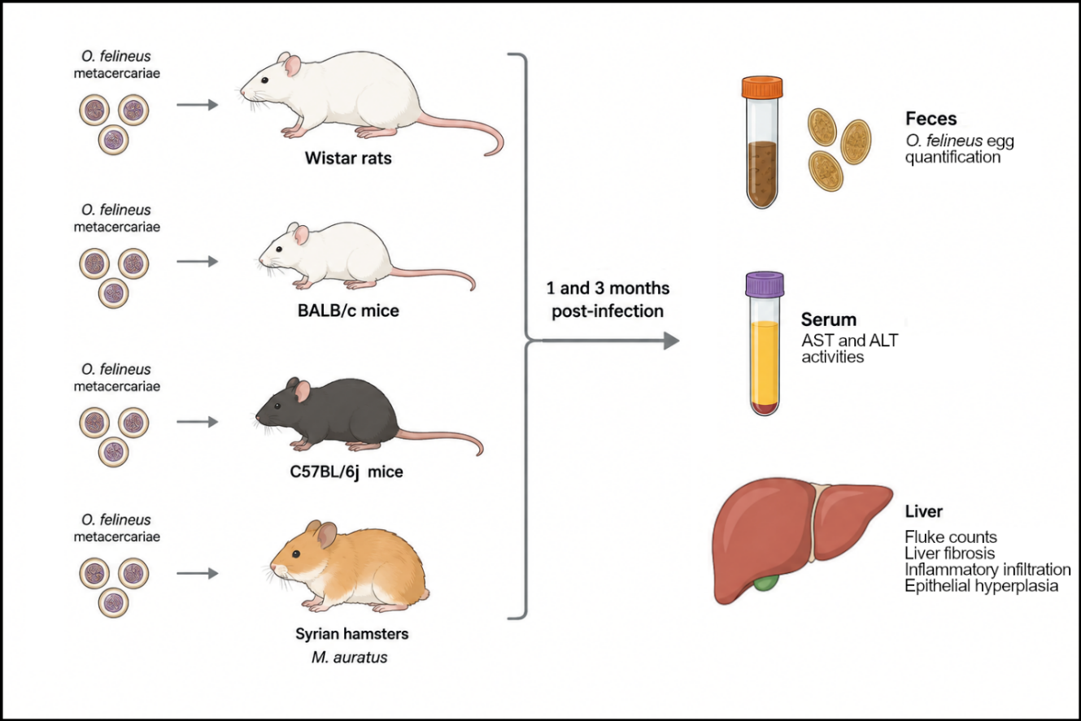
Figure 1. Design of experiment. Model animals (Wistar rats, BALB/c mice, C57Bl/6j mice and Syrian hamsters) were infected with 100 O. felineus metacercariae. After 1 and 3 m.p.i. feces were collected for evaluation of number of eggs, liver for histological examination and fluke counting and blood serum to measure AST and ALT activity.

2.2. Biochemical Analysis
Serum alanine aminotransferase (ALT) and aspartate aminotransferase (AST) activities were measured using commercially available, ready-to-use kits (Vector-Best, Russia) according to the manufacturer’s guidelines. Measurements were performed using an Eppendorf BioPhotometer Plus spectrophotometer (Eppendorf, Germany).

2.3. Histological Examination of Liver Tissue
Liver samples were fixed in a 10% formalin solution. The samples were dehydrated through a graded series of ethanol and xylene, and embedded in paraffin using a spin tissue processor (STP-120, Thermo Scientific, USA). Tissue blocks were prepared using an embedding station (EC-350, Thermo Scientific, USA). 5 μm sections were obtained using a Microm HM 355S microtome (Thermo Scientific, USA). Sections were stained with hematoxylin and eosin, PASM, and Masson’s trichrome using ready-to-use staining kits according to the manufacturers’ guidelines. To assess the histological changes 20 visual fields (magnification 200X) were used. In a closed test grid system with 100 squares, area of epithelial hyperplasia, inflammatory infiltration and fibrosis were measured. The calculation protocol has been previously described [17].

2.4. Assessment of Infection Intensity
The intensity of O. felineus infection was assessed at 1 and 3 m.p.i. by counting helminths recovered from the liver and quantifying helminth eggs in feces. Fecal samples were processed using a Mini Parasep 15 mL Intestinal Parasite Concentrator (Apacor, UK). Eggs were counted using a Lacopa light microscope equipped with a Lacopa PC3-HI20M camera. Three specimens were examined per animal. Egg counts were normalized as the number of eggs per gram of feces [18].

2.5. Statistical Analysis
Statistical analysis was performed using Python (version 3.13.5). Data preprocessing was carried out with the pandas package (version 2.3.1). The Shapiro-Wilk test (scipy package, version 1.16.0) was used to assess the normality of data distribution in each group. For multiple comparisons, the Kruskal-Wallis test (scipy package, version 1.16.0) was applied, followed by pairwise Wilcoxon tests (scikit_posthocs package, version 0.11.4) with Benjamini-Hochberg correction for p-value adjustment. Fisher’s exact test was used to calculate distinctions in egg granulomas number between groups (scipy package, version 1.16.0). Statistical significance was defined as P < 0.05. Data visualizations were generated using Matplotlib package (version 3.10.3) and Seaborn package (version 0.3.12).

3. Results

3.1. Intensity of O. felineus Infection in Different Experimental Animals
The median number of flukes recovered from Syrian hamsters was 25 per animal at 1 m.p.i. and 36 per animal at 3 m.p.i. (Figure 2A). In BALB/c mice no flukes were observed at 1 m.p.i.; from two C57Bl/6j mice one fluke was obtained each. However, the median number increased to 1 per animal at 3 m.p.i. in BALB/c mice and 7 per animal at 3 m.p.i. in C57Bl/6j mice. No flukes were recovered from the livers of Wistar rats at either time point.
Fecal egg counts were used to assess the intensity of infection and maturation of trematodes (Figure 2B). In Syrian hamsters, fecal egg counts were relatively low at 1 m.p.i. (median=130 eggs per gram) and increased by 3 m.p.i. (median=1250 eggs per gram) A similar pattern was observed in C57Bl/6j mice, although egg counts were much lower than those in Syrian hamsters. At 1 m.p.i. no eggs were found except one animal, however at 3 m.p.i. in four samples eggs were found (median=99). No eggs were detected in the feces of BALB/c mice at 1 m.p.i.; at 3 m.p.i., eggs were detected in only three animals (median=19). No eggs were detected in the feces of Wistar rats at either time point. At 3 m.p.i., the average fecal egg count per recovered fluke was 35.2 in Syrian hamsters, 5.4 in C57BL/6J mice, and 0.48 in BALB/c mice (Figure 2C).

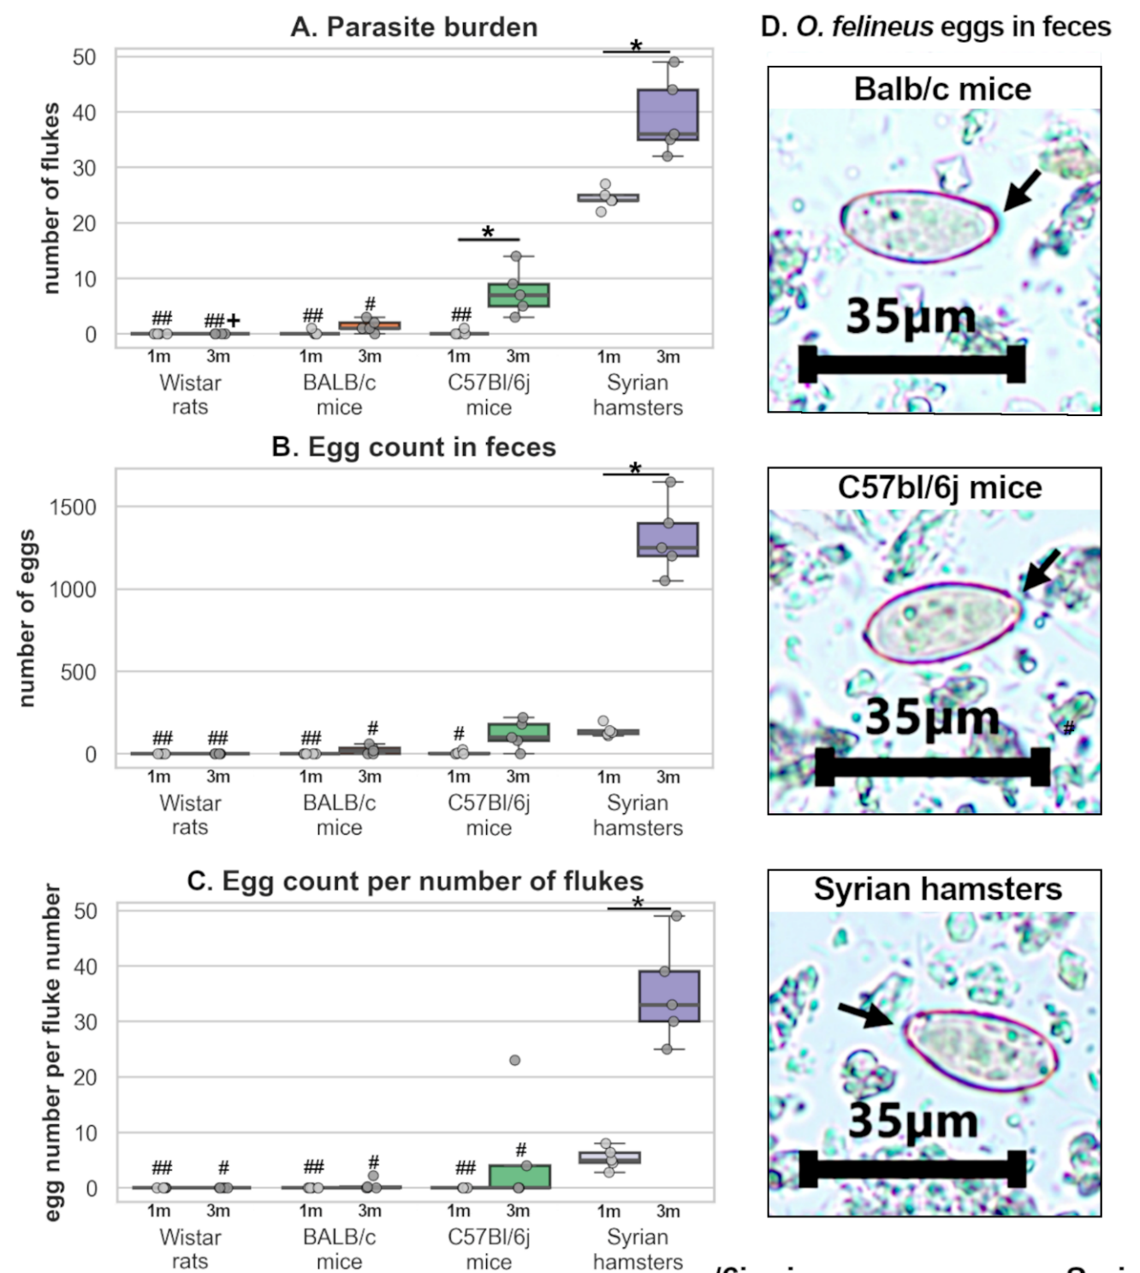
Figure 2. Estimation of parasite burden among experimental animals. A. Number of flukes, recovered from liver; B. Number of eggs, recovered from feces normalized to 1 gram; C. Number of eggs normalized to number of recovered flukes. D. Microscopic visualization of O. felineus eggs (magnification 400X). Arrows point operculum; *P<0.05 in the same animal group; +P<0.05 vs C57Bl/6j mice of the same age; #P<0.05, ##P<0.01 vs Syrian hamster of the same age.

3.2. Serum ALT and AST Activities
Serum ALT and AST activities were measured to assess liver injury in infected animals. In Syrian hamsters, the activities of both enzymes were elevated at 3 m.p.i. (ALT P=0.018; AST P=0.001) compared to uninfected control group. AST activity was elevated at both timepoints in C57Bl/6j (1 m.p.i. P=0.042, 3 m.p.i. P=0.005) and BALB/c mice (1 m.p.i. P=0.009, 3 m.p.i. P=0.029), whereas no increase in ALT activity was observed. No increase in either enzyme activity was detected in Wistar rats.

3.3. Morphological Changes in the Livers of Experimental Animals
Histological changes in the livers of the different experimental hosts are presented in Figure 3. Epithelial hyperplasia was most pronounced in Syrian hamsters (Figure 3A), with median values increasing from 6.8% at 1 m.p.i. (P=0.043 vs control group) to 8.4% at 3 m.p.i. (P=0.006 vs control group) Hyperplasia was less pronounced in mice. In BALB/c mice, the corresponding values were 4.1% (P=0.07 vs control group) and 5.6% (P=0.05 vs control group), respectively, whereas in C57Bl/6j mice, they were 4.1% (P=0.05 vs control group) and 3.2% (P=0.004 vs control group), respectively.
Inflammatory infiltration was also most pronounced in Syrian hamsters (Figure 3B), with median values of 6.7% at 1 m.p.i. (P=0.05 vs control group) and 11.0% at 3 m.p.i. (P=0.004 vs control group). Inflammatory infiltration was less pronounced in mice. In BALB/c mice, the median values were 4.7% and 3.9% at 1 m.p.i. (P=0.024 vs control group) and 3 m.p.i. (P=0.011 vs control group), respectively; in C57Bl/6j mice, the corresponding values were 1.8% (P=0.013 vs control group) and 1.4% (P=0.013 vs control group). Neither inflammatory infiltration nor epithelial hyperplasia was detected in Wistar rats.
Egg granulomas were observed only in the livers of Syrian hamsters; none were detected in mice or rats (Fisher’s exact test: P < 0.001).
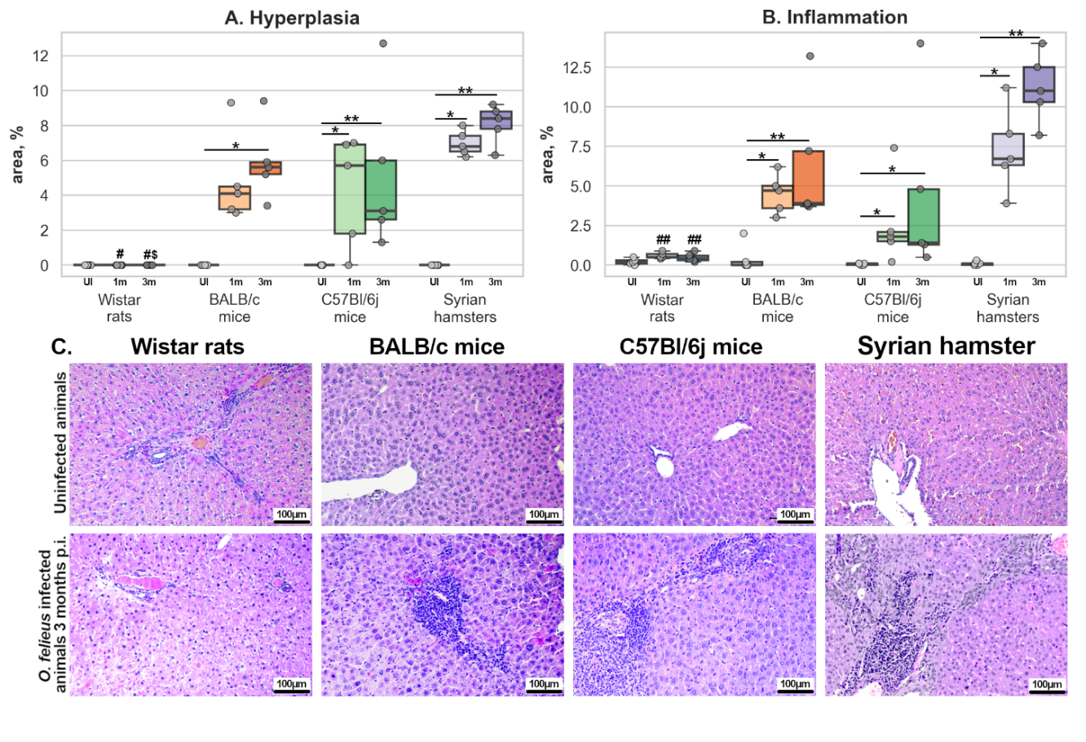
Figure 3. Histological manifestations of O. felineus infection among different experimental animals. A. Boxplots represent level of biliary epithelial hyperplasia; B. Boxplots represent level of inflammatory infiltration C. H&E staining of liver tissue (magnification 200X). *P<0.05; **P<0.01 in the same animal group; $P<0.05 vs BALB/c mice of the same age; #P<0.05; ##P<0.01 vs Syrian hamster of the same age.

Masson’s trichrome staining was used to assess liver fibrosis (Figure 4A, B). Fibrosis was detected in all experimental host groups except Wistar rats. In BALB/c mice, the median fibrosis values were 9.8% at 1 m.p.i. (P = 0.029 versus uninfected controls) and 7.7% at 3 m.p.i. (P = 0.029 versus uninfected controls). In C57Bl/6j mice, the median values were 9.9% at 1 m.p.i. (P = 0.042 versus uninfected controls) and 14.9% at 3 m.p.i. (P = 0.05 versus uninfected controls; P = 0.012 versus Wistar rats at 3 m.p.i.).
Liver fibrosis was most pronounced in Syrian hamsters at both time points. The median fibrosis value was 29.7% at 1 m.p.i. (P = 0.014 versus uninfected controls; P = 0.003 versus Wistar rats at 1 m.p.i.) and 24.8% at 3 m.p.i. (P = 0.014 versus uninfected controls; P = 0.003 versus Wistar rats at 3 m.p.i.)
PASM silver staining was performed as a complementary assessment to Masson’s trichrome staining (Figure 4C). The strongest silver staining was observed in Syrian hamsters and C57Bl/6j mice, whereas staining was less pronounced in BALB/c mice.
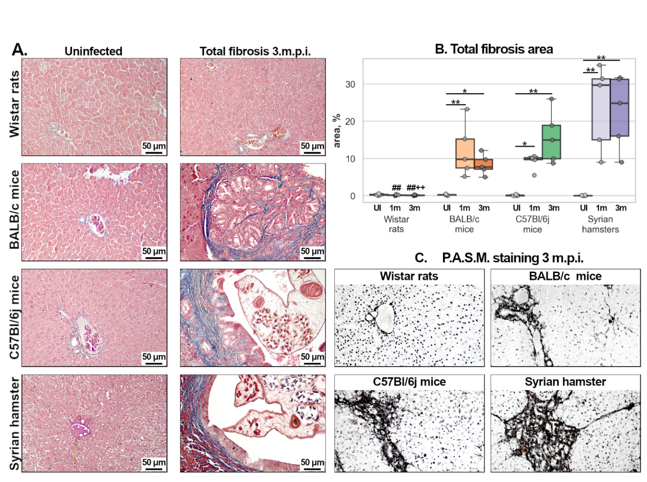
Figure 4. Liver fibrosis representation during O. felineus infection among different experimental animals. A. Masson’s trichrome staining of liver tissue (magnification 200X). B. Boxplots represent total fibrosis area; C. P.A.S.M-silver staining of liver tissue (magnification 200X). Fibrosis reveals with black color. *P<0.05; **P<0.01 in the same animal group vs uninfected animals; +P<0.05 vs C57Bl/6j mice of the same age; #P<0.05, ##P<0.01 vs Syrian hamster of the same age.

3.4. Whole-Slide Imaging of Liver Tissue
Whole-slide images of liver tissue from all experimental animal groups at 3 m.p.i. and a sample from human were examined (Figure 5). Slides with average level of fibrosis among group were chosen. In Wistar rat liver fibrosis area was relatively neglectable comparing to other species. BALB/c and C57Bl/6j mice have more pronounced fibrosis, however only in periductal area. In Syrian hamster fibrosis was most pronounced covering third part of the slide. In human sample level of fibrosis was similar to those in Syrian hamster with large amount of connective tissue in periductal area and small fibrosis foci in liver parenchyma. Histological findings in Syrian hamsters were consistent with a chronic stage of infection.
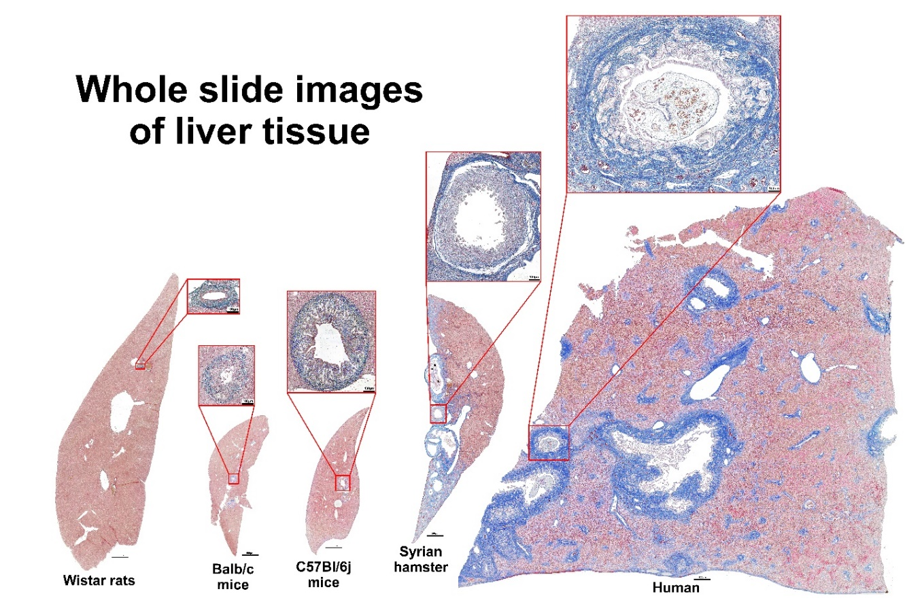
Figure 5. Whole slide images of liver tissue. Slides were stained with Masson’s trichrome staining. Blue color represents liver fibrosis (magnification 100X). In red frames bile duct presented (magnification 200X)

4. Discussion
Selecting an appropriate animal model is essential for interpreting experimental findings and assessing their relevance to humans. Although animal models are widely used to investigate disease, they have several limitations. An appropriate model should reproduce the phenotypic features of the human disease (face validity) and the mechanisms underlying its development (construct validity). For studies aimed at developing therapeutic approaches, the model should also predict treatment responses in humans (predictive validity) [1]. In infectious disease research, susceptibility to the pathogen is essential for model selection.
The history of drug development illustrates the limitations of translating findings from animal models to humans. Many anticancer drugs that were effective in animal models have failed to demonstrate comparable efficacy in patients [19]. One example is the development of matrix metalloproteinase inhibitors. Matrix metalloproteinases contribute to extracellular matrix remodeling and tumor invasion, making them potential therapeutic targets. Marimastat, a widely studied matrix metalloproteinase inhibitor, showed promising effects in preclinical studies [20, 21]. However, clinical studies did not demonstrate a favorable therapeutic effect and reported adverse effects, including severe joint pain [22]. Another example is the inhibition of Hedgehog signaling, a pathway involved in embryonic development, cell differentiation, and tissue regeneration that can also contribute to tumor progression. Saridegib (IPI-926), an inhibitor of the Hedgehog pathway component SMO, produced promising results in animal models but did not demonstrate comparable effect in the clinical trials [19].
The development of statins provides a contrasting example. Clinical trials of lovastatin, an early cholesterol-lowering drug, were temporarily stopped because animal studies raised concerns about its safety. Subsequent treatment of a small group of patients with hereditary hypercholesterolemia who had not responded adequately to other therapies demonstrated lowering in cholesterol with relatively few adverse effects. These findings supported further use of lovastatin on humans and development of other statins for the treatment of hypercholesterolemia [23].
Alternatives to animal models include cell culture systems, which are widely used to investigate the effects of treatments on specific cell types. These systems are particularly useful for examining mechanisms of cytotoxicity and cell proliferation [24]. For example, Opisthorchis felineus excretory-secretory products were shown to stimulate proliferation in immortalized human cholangiocytes through EGFR signaling pathway [25]. Cell cultures are also used to produce viral particles for vaccine development [26].
Nevertheless, cell culture systems have important limitations. Although they allow detailed investigation of individual cell types, reproducing the responses of tissues containing multiple interacting cell populations is challenging. Conventional 2D monolayer cultures do not fully reproduce tissue architecture. 3D approaches, including organoids [27, 28] and scaffold-based cultures [29], can more closely reproduce aspects of tissue physiology but require specialized resources and expertise. Even advanced culture systems cannot fully reproduce interactions at the whole-organism level.
Given these limitations, animal models remain necessary for numerous research questions. Selecting an appropriate host is particularly important when investigating infections such as opisthorchiasis and attempting to extrapolate the findings to humans. Partially or completely resistant hosts may fail to reproduce key aspects of disease pathogenesis, potentially leading to conclusions with limited relevance to human infection [30].
These challenges are particularly relevant to O. felineus research, for which Syrian hamsters are the principal experimental animal. Although this model is widely used, methodological limitations can hinder investigations of the effects of infection on different organ systems. For example, studies examining possible neurological effects of O. felineus infection require methods for assessing neurological function. Many such methods have been developed for mice and rats but are less well adapted to Syrian hamsters. Similarly, commercially available reagents, including antibodies, may be validated in mice and rats but poorly characterized in hamsters. Although some methods can be adapted, these modifications may limit comparisons with published data.
Another advantage of mice and rats is the availability of transgenic and knockout strains for investigating individual diseases and comorbid conditions [31]. COVID-19 disease pushed hamster modeling to the forefront due to its advantages over mice in recapitulating human pathology and transmission [32]. Nevertheless, mice and rats remain widely used to investigate disease mechanisms. These considerations highlight the importance of determining whether they can provide suitable alternatives to Syrian hamsters in opisthorchiasis research.
In this study, we primarily evaluated the face validity of O. felineus infection in several commonly used laboratory hosts: Wistar rats, BALB/c mice, C57Bl/6j, and Syrian hamsters.
We first assessed host susceptibility to infection. In Syrian hamsters, fecal egg counts were higher at 3 m.p.i. than at 1 m.p.i., indicating parasite maturation. A similar temporal pattern was observed in C57Bl/6j and BALB/c mice, although fecal egg counts were lower. Egg granulomas were detected in hamster livers but not in mouse or rat livers. Together, these findings indicate that parasite establishment and egg output were more limited in mice than in hamsters.
The number of flukes recovered from the liver was also highest in Syrian hamsters. BALB/c and C57Bl/6j mice were significantly less susceptible, whereas no flukes were recovered from Wistar rats.
A similar pattern of host susceptibility has been reported for O. viverrini. Syrian hamsters are susceptible to infection, whereas BALB/c mice are relatively resistant [30, 33]. Resistance to O. viverrini infection has also been reported in rats [34]. By contrast, Clonorchis sinensis can infect Sprague-Dawley and Wistar rats, with the development of biliary epithelial hyperplasia and periductal fibrosis [35, 36]. These differences emphasize the need to evaluate host suitability for each parasite species rather than assume that susceptibility to one liver fluke predicts susceptibility to another.
The mechanisms underlying differences in susceptibility to trematode infection between mouse strains remain poorly understood but may involve differences in immune responses [30, 33]. BALB/c mice typically exhibit stronger Th2-associated responses, including IgE production and IL-5-mediated eosinophil recruitment, which may contribute to protection during early period of infection. In contrast, C57Bl/6j mice tend to exhibit stronger Th1-associated responses, which may contribute to their higher susceptibility to opisthorchiasis [37]. However, immune mechanisms were not examined in the present study, and their contribution to the observed differences remains to be established.
Liver fibrosis [38, 39], biliary neoplasia, and inflammation as well as formation of egg granulomas [39] have been described in human opisthorchiasis. Elevated serum ALT and AST activities have also been reported in infected patients [39].
In the present study, both enzyme activities were elevated in Syrian hamsters at 3 m.p.i., whereas mice showed increased AST activity without an increase in ALT. The characteristic morphological changes associated with infection, including inflammatory infiltration, fibrosis, and epithelial hyperplasia, were most pronounced in Syrian hamsters. These findings resembled the changes described in humans with chronic opisthorchiasis. Both mouse strains developed hepatic changes, although these were generally less pronounced than those observed in hamsters. Egg granulomas were observed only in hamsters but not in mice.
Overall, Syrian hamsters reproduced a broader range of the disease features considered here, whereas mice generally exhibited less pronounced fibrosis and inflammation and did not develop egg granulomas (Table 1). These findings support the face validity of the hamster model for the features assessed in this study.

Table 1. Characteristic features of O. felineus infection among rodent models and humans
Species  Feature | Wistar  rats | Balb/c  mice | C57Bl/6j mice | Syrian hamsters | Humans
Eggs  in feces | – | – | + | +++ | +++
Parasite burden | – | + | ++ | +++ | +++
Egg granulomas | – | – | – | +++ | +++
Liver  fibrosis | – | + | ++ | +++ | +++
Liver inflammation | – | ++ | + | +++ | +++
Liver epithelial hyperplasia | – | ++ | ++ | ++ | +++
AST | – | + | + | + | ++
ALT | – | – | – | ++ | +++

Assessing the construct validity of the Syrian hamster model was beyond the scope of this study, although previous research has addressed aspects of this question. A major challenge is the limited availability of human biological material. Liver biopsy is invasive, carries a risk of complications, and is not routinely required to diagnose opisthorchiasis. Postmortem material provides an alternative, but access may be limited, and coexisting diseases can complicate interpretation of infection-associated changes. Nevertheless, published studies suggest that some pathogenic mechanisms are shared between humans and hamsters. Activation of Jagged-1/Notch pathway [40, 41] and activation of neoangiogenesis [42] was described both for hamsters and for humans. In Syrian hamsters, biliary neoplasia has been associated with reactive oxygen species-mediated DNA damage, chronic inflammation, and mechanical injury to the epithelium [3]. Similar mechanisms have been proposed for human disease [43].
Evidence relevant to predictive validity is also available. Praziquantel, which is used to treat human opisthorchiasis, has demonstrated efficacy against O. felineus infection in Syrian hamsters [44]. This finding supports the model’s relevance to treatment research, although its ability to predict responses to other interventions requires further evaluation.

5. Conclusions
Overall, our results support Syrian hamsters as the most suitable of the hosts tested for reproducing the features of O. felineus infection assessed here. When a mouse model is required, C57Bl/6j mice may provide an alternative, but several limitations should be considered. Parasite recovery was low despite an infestation of 100 metacercariae per animal, with no more than 15 flukes recovered from any individual animal. Fecal egg counts also remained low at 3 m.p.i. Longer follow-up may help determine whether parasite establishment and reproductive output change at later stages of infection. If a mouse strain with uncharacterized susceptibility is to be used, preliminary assessment of its ability to support infection is essential. Finally, no evidence of established infection was detected in Wistar rats at either time point, indicating that this model was unsuitable for the present experimental protocol.

Author Contributions: [TO BE COMPLETED BY THE AUTHORS: provide each author’s CRediT roles and confirm approval of the manuscript.]
Funding: [TO BE COMPLETED BY THE AUTHORS: provide funding agency and grant number, or confirm that no external funding was received.]
Institutional Review Board Statement: The animal experiment was approved by the Ethics Committee of the Institute of Cytology and Genetics (protocol extract No. 221; approval date to be supplied). Analysis of human autopsy liver material was approved by the Ethics Committee of the Institute of Molecular Biology and Biophysics SB RAS (Protocol No. 2/2016, 27 October 2016) and the Medical Ethics Committee of the Clinical Hospital of Khanty-Mansiysk (Protocol No. 5/2023, 26 August 2023). The human study was conducted in accordance with the Declaration of Helsinki.
Informed Consent Statement: Written informed consent for the analysis of human autopsy material was obtained from the next of kin, as reported in the Materials and Methods. [AUTHORS: confirm the precise scope of consent and whether consent for publication is applicable.]
Data Availability Statement: [TO BE COMPLETED BY THE AUTHORS: specify where the underlying data and analysis code can be accessed, or explain applicable restrictions.]
Acknowledgments: [TO BE COMPLETED OR REMOVED BY THE AUTHORS. Confirm acknowledgment of any AI-assisted text or figure generation, where applicable; identify the tool and purpose and confirm author review and responsibility.]
Conflicts of Interest: [TO BE COMPLETED BY THE AUTHORS: declare any conflicts or explicitly confirm that none exist.]

References
1. Belzung, C.; Lemoine, M.. Criteria of validity for animal models of psychiatric disorders: focus on anxiety disorders and depression. Biol Mood Anxiety Disord. 2011, 1, 9. doi: 10.1186/2045-5380-1-9.
2. World Health Organization. WHO estimates of the global burden of foodborne diseases: foodborne disease burden epidemiology reference group 2007–2015. Geneva: World Health Organization; 2015. Available from: https://www.who.int/publications/i/item/9789241565165.
3. Pakharukova, M.Y.; Zaparina, O.G.; Kapushchak, Y.K.; Baginskaya, N.V.; Mordvinov, V.A.. Opisthorchis felineus infection provokes time-dependent accumulation of oxidative hepatobiliary lesions in the injured hamster liver. PLoS One. 2019, 14(5), e0216757. doi: 10.1371/journal.pone.0216757.
4. Mahmoud, M.; Allam, A.F.; Essawy, A.E.; Shalaby, T.I.; El-Sherif, S.S.. Therapeutic efficacy of praziquantel loaded-chitosan nanoparticles on juvenile Schistosoma mansoni worms in murine model. Exp Parasitol. 2024, 266, 108843. doi: 10.1016/j.exppara.2024.108843.
5. Liang, T.R.; Liu, C.Z.; Peng, S.Y.. Naringenin attenuates liver injury in Schistosoma mansoni-induced liver fibrosis and oxidative stress in mice model. PLoS Negl Trop Dis. 2025, 19(12), e0013825. doi: 10.1371/journal.pntd.0013825.
6. Agnew, A.M.; Lucas, S.B.; Doenhoff, M.J.. The host-parasite relationship of Schistosoma haematobium in CBA mice. Parasitology. 1988, 97(Pt 3), 403-24. doi: 10.1017/s0031182000058820.
7. Chala, B.; Choi, M.H.; Moon, K.C.; Kim, H.S.; Kwak, C.; Hong, S.T.. Development of Urinary Bladder Pre-Neoplasia by Schistosoma haematobium Eggs and Chemical Carcinogen in Mice. Korean J Parasitol. 2017, 55(1), 21-29. doi: 10.3347/kjp.2017.55.1.21.
8. Song, X.; Shen, J.; Wen, H.; Zhong, Z.; Luo, Q.; Chu, D.; et al. Impact of Schistosoma japonicum infection on collagen-induced arthritis in DBA/1 mice: a murine model of human rheumatoid arthritis. PLoS One. 2011, 6(8), e23453. doi: 10.1371/journal.pone.0023453.
9. Fang, W.; Yang, J.; Wang, H.Y.; Chen, S.R.; Li, K.R.; Liu, Y.H.; et al. Exploration of animal models to study the life cycle of Fasciola hepatica. Parasitology. 2022, 149(10), 1349-1355. doi: 10.1017/S0031182022000609.
10. Woo, H.; Han, J.K.; Kim, J.H.; Hong, S.T.; Uddin, M.H.; Jang, J.J.. In-vivo monitoring of development of cholangiocarcinoma induced with C. sinensis and N-nitrosodimethylamine in Syrian golen hamsters using ultrasonography and magnetic resonance imaging: a preliminary study. Eur Radiol. 2017, 27(4), 1740-1747. doi: 10.1007/s00330-016-4510-4.
11. Qi, Y.; Hu, J.; Liang, J.; Hu, X.; Ma, N.; Xiang, B.. Clonorchis sinensis infection contributes to hepatocellular carcinoma progression in rat. Parasitol Res. 2022, 121(12), 3403-3415. doi: 10.1007/s00436-022-07699-x.
12. Li, S.; Jiang, Y.; Kawanokuchi, J.; Deng, X.; Wu, Y.; Chen, Y.; et al. Exploratory study on the role of Clonorchis sinensis infection in promoting cholangiocarcinoma progression. Parasit Vectors. 2025, 19(1), 29. doi: 10.1186/s13071-025-07183-2.
13. Pakharukova, M.Y.; Mordvinov, V.A.. The liver fluke Opisthorchis felineus: biology, epidemiology and carcinogenic potential. Trans R Soc Trop Med Hyg. 2016, 110(1), 28-36. doi: 10.1093/trstmh/trv085.
14. Schuster, R.K.; Specht, P.; Rieger, S.. On the Helminth Fauna of the Muskrat (Ondatra zibethicus (Linnaeus, 1766)) in the Barnim District of Brandenburg State/Germany. Animals. 2021, 11(8), 2444. doi: 10.3390/ani11082444.
15. Beer, S.A.. The Biology of the Opisthorchiasis Agent. Moscow: KMK Scientific Press; 2005. Russian.
16. Lvova, M.N.; Tangkawattana, S.; Balthaisong, S.; Katokhin, A.V.; Mordvinov, V.A.; Sripa, B.. Comparative histopathology of Opisthorchis felineus and Opisthorchis viverrini in a hamster model: An implication of high pathogenicity of the European liver fluke. Parasitol Int. 2012, 61(1), 167–172. doi: 10.1016/j.parint.2011.08.005.
17. Pakharukova, M.Y.; Zaparina, O.G.; Kovner, A.V.; Mordvinov, V.A.. Inhibition of Opisthorchis felineus glutathione-dependent prostaglandin synthase by resveratrol correlates with attenuation of cholangiocyte neoplasia in a hamster model of opisthorchiasis. Int J Parasitol. 2019, 49(12), 963-973. doi: 10.1016/j.ijpara.2019.07.002.
18. Katz, N.; Chaves, A.; Pellegrino, J.. A simple device for quantitative stool thick-smear technique in Schistosomiasis mansoni. Rev Inst Med Trop Sao Paulo. 1972, 14(6), 397-400.
19. Mak, I.W.; Evaniew, N.; Ghert, M.. Lost in translation: animal models and clinical trials in cancer treatment. Am J Transl Res. 2014, 6(2), 114-8.
20. Maekawa, K.; Sato, H.; Furukawa, M.; Yoshizaki, T.. Inhibition of cervical lymph node metastasis by marimastat (BB-2516) in an orthotopic oral squamous cell carcinoma implantation model. Clin Exp Metastasis. 2002, 19(6), 513-8. doi: 10.1023/a:1020329411957.
21. Skipper, J.B.; McNally, L.R.; Rosenthal, E.L.; Wang, W.; Buchsbaum, D.J.. In vivo efficacy of marimastat and chemoradiation in head and neck cancer xenografts. ORL J Otorhinolaryngol Relat Spec. 2009, 71(1), 1-5. doi: 10.1159/000163217.
22. Sparano, J.A.; Bernardo, P.; Stephenson, P.; Gradishar, W.J.; Ingle, J.N.; Zucker, S.; et al. Randomized phase III trial of marimastat versus placebo in patients with metastatic breast cancer who have responding or stable disease after first-line chemotherapy: Eastern Cooperative Oncology Group trial E2196. J Clin Oncol. 2004, 22(23), 4683-90. doi: 10.1200/JCO.2004.08.054.
23. Hajar, R.. Statins: past and present. Heart Views. 2011, 12(3), 121-7. doi: 10.4103/1995-705X.95070.
24. Segeritz, C.P.; Vallier, L.. Cell Culture: Growing Cells as Model Systems In Vitro. Basic Science Methods for Clinical Researchers. 2017:151–72. doi: 10.1016/B978-0-12-803077-6.00009-6.
25. Ponomarev, D.; Zaparina, O.; Kovner, A.; Hadieva, E.; Persidskij, M.; Pakharukova, M.. The EGFR Signaling Pathway Is Involved in the Biliary Intraepithelial Neoplasia Associated with Liver Fluke Infection. Pathogens. 2025, 14(7), 620. doi: 10.3390/pathogens14070620.
26. Demirden, S.F.; Kimiz-Gebologlu, I.; Oncel, S.S.. Animal Cell Lines as Expression Platforms in Viral Vaccine Production: A Post Covid-19 Perspective. ACS Omega. 2024, 9(15), 16904-16926. doi: 10.1021/acsomega.3c10484.
27. Suarez-Martinez, E.; Suazo-Sanchez, I.; Celis-Romero, M.; Carnero, A.. 3D and organoid culture in research: physiology, hereditary genetic diseases and cancer. Cell Biosci. 2022, 12(1), 39. doi: 10.1186/s13578-022-00775-w.
28. Leisengang, S.. Pain research in a petri dish? Advantages and limitations of neuro-glial primary cell cultures from structures of the nociceptive system. Brain Behav Immun Health. 2024, 41, 100854. doi: 10.1016/j.bbih.2024.100854.
29. Abuwatfa, W.H.; Pitt, W.G.; Husseini, G.A.. Scaffold-based 3D cell culture models in cancer research. J Biomed Sci. 2024, 31(1), 7. doi: 10.1186/s12929-024-00994-y.
30. Tangkawattana, S.; Suyapoh, W.; Thongrin, T.; Wendo, W.D.; Salao, K.; Suttiprapa, S.; et al. Inflammatory Responses to Opisthorchis viverrini Infection in Animal Models: A comparison between susceptible and non-susceptible hosts in different anatomical locations. Open Vet J. 2024, 14(2), 664–673. doi: 10.5455/OVJ.2024.v14.i2.6.
31. Wong, S.K.; Chin, K.Y.; Suhaimi, F.H.; Fairus, A.; Ima-Nirwana, S.. Animal models of metabolic syndrome: a review. Nutr Metab (Lond). 2016, 13, 65. doi: 10.1186/s12986-016-0123-9.
32. Reyna, R.A.; Walker, J.; Viveros, A.; Mitchell, B.; Dulaney, E.; Shinde, D.P.; et al. Optimization of a panel of behavioral tests for use in containment using a golden Syrian hamster model. J Virol Methods. 2025, 335, 115132. doi: 10.1016/j.jviromet.2025.115132.
33. Srisai, P.; Chaiyadet, S.; Jumnainsong, A.; Suttiprapa, S.; Leelayuwat, C.; Saichua, P.. T helper cell responses to Opisthorchis viverrini infection associate with host susceptibility. Parasitol Res. 2024, 123(2), 135. doi: 10.1007/s00436-024-08154-9.
34. Boonmars, T.; Boonjaraspinyo, S.; Kaewsamut, B.. Animal models for Opisthorchis viverrini infection. Parasitol Res. 2009, 104(3), 701–703. doi: 10.1007/s00436-008-1268-x.
35. Qian, M.B.; Keiser, J.; Utzinger, J.; Zhou, X.N.. Clonorchiasis and opisthorchiasis: epidemiology, transmission, clinical features, morbidity, diagnosis, treatment, and control. Clin Microbiol Rev. 2024, 37(1), e0000923. doi: 10.1128/cmr.00009-23.
36. Wang, X.; Liang, C.; Chen, W.; Fan, Y.; Hu, X.; Xu, J.; et al. Experimental model in rats for study on transmission dynamics and evaluation of Clonorchis sinensis infection immunologically, morphologically, and pathologically. Parasitol Res. 2009, 106(1), 15–21. doi: 10.1007/s00436-009-1622-7.
37. Watanabe, H.; Numata, K.; Ito, T.; Takagi, K.; Matsukawa, A.. Innate immune response in Th1- and Th2-dominant mouse strains. Shock. 2004, 22(5), 460–466. doi: 10.1097/01.shk.0000142249.08135.e9.
38. Kovner, A.V.; Pakharukova, M.Y.; Maksimova, G.A.; Mordvinov, V.A.. Characteristics of liver fibrosis associated with chronic Opisthorchis felineus infection in Syrian hamsters and humans. Exp Mol Pathol. 2019, 110, 104274. doi: 10.1016/j.yexmp.2019.104274.
39. Yablokov DD (1984) Opisthorchiasis in Man. Tomsk, Russia: Tomsk University Press; (in Russian).
40. Kovner, A.; Zaparina, O.; Kapushchak, Y.; Minkova, G.; Mordvinov, V.; Pakharukova, M.. Jagged-1/Notch Pathway and Key Transient Markers Involved in Biliary Fibrosis during Opisthorchis felineus Infection. Trop Med Infect Dis. 2022, 7(11), 364. doi: 10.3390/tropicalmed7110364.
41. Kovner, A.; Zaparina, O.; Kapushchak, Y.; Minkova, G.; Mordvinov, V.; Pakharukova, M.. Correction: Kovner et al. Jagged-1/Notch Pathway and Key Transient Markers Involved in Biliary Fibrosis during Opisthorchis felineus Infection. Trop. Med. Infect. Dis. 2022, 7, 364. Trop Med Infect Dis. 2025, 10(10), 298. doi: 10.3390/tropicalmed10100298.
42. Kovner, A.V.; Kapushchak, Y.K.; Zaparina, O.; Mordvinov, V.A.; Pakharukova, M.Y.. Hepatic vascular changes associated with Opisthorchis felineus infection in Syrian hamsters and humans. Acta Trop. 2024, 250, 107100. doi: 10.1016/j.actatropica.2023.107100.
43. Grigorieva, I.N.. Opisthorchiasis: tradition and innovation. Experimental & Clinical Gastroenterology. 2012;(4):54–59. Russian.
44. Pakharukova, M.Y.; Shilov, A.G.; Pirozhkova, D.S.; Katokhin, A.V.; Mordvinov, V.A.. The first comprehensive study of praziquantel effects in vivo and in vitro on European liver fluke Opisthorchis felineus (Trematoda). Int J Antimicrob Agents. 2015, 46(1), 94-100. doi: 10.1016/j.ijantimicag.2015.02.012.

