EXPLAINABLE AI FOR BUSINESS ANALYTICS: COMPARING MACHINE LEARNING MODELS AND AN RF–HGB HYBRID ENSEMBLE
A Mini Project Report Submitted in partial fulfillment of the requirements for the award of the degree of
BACHELOR OF TECHNOLOGY
In
DEPARTMENT OF COMPUTER SCIENCE AND ENGINEERING
By
Bongu Lakshmi Sai Prasanna – 2420030525 (Team Lead)
Allam Neha Reddy – 2420030508
Yarlagadda Divya Sri – 2420030529

Under the Esteemed Guidance of
K. Swapnika


K L (Deemed to be) University
DEPARTMENT OF COMPUTER SCIENCE AND ENGINEERING
DECLARATION
The mini-project report entitled “Explainable AI for Business Analytics: Comparing Machine Learning Models and an RF–HGB Hybrid Ensemble” is a record of bona fide work carried out by Bongu Lakshmi Sai Prasanna (2420030525), Allam Neha Reddy (2420030508), Yarlagadda Divya Sri (2420030529) in partial fulfillment of the requirements for the award of the B.Tech degree at K L (Deemed to be) University. The work presented in this report is original to the best of our knowledge, and all datasets, tools, code, and external sources used have been appropriately acknowledged.

Bongu Lakshmi Sai Prasanna – 2420030525
Allam Neha Reddy – 2420030508
Yarlagadda Divya Sri – 2420030529

K L (Deemed to be) University
DEPARTMENT OF COMPUTER SCIENCE AND ENGINEERING
CERTIFICATE
This is to certify that the mini-project report entitled “Explainable AI for Business Analytics: Comparing Machine Learning Models and an RF–HGB Hybrid Ensemble” is a bona fide work carried out by Bongu Lakshmi Sai Prasanna (2420030525), Allam Neha Reddy (2420030508), Yarlagadda Divya Sri (2420030529) under the supervision of
K.Swapnika during the academic year [2026-2027] in partial fulfillment of the requirements for the award of the Bachelor of Technology degree at K L (Deemed to be) University.

Signature of the Project Supervisor
Signature of the HOD | Signature of the External Examiner
ACKNOWLEDGEMENT
The success of this project would not have been possible without the timely help and guidance rendered by many people. We wish to express our sincere thanks to all those who have assisted us in one way or the other in the completion of our project.
Our greatest appreciation goes to our guide, K. Swapnika
Department of Computer Science and Engineering, whose tremendous support, encouragement and guidance for this project cannot be expressed in words.
We express our gratitude to Dr. P. Venkateshwar Sir, Head of the Department of Computer Science and Engineering, for providing us with adequate facilities, ways and means by which we were able to complete this project-based lab.
We thank all the members of the teaching and non-teaching staff who have assisted us directly or indirectly in the successful completion of this project. Finally, we sincerely thank our parents, friends and classmates for their kind help and cooperation during our work.

Bongu Lakshmi Sai Prasanna – 2420030525
Allam Neha Reddy – 2420030508
Yarlagadda Divya Sri – 2420030529
TABLE OF CONTENTS
S.No. | Contents | Page no.
1. | Abstract | 6
2. | Introduction | 7
3. | Literature Survey | 9
4. | Problem Statement and Objectives | 12
5. | Hardware and Software Requirements | 13
6. | Implementation | 14
7. | Results & Discussion | 16
8. | Conclusion & Future Scope | 19
9. | References | 20
1. ABSTRACT
Machine-learning models are widely used in business analytics, but complex models are hard to interpret, which reduces trust in their predictions. This project compares five classifiers, namely Logistic Regression, Decision Tree, Random Forest, XGBoost and HistGradientBoosting (HGB), together with a proposed hybrid that combines Random Forest and HGB through weighted soft voting and a tuned classification threshold, inside an Explainable AI (XAI) framework. Three public business datasets are used: the UCI Bank Marketing, Telco Customer Churn and UCI Online Retail datasets. Preprocessing covers cleaning, missing-value handling, duplicate removal, outlier treatment, encoding, scaling, feature engineering and feature selection, followed by a training, validation and test split. The ensemble weights and threshold were chosen on validation data by testing 867 weight–threshold configurations, keeping the test set untouched. Models are evaluated with accuracy, precision, recall, F1-score, ROC-AUC, confusion matrices and classification reports, and are explained using SHAP, LIME, PDP, ICE and permutation feature importance. On the Online Retail test set, the hybrid (weights 0.30 RF and 0.70 HGB, threshold 0.64) obtained accuracy 0.9277, precision 0.9319, recall 0.9938, F1-score 0.9618 and ROC-AUC 0.8184. Its F1-score is higher than HGB’s 0.9601, but its ROC-AUC is slightly lower than HGB’s 0.8235, so the gain applies to the F1 objective only. The work helps business users select ML–XAI combinations that balance predictive performance and interpretability.
Team Members and Responsibilities:
S.No. | Name | Roll No. | Role / Responsibility
1 | Bongu Lakshmi Sai Prasanna (Team Lead) | 2420030525 | XAI implementation, comparative analysis, visualization.
2 | Allam Neha Reddy | 2420030508 | dataset analysis, machine learning implementation.
3 | Yarlagadda Divya Sri | 2420030529 | evaluation and documentation.

Dataset / source and project repository:
- UCI Bank Marketing: https://doi.org/10.24432/C5K306
- Telco Customer Churn: https://www.kaggle.com/datasets/blastchar/telco-customer-churn
- UCI Online Retail: https://doi.org/10.24432/C5BW33
- Project repository: https://github.com/Lakshmi362/KLH-CSE-2026-27-2420030525-Explainable-AI-in-Business-Analytics
2. INTRODUCTION
2.1 Background
Business analytics works with large quantities of data to help organizations make informed decisions. Machine learning is now applied to customer churn, marketing response, customer behaviour and transaction analysis. These models detect patterns in historical data and produce predictions that support business decisions [7]–[9]. Examining such data manually is difficult at scale, because the number of records and the number of interacting factors quickly exceed what an analyst can inspect by hand.
Complex machine-learning models often give good predictive results, but their decision-making process is hard for business users to grasp. A user may see a prediction without knowing which factors influenced it. This lack of clarity reduces confidence in the model, harms transparency and interpretability, and can affect the quality of the decisions made from its output [18]–[20]. Explainable Artificial Intelligence (XAI) addresses this problem by offering methods that let users investigate how a model behaves and which features contributed to its predictions [10], [11], [19].
2.2 Target users, input and output
The target users are business analysts and decision makers in banking and marketing, telecom and e-commerce. The input to the system is a structured (tabular) customer or transaction record from one of the three datasets, and the predicted output is a binary class label, for example a repeat customer or not in the Online Retail case, together with an explanation of the features that drove the prediction.
2.3 Proposed pipeline
The proposed pipeline has five stages: (i) data collection, cleaning and preprocessing; (ii) baseline model development with Logistic Regression, Decision Tree, Random Forest, XGBoost and HistGradientBoosting; (iii) construction of a hybrid Random Forest–HistGradientBoosting (RF–HGB) ensemble whose weights and classification threshold are tuned on validation data; (iv) one-time evaluation on an independent test set; and (v) explanation of the chosen model using SHAP and LIME, with PDP, ICE and permutation feature importance as supporting tools.
2.4 Research questions
- RQ1: How do the five classifiers perform differently when predicting outcomes across business analytics datasets?
- RQ2: Which XAI techniques give the most helpful global and local explanations for the models studied?
- RQ3: How do explanation fidelity, sparsity, interpretability and computational efficiency change when different models are paired with different XAI methods?
- RQ4: Which combination of model and XAI approach gives the best trade-off between accurate predictions and understandable explanations?
2.5 Contributions
- A single framework for evaluating machine-learning models and XAI methods on standard business datasets.
- A validation-based procedure for choosing the ensemble weights and the decision threshold without touching the test data.
- A direct comparison of predictive performance and interpretability for each model.
- Global and local explanations of model behaviour using SHAP and LIME, with fidelity and sparsity as measures of explanation quality.
2.6 Organization of the report
Section 3 reviews related work. Section 4 states the problem and objectives. Section 5 lists the hardware and software requirements. Section 6 describes the implementation, covering data, preprocessing, models, validation strategy and metrics. Section 7 presents the results and discussion, including limitations. Section 8 gives the conclusion and future scope, and Section 9 lists the references.
3. LITERATURE SURVEY
Earlier work on machine learning emphasised how well a model predicts an outcome. Logistic Regression, Decision Trees and ensemble methods are widely used for classification and prediction. Simple models are easier to understand, while more complex models capture subtle patterns but are much harder to interpret [18]–[20]. This gap led to Explainable AI, a set of methods that show how a model reaches its conclusions and which inputs mattered most [10], [11], [19]. The studies below were consulted for this work.
Lundberg and Lee (2017), SHAP [10]. The authors address the inconsistency among existing feature-attribution methods and propose SHAP, which assigns each feature an importance value based on Shapley values from game theory. The framework unifies several earlier attribution methods and is demonstrated through computational comparisons and human-intuition experiments. SHAP explains single predictions and, when aggregated, global behaviour. Its main limitation is the computational cost of exact Shapley values, which is why approximations are used in practice.
Ribeiro, Singh and Guestrin (2016), LIME [11]. This paper proposes LIME, which explains an individual prediction of any classifier by fitting a simple interpretable model in the neighbourhood of that prediction. It was evaluated on text and image classifiers, including experiments with human users on trusting and choosing models. The method is model-agnostic and easy to apply. Its limitations are that explanations are local only and depend on how neighbourhood samples are drawn.
Rudin (2019) [18]. Rudin argues that for high-stakes decisions, inherently interpretable models should be used instead of post-hoc explanations of black boxes, because explanations can be unfaithful to the model they describe. The paper discusses the supposed accuracy–interpretability trade-off and challenges it. It is largely a position paper rather than an experimental comparison, and it focuses on high-stakes domains rather than business analytics.
Guidotti et al. (2018) [19]. This survey classifies methods for explaining black-box models into problems such as model explanation, outcome explanation, black-box inspection and transparent design. It organises the methods by the type of model and data they apply to. As a survey, it does not provide a new experimental comparison of explanation quality across methods and datasets.
Arrieta et al. (2020) [20]. The authors present concepts, taxonomies, opportunities and challenges of XAI in the context of responsible AI. They distinguish transparent models from post-hoc explanation techniques and discuss open issues. The work is conceptual and does not supply a unified quantitative benchmark for comparing explanation methods.
Lipton, Elkan and Narayanaswamy (2014) [21]. This paper studies how to choose the classification threshold that maximises the F1 measure and shows that the optimal threshold is related to the best achievable F1 value. It supports the use of a tuned threshold instead of the default 0.5. The result assumes reasonably calibrated probability scores, which is a limitation for models whose scores are not well calibrated.
Cawley and Talbot (2010) [26]. The authors show that tuning model settings on the same data used for performance estimation produces optimistic, biased results, and they recommend keeping model selection separate from final evaluation. This directly motivates keeping the test set untouched while tuning the weights and threshold. The limitation is the extra computation needed for strict separation, for example nested validation.
Recent comparative studies include Lazar et al. [28], who compare gradient boosting with tabular deep learning using SHAP and LIME on mixed-type tabular data, and Panthi et al. [29], who analyse the performance of SHAP and LIME for boosting models in phishing URL detection.
3.1 Critical comparison of XAI studies
Table 1. Comparison of representative studies on Explainable AI, with what each contributes and where it falls short.
# | Study / Publication | Key Contribution | Limitation
1 | Model-Agnostic Explainable Artificial Intelligence Methods in Finance: A Systematic Review (2025) | Reviews SHAP, LIME, PDP, counterfactuals and other model-agnostic XAI techniques. | Lacks extensive real-world validation of XAI methods on different financial datasets.
2 | A Comprehensive Review on Financial Explainable AI (2025) | Reviews XAI techniques, applications and challenges in financial decision-making. | Does not propose a unified framework for improving financial XAI.
3 | XAI: Survey of Needs, Techniques, Applications & Future Direction (2024) | Gives a broad overview of XAI methods, applications, requirements and future directions. | Lacks standardized metrics for evaluating explanation quality.
4 | XAI in Finance: A Systematic Literature Review (2024) | Reviews XAI applications in finance and the challenges in evaluating explanations. | Does not fully resolve the trade-off between accuracy and interpretability.
5 | A Comprehensive Taxonomy for Explainable Artificial Intelligence: A Systematic Survey of Surveys on Methods and Concepts (2023/24) | Gives a taxonomy for classifying XAI methods and concepts. | Lacks practical implementation and evaluation of the classified XAI methods.
6 | Interpreting Black-Box Models: A Review on XAI (2024) | Reviews black-box interpretation techniques and discusses their strengths and limitations. | Gives limited guidance on choosing the best explanation method for different applications.
7 | Transformative Impact of XAI: Bridging Complexity and Trust (2025) | Reviews model-specific, model-agnostic and hybrid XAI approaches and discusses accuracy–interpretability trade-offs. | Further practical validation is needed to show how XAI improves user trust in real-world systems.
8 | Review of Evaluation Approaches for XAI (2024) | Examines XAI evaluation approaches and finds little systematic evaluation. | No universally accepted framework exists for evaluating explanation quality.
9 | Privacy-Preserving XAI: A Survey (2024/25) | Reviews XAI methods while addressing privacy-related challenges. | Maintaining privacy while providing detailed and useful explanations remains challenging.
10 | User-Centered XAI Design Guidelines: Systematic Literature Review (2025) | Reviews factors affecting explanation usefulness, usability and user trust. | More empirical studies are required to validate user-centered XAI guidelines across domains.
3.2 Research gap
The existing research shows that XAI methods differ in purpose, in how they create explanations, in how those explanations are checked and in where they can be applied [10], [11], [19], [20]. Open problems include measuring whether explanations are good and consistent, how understandable they are, how much computing they need, and whether they actually help users [8], [10], [19]. Studies also report a trade-off between predictive power and interpretability for complex black-box models [13], [17]. Many past studies examine one model, one XAI method or one area of use instead of comparing several models across several business datasets [3]–[5], [19], [20]. Most also treat each model on its own rather than asking whether combining complementary tree-based models could improve predictions while keeping them explainable. This mini-project addresses the gap with a shared comparison framework and a validation-optimized RF–HGB hybrid ensemble explained with SHAP and LIME.
4. PROBLEM STATEMENT AND OBJECTIVES
Problem Statement
To identify which combination of machine-learning model and XAI technique gives accurate predictions together with understandable explanations on business analytics datasets, using a validation-optimized RF–HGB hybrid ensemble as the proposed model.
Problem Description
Machine-learning algorithms can produce accurate predictions, but those predictions do not always come with a clear reason. Business users such as analysts and decision makers need to know which factors drive a prediction before they act on it. Earlier work usually focuses on a single model, a single XAI method or a single use case, so prediction quality and explanation quality are rarely compared side by side [18]–[20]. A shared framework that tests several models and XAI methods across different business datasets is therefore needed.
Objectives
- Build machine-learning models that study and forecast outcomes on business datasets (UCI Bank Marketing, Telco Customer Churn and UCI Online Retail).
- Apply SHAP, LIME, PDP, ICE and Permutation Feature Importance to clarify what each model’s predictions mean.
- Compare the predictive performance of Logistic Regression, Decision Tree, Random Forest, XGBoost and HistGradientBoosting using accuracy, precision, recall, F1-score, ROC-AUC and confusion matrices.
- Compare the explainability of different ML–XAI pairings in terms of clarity, fidelity, sparsity and speed.
- Evaluate the proposed RF–HGB hybrid together with the XAI methods for prediction performance, explanation fidelity, interpretability and computational efficiency, and recommend ML–XAI combinations for business decision making.
5. HARDWARE AND SOFTWARE REQUIREMENTS
Hardware Requirements
- Computer/laptop with a modern multi-core CPU; 8 GB RAM or more recommended.
- Internet access for downloading datasets and packages; a GPU is optional because the models used are classical tree-based and linear models.
- Sufficient disk space for dataset files, notebooks, saved models and result figures.
Software Requirements
- Python 3.x with Jupyter Notebook or Google Colab.
- Libraries: Pandas, NumPy, Scikit-learn, XGBoost, SHAP, LIME, Matplotlib and Seaborn.
- Datasets in CSV format from open sources: UCI Machine Learning Repository (Bank Marketing, Online Retail) and the Telco Customer Churn dataset; the project uses open-source tools and publicly available datasets.
- Optional: Git for version control.
6. IMPLEMENTATION
6.1 Data and task
The task is binary classification on three structured business datasets. The UCI Bank Marketing dataset represents banking and marketing analytics [31]; the Telco Customer Churn dataset represents customer analytics and churn prediction [32]; and the UCI Online Retail dataset represents e-commerce and customer transaction analytics [30]. For Online Retail, the target class 1 corresponds to a repeat customer. The datasets are public and were obtained from the UCI Machine Learning Repository and the Telco source listed in Section 9. After preprocessing and feature engineering, each dataset is split into training, validation and test parts .The training part trains the models, the validation part tunes the hybrid’s weights and threshold, and the test part is used only for the final evaluation of the chosen model [25], [26].
6.2 Preprocessing and features
The data is structured rather than free text, so tokenization, stop-word removal and stemming do not apply. The following steps are part of the pipeline: data cleaning; missing-value handling; duplicate record removal; outlier detection and treatment; categorical encoding; feature scaling or normalization; feature engineering; feature selection; and train/validation/test splitting. Exploratory data analysis examines the dataset overview, summary statistics, missing values, duplicates and outliers, followed by univariate, bivariate, multivariate and correlation analysis. Heatmaps, boxplots, correlation matrices and feature-importance graphs are used to understand the data
6.3 Model training and evaluation
Five baseline models are trained first to set the reference performance: Logistic Regression (linear), Decision Tree (tree-based), Random Forest (bagging), and XGBoost and HistGradientBoosting (boosting) [1], [2], [7], [9]. Hyperparameters for each baseline are set for the specific classification task .To avoid data leakage, preprocessing is fitted on training data only, and the test set is not used for any tuning. The best model is selected by validation F1-score and then evaluated once on the test set.
A. Project workflow and modules
- Data loading and exploratory analysis: [filename.py / notebook]
- Data cleaning and preprocessing: [filename.py / notebook]
- Feature engineering, model training and hybrid tuning: [filename.py / notebook]
- Evaluation, plots, SHAP/LIME explanations and error analysis: [filename.py / notebook]
B. Machine-learning implementation
Baselines. Logistic Regression, Decision Tree, Random Forest, XGBoost and HistGradientBoosting (HGB) are compared using accuracy, precision, recall, F1-score and ROC-AUC.
Proposed hybrid. Random Forest supplies a set of decision trees that vote together, while HGB uses gradient boosting to capture non-linear patterns [3]–[5]. Instead of picking the prediction of one classifier, the model blends the probability scores of both. The hybrid probability is:
P_{Hybrid}(x) = w_{RF} · P_{RF}(x) + w_{HGB} · P_{HGB}(x)
where P_RF(x) and P_HGB(x) are the probabilities predicted by Random Forest and HGB, and the weights satisfy w_RF + w_HGB = 1 with both weights non-negative. The class is decided by a threshold T [21]:
ŷ = 1 if P_{Hybrid}(x) ≥ T; ŷ = 0 otherwise
Validation-based tuning. The weights and threshold are tuned on the validation set. A total of 867 weight–threshold configurations were evaluated, and the one with the highest validation F1-score was kept [21], [26]. The test set was not used during this search, and the chosen hybrid was run once on the independent test set. For Online Retail the best configuration is:
w_{RF} = 0.30, w_{HGB} = 0.70, T = 0.64
Explainability. SHAP shows how much each feature contributes to predictions [10]; LIME explains single predictions [11]; Partial Dependence Plots show how a predictor relates to model output [2]; ICE plots show instance-level behaviour [14]; and Permutation Feature Importance estimates importance from the drop in performance when a feature is shuffled [15], [16]. Explanations are assessed with two measures. Fidelity shows how closely an explanation follows the model’s behaviour, so higher is better. Sparsity counts how many features are needed to explain a prediction, so a smaller explanation is easier for a business user to read [10], [11], [19].
Evaluation metrics. Accuracy = (TP + TN) / (TP + TN + FP + FN); Precision = TP / (TP + FP); Recall = TP / (TP + FN); F1 = 2 × (Precision × Recall) / (Precision + Recall), where TP, TN, FP and FN are true positives, true negatives, false positives and false negatives [22]–[24]. ROC-AUC shows how well a model separates the two classes, the confusion matrix breaks down correct and incorrect predictions, and the classification report gives per-class metrics.
C. Demonstration / API
No separate web interface is described for this project; the workflow is run as a Python notebook/script pipeline, and predictions and explanations are produced as plots and tables.
7. RESULTS AND DISCUSSION
7.1 Overall performance and model comparison
The baseline models are compared with the proposed RF–HGB hybrid using accuracy, precision, recall, F1-score and ROC-AUC [18]–[20]. The measured results reported here are for the Online Retail test set
Table 2. Comparative performance of the models on the Online Retail test set.
Method | Accuracy | Precision | Recall | F1-score | ROC-AUC
Logistic Regression | 0.542724 | 0.933015 | 0.539655 | 0.683800 | 0.580572
Decision Tree | 0.593068 | 0.954958 | 0.583374 | 0.724288 | 0.694895
Random Forest | 0.665211 | 0.965428 | 0.658166 | 0.782723 | 0.775211
XGBoost | 0.920422 | 0.920161 | 0.999903 | 0.958376 | 0.742217
HistGradientBoosting | 0.923834 | 0.923478 | 0.999708 | 0.960082 | 0.823543
Proposed RF–HGB Hybrid | 0.927730 | 0.931873 | 0.993774 | 0.961829 | 0.818351

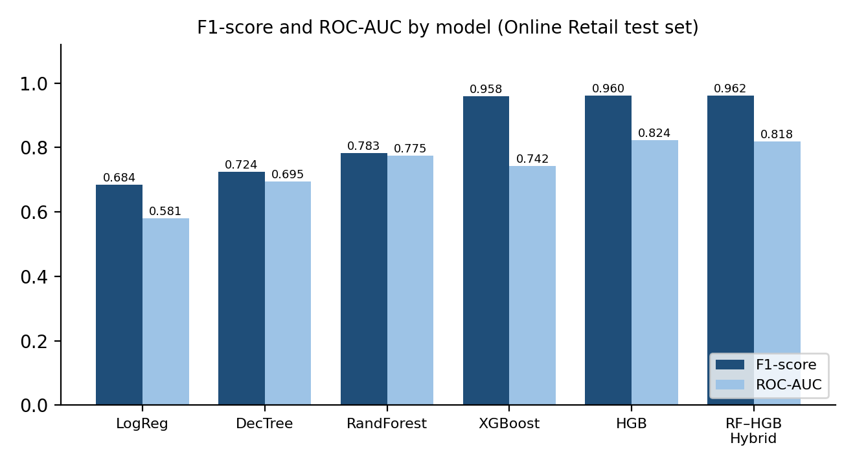
Figure 1. F1-score and ROC-AUC of each model on the Online Retail test set.
The hybrid obtains the highest F1-score among the reported models (0.961829), improving on HistGradientBoosting (0.960082). The two boosting models are far ahead of Logistic Regression, Decision Tree and Random Forest on F1. However, the hybrid’s ROC-AUC (0.818351) is slightly lower than that of HistGradientBoosting (0.823543). The hybrid should therefore be read as an improvement for the selected F1-based decision objective, not as a model that beats the baselines on every metric [22], [23].
7.2 Error and confusion analysis
The confusion matrix of the hybrid on the independent Online Retail test set is shown in Figure 2. It contains 1,352 true negatives, 5,228 false positives, 448 false negatives and 71,511 true positives.
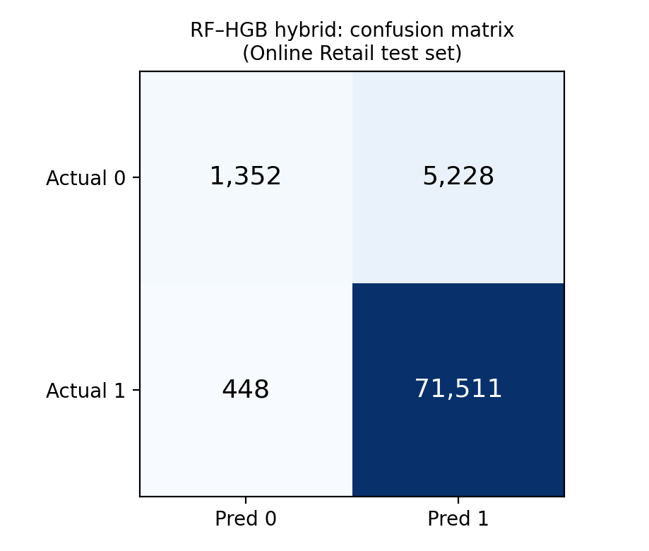
Figure 2. Confusion matrix of the RF–HGB hybrid on the Online Retail test set.
The high recall of 0.993774 shows that the model finds the majority of repeat customers. Most errors are false positives, meaning that many class-0 customers are predicted as repeat customers, so the negative class is identified poorly. The target is strongly imbalanced towards the repeat-customer class (about 91.6% of the test records are class 1), which is why F1-score, precision, recall and ROC-AUC are more informative than accuracy alone [22]–[24].
7.3 Feature importance and explanations
Feature-importance graphs, SHAP and LIME visualizations, PDP, ICE and Permutation Feature Importance are used to find the factors that influence the model’s predictions, and to compare global feature importance with local interpretability. SHAP gives feature-attribution explanations [10], LIME explains individual predictions [11], PDP shows the relationship between predictors and model output [2], ICE shows instance-level effects [14], and permutation importance measures the effect of disrupting a feature on performance [15], [16].
[Insert SHAP summary plot, LIME explanation for one prediction, and fidelity/sparsity values from your notebook here, with a 2–4 sentence explanation for each figure.]
7.4 Discussion
Interpretation of findings. Combining Random Forest and HistGradientBoosting through weighted voting gives a small gain in F1-score over the strongest single baseline [3]–[5]. The final hybrid uses a Random Forest weight of 0.30, an HGB weight of 0.70 and a threshold of 0.64. The hybrid reached a test F1-score of 0.961829 against 0.960082 for HGB, along with accuracy 0.927730, precision 0.931873 and recall 0.993774. Because its ROC-AUC is slightly lower, the benefit comes from the tuned classification objective and threshold rather than a uniform rise in all metrics [21].
Comparison with previous studies. Earlier work points to challenges in evaluating explanations, the trade-off between accuracy and interpretability, consistency of explanations, computational cost and user understanding [18]–[20]. This study addresses these by placing the evaluation factors in a single comparison framework.
Practical implications. The RF–HGB hybrid suits business applications that need both accurate classification and clear, interpretable predictions [18]–[20]. In the Online Retail case its high recall and F1-score mean it detects repeat-customer behaviour well, which helps businesses plan marketing and retention strategies. SHAP and LIME explanations show which features influence each prediction, so business users can trust and act on the output in customer engagement, promotions or service improvements [26].
7.5 Limitations
- The study focuses on the three chosen benchmark business datasets.
- How well XAI techniques work can differ depending on the machine-learning model and the data.
- It is hard to measure how good and understandable explanations are with a single measure.
- The computing power needed varies between machine-learning methods and between XAI techniques.
- Not all business users will understand the explanations equally well.
- Measured results in this report are given for the Online Retail dataset, and the Online Retail target is strongly imbalanced towards one class.
8. CONCLUSION AND FUTURE SCOPE
This project compared five machine-learning models and a proposed RF–HGB hybrid ensemble for business analytics, within an Explainable AI framework. The hybrid combines Random Forest and HistGradientBoosting through weighted soft voting and a tuned classification threshold [3]–[5]. It was tuned on validation data, with 867 weight–threshold configurations tested, while the test set remained untouched.
On the Online Retail test set, the best configuration (0.30 RF, 0.70 HGB, threshold 0.64) gave accuracy 0.927730, precision 0.931873, recall 0.993774, F1-score 0.961829 and ROC-AUC 0.818351. The hybrid improved the F1-score over the HistGradientBoosting baseline but did not beat it on every metric, since its ROC-AUC was slightly lower. Objectives 1, 3 and the performance part of objective 5 were achieved on Online Retail. SHAP and LIME were applied to explain the model globally and locally [10], [11] ([confirm the PDP, ICE, permutation-importance, fidelity and sparsity outputs obtained]). The most important limitation is that measured results are reported for one dataset, whose target class is strongly imbalanced.
Future Scope
- Expand the framework to more business datasets and different application areas.
- Add more XAI methods and ways to measure explanation quality.
- Perform thorough statistical tests of the differences between models and explanations.
- Improve the interactive dashboard so business users can evaluate predictions and make decisions easily.
9. REFERENCES
[1] Breiman, L. (2001). Random Forests. Machine Learning, 45, 5–32. https://doi.org/10.1023/A:1010933404324
[2] Friedman, J. H. (2001). Greedy Function Approximation: A Gradient Boosting Machine. The Annals of Statistics, 29(5), 1189–1232. https://doi.org/10.1214/aos/1013203451
[3] Dietterich, T. G. (2000). Ensemble Methods in Machine Learning. Multiple Classifier Systems, 1–15. https://doi.org/10.1007/3-540-45014-9_1
[4] Breiman, L. (1996). Bagging Predictors. Machine Learning, 24, 123–140. https://doi.org/10.1007/BF00058655
[5] Wolpert, D. H. (1992). Stacked Generalization. Neural Networks, 5(2), 241–259. https://doi.org/10.1016/S0893-6080(05)80023-1
[6] Ke, G., et al. (2017). LightGBM: A Highly Efficient Gradient Boosting Decision Tree. Advances in Neural Information Processing Systems 30. https://proceedings.neurips.cc/paper/2017/hash/6449f44a102fde848669bdd9eb6b76fa-Abstract.html
[7] Chen, T., and Guestrin, C. (2016). XGBoost: A Scalable Tree Boosting System. Proceedings of the 22nd ACM SIGKDD International Conference on Knowledge Discovery and Data Mining. https://doi.org/10.1145/2939672.2939785
[8] Hastie, T., Tibshirani, R., and Friedman, J. (2009). The Elements of Statistical Learning: Data Mining, Inference, and Prediction (2nd ed.). Springer. https://doi.org/10.1007/978-0-387-84858-7
[9] Friedman, J. H. (2002). Stochastic Gradient Boosting. Computational Statistics & Data Analysis, 38(4), 367–378. https://doi.org/10.1016/S0167-9473(01)00065-2
[10] Lundberg, S. M., and Lee, S.-I. (2017). A Unified Approach to Interpreting Model Predictions. Advances in Neural Information Processing Systems 30. https://proceedings.neurips.cc/paper/2017/hash/8a20a8621978632d76c43dfd28b67767-Abstract.html
[11] Ribeiro, M. T., Singh, S., and Guestrin, C. (2016). “Why Should I Trust You?”: Explaining the Predictions of Any Classifier. Proceedings of the 22nd ACM SIGKDD International Conference on Knowledge Discovery and Data Mining, 1135–1144. https://doi.org/10.1145/2939672.2939778
[12] Molnar, C. (2022). Interpretable Machine Learning (2nd ed.). https://christophm.github.io/interpretable-ml-book/
[13] Apley, D. W., and Zhu, J. (2020). Visualizing the Effects of Predictor Variables in Black Box Supervised Learning Models. Journal of the Royal Statistical Society: Series B, 82(4), 1059–1086. https://doi.org/10.1111/rssb.12377
[14] Goldstein, A., Kapelner, A., Bleich, J., and Pitkin, E. (2015). Peeking Inside the Black Box: Visualizing Statistical Learning with Plots of Individual Conditional Expectation. Journal of Computational and Graphical Statistics, 24(1), 44–65. https://doi.org/10.1080/10618600.2014.907095
[15] Fisher, A., Rudin, C., and Dominici, F. (2019). All Models Are Wrong, but Many Are Useful: Learning a Variable’s Importance by Studying an Entire Class of Prediction Models Simultaneously. Journal of Machine Learning Research, 20(177), 1–81. https://www.jmlr.org/papers/v20/18-760.html
[16] Hooker, G., and Mentch, L. (2019). Please Stop Permuting Features: An Explanation and Alternatives. https://arxiv.org/abs/1905.03151
[17] Doshi-Velez, F., and Kim, B. (2017). Towards a Rigorous Science of Interpretable Machine Learning. https://arxiv.org/abs/1702.08608
[18] Rudin, C. (2019). Stop Explaining Black Box Machine Learning Models for High Stakes Decisions and Use Interpretable Models Instead. Nature Machine Intelligence, 1, 206–215. https://doi.org/10.1038/s42256-019-0048-x
[19] Guidotti, R., et al. (2018). A Survey of Methods for Explaining Black Box Models. ACM Computing Surveys, 51(5), Article 93. https://doi.org/10.1145/3236009
[20] Arrieta, A. B., et al. (2020). Explainable Artificial Intelligence (XAI): Concepts, Taxonomies, Opportunities and Challenges toward Responsible AI. Information Fusion, 58, 82–115. https://doi.org/10.1016/j.inffus.2019.12.012
[21] Lipton, Z. C., Elkan, C., and Narayanaswamy, B. (2014). Optimal Thresholding of Classifiers to Maximize F1 Measure. Machine Learning and Knowledge Discovery in Databases, 225–239. https://doi.org/10.1007/978-3-662-44851-9_15
[22] Saito, T., and Rehmsmeier, M. (2015). The Precision-Recall Plot Is More Informative than the ROC Plot When Evaluating Binary Classifiers on Imbalanced Datasets. PLOS ONE, 10(3), e0118432. https://doi.org/10.1371/journal.pone.0118432
[23] Davis, J., and Goadrich, M. (2006). The Relationship Between Precision-Recall and ROC Curves. Proceedings of the 23rd International Conference on Machine Learning, 233–240. https://doi.org/10.1145/1143844.1143874
[24] Fawcett, T. (2006). An Introduction to ROC Analysis. Pattern Recognition Letters, 27(8), 861–874. https://doi.org/10.1016/j.patrec.2005.10.010
[25] Kohavi, R. (1995). A Study of Cross-Validation and Bootstrap for Accuracy Estimation and Model Selection. Proceedings of the 14th International Joint Conference on Artificial Intelligence, 1137–1145. https://mlanthology.org/ijcai/1995/kohavi1995ijcai-study/
[26] Cawley, G. C., and Talbot, N. L. C. (2010). On Over-fitting in Model Selection and Subsequent Selection Bias in Performance Evaluation. Journal of Machine Learning Research, 11, 2079–2107. https://www.jmlr.org/papers/v11/cawley10a.html
[27] Guo, C., Pleiss, G., Sun, Y., and Weinberger, K. Q. (2017). On Calibration of Modern Neural Networks. Proceedings of the 34th International Conference on Machine Learning, 1321–1330. https://proceedings.mlr.press/v70/guo17a.html
[28] Lazar, A., Pokhrel, P., and Das, S. (2026). Beyond Accuracy: A Comprehensive Comparative Study of Gradient Boosting Versus Tabular Deep Learning and Explainability Techniques for Mixed-Type Tabular Data Models Using SHAP and LIME. International Journal on Artificial Intelligence Tools. https://doi.org/10.1142/S0218213026400038
[29] Panthi, S., Patidar, M., Zalawadia, K., et al. (2026). A Performance Analysis of SHAP and LIME for Interpreting Boosting Models in Phishing URL Detection. Scientific Reports. https://doi.org/10.1038/s41598-026-66800-x
[30] Chen, D. (2015). Online Retail. UCI Machine Learning Repository. https://doi.org/10.24432/C5BW33
[31] Moro, S., Rita, P., and Cortez, P. (2014). Bank Marketing. UCI Machine Learning Repository. https://doi.org/10.24432/C5K306
[32] IBM Sample Data Sets (n.d.). Telco Customer Churn. https://www.kaggle.com/datasets/blastchar/telco-customer-churn

