Unified Explainable Artificial Intelligence for Business Analytics: Comparing Machine Learning Models and XAI Techniques
Bongu Lakshmi Sai Prasanna, Allam Neha Reddy, Yarlagadda Divya Sri
Department of Computer Science and Engineering, Koneru Lakshmaiah Education Foundation, Bachupally, Hyderabad
Engineering Capstone Project – 1
ABSTRACT
Business Analytics plays an important role in helping organizations make data-driven decisions by deriving meaningful insights from large volumes of data. Machine learning algorithms are increasingly used for prediction and decision making in business applications, but business users often struggle to interpret complex machine learning algorithms. This opacity can diminish trust in model predictions and hinder understanding of what factors influence business decisions. In this paper, we propose a unified framework to compare machine learning algorithms and Explainable Artificial Intelligence (XAI) techniques for business analytics.
The proposed framework uses three benchmark datasets: the UCI Bank Marketing Dataset, the Telco Customer Churn Dataset, and the UCI Online Retail Dataset, representing different business scenarios. The methodology includes exploratory data analysis, data cleaning, missing-value handling, duplicate removal, outlier detection, encoding, normalization, feature engineering, feature selection and train-test splitting. Five Machine learning algorithms are evaluated i.e. Logistic Regression, Decision Tree, Random Forest, XGBoost and CatBoost. The evaluation metrics are Accuracy, Precision, Recall, F1-Score, ROC-AUC, Confusion Matrix and Classification Report. We use XAI techniques (SHAP, LIME, Partial Dependence Plots (PDP), Individual Conditional Expectation (ICE) and Permutation Feature Importance) to provide explanations at global and local level. The goal of this study is to compare predictive performance, interpretability, explanation fidelity, sparsity and computational efficiency. The resulting framework aims to identify appropriate ML-XAI pairs for trustworthy business decision making.
Keywords: Explainable Artificial Intelligence; Business Analytics; Machine Learning; SHAP; LIME; Interpretability; Model Comparison; Feature Importance
1. INTRODUCTION
1.1 Background
Business analytics is a tool that helps organizations to analyze large volumes of data to generate useful insights for decision making. Machine learning techniques are being increasingly applied to business problems such as predicting customer churn, marketing response prediction, customer behavior analysis and transaction analytics. Machine learning algorithms can detect trends in data and make predictions that can inform business decisions [1], [2].
However, high-performing machine learning algorithms, especially complex ones, are black boxes. Such models may provide accurate predictions but business users may not understand why a prediction was made. This brings challenges of transparency, trust, interpretability and optimal decision-making [13]–[15]. Explainable Artificial Intelligence offers ways to comprehend the behavior of models and to find the features influencing predictions [13], [14].
1.2 Problem Statement
Machine learning algorithms can make accurate predictions but are often hard to understand. Different machine learning algorithms and explainable AI methods may have different accuracy in prediction and explainability [14], [15]. Existing approaches might be limited to single models, single XAI methods or specific applications [1], [4].
This motivates the need for a common framework to compare several machine learning algorithms and XAI techniques across different business datasets while considering both predictive performance and explainability [1], [3], [5].
The main research challenge is to discover the combinations of machine learning algorithms and XAI techniques that achieve a good trade-off among prediction performances, interpretability, explanation quality and computational effectiveness in business analytics.
1.3 Research Gap
Prior research has investigated explainable AI from different methodological and application-oriented perspectives, including model-agnostic explanation methods, financial applications, taxonomies, and evaluation approaches [1]–[6]. However, challenges remain in evaluating explanation quality, consistency, interpretability, computational cost, and user usefulness [8], [10], [19]. Existing literature also highlights the trade-off between predictive performance and interpretability, particularly when complex black-box models are used [13], [17]. Therefore, there is a need for a unified comparative framework that evaluates multiple machine learning models and XAI techniques across different business analytics datasets.
1.4 Research Objectives
- To develop machine learning models for analyzing and predicting outcomes from benchmark business datasets.
- To integrate SHAP, LIME, PDP, ICE, and Permutation Feature Importance for explaining model predictions.
- To evaluate and compare the predictive performance of Logistic Regression, Decision Tree, Random Forest, XGBoost, and CatBoost.
- To compare the explainability of different ML-XAI combinations using interpretability, fidelity, sparsity, and computational effectiveness.
- To identify and recommend suitable machine learning and XAI combinations for business analytics decision-making.
1.5 Research Questions
- RQ1: How do Logistic Regression, Decision Tree, Random Forest, XGBoost, and CatBoost differ in predictive performance across business analytics datasets?
- RQ2: Which XAI techniques provide the most useful global and local explanations for the selected machine learning models?
- RQ3: How do explanation fidelity, sparsity, interpretability, and computational effectiveness vary across different ML-XAI combinations?
- RQ4:Which ML-XAI combination provides the most suitable balance between predictive performance and explainability for business decision-making?
1.6 Contributions
- A unified framework for comparing multiple machine learning models and XAI techniques across benchmark business datasets.
- A systematic comparison of predictive performance and explainability.
- Integration of explanation fidelity and sparsity to assess the reliability and simplicity of explanations.
- Comparative evaluation of ML-XAI combinations.
1.7 Organization of the Paper
Section 2 reviews existing research related to machine learning and Explainable Artificial Intelligence. Section 3 describes the proposed methodology, datasets, preprocessing, machine learning models, and XAI techniques. Section 4 presents the experimental setup and evaluation metrics. Section 5 presents the experimental results and comparison. Section 6 discusses the findings and their practical implications. Section 7 describes the limitations of the study. Section 8 concludes the paper and presents future work.]
2. RELATED WORK
2.1 Existing Approaches
Traditional machine learning approaches focus primarily on predictive performance. Models such as Logistic Regression, Decision Trees, and ensemble methods have been widely used for classification and prediction tasks. While simpler models can provide comparatively easier interpretation, complex models can capture more complicated relationships within datasets but may be difficult to understand [13]–[15].
This trade-off has motivated the development of Explainable Artificial Intelligence (XAI), which provides techniques for understanding model behavior and explaining the factors contributing to individual predictions [13], [14]
2.2 Machine Learning / Computational Approaches
Machine learning approaches used in business analytics include Logistic Regression, Decision Tree, Random Forest, XGBoost, and CatBoost. Logistic Regression provides a relatively interpretable baseline, while Decision Trees represent decisions through a tree structure. Random Forest combines multiple decision trees to improve robustness and predictive performance [27]. XGBoost is a scalable gradient boosting approach [28], while CatBoost is a boosting algorithm designed to handle categorical features effectively [29].
2.3 Advanced / Alternative Approaches
Advanced explainability approaches include model-agnostic and model-specific techniques. LIME provides local explanations by approximating the behavior of a model around individual predictions [11]. SHAP provides feature-attribution explanations based on Shapley values and can be used to obtain both local and global interpretations [12], [25]. Partial Dependence Plots (PDP) provide information about the relationship between predictor variables and model predictions [21], while Individual Conditional Expectation (ICE) plots illustrate prediction behavior at the individual-instance level [22]. Permutation Feature Importance estimates feature importance by measuring the change in model performance after feature values are permuted [23].
2.4 Explainability / Interpretability (or other relevant sub-theme) Explainability is important because accurate predictions alone may not be sufficient for business decision-making. XAI methods aim to improve understanding of machine learning predictions and model behavior [13]–[16]. SHAP and LIME can provide local and global perspectives on model predictions [11], [12], [25]. PDP, ICE, and feature-importance methods provide complementary information about feature influence [21]–[23].
Previous research has identified challenges in evaluating explanation quality, consistency, computational cost, and user usefulness. Therefore, the proposed framework considers explainability alongside predictive performance rather than treating it as a separate concern [8], [10], [19], [20].

2.5 Critical Comparison
Table 1 summarizes representative studies from the literature, highlighting their key contributions and limitations.

# | Study / Publication | Key Contribution | Limitation
1 | Model-Agnostic Explainable Artificial Intelligence Methods in Finance: A Systematic Review (2025)[1] | Reviews SHAP, LIME, PDP, counterfactuals and other model-agnostic XAI techniques. | Lacks extensive real-world validation of XAI methods on diverse financial datasets.
2 | A Comprehensive Review on Financial Explainable AI (2025)[2] | Reviews XAI techniques, applications and challenges in financial decision-making. | Does not propose a unified framework for improving financial XAI.
3 | XAI: Survey of Needs, Techniques, Applications & Future Direction (2024)[3] | Gives a broad overview of XAI methods, applications, requirements, and future directions. | Lacks standardized metrics for evaluating explanation quality.
4 |  | Reviews XAI applications in finance and the challenges in evaluating explanations. | Does not fully resolve the trade-off between accuracy and interpretability.
  XAI in Finance: A Systematic Literature Review (2024)[4]
5 | A Comprehensive Taxonomy for Explainable Artificial Intelligence: A Systematic Survey of Surveys on Methods and Concepts (2023/24)[5] | Provides a taxonomy for classifying XAI methods and concepts. | Lacks practical implementation and evaluation of the classified XAI methods.
6. |  | Reviews black-box interpretation techniques and discusses their strengths and limitations. | Provides limited guidance on selecting the most suitable explanation method for different applications.
  Interpreting Black-Box Models: A Review on XAI (2024) [6]
7. | Transformative Impact of XAI: Bridging Complexity and Trust (2025) [7] | Reviews model-specific, model-agnostic and hybrid XAI approaches and discusses accuracy–interpretability trade-offs. | Further practical validation is needed to determine how XAI improves user trust in real-world systems.
8. | Review of Evaluation Approaches for XAI (2024) [8] | Examines XAI evaluation approaches and highlights the lack of systematic evaluation. | No universally accepted framework exists for evaluating explanation quality.
9. | Privacy-Preserving XAI: A Survey (2024/25) [9] | Reviews XAI methods while addressing privacy-related challenges. | Maintaining privacy while providing detailed and useful explanations remains challenging.
10. |  | Reviews factors affecting explanation usefulness, usability and user trust. | More empirical studies are required to validate user-centered XAI guidelines across different domains.
  User-Centered XAI Design Guidelines: Systematic Literature Review (2025) [10]
Table 1. Comparison of representative studies on Explainable Artificial Intelligence, highlighting their key contributions and limitations.
2.6 Research Gap (Summary)
The literature indicates that XAI methods differ in their objectives, explanation mechanisms, evaluation requirements, and applicability across domains [1], [3], [5], [6]. Existing studies frequently focus on particular techniques or application domains rather than performing unified comparisons across multiple machine learning models and business datasets [1], [2], [4]. This research therefore compares ML and XAI methods using predictive performance, fidelity, sparsity, interpretability, and computational effectiveness.
3. PROPOSED METHODOLOGY
3.1 Overall Framework
The proposed framework follows a sequential pipeline beginning with benchmark dataset collection, followed by data cleaning, data analysis, feature engineering, feature selection, and train-test splitting. The processed data is then provided to multiple machine learning models. Their predictive performance is evaluated using standard classification metrics. XAI techniques are subsequently applied to generate global and local explanations. Finally, the models and explanations are compared to identify suitable ML-XAI combinations.
System design
3.2 Dataset(s)
- UCI Bank Marketing Dataset: Used to represent banking and marketing analytics.[31]
- Telco Customer Churn Dataset: Used to represent customer analytics and churn prediction[32]
- UCI Online Retail Dataset: Used to represent e-commerce and customer transaction analytics.[33]

3.3 Data Preprocessing
The following preprocessing steps are proposed:
- Data cleaning
- Missing-value handling
- Duplicate record removal
- Outlier detection and treatment
- Categorical data encoding
- Feature scaling or normalization
- Feature engineering
- Feature selection
- Train-test splitting
These steps are included in the proposed project pipeline.
3.4 [ Exploratory Analysis / Feature Engineering, as relevant ]
Exploratory Data Analysis is performed to understand the structure and quality of the datasets. The analysis includes dataset overview, descriptive statistics, missing-value analysis, duplicate detection, outlier detection, univariate analysis, bivariate analysis, multivariate analysis, and correlation analysis. Feature engineering and feature selection are then performed to prepare relevant features for model development. Visualization techniques include heatmaps, boxplots, correlation matrices, and feature importance graphs

3.5 Proposed Model(s) and Baselines
- The study evaluates five machine learning models: Logistic Regression, Decision Tree, Random Forest, XGBoost, and CatBoost. Logistic Regression is used as an interpretable baseline classification model, while Decision Trees provide a tree-based decision structure. Random Forest uses an ensemble of decision trees to improve predictive performance and robustness [27]. XGBoost is a scalable gradient boosting method [28], and CatBoost is a gradient boosting algorithm designed to effectively handle categorical features [29].

Where:
- Random Forest → [27]
- XGBoost → [28]

Explainability Techniques
SHAP is used to determine feature contributions to model predictions [12], [25]. LIME is used to generate local explanations for individual predictions [11]. Partial Dependence Plots are used to examine the relationship between predictor variables and model predictions [21]. Individual Conditional Expectation plots are used to analyze prediction behavior for individual instances [22]. Permutation Feature Importance is used to estimate feature importance through changes in model performance.
3.6 Algorithmic / Mathematical Formulation
For classification evaluation, the following measures are considered:
Accuracy:
Accuracy = (TP + TN) / (TP + TN + FP + FN)
Precision:
Precision = TP / (TP + FP)
Recall:
Recall = TP / (TP + FN)
F1-Score:
F1 = 2 × (Precision × Recall) / (Precision + Recall)
where TP represents true positives, TN represents true negatives, FP represents false positives, and FN represents false negatives
Explainability Evaluation
To quantitatively evaluate the quality of the explanations generated by SHAP and LIME, two evaluation measures, Fidelity and Sparsity, were considered.
Fidelity
Fidelity measures the extent to which an explanation is consistent with the prediction behavior of the original machine learning model. It indicates how accurately the explanation represents the decision-making behavior of the underlying model. A higher fidelity value indicates that the generated explanation better approximates the behavior of the original model.
In this research, fidelity is used to assess the reliability of the explanations generated by SHAP and LIME for the Bank Marketing, Online Retail, and Telco Customer Churn datasets. The measure provides a quantitative evaluation of explanation quality rather than relying only on visual interpretation of feature-importance plots.
Sparsity
Sparsity measures the compactness of an explanation by considering the number of features that contribute to the explanation. An explanation involving fewer influential features is more compact and can be easier for business users to interpret. Therefore, sparsity evaluates whether an explanation can represent a model prediction using a limited number of important features.
In this research, sparsity is used to evaluate the complexity of SHAP and LIME explanations. It helps determine whether the explanation identifies a concise set of influential features while retaining meaningful information about the model prediction.
Fidelity evaluates the reliability of an explanation with respect to the original model, whereas sparsity evaluates the simplicity and compactness of the explanation. These measures are therefore incorporated into the proposed framework to provide a quantitative assessment of SHAP and LIME explanations across the three benchmark business datasets.

4. EXPERIMENTAL SETUP
4.1 Hardware and Software
The proposed implementation uses Python-based data analytics and machine learning tools. The major software libraries and tools include:
- Python
- Pandas
- NumPy
- Scikit-learn
- XGBoost
- SHAP
- LIME
- Matplotlib
- Seaborn
The project is designed using open-source software and publicly available datasets, making the implementation technically and economically feasible.
4.2 Dataset Split / Design
After preprocessing and feature selection, the datasets are divided into training and testing subsets. The training data is used for developing the machine learning models, while the testing data is used to evaluate their predictive performance.
4.3 Hyperparameter Configuration
The selected machine learning models are configured using suitable model parameters. Hyperparameter tuning can be performed where required to improve model performance and obtain a fair comparison among the selected algorithms.
4.4 Validation Strategy
The models are evaluated using a consistent evaluation procedure across the selected datasets. The same evaluation metrics are used to enable comparison between models. Where applicable, cross-validation can be incorporated to assess the stability of model performance.
4.5 Evaluation Metrics
- Accuracy: Measures the proportion of correctly classified instances.
- Precision: Measures the proportion of predicted positive instances that are actually positive.
- Recall: Measures the proportion of actual positive instances correctly identified.
- F1-Score: Represents the harmonic mean of precision and recall.
- ROC-AUC: Measures the model's ability to distinguish between classes.
- Confusion Matrix: Provides a detailed breakdown of correct and incorrect classifications.
- Classification Report: Provides classification performance measures for individual classes.
4.6 Statistical Testing
The project proposes comparative evaluation of model performance and explainability.
5. RESULTS
5.1 Overall Performance
The experimental analysis will compare Logistic Regression, Decision Tree, Random Forest, XGBoost across the selected business datasets. The comparison will identify models that provide stronger predictive performance while also considering their interpretability and explanation characteristics.
5.2 Model / Method Comparison
Table 2 compares the performance of each method/model considered in this study.

Method | Metric A | Metric B | Notes
Logistic Regression | 89.94 | 64.29 | Baseline model
Decision Tree | 86.17 | 41.25 | Interpretable model
Random Forest | 89.66 | 59.30 | Ensemble model
XGBoost | 90.14 | 62.50 | Boosting model
Table 2. Comparative performance of machine learning models on the selected business analytics datasets.

Fig. 3. Overall performance comparison of the selected machine learning models across key evaluation metrics.
5.3 [ Additional Result Sub-section, e.g., Error/Confusion Analysis ]
Confusion matrices will be used to examine correct and incorrect classifications for each machine learning model. This analysis will help identify the types of classification errors made by the models.
5.4 [ Additional Result Sub-section, e.g., Feature/Factor Importance ]
Feature importance graphs, model predictions. These explanations will be compared to understand differences in global and local interpretability. SHAP visualizations, LIME visualizations, PDP, ICE, and Permutation Feature Importance will be used to identify the factors influencing
6. DISCUSSION
6.1 Interpretation of Findings
The comparative analysis is expected to demonstrate that machine learning models can differ in both predictive performance and interpretability. More complex models may provide stronger predictive capabilities while requiring XAI techniques to make their decisions understandable.
The use of multiple XAI techniques allows the study to examine model behavior from different perspectives. Global explanations can identify overall important features, while local explanations can help understand individual predictions.
6.2 Comparison With Previous Studies
Previous literature has highlighted challenges related to explanation evaluation, accuracy–interpretability trade-offs, consistency, computational cost, and user understanding [8], [10], [13], [16], [17], [19]. The proposed study addresses these issues by incorporating multiple evaluation dimensions within a common comparative framework.
6.3 Theoretical Implications
Rather than considering accuracy as the only measure of model effectiveness, the proposed framework considers interpretability, fidelity, sparsity, and computational effectiveness, reflecting broader concerns identified in explainable AI research [8], [19], [20], [24].
6.4 Practical Implications
The framework can help business users and organizations select machine learning models that provide an appropriate balance between predictive performance and transparency. Such considerations are important because model explanations should support meaningful understanding rather than merely provide technically complex outputs [16], [17], [18].
6.5 Unexpected Findings
This section should be completed after the experimental analysis. Any unexpected differences between models or XAI techniques should be documented based on actual results.
7. LIMITATIONS
1.The study is limited to the selected benchmark business datasets.
2. The effectiveness of XAI techniques may vary depending on the machine learning model and dataset.
3. Explanation quality and interpretability can be difficult to measure using a single metric.
4. Computational requirements may differ across machine learning and XAI techniques.
5. User understanding of generated explanations may vary between different business users.
8. CONCLUSION AND FUTURE WORK
This research proposes a unified framework for comparing machine learning models and Explainable Artificial Intelligence techniques in business analytics. The study considers Logistic Regression, Decision Tree, Random Forest, XGBoost, across three benchmark business datasets. Multiple XAI techniques, including SHAP, LIME, PDP, ICE, and Permutation Feature Importance, are incorporated to evaluate model explanations.
The framework evaluates predictive performance together with explainability-related factors such as interpretability, fidelity, sparsity, and computational effectiveness. The comparison is intended to identify suitable ML-XAI combinations for transparent and reliable business decision-making. The proposed framework provides a structured approach for understanding the trade-off between model accuracy and interpretability.
Future Work
- Extend the framework to additional business datasets and application domains.
- Incorporate additional XAI techniques and explanation-quality measures.
- Perform more extensive statistical validation of model and explanation differences.
- Improve the interactive dashboard for business-user evaluation and decision support.
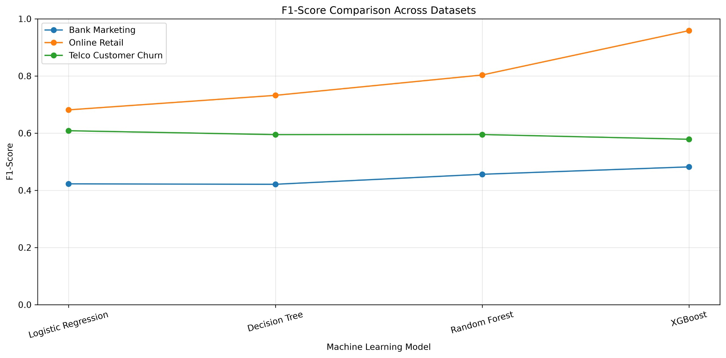
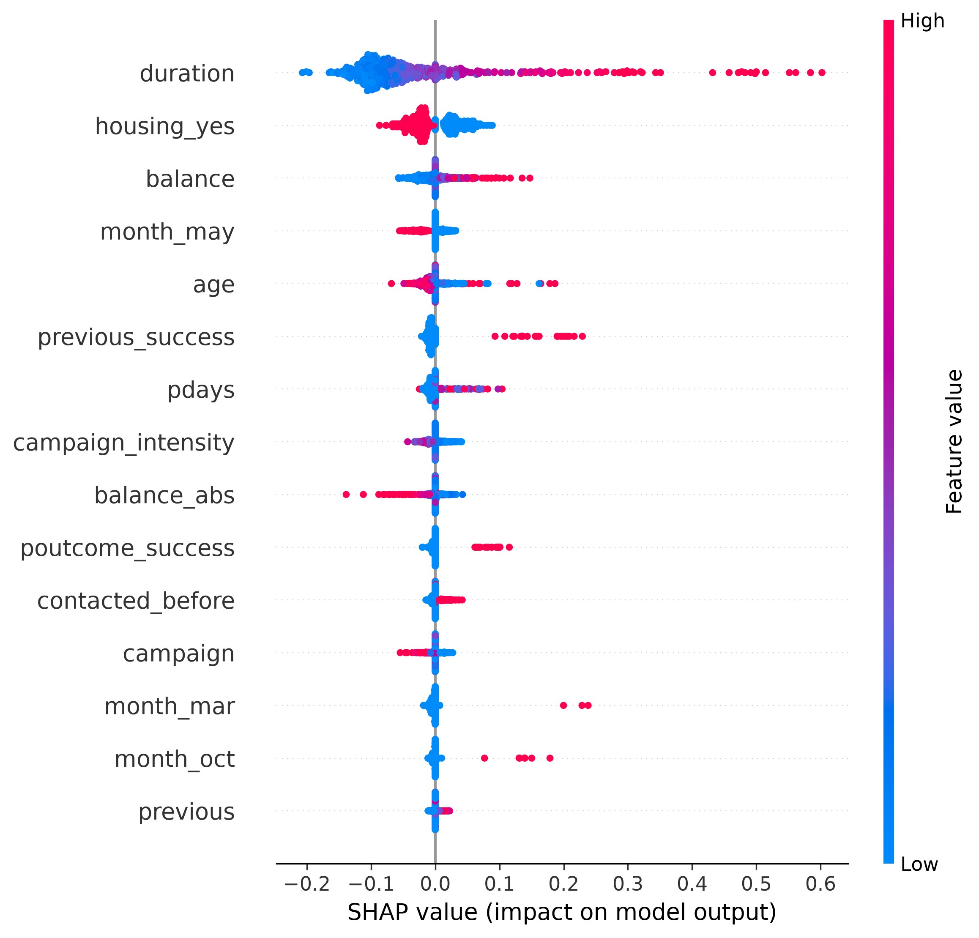
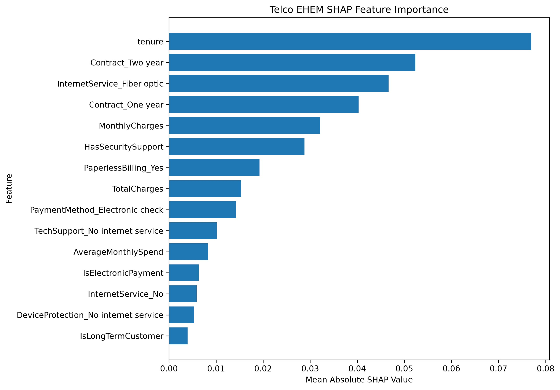
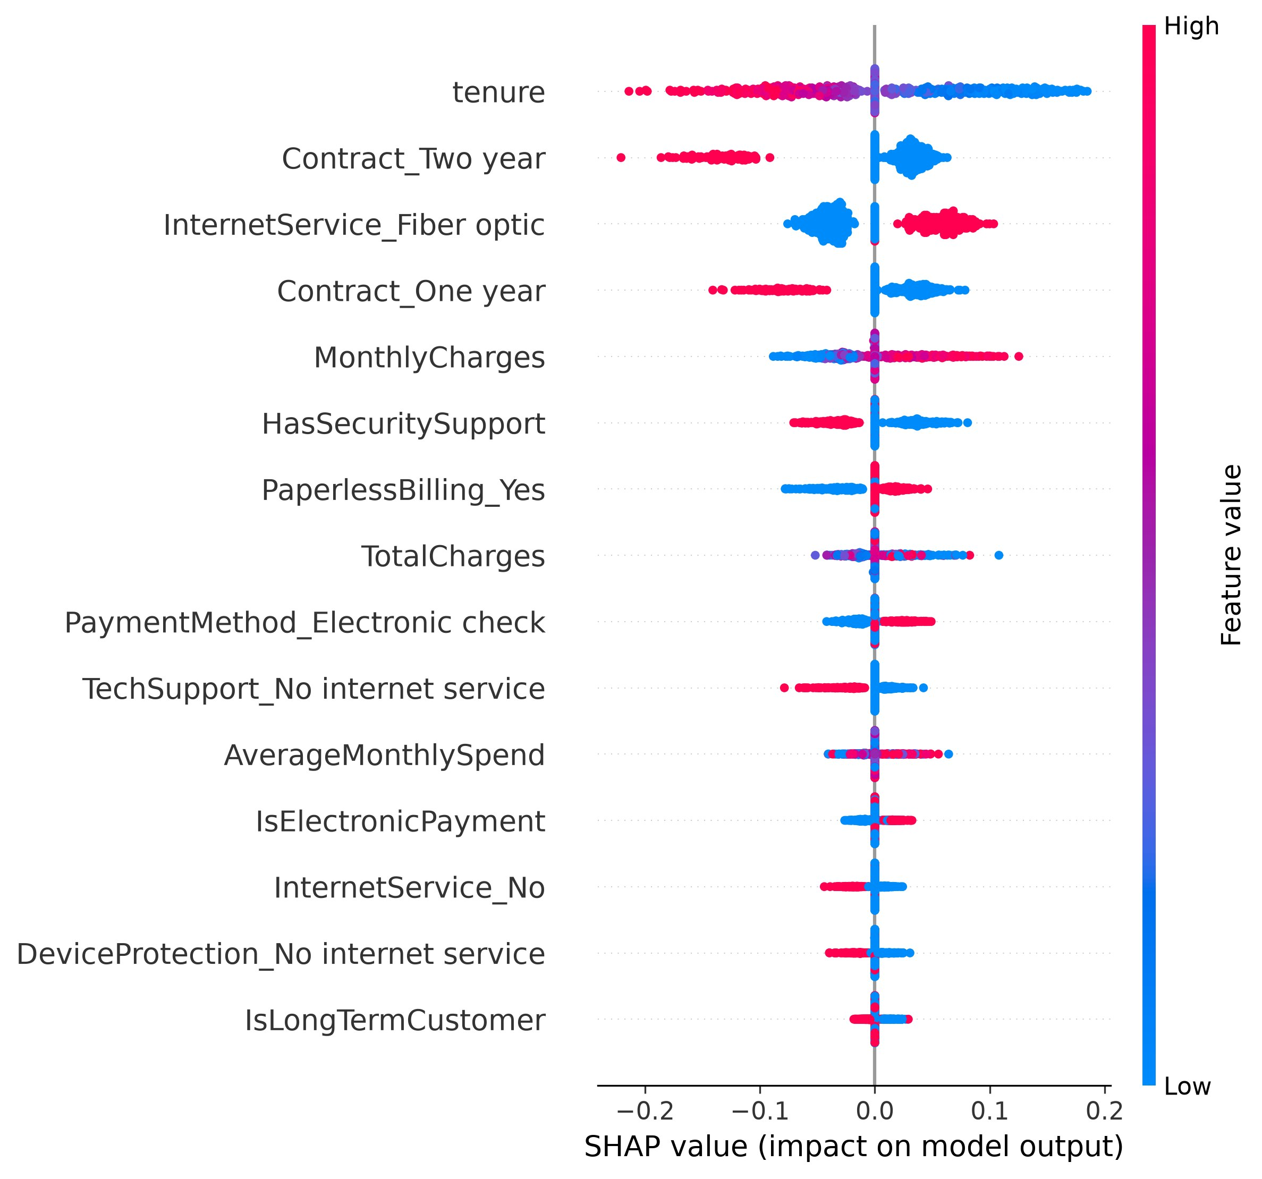
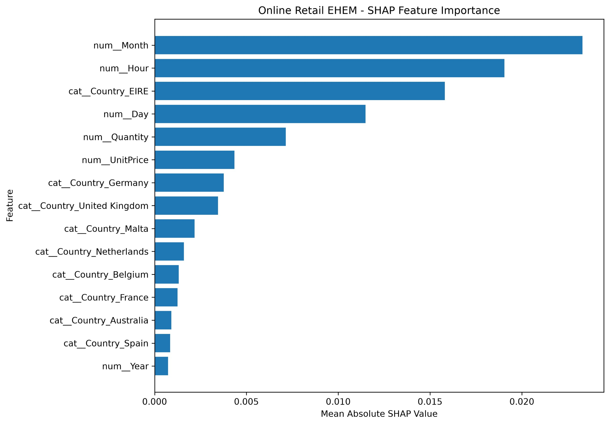
DECLARATIONS
Funding
This project does not use any external funding. The proposed implementation relies on open-source software and publicly available datasets.
Ethics Statement
[ State data privacy The study uses publicly available benchmark datasets. No direct collection of personal information from human participants is proposed.
Data Availability
The study uses the UCI Bank Marketing Dataset, Telco Customer Churn Dataset, and UCI Online Retail Dataset.
Author Contributions
Bongu Lakshmi Sai Prasanna: XAI implementation, comparative analysis, visualization, and documentation.
Allam Neha Reddy: Dataset analysis, machine learning implementation, and evaluation.
Yarlagadda Divya Sri: Literature survey, research-gap identification, methodology development, and documentation.
Acknowledgements
We would like to express our gratitude to Dr. K. Swapnika, Project Guide, and the Department of Computer Science and Engineering for their guidance and support throughout the project.

REFERENCES
[1] F. S. Khan, S. S. Mazhar, K. Mazhar, D. A. AlSaleh, et al., “Model-agnostic explainable artificial intelligence methods in finance: A systematic review, recent developments, limitations, challenges and future directions,” Artificial Intelligence Review, vol. 58, Art. no. 232, 2025, doi: 10.1007/s10462-025-11215-9.
Paper: Springer — Full Paper
[2] W. J. Yeo, W. Van Der Heever, R. Mao, E. Cambria, R. Satapathy, et al., “A comprehensive review on financial explainable AI,” Artificial Intelligence Review, vol. 58, Art. no. 189, 2025, doi: 10.1007/s10462-024-11077-7.
Paper: Springer — Full Paper
[3] “Explainable artificial intelligence: A survey of needs, techniques, applications, and future direction,” Neurocomputing, vol. 599, Art. no. 128111, 2024, doi: 10.1016/j.neucom.2024.128111.
Paper: ScienceDirect — Full Paper
[4] J. Černevičienė and A. Kabašinskas, “Explainable artificial intelligence (XAI) in finance: A systematic literature review,” Artificial Intelligence Review, vol. 57, Art. no. 216, 2024, doi: 10.1007/s10462-024-10854-8.
Paper: Springer — Full Paper
[5] G. Schwalbe and B. Finzel, “A comprehensive taxonomy for explainable artificial intelligence: A systematic survey of surveys on methods and concepts,” Data Mining and Knowledge Discovery, vol. 38, pp. 3043–3101, 2024, doi: 10.1007/s10618-022-00867-8.
Paper: Springer — Full Paper
[6] V. Hassija, V. Chamola, A. Mahapatra, A. Singal, D. Goel, K. Huang, et al., “Interpreting black-box models: A review on explainable artificial intelligence,” Cognitive Computation, vol. 16, pp. 45–74, 2024, doi: 10.1007/s12559-023-10179-8.
Paper: Springer — Full Paper
[7] G. Paliwal, A. Kumar, K. P. Sharma, D. Bhargava, et al., “Transformative impact of explainable artificial intelligence: Bridging complexity and trust,” Discover Artificial Intelligence, vol. 5, Art. no. 51, 2025, doi: 10.1007/s44163-025-00281-1.
Paper: Springer — Full Paper
[8] A. M. Salih, I. Boscolo Galazzo, P. Gkontra, et al., “A review of evaluation approaches for explainable AI with applications in cardiology,” Artificial Intelligence Review, vol. 57, Art. no. 240, 2024, doi: 10.1007/s10462-024-10852-w.
Paper: Springer — Full Paper
[9] T. T. Nguyen, T. T. Huynh, Z. Ren, T. T. Nguyen, P. L. Nguyen, H. Yin, et al., “Privacy-preserving explainable AI: A survey,” Science China Information Sciences, vol. 68, Art. no. 111101, 2025, doi: 10.1007/s11432-024-4123-4.
Paper: Springer — Full Paper
[10] S. Hong and W. Park, “Developing user-centered system design guidelines for explainable AI: A systematic literature review,” Artificial Intelligence Review, vol. 58, Art. no. 386, 2025, doi: 10.1007/s10462-025-11363-y.
Paper: Springer — Full Paper
[11] M. T. Ribeiro, S. Singh, and C. Guestrin, “‘Why should I trust you?’: Explaining the predictions of any classifier,” in Proc. 22nd ACM SIGKDD Int. Conf. Knowledge Discovery and Data Mining, 2016, pp. 1135–1144, doi: 10.1145/2939672.2939778.
Paper: ACM — Full Paper
PDF/Preprint: arXiv
[12] S. M. Lundberg and S.-I. Lee, “A unified approach to interpreting model predictions,” in Advances in Neural Information Processing Systems 30, 2017, doi: 10.48550/arXiv.1705.07874.
Paper: arXiv — Full Paper
[13] A. Barredo Arrieta, N. Díaz-Rodríguez, J. Del Ser, et al., “Explainable artificial intelligence (XAI): Concepts, taxonomies, opportunities and challenges toward responsible AI,” Information Fusion, vol. 58, pp. 82–115, 2020, doi: 10.1016/j.inffus.2019.12.012.
Paper: ScienceDirect — Full Paper
[14] R. Guidotti, A. Monreale, S. Ruggieri, F. Turini, F. Giannotti, and D. Pedreschi, “A survey of methods for explaining black box models,” ACM Computing Surveys, vol. 51, no. 5, Art. no. 93, 2018, doi: 10.1145/3236009.
Paper: ACM — Full Paper
[15] A. Adadi and M. Berrada, “Peeking inside the black-box: A survey on explainable artificial intelligence (XAI),” IEEE Access, vol. 6, pp. 52138–52160, 2018, doi: 10.1109/ACCESS.2018.2870052.
Paper: IEEE — Paper
[16] T. Miller, “Explanation in artificial intelligence: Insights from the social sciences,” Artificial Intelligence, vol. 267, pp. 1–38, 2019, doi: 10.1016/j.artint.2018.07.007.
Paper: ScienceDirect — Full Paper
[17] C. Rudin, “Stop explaining black box machine learning models for high stakes decisions and use interpretable models instead,” Nature Machine Intelligence, vol. 1, pp. 206–215, 2019, doi: 10.1038/s42256-019-0048-x.
Paper: Nature — Full Paper
[18] Z. C. Lipton, “The mythos of model interpretability,” ACM Queue, vol. 16, no. 3, 2018, doi: 10.1145/3236386.3241340.
Paper: ACM Queue — Paper
[19] F. Doshi-Velez and B. Kim, “Towards a rigorous science of interpretable machine learning,” arXiv:1702.08608, 2017.
Paper: arXiv — Full Paper
[20] J. Adebayo, J. Gilmer, M. Muelly, I. Goodfellow, M. Hardt, and B. Kim, “Sanity checks for saliency maps,” in Advances in Neural Information Processing Systems 31, 2018, pp. 9505–9515.
Paper: NeurIPS — Paper
[21] D. W. Apley and J. Zhu, “Visualizing the effects of predictor variables in black box supervised learning models,” Journal of the Royal Statistical Society: Series B, vol. 82, no. 4, pp. 1059–1086, 2020, doi: 10.1111/rssb.12377.
Paper: Wiley — Full Paper
[22] A. Goldstein, A. Kapelner, J. Bleich, and E. Pitkin, “Peeking inside the black box: Visualizing statistical learning with plots of individual conditional expectation,” Journal of Computational and Graphical Statistics, vol. 24, no. 1, pp. 44–65, 2015, doi: 10.1080/10618600.2014.907095.
Paper: Taylor & Francis — Full Paper
[23] C. Molnar, G. Casalicchio, and B. Bischl, “Interpretable machine learning—A brief history, state-of-the-art and challenges,” in Machine Learning and Knowledge Discovery in Databases, 2020, pp. 417–431, doi: 10.1007/978-3-030-65965-3_28.
Paper: Springer — Paper
[24] C. Rudin, C. Chen, Z. Chen, H. Huang, L. Semenova, and C. Zhong, “Interpretable machine learning: Fundamental principles and 10 grand challenges,” arXiv:2103.11251, 2021.
Paper: arXiv — Full Paper
[25] S. M. Lundberg, G. Erion, H. Chen, A. DeGrave, J. M. Prutkin, B. Nair, R. Katz, J. Himmelfarb, N. Bansal, and S.-I. Lee, “From local explanations to global understanding with explainable AI for trees,” Nature Machine Intelligence, vol. 2, pp. 56–67, 2020, doi: 10.1038/s42256-019-0138-9.
Paper: Nature — Full Paper
[26] J. H. Friedman, “Greedy function approximation: A gradient boosting machine,” The Annals of Statistics, vol. 29, no. 5, pp. 1189–1232, 2001, doi: 10.1214/aos/1013203451.
Paper: Project Euclid — Full Paper
[27] L. Breiman, “Random forests,” Machine Learning, vol. 45, pp. 5–32, 2001, doi: 10.1023/A:1010933404324.
Paper: Springer — Full Paper
[28] T. Chen and C. Guestrin, “XGBoost: A scalable tree boosting system,” in Proc. 22nd ACM SIGKDD Int. Conf. Knowledge Discovery and Data Mining, 2016, pp. 785–794, doi: 10.1145/2939672.2939785.
Paper: ACM — Full Paper
[29] L. Prokhorenkova, G. Gusev, A. Vorobev, A. V. Dorogush, and A. Gulin, “CatBoost: Unbiased boosting with categorical features,” in Advances in Neural Information Processing Systems 31, 2018.
Paper: NeurIPS — Full Paper
[30] F. Pedregosa, G. Varoquaux, G. Gramfort, et al., “Scikit-learn: Machine learning in Python,” Journal of Machine Learning Research, vol. 12, pp. 2825–2830, 2011.
Paper: JMLR — Full Paper

