Adaptive Software Engineering

Name: Yarlagadda Divya Sri
Roll no: 2420030529
Section - 1

GitHub
Step 1: Create a GitHub Account
Open GitHub.
Sign up using an email address.
Verify the email address.
Set up the GitHub account.

Step 2: Create a Repository
Log in to GitHub.
Click New Repository.
Enter the repository name.
Select Public or Private.
Add a README file if required.
Click Create Repository.

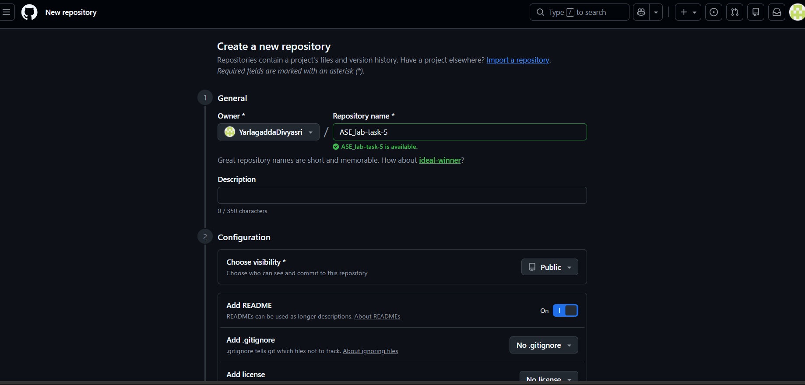
Step 3: Create a Local Git Repository
Open the project folder in the terminal and use:
git init
This initializes a new Git repository in the current project folder.
Step 4: Check Git Status
git status
This shows modified files, untracked files, staged files, and the current branch.
Step 5: Add Files
To add a particular file:
git add filename
To add all files:
git add .
This moves the changes to the staging area.
Step 6: Create a Commit
git commit -m "Initial commit"
A commit saves the staged changes with a message describing the changes.
Step 7: Connect the Local Repository to GitHub
git remote add origin <repository-url>
This connects the local repository to the GitHub repository.
To check the remote:
git remote -v
Step 8: Push Code to GitHub
git push -u origin main
This uploads the local commits to the main branch of the GitHub repository.
After the first push, we can usually use:
git push

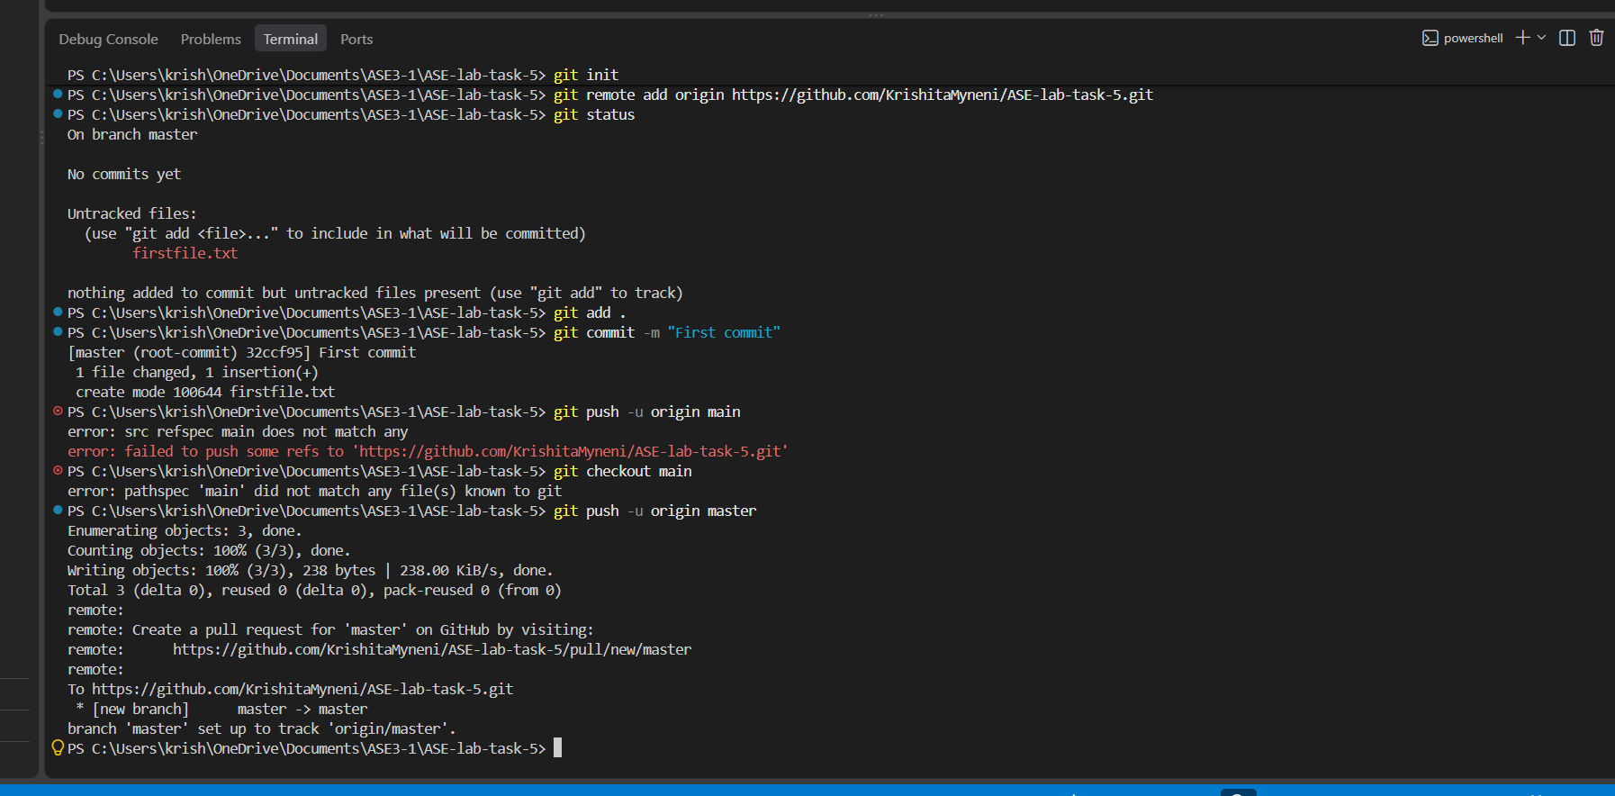
Step 9: README.md
README.md is a Markdown file used to provide information about a project.
It can contain:
• Project title
• Description
• Features
• Installation steps
• Usage
• Technologies used
• Author information
Example:
# My Project
This is my first GitHub project.
## Technologies
- HTML
- CSS
- JavaScript

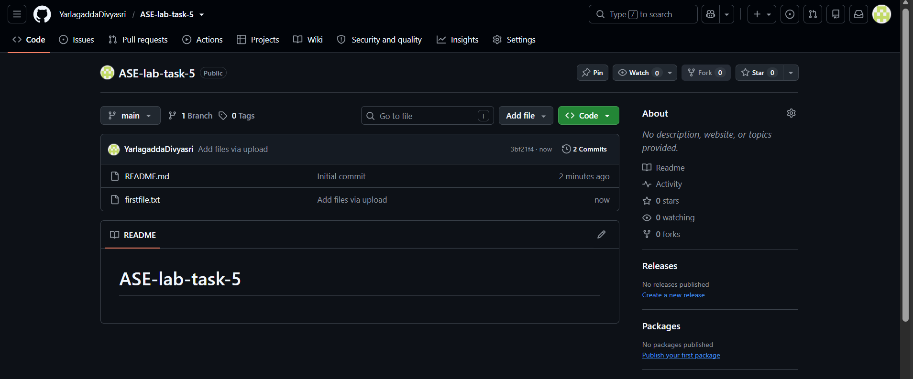
Step 10: Delete a Repository
Open the repository.
Go to Settings.
Scroll to Danger Zone.
Select Delete this repository.
Confirm the repository name.
Confirm deletion.

