TASK-2

USER FLOW:

User clicks on the ORDER NOW CTA button goes to the list of items after choosing the iems and adding to the cart he will go to the payment page and then he finds the payment method suitable for and then he complete his transaction and redirect to the the main screen

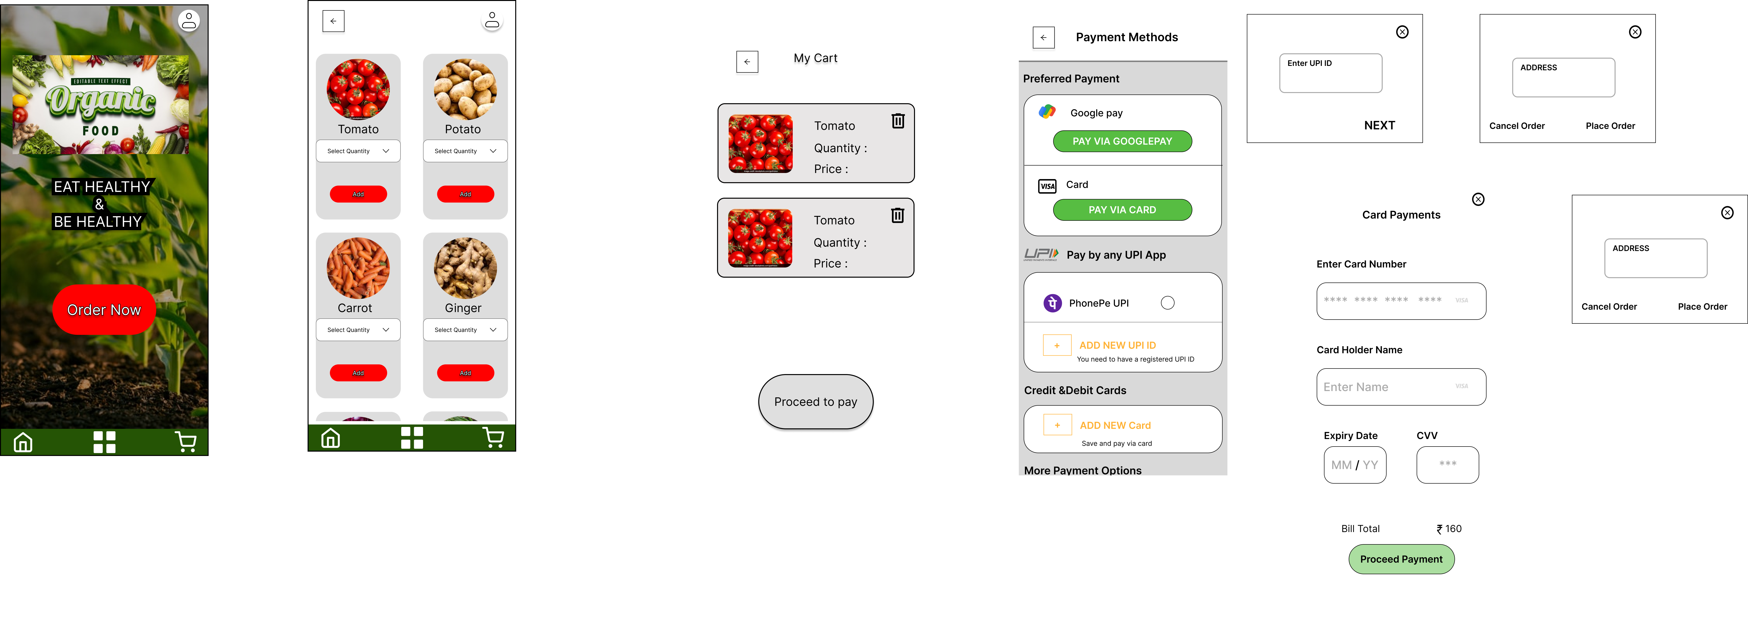

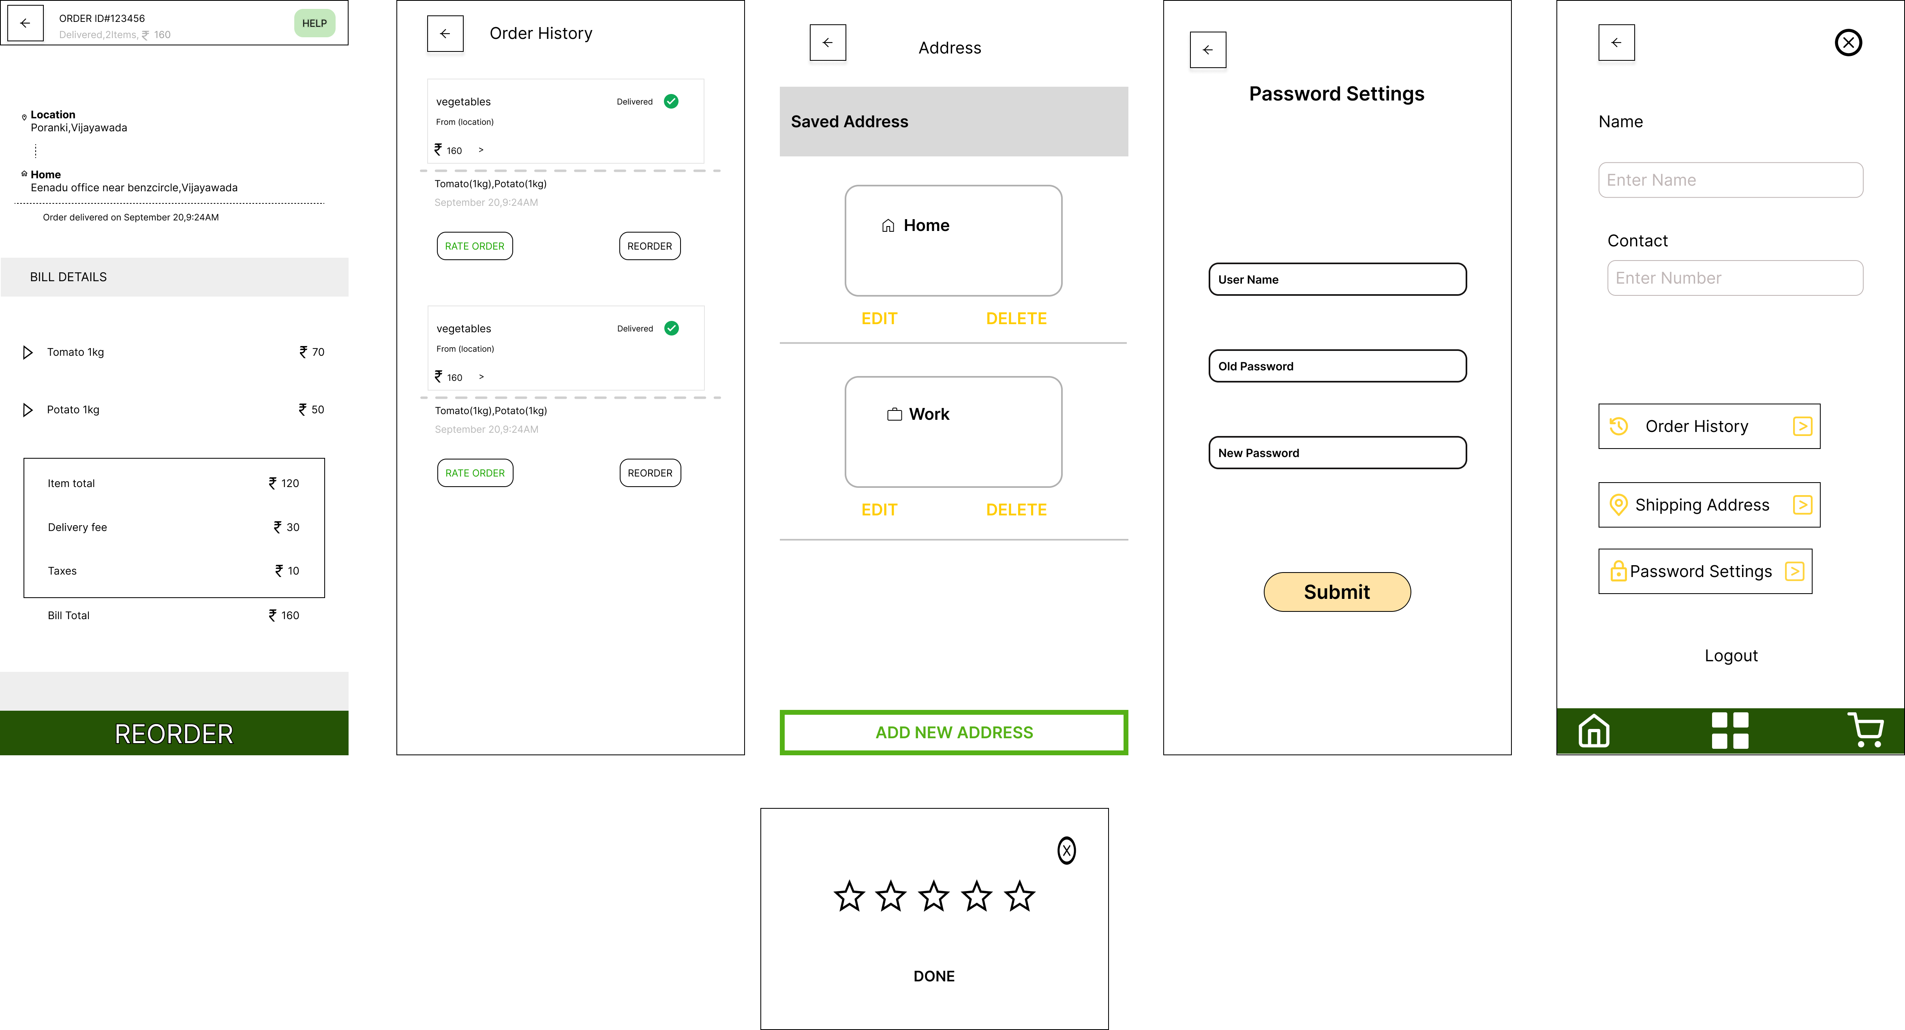

FIGMA FILE:

https://www.figma.com/design/0QeD2QAGsuzneeimEEfctB/Elevate-labs?node-id=42-8&t=Gf1EExbSaYIgaZxj-1