**Task-4**

Pantaloons

**original**

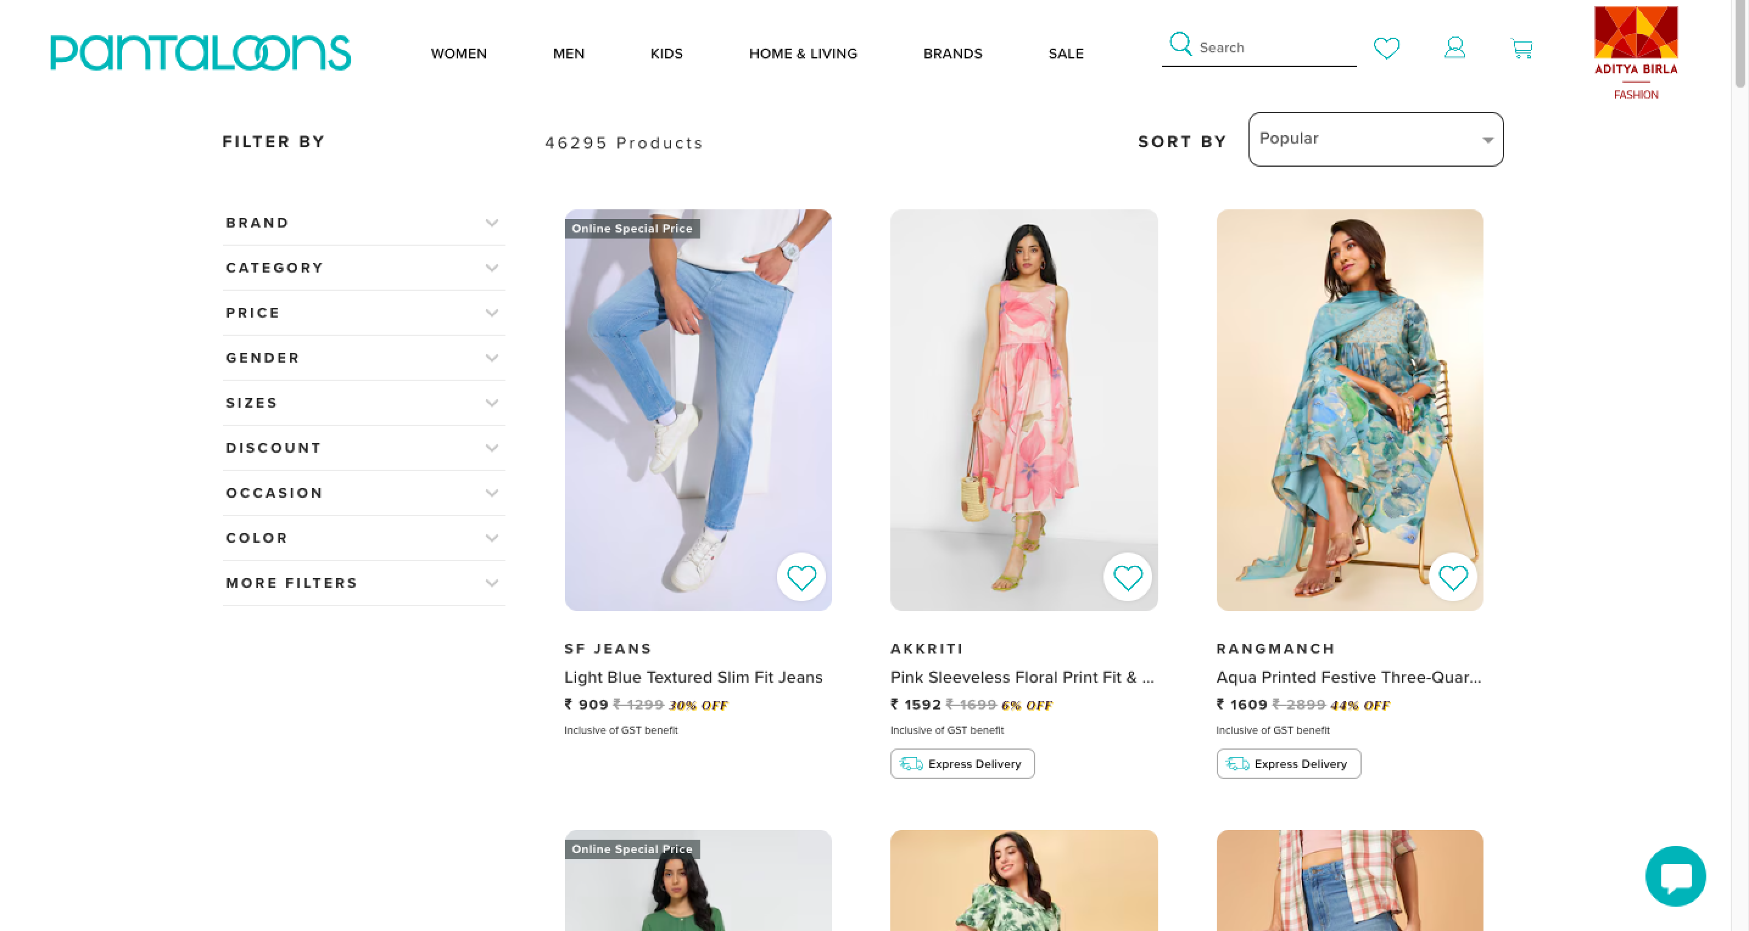

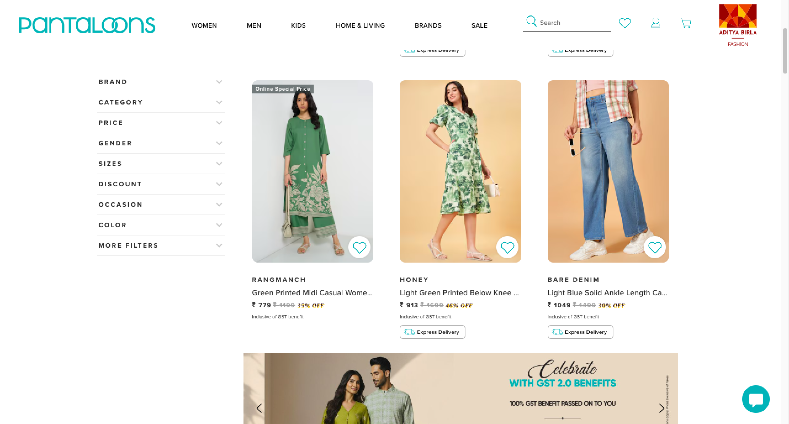

**Changes done by me**

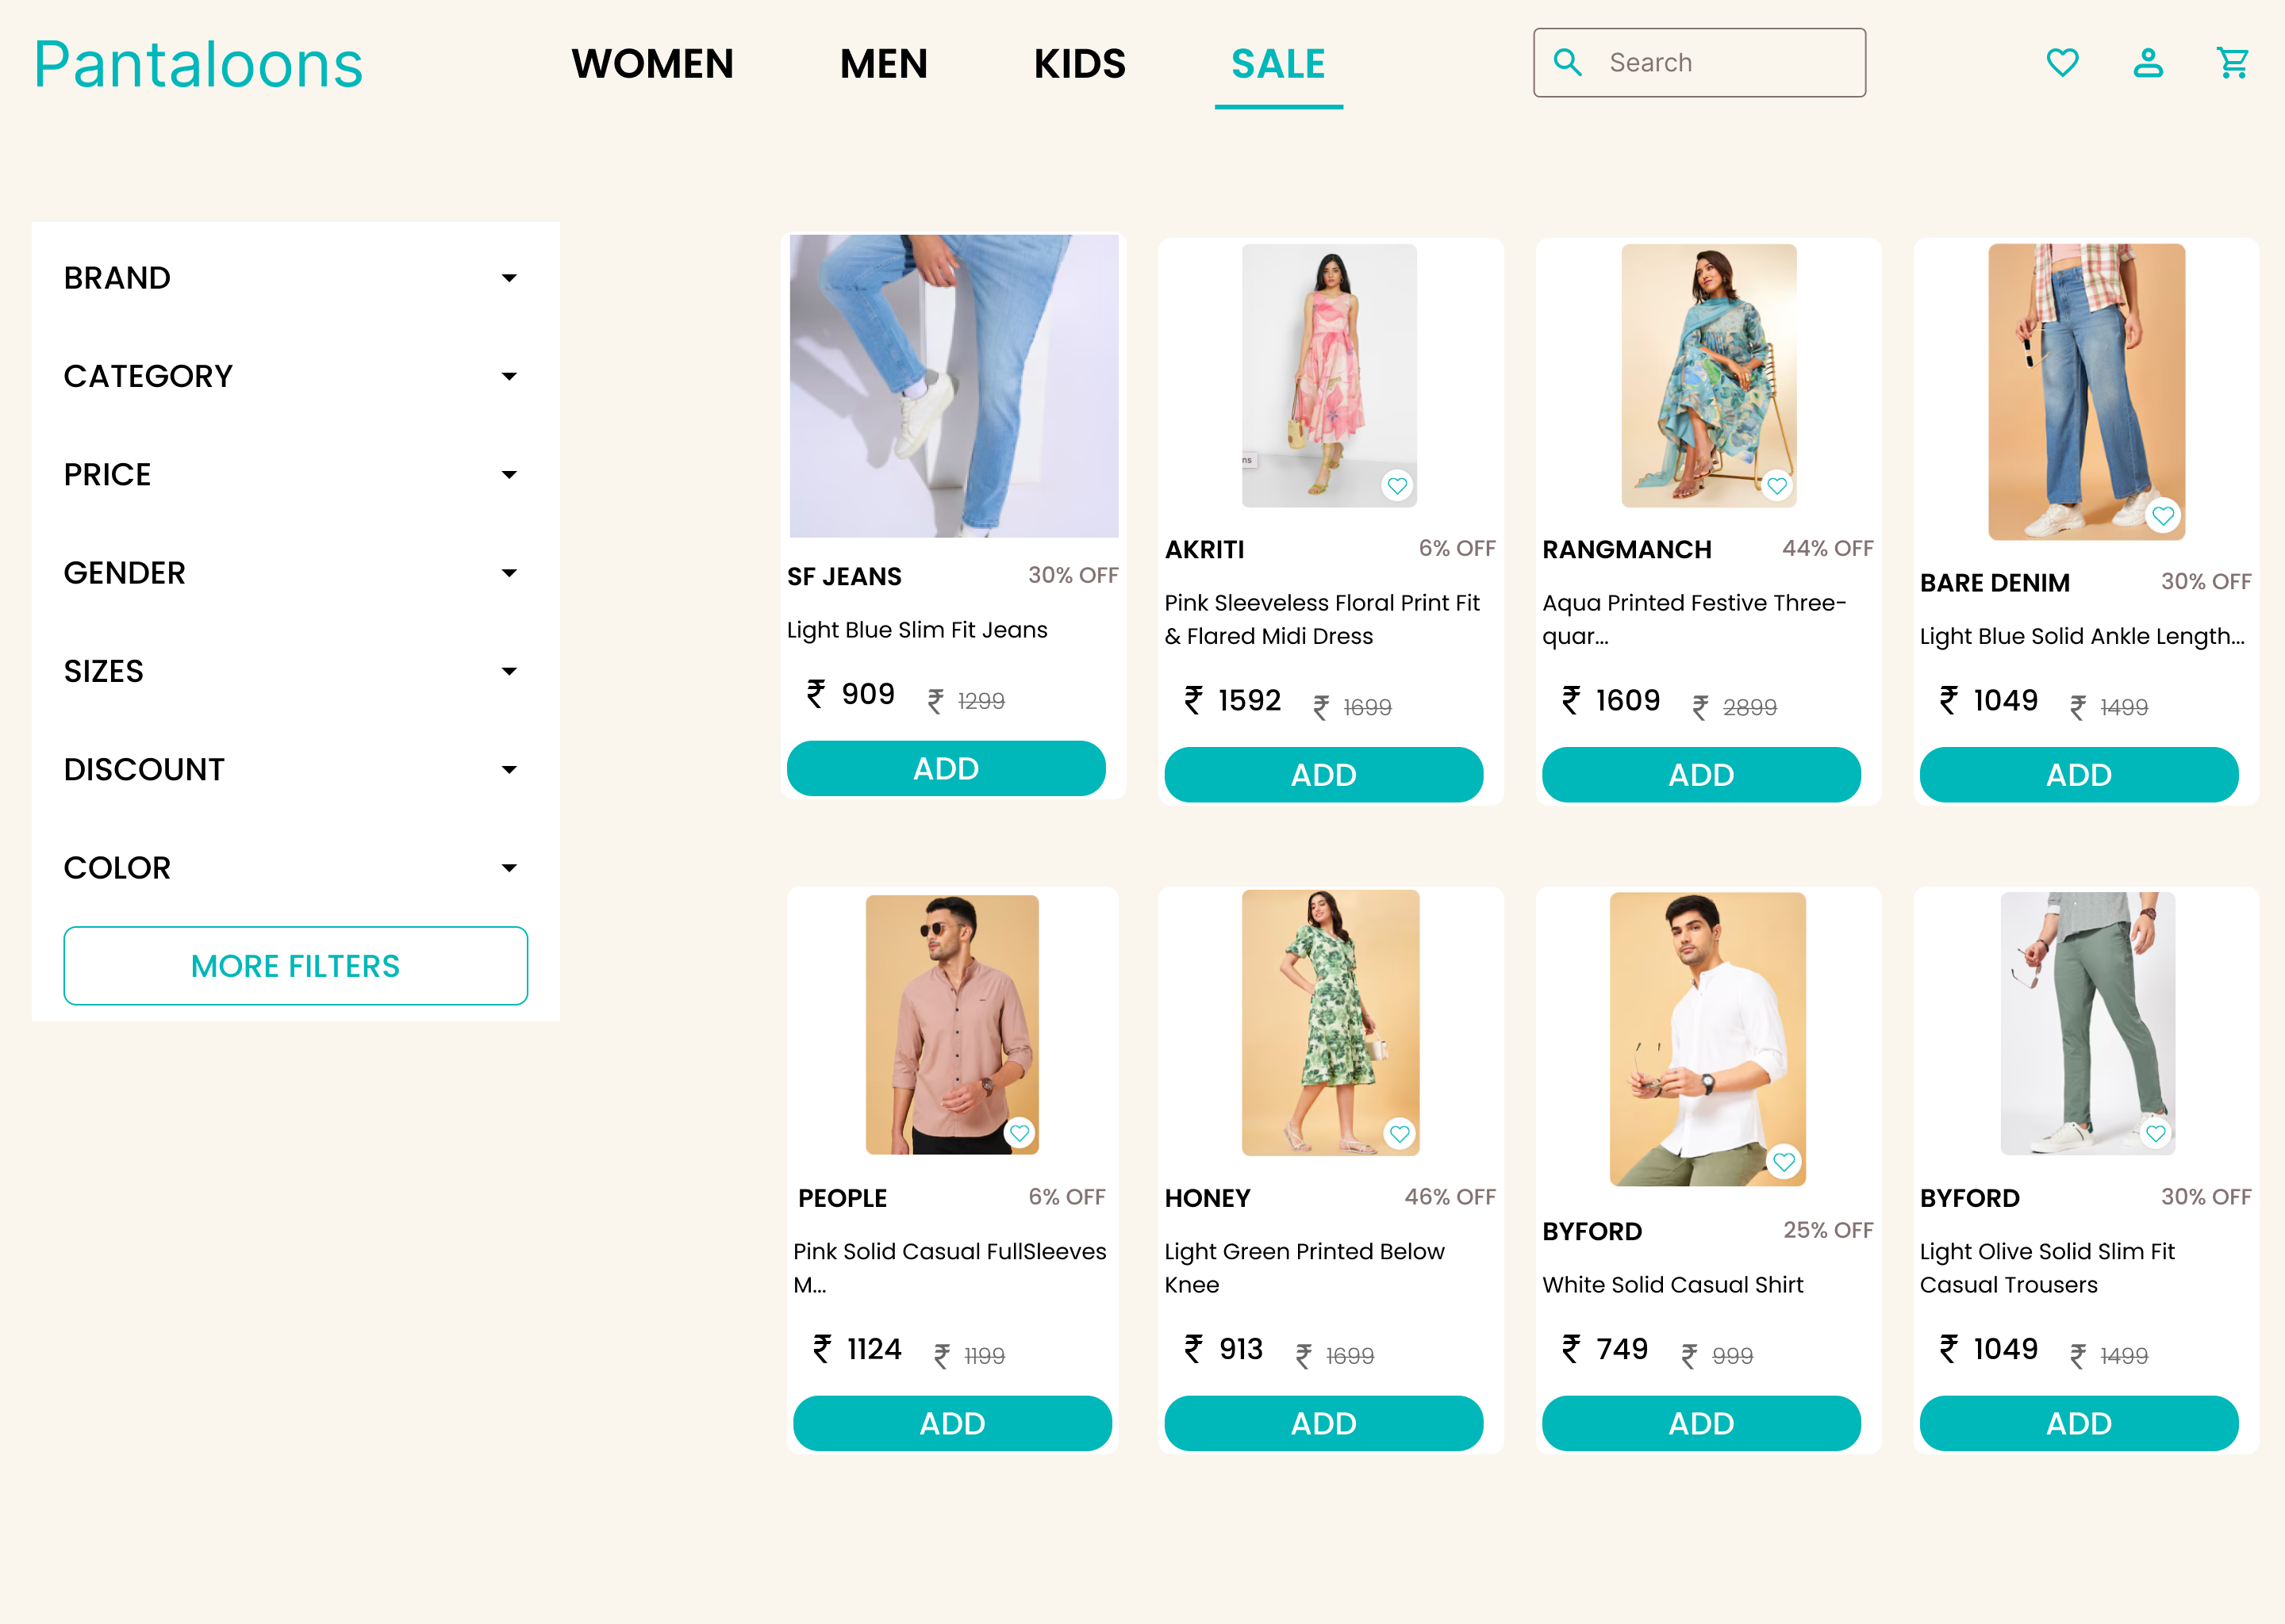

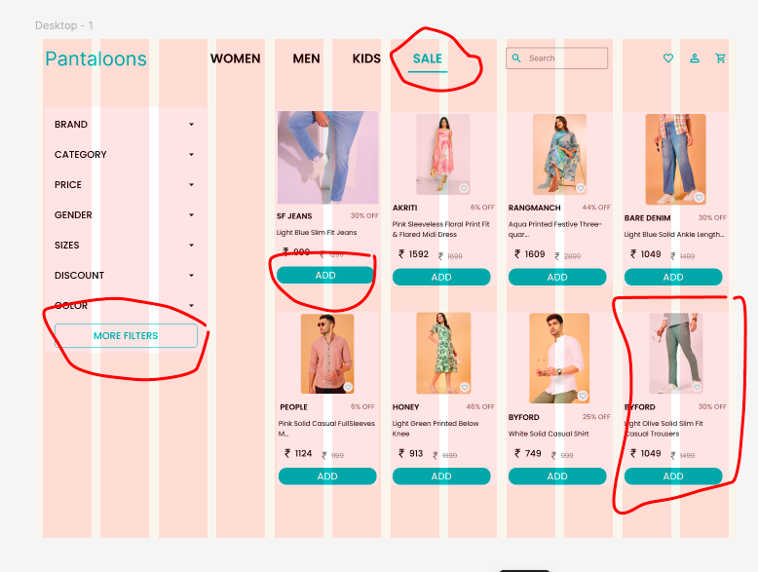

**Description: example of sale page from pantaloons**

On the official application there is lot of spacing in left and right of the screen.

If we clearly observe there is no difference between the background and item both are in white color it is difficult to read and there is no add button. There is no clear navigation(where the user is)  
  
In my design I had added the add button in the list and I there is some difference between the list as well as background and I added some part in the navigation bar

Figma file :

https://www.figma.com/design/0QeD2QAGsuzneeimEEfctB/Elevate-labs?node-id=47-249&t=hPJcuIM02hJTZRHg-1