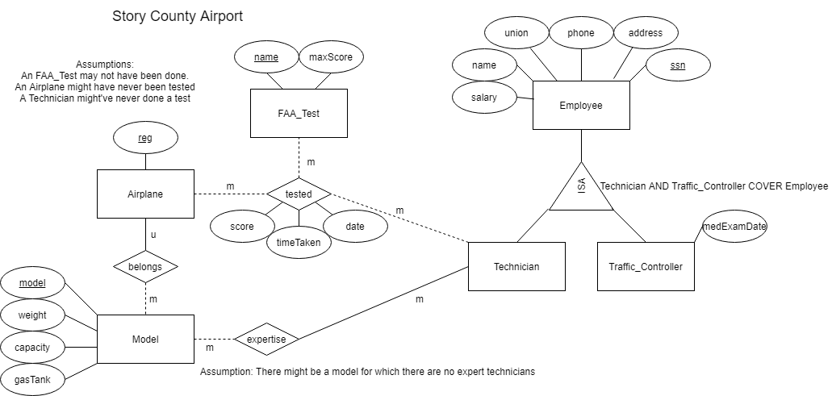Question 1:

Question 2:

CREATE DATABASE IF NOT EXISTS exam1;

USE exam1;

CREATE TABLE IF NOT EXISTS Customer(

cust_id int NOT NULL UNIQUE,

name varchar(20),

address varchar(50),

amount double,

PRIMARY KEY(cust_id)

);

# name of Group changed to ArtGroup because Group is a reserved MySQL keyword

CREATE TABLE IF NOT EXISTS ArtGroup(

name varchar(10) NOT NULL UNIQUE,

PRIMARY KEY(name)

);

CREATE TABLE IF NOT EXISTS Like_Group(

groupName varchar(10),

cust_id int,

FOREIGN KEY(cust_id) REFERENCES Customer(cust_id),

FOREIGN KEY(groupName) REFERENCES ArtGroup(name)

);

CREATE TABLE Artist(

name varchar(20) NOT NULL,

birthplace varchar(20),

style varchar(10),

age int,

PRIMARY KEY(name)

);

CREATE TABLE IF NOT EXISTS Like_Artist(

artistName varchar(20),

cust_id int,

FOREIGN KEY(cust_id) REFERENCES Customer(cust_id),

FOREIGN KEY(artistName) REFERENCES Artist(name)

);

CREATE TABLE IF NOT EXISTS Artwork(

title varchar(50) NOT NULL,

price double,

type varchar(10) NOT NULL,

year int,

creator varchar(20) NOT NULL,

PRIMARY KEY(title),

FOREIGN KEY(creator) REFERENCES Artist(name)

);

CREATE TABLE IF NOT EXISTS Paints(

work varchar(50) NOT NULL UNIQUE,

artist varchar(20) NOT NULL,

FOREIGN KEY(artist) REFERENCES Artist(name),

FOREIGN KEY(work) REFERENCES Artowrk(title)

);

CREATE TABLE IF NOT EXISTS Classify(

classification varchar(10),

work varchar(50) NOT NULL,

FOREIGN KEY(classification) REFERENCES ArtGroup(name),

FOREIGN KEY(work) REFERENCES Artwork(title)

);

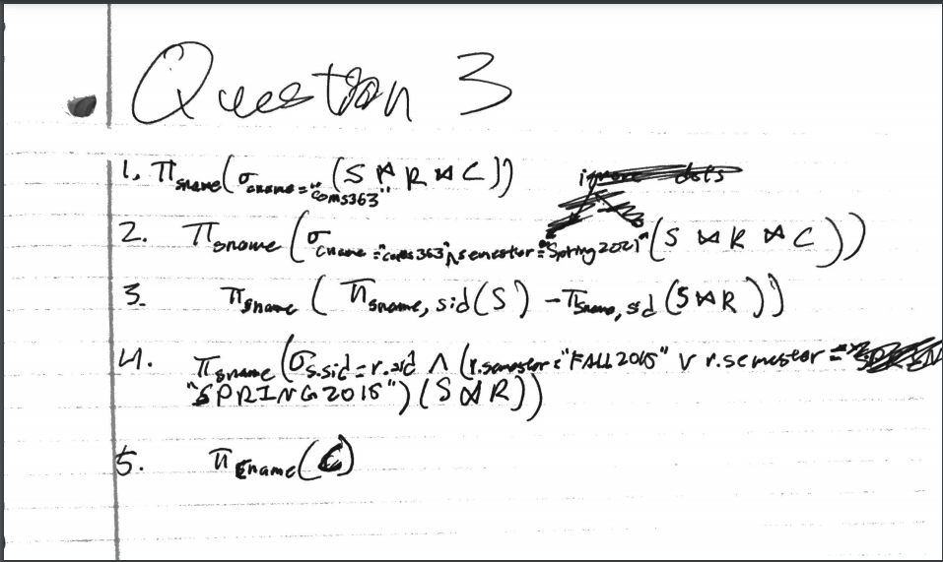Question 3