**Project 1.A**

1. Project Description

In your first homework, you were asked to design a database that stores some information about a university. Many of you have done an excellent job. Figure 1 shows an ER diagram that is among some good ones.

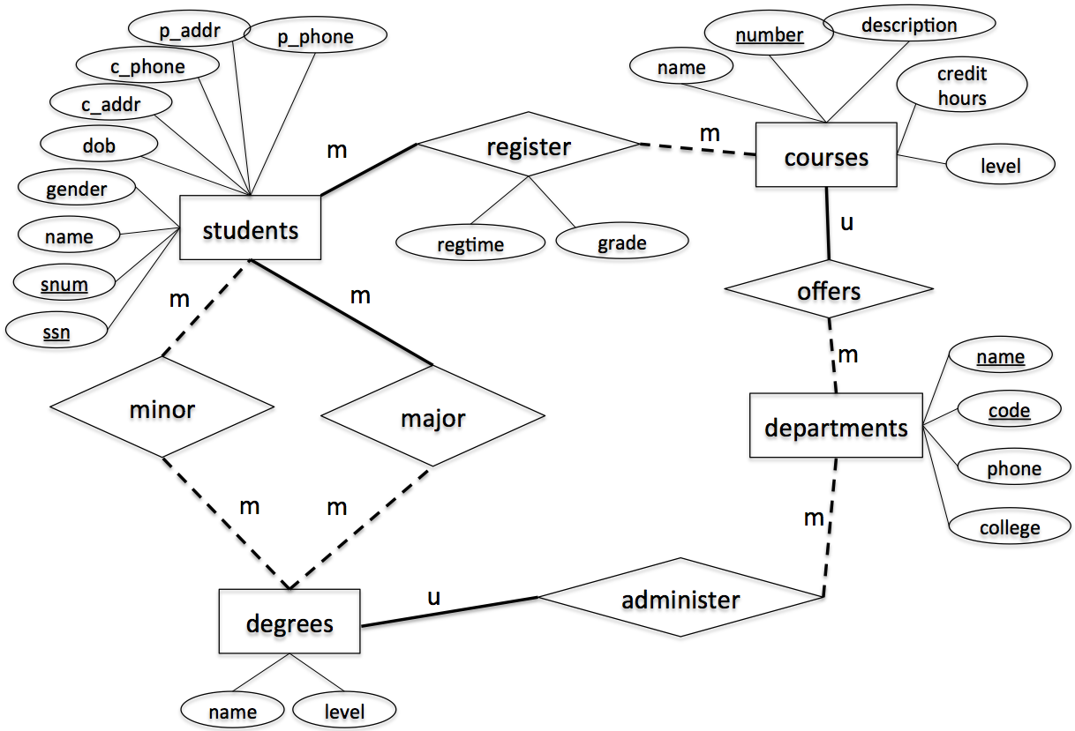

Figure 1. ER-diagram

This project is to implement the above design using a relational data model. Specifically, you are asked to write the following SQL scripts.

1. **CreateTables.sql [Points: 15]**

This script creates the following tables. Each table must be created with the table name, attribute names and corresponding types and length as specified. Also, make sure to specify primary key, candidate key and foreign key (if any), accordingly.

* students
  1. Attribute, type and length: *snum: integer, ssn: integer, name: varchar(10), gender: varchar(1), dob: datetime, c_addr: varchar(20), c_phone: varchar(10), p_addr: varchar(20), p_phone: varchar(10)*
  2. Primary key: *ssn*
  3. Candidate key: *snum*
  4. Foreign key: *N/A*
* departments
  1. Attribute, type and length: *code: integer, name: varchar(50), phone: varchar(10), college: varchar(20)*
  2. Primary key: *code*
  3. Candidate key: *name*
  4. Foreign key: *N/A*
* degrees
  1. Attribute, type and length: *name: varchar(50), level: varchar(5),* department_code: integer
  2. Primary key: *name, level*
  3. Candidate key: *N/A*
  4. Foreign key: *department_code refers to code in table departments*
* courses

1. Attribute, type and length: *number: integer, name: varchar(50), description: varchar(50), credithours: integer, level: varchar(20), department_code: integer*
2. Primary key: *number*
3. Candidate key: *name*
4. Foreign key: *department_code refers to code in table departments*

* register

1. Attribute, type and length: *snum: integer, course_number: integer, regtime: varchar(20), grade: integer*
2. Primary key: *snum, course_number*
3. Candidate key: *N/A*
4. Foreign key: *snum refers to snum in table students, course_number refers to number in table courses*

* major

1. Attribute, type and length: *snum: integer, name: varchar(50), level: varchar(5)*
2. Primary key: *snum, name, level*
3. Candidate key: *N/A*
4. Foreign key: *snum refers to snum in table students, name & level refer to name & level in table degrees*

* minor

1. Attribute, type and length: *snum: integer, name: varchar(50), level: varchar(5)*
2. Primary key: *snum, name, level*
3. Candidate key: *N/A*
4. Foreign key: *snum refers to snum in table students, name & level refer to name & level in table degrees*

1. **InsertRecords.sql [Points: 15]**

This script inserts the following records to the appropriate tables created by CreateTables.sql.

* **students**

snum, ssn, name, gender, dob, c_addr, c_phone, p_addr, p_phone

1001**,** 654651234, Randy, M, 2000/12/01, 301 E Hall, 5152700988, 121 Main, 7083066321

1002**,** 123097834, Victor, M, 2000/05/06, 270 W Hall, 5151234578, 702 Walnut, 7080366333

1003**,** 978012431, John, M, 1999/07/08, 201 W Hall, 5154132805, 888 University, 5152012011

1004**,** 746897816, Seth, M, 1998/12/30, 199 N Hall, 5158891504, 21 Green, 5154132907

1005**,** 186032894, Nicole, F, 2001/04/01, 178 S Hall, 5158891155, 13 Gray, 5157162071

1006**,** 534218752, Becky, F, 2001/05/16, 12 N Hall, 5157083698, 189 Clark, 2034367632

1007**,** 432609519, Kevin, M, 2000/08/12, 75 E Hall, 5157082497, 89 National, 7182340772

* **departments**

**code, name, phone, college**

401, Computer Science, 5152982801, LAS

402, Mathematics, 5152982802, LAS

403, Chemical Engineering, 5152982803, Engineering

404, Landscape Architect, 5152982804, Design

* **degrees**

**name, level, department_code**

Computer Science, BS, 401

Software Engineering, BS, 401

Computer Science, MS, 401

Computer Science, PhD, 401

Applied Mathematics, MS, 402

Chemical Engineering, BS, 403

Landscape Architect, BS, 404

* **major**

**snum, name, level**

1001, Computer Science, BS

1002, Software Engineering, BS

1003, Chemical Engineering, BS

1004, Landscape Architect, BS

1005, Computer Science, MS

1006, Applied Mathematics, MS

1007, Computer Science, PhD

* **minor**

**snum , name , level**

1007, Applied Mathematics, MS

1005, Applied Mathematics, MS

1001, Software Engineering, BS

* **courses**

**number, name, description, credithours, level, department_code**

113, Spreadsheet, Microsoft Excel and Access, 3, Undergraduate, 401

311, Algorithm, Design and Analysis, 3, Undergraduate, 401

531, Theory of Computation, Theorem and Probability , 3, Graduate, 401

363, Database, Design Principle, 3, Undergraduate, 401

412, Water Management, Water Management, 3, Undergraduate, 404

228, Special Topics, Interesting Topics about CE, 3, Undergraduate, 403

101, Calculus, Limit and Derivative, 4, Undergraduate, 402

* **register**

**snum, course_number, regtime, grade**

1001, 363, Fall2020, 3

1002, 311, Fall2020, 4

1003, 228, Fall2020, 4

1004, 363, Spring2021, 3

1005, 531, Spring2021, 4

1006, 363, Fall2020, 3

1007, 531, Spring2021, 4

1. **Query.sql [Points: 55]**

This script prints out the following information

* 1. The student number and ssn of the student whose name is "Becky"
  2. The major name and major level of the student whose ssn is 123097834
  3. The names of all courses offered by the department of Computer Science
  4. All degree names and levels offered by the department Computer Science
  5. The names of all students who have a minor
  6. The number of students who have a minor
  7. The names and numbers of all students enrolled in course “Algorithm”
  8. The name and snum of the oldest student
  9. The name and snum of the youngest student
  10. The name, snum and SSN of the students whose name contains letter “n” or “N”
  11. The name, snum and SSN of the students whose name does not contain letter “n” or “N”
  12. The course number, name and the number of students registered for each course
  13. The name of the students enrolled in Fall2020 semester.
  14. The course numbers and names of all courses offered by Department of Computer Science
  15. The course numbers and names of all courses offered by either Department of Computer Science or Department of Landscape Architect.

1. **ModifyRecords.sql [10]**

This script modify the following information

1. Change the name of the student with ssn = 746897816 to Scott
2. Change the major of the student with ssn = 746897816 to Computer Science, Master.
3. Delete all registration records that were in “Spring2021”,
4. **DropTables.sql [5]**

This script deletes all tables.

**Submission Instruction**

*Submit all your scripts to your Canvas account. Be sure to name your scripts as required, i.e., CreateTables.sql, InsertRecords.sql, Query.sql, ModifyRecords.sql, DropTables.sql.*

1. Developing and Testing Your Code

Use MySQL server and MySQL Workbench (client) to develop and test your code. You can download MySQL server at <https://dev.mysql.com/downloads/windows/installer/5.7.html>, and MySQL Workbench at <https://dev.mysql.com/downloads/workbench>. You may need to cut and paste the two links to your browser. After you get the installation files, install them on your computer. Make sure that you download the version that correctly matches you operating system. Follow this link (<https://www.youtube.com/watch?v=OWfq_JlvJxM> ) to specify connection parameters and create a connection.