**HOMEWORK 3**

*Scatterplots, Correlation, and Simple Linear Regression*

Reading: This assignment focuses on content from your textbook, *STAT2: Building Models for a World of Data*, Chapter 1 Section 1. Read this section of your textbook.

Notes:

* These questions are all from the Stat2 text, section 1.1. The questions start on page 52.
* Round all numbers to 2 decimal places unless otherwise specified.
* When using numbers for follow on calculations, use all digits (not the rounded number).
* The full text of each question is in the textbook.

You will need Grinnell.jmp.

Part 1 1.20 – House sales in Grinnell

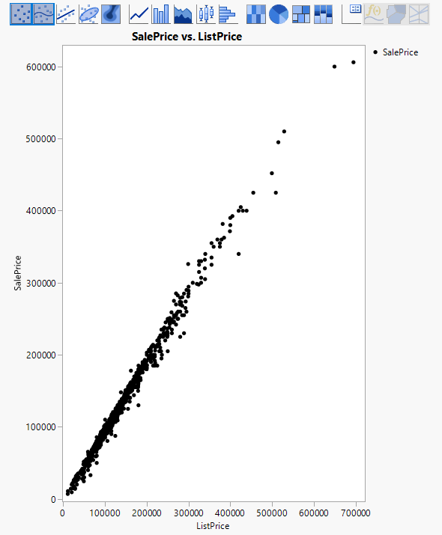1. Draw a scatter plot with list price on the X axis and sale price on the Y axis. Your answer is an uploaded copy of your scatterplot

Note: make sure you can explain why it is appropriate to put list price on the X axis and sale price on the Y axis. (no answer required)

2. Based on the scatterplot, which variable is the

Explanatory variable: List Price

Response variable: Sale Price

3. interpret the scatterplot by answering the following questions:

Is the form curved? no

Is the direction positive yes

Is the strength weak, moderate, or strong? Strong

Are there any outliers (yes/no). yes

4.Fit a least squares regression to predict sale price and report (remember, round to 2 digits, so 115309.2 is 120000 and 0.005318 is 0.0053)

a. Intercept value: -140

b. Slope value: .94

5. Interpret the value of the slope (not just its sign) in the context of this problem: (free answer).

Ever dollar increase in list price is associated with a 94 cent increase in sale price.

Part 2 1.22 – Grinnell house sales, continued

1. Prediction:

$93690.11 = -144.8329 + 0.9430648*(99500)

2. a. Compute residual:

95000-93690.11 = 1309.89

2. b. Interpret the value of the residual in context: (free answer)

The actual price of the house was $1309.89 higher than what the regression predicted.

3. Linear regression model good summary? (yes/no)

Yes

Part 3 More Grinnell house sale questions not in your book.

1. What is the value of the y-intercept?

-144.8329

2. Is this a meaningful result in the context of this problem? (yes/no)

No, house prices can’t be negative

Note: Make sure you can explain why it is or is not meaningful. (no answer required).

3. House B has a list price that is $25,000 higher than house A. Use the coefficients from the linear regression fit to predict how much higher House B’s sale price will be.

The sale price of House B will be approximately $23576.62 higher

4. What is the value of the correlation?

.9947

5. Interpret the correlation. (free answer)

There is an extremely strong and positive correlation between list price and sale price

6. What is the value of the coefficient of determination (i.e., R2)?

.98943