**cpre419 Lab 1**

Experiment 1:

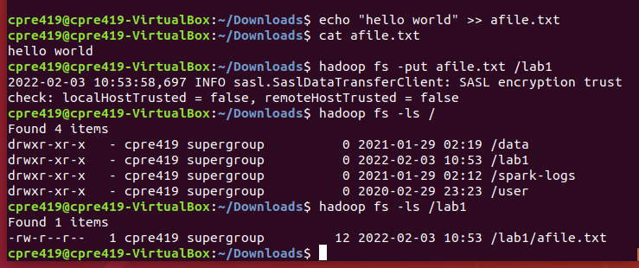

Here, we can see that my afile.txt was successfully added to the Hadoop file system

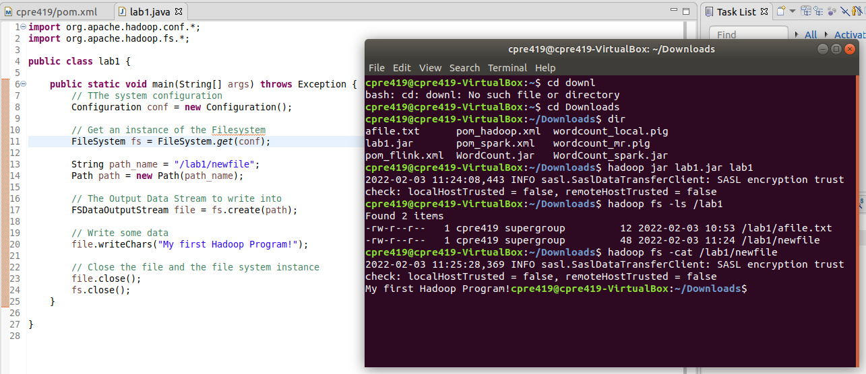

Hello World!

Experiment 2:

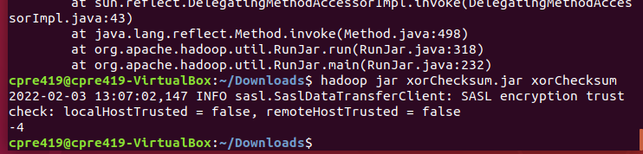

Upon running the jar within Hadoop fs, the output shows -4, the correct checksum