**Lab 5 Submission**

netids: yarles, bkrouse

Summary

We wrote programs that counted the use of each word and sorted them from most to least used and to regenerate two firewall logs. Spark is pretty dope, the RDD mapping functionality is somewhat overpowered.

Experiment 1

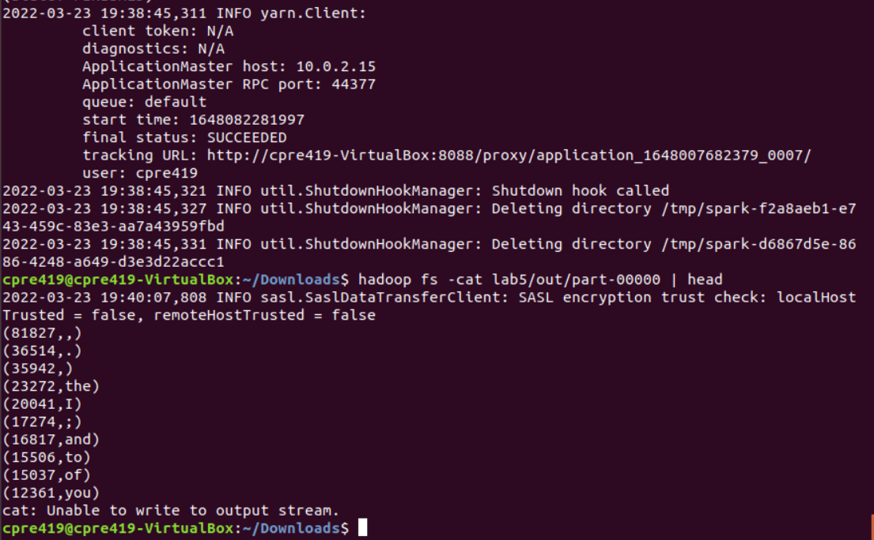

Experiment 2

