First we need to have a github account, and create a repository there:
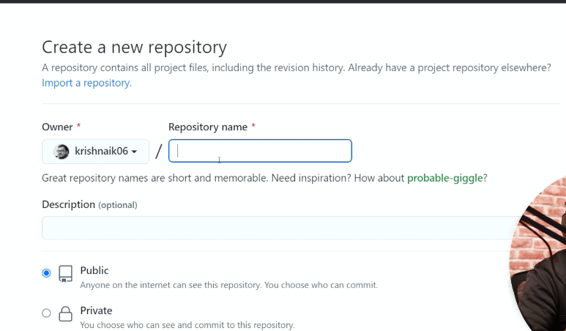
Then we need to install git cli:
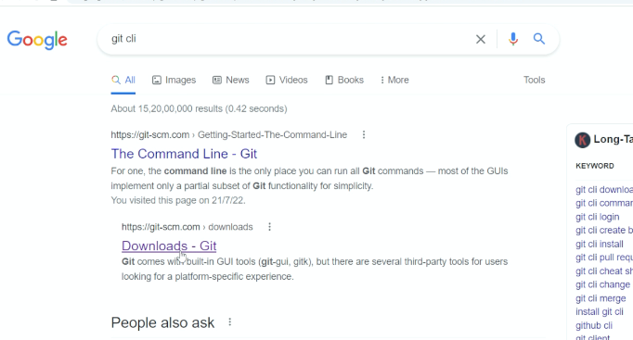
Then we check the version of git in cmd to make sure it is installed:
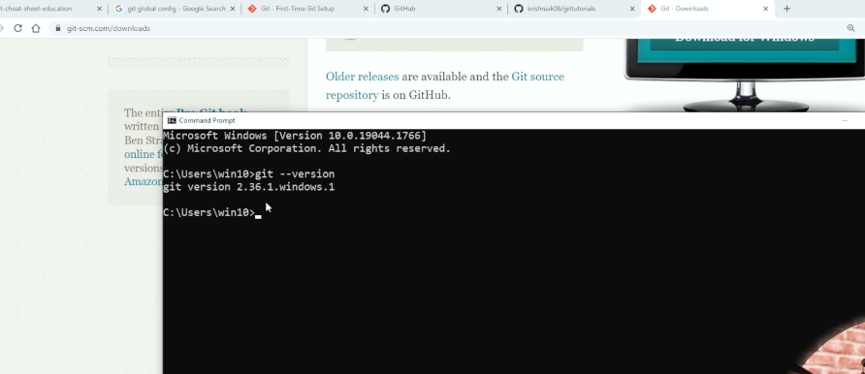
Then we create some files locally and commit them to the repository I created. Fisrt we create a readMe.md file and we copy its pass from local, and we cd to that path:
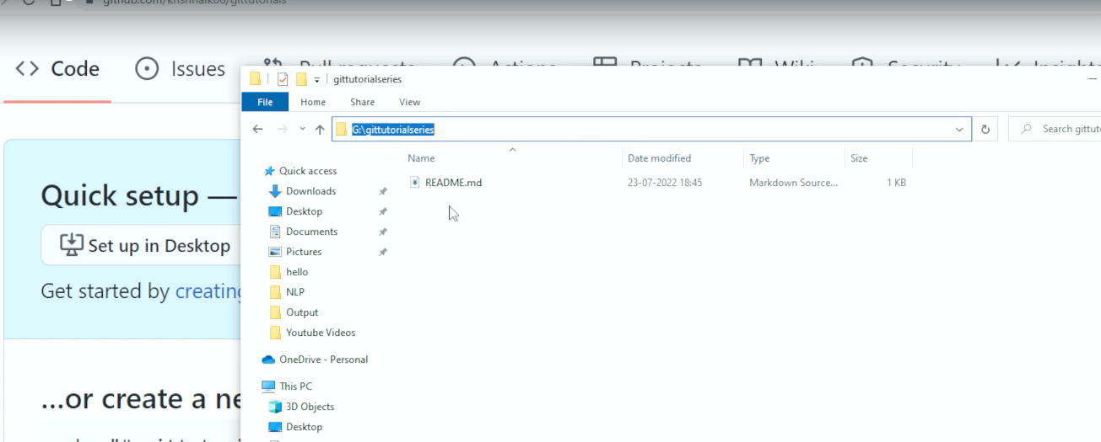
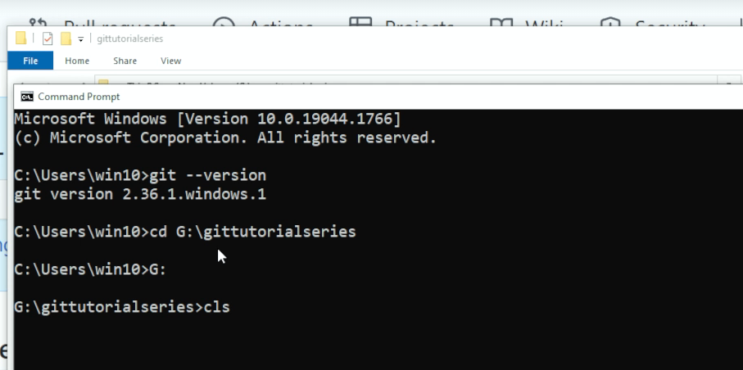
Then we first initialize the git , which will create a .git file in that local path
To see the files in your directory, use dir:
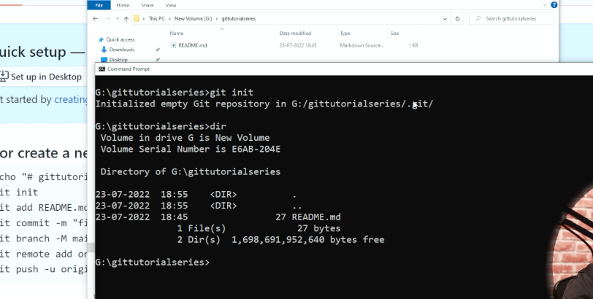
We need to configure our Github account to this git folder to be able to commit to the repository, to check if we config or not, run the below command:
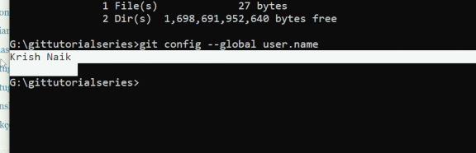
Also for user email do the same: 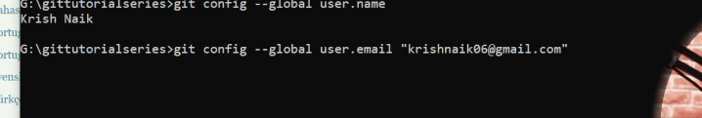
With git status we can see the tracked and untracked files:
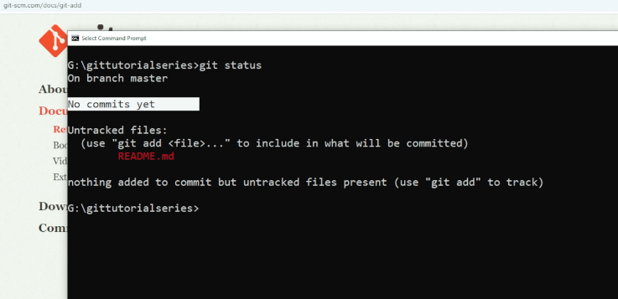
To track the file run git add:

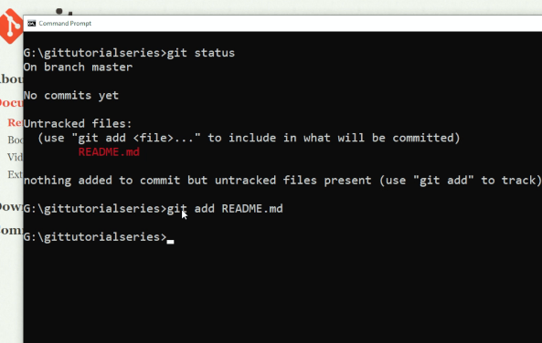
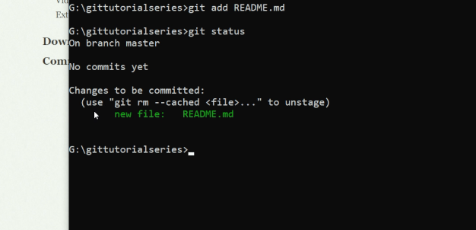
Now that we add the file to the stage, we can commit it using git commit -m “message”:
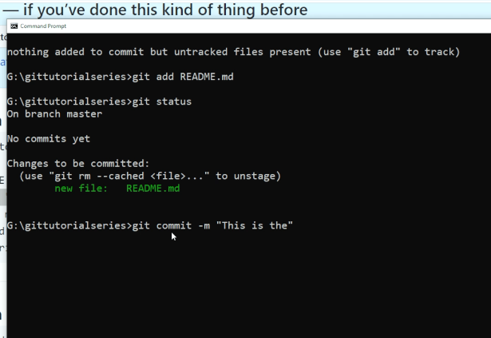
To check the branch use git branch:
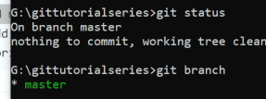
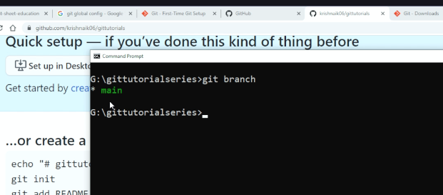
Now we should make sure that our local repository is connected to the GitHub repository. For that we copy the http link from our repository, and we will run the command below:
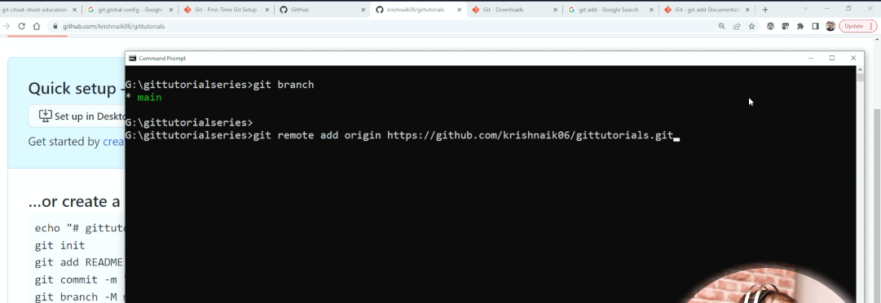
Run below command to see where you fetch and push from local to:
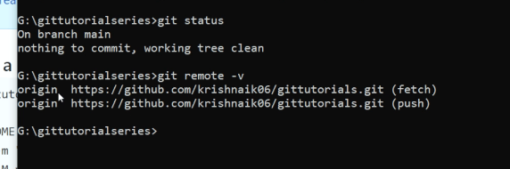
Now we use git push to push the file to github repository branch main:
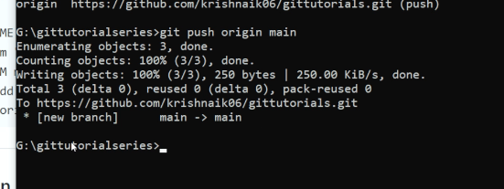
Then if we refresh the github page, we can see the branch is created and the Readme file that we pushed.
Now suppose I make some changes to this file and save it. Now, if I say git status we will se that the file is modified:
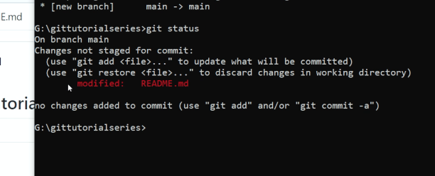
Now you can add this file or restore the previous file:

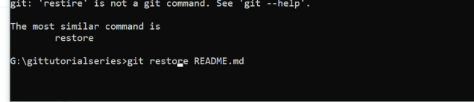
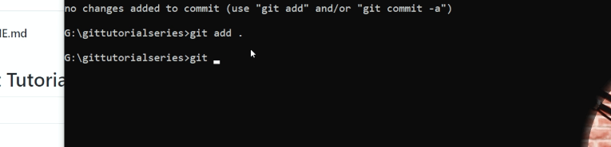
Now suppose we want to clone the repository completely to a new folder in our local system, we used its http URL, with git clone. Then after cloning, everything will be copied on the local system:
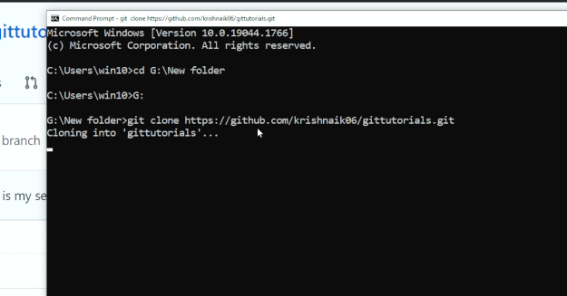
Git Merge,push,…:
We can use git reset to, it will return the file back from staging to untracked:
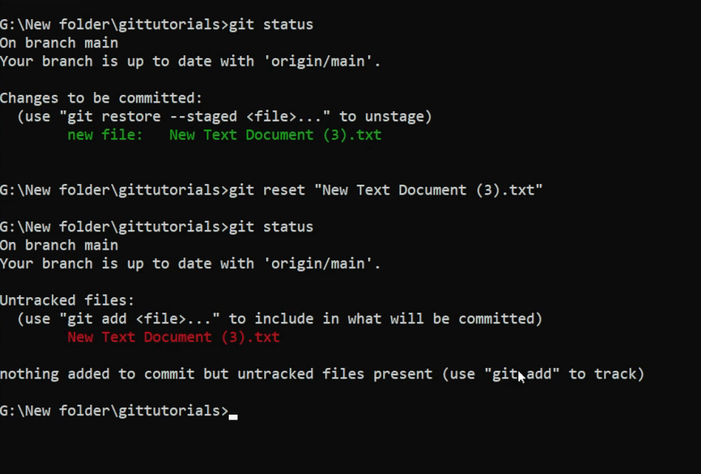
Branch:
Use git branch to create a new branch, use git checkout to go to another branch
