React Test

**1#**

What is props drilling and how can we improve this mechanism for large scale applications?

(Explain in your own words)

Props drilling is when a prop from a parent component is required in child component which is child of another child component so we have to pass through all components when though it is not need there like example below,

Parent Component

Child Component 1

Child Component 2

Child Component 3

Child Component 4

Now like the diagram we need some data from parent component to child 4 component so we to pass through all the other sub parent components even though we don’t need it there, to over come this situation we use a library like context or redux tool kit there are many other too they almost work like same they keep data in separate store which is provider to App component through that we can get data without passing down the probs,

Parent Component

Child Component 1

Centralized store

Child Component 2

Child Component 3

Child Component 4

**2#**

What are refs and when to use them ?

Use refs allow us to keep value between renders and also changing value without causing re-renders,

To use them we import them form react library and assign it as value like const count = useRef(0)

Then we can increased it in useEffect or a separate function and add count.current = count.current +1 it will increase the value onClick

**3#**

Why we use middlewares in React like (Redux-Saga, Redux-Thunk etc) ?

Redux doesn’t allow us to use complex logic inside function like Dogapi I cant use it insdie redux for that I have to use thunk to use complex logic and fetch api data,

**4#**

What is the replacement of componentWillReceiveProps lifecycle method in React v17, what parameters do that method accepts?

Im not sure about this, maybe use hooks as replacement after react 16 class based methods were deprecated and functional components were used even though their documentation is still in class base components,

**5#**

**TASK:**

Make a screen which shows the list of all dog breeds got from API.

The API end point will be:

**https://dog.ceo/api/breeds/list/all**

**TYPE: GET**

Clicking on any of the breed will open a MODAL popup, and it will show all the images of that particular breed. For instance, we click on **hound,** so the Modal will show images of hounds.

API endpoint to be used:

[**https://dog.ceo/api/breed/{breedNAME}/images**](https://dog.ceo/api/breed/hound/images)

**TYPE: GET**

The images will be shown in form of a GRID. (Rows and Cols). Each row will have 5 images.

You can use any UI library for your ease.

NOTE: ***API callings will be done via middleware (Redux-Thunk or Redux-Saga).***

**Screenshots**

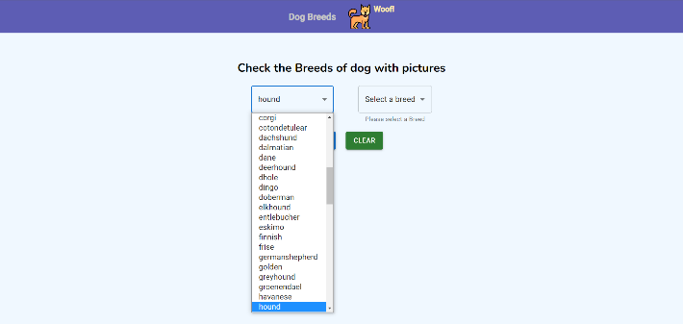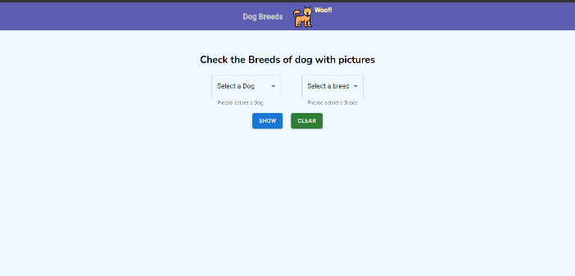

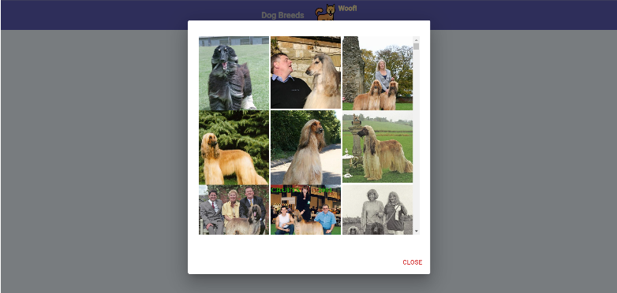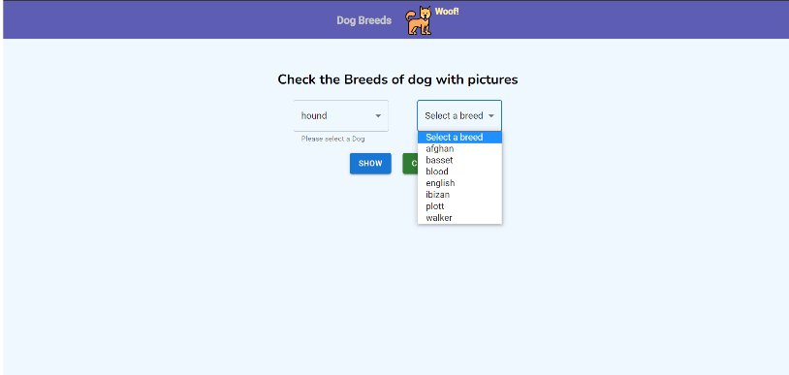

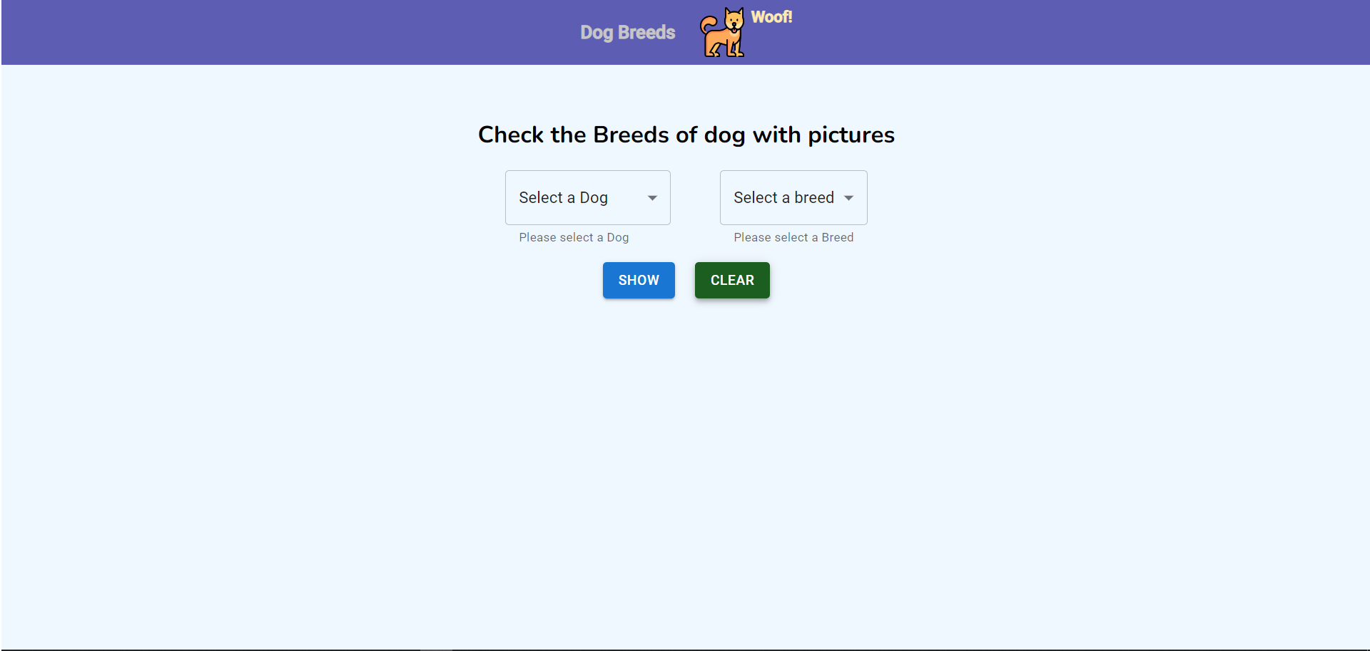

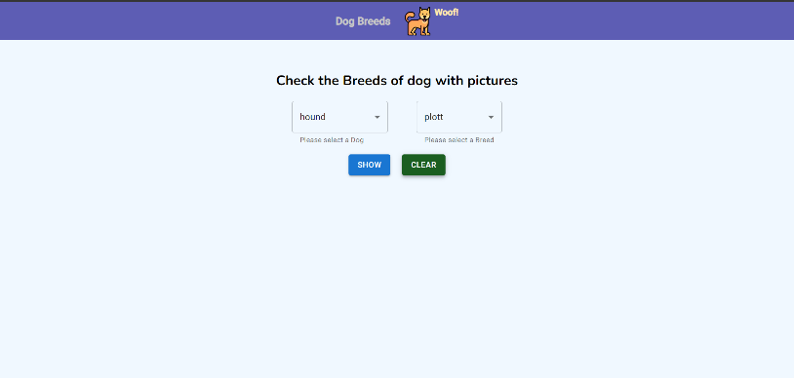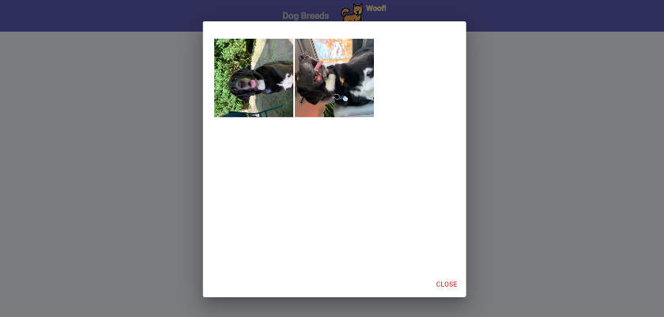

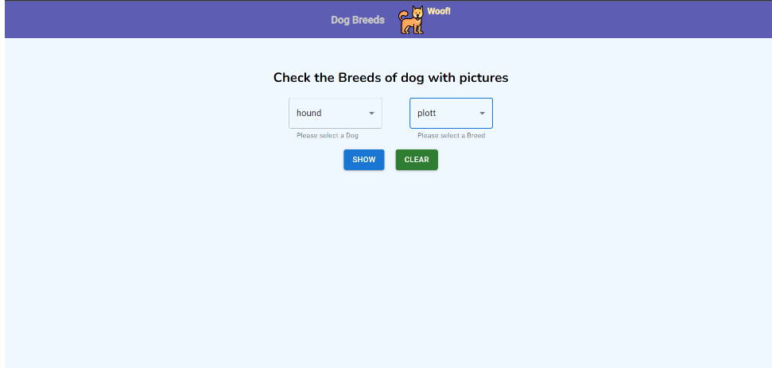

Note : Please submit code and your theory on github : https://github.com/prism-me/react_jobtest.git