**Chocolate Chip Cookies**

**1 /4 c. shortening**

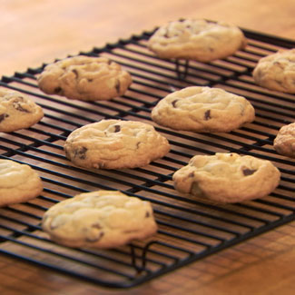

**1/4 c. margarine**

**1 /4 c. sugar**

**1/2 c. brown sugar, packed**

**1 egg**

**1/8 tsp. salt**

**1/2 tsp. baking soda**

**1 tsp. vanilla**

**1 1/4 c. flour**

**1 c. chocolate chips**

1. **Preheat oven to 375 degrees.**
2. **In mixer, CREAM shortening, margarine and sugars until smooth.**
3. **Beat in egg, and mix until smooth again.**
4. **Mix in salt, baking soda, and vanilla.**
5. **Gradually stir in flour. CHECK OFF YOUR COOKIE DOUGH WITH YOUR TEACHER BEFORE MOVING ON!**
6. **Finally add chocolate chips; then form into small round balls and place on a greased cookie sheet. (Allow space because they spread out while baking).**
7. **Bake for 8-10 minutes.**
8. **Let cookies cool for 1 minute; then remove with a turner onto a cooling rack. After cooling about 5 minutes, ENJOY!**