Main launch result -
SVM (LBP) Accuracy: 36.36%
precision recall f1-score support

anger 0.00 0.00 0.00 18
fear 0.00 0.00 0.00 7
happy 0.50 0.47 0.48 30
neutral 0.30 0.58 0.40 36
sadness 0.33 0.12 0.17 17
surprise 0.38 0.43 0.40 35

accuracy 0.36 143
macro avg 0.25 0.27 0.24 143
weighted avg 0.31 0.36 0.32 143

/usr/local/lib/python3.12/dist-packages/sklearn/metrics/_classification.py:1565: UndefinedMetricWarning: Precision is ill-defined and being set to 0.0 in labels with no predicted samples. Use `zero_division` parameter to control this behavior.
_warn_prf(average, modifier, f"{metric.capitalize()} is", len(result))
/usr/local/lib/python3.12/dist-packages/sklearn/metrics/_classification.py:1565: UndefinedMetricWarning: Precision is ill-defined and being set to 0.0 in labels with no predicted samples. Use `zero_division` parameter to control this behavior.
_warn_prf(average, modifier, f"{metric.capitalize()} is", len(result))
/usr/local/lib/python3.12/dist-packages/sklearn/metrics/_classification.py:1565: UndefinedMetricWarning: Precision is ill-defined and being set to 0.0 in labels with no predicted samples. Use `zero_division` parameter to control this behavior.
_warn_prf(average, modifier, f"{metric.capitalize()} is", len(result))
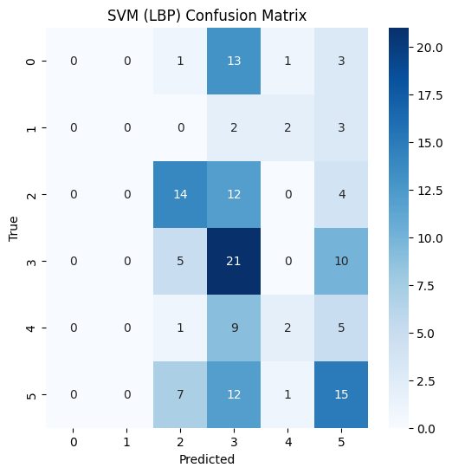
Decision Tree (LBP) Accuracy: 28.67%
precision recall f1-score support

anger 0.21 0.22 0.22 18
fear 0.00 0.00 0.00 7
happy 0.36 0.40 0.38 30
neutral 0.28 0.28 0.28 36
sadness 0.29 0.29 0.29 17
surprise 0.32 0.29 0.30 35

accuracy 0.29 143
macro avg 0.24 0.25 0.25 143
weighted avg 0.29 0.29 0.29 143

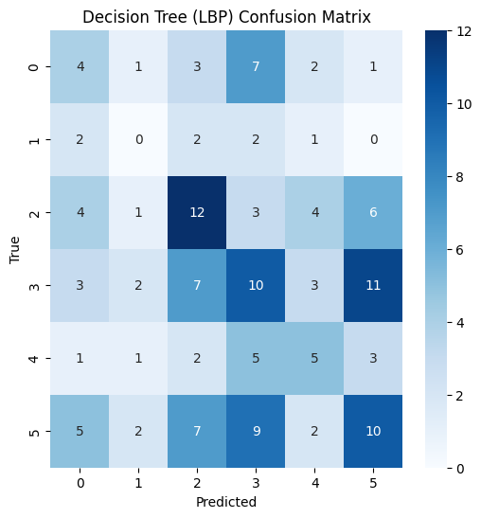
KNN (HOG) Accuracy: 58.74%
precision recall f1-score support

anger 0.47 0.44 0.46 18
fear 0.25 0.14 0.18 7
happy 0.85 0.73 0.79 30
neutral 0.45 0.78 0.57 36
sadness 0.43 0.18 0.25 17
surprise 0.81 0.63 0.71 35

accuracy 0.59 143
macro avg 0.54 0.48 0.49 143
weighted avg 0.61 0.59 0.58 143

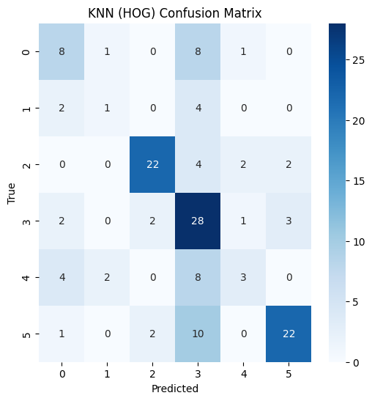

Naive Bayes (HOG) Accuracy: 65.73%
precision recall f1-score support

anger 0.69 0.50 0.58 18
fear 0.00 0.00 0.00 7
happy 0.96 0.87 0.91 30
neutral 0.50 0.81 0.62 36
sadness 0.36 0.29 0.32 17
surprise 0.81 0.71 0.76 35

accuracy 0.66 143
macro avg 0.55 0.53 0.53 143
weighted avg 0.65 0.66 0.64 143

/usr/local/lib/python3.12/dist-packages/sklearn/metrics/_classification.py:1565: UndefinedMetricWarning: Precision is ill-defined and being set to 0.0 in labels with no predicted samples. Use `zero_division` parameter to control this behavior.
_warn_prf(average, modifier, f"{metric.capitalize()} is", len(result))
/usr/local/lib/python3.12/dist-packages/sklearn/metrics/_classification.py:1565: UndefinedMetricWarning: Precision is ill-defined and being set to 0.0 in labels with no predicted samples. Use `zero_division` parameter to control this behavior.
_warn_prf(average, modifier, f"{metric.capitalize()} is", len(result))
/usr/local/lib/python3.12/dist-packages/sklearn/metrics/_classification.py:1565: UndefinedMetricWarning: Precision is ill-defined and being set to 0.0 in labels with no predicted samples. Use `zero_division` parameter to control this behavior.
_warn_prf(average, modifier, f"{metric.capitalize()} is", len(result))
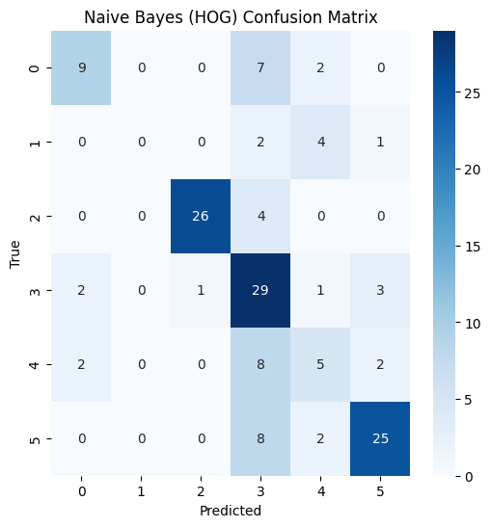

predict_single_image result –
Predicted Emotion: neutral
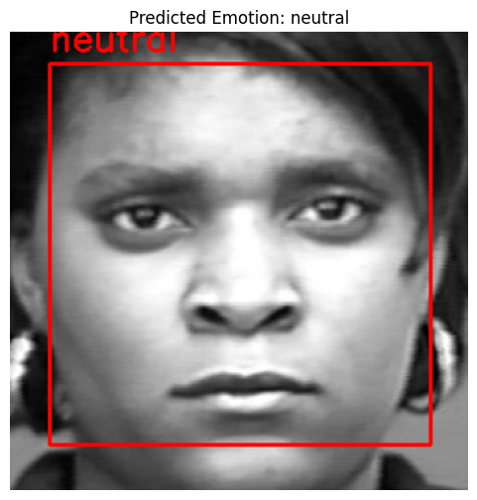
Predicted Emotion: neutral
Predicted Emotion: neutral
Predicted Emotion: anger 