**Report on results of performance testing: Task2 – Generating test data**

**Purpose**

Check the ability to create unique test data in testing tool. Simulate authorization scenario with generating posts. Get skills of using test parameters and making non-linear test scenarios.

**Environment**

Virtual machine emulated with Oracle VM VirtualBox Manager Version 6.0.10:

|  |  |
| --- | --- |
| OS | Windows 10 |
| Base Memory | 2048 MB |
| Processors | 2 |
| Acceleration | VT-x/AMD-V, Nested Paging, PAE/NX, Hyper-V Paravirtualization |
| Attached to | Bridget Adapter |
| Adapter Type | Intel PRO/1000 MT Desktop (82540EM) |
| Promiscuous Mode | Deny |
| MAC Address | 0800272FEB0A |

Host Machine:

|  |  |
| --- | --- |
| Processor | Intel(R) Core(TM) i5-3470 CPU @ 3.20GHz 3.20 GHz |
| Installed memory(RAM) | 16.0 GM (15.9 GB usable) |
| System Type | 64-bit Operating System, x64-based processor |

Parameters:

|  |  |
| --- | --- |
| Server Name | 10.17.172.94/blog |
| Protocol | http |
| Login | Editor |
| Password | Editor |
| Timer delay | 3 sec |
| Timer deviation | 1 sec |

**Load Model**

Thread Group

|  |  |
| --- | --- |
| Number of users | 2 |
| Ramp-Up-Period | 0 |
| Loop Count | 1 |
| Number of posts to create, N | 100, 1000, 2000 |

* Authorize
* Wait (2 sec – 4 sec)
* Create post with random date (for 100 – random, for 1000 and 2000 – one from 10 predefined) and random text (from 50 to 1000 characters) N times

**Results**

|  |  |
| --- | --- |
| Posts | 100 |
| Summary | There are almost no critical delays in creating posts system. There are some CPU jumps, but they do not affect response time and maybe can be explained by not related server’s processes. |
| Time to create N posts | 15 – 16 sec |
| Percent of errors | 2.50 % |
| Generate post - 90% | 298 |
| Generate post - 95% | 422 |
| Generate post - 99% | 819 |

|  |  |
| --- | --- |
| Posts | 1000 |
| Summary | CPU and response time are almost stable, but response time is growing up linearly according to the number of created posts |
| Time to create N posts | 152 – 154 sec |
| Percent of errors | 4.35 % |
| Generate post - 90% | 193 |
| Generate post - 95% | 223 |
| Generate post - 99% | 330 |

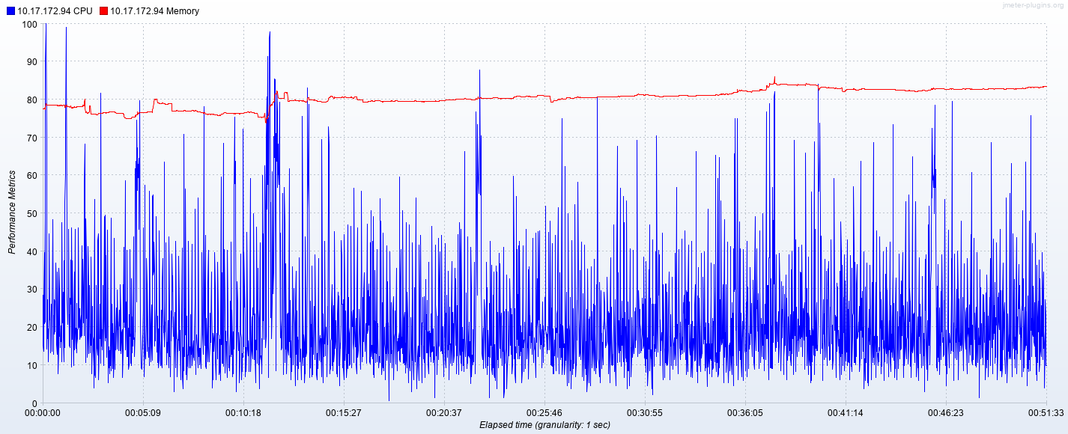

|  |  |
| --- | --- |
| Posts | 2000 |
| Summary | Response time is getting unstable during the test execution, also response time is growing up like in the previous test |
| Time to create N posts | 484 - 490 sec |
| Percent of errors | 7.53 % |
| Generate post - 90% | 311 |
| Generate post - 95% | 349 |
| Generate post - 99% | 440 |

**Summary**

Response time increases according to number of posts. Also as long test goes, then more requests are not processed.