**Report on results of performance testing: Task5 – Perform editor script load test**

**Purpose**

Implement editor scenario to discover system’s performance being used by several number of editors.

**Environment**

Virtual machine emulated with Oracle VM VirtualBox Manager Version 6.0.10:

|  |  |
| --- | --- |
| OS | Windows 10 |
| Base Memory | 4096 MB |
| Processors | 2 |
| Acceleration | VT-x/AMD-V, Nested Paging, PAE/NX, Hyper-V Paravirtualization |
| Attached to | Bridget Adapter |
| Adapter Type | Intel PRO/1000 MT Desktop (82540EM) |
| Promiscuous Mode | Deny |
| MAC Address | 0800272FEB0A |

Host Machine:

|  |  |
| --- | --- |
| Processor | Intel(R) Core(TM) i7-8700 CPU @ 3.20GHz 3.19 GHz |
| Installed memory(RAM) | 32.0 GM (31.7 GB usable) |
| System Type | 64-bit Operating System, x64-based processor |

Parameters:

|  |  |
| --- | --- |
| Server Name | 10.66.154.73/blog |
| Protocol | http |
| Timer delay | 2 sec |
| Timer deviation | 0.5 sec |
| Credentials 1 | EditorOne, EditorOne |
| Credentials 2 | EditorTwo, EditorTwo |
| Predefined date 1 | 2019/09/03 |
| Predefined date 2 | 2019/09/02 |

**Load Model**

Thread Group

|  |  |
| --- | --- |
| Number of users | 2 |
| Ramp-Up-Period (in sec) | 1 |
| Loop Count | Forever |
| Duration | 20 min |
| Number of iterations | 50 |

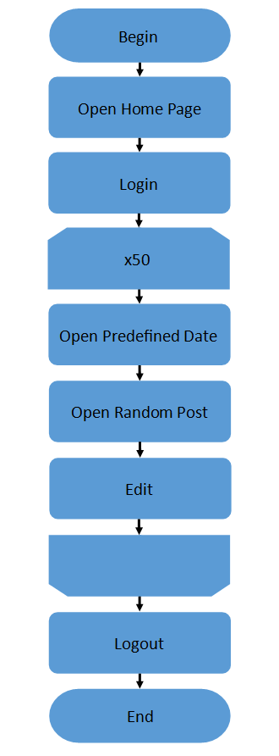**Results**

All requests were proceeded in less than 0.1 seconds. CPU and memory using were stable during whole test. In conclusion, test results are good in comparison to previous tests, such performance can be used for comparing as desired application performance.

|  |  |  |  |  |  |  |  |  |
| --- | --- | --- | --- | --- | --- | --- | --- | --- |
| Label | # Samples | Average, ms | Median, ms | 90%, ms | 95%, ms | 99%, ms | Min, ms | Max, ms |
| Home page request | 12 | 16 | 14 | 21 | 21 | 23 | 1 | 23 |
| Login page request | 6 | 6 | 6 | 7 | 11 | 11 | 4 | 11 |
| Log in request | 6 | 22 | 2 | 27 | 35 | 35 | 16 | 35 |
| Log in request-0 | 6 | 4 | 4 | 6 | 6 | 6 | 4 | 6 |
| Log in request-1 | 6 | 17 | 15 | 19 | 29 | 29 | 12 | 29 |
| Open date | 293 | 16 | 13 | 27 | 32 | 36 | 11 | 4 |
| Open post | 292 | 15 | 12 | 27 | 32 | 36 | 1 | 4 |
| Edit post request | 292 | 8 | 6 | 14 | 17 | 22 | 4 | 28 |
| lookups? | 292 | 6 | 5 | 11 | 13 | 19 | 4 | 23 |
| tags? | 292 | 4 | 3 | 6 | 7 | 16 | 2 | 18 |
| Open edit post page request | 292 | 4 | 4 | 6 | 7 | 11 | 3 | 16 |
| customfields1? | 292 | 3 | 3 | 4 | 5 | 11 | 2 | 16 |
| customfields2? | 292 | 3 | 3 | 4 | 4 | 6 | 2 | 1 |
| Update post request | 291 | 5 | 4 | 9 | 11 | 18 | 3 | 21 |
| Open edited post | 291 | 5 | 4 | 9 | 11 | 17 | 3 | 24 |
| customfields3? | 291 | 2 | 2 | 5 | 5 | 7 | 1 | 19 |
| Log out request | 4 | 17 | 17 | 2 | 2 | 2 | 16 | 2 |
| Log out request-0 | 4 | 4 | 4 | 6 | 6 | 6 | 4 | 6 |
| Log out request-1 | 4 | 13 | 12 | 16 | 16 | 16 | 12 | 16 |
| Open home page | 4 | 11 | 11 | 15 | 15 | 15 | 1 | 15 |
| TOTAL | 4154 | 1 | 6 | 28 | 36 | 55 | 1 | 88 |

