**Report on results of performance testing: Task3 – Perform capacity testing**

**Purpose**

Implement Anonymous user scenario in order to perform basic Capacity testing, gather metrics and make conclusions about system’s limits.

**Environment**

Virtual machine emulated with Oracle VM VirtualBox Manager Version 6.0.10:

|  |  |
| --- | --- |
| OS | Windows 10 |
| Base Memory | 4096 MB |
| Processors | 2 |
| Acceleration | VT-x/AMD-V, Nested Paging, PAE/NX, Hyper-V Paravirtualization |
| Attached to | Bridget Adapter |
| Adapter Type | Intel PRO/1000 MT Desktop (82540EM) |
| Promiscuous Mode | Deny |
| MAC Address | 0800272FEB0A |

Host Machine:

|  |  |
| --- | --- |
| Processor | Intel(R) Core(TM) i7-8700 CPU @ 3.20GHz 3.19 GHz |
| Installed memory(RAM) | 32.0 GM (31.7 GB usable) |
| System Type | 64-bit Operating System, x64-based processor |

Parameters:

|  |  |
| --- | --- |
| Server Name | 10.66.154.62/blog |
| Protocol | http |
| Timer delay | 3 sec |
| Timer deviation | 1 sec |
| Predefined date to use | 2019-09-02 |
| Search | Title |
| Random date interval | 2019-09-01 – 2019-09-04 |
| Number of posts created | 100 |

**Load Model**

Thread Group

|  |  |
| --- | --- |
| Number of users | 500 |
| Ramp-Up-Period (in sec) | 10 hours |
| Loop Count | Forever |

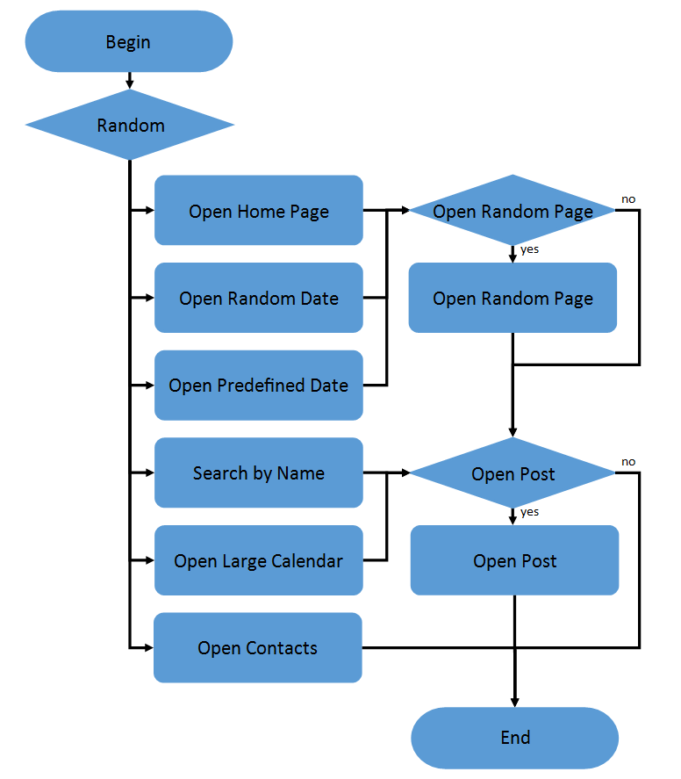

**Results**

1. **System is very unstable to increasing load. It was very hard to complete capacity testing, because reaching of the saturation point breaks the application. CPU and Memory using on server machine become 100% and it stops responding. Therefore, a couple of tests have been executed and results have been compared.**
2. **90 transactions per second was defined as a saturation point, because all tests had overloaded the system after this point. The reason of server’s failings needs deep research to be discovered, because after reaching saturation point, server stops processing requests and they cannot be found in logs.**

**Results of tests**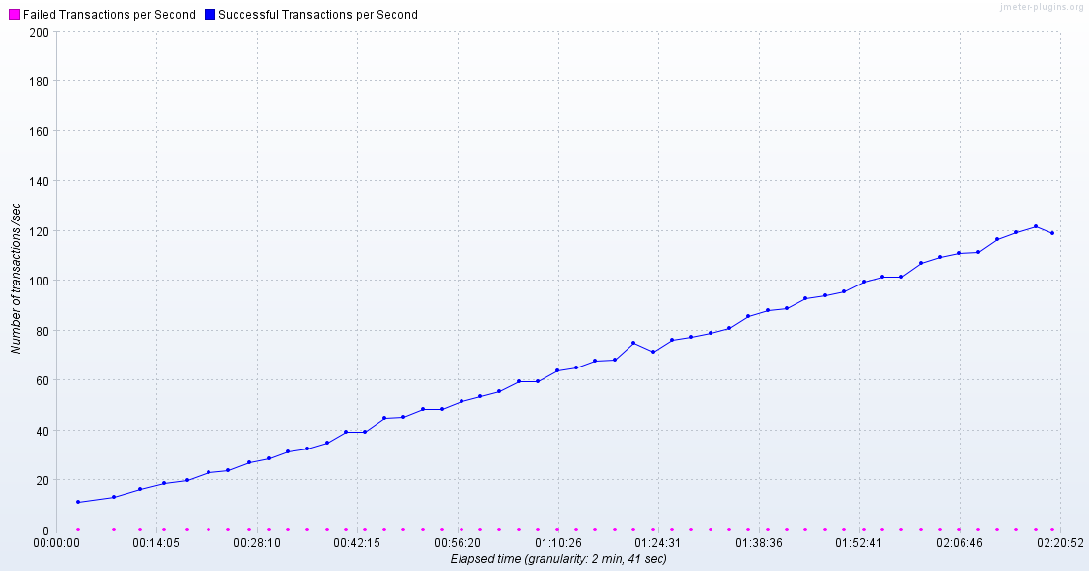

**Number of successful transactions per second.**

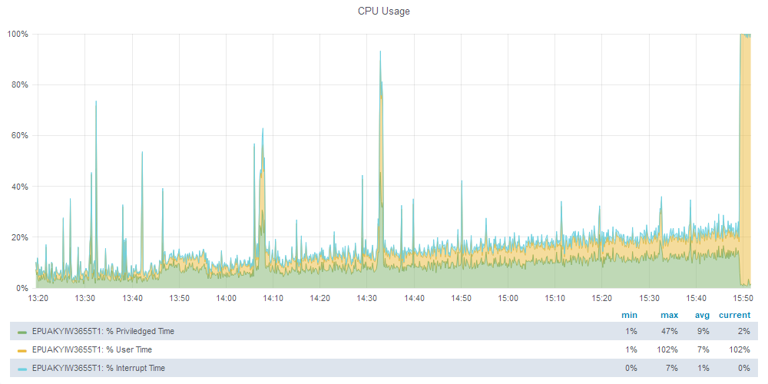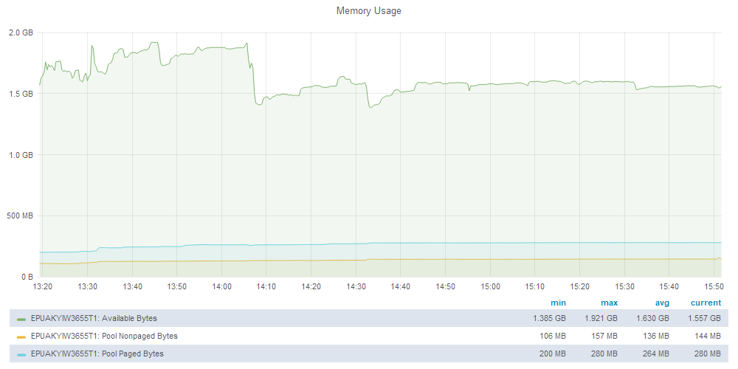

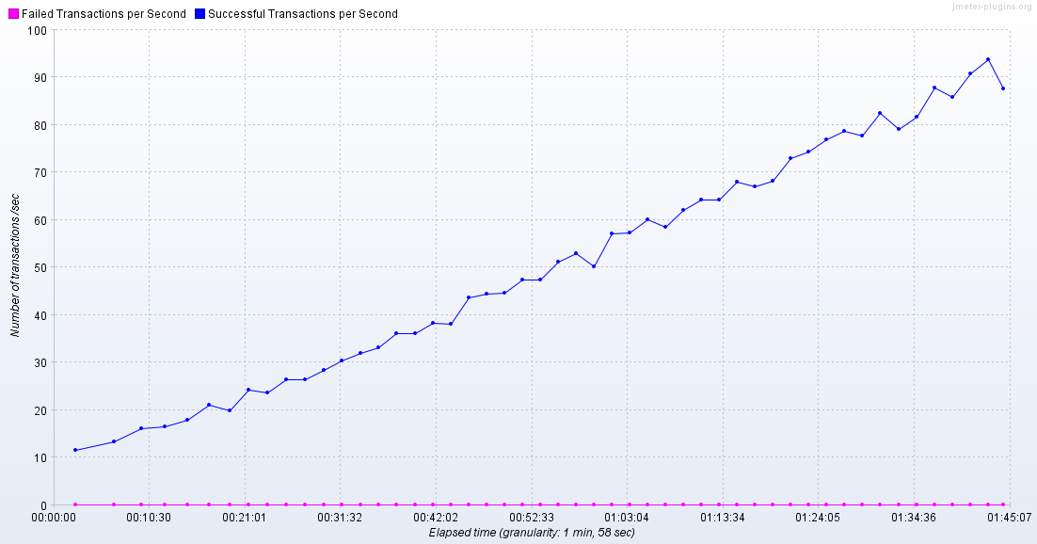

**Number of successful transactions per second.**

