**Report on results of performance testing: Task3 – Perform capacity testing**

**Purpose**

Implement Admin scenario to discover system’s performance under low-level load.

**Environment**

Virtual machine emulated with Oracle VM VirtualBox Manager Version 6.0.10:

|  |  |
| --- | --- |
| OS | Windows 10 |
| Base Memory | 4096 MB |
| Processors | 2 |
| Acceleration | VT-x/AMD-V, Nested Paging, PAE/NX, Hyper-V Paravirtualization |
| Attached to | Bridget Adapter |
| Adapter Type | Intel PRO/1000 MT Desktop (82540EM) |
| Promiscuous Mode | Deny |
| MAC Address | 0800272FEB0A |

Host Machine:

|  |  |
| --- | --- |
| Processor | Intel(R) Core(TM) i7-8700 CPU @ 3.20GHz 3.19 GHz |
| Installed memory(RAM) | 32.0 GM (31.7 GB usable) |
| System Type | 64-bit Operating System, x64-based processor |

Parameters:

|  |  |
| --- | --- |
| Server Name | 10.66.154.73/blog |
| Protocol | http |
| Timer delay | 2000 ms |
| Timer deviation | 500 ms |
| Credentials | admin, admin |

**Load Model**

Thread Group

|  |  |
| --- | --- |
| Number of users | 2 |
| Ramp-Up-Period (in sec) | 1 |
| Loop Count | Forever |
| Duration | 20 min |
| Number of iterations | 10 |

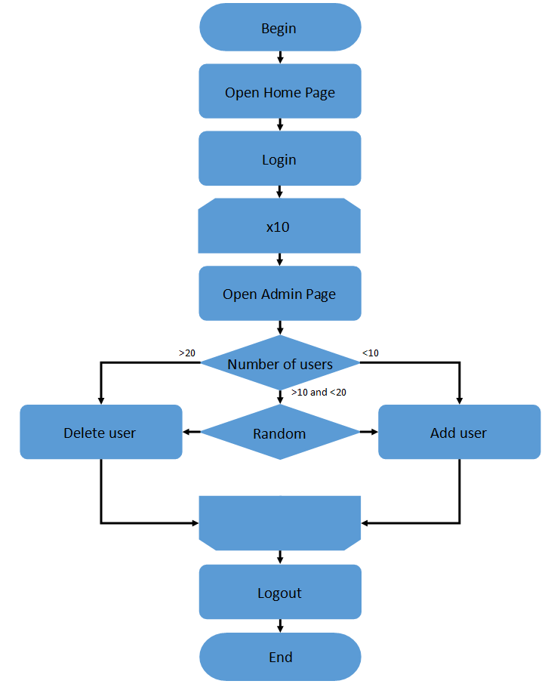

**Results**

**System is stable being used by a small number of admins. All requests were processed fast and without errors. Also there were several number of CPU spikes related to Memory usage. Admin panel requests take the most time to be proceed.**

|  |  |  |  |  |  |  |  |
| --- | --- | --- | --- | --- | --- | --- | --- |
| **Transaction** | **Average**  **(Seconds)** | **Median**  **(Seconds)** | **90%**  **(Seconds)** | **95%**  **(Seconds)** | **99%**  **(Seconds)** | **Min**  **(Seconds)** | **Max**  **(Seconds)** |
| Home page | 0.023 | 0.016 | 0.037 | 0.038 | 0.043 | 0.012 | 0.043 |
| Log in page | 0.009 | **0.006** | **0.020** | **0.021** | **0.023** | **0.003** | **0.023** |
| Log in | 0.032 | 0.027 | 0.048 | 0.049 | 0.057 | 0.019 | 0.057 |
| Admin panel | 1.004 | 0.989 | 1.110 | 1.146 | 1.270 | 0.834 | 1.710 |
| Users panel | 0.017 | 0.014 | 0.029 | 0.032 | 0.040 | 0.007 | 0.127 |
| Change number of users | 0.001 | 0 | 0.001 | 0.001 | 0.001 | 0 | 0.240 |
| Logout | **0** | **0** | **0** | **0** | **0** | **0** | **0** |
| Total | **0.171** | **0.011** | **0.560** | **0.974** | **1.103** | **0** | **1.710** |



