**Report on results of performance testing: Task6 – Perform editor script load test**

**Purpose**

Implement and run two different anonymous scenarios with different usage and user’s paths to discover how the wide use of application functions makes it possible to evaluate the capacity of an application differently. Testing with different amount of data gives an opportunity to conduct basic volume testing.

**Environment**

Virtual machine emulated with Oracle VM VirtualBox Manager Version 6.0.10:

|  |  |
| --- | --- |
| OS | Windows 10 |
| Base Memory | 4096 MB |
| Processors | 2 |
| Acceleration | VT-x/AMD-V, Nested Paging, PAE/NX, Hyper-V Paravirtualization |
| Attached to | Bridget Adapter |
| Adapter Type | Intel PRO/1000 MT Desktop (82540EM) |
| Promiscuous Mode | Deny |
| MAC Address | 0800272FEB0A |

Host Machine:

|  |  |
| --- | --- |
| Processor | Intel(R) Core(TM) i7-8700 CPU @ 3.20GHz 3.19 GHz |
| Installed memory(RAM) | 32.0 GM (31.7 GB usable) |
| System Type | 64-bit Operating System, x64-based processor |

Parameters:

|  |  |
| --- | --- |
| Server Name | 10.66.154.88/blog |
| Protocol | http |
| Timer delay | 3000 ms |
| Timer deviation | 1000 ms |

**Load Model**

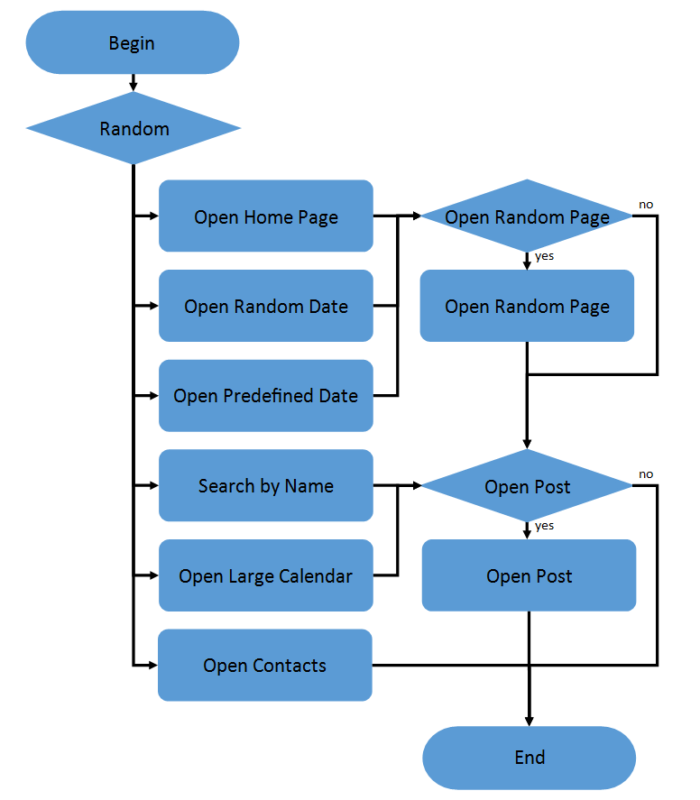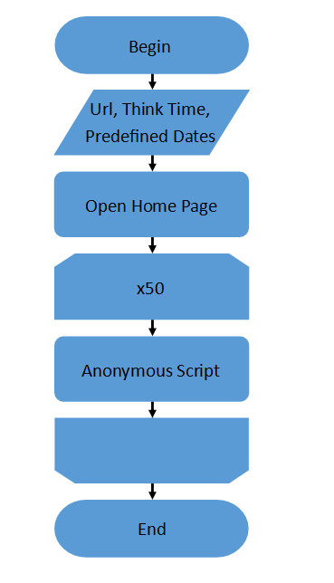

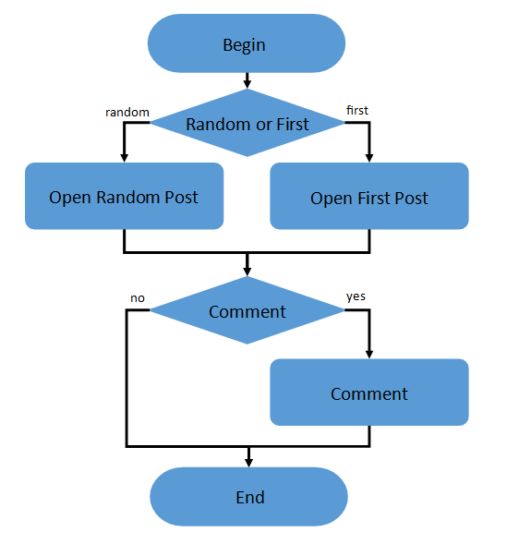

|  |  |
| --- | --- |
| Number of users | 2 |
| Ramp-Up-Period (in sec) | 1 |
| Loop Count | Forever |
| Duration | 60 min |
| Number of iterations | 50 |
| Home Page | 15% |
| Open Random Date | 10% |
| Open Predefined Date | 30% |
| Search by Name | 30% |
| Open Large Calendar | 10% |
| Open Contacts | 5% |

**Results**

**Comparing the launches of Scenarios 3, we can assume that changing the number of posts really affects the speed of processing requests. The values of almost all metrics have increased.**

**However, if you look at the comparison of launches of scenario 6, it looks different. The increase in processing time has not increased for all queries, and not as dramatically as for the 3 scenarios. From this we can conclude that the processed volume of data does not affect all the functions of the application. There is no point in comparing the processing time of the same requests between scenario 3 and 6 because of different caching data models, which affects the total page load time.**

**From this we can conclude that the approach to building a script for testing has a great impact on the comparable results. One should pay attention to how the data is cached and which parts of the application may be affected by the change in data size.**



Task 3 100 Posts

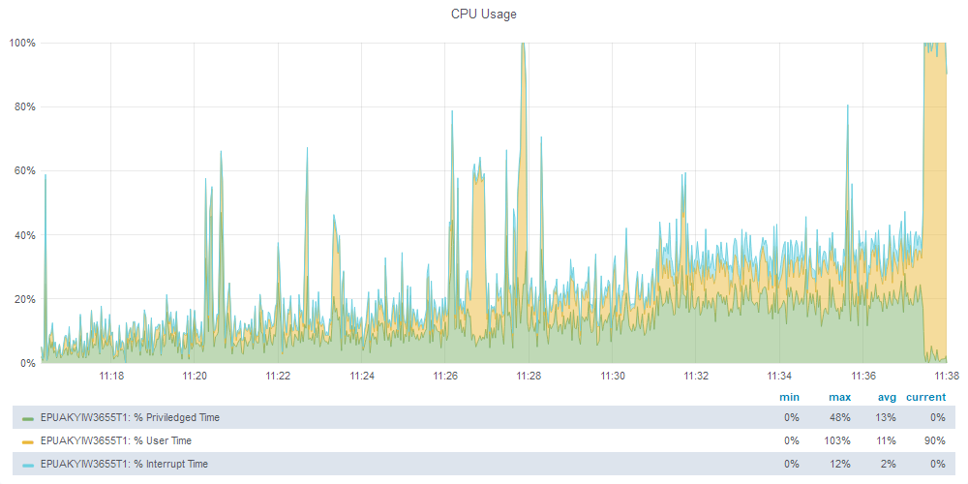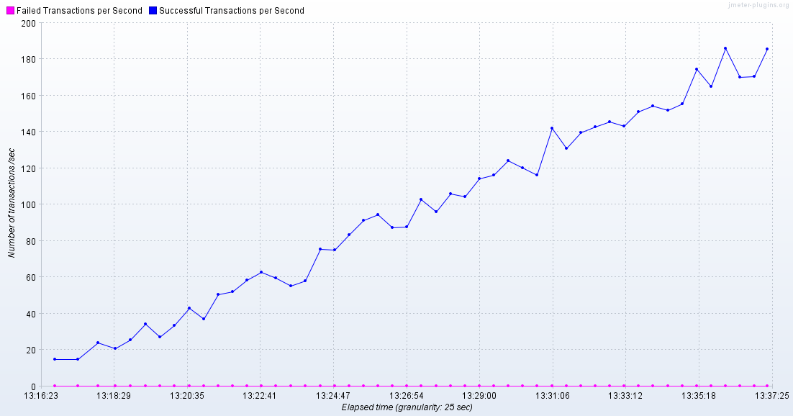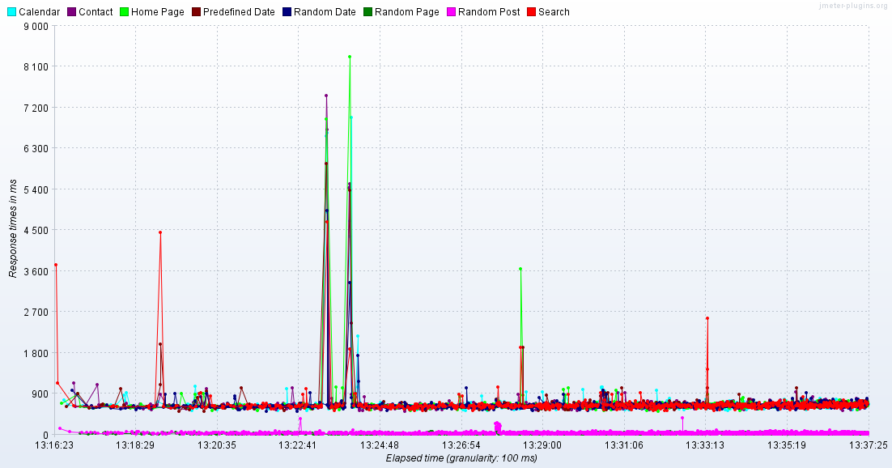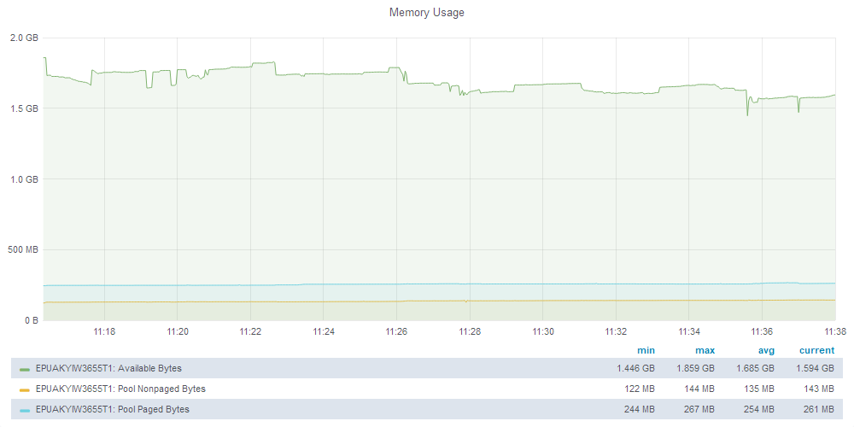

Task 3 1000 Posts

Here at the end of the test we got a lot of errors related to static data loading.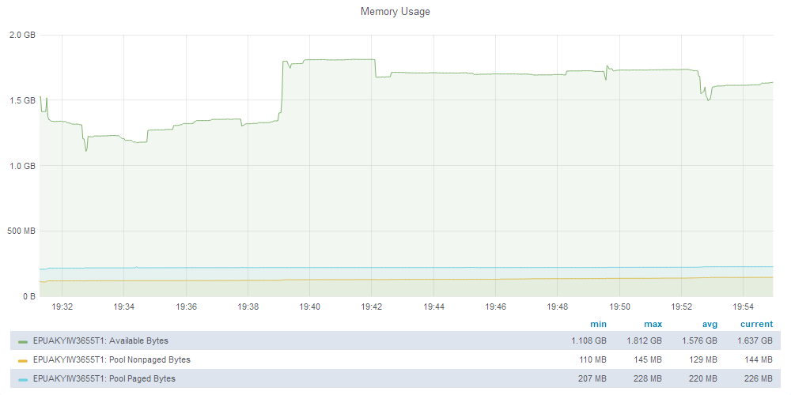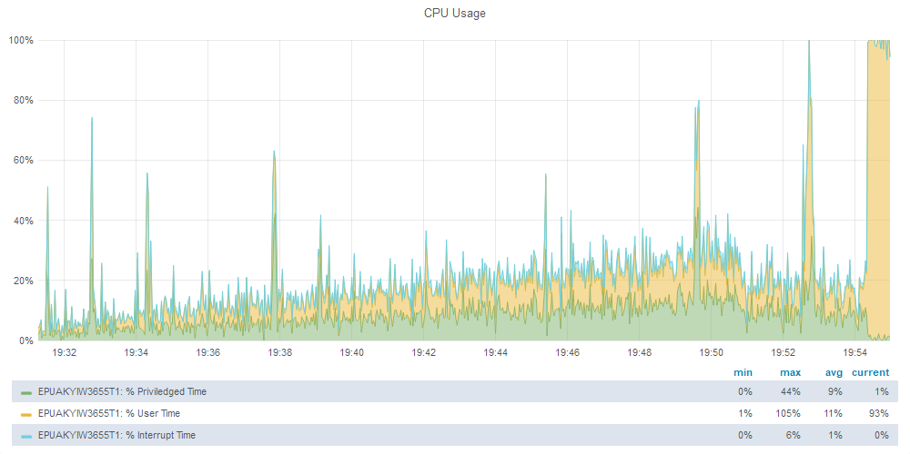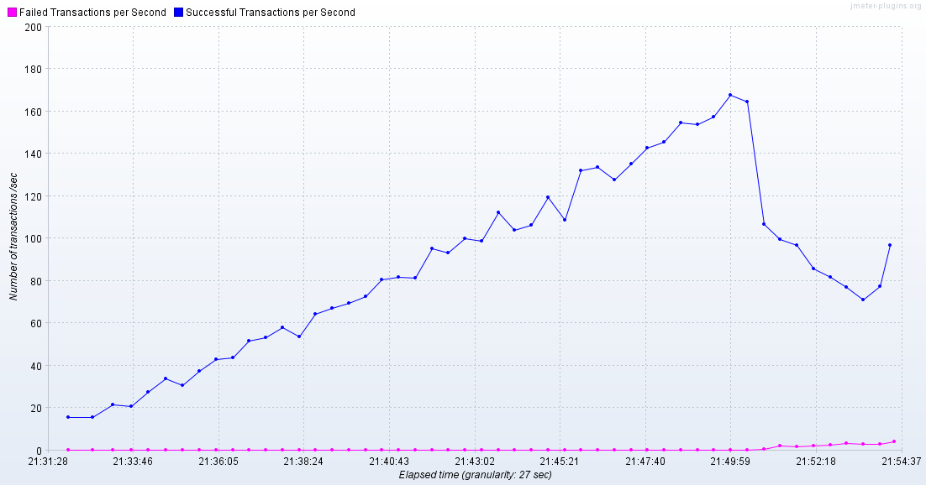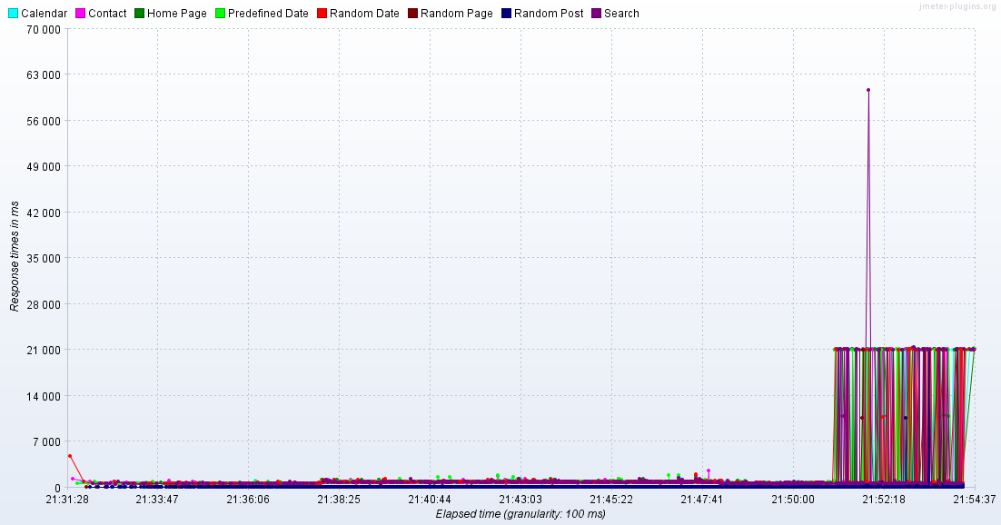

Task 6 100 Posts

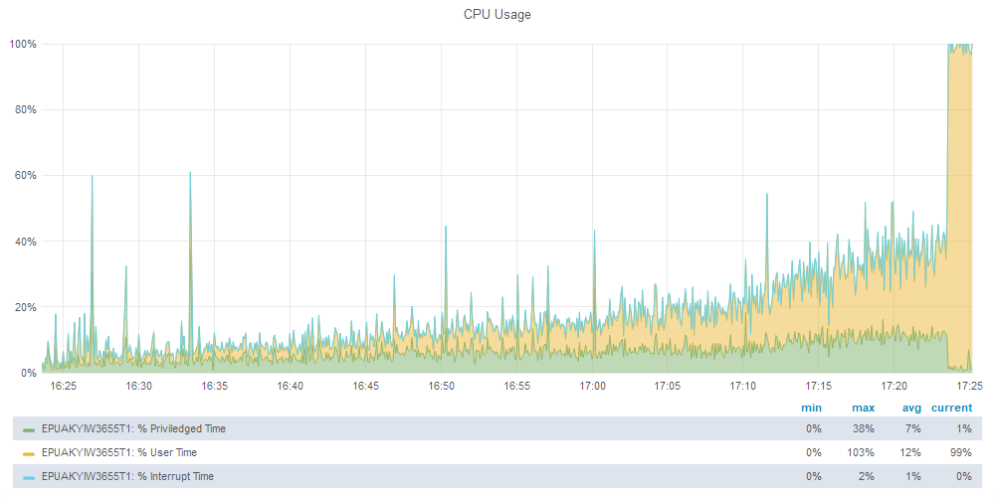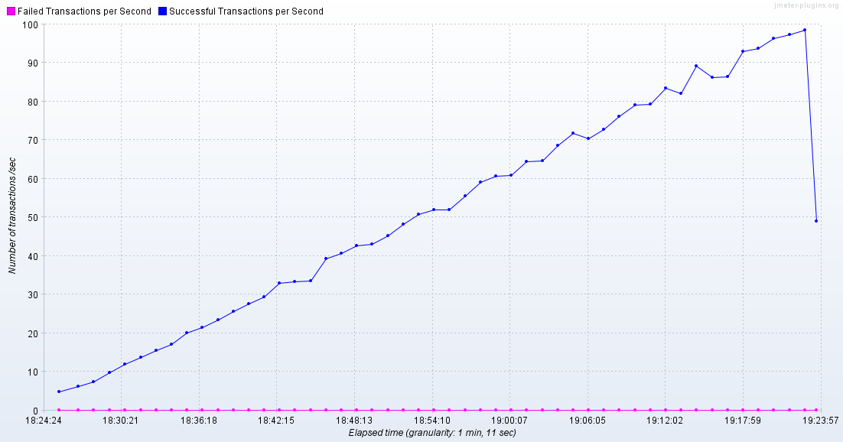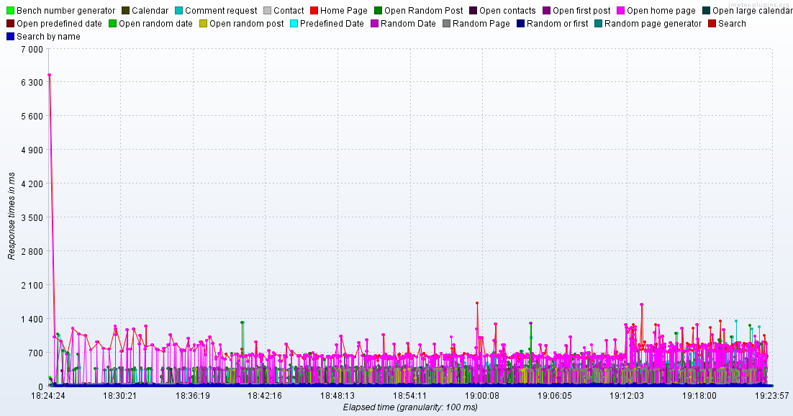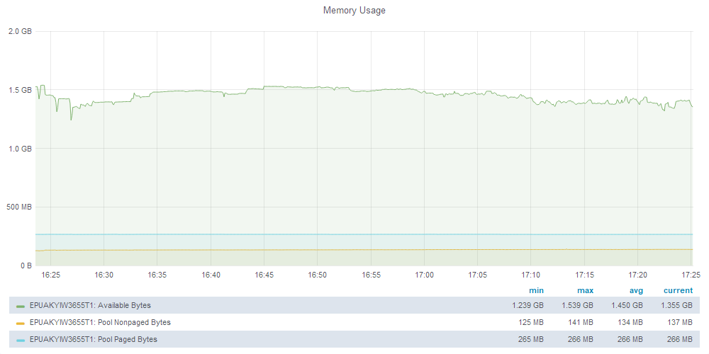

Task 6 1000 Posts

