**Report on results of performance testing: Task7 – Perform general load test**

**Purpose**

Combine three scenarios for different users to simulate real combined load. Perform smoke and capacity tests to analyze application’s performance under combine load.

**Environment**

Virtual machine emulated with Oracle VM VirtualBox Manager Version 6.0.10:

|  |  |
| --- | --- |
| OS | Windows 10 |
| Base Memory | 8192 MB |
| Processors | 4 |
| Acceleration | VT-x/AMD-V, Nested Paging, PAE/NX, Hyper-V Paravirtualization |
| Attached to | Bridget Adapter |
| Adapter Type | Intel PRO/1000 MT Desktop (82540EM) |
| Promiscuous Mode | Deny |
| MAC Address | 0800272FEB0A |

Host Machine:

|  |  |
| --- | --- |
| Processor | Intel(R) Core(TM) i7-8700 CPU @ 3.20GHz 3.19 GHz |
| Installed memory(RAM) | 32.0 GM (31.7 GB usable) |
| System Type | 64-bit Operating System, x64-based processor |

Parameters:

|  |  |
| --- | --- |
| Server Name | 10.66.154.88/blog |
| Protocol | http |
| Timer delay | 3 sec |
| Timer deviation | 1 sec |

**Load Model**

**Anonymous script:**

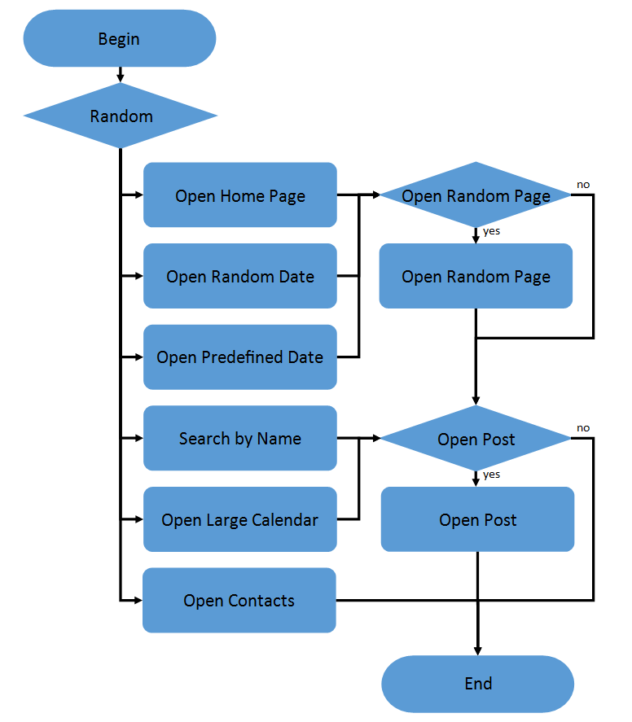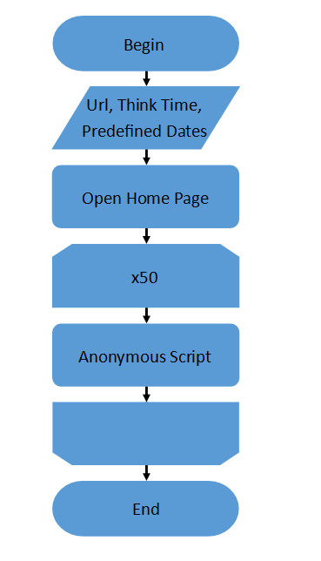

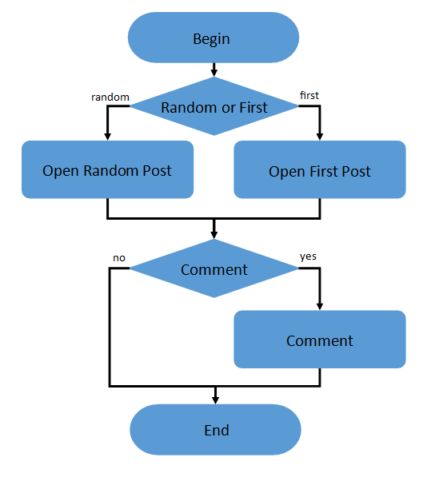**Admin script: Editor script:**

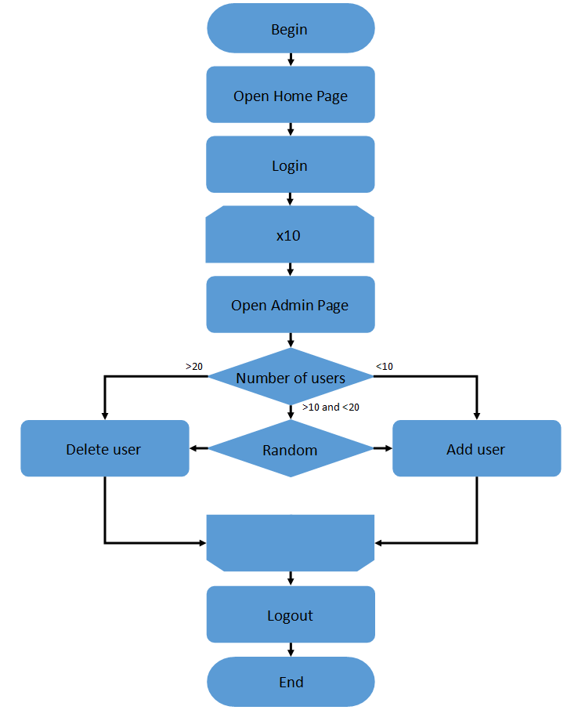 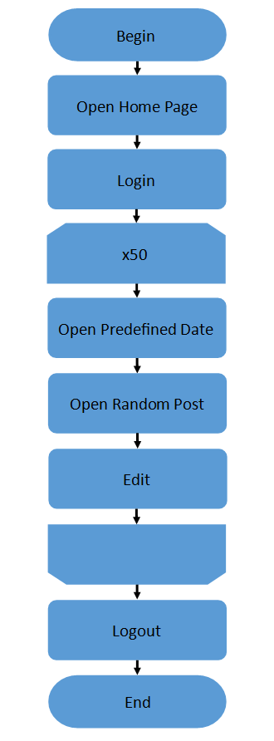

|  |  |
| --- | --- |
| Number of anonymous users | 50 |
| Number of editor users | 1 |
| Number of admin users | 1 |
| Ramp-Up-Period (in sec) | 25 min |
| Loop Count | Forever |
| Duration | 25 min |

**Results**

**It was very hard to complete capacity testing, because reaching of the saturation point breaks the application. CPU and Memory using on server machine become 100% and it stops responding. Therefore, a couple of tests have been executed and results have been compared.**

**25 transactions per second was defined as a saturation point, what corresponds 40 virtual users.**

|  |  |  |  |  |  |  |  |
| --- | --- | --- | --- | --- | --- | --- | --- |
|  | Avg, ms | Median, ms | 90%Line, ms | 95%Line, ms | 99%Line, ms | Min, ms | Max, ms |
| Admin | 7 | 5 | 12 | 18 | 48 | 3 | 366 |
| Calendar | 18 | 15 | 29 | 38 | 59 | 12 | 154 |
| Comment request | 1060 | 347 | 3519 | 4314 | 5161 | 5 | 6096 |
| Contact | 15 | 12 | 22 | 35 | 51 | 10 | 229 |
| Home Page | 19 | 15 | 29 | 38 | 50 | 12 | 189 |
| Log in page | 6 | 4 | 7 | 11 | 18 | 3 | 78 |
| Log in request | 30 | 25 | 40 | 56 | 75 | 20 | 105 |
| Log out request | 25 | 21 | 37 | 45 | 56 | 17 | 61 |
| Login page request | 7 | 4 | 12 | 12 | 25 | 3 | 25 |
| Open date | 15 | 13 | 25 | 36 | 41 | 10 | 48 |
| Open edit post page request | 6 | 5 | 9 | 15 | 21 | 4 | 34 |
| Open edited post | 6 | 5 | 9 | 16 | 22 | 4 | 26 |
| Open post | 1414 | 1396 | 1786 | 1872 | 2001 | 809 | 2135 |
| Open random post | 32 | 32 | 47 | 57 | 84 | 12 | 179 |
| Predefined Date | 15 | 12 | 22 | 33 | 70 | 9 | 171 |
| Random Date | 15 | 12 | 22 | 32 | 86 | 9 | 175 |
| Random Page | 19 | 15 | 29 | 39 | 65 | 12 | 162 |
| Search | 20 | 16 | 30 | 39 | 77 | 12 | 172 |
| Update post request | 5 | 4 | 11 | 14 | 21 | 2 | 224 |

