**Report on results of performance testing: Task10 – Perform stability test**

**Purpose**

Prepare different amounts of data to test application using them.

The purpose of Volume Testing is to investigate performance characteristics of the system under test at different volumes of stored/processed data.

This type of performance testing helps to find answers to the following questions:

How will the system performance change when the volume of processed data doubles?

What is the maximum amount of data a system can work with the required quality level?

**Environment**

Virtual machine emulated with Oracle VM VirtualBox Manager Version 6.0.10:

|  |  |
| --- | --- |
| OS | Windows 10 |
| Base Memory | 6144 MB |
| Processors | 2 |
| Acceleration | VT-x/AMD-V, Nested Paging, PAE/NX, Hyper-V Paravirtualization |
| Attached to | Bridget Adapter |
| Adapter Type | Intel PRO/1000 MT Desktop (82540EM) |
| Promiscuous Mode | Deny |
| MAC Address | 0800272FEB0A |

Host Machine:

|  |  |
| --- | --- |
| Processor | Intel(R) Core (TM) i7-8700 CPU @ 3.20GHz 3.19 GHz |
| Installed memory(RAM) | 32.0 GM (31.7 GB usable) |
| System Type | 64-bit Operating System, x64-based processor |

Parameters:

|  |  |
| --- | --- |
| Server Name | 10.66.154.88/blog |
| Protocol | http |
| Timer delay | 3000 ms |
| Timer deviation | 1000 ms |

**Load Model**

**Anonymous script:**

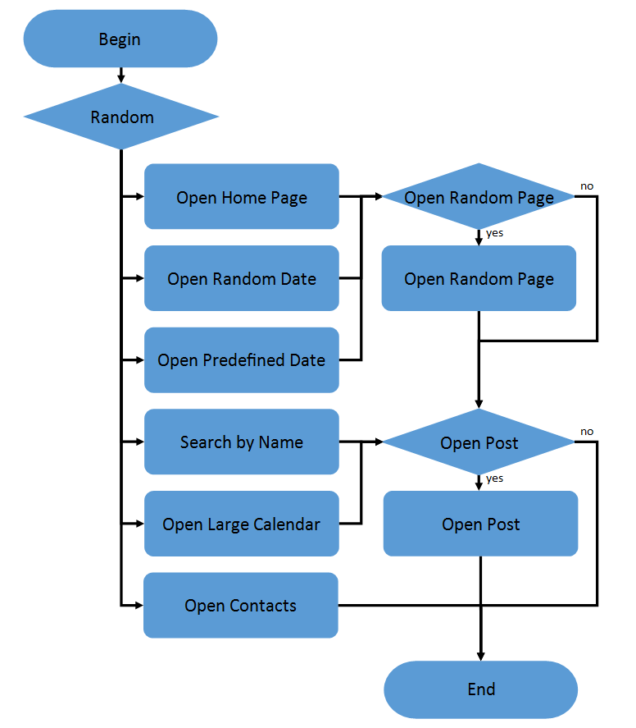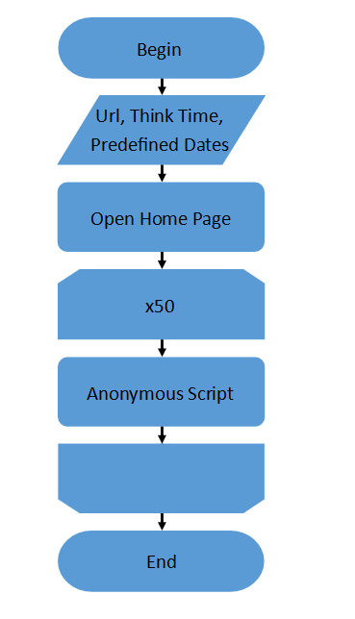

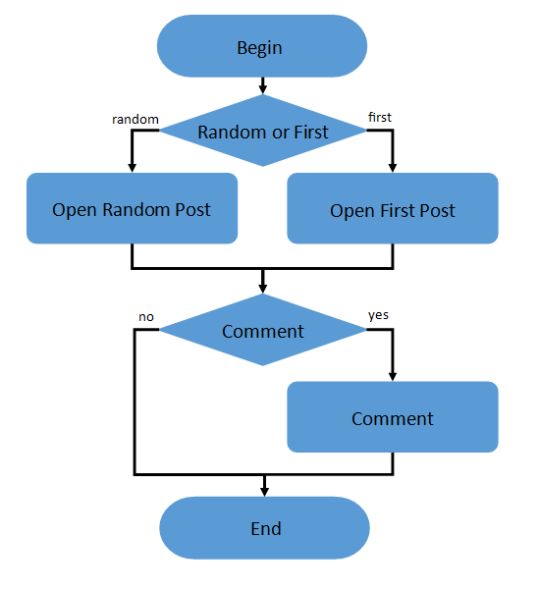**Admin script: Editor script:**

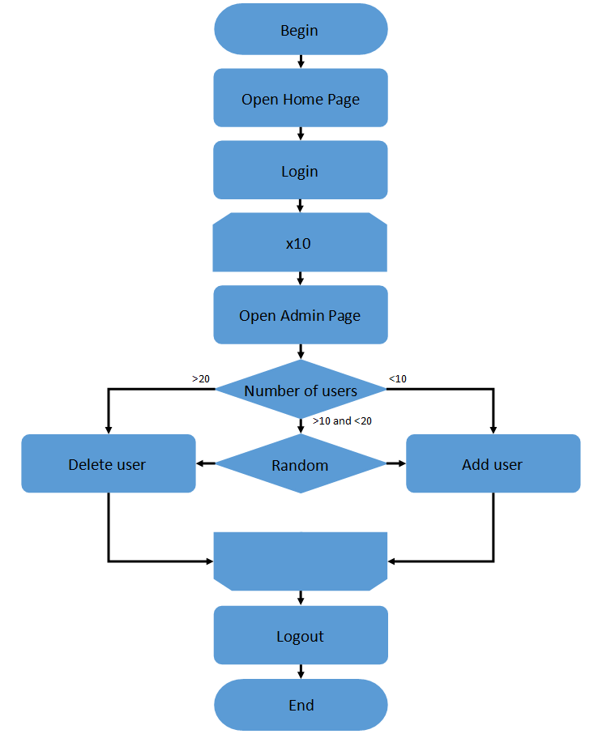 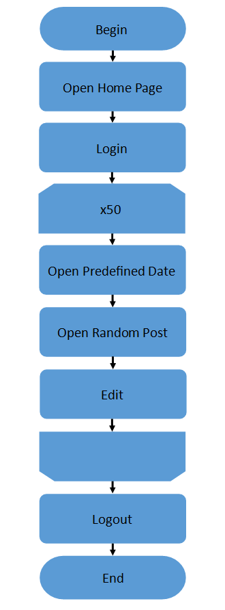

|  |  |
| --- | --- |
| Number of anonymous users | 18 (45 % from maximum load) |
| Number of editor users | 1 |
| Number of admin users | 1 |
| Ramp-Up-Period | 2.5 minutes |
| Loop Count | Forever |
| Duration | 30 minutes |

**Tests**

|  |  |
| --- | --- |
| **1** | **100 Posts** |
| **2** | **1000 Posts** |
| **3** | **2000 Posts** |
| **4** | **5000 Posts** |
| **5** | **1000 Posts with a large text and 1000 with 1MB image** |

**Also complete and analyse the same testing for application with DB data source. DB that I was using is SQLite. Posts were generated by the same script as for File System testing. Capacity testing showed the same capacity point as for FS configuration, so the number of users that was taken for tests is the same.**

**Results**

The results of the file system tests do not contradict expectations: we have a directly proportional relationship of response time to the number of records in the application.

Adding images to the posts has not changed the speed of processing the request, most likely because the generator receives the response and information about static resources as well as the image, but does not request them to the server.

Also, as the number of posts increases, the probability of receiving a 500 response from the server increases.

**Changing the server configuration to use a database instead of a file system has resulted in performance degradation although it has significantly increased application resilience, which was revealed by stress and capacity tests.**

**Problems with using the database include the fact that Non HTTP response message: invalid code lengths set errors have started to appear regularly. The connection of these errors with the database still needs to be clarified.**

**A lot of effort and time was spent on changing the test scenario to work with the database because many URLs have changed. This explains the difference in the total number of requests, I had to add more scripts for dynamic parametrization.**

**I'm sure that the performance when working with a database depends heavily on the database itself. SQLite showed bad results compared to the use of the file system.**

**Given the comparison of the median and 90 percentiles, it is worth to conduct tests with an even greater number of posts, maybe further use of the database becomes faster than the file system.**

**Maximum data size needs to be found with more tests.**

**FILE SYSTEM TESTS**

|  |  |  |  |  |  |  |  |  |  |
| --- | --- | --- | --- | --- | --- | --- | --- | --- | --- |
|  | **N** | **Avg** | **Med** | **90** | **95** | **99** | **Max** | **Err** | **Throughput** |
| **100** | **19126** | **18** | **9** | **32** | **35** | **448** | **3593** | **0** | **10.64019** |
| **1000** | **19019** | **21** | **12** | **38** | **43** | **445** | **4037** | **0** | **10.57956** |
| **2000** | **18886** | **24** | **15** | **43** | **50** | **452** | **3724** | **5.29E-05** | **10.50705** |
| **5000** | **18849** | **33** | **23** | **64** | **71** | **448** | **4289** | **2.12E-04** | **10.47854** |
|  |  |  |  |  |  |  |  |  |  |
| **2000** | **18886** | **24** | **15** | **43** | **50** | **452** | **3724** | **5.29E-05** | **10.50705** |
| **2000Mixed** | **18963** | **25** | **16** | **45** | **51** | **450** | **3915** | **5.27E-05** | **10.5499** |

**DATABASE TESTS**

|  |  |  |  |  |  |  |  |  |  |
| --- | --- | --- | --- | --- | --- | --- | --- | --- | --- |
|  | **N** | **Avg** | **Med** | **90** | **95** | **99** | **Max** | **Err** | **Throughput** |
| **100** | **21440** | **28** | **10** | **38** | **63** | **505** | **4731** | **9.33E-05** | **11.92224** |
| **1000** | **21353** | **32** | **12** | **42** | **78** | **532** | **4777** | **4.21E-04** | **11.87678** |
| **2000** | **21526** | **32** | **15** | **47** | **79** | **516** | **5607** | **6.04E-04** | **11.96842** |
| **5000** | **21234** | **39** | **22** | **60** | **97** | **506** | **13728** | **5.65E-04** | **11.8214** |
|  |  |  |  |  |  |  |  |  |  |
| **2000** | **21526** | **32** | **15** | **47** | **79** | **516** | **5607** | **6.04E-04** | **11.96842** |
| **2000Mixed** | **21581** | **28** | **15** | **44** | **65** | **450** | **7085** | **3.24E-04** | **12.00185** |

**DB Capacity Testing 95 Percentile**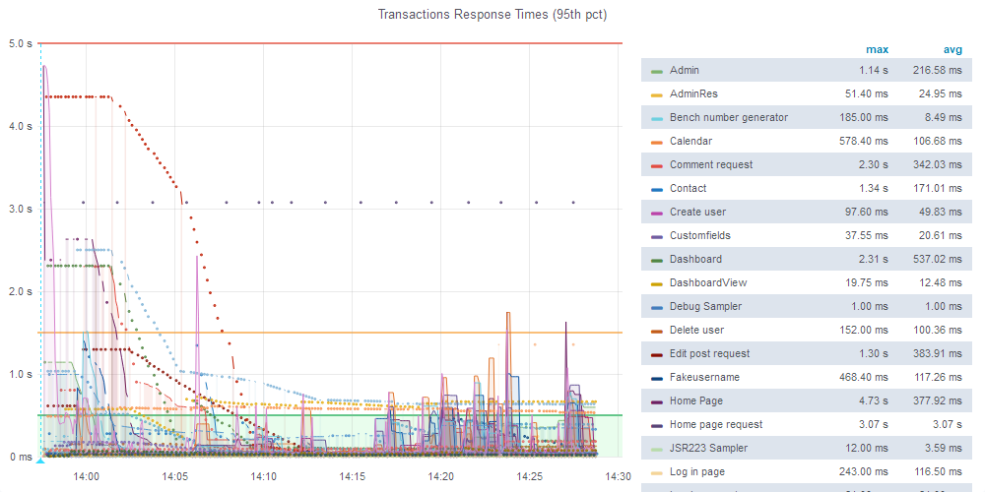

**Capacity Point**

**14:16 was the point for 18 users**

**Also, screenshot for bug founded**