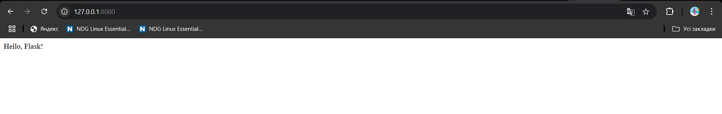GitHub:  
<https://github.com/YaroslavPogonchuk/flask_app_Pogonchuk>