REFLECTION
FINAL PROJECT PHASE 1 & 2
MURAT YILDIZ, YAROSLAV TRACH, AIDEN SHEEHY
CSC-220 OPERATING SYSTEMS & SYSTEMS PROGRAMMING
DR.KANCHARLA
MARCH 24TH, 2026

1.List all threads implemented in your system and briefly describe their responsibilities.
The system implements five threads: engine_thread, motion_thread, fuel_thread, ecu_thread, and dashboard_thread. The engine_thread simulates the motorcycle’s RPM and engine temperature based on whether the engine is on, idling, or moving. The motion_thread controls the motorcycle’s speed and updates both total distance and trip distance over time. The fuel_thread models fuel consumption, where fuel decreases continuously and is affected by speed and RPM. The ecu_thread acts like the electronic control unit by monitoring the shared state and updating derived values such as RPM zone, temperature classification, and signal state. Finally, the dashboard_thread is responsible for displaying the formatted motorcycle dashboard in real time by reading the shared system state and refreshing the terminal output continuously.

2. Describe how your system state is organized. Did you use a single struct? Multiple structs? Global variables? Nested structures? Explain your reasoning.
Our system state is organized using a single global struct called system_state_t, and the shared instance is the global variable g_state. This struct stores all important values for the simulation in one place, such as RPM, engine temperature, speed, total distance, trip distance, fuel level, engine status, RPM zone, temperature classification, signal state, headlight status, time values, and display preference. We used one struct instead of multiple structs or many separate global variables because it keeps the program more organized and makes it easier for all subsystem threads to access the same shared data. It also makes the design simpler to manage, since every subsystem reads from or writes to the same shared state object rather than passing around many separate variables. This approach matched our project well because the system is small enough that one shared structure is clean, readable, and easy to maintain.

3. Explain how you ensured that:
(a) Simulation logic is not mixed with dashboard printing.
(b) The ECU does not simulate physical quantities.
(c) The dashboard does not enforce system rules.
We separated responsibilities by giving each subsystem its own specific job. (a) Simulation logic is not mixed with dashboard printing because the physical behavior of the motorcycle is handled in files like engine.c, motion.c, and fuel.c, while dashboard.c only reads the shared state and prints it to the terminal. In other words, the dashboard is just for display and does not calculate RPM, speed, fuel usage, or temperature itself. (b) The ECU does not simulate physical quantities because it only monitors existing values in g_state and classifies them into higher-level states, such as RPM zone and temperature category. It also cycles the signal state for the demo, but it does not generate speed, fuel consumption, or engine temperature values. Those physical quantities are produced by the simulation subsystems. (c) The dashboard does not enforce system rules because it never changes the logic of the motorcycle system. It only formats and shows the current values. For example, it can display a low-fuel warning, but it does not decide fuel consumption, engine behavior, or trip reset rules. Those rules are enforced by the other subsystems, which helped us keep the design modular and closer to good software engineering practice.
4. Describe how information flows in your system.
(a) How does RPM move from Engine − > ECU − > Dashboard?
In our system, RPM starts in the engine_thread, where the engine subsystem calculates and updates g_state.rpm based on whether the motorcycle is idling or moving. After that, the ecu_thread reads that RPM value from the shared state and uses it to determine the correct RPM classification, such as idle, normal, high, or redline, which it stores in g_state.rpm_zone. Then the dashboard_thread reads both g_state.rpm and g_state.rpm_zone from the shared struct and displays them on the screen as the numeric RPM value and the RPM status label. So the flow is: the Engine produces the RPM value, the ECU interprets it, and the Dashboard presents both pieces of information to the user.

(b) How does fuel consumption affect what is displayed?
Fuel consumption is handled by the fuel_thread, which continuously decreases g_state.fuel_gallons while the engine is on. The amount of fuel used depends on the current speed and RPM, so as those values increase, fuel is consumed faster. The dashboard_thread then reads the updated g_state.fuel_gallons value from the shared state and shows it as both a percentage and a fuel bar on the dashboard. If the fuel level drops below the low-fuel threshold, the dashboard also prints a warning message. So in our design, the fuel subsystem updates the actual fuel value, and the dashboard simply reflects those changes visually.

5. Attach a screenshot of your dashboard output. Why did you choose this layout? Did you prioritize readability, realism, minimalism, compactness, or visual appeal?

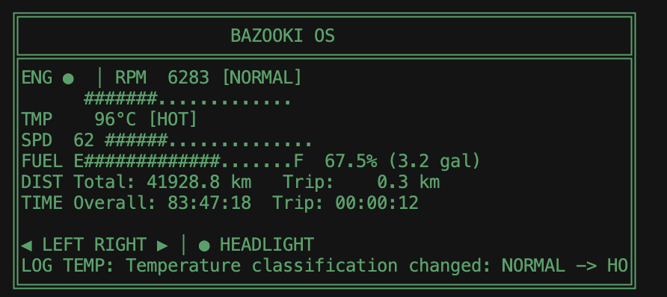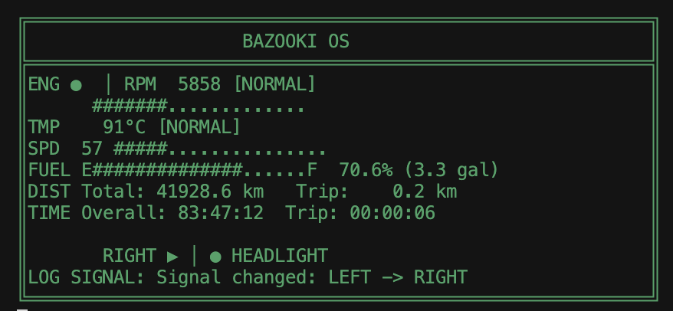
For the design of our dashboard, we prioritized minimalism and the example we saw on Canvas.
6. Explain how you represented the following: RPM, Fuel level, Speed, Engine state. Why did you choose numeric values, bars, symbols, or a hybrid approach?
RPM (engine speed)
- Hybrid: a numeric value (5858), a text label ([NORMAL]), a symbol (green dot as “running/OK”), and an ASCII bar (#######................) for quick “how hard it’s working” at a glance.
- The bar is normalized to a fixed width so it reads like a gauge even in a text-only UI.
Fuel level
- Hybrid: E–F anchors (symbols for empty/full), a long bar for proportion, and numeric detail (70.6% (3.3 gal)) for precision and real planning.
- Bars are good for “how much left”; numbers answer “how many gallons” and match human mental models for refueling.
Speed
- Hybrid: numeric 57 (exact requirement for speed limits / law), plus a short bar for trend or “headroom” without duplicating the number as the only signal.
Engine state
- Symbolic + textual: green dot + [NORMAL] (and the RPM context) encode state faster than a number; state is categorical (normal/warn/fault), not a continuous quantity, so a symbol + word fits better than a bar alone.

7. Describe at least two relationships between subsystems, note that the relationship logic will be implemented in future phases.
One relationship between subsystems is the connection between the engine subsystem and the fuel subsystem. In our current design, higher RPM and speed already cause more fuel to be consumed, so there is a clear relationship between engine behavior and fuel usage. In future phases, this relationship logic could be extended further so that low fuel affects engine performance, limits RPM, or eventually shuts the engine off when the tank is empty.
A second relationship is between the engine subsystem, motion subsystem, and ECU subsystem. Right now, the engine produces RPM, the motion subsystem updates speed and distance, and the ECU reads those values to classify the system state, such as RPM zone and engine temperature category. In future phases, this relationship could become more realistic by making ECU rules influence the physical simulation, for example reducing speed when overheating happens, limiting unsafe RPM ranges, or changing system behavior based on warning conditions.
Another good relationship is between the ECU subsystem and the dashboard subsystem. At the moment, the ECU updates derived states like RPM classification and temperature status, and the dashboard displays them. In future phases, this could become more advanced by adding warning priorities, fault messages, maintenance alerts, or smarter driver feedback based on ECU decisions.

8. What responsibilities does your ECU handle in Phase 1?
In Phase 1, our ECU is responsible for monitoring the shared system state and updating derived system information, rather than simulating physical behavior itself. Specifically, it classifies the current RPM into zones such as idle, normal, high, or redline, and it classifies the engine temperature into states like cold, normal, hot, or overheat. It also cycles the turn signal state for demonstration purposes so the dashboard can visibly show signal changes during the simulation. In addition, when the engine is off, the ECU resets the trip distance. So overall, in Phase 1, the ECU mainly acts as a monitoring and classification subsystem that interprets existing values and updates higher-level status information for the rest of the system, especially for the dashboard.

9. Even though synchronization is not implemented in Phase 1: Identify at least two shared variables that could cause race conditions in your program. Explain why concurrent access might be problematic.
Two shared variables that could cause race conditions in our program are g_state.rpm and g_state.fuel_gallons. The variable g_state.rpm is written by the engine_thread, read by the ecu_thread for RPM classification, and also read by the dashboard_thread for display. Since these threads run at the same time, one thread could read the RPM value while another thread is in the middle of updating it, which could lead to inconsistent or outdated data being displayed or classified. Similarly, g_state.fuel_gallons is updated by the fuel_thread while the dashboard_thread reads it to show the fuel bar, percentage, and low-fuel warning. Without synchronization, the dashboard could read the value during an update, which may cause incorrect or inconsistent output.
Another good example is g_state.speed. It is updated by the motion_thread, used by the engine_thread to help calculate RPM, and displayed by the dashboard_thread. Because multiple threads depend on it at the same time, concurrent access could make one subsystem use a partially updated or stale value. In general, the problem is that all threads share the same global struct, so without mutexes or other synchronization tools, reads and writes can overlap and create unpredictable behavior.

10. What is one design weakness in your system that you would improve in the next phase?
One design weakness in our system is that all subsystems directly access the same global shared state, g_state, without synchronization or stricter control over how data is read and written. While this approach keeps the Phase 1 design simple, it also creates the risk of race conditions and inconsistent state when multiple threads operate at the same time. In the next phase, this should be improved by introducing synchronization mechanisms such as mutexes to protect shared data and coordinate thread access more safely. This would make the system more reliable, easier to maintain, and better aligned with sound multithreaded software design principles.

PHASE II
1) Which shared variables required synchronization and why?
The shared variables that required synchronization were the ones accessed by multiple subsystem threads. These included rpm, engine_temp_celsius, and engine_on in the engine subsystem; speed, total_distance, and trip_distance in the motion subsystem; fuel_gallons in the fuel subsystem; and rpm_zone, temp_classification, signal_state, and headlight_on in the ECU/dashboard side. These variables needed synchronization because multiple threads could read and write them at the same time. Without synchronization, the program could have race conditions, inconsistent dashboard output, or incorrect ECU rule enforcement.
2)What synchronization mechanisms did you use (mutex, semaphore, condition variable) and how are they implemented in your program?
We used pthread_mutex_t mutex locks and pthread_cond_t condition variables. The mutexes were split by subsystem: mtx_engine, mtx_motion, mtx_fuel, and mtx_ecu. Each mutex protects the shared data that belongs to that subsystem. For example, engine-related values such as RPM and temperature are protected by mtx_engine, motion values such as speed and distance are protected by mtx_motion, fuel level is protected by mtx_fuel, and ECU-derived values such as RPM zone, temperature classification, and signal state are protected by mtx_ecu.
We also used condition variables for coordination. cond_engine_run allows the motion and fuel threads to wait when the engine is off instead of continuously polling. cond_ecu allows the ECU thread to block with pthread_cond_timedwait and wake up when other subsystems notify it using sync_notify_ecu().
3) How did you avoid deadlocks in your implementation?
We avoided deadlocks by following a consistent lock acquisition order throughout the program. Our order was mtx_engine -> mtx_motion -> mtx_fuel -> mtx_ecu. We made sure threads did not acquire these locks in conflicting orders. We also kept critical sections as short as possible and released locks immediately after the shared data was read or updated. In my opinion, the fixed lock order was the main reason the program stayed safe from circular waiting and deadlock problems.
4) Describe the locking strategy used in your program.
The locking strategy was based on dividing the shared system state into subsystem groups and protecting each group with its own mutex instead of using one global lock. This made synchronization more organized and reduced unnecessary blocking between unrelated threads. The engine thread mainly locks mtx_engine, the motion thread uses mtx_engine and mtx_motion, the fuel thread uses mtx_engine, mtx_motion, and mtx_fuel, and the ECU reads from several subsystems and writes its derived values under mtx_ecu. The dashboard takes a synchronized snapshot by locking the subsystem mutexes in the defined order, copying g_state, and then printing from the snapshot after releasing the locks.
5)What system rules are enforced by the ECU?
The ECU enforces four main Phase II system rules. First, if the engine is off, RPM is forced to 0 and the speed gradually returns to 0 instead of stopping instantly. Second, if the engine temperature exceeds the overheat threshold, the ECU limits RPM and also caps speed to reduce performance. Third, if the fuel level drops below the low-fuel threshold, the ECU limits maximum speed. Fourth, if the engine is on and speed is 0, the ECU keeps RPM within the idle range. In my opinion, these rules made the simulation more realistic because the ECU was actively controlling behavior instead of only monitoring values.

6) How did synchronization affect the dashboard behavior?
Synchronization made the dashboard more consistent and stable. Instead of showing mixed values from different update moments, the dashboard now reads a protected snapshot of the system state. This prevents partial updates such as a new RPM being displayed with an old speed or fuel value. It also made the output look smoother and more realistic because subsystem values changed in a controlled way. Overall, synchronization improved both correctness and the visual quality of the dashboard. However, the GUI aspect of the dashboard remained the same as in the Phase I.

