**Project Title : Employee Recognition Tracker**

**Abstract:**

The Employee Recognition Tracker is a comprehensive Salesforce-based solution designed to automate the identification, evaluation, and acknowledgment of top-performing employees. It utilizes two custom objects—Data (for employee performance records) and Voting (for manager evaluations).

Initially, employee data is imported into the Data object. A record-triggered Flow 1 automatically moves employees with a performance percentage greater than 80% to the Voting object. Managers, using a dedicated Manager Profile and Permission Set, assign ratings and provide feedback for these top performers. If a rating of 4 or above is given, Flow 2 sends an automatic email to notify the employee of their recognition.

Security and control are enforced through Validation Rules, Profiles, and Permission Sets. Employees cannot view feedback or ratings, while managers have restricted access only to the Voting object. The system includes well-structured Reports and Dashboards, which help HR and leadership teams analyze performance trends and recognition distribution.

An additional operational step involves sending the performance and recognition data from reports to the Finance Department, where budget allocation is done for the top performers. Based on recognition scores, the finance team categorizes the budget distribution accordingly.

**Business Requirements :**

* **Functional Requirements**
  + **Employee Data Object Management**
    - Creation of custom Object to store employee records
    - It includes Fields like Employee Name, ID, Attendance, Performance etc.
  + **Top Performer Identification**
    - The System has to Identify the top employees who are at the top based on the criteria.
  + **Email Notification**
    - After the evaluation of the employee the email has to be sent to the selected top performers which contain message about their recognition.
* **Non – Functional Requirements**
  + **Security** 
    - Only authorized users should be able to modify and access the voting and enter the details.
    - Use Profiles to control access.
  + **Scalability**
    - It must be capable of handling a growing number of employee records.

**Step 1: Creating App**

Switch to Salesforce Classic

Setup > Build > Create > Apps > Quick Start

Create Recognition Tracker App

Add the following tabs to the Selected Tabs

* Home
* Reports
* Dashboards
* Other tabs which will be created later should also be added like – Employee Details, Voting

Check Show in Lightning

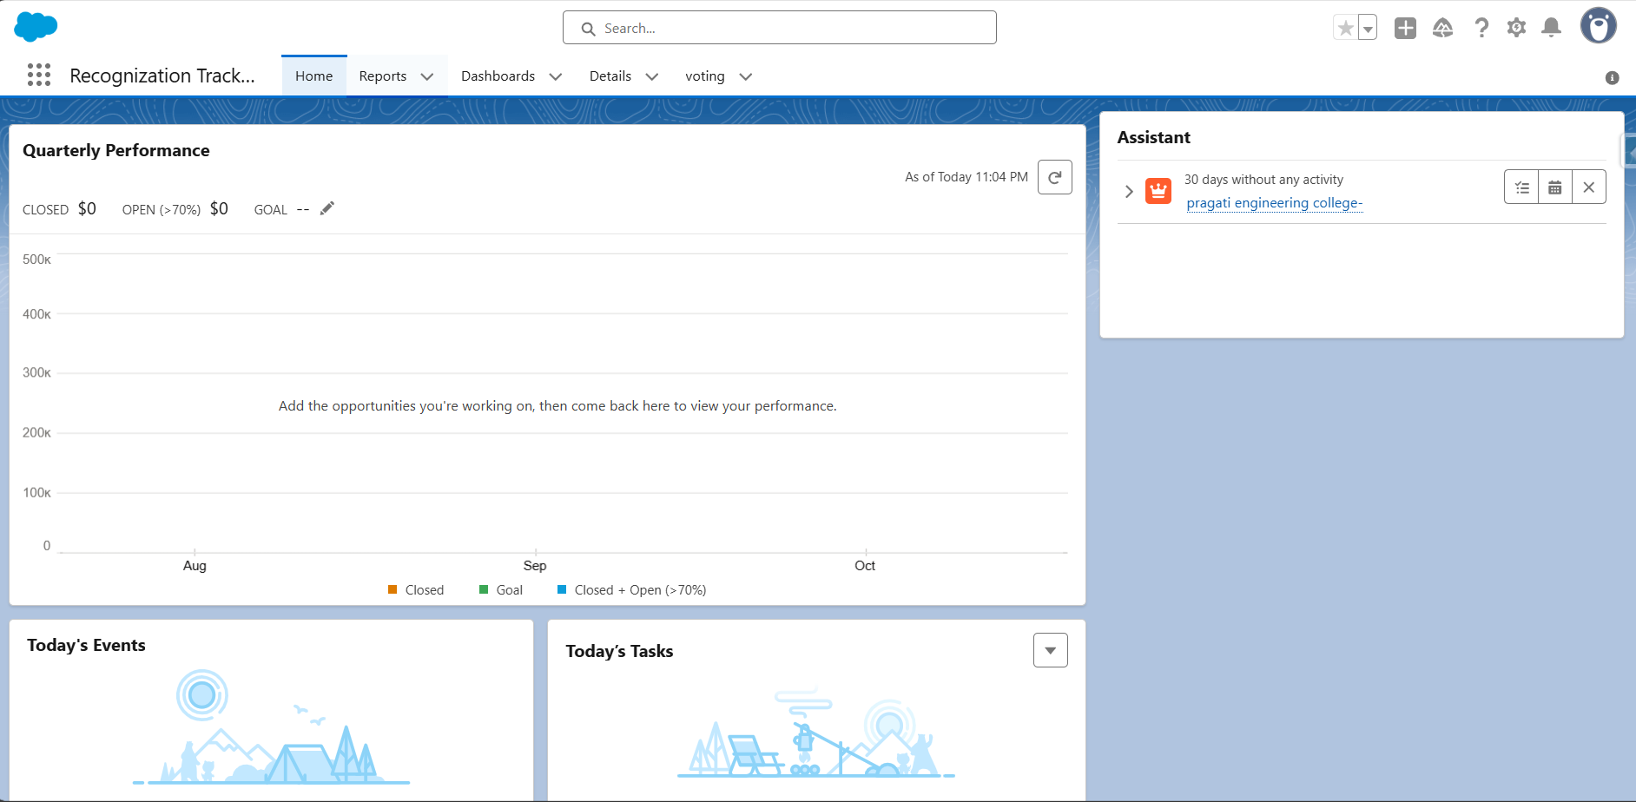

**Step 2: Create Objects and Add Fields**

Here in our project we have 2 objects –

* Data, Voting

**Details Object (Employee Data):**

Create Data Object by checking Allow for required fields and Enable Launch Tab

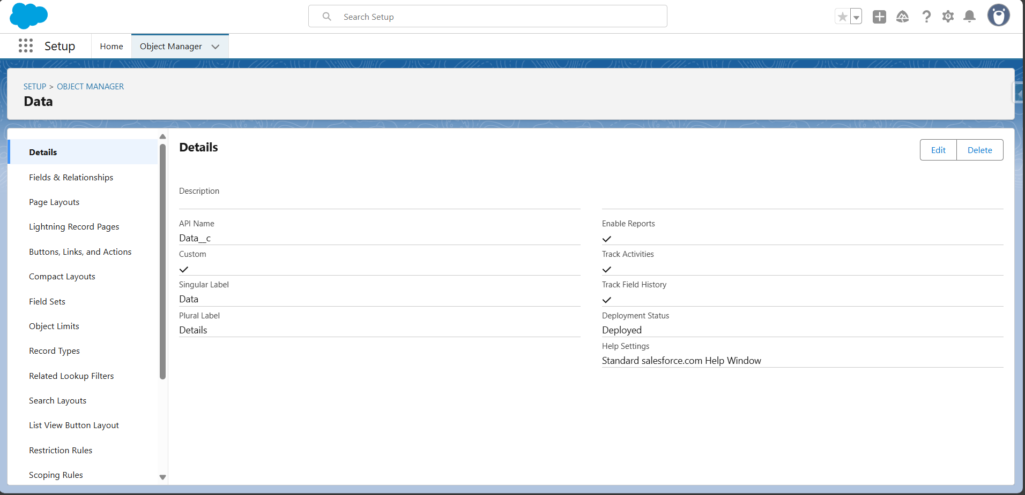

Data > Fields & Relationships :

Click New

Add the following fields with the configurations

**Employee Name**  
  [Data Type: Text, Length: 40, Required: True]

**Employee ID**  
  [Data Type: Text, Length: 10, Unique: True]

**Email**  
 [Data Type: Email, Required: True, Unique: True]

**Department**  
  [Data Type: Picklist. Values : Sales, HR, Engineering, Support, Marketing, Finance]

**Experience**  
  [Data Type: Number, Length : 2, Scale: 0]

**Number of Tasks Assigned**  
  [Data Type: Number, Length : 5, Scale: 0]

**Number of Tasks Completed**  
  [Data Type: Number, Length: 5, Scale: 0]

**Number of Working Days**  
  [Data Type: Number, Length : 3, Scale: 0]

**Total Number of Working Days**  
  [Data Type: Number, Length : 3, Scale: 0]

**Attendance Percentage**  
  [Data Type: Formula (Percent) - ( Number_of_Working_Days__c / Total_Number_of_Working_Days__c )]

**Tasks Completion Percentage**  
  [Data Type: Formula (Percent) - ( Number_of_Tasks_Completed__c / Number_of_Tasks_Assigned__c )]

**Performance Score**  
  [Data Type: Formula (Percent) - (( Attendance_Percentage__c + Tasks_Completion_Percentage__c ) / 2)]

**Role**  
  [Data Type: Text, Length: 40]

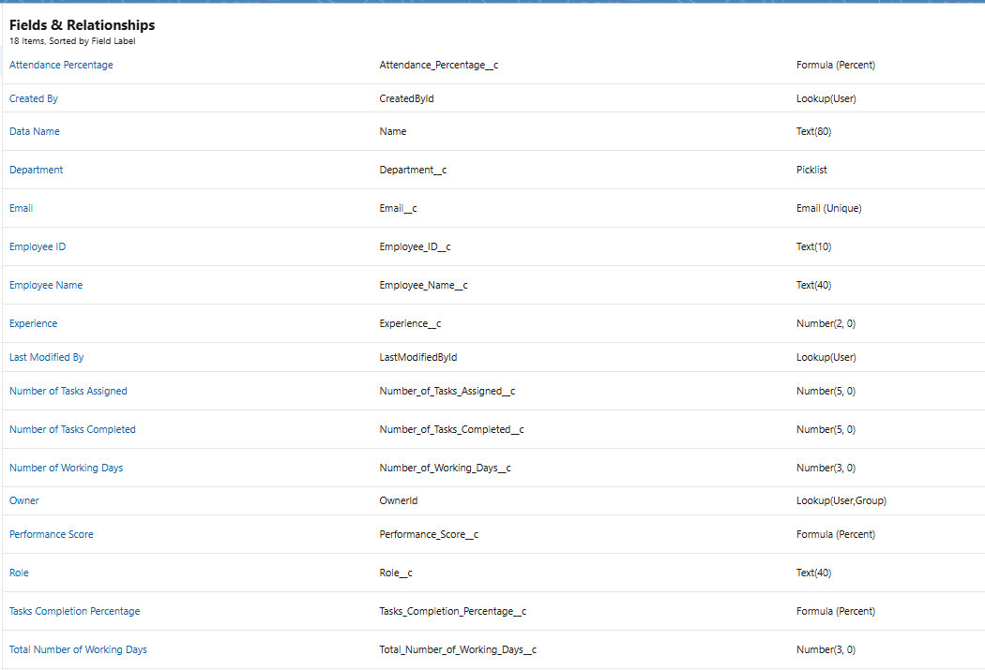

**Voting Object**

Now create Voting object .

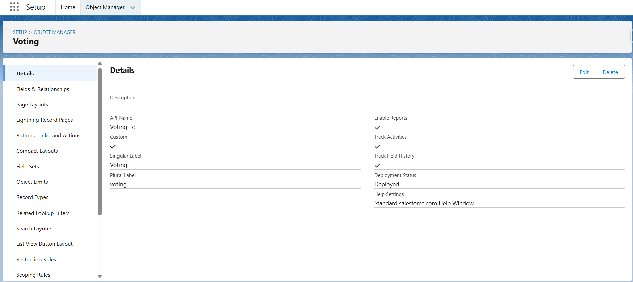

**Fields & Relationships :**

Now create fields required to match the fields in Employee data

Not all are required but only required as shown as below:

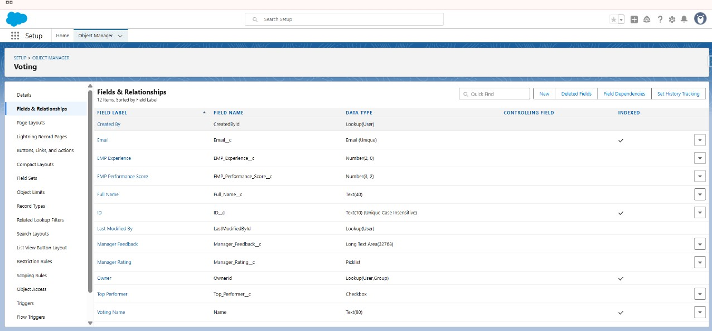

Add a Field named Manager Rating

Manager Rating

Data Type : picklist

Values: 1 to 5

Create Top performer CheckBox (Optional)

Add a Field named Manager Feedback

Manager Feedback

Data Type : Longtext

**Step 3: Validation Rules**

**Validation Rule 1: Attendence_Rule**

**Purpose:**  
This validation rule ensures that users do not enter a number of working days attended that is greater than the total number of working days. This maintains logical accuracy and prevents incorrect attendance data.

**Trigger Condition:**  
The rule is triggered when:

No_of_Working_Day__c > Total_No_of_Working_Days__c

**Error Message Displayed:**  
"Number of Working Days cannot be greater than Total Number of Working Days.  
Please correct the values."

**Error Display Location:**  
Field-level error shown under: No_of_Working_Day__c

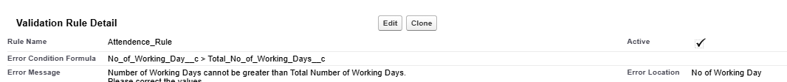

**Validation Rule 2: Task_Completion_Validation**

**Purpose:**This rule prevents users from entering a number of tasks completed that is higher than the number of tasks assigned. It is used to ensure consistency in task reporting.

**Trigger Condition:**  
The rule is triggered when:

No_of_Tasks_Completed__c > No_of_Tasks_Assigned__c

**Error Message Displayed:**  
"Number of tasks completed cannot be greater than number of tasks assigned."

**Error Display Location:**Field-level error shown under: No_of_Tasks_Completed__c



**Step – 4: Create Flows**

Flows > New Flow > Record triggered Flow

**Flow – 1:**

Under the Configure Start Option – Enter the following

Object : Data

Select “A record is created or updated” option

Entry Conditions:

Performance Score > 80

Under “When to Run the Flow for Updated Records”,

Select “Every time a record is updated and meets the condition requirements”.

Select Actions and Related Fields

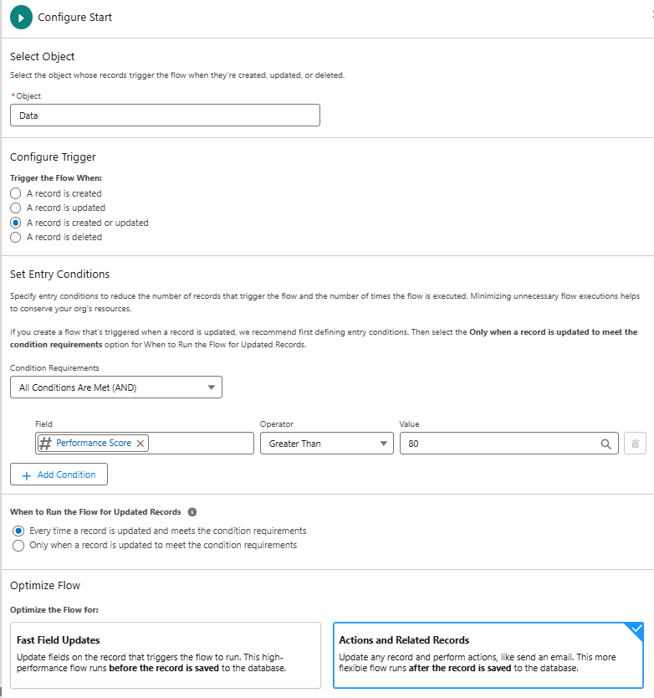

Now Click + Symbol under Record-Triggered Flow Component

Select Create Records

Label : Create Records For Voting

How to select Field values : manually

Object : Voting

| **Field Label** | **API Name (if applicable)** | **Value Source** |
| --- | --- | --- |
| **EmpID** | EmpID | Triggering Data__c > Employee ID |
| **Emp Email** | Emp_Email | Triggering Data__c > Email |
| **Emp Experience** | Emp_Experience | Triggering Data__c > Experience |
| **Emp Performance Score** | Emp_Performance_Score | Triggering Data__c > Performance Score |
| **Full Name** | Full_Name | Triggering Data__c > Employee Name |
| **Top Performer** | Top_Performer (Checkbox) | True |

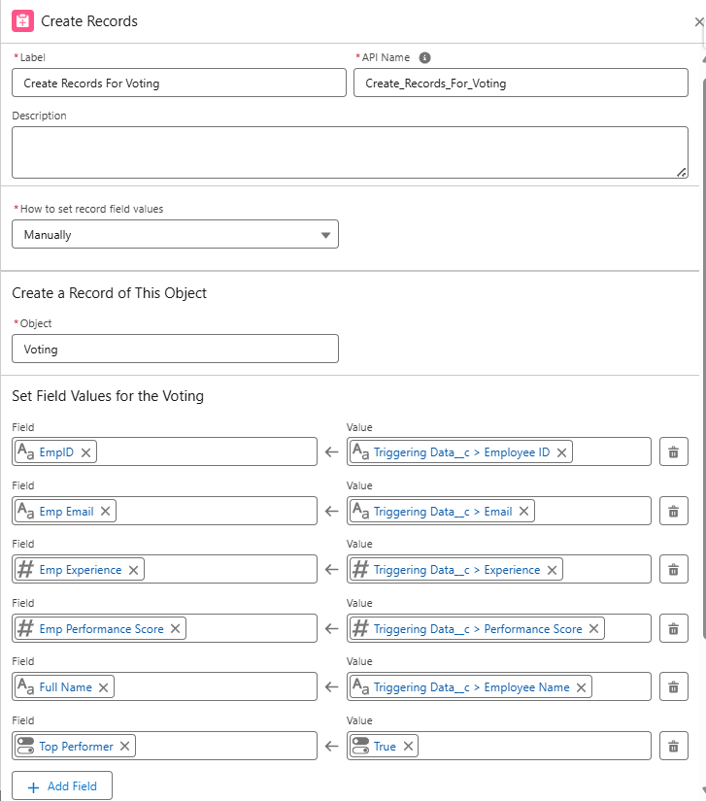

Now the flow is Completed

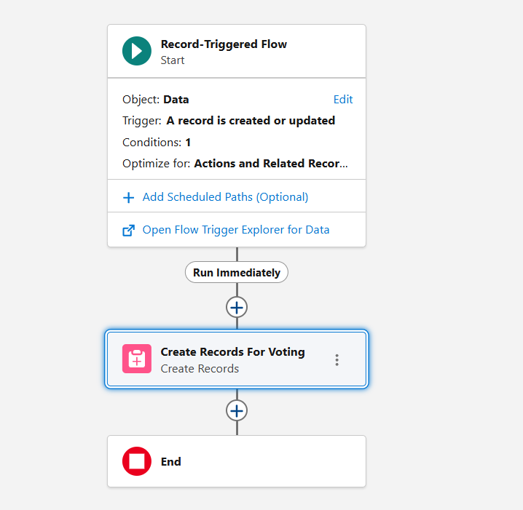

Save the flow and Activate it.

Now create Flow -2

**Flow – 2:**

Now create another record triggered flow to send mails

Under Configure Start

Object : Voting

Configure trigger : When A Record is Updated

Entry Conditions:

Manager Rating = 5

Or

Manager Rating = 4

When to Run the Flow for Updated Records :

Every time a record is updated and meets the condition requirements

Optimize the Flow for:

Actions and Related Records

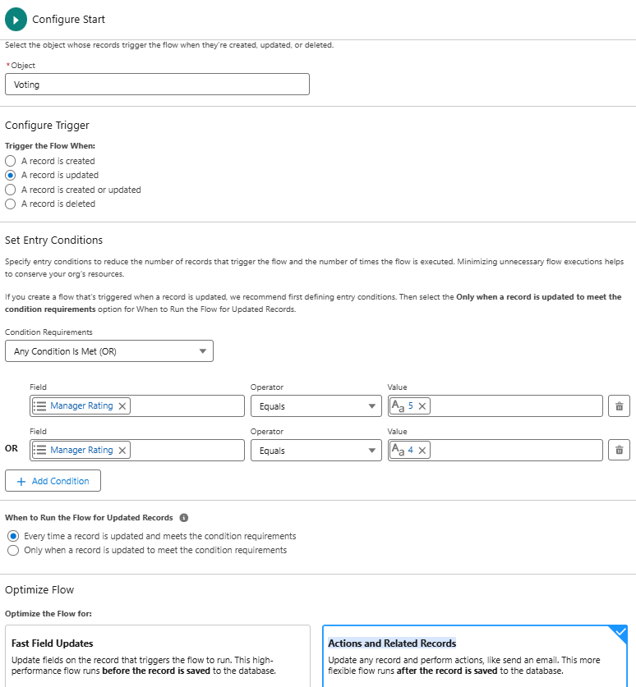

Click + Symbol and Add Action

Email > Send mail

**Label :** Send Mails to Selected Employees

Recipient Address List : {!$Record.Emp_Email__c}

Compose Email Content:

**Subject :** Congratulations {!$Record.Emp_Name__c}, You’ve Been Recognized! 🎉

**Body :**

Hello {!$Record.Emp_Name__c},

We’re thrilled to inform you that you’ve been recognized as a **Top-Performing Employee** based on your outstanding contributions, dedication, and consistent performance.

Your hard work, positive attitude, and commitment to excellence have truly made a difference. Thank you for being an integral part of the team.

Keep up the great work!

Warm regards,

HR Team

Select View as **Plain Text**

Rich-Text Formatted body : **True**

Click Save and Activate the Flow

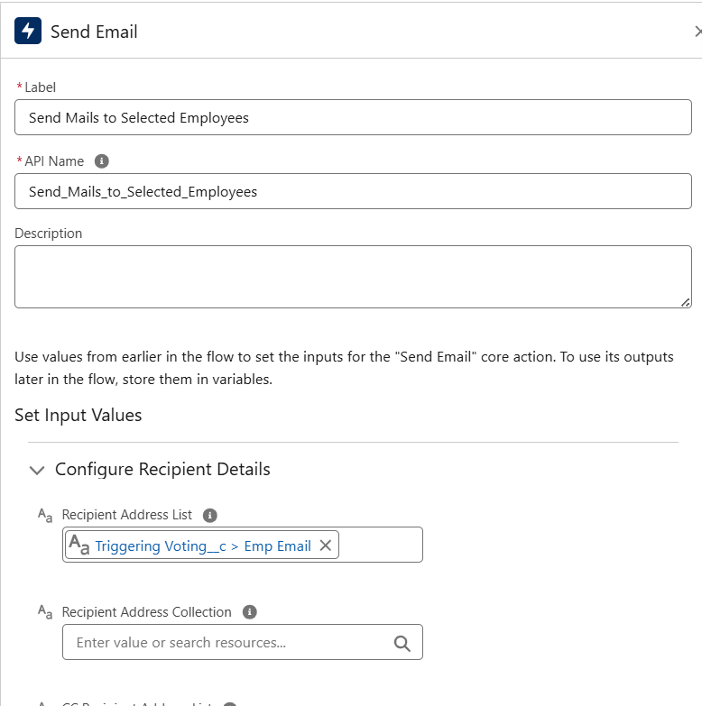

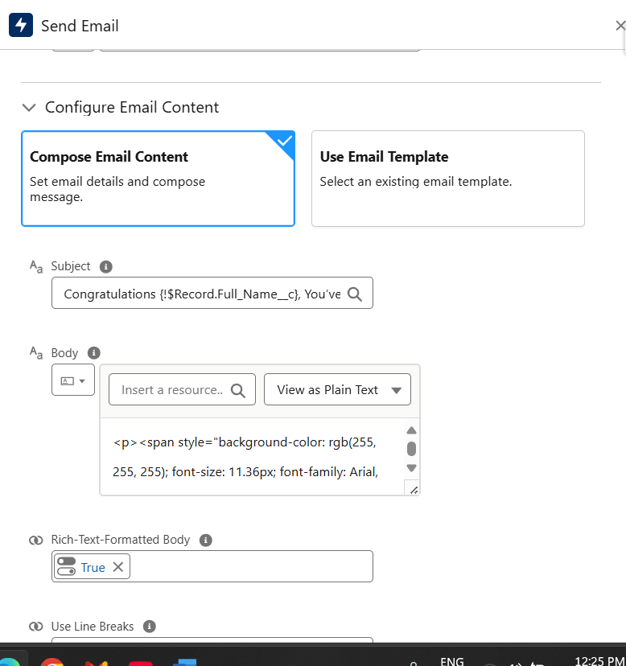

Now the flow Created.

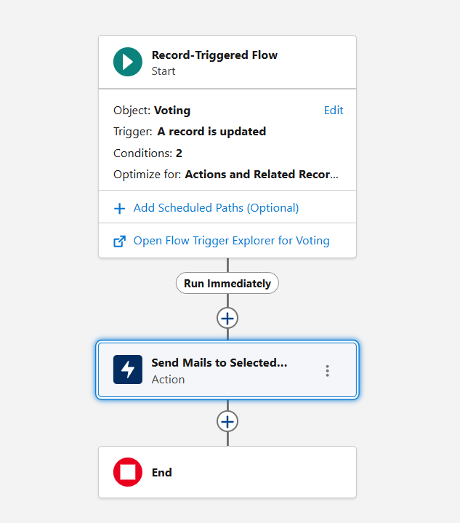

How the flows work:

When the person who has access to employees data enters the details in the details object by clicking new or may try to import the data

When the details are entered the record triggers the flow – 1 and if the performance score greater than 80 it will push the record into the voting object, then manager will edit the rating between 1 to 5 and and clicks save button then the flow – 2 is triggered and if the rating is either 4 or 5 then emails will be sent to them.

**Step – 4 : Profiles , Permission sets**

**Profiles :**

We are considering the person who enters the details as Company so we will create Company profile

Setup > Profiles > New > Existing Profile : Standard user > Profile Name : Company

Now Profiles > New > Existing Profile : Standard user > Profile Name : Manager

**Users :**

Create two users with Profiles – Manager Profile , Company profile

License : Salesforce

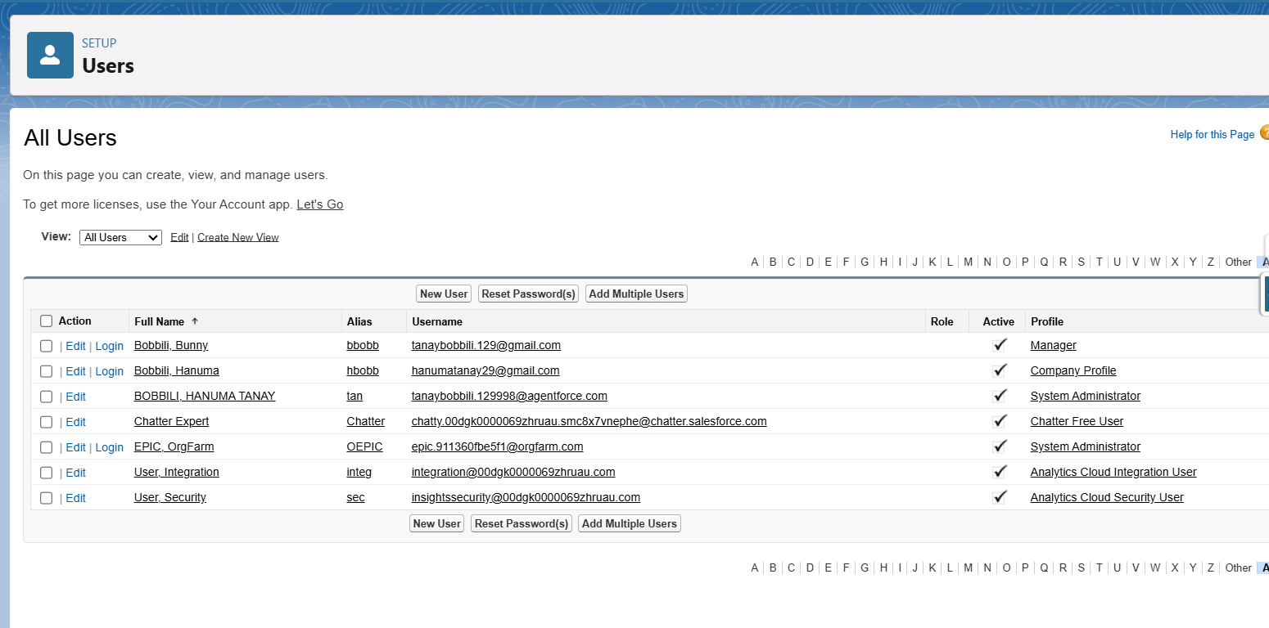

**Permission Sets :**

Now Go to Permission sets

Create New

Label : Restrict manager

Object : Voting and Data

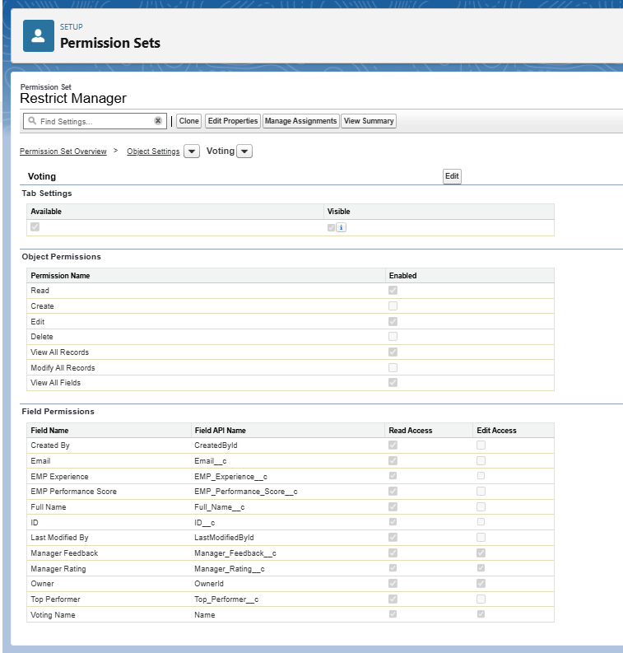

Just give the manager edit access for Manager Rating Field.

And then Click Manage Assignments

Click Add Assignment

Select user who has manager access

Now in the similar way create another permission set named Restrict Manager to Employee Data and Give no access to it and assign it to Manager Profile.

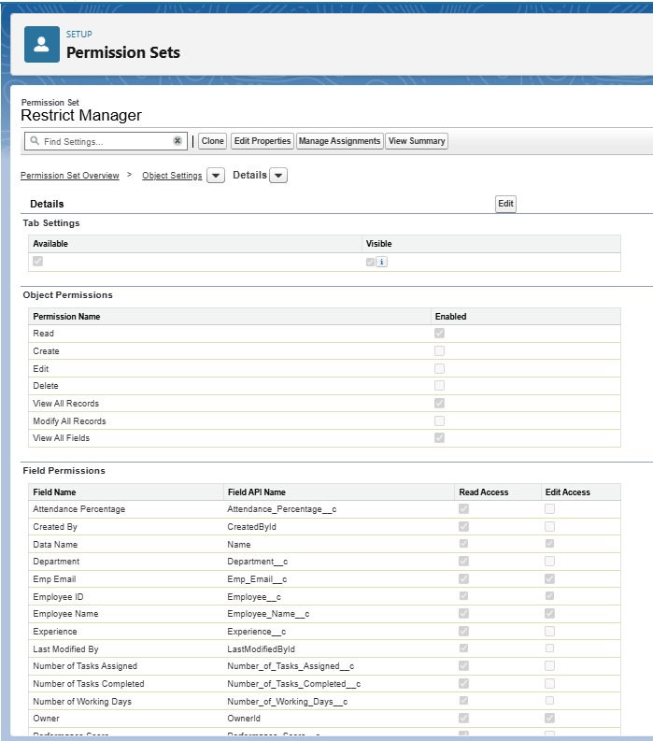

Now Create another permission set

Restrict Company Profile Person who enters employee data such that he cannot alter or view Voting data.

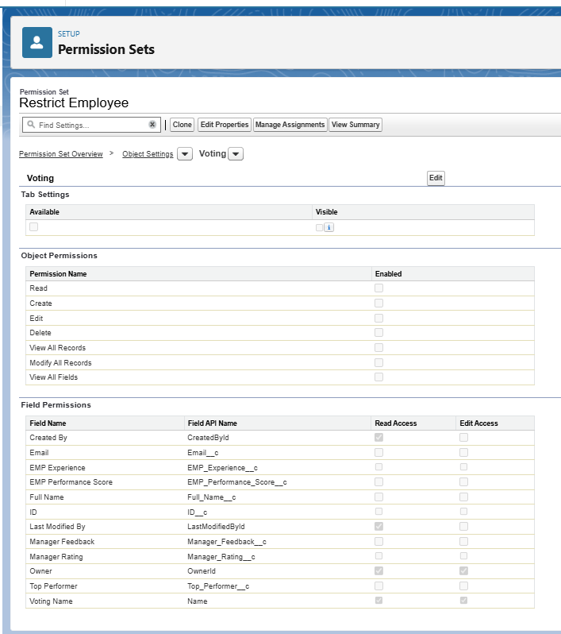

Now the permission sets, profiles have been configured.

**Step – 5 : Reports & Dashboards**

Now create Reports Required to display in the dashboard

We are creating 3 Reports to display in the dashboard based on performance score.

**Report 1:**

Name : Attendance list

Group Rows : Employee Name

Columns : Number of working days, Total number of working days, Attendance Percentage

Filter : Attendance Percentage – Greater than 90%

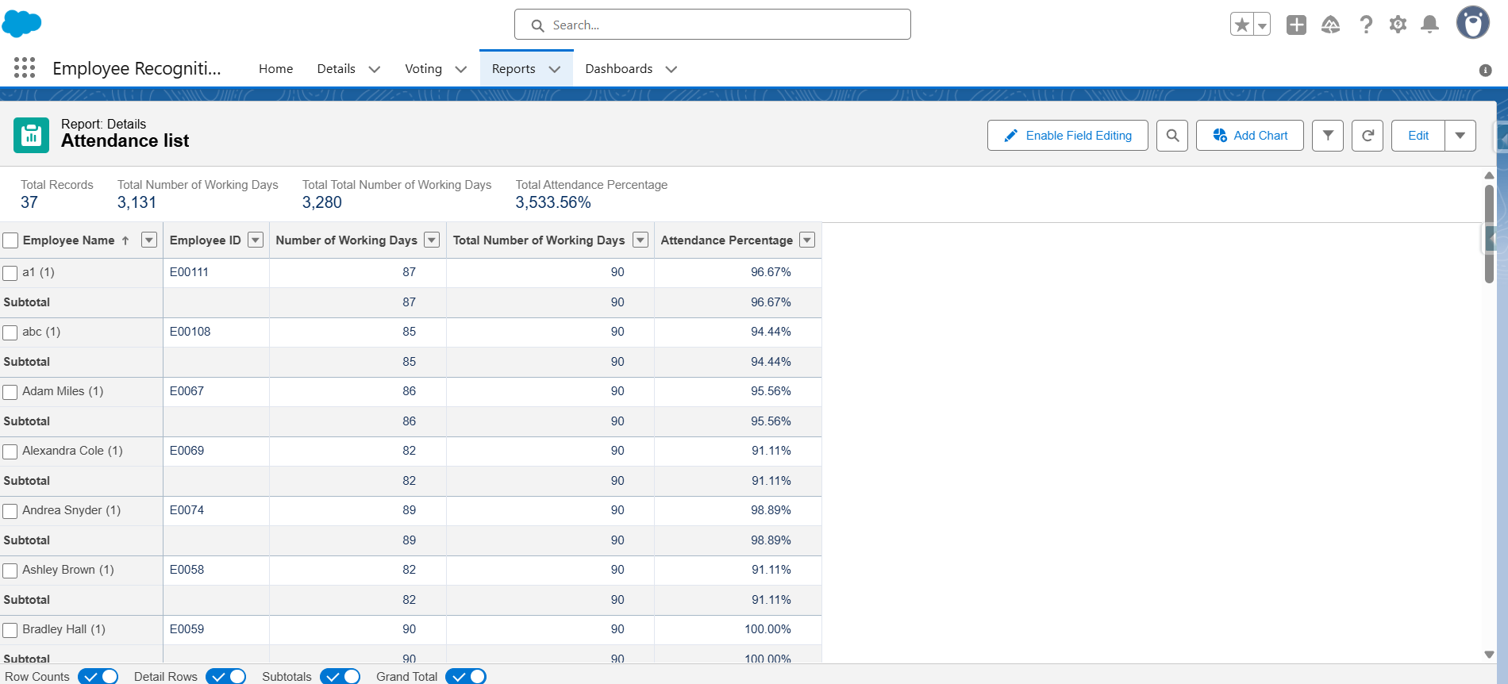

**Report 2:**

Name : Task Completion List

Group Rows : Employee Name

Columns : Performance Based Score, Number of tasks assigned, Number of tasks completed, Tasks completion Percentage

Filter : Tasks completion Percentage – Greater than 85%

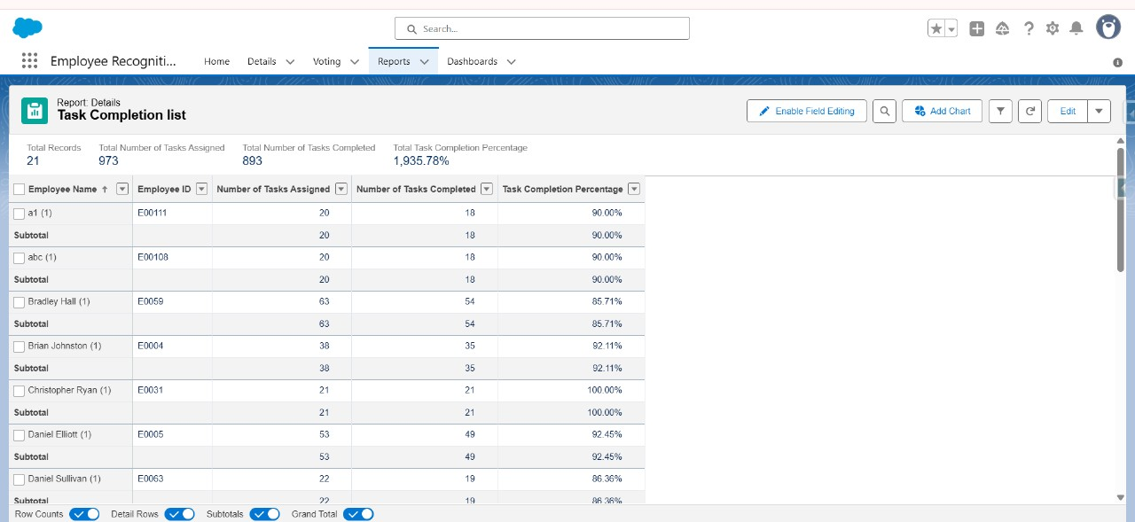

**Report 3:**

Name : Top Performance by department

Group Rows : Department

Columns : Performance Based Score, Tasks completion Percentage, Attendance Percentage

Filter : Performance Based Score – Greater than 90%

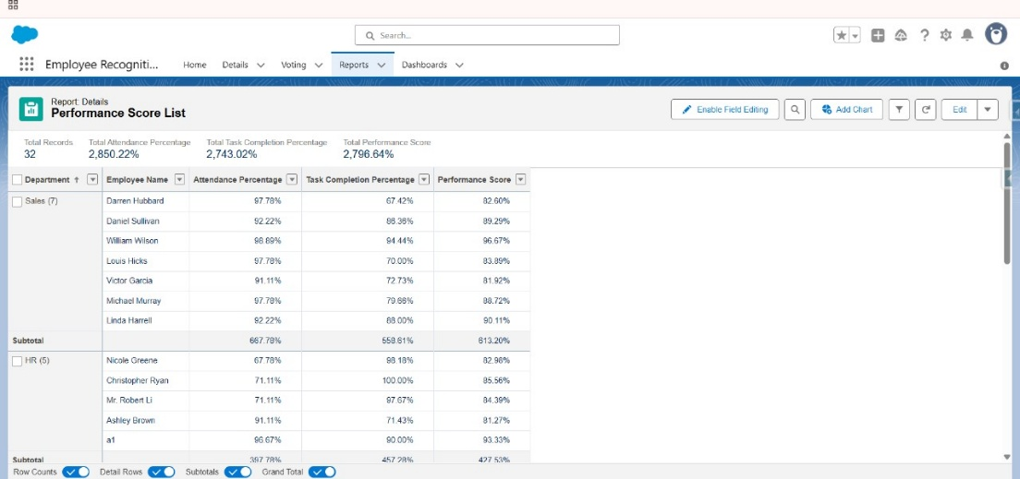

**Report 4:**

Name : Finalized Employees Report

Columns : Manager Rating , Full Name

Filter : Manager Rating – Greater than 3

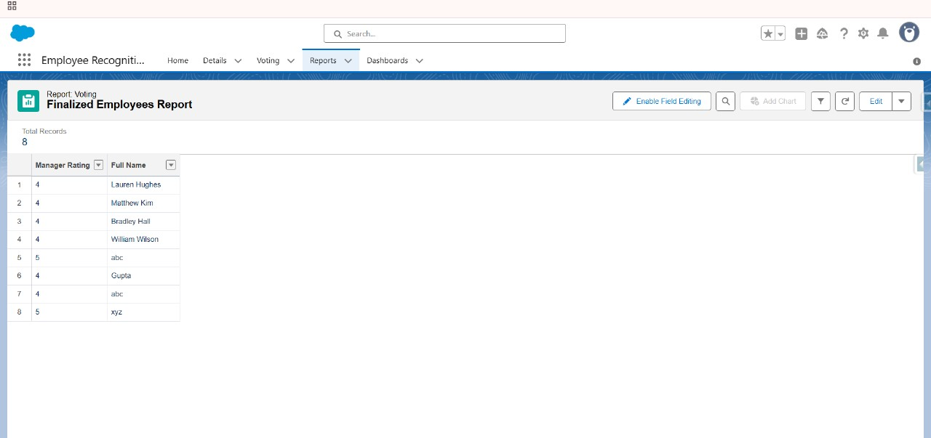

Save all the reports

**Dashboards**

Now Click Dashboards and then ,

New Dashboard

Click +widget button and then add the 3 reports based on required customization.

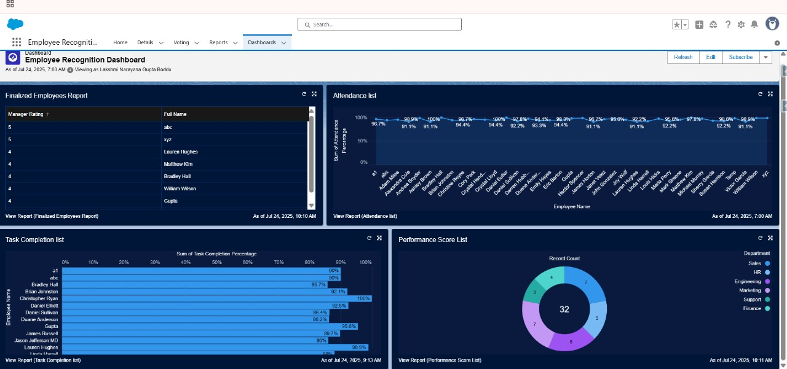

Save the dashboard.

For our convenience to test data we have used Salesforce Inspector Reloaded to import Sample data.

These are the proceedings of our project employee recognition.

**Testing :**

**Best Case:** If everything is correct works fine then we can see that the employees will receive an email as shown below

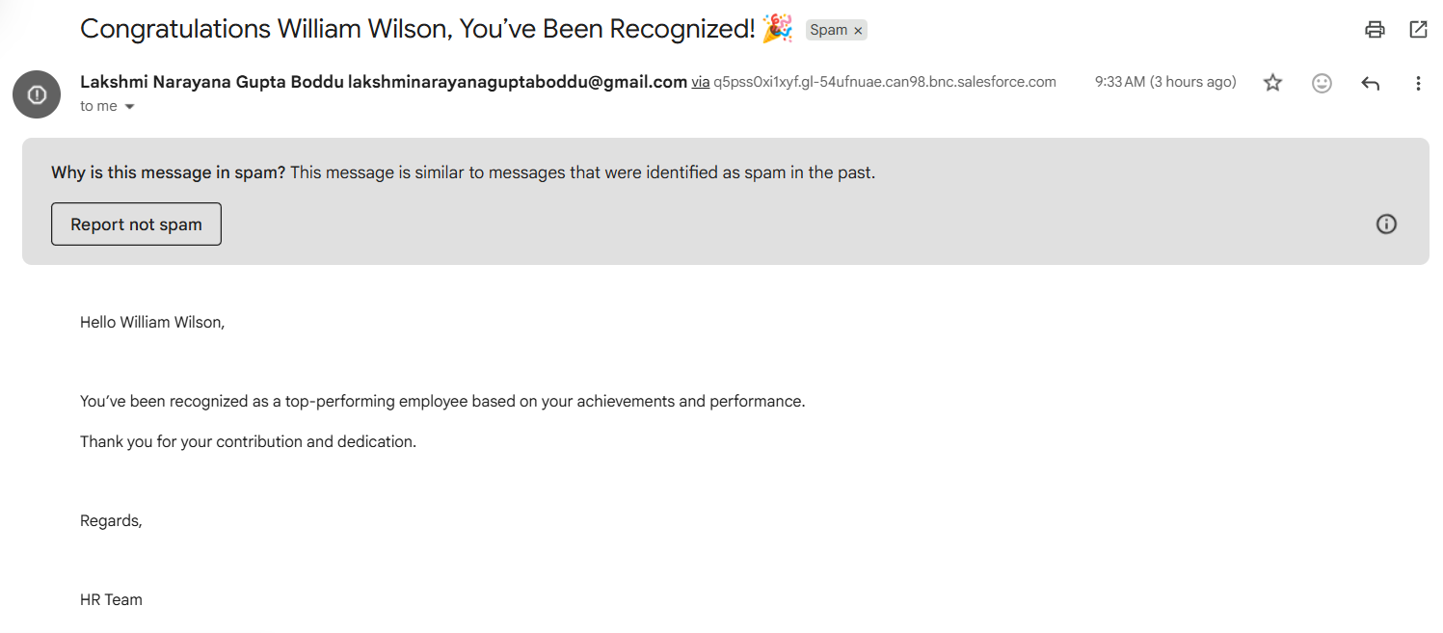

**Worst Case:**

**Here we have given respective email address for the employee.**

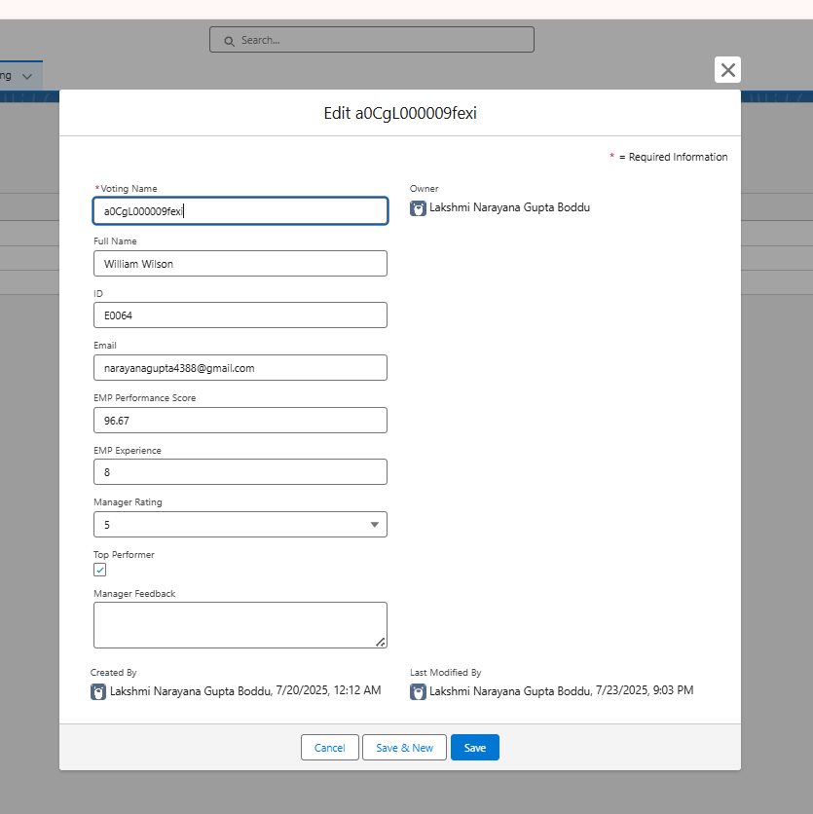

If you are trying to give the same email address for another employee it will encounter an issue as shown below, because it doesn’t allow duplicate records with same email address

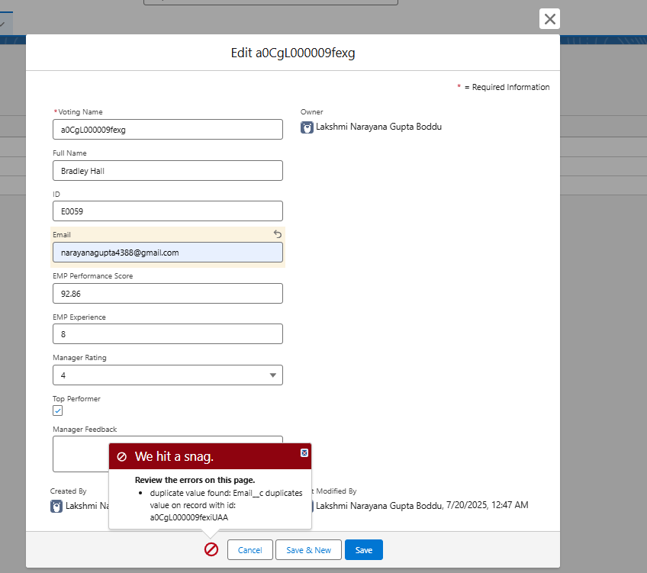

**Future Enhancements:**

* Automate the **data transfer to the Finance Department** using Salesforce **Flows**.
* Add a **monthly leaderboard** or **recognition history tracking** for long-term visibility.
* Integrate with external **HRMS or Payroll systems** for direct reward disbursement.
* Introduce a **reward points system** that employees can redeem based on recognition.

**Conclusion:**

The **Employee Recognition Tracker** successfully automates the process of recognizing high-performing employees, promotes transparency in evaluation, and boosts employee morale through timely recognition emails and structured managerial feedback.

By integrating performance records, managerial input, automated email notifications, and analytical dashboards within Salesforce, the system reduces manual work, enhances data accuracy, and empowers decision-makers.

The workflow extends its utility beyond HR, with data from dashboards being shared with the **Finance Department** for **budget allocation to top performers**. This ensures a holistic approach where recognition is not just verbal or digital—but also financially appreciated.

**Thank You**