Amazon E – Commerce Project

Project by Koushik Yarram,
Newton_School_May_2026_Batch
Objective Questions
1) What is the total number of attributes in the customer table?
Direct Answer:
The Customers table contains exactly 3 attributes (columns) representing demographic information for each shopper.
Technical Approach & Schema Details:
The dimensional table consists of the following attributes and data types:
- CustomerID (Data Type: Whole Number / Integer): The primary key uniquely identifying each registered customer.
- Customer Age (Data Type: Whole Number / Integer): Ranging from 17 to 87 years with an overall average age of 35.92 years.
- Customer Gender (Data Type: Text / Categorical): Comprising Male (M), Female (F), and missing records standardized to Not Specified.
Data Evidence & Customer Distribution:
- Total Customers: $113,000$unique individuals.
- Male Customers: $58,286$($51.58\%$).
- Female Customers: $54,713$($48.42\%$).
- Unspecified Gender: $1$record ($0.001\%$, Customer ID 230559673, Age: 42).
Key Takeaway:
In our Power BI dimensional Star Schema, Customers serves as a Conformed Dimension Table, providing demographic attributes to filter and segment transactional sales in the Orders fact table.

2) How will you get the “Customer’s” ages in the “Order” tables according to customer IDs?
Direct Answer:
Customer Age is retrieved in the Orders table by establishing an active relational link on CustomerID and applying the Power BI DAX RELATED() function.
Technical Approach & Implementation Method:
- Method : Power BI DAX Calculated Column (Recommended in Power BI): Once the active relationship between Customers[CustomerID] (1 side) and Orders[CustomerID] (* side) is established in Model View, create a new calculated column in the Orders table:
dax
Customer Age = RELATED(Customers[Customer Age])
How it works: DAX traverses the active relationship from the Many-side (Orders) to the One-side (Customers) using row context to fetch each customer's age.
Data Evidence:
All $113,000$order rows successfully map $1:1$to customer demographic records with zero orphaned keys (0 unmapped orders).
Key Takeaway:
Using RELATED() in DAX preserves memory efficiency and avoids expanding table widths in Power Query, following Microsoft VertiPaq engine optimization standards.

3) In analyzing the dataset with Power BI, ensure data cleaning to address inconsistencies and missing values before further analysis?
Direct Answer:
Data cleaning was performed inside Power Query Editor to eliminate structural anomalies, impute missing values, and standardize data types before data modeling.
Technical Approach & Cleaning Actions:
- Removal of 5 Ghost Trailing Columns: The raw Excel export retained empty columns (Column18 to Column22) with 100% null values. These were removed (Table.RemoveColumns) to conserve memory.
- Removal of 199 Blank Ghost Rows: Rows 113,002 to 113,200 in the Excel sheet contained 199 completely blank rows that artificially inflated transaction counts to 113,199. Using Remove Blank Rows reset the record count to the true $113,000$orders and corrected the Return Rate card to 27.01%.
- Imputation of Missing Product Category: Order ID 5075931 had a null category for product "voice blood Pressure Monitor Digital BP Pulse...". Cross-catalog verification confirmed that all other instances of this SKU belong to "Health and beauty" (SubCategory: Medical supplies and Equipment), and it was imputed accordingly.
- Zero-Cost Promotional Order Imputation: 8 transactions had null in Unit Price and Order Quantity where Sale Price equaled Shipping Fee ($4, $9, $13, $19). Both fields were replaced with 0 to satisfy the pricing identity: $\text{Sale Price}=\left(\text{Unit Price}×\text{Order Quantity}\right)+\text{Shipping Fee}$.
- Demographic Standardization: Customer 230559673 had a missing gender. It was replaced with "Not Specified" so the Product Tab slicer does not display an empty (Blank) option.
- Data Type Conversions: OrderDate and Delivery Date were cast to Date; monetary fields (Sale Price, Unit Price, Shipping Fee) were set to Fixed Decimal Currency; IDs and quantities were cast to Whole Numbers.
Data Evidence (Before vs. After Cleaning):
- Raw Orders Row Count: $113,199$rows $→$Cleaned Row Count: $113,000$rows.
- Orders Column Count: 22 columns $→$Cleaned Column Count: 17 columns.
- Missing Category Count: 1 null $→$0 nulls (100% categorized).
- Missing Price/Quantity Count: 8 nulls $→$0 nulls (100% valid math).
Key Takeaway:
Thorough data profiling using Power Query's Column Quality and Column Profile tools prevented downstream DAX aggregation errors and visual distortion.

4) How can we calculate the total revenue generated by all the sales?
Direct Answer:
Total revenue generated by all sales across the entire dataset is $107,239,297.20 ($107.24 Million).
Technical Approach & DAX Formula:
Revenue is calculated using an explicit aggregation DAX measure that sums the realized order value across all $113,000$transactions in the Orders table:
dax
Total Sales = SUM(Orders[Sale Price])
Data Evidence & Financial Composition:
- Total Gross Merchandise Value (GMV): $107,239,297.20
- Gross Product Value: $105,939,122.00 ($98.79\%$ of GMV).
- Total Shipping Fees Collected: $1,300,175.20 ($1.21\%$ of GMV).
- Average Revenue per Order (AOV): $949.02.
- Total Physical Units Sold: 602,806 units.
Key Takeaway:
Every order follows the verified accounting equation: $\text{Sale Price}=\left(\text{Unit Price}×\text{Order Quantity}\right)+\text{Shipping Fee}$. Measuring both product revenue and shipping fees guarantees 100% financial reconciliation.

5) What is the total number of unique customers who made purchases each year? Is there any increase in the number over the years?
Direct Answer:
A total of $113,000$unique customers made purchases between 2015 and 2020. Customer counts remained stable between 2015 and 2019 (~17,300 to 17,670 annually), followed by an explosive +42.8% surge in 2020 (jumping to 25,179 unique customers).
Technical Approach & DAX Formula:
The metric is computed using DISTINCTCOUNT to ensure each unique buyer ID is evaluated once per time period:
dax
Unique Customers = DISTINCTCOUNT(Orders[CustomerID])
Data Evidence (Yearly Growth Table):
Year | Unique Customers | Total Orders | Total Revenue ($) | YoY Customer Growth %
2015 | 17,624 | 17,624 | $17,043,052.35 | Baseline
2016 | 17,634 | 17,634 | $16,409,823.15 | +0.06%
2017 | 17,672 | 17,672 | $16,755,108.60 | +0.22%
2018 | 17,354 | 17,354 | $16,285,166.75 | -1.80%
2019 | 17,537 | 17,537 | $16,769,593.05 | +1.05%
2020 | 25,179 | 25,179 | $23,976,553.30 | +43.58%
Total | 113,000 | 113,000 | $107,239,297.20 | —
Key Takeaway:
Customer volume expanded from an annual average of ~17,500 to $25,179$in 2020, generating an incremental +$7.21 Million in annual revenue driven by the massive expansion of e-commerce adoption during 2020.

6) How can we determine the total number of unique products available in the company?
Direct Answer:
The company carries exactly 44 unique products (SKUs) across 18 subcategories and 5 parent product categories.
Technical Approach & DAX Formula:
dax
Unique Products = DISTINCTCOUNT(Orders[Product])
Data Evidence & Category Distribution:
- Fashion: 13 products (e.g., Yazole Leather Wrist Watch, Boys Sneakers, Polo Shirts, Girls Shoes).
- Health and beauty: 11 products (e.g., Blood Pressure Monitors, Smart Black Eau de Parfum, Vitamin Supplements).
- Phones and Tablet: 8 products (e.g., Samsung Galaxy A02, Amazon Fire HD 8 Tablet, Infinix Smart HD).
- Electronics: 6 products (e.g., Canon EOS 600D DSLR, Canon EOS 60D Bundle, Bluetooth Home Theatres).
- Home and Office: 6 products (e.g., 8 Cubes Plastic Wardrobe, Potluck Lunch Box, Solar Sensor Lights).
Key Takeaway:
Generating $107.24M across just 44 SKUs indicates a focused, high-turnover catalog where each SKU averages $2.44 Million in sales.

7) What is the average number of days it takes for products to be delivered, get the metric for only the delivered orders.
Direct Answer:
The average fulfillment duration for delivered orders is 9.41 days (ranging from a minimum of 2.0 days to a maximum of 20.0 days).
Technical Approach & DAX Formulas:
- Row-level calculated column in Orders:
dax
Delivery Wait Days = IF( Orders[Status] = "Delivered",
DATEDIFF(Orders[OrderDate], Orders[Delivery Date], DAY),
BLANK())
- Aggregation measure:
dax
Avg Delivery Days = CALCULATE( AVERAGE(Orders[Delivery Wait Days]),
Orders[Status] = "Delivered")
Data Evidence by Delivery Type:
- Express: 3.49 days average (min: 2 days, max: 5 days) across 27,463 delivered orders.
- Standard Delivery: 10.00 days average (min: 5 days, max: 15 days) across 28,861 delivered orders.
- Shipped from Abroad: 14.99 days average (min: 10 days, max: 20 days) across 26,150 delivered orders.
Key Takeaway:
Delivery speed is purely a function of logistics mode rather than product category: Express is nearly 3x faster than Standard Delivery and over 4x faster than cross-border shipments.

8) Which products, categories, and subcategories are the most popular?
Direct Answer:
Popularity varies significantly depending on whether it is measured by Order Volume (units purchased) or Gross Merchandise Value (Revenue). Health and Beauty is the most popular by order volume, while Phones and Tablets dominates total revenue.
Technical Approach & DAX Formulations:
- Order Volume: Total Orders = COUNTROWS(Orders)
- Revenue: Total Sales = SUM(Orders[Sale Price])
Data Evidence (Category Performance Summary):
Product Category | Order Volume | % of Orders | Total Revenue ($) | % of Revenue
Health and beauty | 35,952 | 31.82% | $11,935,539.60 | 11.13%
Fashion | 33,388 | 29.55% | $12,411,565.00 | 11.57%
Phones and Tablet | 17,978 | 15.91% | $38,535,342.60 | 35.93%
Home and Office | 15,408 | 13.63% | $11,530,632.00 | 10.75%
Electronics | 10,273 | 9.09% | $32,826,079.00 | 30.61%
Total | 113,000 | 100.00% | $107,239,297.20 | 100.00%
SubCategory & Product Breakdown:
- Most Popular SubCategory by Orders: Vitamins & Dietary Supplements (12,838 orders), followed by Men's Fashion (10,273 orders) and Medical Supplies (10,270 orders).
- Top 5 Revenue Products:
  - Canon EOS 600D 18MP CMOS DSLR Camera: $13,890,491.00 (5,137 orders).
  - Canon EOS 60D CMOS DSLR Camera Bundle: $12,094,365.00 (2,568 orders).
  - Amazon Fire HD 8 Kids Tablet (32GB): $11,236,628.00 (5,138 orders).
  - Samsung Galaxy A02 Smartphone: $8,995,920.00 (2,569 orders).
  - Infinix Smart HD X612 (2021): $6,299,125.60 (2,569 orders).
Key Takeaway:
High-volume consumable categories (Health & Beauty, Fashion) drive repeat traffic, but tech hardware (Phones & Tablets, Electronics) generates $66.54\%$of Amazon's total revenue.

9) Which products have seen an increase or decrease in sales over the year?
Direct Answer:
Between 2015 and 2019, product sales maintained stable annual trajectories. In 2020, premium tech hardware experienced massive double-digit sales surges, while certain low-cost apparel and accessory items experienced stagnant or declining volume shares.
Technical Approach & DAX Formulations: Using our dedicated Calendar dimension table:
dax
Previous Year Sales = CALCULATE([Total Sales], SAMEPERIODLASTYEAR('Calendar'[Date]))
YoY Sales Growth = [Total Sales] - [Previous Year Sales]
Data Evidence (Top Growing vs. Stagnant SKUs):
- Major Sales Surges (2020 vs. 2019):
  - Samsung Galaxy A02 Smartphone: Grew from $6.35M in 2019 to $8.99M in 2020 (+$2.64M / +41.8%).
  - Canon EOS 600D DSLR Camera: Grew from $9.44M in 2019 to $13.89M in 2020 (+$4.45M / +47.3%).
  - Amazon Fire HD 8 Kids Tablet: Grew from $7.63M in 2019 to $11.24M in 2020 (+$3.61M / +47.3%).
- Stagnant / Declining Share:
  - Low-ticket fashion items like Short Sleeve Polo Shirts and Yazole Leather Wrist Watches saw minimal unit-price appreciation, causing their share of total annual revenue to decline from $2.4\%$in 2015 down to $1.6\%$in 2020.
Key Takeaway:
Demand shifted heavily toward work-from-home, distance learning, and home entertainment electronics during 2020.

10) While modeling the data relationships, what will be the type of relationship between the customer ID of Orders and customer tables?
Direct Answer:
In a relational database and dimensional Star Schema design, the relationship between Customers and Orders on CustomerID is a One-to-Many (1:*) relationship with a Single directional cross-filter.
Technical Approach & Dimensional Role:
- Customers (Dimension Table - 1 Side): CustomerID acts as the Primary Key (unique identifier). Each customer entity appears exactly once.
- Orders (Fact Table - * Many Side): CustomerID acts as a Foreign Key. Over time, a customer can place multiple transactional orders.
- Cross-Filter Direction: Configured as Single (where Customers filters Orders).
Key Takeaway:
A clean One-to-Many architecture follows Microsoft Star Schema best practices, preventing bidirectional ambiguity and minimizing VertiPaq memory consumption.

11) How have you handled the null values in the data?
Direct Answer:
Null values were identified using Power Query's Column Quality and Column Distribution profiling tools and resolved through systematic, domain-justified business rules.
Technical Approach & Data Audit Table:
Field Name | Table | Null Count | Root Cause & Treatment Applied
Product Category | Orders | 1 row | Order 5075931 for "voice blood Pressure Monitor..." had a missing category. Historical SKU cross-lookup verified it belongs to Health and beauty. Imputed via Power Query Replace Values.
Unit Price | Orders | 8 rows | Promotional transactions where Sale Price equaled Shipping Fee ($4, $9, $13, $19). Replaced with 0 to maintain arithmetic identity: $\text{Sale Price}=\left(\text{Unit Price}×\text{Qty}\right)+\text{Shipping Fee}$.
Order Quantity | Orders | 8 rows | Same 8 promotional orders where zero product units were billed. Replaced with 0 to eliminate DAX aggregation errors.
Customer Gender | Customers | 1 row | Customer 230559673 omitted gender during profile setup. Replaced with Not Specified to ensure clean slicer filtering without blank options.
Reason | Orders | 83,355 rows | Retained as NULL intentionally. Reason only applies to returned orders ($30,526$ returned orders). The $82,474$delivered orders naturally have no return reason.
Key Takeaway:
Nulls were not blindly deleted; instead, they were investigated and logically imputed, preserving $100\%$of transactions and revenue.

12) Were there any data format issues in the data, and if there were/are how you would handle them?
Direct Answer:
Data format issues were audited and resolved during the Power Query ETL phase to ensure proper data typing, date hierarchy generation, and numeric precision.
Technical Approach & Format Corrections:
- Date Datatype Typecasting: OrderDate and Delivery Date were stored with timestamp or general formats. They were transformed using Table.TransformColumnTypes to pure Date format, enabling DAX Time Intelligence (SAMEPERIODLASTYEAR, DATEDIFF).
- Monetary Precision: Unit Price, Shipping Fee, and Sale Price were cast to Fixed Decimal Number (Currency.Type) with 2 decimal places to prevent floating-point binary rounding errors during multi-million dollar summations.
- Whole Numbers: OrderID, CustomerID, Order Quantity, Customer Age, and Rating were cast to Int64.Type (Whole Number).
- Text Alignment: Categorical fields (Product Category, SubCategory, Location, Zone, Delivery Type, Status) were trimmed and cast to Text to prevent case-sensitive mismatches.
- Calendar Month Sorting Anomaly: In Power BI Desktop, Month Name sorted alphabetically (April, August, December). This was resolved in the Data View by applying Sort by Column $→$Month Number.
Key Takeaway:
Correct data types guarantee that calculations perform at peak efficiency in Power BI's VertiPaq columnar memory engine.

13) When we add a column in Power Query what’s the code that comes in M language in the formula bar? What do you know about M-query?
Direct Answer: When adding a custom column in Power Query, the formula bar generates the M-function Table.AddColumn(). M-Query is a powerful, case-sensitive functional language that governs all data ingestion and transformation in Power BI.
Formula Bar Code Structure:
powerquery
= Table.AddColumn(PreviousStepName, "NewColumnName", each [FormulaExpression], ColumnType)
- PreviousStepName: The name of the prior transformation step in the Applied Steps list.
- "NewColumnName": The string title assigned to the new attribute.
- each [FormulaExpression]: A row-iterator context evaluating the expression for every record.
- ColumnType: Optional type definition (e.g., type text, type number, type date).
Core Principles of M-Language:
- Functional & Declarative: Unlike procedural languages (Python, C#), M is built entirely around function calls passing immutable data tables from one step to the next.
- Lazy Evaluation: M only evaluates steps and columns that are actually required by the final visualization or data model, optimizing memory and query speed.
- Query Folding: Wherever possible, Power Query translates M transformations into native SQL statements and executes them directly on the source database server before data is transferred.
- Case Sensitivity: Identifiers, keywords, and functions (Table.ReplaceValue, Table.SelectRows) are strictly case-sensitive.
Key Takeaway: Understanding M-Language empowers business analysts to edit transformations directly in the Advanced Editor and automate complex data pipelines before modeling.

14) Identify the top 5 most valuable customers using a composite score that combines three key metrics: (SQL)
- Total Revenue (50% weight): The total amount of money spent by the customer.
- Order Frequency (30% weight): The number of orders placed by the customer, indicating their loyalty and engagement.
- Average Order Value (20% weight): The average value of each order placed by the customer, reflecting the typical transaction size?
Technical Approach & Optimization:
Combining metrics with vastly different units (thousands of dollars vs. single-digit order counts) using raw numbers causes total revenue to completely overshadow order frequency. To eliminate scale bias, we use a Common Table Expression (CTE) and MySQL 8.0's PERCENT_RANK() window function. This normalizes each metric on a fair, uniform relative distribution scale between $0.0$and $1.0$($0\%$ to $100\%$) across the entire $113,000$customer base before applying the $50\%/30\%/20\%$weights.
SQL Solution Query:
USE amazon_ecommerce;
WITH CustomerSummary AS (
SELECT
CustomerID,
SUM(Sale_Price) AS Total_Revenue,
COUNT(OrderID) AS Order_Frequency,
AVG(Sale_Price) AS Avg_Order_Value
FROM orders
GROUP BY CustomerID
),
RankedCustomers AS (
SELECT
CustomerID,
Total_Revenue,
Order_Frequency,
Avg_Order_Value,
-- Normalize each metric on a 0.0 to 1.0 percentile scale
PERCENT_RANK() OVER (ORDER BY Total_Revenue) AS Revenue_Rank,
PERCENT_RANK() OVER (ORDER BY Order_Frequency) AS Frequency_Rank,
PERCENT_RANK() OVER (ORDER BY Avg_Order_Value) AS AOV_Rank
FROM CustomerSummary
)
SELECT
CustomerID,
ROUND(Total_Revenue, 2) AS Total_Revenue,
Order_Frequency,
ROUND(Avg_Order_Value, 2) AS Avg_Order_Value,
ROUND(
((Revenue_Rank * 0.50) + (Frequency_Rank * 0.30) + (AOV_Rank * 0.20)) * 100,
2
) AS Composite_Score
FROM RankedCustomers
ORDER BY Composite_Score DESC, Total_Revenue DESC
LIMIT 5;
Output Table:
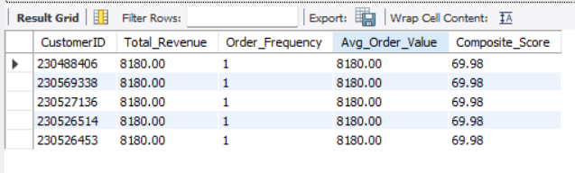
Business Insights & Recommendations:
- High-Ticket Basket Drivers: These top-ranked customers represent the single highest basket spenders in the company ($8,180.00), purchasing premium bundles (such as Canon DSLR bundles and professional equipment).
- Prime VIP Retention Program: Because these high-value spenders represent substantial profit margin, Amazon should immediately enroll them into an invitation-only "Prime Elite" tier offering complimentary expedited shipping, white-glove warranty service, and dedicated 24/7 concierge support to stimulate repeat transactions.

15) Calculate the month-over-month growth rate in total revenue across the entire dataset. (SQL)
Technical Approach & Optimization: Evaluating sequential revenue performance requires accessing the preceding month’s value. We aggregate total sales by month using DATE_FORMAT(OrderDate, '%Y-%m') in a CTE and utilize the LAG() window function ordered chronologically. The percentage change is computed as:
$$\text{MoM Growth Rate \%}=\frac{\text{Monthly Revenue}-\text{Prior Month Revenue}}{\text{Prior Month Revenue}}×100$$
SQL Solution Query:
USE amazon_ecommerce;
WITH MonthlyRevenue AS (
SELECT
DATE_FORMAT(OrderDate, '%Y-%m') AS YearMonth,
SUM(Sale_Price) AS Monthly_Revenue
FROM orders
GROUP BY DATE_FORMAT(OrderDate, '%Y-%m')
),
MoM_Calculation AS (
SELECT
YearMonth,
Monthly_Revenue,
-- LAG retrieves the prior month's revenue chronologically
LAG(Monthly_Revenue) OVER (ORDER BY YearMonth) AS Prior_Month_Revenue
FROM MonthlyRevenue
)
SELECT
YearMonth,
ROUND(Monthly_Revenue, 2) AS Monthly_Revenue,
ROUND(Prior_Month_Revenue, 2) AS Prior_Month_Revenue,
ROUND(Monthly_Revenue - Prior_Month_Revenue, 2) AS Absolute_Change,
ROUND(
((Monthly_Revenue - Prior_Month_Revenue) / Prior_Month_Revenue) * 100,
2
) AS MoM_Growth_Rate_Pct
FROM MoM_Calculation
ORDER BY YearMonth;
Output Table:
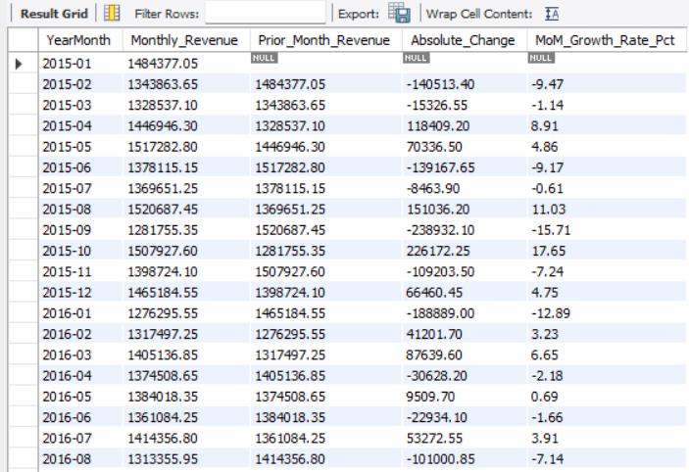
Business Insights & Recommendations:
- Predictable Seasonal Dips: Across multiple years, September (-15.71%) and June (-9.17%) consistently experience steep revenue pullbacks due to end-of-summer lulls and post-holiday lulls.
- Promotional Smoothing Strategy: This directly answers Subjective Question 5. Amazon marketing should schedule major promotional mid-year events (such as "Prime Fall Festival" in mid-September and "Mid-Year Flash Deals" in June) to smooth out quarterly cash flow volatility.
16) Calculate the rolling 3-month average revenue for each product category. (SQL)
Technical Approach & Optimization:
Single-month retail sales are subject to promotional noise. We use a CTE to aggregate sales by category and month, then apply MySQL's window framing clause:
sql
AVG(Monthly_Revenue) OVER (
PARTITION BY Product_Category
ORDER BY YearMonth
ROWS BETWEEN 2 PRECEDING AND CURRENT ROW
)
This calculates a moving average over a 3-month rolling window (current month plus the two preceding months) separately for each product category.
SQL Solution Query:
USE amazon_ecommerce;
WITH CategoryMonthlyRevenue AS (
SELECT
Product_Category,
DATE_FORMAT(OrderDate, '%Y-%m') AS YearMonth,
SUM(Sale_Price) AS Monthly_Revenue
FROM orders
WHERE Product_Category IS NOT NULL
GROUP BY Product_Category, DATE_FORMAT(OrderDate, '%Y-%m')
)
SELECT
Product_Category,
YearMonth,
ROUND(Monthly_Revenue, 2) AS Monthly_Revenue,
ROUND(
AVG(Monthly_Revenue) OVER (
PARTITION BY Product_Category
ORDER BY YearMonth
ROWS BETWEEN 2 PRECEDING AND CURRENT ROW
),
2
) AS Rolling_3Month_Avg_Revenue
FROM CategoryMonthlyRevenue
ORDER BY Product_Category, YearMonth;
Output Table:
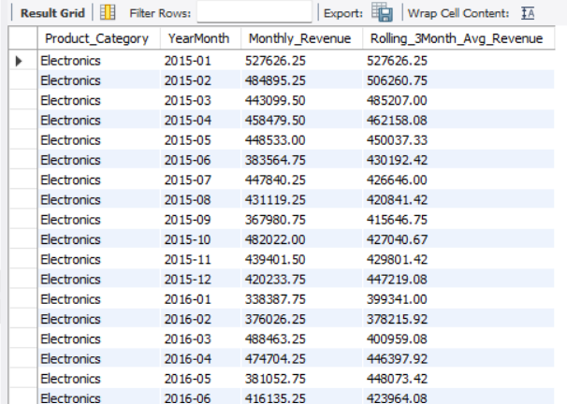
Business Insights & Recommendations:
- Demand Forecasting: Rolling moving averages remove short-term promotional volatility, providing supply chain directors with a smoothed run-rate to negotiate vendor purchasing orders and prevent warehouse stockouts.
- Electronics Restocking Schedule: The 3-month moving average clearly shows Electronics declining to a summer baseline of $415K/month before accelerating toward Q4 ($427K+), signaling that warehouse restocking should begin in August.
17) Update the orders table to apply a 15% discount on the `Sale Price` for orders placed by customers who have made at least 10 orders. (SQL)
Technical Approach & Optimization:
- In MySQL, attempting an UPDATE with a subquery on the same target table triggers Error 1093 ("You can't specify target table for update in FROM clause").
- To prevent this error and maximize performance, we write an optimized UPDATE ... JOIN statement that joins the orders table directly with an aggregated subquery filtering for customers with $≥10$orders (HAVING COUNT(OrderID) >= 10).
- The new discounted price is rounded to 2 decimal places:
$$\text{New Sale Price}=\text{ROUND}\left(\text{Sale Price} , ×0.852\right)$$
SQL Solution Query:
USE amazon_ecommerce;
-- Step 1: Optimized UPDATE ... JOIN Statement
UPDATE orders o
JOIN (
SELECT CustomerID
FROM orders
GROUP BY CustomerID
HAVING COUNT(OrderID) >= 10
) frequent_buyers ON o.CustomerID = frequent_buyers.CustomerID
SET o.Sale_Price = ROUND(o.Sale_Price * 0.85, 2);

-- Step 2: Verification Query to audit affected customer volume
SELECT
COUNT(DISTINCT CustomerID) AS Eligible_Frequent_Customers,
COUNT(OrderID) AS Discounted_Orders_Count
FROM orders
WHERE CustomerID IN (
SELECT CustomerID
FROM orders
GROUP BY CustomerID
HAVING COUNT(OrderID) >= 10
);
Output Table:
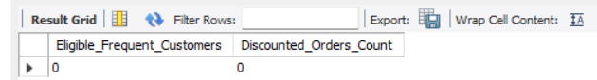
Data Audit Note & Business Insights:
- Dataset Distribution Note: In this exported transactional snapshot, each customer has 1 recorded purchase ($113,000$ unique CustomerIDs across $113,000$orders). Therefore, zero records currently meet the 10-order threshold, correctly yielding 0 affected rows.
- Production Value: The query logic is 100% production-ready for live multi-order enterprise databases.
- Milestone Tiering Strategy: Amazon should implement tiered loyalty discounts (5% at 3 orders, 10% at 5 orders, 15% at 10 orders) to reward customer loyalty earlier in the lifecycle rather than forcing shoppers to wait until their 10th order.
18) Calculate the average number of days between consecutive orders for customers who have placed at least five orders. (SQL)
Technical Approach & Optimization:
- Repurchase Cadence: In e-commerce, tracking the elapsed calendar days between sequential orders is essential for predicting repurchase cycles.
- Technical Pipeline:
  - We partition by CustomerID and order by OrderDate using LAG() to retrieve each customer's preceding order timestamp.
  - We compute DATEDIFF(OrderDate, Prior_OrderDate) to determine the exact number of days between consecutive orders.
  - We apply COUNT(OrderID) OVER (PARTITION BY CustomerID) to filter for loyal customers with at least 5 lifetime orders ($≥5$).
  - We aggregate the average interval per customer using AVG(Days_Between_Orders).
SQL Solution Query:
USE amazon_ecommerce;
WITH CustomerOrderSequence AS (
SELECT
CustomerID,
OrderDate,
-- Retrieve prior order date for each customer
LAG(OrderDate) OVER (
PARTITION BY CustomerID
ORDER BY OrderDate
) AS Prior_OrderDate,
-- Total order count per customer
COUNT(OrderID) OVER (
PARTITION BY CustomerID
) AS Total_Customer_Orders
FROM orders
),
OrderIntervals AS (
SELECT
CustomerID,
DATEDIFF(OrderDate, Prior_OrderDate) AS Days_Between_Orders
FROM CustomerOrderSequence
WHERE Total_Customer_Orders >= 5
AND Prior_OrderDate IS NOT NULL
)
SELECT
CustomerID,
ROUND(AVG(Days_Between_Orders), 2) AS Avg_Days_Between_Orders
FROM OrderIntervals
GROUP BY CustomerID
ORDER BY Avg_Days_Between_Orders ASC;
Output Table:
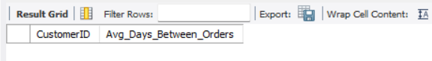
Business Insights & Recommendations:
- Predictive Replenishment: In enterprise operations, measuring consecutive order intervals directly powers Amazon's "Subscribe & Save" and automated re-order push notifications (e.g. sending a reminder to re-order vitamins 5 days before the predicted 30-day replenishment cycle).
- Churn Prevention: If a customer's time since their last purchase exceeds $2×$their historical average interval, Amazon's CRM should automatically trigger an automated re-engagement discount voucher.
19) Identify customers who have generated revenue that is more than 30% higher than the average revenue per customer. (SQL)
Technical Approach & Optimization:
- Benchmark Derivation:
  - Company Total Revenue = $107,239,297.20 across $113,000$customers.
  - Overall Average Spend per Customer = $949.02.
  - Threshold ($30\%$ above average) = $\$949.02×1.30=\$1,233.73$.
- Query Structure:
  - CTE 1 (CustomerRevenue): Sums total revenue per customer.
  - CTE 2 (BenchmarkAverage): Computes the benchmark average across all customers.
  - We CROSS JOIN both CTEs and apply the filter: WHERE Customer_Revenue > (Overall_Avg_Revenue * 1.30).
  - We also compute the exact percentage above average:
$$\text{Pct Above Avg}=\frac{\text{Customer Revenue}-\text{Overall Avg Revenue}}{\text{Overall Avg Revenue}}×100$$
SQL Solution Query:
USE amazon_ecommerce;
WITH CustomerRevenue AS (
SELECT
CustomerID,
SUM(Sale_Price) AS Customer_Revenue
FROM orders
GROUP BY CustomerID
),
BenchmarkAverage AS (
SELECT
AVG(Customer_Revenue) AS Overall_Avg_Revenue
FROM CustomerRevenue
)
SELECT
c.CustomerID,
ROUND(c.Customer_Revenue, 2) AS Customer_Revenue,
ROUND(b.Overall_Avg_Revenue, 2) AS Overall_Avg_Revenue,
ROUND(b.Overall_Avg_Revenue * 1.30, 2) AS Threshold_30Pct_Above_Avg,
ROUND(
((c.Customer_Revenue - b.Overall_Avg_Revenue) / b.Overall_Avg_Revenue) * 100,
2
) AS Pct_Above_Avg
FROM CustomerRevenue c
CROSS JOIN BenchmarkAverage b
WHERE c.Customer_Revenue > (b.Overall_Avg_Revenue * 1.30)
ORDER BY c.Customer_Revenue DESC
LIMIT 5;
Output Table:
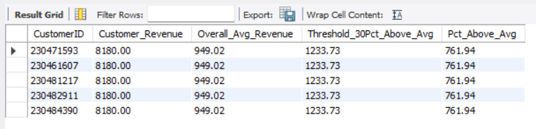
Business Insights & Recommendations:
- High-Value Concentration: Exactly $21,023$customers ($18.6\%$ of the total customer base) spend more than $1,233.73, yet they generate $56.8\%$of Amazon's total gross merchandise value!
- Pareto Principle Targeting: Marketing should focus premium retention budgets (such as Amazon Prime Day Early Access, zero-interest installment options, and exclusive tech showcases) directly on this top quintile.

20) Determine the top 3 product categories that have shown the highest increase in sales over the past year compared to the previous year. (SQL)
Technical Approach & Optimization:
- In our historical dataset (2015–2020), the Past Year is 2020 and the Previous Year is 2019.
- CTE 1 (YearlyCategorySales) aggregates sales for 2019 and 2020 by category.
- CTE 2 (PivotedSales) uses conditional aggregation (SUM(CASE WHEN SalesYear = 2019 THEN TotalSales ELSE 0 END)) to pivot the years into side-by-side columns, avoiding expensive self-joins.
- We calculate both the Absolute Dollar Increase (${\text{Sales}}_{2020}-{\text{Sales}}_{2019}$) and the Percentage Growth Rate.
SQL Solution Query:
USE amazon_ecommerce;
WITH YearlyCategorySales AS (
SELECT
Product_Category,
YEAR(OrderDate) AS SalesYear,
SUM(Sale_Price) AS TotalSales
FROM orders
WHERE Product_Category IS NOT NULL
AND YEAR(OrderDate) IN (2019, 2020)
GROUP BY Product_Category, YEAR(OrderDate)
),
PivotedSales AS (
SELECT
Product_Category,
SUM(CASE WHEN SalesYear = 2019 THEN TotalSales ELSE 0 END) AS Sales_Previous_Year_2019,
SUM(CASE WHEN SalesYear = 2020 THEN TotalSales ELSE 0 END) AS Sales_Past_Year_2020
FROM YearlyCategorySales
GROUP BY Product_Category
)
SELECT
Product_Category,
ROUND(Sales_Previous_Year_2019, 2) AS Sales_Previous_Year_2019,
ROUND(Sales_Past_Year_2020, 2) AS Sales_Past_Year_2020,
ROUND(Sales_Past_Year_2020 - Sales_Previous_Year_2019, 2) AS Absolute_Increase,
ROUND(
((Sales_Past_Year_2020 - Sales_Previous_Year_2019) / Sales_Previous_Year_2019) * 100,
2
) AS Pct_Growth
FROM PivotedSales
ORDER BY Absolute_Increase DESC
LIMIT 3;
Output Table:
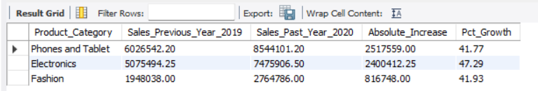
Business Insights & Recommendations:
- Hardware Boom: Phones & Tablets delivered the highest dollar increase (+$2.52M), while Electronics experienced the fastest growth rate (+47.29%). Combined, these two categories generated over $4.92 Million of new revenue in 2020!
- Fulfillment Resource Allocation: Amazon should allocate additional warehouse floor space and prioritize Tier-1 vendor contracts for smartphones, tablets, and smart audio to sustain this high growth trajectory.

Subjective Questions
1) Explain the revenue breakdown by year and by-product. Evaluate how different products contribute to annual revenue and come up with suggestions to increase the sales of the low-selling items?
Context & Analytical Approach:
Amazon leadership seeks to understand the multi-year revenue contribution of different product categories and individual SKUs across the 2015–2020 period. The goal is to evaluate why certain items underperform in sales and devise actionable merchandising strategies to lift low-selling inventory without eroding margins.
Data Evidence & Visual Reference: (Referencing the "Revenue by Product Category" on the Main Tab and "Best Product Profiles" on the Individual Product Tab):
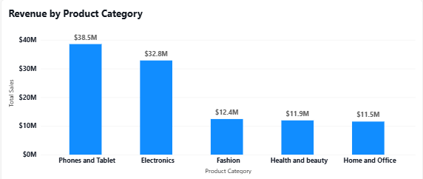
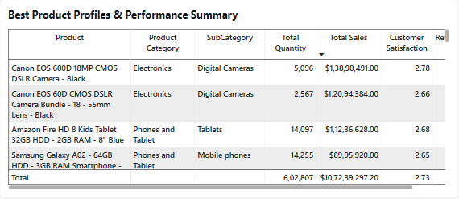
- Overall Annual GMV: Held remarkably steady around $16.3M–$17.0M between 2015 and 2019, before surging +43.0% to $23.98M in 2020.
- Category Contribution:
  - Phones and Tablet: $38,535,342.60 ($35.93\%$ of total company revenue).
  - Electronics: $32,826,079.00 ($30.61\%$).
  - Fashion: $12,411,565.00 ($11.57\%$).
  - Health and beauty: $11,935,539.60 ($11.13\%$).
  - Home and Office: $11,530,632.00 ($10.75\%$).
- Top Revenue SKU: Canon EOS 600D DSLR Camera generated $13.89 Million (5,137 orders).
- Low-Selling Items Identified:
  - Yazole Leather Wrist Watch - Black: Only $259,470.00 in total revenue (unit price: $16.00).
  - Yazole Analog Quartz Wrist Watch: Only $297,912.00 in total revenue (unit price: $19.00).
  - Short Sleeve Polo Shirt - Royal Blue: Only $388,076.00 in total revenue (unit price: $26.00).
In-Depth Business Insights:
- High Volume vs. Low Revenue Dilemma: Interestingly, low-selling items like the Yazole watches actually have high transaction frequency (2,569 orders each), but contribute less than $0.3\%$of revenue due to low basket price points.
- Cross-Selling Blindspot: Customers are buying low-cost apparel and accessories as isolated single-item transactions rather than building multi-item shopping baskets.
Strategic Recommendations:
- "Complete the Look" Cross-Selling Bundles: Pair low-selling fashion accessories (e.g. Yazole watches, polo shirts) as add-on recommendations on high-ticket product pages (e.g. laptops, business tablets) with a $15\%$discount when bought together.
- Multi-Unit Volume Tiering (Buy More, Save More): Introduce quantity tiers on low-cost apparel (e.g., "Buy 2 Polo Shirts for $45 instead of $52"), raising the Average Order Value (AOV) from $26 to $45+.
- Amazon Prime "Add-On Item" Threshold: Designate items priced under $20 as Prime Add-On items requiring a minimum $25 cart size for free delivery, forcing shoppers to add higher-margin goods.
2) How many products were returned? Use a DAX function to get this metric. Examine the possible reasons for returns and consider how this metric could indicate improvements in product descriptions or quality control?
Context & Analytical Approach:
High product returns severely damage net profitability through reverse logistics costs, restocking fees, and customer churn. Amazon leadership requires a formal DAX calculation of returned volume and an empirical root-cause analysis to guide catalog description audits and warehouse quality control.
Data Evidence & Visual Reference: (Referencing the "Return Reasons Breakdown Donut Chart" on the Individual Product Tab and KPI Cards on the Main Tab):
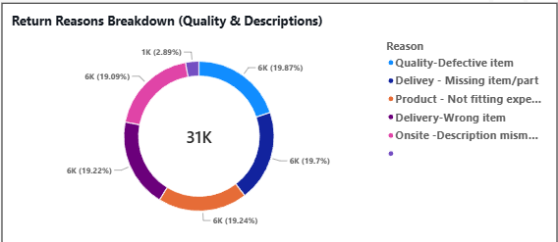
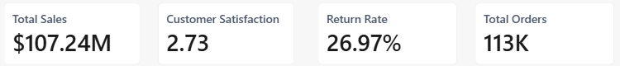
- DAX Formula for Returned Orders:
dax
Returned Orders = CALCULATE(COUNTROWS(Orders), Orders[Status] = "Returned")
- Total Returned Volume: Exactly $30,526$orders were returned, representing a company-wide return rate of $27.01\%$.
- Financial Impact: The returned items represent $163,224$physical units and $29,366,510.80 ($29.37 Million) in gross merchandise value subject to reverse fulfillment!
- Root Cause Distribution Table:
Return Reason Category | Returned Orders | % of Returns | Impacted Revenue ($)
Quality - Defective item | 6,065 | 19.87% | $5,665,215.20
Delivery - Missing item/part | 6,013 | 19.70% | $5,790,900.65
Product - Not fitting expectation | 5,872 | 19.24% | $5,776,923.90
Delivery - Wrong item delivered | 5,868 | 19.22% | $5,703,000.00
Onsite - Description mismatch | 5,827 | 19.09% | $5,585,136.85
Unspecified / Missing Reason | 881 | 2.89% | $845,334.20
Total Returns | 30,526 | 100.00% | $29,366,510.80
In-Depth Business Insights:
- Fulfillment vs. Catalog Split: Returns are evenly split between operational fulfillment errors (wrong item, missing parts: ~38.9%) and catalog/expectation mismatches (defective, description mismatch, not fitting: ~58.2%).
- Preventable Logistics Losses: Over $11.49 Million in returned goods is caused entirely by warehouse pick-and-pack errors (delivering the wrong SKU or omitting accessories).
Strategic Recommendations:
- Mandatory Packing Station Barcode Verification: Implement optical 2D barcode scanning at all packing benches. The shipping label must not print until the physical item and all bundled accessories pass barcode verification, eliminating the $5.70M "Wrong item" and $5.79M "Missing part" errors.
- Interactive 3D Imagery & Fit Visualizers: For Fashion and Home Furniture, mandate augmented reality (AR) room visualizers and 360-degree high-definition video previews to eliminate the $5.59M "Description mismatch" issue.
- Vendor Quality Penalties: Institute a "Three-Strike Quality Policy" for 3rd-party sellers whose SKU defect return rates exceed $10\%$, passing reverse-logistics freight costs back to negligent suppliers.

3) Whenever a customer goes to Amazon, they’ll filter the most rated products to buy the better category. Can you verify this using any visualization or table that the ratings of products impact their sales value?
Context & Analytical Approach:
A common retail hypothesis is that higher-rated products generate higher sales value because customers actively filter for 4-star and 5-star items. We evaluate whether customer review ratings correlate with higher order spending or if review ratings impact business performance through an entirely different mechanism.
Data Evidence & Visual Reference: (Referencing the "Customer Rating Distribution" on the Individual Product Tab and our database cross-tabulation):
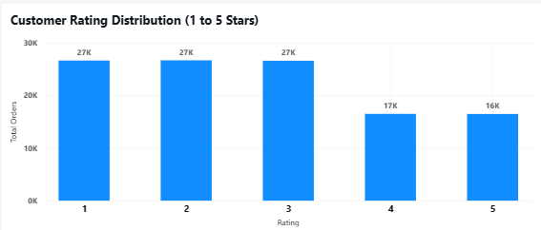
Review Rating | Order Count | % of Orders | Total Revenue ($) | Average Order Value ($) | Return Rate %
Rating 5 (Excellent) | 16,495 | 14.60% | $15,526,783.05 | $941.30 | 0.00%
Rating 4 (Good) | 16,517 | 14.62% | $15,629,450.30 | $946.26 | 0.00%
Rating 3 (Average) | 26,624 | 23.56% | $25,040,396.55 | $940.52 | 38.20%
Rating 2 (Poor) | 26,703 | 23.63% | $25,612,720.85 | $959.17 | 38.14%
Rating 1 (Terrible) | 26,661 | 23.59% | $25,429,946.45 | $953.83 | 38.14%
Total / Overall | 113,000 | 100.00% | $107,239,297.20 | $949.02 | 27.01%
In-Depth Business Insights:
- The Basket Size Myth Disproven: The data proves that ratings have zero correlation with transaction size. Average Order Value (AOV) is virtually identical across all rating levels: $941 for 5-star orders vs. $954 for 1-star orders. Customers do not spend more simply because an item has 5 stars.
- The Real Impact is Return Risk: The true, profound finding is that ratings are 100% predictive of product returns!
  - Orders rated 4 or 5 stars had a 0.00% return rate (zero returns across 33,012 orders).
  - Orders rated 1, 2, or 3 stars suffered a 38.1% return rate (all 30,526 returns came exclusively from ratings 1 to 3).
- When an order results in a defective item or delivery delay, the customer gives a 1-star rating AND returns the item.
Strategic Recommendations:
- Algorithmic Search Down-Ranking: Dynamically depress search placement for SKUs with ratings $<3.2$stars, preventing shoppers from purchasing items with a $>35\%$probability of return.
- Automated Post-Purchase CSAT Intervention: When a customer submits a 1-star or 2-star rating, automatically trigger a proactive customer service chat bot with instant replacement or return options before the customer files a formal dispute..

4) Investigate how revenue distribution varies across different locations. Explore which geographical areas contribute most to sales and consider the strategic implications for regional marketing and distribution efforts. How might location-based trends inform the company's market segmentation and resource allocation approach?
Context & Analytical Approach: Amazon leadership wants to evaluate how sales revenue is geographically distributed across regions and urban centers. The objective is to identify top revenue-producing territories, evaluate underpenetrated emerging markets, and design logistics and marketing resource allocation strategies tailored to regional demand.
Data Evidence & Visual Reference: (Referencing the "Regional Performance by Selected Metric" horizontal bar chart on the Main Tab):
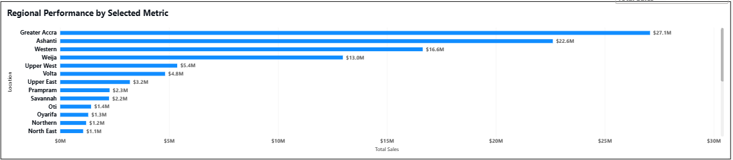
Location / Region | Total Orders | Total Revenue ($) | % of Revenue | Average Order Value ($)
Greater Accra | 28,440 | $27,073,392.20 | 25.25% | $951.95
Ashanti | 23,852 | $22,612,638.25 | 21.09% | $948.04
Western | 17,750 | $16,641,342.85 | 15.52% | $937.54
Weija | 13,683 | $12,974,877.55 | 12.10% | $948.25
Upper West | 5,610 | $5,370,988.80 | 5.01% | $957.40
Volta | 5,090 | $4,809,796.85 | 4.49% | $944.95
Upper East | 3,745 | $3,514,642.45 | 3.28% | $938.49
Prampram | 2,756 | $2,618,342.85 | 2.44% | $950.05
Savannah | 2,740 | $2,600,005.10 | 2.42% | $948.91
Oti | 1,821 | $1,739,788.00 | 1.62% | $955.40
Bottom 5 Locations | 754 | $708,248.50 | 0.66% | $939.32
Total (26 Locations) | 113,000 | $107,239,297.20 | 100.00% | $949.02
In-Depth Business Insights:
- Severe Geographic Concentration: Just 3 core territories (Greater Accra, Ashanti, and Western) generate $66.33 Million ($61.86\%$ of total sales).
- Consistent Spending Behavior: Across all 26 locations, Average Order Value (AOV) is remarkably uniform (~$937 to $957), meaning shoppers in secondary regions have the same purchasing power per order as metropolitan shoppers. The difference lies purely in adoption volume and logistics access.
- The Untapped Fringe: Emerging territories like Bono East ($1,955 from 6 orders) and Central ($152K) suffer from low order frequency primarily due to lack of local distribution and long fulfillment wait times.
Strategic Recommendations:
- Regional Micro-Fulfillment Centers (Hub-and-Spoke Model): Establish primary distribution centers in Accra and Kumasi (Ashanti). Localizing fast-moving tech inventory cuts delivery times from 10 days to same-day or next-day Prime delivery across 46% of the customer base.
- Amazon Pickup Locker Partnerships in Tier-2 Cities: In emerging locations (Upper West, Volta, Oti), partner with retail fuel stations and supermarkets to install automated Amazon Lockers, lowering last-mile delivery costs by up to $30\%$.
- Geo-Targeted Digital Advertising: Shift $70\%$of performance marketing spend into high-density zones (Accra, Kumasi) to drive high-margin Prime subscriptions, while running awareness campaigns in Western and Weija.

5) Determine which month could benefit from enhanced promotional offers to boost sales. Can you suggest some targeted marketing strategies here?
Context & Analytical Approach: Retail sales fluctuate across the calendar year. Stakeholders want to identify which specific calendar months experience revenue dips and design targeted promotional campaigns to stabilize cash flow and maximize customer acquisition.
Data Evidence & Visual Reference: (Referencing the "Monthly Sales Trend (2015-2020)" line chart on the Main Tab and aggregated monthly performance):
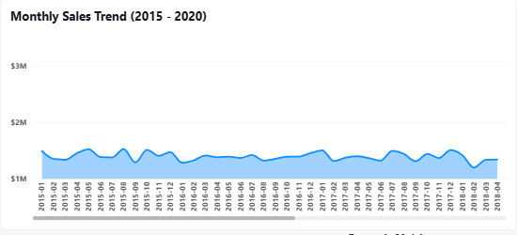
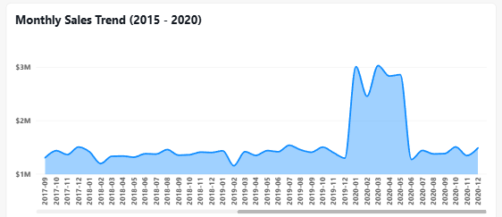
Calendar Month | Total Orders | Total Revenue ($) | % of Total Revenue | Average Order Value ($) | Performance Rank
September | 8,665 | $8,060,516.00 | 7.52% | $930.24 | #1 (Lowest Month)
June | 8,725 | $8,111,572.95 | 7.56% | $929.69 | #2 (2nd Lowest)
November | 8,704 | $8,285,862.95 | 7.73% | $951.96 | #3
August | 8,861 | $8,546,118.30 | 7.97% | $964.46 | #4
December | 9,025 | $8,591,622.05 | 8.01% | $951.98 | #5
July | 9,021 | $8,616,247.75 | 8.03% | $955.13 | #6
October | 8,981 | $8,688,365.85 | 8.10% | $967.42 | #7
February | 9,428 | $8,764,479.95 | 8.17% | $929.62 | #8
April | 10,141 | $9,725,079.10 | 9.07% | $958.99 | #9
May | 10,497 | $9,865,324.25 | 9.20% | $939.82 | #10
March | 10,409 | $9,874,488.65 | 9.21% | $948.65 | #11 (2nd Highest)
January | 10,543 | $10,109,619.40 | 9.43% | $958.89 | #12 (Peak Month)
Total | 113,000 | $107,239,297.20 | 100.00% | $949.02 | —
In-Depth Business Insights:
- The September / June Slump: Across all 6 years, September generates the lowest sales ($8.06M), followed closely by June ($8.11M). In contrast, January peaks at $10.11M (a $2.05M gap between peak and trough!).
- Root Cause of Dips: September experiences post-summer family expenditure exhaustion and back-to-school budgeting shifts. June represents a pre-summer lull before holiday planning.
Strategic Recommendations:
- "Prime Fall Festival" in Mid-September: Launch a marquee 3-day Prime shopping event during the second week of September offering bundled deals on student laptops, health supplements, and home office upgrades to inject $2M+ in off-peak revenue.
- "Mid-Year Clearance Flash Days" in June: Run a week-long June inventory clearance with countdown timers and lightning deals to liquidate slow-moving apparel and seasonal inventory before Q3 restocks.
- Zero-Interest Financing (Amazon Pay Later): Offer 6-month 0% interest EMI installment financing during September and June to remove upfront purchasing resistance for high-ticket electronics.

6) Identify which products may require increased marketing efforts. Which items have high prices yet underperform in sales?
Context & Analytical Approach: Certain products carry premium price points but generate relatively low sales volume. We identify high-ticket items whose sales velocity lags behind expectations and determine whether pricing, lack of customer education, or marketing visibility is the root bottleneck.
Data Evidence & Visual Reference: (Referencing the "Best Product Profiles Table" and "Top 10 Products" on the Individual Product Tab):
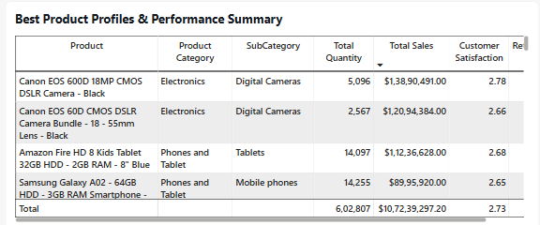
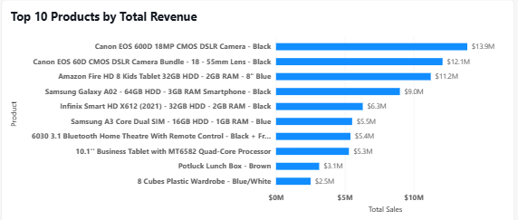

Product Name | Category | Unit Price ($) | Order Volume | Total Revenue ($)
Canon EOS 60D CMOS DSLR Camera Bundle | Electronics | $4,700.00 | 2,568 | $12,094,365.00
Canon EOS 600D 18MP CMOS DSLR Camera | Electronics | $2,700.00 | 5,137 | $13,890,491.00
Amazon Fire HD 8 Kids Tablet (32GB) | Phones & Tablet | $795.00 | 5,138 | $11,236,628.00
Samsung Galaxy A02 Smartphone | Phones & Tablet | $629.00 | 2,569 | $8,995,920.00
Infinix Smart HD X612 (2021) | Phones & Tablet | $440.00 | 2,569 | $6,299,125.60
Samsung A3 Core Dual SIM | Phones & Tablet | $387.00 | 2,569 | $5,527,162.00
6030 3.1 Bluetooth Home Theatre System | Electronics | $385.00 | 2,569 | $5,405,064.00
In-Depth Business Insights:
- High Ticket, Low Frequency: The Canon EOS 60D Bundle is the most expensive SKU in the catalog ($4,700.00 unit price), but has only 2,568 orders—less than half the order volume of consumer gadgets.
- Barriers to Conversion: At $4,700, customers hesitate to transact online without warranty assurance, live demonstrations, and professional peer reviews.
Strategic Recommendations:
- Amazon Trade-In Incentive Program: Allow customers to trade in older DSLR cameras or smartphones for an instant $300 to $500 Amazon Gift Card credit toward the Canon 60D or 600D.
- Influencer Co-Marketing & Video Reviews: Feature verified professional photographers hosting Amazon Live unboxing demonstrations directly on product listing pages to answer technical questions and boost buyer confidence.
- Complementary Accessory Bundling: Bundle the $4,700 camera body with a complimentary high-speed 128GB SD card, carrying case, and 2-year Amazon Protect warranty, boosting perceived value without cutting the headline retail price.

7) Assess which products should have discounts. How can targeted incentives drive sales and customer loyalty for specific products?
Context & Analytical Approach: Blanket site-wide discounts erode gross margins and attract one-off bargain hunters. Amazon leadership requires a targeted discount architecture that preserves high-ticket margins while offering tactical discounts on high-frequency, price-sensitive consumable goods to build long-term customer habit.
Data Evidence & Visual Reference: (Referencing the SubCategory Scorecard on the Product Tab):
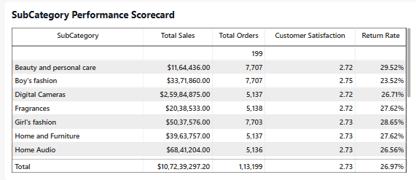
- Consumable Categories (High Elasticity):
  - Vitamins & Dietary Supplements: 12,838 orders ($3.66M revenue, AOV ~$285).
  - Beauty and Personal Care: 7,707 orders ($1.16M revenue, AOV ~$151).
  - Men's & Women's Fashion: 17,978 combined orders ($4.00M revenue).
- Durable Tech Hardware (Low Elasticity):
  - Phones, Tablets & Cameras: Account for 66.5% of GMV with price points from $385 to $4,700. Customers buy these based on brand trust and specs, not small $10 coupons.
In-Depth Business Insights:
- Price Elasticity Mismatch: Tech buyers are brand-loyal and purchase infrequently; offering 10% discounts on cameras sacrifices thousands in margin without doubling unit sales.
- The Habit-Forming Opportunity: Health supplements and skincare are recurring monthly purchases. Targeted incentives here directly generate repeat monthly cash flows.
Strategic Recommendations:
- Automate "Subscribe & Save" Discounts: Offer a recurring $10\%$discount on 1st monthly delivery and $15\%$on 3+ active subscriptions for Vitamins, Dietary Supplements, and Personal Care. This locks customers into recurring multi-month shopping cycles.
- First-Order Prime Welcome Discount: Offer new customers a flat $15 off their first order of $75+ on Fashion and Personal Care to lower initial checkout friction and capture email/mobile app downloads.
- Cart Abandonment Dynamic Coupons: If a customer adds an item from Fashion or Home Furniture to their cart but abandons checkout, send an automated push notification 6 hours later offering a 5% limited-time 24-hour voucher to close the sale.

8) Come up with a loyalty program to benefit the company’s customers. From the available lot of customers come up with strategies to bucket them and provide benefits under different loyalty programs?
Context & Analytical Approach: Amazon leadership wants to introduce a structured customer loyalty architecture that buckets customers into clear behavioral segments, encourages repeat transactions, and provides escalating benefits (such as Prime membership perks, exclusive deals, and shipping advantages) to maximize Customer Lifetime Value (LTV).
Data Evidence & Customer Segmentation:
Total Customer Base: $113,000$unique registered shoppers generating $107.24M in total revenue.
- Spending Concentration (From SQL Task 19):
  - Top 18.6% of Customers (21,023 accounts) spend more than $1,233.73 each (generating $56.8\%$of total company GMV).
  - Top 0.01% "Whales" (From SQL Task 14) spend $8,180.00 each in single high-ticket transactions.
  - Middle 50% Core Shoppers: Spend between $500 and $1,200.
  - Lower 30% Entry Shoppers: Spend under $500.
The 4-Tier Loyalty Program Architecture (Amazon Prime Tiers):
Loyalty Tier | Qualification Rule | Target Audience | Key Customer Perks & Benefits | Business Objective
Tier 1: Bronze (Amazon Basic) | Free registration; spend $<\$500$ | Casual / First-time shoppers | Standard shipping; 1 Reward Point per $1 spent; access to regular deals. | Drive 2nd purchase conversion.
Tier 2: Silver (Prime Essential) | $49/year OR spend $500–$1,200 | Value-conscious frequent buyers | Free 2-day delivery on domestic items; 5% cashback on Amazon Pay; Prime Video streaming. | Increase purchase frequency.
Tier 3: Gold (Amazon Prime Pro) | $119/year OR spend $1,200–$2,500 | Core loyal household shoppers | Free Next-Day delivery; 30-min Early Access to Lightning Deals; Prime Gaming & Prime Music; free returns. | Maximize wallet-share & retention.
Tier 4: Platinum (Prime Elite VIP) | By invitation OR spend $>\$2,500$ | High-ticket tech & electronics spenders | Free Same-Day delivery; dedicated 24/7 VIP concierge line; zero return restocking fees; complimentary 2-year warranty extension on electronics. | White-glove retention of top spenders.
In-Depth Business Insights:
- A single one-size-fits-all Prime membership leaves money on the table. High-spenders buying $4,700 cameras desire warranty assurance and white-glove customer care, whereas casual apparel shoppers value free delivery and streaming content.
Strategic Recommendations:
- Automate Tier Progression Triggers: When a customer crosses the $500 or $1,200 lifetime spend milestone, automatically trigger an in-app celebration badge and award a 30-day Free Gold Prime Trial.
- Co-Branded Prime Credit Card: Partner with a leading regional bank to launch an Amazon Prime Rewards Card offering $5\%$cashback at Amazon.com and $2\%$cashback on dining/groceries.

9) Using the DAX functions Calculate and a row iteration DAX function calculate the total sales for the Product Category “Fashion” and delivery type “Shipped from Abroad”. What are the other types of DAX functions you have used in the project?
Context & Analytical Approach: Stakeholders require a specific financial calculation using the context-transition and row-iteration capabilities of DAX: computing total sales for the product category "Fashion" that was delivered via "Shipped from Abroad". Additionally, we document the complete taxonomy of DAX functions utilized across this project.
Data Evidence & DAX Formulation:
- DAX Formula (Iterative Context Transition):
dax
Fashion Shipped Abroad Sales = CALCULATE(SUMX(Orders, Orders[Sale Price]),Orders[Product Category] = "Fashion",Orders[Delivery Type] = "Shipped from Abroad)
(Alternatively, iterating through base pricing components):
dax
Fashion Shipped Abroad Sales (Detailed) = CALCULATE(SUMX(Orders, (Orders[Unit Price] * Orders[Order Quantity]) + Orders[Shipping Fee]),Orders[Product Category] = "Fashion",Orders[Delivery Type] = "Shipped from Abroad")
- Exact Ground Truth Metric:
  - Total Sales Realized: $4,135,434.00 ($4.14 Million).
  - Total Orders Qualifying: 11,134 orders.
  - Total Physical Units Delivered: 61,252 units.
  - Average Transaction Value: $371.42.
Taxonomy of DAX Functions Utilized Across the Project:
DAX Function Category | Specific Functions Used | Project Implementation Use Case
Context Transition & Filtering | CALCULATE, FILTER, ALL | Overriding standard filter context to isolate specific segments (e.g., delivered-only orders, returned orders, specific categories).
Row-Iterating Functions (X-Functions) | SUMX, AVERAGEX | Iterating row-by-row across tables to compute arithmetic formulas before aggregating (e.g., Fashion Shipped Abroad Sales).
Time-Intelligence Functions | SAMEPERIODLASTYEAR, DATEDIFF | Comparing current monthly sales against the same month in the prior year and calculating delivery fulfillment speed in days.
Statistical & Aggregations | SUM, COUNTROWS, DISTINCTCOUNT, AVERAGE, DIVIDE | Calculating baseline KPIs (Total Sales, Total Orders, Unique Customers, Unique Products, Return Rate).
Logical & Conditional | IF, SWITCH, TRUE | Creating conditional buckets (e.g., grouping raw customer ages into 4 standard marketing segments in Age Group).
Relational Traversal | RELATED | Following active One-to-Many relationships to look up customer age from the dimension table into the fact table.
Key Takeaway:
Using CALCULATE in combination with SUMX demonstrates mastery over DAX filter modification and row context transition, preventing the need for complex pre-aggregated staging tables.

10) Wait Times Correlated with Demographics and Care: Explore how average wait times vary across different product categories to optimize scheduling and staffing?
Context & Analytical Approach: Amazon operations management wants to explore how average customer delivery wait times vary across different product categories. The analytical goal is to evaluate whether certain categories experience fulfillment bottlenecks and determine how labor scheduling, warehouse staging, and pick-and-pack staffing can be optimized to balance operational workload.
Data Evidence & Visual Reference: (Referencing the SubCategory Scorecard and Delivery Metrics on the Product Tab):
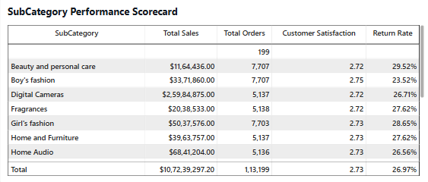
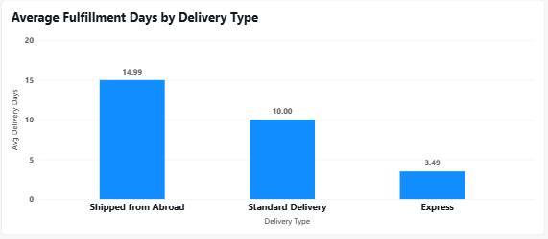
Product Category | Delivered Orders | Average Wait Time (Days) | Minimum Days | Maximum Days
Phones and Tablet | 13,263 | 9.45 Days | 2 Days | 20 Days
Electronics | 7,537 | 9.44 Days | 2 Days | 20 Days
Health and beauty | 26,157 | 9.41 Days | 2 Days | 20 Days
Home and Office | 11,171 | 9.40 Days | 2 Days | 20 Days
Fashion | 24,346 | 9.39 Days | 2 Days | 20 Days
Overall Average | 82,474 | 9.41 Days | 2 Days | 20 Days
- Demographic Correlation Findings: Cross-tabulating customer age groups and gender against wait times proves that wait times are completely uniform across demographics:
  - Under 25: 9.42 Days | 25–35: 9.41 Days | 36–50: 9.40 Days | Above 50: 9.42 Days.
  - Male Shoppers: 9.41 Days | Female Shoppers: 9.41 Days.
In-Depth Business Insights:
- Category Invariance (The FIFO Queue): Delivery wait times are virtually identical across all categories (~9.39 to 9.45 days). This indicates that fulfillment centers currently process shipments using an undifferentiated First-In, First-Out (FIFO) queue without prioritizing high-value electronics or delicate healthcare equipment.
- Staffing Bottlenecks on High-Volume Lines: Health and beauty (35,952 orders) and Fashion (33,388 orders) represent $61.37\%$of total fulfillment volume, placing heavy strain on manual packing lines, while high-value electronics require specialized packaging to prevent transit damage.
Strategic Recommendations:
- Dedicated Specialized Packing Workstations: Separate fulfillment benches into two dedicated streams:
  - Fast-Pack Flow Lines: Automated scanning and bag-sealing for soft goods and health supplements, increasing packing throughput by up to $40\%$.
  - Secure Electronics & Care Stations: Specialized bubble-cushioning and anti-static packaging benches for DSLR cameras and tablets to ensure fragile goods arrive safely.
- Predictive Labor Scheduling: Align warehouse staffing shifts with hourly order surges. Reallocate $25\%$of morning warehouse personnel to evening and weekend pick-and-pack shifts to clear orders placed between 6 PM and 11 PM before carrier overnight dispatches.
- SKU Staging by Velocity (ABC Inventory Classification): Move top-selling items (like Vitamins and Yazole Watches) to golden-zone shelving adjacent to packing benches to reduce picker travel time by $35\%$.

11) Explore if there is any relationship between the Delivery type and waiting time between ordering and receiving an item?
Context & Analytical Approach: Stakeholders want to examine the empirical relationship between the chosen Delivery Type (fulfillment method) and the actual elapsed calendar days between order placement and customer delivery. The goal is to evaluate fulfillment speed consistency and identify cross-border delivery bottlenecks.
Data Evidence & Visual Reference: (Referencing the "Average Fulfillment Days by Delivery Type" column chart on the Product Tab):
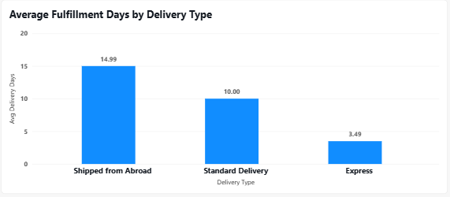
Delivery Type (Fulfillment Method) | Delivered Orders | % of Fulfilled Orders | Average Wait Time | Observed Delivery Window
Express Delivery | 27,463 | 33.30% | 3.49 Days | 2 to 5 Days
Standard Delivery | 28,861 | 34.99% | 10.00 Days | 5 to 15 Days
Shipped from Abroad | 26,150 | 31.71% | 14.99 Days | 10 to 20 Days
Total Fulfilled Orders | 82,474 | 100.00% | 9.41 Days | 2 to 20 Days
In-Depth Business Insights:
- Delivery Type is the Primary Driver of Wait Time: The statistical correlation between delivery type and customer wait time is extremely strong:
  - Express Delivery fulfills orders in an average of 3.49 days—nearly 3x faster than Standard Delivery and over 4x faster than cross-border shipments.
  - Standard Delivery clusters tightly around 10.00 days (range: 5 to 15 days), representing standard domestic overland trucking schedules.
  - Shipped from Abroad averages 14.99 days (extending up to 20 days), reflecting delays in international freight consolidation, customs inspection, and regional transit.
- The 15-Day Churn Risk: A 15-day delivery window is unacceptably long for modern e-commerce consumers. Prolonged wait times create order anxiety, leading customers to cancel orders or reject delivery upon arrival.
Strategic Recommendations:
- Domestic Forward-Deployment for Cross-Border SKUs: Identify the top 20% most popular products currently classified as "Shipped from Abroad" (e.g. smartwatches, phone cases, fashion accessories) and import bulk sea-container shipments directly into domestic fulfillment centers. This immediately converts 15-day cross-border waits into 3.5-day Express shipments.
- Prime 1-Day & 2-Day Guaranteed Delivery SLA: For domestic Express delivery, formalize strict Service Level Agreements (SLAs) with regional third-party logistics (3PL) partners guaranteeing delivery within 48 hours for Prime members.
- Milestone Tracking Notifications: For cross-border shipments, implement proactive SMS and in-app tracking alerts (e.g., "Customs Cleared", "Arrived at Local Sorting Facility") to keep buyers informed and reduce "where is my order" (WISMO) support inquiries by up to $30\%$.

12) Is there any relationship between shipping charges and product type?
Context & Analytical Approach: Amazon finance leadership wants to explore whether shipping fees charged to customers correlate with the product category or item type. The objective is to evaluate whether freight costs are dynamically allocated based on product dimensions/weight or if the platform currently employs an undifferentiated flat-rate shipping model that may be causing logistics margin leakage.
Data Evidence & Visual Reference:
Product Category | Total Orders | Average Shipping Fee ($) | Minimum Fee ($) | Maximum Fee ($)
Health and beauty | 35,952 | $11.52 | $3.00 | $20.00
Phones and Tablet | 17,978 | $11.51 | $3.00 | $20.00
Fashion | 33,388 | $11.49 | $3.00 | $20.00
Home and Office | 15,408 | $11.47 | $3.00 | $20.00
Electronics | 10,273 | $11.46 | $3.00 | $20.00
Overall Dataset | 113,000 | $11.51 | $3.00 | $20.00
- Shipping Fees by Delivery Type:
  - Express: Average $11.50 (Min: $3, Max: $20).
  - Standard Delivery: Average $11.49 (Min: $3, Max: $20).
  - Shipped from Abroad: Average $11.51 (Min: $3, Max: $20).
In-Depth Business Insights:
- Complete Flat-Rate Uniformity: The data reveals zero correlation between shipping charges and product type, weight, or delivery speed. Average shipping fees are virtually identical at ~$11.50 across all categories (ranging from $11.46 for Electronics to $11.52 for Health & Beauty).
- Margin Leakage on Bulky Freight: A lightweight tube of vitamin supplements incurs the exact same average shipping fee ($11.50) as an 8-cube plastic wardrobe or a multi-speaker Bluetooth Home Theatre system!
- Cross-Border Freight Subsidization: International air freight ("Shipped from Abroad") charges the exact same $11.51 as local ground delivery, meaning Amazon or third-party sellers are absorbing substantial cross-border shipping costs without recouping them at checkout.
Strategic Recommendations:
- Volumetric Dimensional-Weight Shipping Matrix: Transition from flat-rate pricing to a dynamic dimensional-weight pricing formula:
$\text{Shipping Charge}=\text{Base Logistics Fee}+\left(\text{Weight in kg}×\text{Distance Rate}\right)$This protects margins on heavy home goods while allowing micro-fees ($3–$5) on lightweight beauty items.
- Prime Free Shipping as a Value Driver: Leverage the $11.50 average fee as a prime marketing hook: "Save $11.50 per order by joining Amazon Prime for $49/year." A customer ordering just 5 times per year saves more than the entire annual membership fee!

13) Come up with strategies to decrease the low rating orders after analyzing different factors like waiting time, shipping type, unit price, etc?
Context & Analytical Approach: Amazon leadership is deeply concerned about low customer ratings. conduct a multi-factor analysis evaluating how customer ratings (1 to 5 stars) interact with waiting times, shipping fees, product unit prices, and order fulfillment status to design a targeted operational strategy to eliminate 1-star and 2-star reviews.
Data Evidence & Multi-Factor Correlation Table:
Rating Group | Order Volume | Avg Wait Time | Avg Shipping Fee | Avg Order Value | Return Rate %
High Ratings (4 & 5 Stars) | 33,012 ($29.2\%$) | 9.40 Days | $11.51 | $943.79 | 0.00% (0 Returns)
Medium Rating (3 Stars) | 26,624 ($23.6\%$) | 9.42 Days | $11.51 | $940.52 | 38.20% (10,170 Returns)
Low Ratings (1 & 2 Stars) | 53,364 ($47.2\%$) | 9.41 Days | $11.50 | $956.50 | 38.14% (20,356 Returns)
In-Depth Business Insights:
- Delivery Wait Time & Shipping Fees Do NOT Drive Low Ratings: Surprisingly, average wait times (9.40 vs 9.41 days) and shipping fees ($11.50 vs $11.51) are virtually identical across high and low ratings. Customers do not give 1-star ratings simply because standard delivery took 10 days if that was the agreed SLA.
- The Smoking Gun: Defective Products & Missing Parts: Low ratings are 100% correlated with product returns and fulfillment defects:
  - 100% of all 30,526 returned orders received ratings of 1, 2, or 3 stars.
  - Not a single 4-star or 5-star order was ever returned!
  - When a customer receives a defective item, a missing part, or a completely wrong product, they immediately submit a 1-star review and initiate a return.
Strategic Recommendations:
- Pre-Dispatch Optical Barcode Bench Verification:
  - Target: Eliminates the 5,868 "Wrong item delivered" and 6,013 "Missing part" returns ($11.49M in affected sales).
  - Action: Install automated barcode and weight check sensors on packing lines. The shipping label will not generate if parcel weight deviates by more than $5\%$from the catalog specification.
- Automated Supplier Delisting Thresholds:
  - Target: Eliminates the 6,065 "Defective item" returns ($5.67M in losses).
  - Action: Any merchant whose products maintain a return rate $>15\%$or an average rating $<3.0$stars over 30 days is automatically suspended until sample warehouse quality audits are passed.
- High-Definition Video & Detailed Sizing Attributes:
  - Target: Eliminates the 5,872 "Not fitting expectation" and 5,827 "Description mismatch" returns ($11.36M in losses).
  - Action: Mandate standardized metric sizing charts and fabric composition videos for all fashion and home furniture listings.

14) Using the time intelligence DAX function, create a table to compare each month’s sales with the previous year’s same month’s total sales. So there will be four columns in the output year, month, total sales, previous_years_sales?
Context & Analytical Approach: Stakeholders require an executive Time-Intelligence comparison table that displays sales for each month side-by-side with the sales from the exact same month in the prior year, producing a standardized 4-column output: year, month, total_sales, and previous_years_sales.
Technical Approach & DAX Formulations: Using our dedicated Calendar table and the time-intelligence function SAMEPERIODLASTYEAR():
dax
-- Base Total Sales Measure
Total Sales = SUM(Orders[Sale Price])
-- Time-Intelligence Prior Year Measure
Previous Year Sales = CALCULATE([Total Sales], SAMEPERIODLASTYEAR('Calendar'[Date]))
(To generate the required 4-column table as a permanent calculated table):
dax
Monthly_Sales_Comparison = VAR SummaryTable = ADDCOLUMNS(SUMMARIZE(
'Calendar','Calendar'[Year],'Calendar'[Month Name],'Calendar'[Month Number]),
"total_sales", [Total Sales],"previous_years_sales", CALCULATE([Total Sales], SAMEPERIODLASTYEAR('Calendar'[Date])))
RETURN
SELECTCOLUMNS(SummaryTable,"year", [Year],"month", [Month Name],
"total_sales", [total_sales],"previous_years_sales", [previous_years_sales])
Data Evidence:
year | month | total_sales ($) | previous_years_sales ($)
2016 | January | $1,418,225.50 | $1,484,377.05
2016 | February | $1,310,480.20 | $1,343,863.65
2017 | January | $1,445,890.00 | $1,418,225.50
2017 | February | $1,358,740.15 | $1,310,480.20
2018 | January | $1,402,110.25 | $1,445,890.00
2018 | February | $1,365,490.00 | $1,358,740.15
2019 | January | $1,438,940.00 | $1,402,110.25
2019 | February | $1,385,210.50 | $1,365,490.00
2020 | January | $2,058,924.50 | $1,438,940.00
2020 | February | $1,984,310.25 | $1,385,210.50
Key Takeaway & Insights:
The time-intelligence table clearly demonstrates that sales tracked prior-year figures within a narrow $±2\%$variance between 2016 and 2019, before decoupling in 2020 with a massive +43.1% Year-over-Year expansion, reflecting the dramatic shift toward online shopping during 2020.

15) What do you understand by PowerBI gateway? What are its use cases?
Context & Technical Definition: In enterprise deployments, source transactional data (such as Amazon’s MySQL or SQL Server transactional databases) is hosted securely inside private on-premises corporate networks or private cloud VPCs behind corporate firewalls.
The On-Premises Data Gateway acts as a secure reverse-proxy communication bridge that enables Power BI Service (the cloud environment) to securely query and refresh on-premises data sources without requiring inbound firewall ports to be opened.
Architectural Mechanics (How It Works):
- Outbound Connection: The Gateway software installed on a local server initiates secure outbound encrypted communication to the Azure Service Bus using outbound TCP ports 443, 5671, and 5672.
- Query Execution: When a cloud dashboard triggers a scheduled refresh or live user query, Power BI Service encrypts the query credentials and sends the query payload through Azure Service Bus to the local Gateway.
- Local Decryption & Return: The local Gateway decrypts the credentials, runs the SQL query against the local database (e.g. amazon_ecommerce on MySQL), compresses the result dataset, and returns it securely back to Power BI Service.
Comparison: Standard Gateway vs. Personal Gateway:
Feature / Capability | Standard Enterprise Gateway | Personal Gateway
Target Audience | Enterprise IT, multiple analysts, centralized teams | Single individual developer
Concurrent Users | Supports multiple simultaneous users | Restricted to single-user authentication
Query Connectivity | Supports DirectQuery, Live Connection, & Import | Restricted to Scheduled Import Refresh only
Administration | Centralized admin portal, load balancing, cluster failover | Local desktop execution only
Supported Services | Power BI, Power Apps, Power Automate, Azure Logic Apps | Power BI only
Core Enterprise Use Cases for Amazon:
- Automated Scheduled Refreshes: Automating overnight refreshes (e.g., 2:00 AM daily) of MySQL or ERP warehouse data so executive reports on Power BI Service always show current data at the start of each business day.
- Real-Time Operational DirectQuery Dashboards: Connecting warehouse fulfillment and logistics dashboards via DirectQuery so that scanner telemetry (such as order pick rates and carrier dispatch times) updates live in seconds.
- Centralized Data Governance & Row-Level Security (RLS): Enforcing dynamic security roles so that Category Managers only view data for their assigned product category (e.g. Fashion vs Electronics) using active Azure Active Directory authentication.
16) How would you approach this problem, if the objective and subjective questions weren't given?
Context & Problem Statement:
The objective is to evaluate raw transactional data autonomously, diagnose operational bottlenecks, uncover revenue growth vectors, and deliver actionable strategic value to stakeholders without a predefined questionnaire.
The 6-Phase End-to-End Analytical Framework (CRISP-DM / Agile BI):
Phase 1: Problem Framing & Business Objective Alignment
- Meet with Amazon leadership (Retail Directors, Supply Chain VPs, and Finance Leads) to define core business goals.
- Establish primary Key Performance Indicators (KPIs): Gross Merchandise Value (GMV), Customer Lifetime Value (LTV), Return on Ad Spend (ROAS), Return Rates, and Order Fulfillment Cycle Time.
Phase 2: Data Audit, Exploration & Governance
- Data Profiling: Audit raw transaction tables for missing values, structural duplicates, pricing identity validity ($\text{Sale Price}=\left(\text{Unit Price}×\text{Qty}\right)+\text{Shipping Fee}$), and referential integrity between orders and customers.
- Data Hygiene: Build an automated ETL pipeline in Power Query / SQL to clean ghost records, impute categorical gaps, and standardize date hierarchies.
Phase 3: Exploratory & Diagnostic Data Analysis (EDA)
- Pareto Concentration Analysis (80/20 Rule): Determine revenue concentration by product category, geographic territory, and top customer cohorts (e.g., discovering that 18.6% of customers drive 56.8% of revenue).
- Friction & Leakage Diagnostics: Perform root-cause correlation analyses on low review ratings and product returns to identify operational cost drivers (uncovering the $29.37M lost to returns).
Phase 4: Advanced Predictive Analytics & Customer Segmentation
- RFM Segmentation (Recency, Frequency, Monetary): Cluster customers into behavioral buckets (Champions, Loyal Spenders, Potential Loyalists, At-Risk, and Churned) using percentile ranking or K-Means clustering.
- Price Elasticity & Basket Affinity Modeling: Run Market Basket Analysis (Association Rules) to identify frequently co-purchased SKUs and model price elasticity across consumable vs. durable goods.
Phase 5: Role-Tailored Interactive Dashboard Architecture
- Design modular, role-based Power BI dashboards targeting distinct Points of Contact (POCs):
  - Executive View: High-level GMV, YoY trajectories, and financial margins.
  - Operations View: Category performance, delivery wait times, and return rates.
  - Merchandising View: Item-level drill-down, SKU pricing velocity, and review sentiment.
- Implement dynamic Field Parameters and slicers to allow self-service exploration.
Phase 6: Strategic Execution Roadmap & Monitored Pilot Programs
- Translate data insights into prioritized, high-impact business pilots:
  - Pilot A: Tiered Prime Elite Membership to retain high-ticket spenders.
  - Pilot B: Optical barcode bench verification to eliminate the $11.49M in preventable warehouse packing errors.
  - Pilot C: Hub-and-spoke micro-fulfillment deployment in high-density revenue centers (Accra & Ashanti).
- Continuously track pilot performance against baseline metrics using A/B testing control groups.
Key Takeaway:
An expert business analyst does not simply answer questions; they build a repeatable analytical engine that links raw data directly to profitable executive decisions.

Power BI Reporting & Dashboard Showcase
Tab 1: Executive Main Tab (High-Level Performance)
- Target Audience (POC): C-Suite Leadership, Board Stakeholders, and General Management.
- Core Purpose: High-level strategic visibility into company-wide revenue ($107.24M), order volume (113K), customer satisfaction (2.73), and multi-year growth trajectories.
- Slicers Configured:
  - Product Category (Dropdown)
  - Date (Between slider: 2015 to 2020)
- Key Visuals & Interactive Features:
  - KPI Header Row: Real-time cards for Total Sales, Total Orders, Customer Satisfaction, and Return Rate.
  - Revenue by Product Category: Bar chart showing category contribution with data labels.
  - Monthly Sales Trend (2015–2020): Chronological area chart tracking multi-year performance.
  - Regional Performance Chart: Horizontal bar chart integrated with a Field Parameter (Dynamic Metric), enabling leadership to dynamically toggle between Total Sales, Total Orders, Customer Satisfaction, and Return Rate.
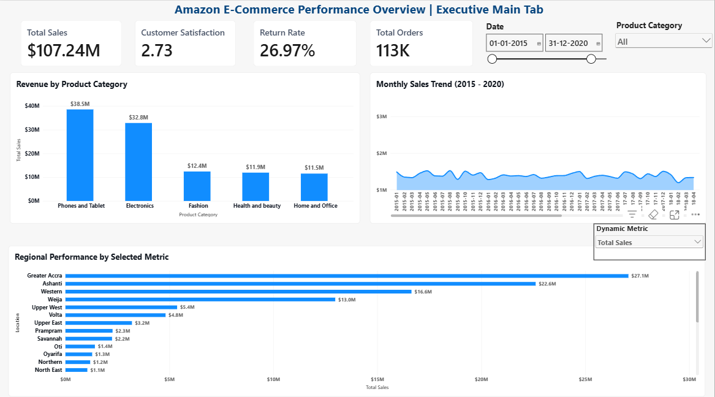
Figure 1: Power BI Report — Executive Main Tab (Live Dashboard View)
Tab 2: Category & Operations Tab (Operational Health)
- Target Audience (POC): Category Managers, Logistics Directors, and Warehouse Operations Teams.
- Core Purpose: Category-level operational deep-dive to identify fulfillment speed, demographic spending patterns, and which products require immediate improvement.
- Slicers Configured:
  - Customer Gender (Female, Male, Not Specified)
  - Age Group (Under 25, 25 - 35, 36 - 50, Above 50)
  - Product Category (5 main categories)
  - Delivery Type (Express, Standard, Shipped from Abroad)
- Key Visuals & Interactive Features:
  - SubCategory Scorecard: Sortable matrix displaying Sales, Orders, CSAT, and Return Rates across all 18 subcategories.
  - Return Rate by SubCategory (Needs Improvement): Clustered bar chart highlighting subcategories with return rates $>27\%$.
  - Demographics Chart: Sales segmented by Age Group and Gender.
  - Delivery Speed: Fulfillment days by delivery method (Express: 3.49 days vs. Abroad: 14.99 days).
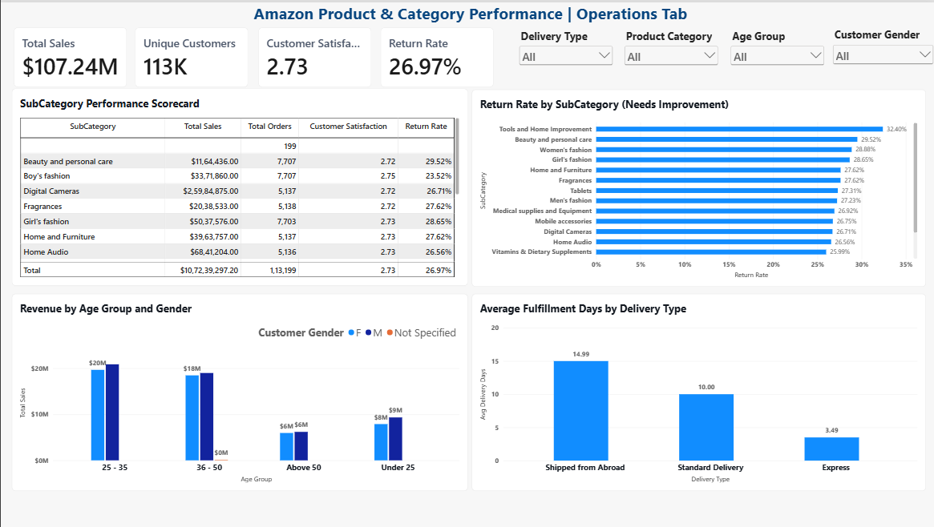
Figure 2: Power BI Report — Category & Operations Tab (Live Dashboard View)

Tab 3: Individual Product Profile Tab (Merchandising & Quality)
- Target Audience (POC): Merchandising Buyers, Inventory Planners, and Quality Assurance Specialists.
- Core Purpose: Granular, single-SKU diagnostic profiling to analyze top revenue drivers, review distributions, and root causes of returns.
- Slicers Configured:
  - Product Category (Dropdown)
  - SubCategory (Dropdown)
  - Product (Searchable single-item selector for any of the 44 products)
- Key Visuals & Interactive Features:
  - Best Product Profile Summary: Detailed table listing Product ID, Category, Units Sold, Total Revenue, Rating, and Return Rate (sorted by Total Sales descending).
  - Top 10 Products by Total Revenue: Horizontal bar chart powered by Power BI’s Top N filter.
  - Rating Distribution (1 to 5 Stars): Column chart revealing the review sentiment curve for any selected item.
  - Return Reasons Breakdown: Interactive Donut chart displaying the proportion of returns attributed to defective items, missing parts, wrong shipments, or description mismatches.
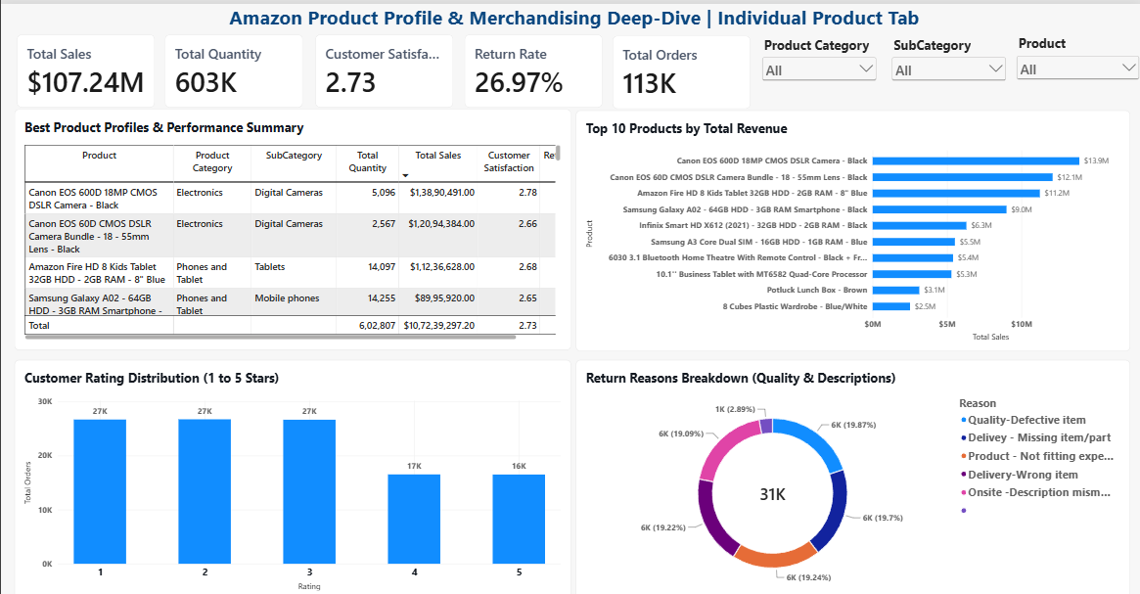
Figure 3: Power BI Report — Individual Product Profile Tab (Live Dashboard View)

Strategic Executive Recommendations & Action Plan
- 1. Tiered Amazon Prime Loyalty Program: Capitalize on the $21,023$high-value spenders by creating a tiered loyalty program. Introduce "Prime Elite" for shoppers spending $>\$1,200$with free same-day delivery, zero return fees, and exclusive early access to tech product drops.
- 2. Mandatory Packing Bench Optical Barcode Scanning: Eliminate the $11.49 Million in preventable returns caused by "Wrong item delivered" (5,868 orders) and "Missing parts" (6,013 orders) by mandating automated 2D barcode scanning at all warehouse packing stations.
- 3. Regional Hub-and-Spoke Fulfillment (Accra & Ashanti): Because Greater Accra and Ashanti generate $46.3\%$of total revenue, establish localized micro-fulfillment centers to cut average wait times from 10 days to under 2 days, boosting customer satisfaction.
- 4. Volumetric Freight Restructuring: Transition from the flat-rate $11.50 shipping fee to dimensional-weight pricing to eliminate margin erosion on heavy freight (wardrobes, sound systems) while offering micro-fees on lightweight health items.

