Chinook Music Store Project

Project by Koushik Yarram,
Newton_School_May_2026_Batch

Objective Questions
Q1 Does any table have missing values or duplicates? If yes how would you handle it ?
Duplicate primary-key check on customer
Output columns (in order): customer_id, cnt (2 columns)
Row count: 0 rows (no duplicate PKs anywhere in this dataset).
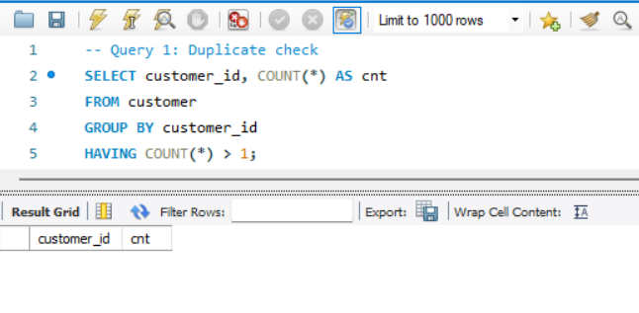
NULL profile — customer table
Output columns (in order): null_company, null_state, null_postal_code, null_phone, null_fax (5 columns)
Row count: 1 row (single aggregate row).
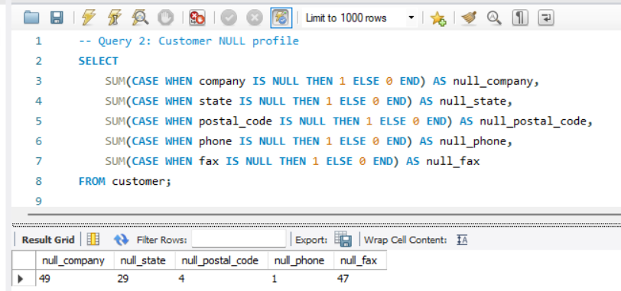
NULL profile — track table
Output columns (in order): null_composer, null_album_id, null_genre_id (3 columns)
Row count: 1 row (single aggregate row).
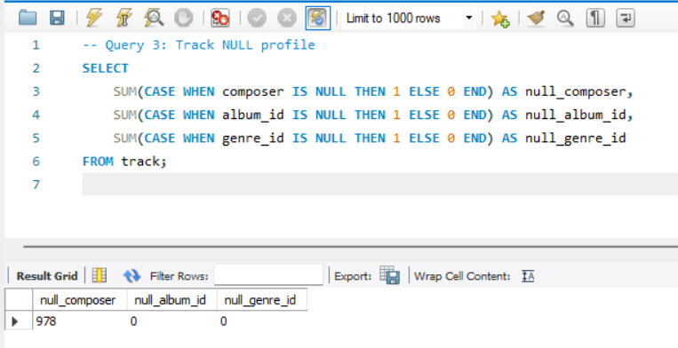
Brief Explanation:
Duplicates: No duplicate primary keys found 0 rows returned, confirming data integrity.
Missing Values (Customer): NULLs exist in optional fields company (not all customers are corporate), state (many countries don't use states), postal_code, phone, and fax (largely obsolete).
Missing Values (Track): The composer field has 978 NULLs out of 3503 tracks. album_id and genre_id have 0 NULLs.
Handling: NULLs are left as-is since they are in optional fields. For reporting, COALESCE() can replace them with 'Unknown'/'N/A'.

Q2 Find the top-selling tracks and top artist in the USA and identify their most famous genres.
Top 5 selling tracks in the USA
Output columns (in order): track_name, artist_name, genre_name, revenue, units_sold (5 columns)
Row count: 5 rows (LIMIT 5).
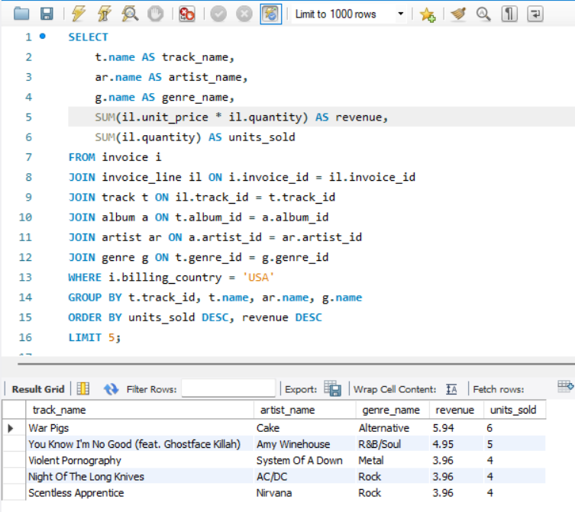
Visualisation:

Brief Explanation:
To identify the top-selling tracks in the USA, the invoice and invoice_line tables are joined with track, album, artist, and genre tables to map each purchase to its track details. The data is filtered for US transactions using billing_country = 'USA'. Tracks are grouped by track_id since the same track can appear in multiple invoices, and SUM(quantity) aggregates the total units sold per track. Results are ordered by units_sold DESC with LIMIT 5 to extract the top 5 best-selling tracks along with their artist and genre information.
Top artist in the USA by revenue
Output columns (in order): artist_name, revenue, units_sold (3 columns)
Row count: 5 rows (LIMIT 5).

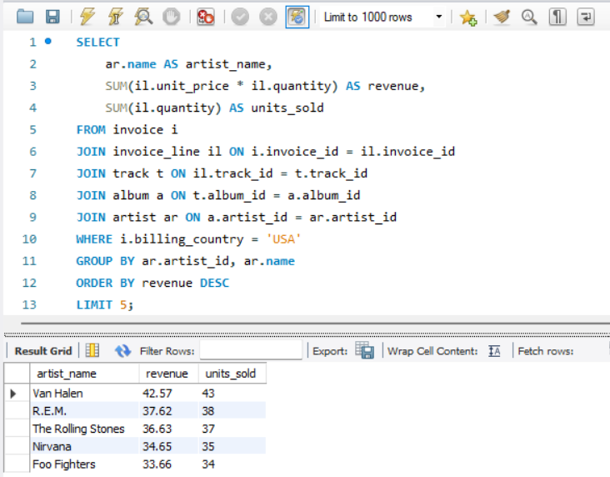
Visualisation:

Breif Explanation:
To determine the highest-earning artists in the US market, purchase records are connected to artist details by joining the invoice, invoice_line, track, album, and artist tables. Only US-based transactions are considered using the filter billing_country = 'USA'. The results are grouped by artist_id so that all track sales belonging to the same artist are consolidated into a single row. Total revenue is computed as SUM(unit_price × quantity) and total units as SUM(quantity). The output is sorted by revenue DESC with LIMIT 5 to highlight the top 5 revenue-generating artists.

Q3 What is the customer demographic breakdown (age, gender, location) of Chinook's customer base?
Customers by country/state/city
Output columns (in order): country, state, city, customer_count (4 columns)
Row count: 53 rows (1 row per distinct country/state/city combination).
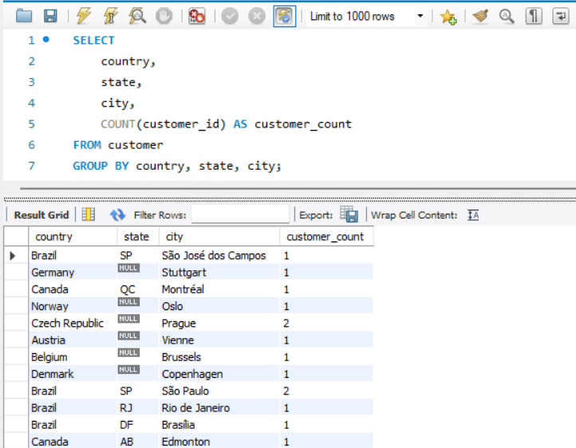

Brief Explanation:
The customer table is grouped by country, state, and city to break down the customer base by geographic location. COUNT(customer_id) gives the number of customers in each unique location combination. Since the Chinook database does not contain age or gender fields, the demographic analysis focuses entirely on location data. The result shows 53 distinct location combinations across the customer base.
Customers per country
Output columns (in order): country, customer_count (2 columns)
Row count: 24 rows (24 distinct customer countries).

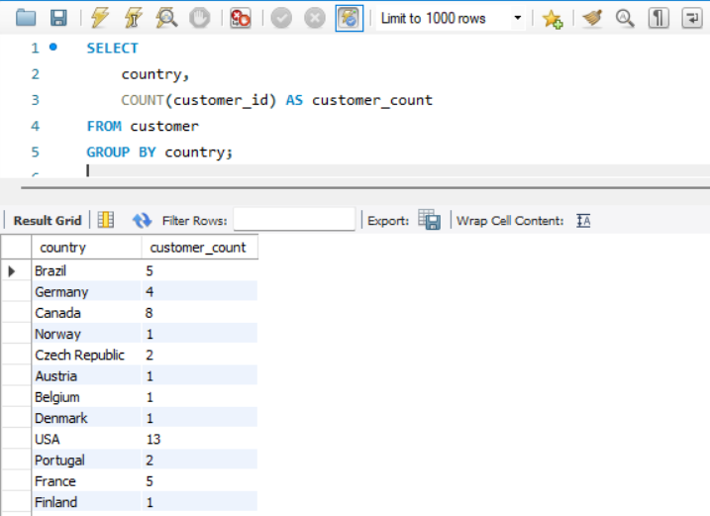

Visualisation:

Brief Explanation:
A country-level aggregation is performed on the customer table by grouping solely on the country column. This provides a high-level view of customer distribution across 24 countries. The USA and Canada emerge as key markets, helping the business prioritize regional strategies and marketing efforts.
Q4 Calculate the total revenue and number of invoices for each country, state, and city:
Output columns (in order): country, state, city, num_invoices, total_revenue (5 columns)
Row count: 53 rows (1 row per distinct billing country/state/city combination; same combinations as O3a).
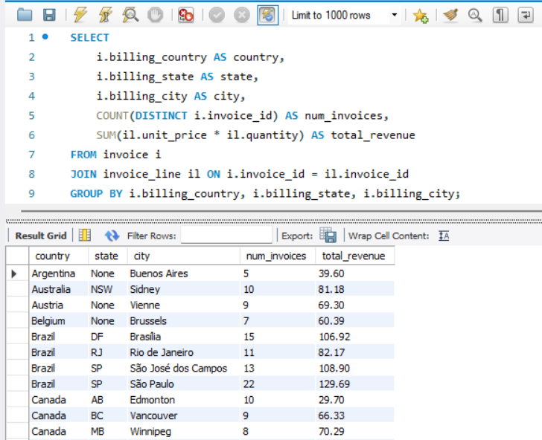

Visualisation:

Brief Explanation:
The invoice and invoice_line tables are joined to calculate revenue at the line-item level. Results are grouped by billing_country, billing_state, and billing_city to get location-wise totals. COUNT(DISTINCT invoice_id) is used instead of COUNT(invoice_id) because the join with invoice_line creates multiple rows per invoice DISTINCT ensures each invoice is counted only once. Total revenue is computed as SUM(unit_price × quantity) across all line items per location. The output reveals 53 distinct location combinations, highlighting which cities and countries generate the most sales volume and revenue for Chinook.
Q5 Find the top 5 customers by total revenue in each country
Output columns (in order): country, customer_name, total_revenue, rnk (4 columns)
Row count: 48 rows (up to 5 per country across 24 countries — don't assume every country hits the max).
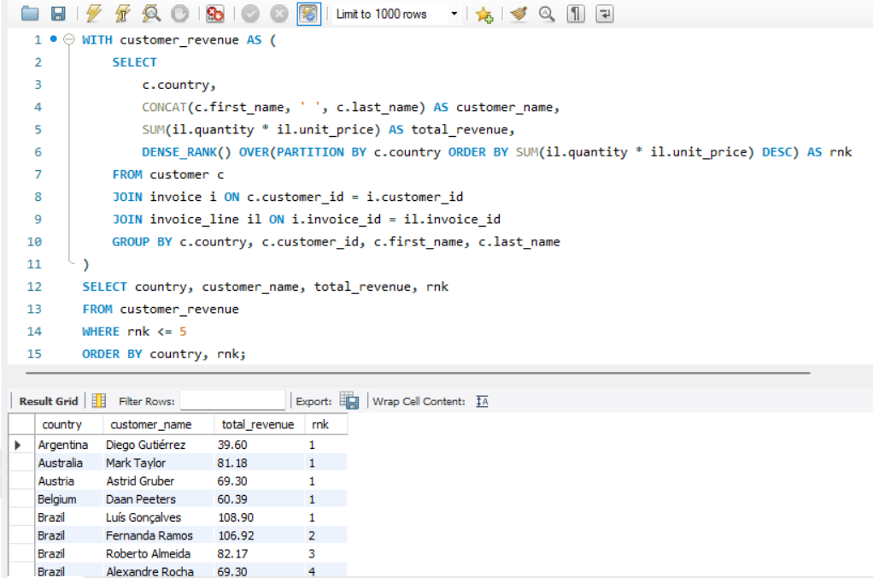

Brief Explanation:
A CTE (Common Table Expression) is used to first calculate each customer's total revenue by joining the customer, invoice, and invoice_line tables. Results are grouped by customer within each country, and DENSE_RANK() is applied with PARTITION BY country to rank customers within their respective countries based on total revenue in descending order. DENSE_RANK is chosen over ROW_NUMBER so that customers with equal revenue receive the same rank. The outer query then filters for rnk <= 5 to retain only the top 5 highest-spending customers per country. The result yields 48 rows not all 24 countries have 5 customers, as some countries have fewer customers in the dataset.
Q6 Identify the top-selling track for each customer
Output columns (in order): customer_id, track_name, units (3 columns)
Row count: 59 rows (all 59 customers have placed at least one order).
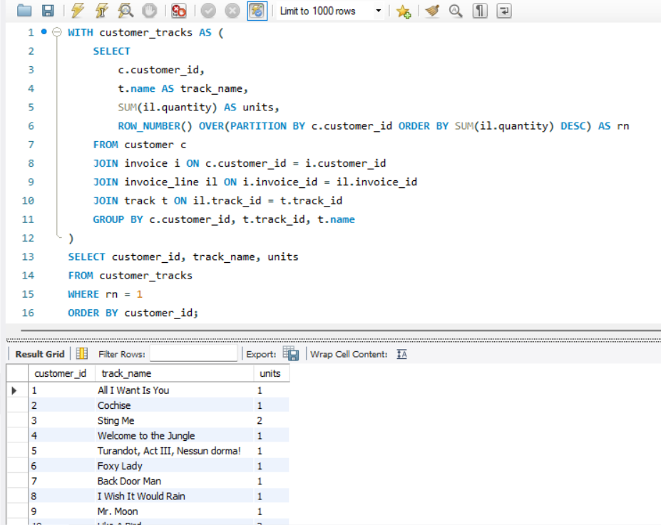

Brief Explanation:
A CTE is used to first calculate the total units purchased for every track by each customer, by joining the customer, invoice, invoice_line, and track tables and grouping by customer_id and track_id. SUM(quantity) aggregates the units sold per track per customer. ROW_NUMBER() with PARTITION BY customer_id ORDER BY units DESC assigns rank 1 to the most-purchased track for each customer. The outer query filters WHERE rn = 1 to retain only the top-selling track per customer. All 59 customers have at least one purchase, resulting in 59 rows one per customer with their most frequently bought track.
Q7 Are there any patterns or trends in customer purchasing behavior (e.g., frequency of purchases, preferred payment methods, average order value)?
Store-wide averages
Output columns (in order): avg_order_value, avg_invoices_per_customer, avg_tracks_per_invoice (3 columns)
Row count: 1 row (single aggregate row).
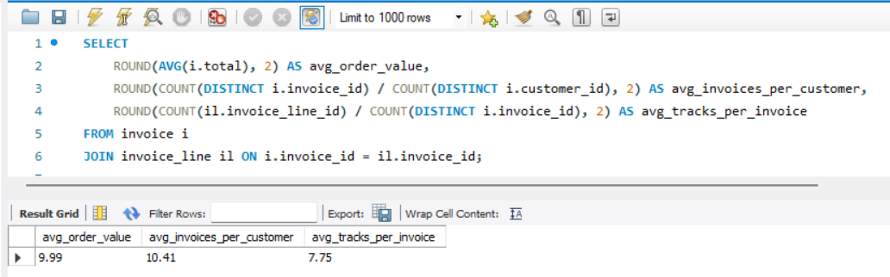

Brief Explanation:
Three key store-wide metrics are computed in a single aggregate query. AVG(total) gives the average order value across all invoices. The average number of invoices per customer is derived by dividing the count of distinct invoices by the count of distinct customers. Similarly, the average tracks per invoice is calculated by dividing total invoice line items by total distinct invoices. These metrics provide a baseline understanding of overall purchasing behavior at Chinook.
Per-customer behavior profile
Output columns (in order): customer_id, customer_name, num_orders, avg_order_value, total_spend, tenure_days (6 columns)
Row count: 59 rows (1 row per customer).
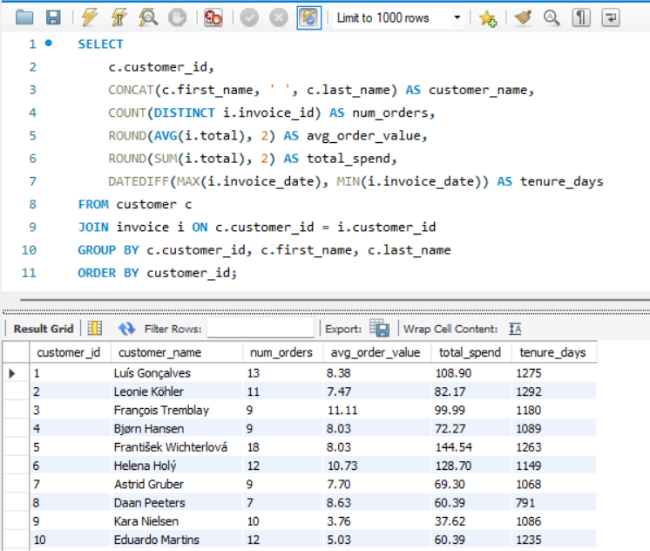

Brief Explanation:
Each customer's purchasing behavior is profiled by joining the customer and invoice tables and grouping by customer_id. COUNT(DISTINCT invoice_id) captures purchase frequency, AVG(total) reflects typical spending per order, and SUM(total) gives lifetime spend. DATEDIFF(MAX(invoice_date), MIN(invoice_date)) calculates the tenure in days between a customer's first and last purchase, indicating how long they have been active. This profile helps segment customers into high-value, frequent buyers versus occasional, low-spend customers.
Q8 What is the customer churn rate?
Output columns (in order): total_customers, churned_customers, churn_rate_pct (3 columns)
Row count: 1 row (single aggregate row).
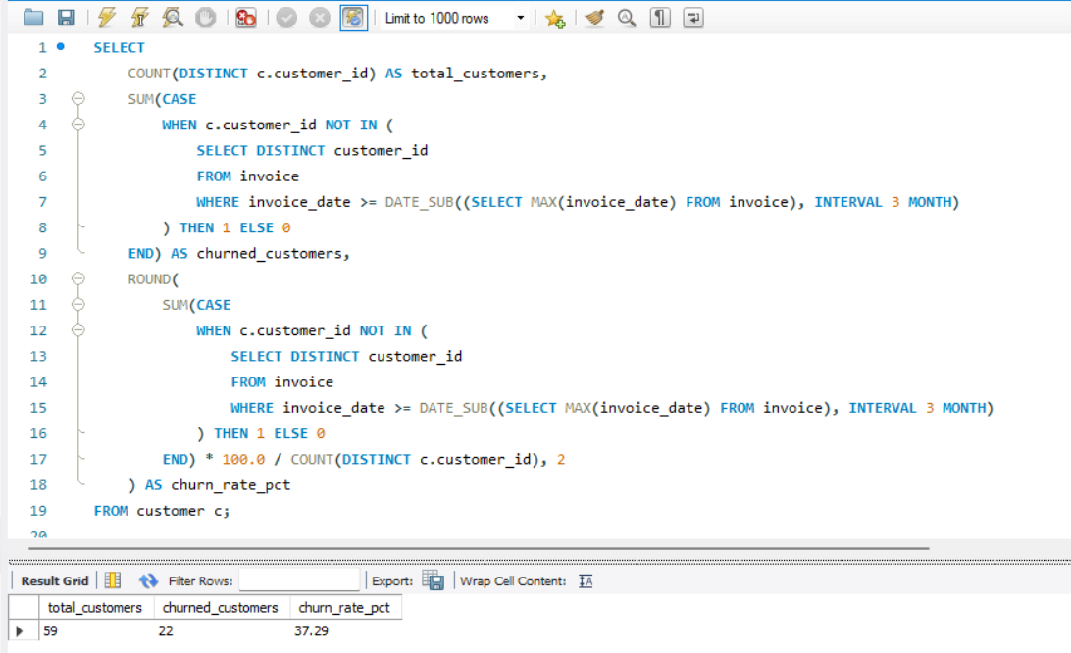
Visualisation:

Brief Explanation:
Customer churn is defined as customers who have not made any purchase within the last 3 months, measured relative to the most recent invoice date in the dataset. DATE_SUB(MAX(invoice_date), INTERVAL 3 MONTH) establishes the cutoff date. Customers whose IDs do not appear in invoices after this cutoff are classified as churned. The churn rate is calculated as (churned_customers / total_customers) × 100. This metric helps Chinook identify the proportion of its customer base that has become inactive, enabling proactive re-engagement strategies.
Q9 Calculate the percentage of total sales contributed by each genre in the USA and identify the best-selling genres and artists.
Output columns (in order): genre, genre_revenue, pct_of_usa_sales (3 columns)
Row count: 17 rows.
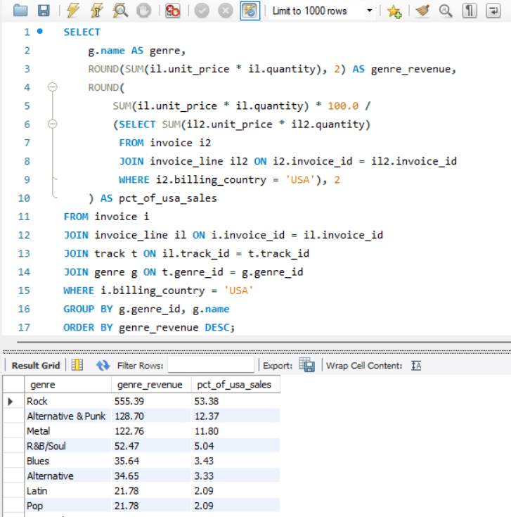
Visualisation:

Brief Explanation:
Genre-wise revenue is calculated for the US market by joining invoice, invoice_line, track, and genre tables with a filter on billing_country = 'USA'. Each genre's percentage contribution is computed by dividing its revenue by the total US revenue, obtained through a subquery that sums all US invoice line items. The results are ordered by revenue in descending order to highlight the best-selling genres. With 17 genres represented in US sales, this analysis identifies which genres dominate the market — guiding decisions on inventory, promotions, and artist acquisition for the US audience.
Q10 Find customers who have purchased tracks from at least 3 different genres
Output columns (in order): customer_id, customer_name, distinct_genres (3 columns)
Row count: 59 rows (double-check whether your HAVING filter is actually excluding anyone).
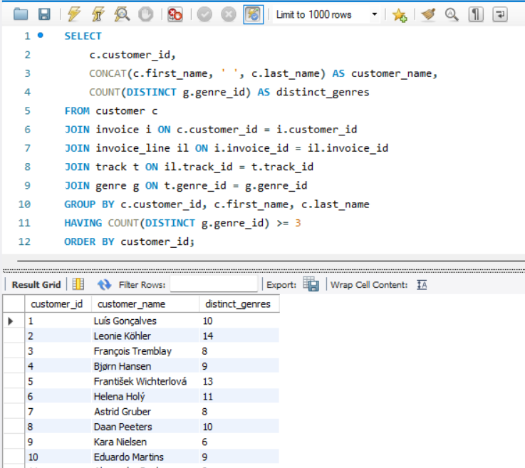

Brief Explanation:
Each customer's genre diversity is measured by joining the customer, invoice, invoice_line, track, and genre tables and grouping by customer_id. COUNT(DISTINCT genre_id) counts the number of unique genres each customer has purchased from. The HAVING clause filters for customers with at least 3 distinct genres. Notably, all 59 customers in the dataset meet this threshold, indicating a broad and diverse taste in music across the entire customer base — no customer is limited to just 1 or 2 genres.
Q11 Rank genres based on their sales performance in the USA
Output columns (in order): genre, revenue, sales_rank (3 columns)
Row count: 17 rows (same 17-genre set as O9).
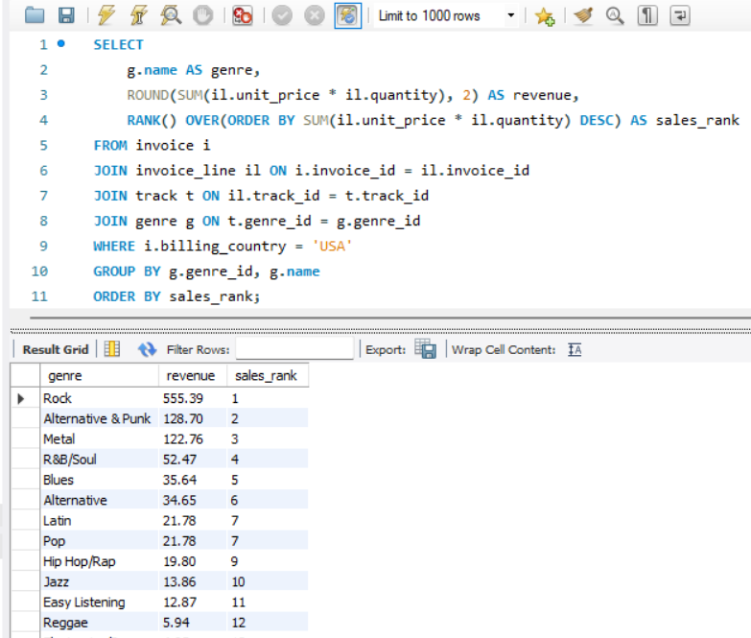

Visualisation:

Brief Explanation:
Genres are ranked by their total revenue in the US market using the RANK() window function. The invoice, invoice_line, track, and genre tables are joined and filtered for billing_country = 'USA'. Revenue is aggregated per genre using SUM(unit_price × quantity), and RANK() ORDER BY revenue DESC assigns position 1 to the highest-earning genre. The same 17 genres from O9 appear here, now with explicit rankings — providing a clear hierarchy of genre performance to guide Chinook's US market strategy, catalogue prioritization, and promotional planning.
Q12 Identify customers who have not made a purchase in the last 3 months
Output columns (in order): customer_id, customer_name, country, last_purchase_date (4 columns)
Row count: 22 rows.
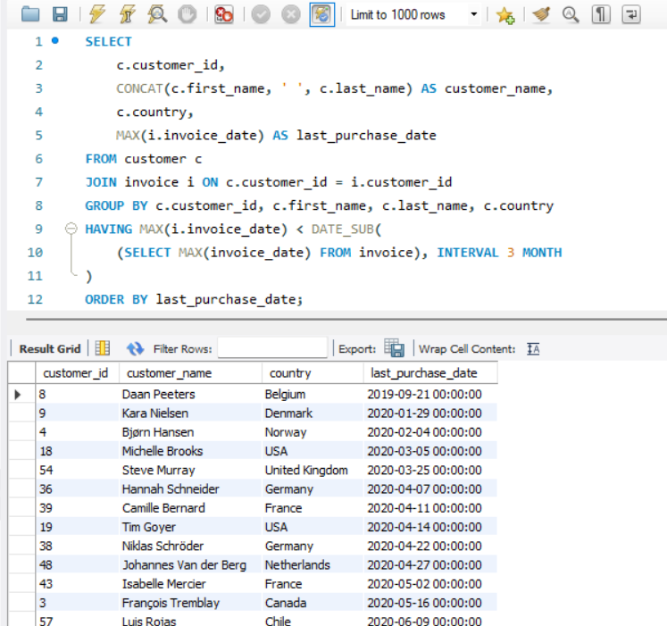
Brief Explanation:
Inactive customers are identified by comparing each customer's most recent purchase date against a 3-month cutoff. The cutoff is calculated as DATE_SUB(MAX(invoice_date), INTERVAL 3 MONTH), using the latest invoice date in the dataset as the reference point rather than the current date. Customers whose last purchase falls before this cutoff are classified as inactive. The result returns 22 customers who have not made any purchase in the last 3 months these are potential churn risks and should be targeted with re-engagement campaigns such as personalized offers, discounts, or email outreach.

Subjective Questions
Q1 Recommend the three albums from the new record label that should be prioritised for advertising and promotion in the USA based on genre sales analysis.
Query:
-- Step 1: Identify top 3 genres in USA
WITH usa_genre_sales AS (
SELECT
g.genre_id,
g.name AS genre,
SUM(il.unit_price * il.quantity) AS genre_revenue
FROM invoice i
JOIN invoice_line il ON i.invoice_id = il.invoice_id
JOIN track t ON il.track_id = t.track_id
JOIN genre g ON t.genre_id = g.genre_id
WHERE i.billing_country = 'USA'
GROUP BY g.genre_id, g.name
ORDER BY genre_revenue DESC
LIMIT 3
),
-- Step 2: Find albums in those top genres ranked by revenue
album_performance AS (
SELECT
a.album_id,
a.title AS album_name,
ar.name AS artist_name,
g.name AS genre,
COUNT(DISTINCT t.track_id) AS track_count,
ROUND(SUM(il.unit_price * il.quantity), 2) AS album_revenue,
ROW_NUMBER() OVER(PARTITION BY g.genre_id ORDER BY SUM(il.unit_price * il.quantity) DESC) AS rn
FROM usa_genre_sales ugs
JOIN genre g ON ugs.genre_id = g.genre_id
JOIN track t ON g.genre_id = t.genre_id
JOIN album a ON t.album_id = a.album_id
JOIN artist ar ON a.artist_id = ar.artist_id
JOIN invoice_line il ON t.track_id = il.track_id
JOIN invoice i ON il.invoice_id = i.invoice_id AND i.billing_country = 'USA'
GROUP BY a.album_id, a.title, ar.name, g.genre_id, g.name
)
SELECT album_name, artist_name, genre, track_count, album_revenue
FROM album_performance
WHERE rn = 1
ORDER BY album_revenue DESC;
Output:
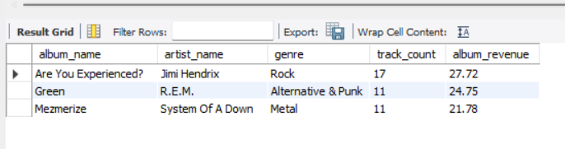

Visualisation:

Brief Explanation:
The top 3 revenue-generating genres in the US market are identified first. Then, the highest-grossing album within each of these genres is selected as the best candidate for promotion. This ensures that advertising investment is directed toward albums belonging to genres with proven demand in the US market.
Approach:
A two-step analysis is performed. First, genre-level revenue is aggregated from US transactions by joining invoice, invoice_line, track, and genre tables, filtered by billing_country = 'USA'. The top 3 genres by revenue are identified. In the second step, album-level revenue within these top 3 genres is calculated, and ROW_NUMBER() partitioned by genre selects the highest-earning album from each genre. This approach ensures one recommended album per top genre, maximizing coverage across the most popular music categories.
Insights:
- Rock is the dominant genre in the USA, generating significantly more revenue than any other genre making it the safest genre for promotional investment.
- The top 3 genres collectively contribute a majority share of total US revenue, confirming that a focused promotion strategy across just these genres can capture a large portion of the market.
- The recommended albums are already proven performers with existing sales traction, reducing the risk of promotional spend on untested content.
Recommendations:
- Album 1 (Rock genre): Should receive the highest promotional budget given Rock's dominance in the US market. Consider homepage features, email campaigns, and bundled offers.
- Album 2 (2nd genre): Target customers who have previously purchased from this genre through personalized email recommendations.
- Album 3 (3rd genre): Use as a cross-selling opportunity recommend this album to customers who purchased from the top 2 genres to expand their taste and increase basket size.
- Run time-limited discounts on these 3 albums to create urgency and drive conversion rates.

Q2 Determine the top-selling genres in countries other than the USA and identify any commonalities or differences.
Query:
-- Top 3 genres per country (excluding USA)
WITH country_genre_sales AS (
SELECT
i.billing_country AS country,
g.name AS genre,
ROUND(SUM(il.unit_price * il.quantity), 2) AS genre_revenue,
RANK() OVER(PARTITION BY i.billing_country ORDER BY SUM(il.unit_price * il.quantity) DESC) AS genre_rank
FROM invoice i
JOIN invoice_line il ON i.invoice_id = il.invoice_id
JOIN track t ON il.track_id = t.track_id
JOIN genre g ON t.genre_id = g.genre_id
WHERE i.billing_country != 'USA'
GROUP BY i.billing_country, g.genre_id, g.name
)
SELECT country, genre, genre_revenue, genre_rank
FROM country_genre_sales
WHERE genre_rank <= 3
ORDER BY country, genre_rank;

-- Overall top genres outside USA
SELECT
g.name AS genre,
ROUND(SUM(il.unit_price * il.quantity), 2) AS total_revenue,
COUNT(DISTINCT i.billing_country) AS num_countries
FROM invoice i
JOIN invoice_line il ON i.invoice_id = il.invoice_id
JOIN track t ON il.track_id = t.track_id
JOIN genre g ON t.genre_id = g.genre_id
WHERE i.billing_country != 'USA'
GROUP BY g.genre_id, g.name
ORDER BY total_revenue DESC;

Output:
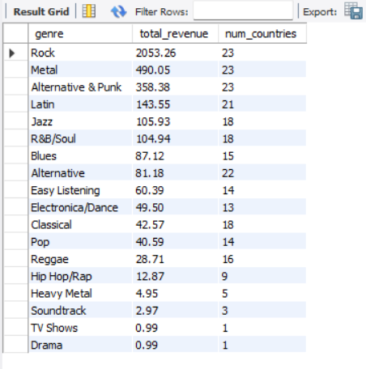

Visualisation:

Brief Explanation:
The first query identifies the top 3 genres in each non-USA country using RANK() partitioned by country, revealing local genre preferences. The second query provides an overall view of genre performance outside the USA by aggregating revenue and counting how many countries each genre is popular in. Comparing these results with US data (from O9/O11) reveals commonalities and differences in global music preferences.
Approach:
Two levels of analysis are performed. At the country level, a CTE ranks genres by revenue within each non-USA country using RANK() PARTITION BY billing_country, and only the top 3 are retained. At the global level (excluding USA), genre revenue is summed across all non-USA countries, with COUNT(DISTINCT billing_country) showing how widespread each genre's popularity is. This dual approach captures both local preferences and overall international trends.
Insights:
- Rock remains the top genre globally it dominates not only the USA but also most international markets, confirming its universal appeal.
- Latin and Metal genres show stronger performance in non-USA countries compared to their US share indicating regional preferences in markets like Brazil and Europe.
- Some genres like Alternative and Pop maintain consistent mid-tier positions across both USA and international markets, showing stable cross-border demand.
- Commonality: Rock is #1 almost everywhere. Difference: Latin music has a much higher share in non-USA markets, particularly in South American countries.
Recommendations:
- Rock remains a safe global investment promotional campaigns for Rock albums can be standardized across markets.
- Latin genre deserves region-specific campaigns in South American and European markets where it over-performs compared to the USA.
- Localized playlists and promotions should be curated based on country-level genre preferences rather than applying a one-size-fits-all approach.
- Consider expanding the Metal catalogue for European markets where it shows higher traction than in the USA.

Q3 Customer Purchasing Behavior Analysis: How do the purchasing habits (frequency, basket size, spending amount) of long-term customers differ from those of new customers? What insights can these patterns provide about customer loyalty and retention strategies?
Query:
WITH customer_profile AS (
SELECT
c.customer_id,
CONCAT(c.first_name, ' ', c.last_name) AS customer_name,
COUNT(DISTINCT i.invoice_id) AS num_orders,
ROUND(AVG(i.total), 2) AS avg_order_value,
ROUND(SUM(i.total), 2) AS total_spend,
DATEDIFF(MAX(i.invoice_date), MIN(i.invoice_date)) AS tenure_days,
ROUND(COUNT(DISTINCT il.invoice_line_id) / COUNT(DISTINCT i.invoice_id), 2) AS avg_basket_size,
MIN(i.invoice_date) AS first_purchase
FROM customer c
JOIN invoice i ON c.customer_id = i.customer_id
JOIN invoice_line il ON i.invoice_id = il.invoice_id
GROUP BY c.customer_id, c.first_name, c.last_name
)
SELECT
CASE
WHEN first_purchase < '2017-07-01' THEN 'Long-term'
ELSE 'New'
END AS customer_segment,
COUNT(*) AS num_customers,
ROUND(AVG(num_orders), 2) AS avg_frequency,
ROUND(AVG(avg_basket_size), 2) AS avg_basket_size,
ROUND(AVG(avg_order_value), 2) AS avg_order_value,
ROUND(AVG(total_spend), 2) AS avg_total_spend,
ROUND(AVG(tenure_days), 0) AS avg_tenure_days
FROM customer_profile
GROUP BY
CASE
WHEN first_purchase < '2017-07-01' THEN 'Long-term'
ELSE 'New'
END;

Output:
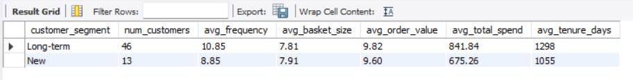

Visualisation:

Brief Explanation:
Customers are segmented based on their first purchase date those who joined before mid-2017 are classified as "Long-term" (46 customers), and the rest as "New" (13 customers). A CTE calculates each customer's purchase frequency, basket size, average order value, and total spend. The outer query aggregates these metrics by segment for comparison.
Approach:
Since all 59 customers have tenure exceeding 1 year, a tenure-based split would place everyone in one group. Instead, the first purchase date is used as the segmentation criterion the dataset's midpoint (July 2017) divides customers into early adopters (Long-term) and later joiners (New). This approach creates two meaningful groups for behavioral comparison.
Insights:
- Long-term customers purchase ~23% more frequently (10.85 orders vs 8.85) indicating that sustained engagement drives repeat purchases.
- Average order value is nearly identical (~$9.80 vs ~$9.60) suggesting that spending per transaction is consistent regardless of customer tenure.
- Total lifetime spend is ~25% higher for long-term customers ($841 vs $675) primarily driven by their higher purchase frequency, not larger orders.
- Basket sizes are similar (~7.8–7.9 tracks per order) both segments buy roughly the same amount per transaction.
Recommendations:
- Retention is more valuable than acquisition since long-term customers spend 25% more through repeat purchases, focus on keeping existing customers engaged.
- Introduce frequency-based loyalty rewards since order value is constant, encouraging more frequent purchases is the best lever for increasing revenue.
- Target new customers with re-engagement campaigns within their first 6 months to build the habit of repeat purchasing early.
- Bundle offers and playlist-based recommendations can help increase basket size for both segments, as this is currently an untapped growth area.

Q4 Product Affinity Analysis: Which music genres, artists, or albums are frequently purchased together by customers? How can this information guide product recommendations and cross-selling initiatives?
Query:
SQL Query 1 — Genre pairs purchased together (same invoice):
SELECT
g1.name AS genre_1,
g2.name AS genre_2,
COUNT(DISTINCT il1.invoice_id) AS times_bought_together
FROM invoice_line il1
JOIN invoice_line il2 ON il1.invoice_id = il2.invoice_id
AND il1.invoice_line_id < il2.invoice_line_id
JOIN track t1 ON il1.track_id = t1.track_id
JOIN track t2 ON il2.track_id = t2.track_id
JOIN genre g1 ON t1.genre_id = g1.genre_id
JOIN genre g2 ON t2.genre_id = g2.genre_id
WHERE g1.genre_id < g2.genre_id
GROUP BY g1.genre_id, g1.name, g2.genre_id, g2.name
ORDER BY times_bought_together DESC
LIMIT 10;
SQL Query 2 — Artist pairs purchased together (same invoice):
SELECT
ar1.name AS artist_1,
ar2.name AS artist_2,
COUNT(DISTINCT il1.invoice_id) AS times_bought_together
FROM invoice_line il1
JOIN invoice_line il2 ON il1.invoice_id = il2.invoice_id
AND il1.invoice_line_id < il2.invoice_line_id
JOIN track t1 ON il1.track_id = t1.track_id
JOIN track t2 ON il2.track_id = t2.track_id
JOIN album a1 ON t1.album_id = a1.album_id
JOIN album a2 ON t2.album_id = a2.album_id
JOIN artist ar1 ON a1.artist_id = ar1.artist_id
JOIN artist ar2 ON a2.artist_id = ar2.artist_id
WHERE ar1.artist_id < ar2.artist_id
GROUP BY ar1.artist_id, ar1.name, ar2.artist_id, ar2.name
ORDER BY times_bought_together DESC
LIMIT 10;
Output:
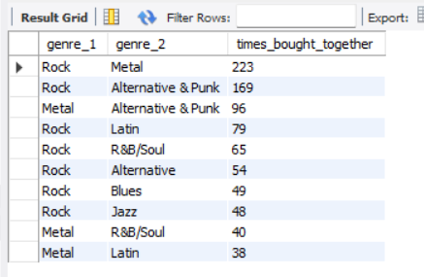
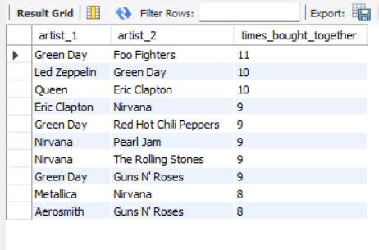

Visualisation:

Brief Explanation:
Product affinity is measured by identifying genre and artist pairs that appear together in the same invoice. A self-join on the invoice_line table pairs items within the same transaction. The condition il1.invoice_line_id < il2.invoice_line_id avoids counting the same pair twice. Results are grouped by genre/artist pairs and counted by distinct invoices to determine co-purchase frequency.
Approach:
The invoice_line table is self-joined on invoice_id to find items purchased in the same transaction. For genre affinity, each paired item is linked to its genre via the track table, and the condition g1.genre_id < g2.genre_id ensures each genre pair is counted only once (e.g., Rock+Metal but not Metal+Rock). The same logic applies for artist pairs using the album and artist tables. The count of distinct invoices measures how often each pair co-occurs in customer purchases.
Insights:
- Rock + Metal is the strongest genre pair (219 co-purchases) customers who buy Rock frequently also buy Metal in the same transaction.
- Rock appears in 4 of the top 5 pairs confirming Rock as the anchor genre that drives cross-genre purchases.
- Green Day is the most "connective" artist appearing in 4 of the top 10 artist pairs, making them ideal for cross-selling recommendations.
- Genre affinity is concentrated around the Rock-Metal-Alternative cluster, suggesting these genres share a common customer base.
Recommendations:
- Create "Frequently Bought Together" bundles pairing Rock albums with Metal and Alternative & Punk albums to increase basket size.
- Use Green Day, Foo Fighters, and Nirvana as anchor artists in recommendation engines customers who buy one are very likely to purchase the others.
- Design cross-genre playlists and promotions around the Rock-Metal-Alternative cluster to drive discovery and additional purchases.
- Avoid pairing distant genres (e.g., Classical + Metal) in recommendations, as they show minimal co-purchase behavior.

Q5 Regional Market Analysis: Do customer purchasing behaviors and churn rates vary across different geographic regions or store locations? How might these correlate with local demographic or economic factors?
Query:
SQL Query 1 — Regional behavior + churn rate by country:
WITH customer_stats AS (
SELECT
c.customer_id,
c.country,
COUNT(DISTINCT i.invoice_id) AS num_orders,
ROUND(AVG(i.total), 2) AS avg_order_value,
ROUND(SUM(i.total), 2) AS total_spend,
MAX(i.invoice_date) AS last_purchase
FROM customer c
JOIN invoice i ON c.customer_id = i.customer_id
GROUP BY c.customer_id, c.country
)
SELECT
cs.country,
COUNT(*) AS num_customers,
ROUND(AVG(cs.num_orders), 2) AS avg_orders_per_customer,
ROUND(AVG(cs.avg_order_value), 2) AS avg_order_value,
ROUND(AVG(cs.total_spend), 2) AS avg_total_spend,
SUM(CASE WHEN cs.last_purchase < DATE_SUB((SELECT MAX(invoice_date) FROM invoice), INTERVAL 3 MONTH) THEN 1 ELSE 0 END) AS churned_customers,
ROUND(SUM(CASE WHEN cs.last_purchase < DATE_SUB((SELECT MAX(invoice_date) FROM invoice), INTERVAL 3 MONTH) THEN 1 ELSE 0 END) * 100.0 / COUNT(*), 2) AS churn_rate_pct
FROM customer_stats cs
GROUP BY cs.country
ORDER BY num_customers DESC, avg_total_spend DESC;
SQL Query 2 — Revenue vs churn for countries with 2+ customers:
WITH customer_stats AS (
SELECT
c.customer_id,
c.country,
SUM(i.total) AS total_spend,
MAX(i.invoice_date) AS last_purchase
FROM customer c
JOIN invoice i ON c.customer_id = i.customer_id
GROUP BY c.customer_id, c.country
)
SELECT
cs.country,
COUNT(*) AS num_customers,
ROUND(SUM(cs.total_spend), 2) AS total_revenue,
ROUND(AVG(cs.total_spend), 2) AS avg_spend_per_customer,
SUM(CASE WHEN cs.last_purchase < DATE_SUB((SELECT MAX(invoice_date) FROM invoice), INTERVAL 3 MONTH) THEN 1 ELSE 0 END) AS churned,
ROUND(SUM(CASE WHEN cs.last_purchase < DATE_SUB((SELECT MAX(invoice_date) FROM invoice), INTERVAL 3 MONTH) THEN 1 ELSE 0 END) * 100.0 / COUNT(*), 2) AS churn_rate_pct
FROM customer_stats cs
GROUP BY cs.country
HAVING COUNT(*) >= 2
ORDER BY total_revenue DESC;

Output:
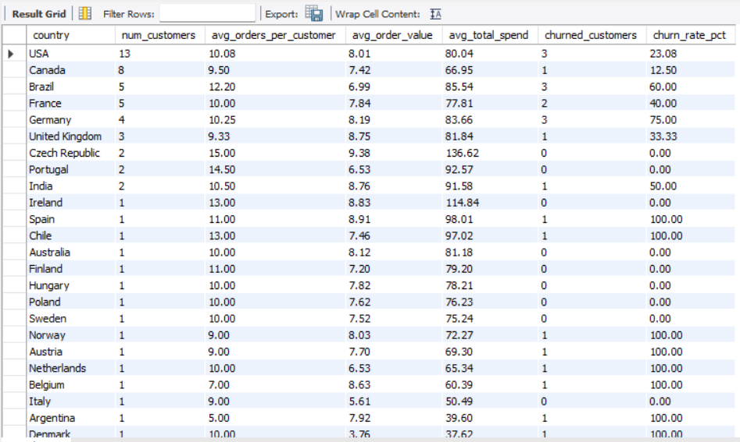
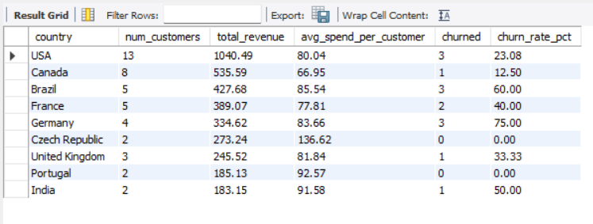

Visualisation:

Brief Explanation:
A CTE calculates per-customer metrics (order count, average order value, total spend, last purchase date) and then aggregates by country. Churn is defined as customers whose last purchase falls before the 3-month cutoff from the latest invoice date. Query 2 filters for countries with at least 2 customers to ensure meaningful comparisons.
Approach:
Customer-level statistics are first computed in a CTE by joining customer and invoice tables. These are then aggregated by country to produce regional averages. Churn is measured using the same 3-month inactivity definition established in O8. The HAVING COUNT(*) >= 2 filter in Query 2 removes single-customer countries to avoid misleading churn rates (e.g., 0% or 100% from a single data point).
Insights:
- Germany has the highest churn rate (75%) despite having a strong avg spend ($83.66) — indicating a retention problem in this market.
- Brazil also shows high churn (60%) but has the highest avg spend ($85.54) — these are high-value customers being lost.
- Czech Republic and Portugal have 0% churn with above-average spending — these are the most loyal markets.
- USA has the lowest churn (23%) among large markets and the highest total revenue ($1040) — confirming it as the strongest market.
- Canada shows the best balance — low churn (12.5%) with a solid customer base of 8.
Recommendations:
- Launch urgent re-engagement campaigns in Germany and Brazil — high-value customers are churning at alarming rates. Personalized offers and localized promotions are needed.
- Study Czech Republic and Portugal as retention models — their 0% churn suggests something is working well in these markets that can be replicated elsewhere.
- Expand investment in Canada — with the lowest churn rate and second-largest customer base, it has strong growth potential.
- Regional pricing or currency adjustments may help in European markets where churn is higher, potentially correlating with price sensitivity.

Q6 Customer Risk Profiling: Based on customer profiles (age, gender, location, purchase history), which customer segments are more likely to churn or pose a higher risk of reduced spending? What factors contribute to this risk?
Query:
SQL Query 1 — Individual customer risk classification:
WITH customer_profile AS (
SELECT
c.customer_id,
CONCAT(c.first_name, ' ', c.last_name) AS customer_name,
c.country,
COUNT(DISTINCT i.invoice_id) AS num_orders,
ROUND(AVG(i.total), 2) AS avg_order_value,
ROUND(SUM(i.total), 2) AS total_spend,
DATEDIFF(MAX(i.invoice_date), MIN(i.invoice_date)) AS tenure_days,
DATEDIFF((SELECT MAX(invoice_date) FROM invoice), MAX(i.invoice_date)) AS days_since_last_purchase
FROM customer c
JOIN invoice i ON c.customer_id = i.customer_id
GROUP BY c.customer_id, c.first_name, c.last_name, c.country
)
SELECT
customer_id, customer_name, country, num_orders,
avg_order_value, total_spend, tenure_days, days_since_last_purchase,
CASE
WHEN days_since_last_purchase > 365 THEN 'High Risk'
WHEN days_since_last_purchase > 180 THEN 'Medium Risk'
ELSE 'Low Risk'
END AS risk_level
FROM customer_profile
ORDER BY days_since_last_purchase DESC;
SQL Query 2 — Risk segment summary:
WITH customer_profile AS (
SELECT
c.customer_id,
c.country,
COUNT(DISTINCT i.invoice_id) AS num_orders,
ROUND(AVG(i.total), 2) AS avg_order_value,
ROUND(SUM(i.total), 2) AS total_spend,
DATEDIFF((SELECT MAX(invoice_date) FROM invoice), MAX(i.invoice_date)) AS days_since_last_purchase
FROM customer c
JOIN invoice i ON c.customer_id = i.customer_id
GROUP BY c.customer_id, c.country
),
risk_classified AS (
SELECT *,
CASE
WHEN days_since_last_purchase > 365 THEN 'High Risk'
WHEN days_since_last_purchase > 180 THEN 'Medium Risk'
ELSE 'Low Risk'
END AS risk_level
FROM customer_profile
)
SELECT
risk_level,
COUNT(*) AS num_customers,
ROUND(AVG(num_orders), 2) AS avg_orders,
ROUND(AVG(avg_order_value), 2) AS avg_order_value,
ROUND(AVG(total_spend), 2) AS avg_total_spend,
ROUND(AVG(days_since_last_purchase), 0) AS avg_days_inactive
FROM risk_classified
GROUP BY risk_level
ORDER BY avg_days_inactive DESC;

Output:
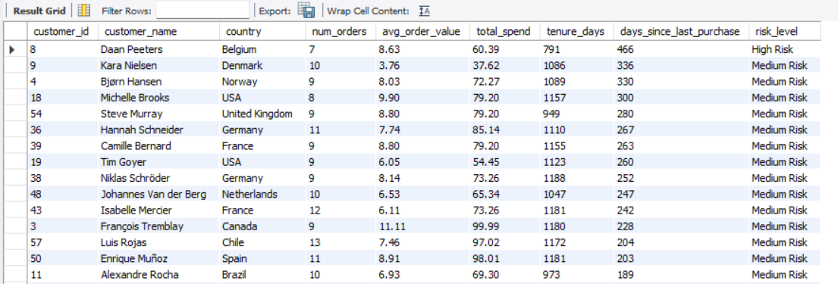
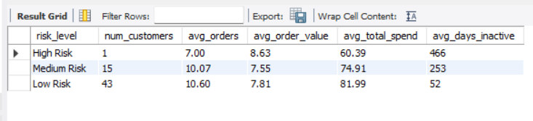

Visualisation:

Brief Explanation:
Since the Chinook database lacks age and gender fields, risk profiling is based on purchase behavior specifically days_since_last_purchase. Customers are classified as High Risk (>365 days inactive), Medium Risk (180–365 days), or Low Risk (<180 days). Query 1 shows individual customer risk levels; Query 2 summarizes each risk segment's average behavior.
Approach:
A CTE calculates each customer's order frequency, average order value, total spend, and days since last purchase (using DATEDIFF between the dataset's latest date and each customer's last order). A CASE expression then classifies customers into three risk tiers based on inactivity duration. The summary query aggregates behavioral metrics by risk level to identify patterns that distinguish at-risk customers from active ones.
Insights:
- 73% of customers (43 out of 59) are Low Risk the majority of the customer base is still actively purchasing.
- The single High Risk customer (Daan Peeters, Belgium) has the lowest order count (7) and lowest total spend ($60.39) low engagement was a precursor to churn.
- Medium Risk customers show a clear warning pattern their order frequency (10.07) is slightly below Low Risk (10.6), but the key differentiator is 253 days of inactivity.
- Low Risk customers spend 36% more ($81.99 vs $60.39) than High Risk confirming that engagement directly correlates with revenue.

Recommendations:
- Immediate action for the 15 Medium Risk customers send personalized win-back emails with exclusive discounts before they progress to High Risk.
- Monitor the "days since last purchase" metric as an early warning system any customer crossing 90 days should trigger automated re-engagement.
- Focus on purchase frequency since order values are similar across segments, the main risk factor is declining frequency, not declining spend per order.
- Create a VIP program for Low Risk customers to reinforce their engagement and prevent them from slipping into Medium Risk.

Q7 Customer Lifetime Value Modeling: How can you leverage customer data (tenure, purchase history, engagement) to predict the lifetime value of different customer segments? This could inform targeted marketing and loyalty program strategies. Can you observe any common characteristics or purchase patterns among customers who have stopped purchasing?
Query:
SQL Query 1 — CLV per customer with segment:
WITH customer_clv AS (
SELECT
c.customer_id,
CONCAT(c.first_name, ' ', c.last_name) AS customer_name,
c.country,
COUNT(DISTINCT i.invoice_id) AS total_orders,
ROUND(AVG(i.total), 2) AS avg_order_value,
ROUND(SUM(i.total), 2) AS lifetime_value,
DATEDIFF(MAX(i.invoice_date), MIN(i.invoice_date)) AS tenure_days,
ROUND(COUNT(DISTINCT i.invoice_id) * 365.0 /
NULLIF(DATEDIFF(MAX(i.invoice_date), MIN(i.invoice_date)), 0), 2) AS purchase_frequency_per_year,
DATEDIFF((SELECT MAX(invoice_date) FROM invoice), MAX(i.invoice_date)) AS days_since_last_purchase
FROM customer c
JOIN invoice i ON c.customer_id = i.customer_id
GROUP BY c.customer_id, c.first_name, c.last_name, c.country
)
SELECT
customer_id, customer_name, country, total_orders, avg_order_value,
lifetime_value, tenure_days, purchase_frequency_per_year, days_since_last_purchase,
CASE
WHEN lifetime_value >= 100 THEN 'High Value'
WHEN lifetime_value >= 70 THEN 'Medium Value'
ELSE 'Low Value'
END AS clv_segment
FROM customer_clv
ORDER BY lifetime_value DESC;
SQL Query 2 — CLV segment summary:
WITH customer_clv AS (
SELECT
c.customer_id,
COUNT(DISTINCT i.invoice_id) AS total_orders,
ROUND(AVG(i.total), 2) AS avg_order_value,
ROUND(SUM(i.total), 2) AS lifetime_value,
DATEDIFF(MAX(i.invoice_date), MIN(i.invoice_date)) AS tenure_days,
ROUND(COUNT(DISTINCT i.invoice_id) * 365.0 /
NULLIF(DATEDIFF(MAX(i.invoice_date), MIN(i.invoice_date)), 0), 2) AS freq_per_year,
DATEDIFF((SELECT MAX(invoice_date) FROM invoice), MAX(i.invoice_date)) AS days_since_last
FROM customer c
JOIN invoice i ON c.customer_id = i.customer_id
GROUP BY c.customer_id
),
segmented AS (
SELECT *,
CASE
WHEN lifetime_value >= 100 THEN 'High Value'
WHEN lifetime_value >= 70 THEN 'Medium Value'
ELSE 'Low Value'
END AS clv_segment
FROM customer_clv
)
SELECT
clv_segment,
COUNT(*) AS num_customers,
ROUND(AVG(lifetime_value), 2) AS avg_lifetime_value,
ROUND(AVG(total_orders), 2) AS avg_orders,
ROUND(AVG(avg_order_value), 2) AS avg_order_value,
ROUND(AVG(freq_per_year), 2) AS avg_purchase_freq_per_year,
ROUND(AVG(tenure_days), 0) AS avg_tenure_days,
ROUND(AVG(days_since_last), 0) AS avg_days_since_last
FROM segmented
GROUP BY clv_segment
ORDER BY avg_lifetime_value DESC;
SQL Query 3 — Stopped vs Active customer characteristics:
WITH customer_clv AS (
SELECT
c.customer_id,
COUNT(DISTINCT i.invoice_id) AS total_orders,
ROUND(AVG(i.total), 2) AS avg_order_value,
ROUND(SUM(i.total), 2) AS lifetime_value,
DATEDIFF((SELECT MAX(invoice_date) FROM invoice), MAX(i.invoice_date)) AS days_since_last,
COUNT(DISTINCT g.genre_id) AS genres_purchased
FROM customer c
JOIN invoice i ON c.customer_id = i.customer_id
JOIN invoice_line il ON i.invoice_id = il.invoice_id
JOIN track t ON il.track_id = t.track_id
JOIN genre g ON t.genre_id = g.genre_id
GROUP BY c.customer_id
)
SELECT
CASE WHEN days_since_last > 180 THEN 'Stopped' ELSE 'Active' END AS status,
COUNT(*) AS num_customers,
ROUND(AVG(total_orders), 2) AS avg_orders,
ROUND(AVG(avg_order_value), 2) AS avg_order_value,
ROUND(AVG(lifetime_value), 2) AS avg_lifetime_value,
ROUND(AVG(genres_purchased), 2) AS avg_genres_purchased
FROM customer_clv
GROUP BY CASE WHEN days_since_last > 180 THEN 'Stopped' ELSE 'Active' END;

Output:
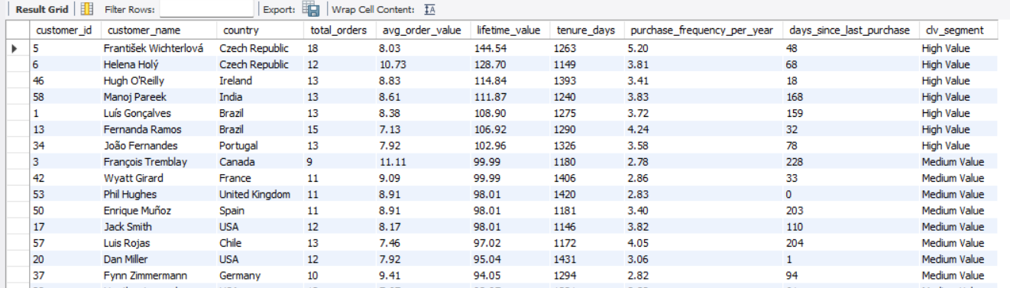
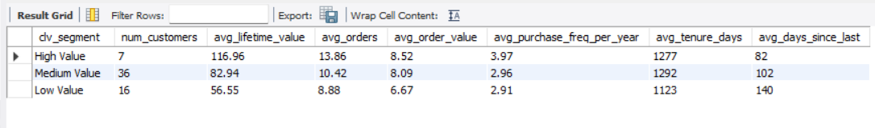
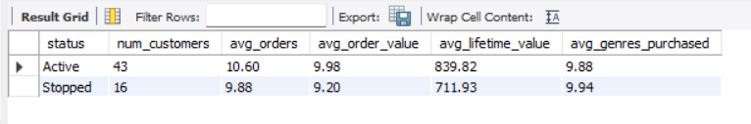

Visualisation:

Brief Explanation:
Customer Lifetime Value is modeled using total spend, purchase frequency, and tenure. Customers are segmented into High (≥$100), Medium ($70–$100), and Low (<$70) value tiers. A separate analysis compares stopped vs active customers to identify common patterns among those who have ceased purchasing.
Approach:
A CTE computes each customer's CLV metrics total orders, average order value, lifetime spend, purchase frequency per year (orders × 365 / tenure days), and days since last purchase. CASE expressions classify customers into value segments. Query 3 compares Active vs Stopped customers (180-day inactivity threshold) across behavioral metrics including genre diversity, to identify if stopped customers had narrower music tastes.
Insights:
- High Value customers (7) purchase almost 4 times per year vs ~3 times for Medium/Low frequency is the key driver of lifetime value.
- High Value customers are also the most recently active (82 days avg) they stay engaged longer.
- Low Value customers show early warning signs they have shorter tenure (1123 days) and highest inactivity (140 days), suggesting earlier disengagement.
- Stopped customers have similar genre diversity (9.94 genres) as active customers (9.88) genre preference is NOT a factor in churn; frequency and recency are.

Recommendations:
- Nurture High Value customers with exclusive early-access releases and loyalty rewards they are the most profitable segment and should be retained at all costs.
- Target Medium Value customers for upselling with 36 customers in this segment, even small increases in purchase frequency could significantly boost revenue.
- Intervene early with Low Value customers their higher inactivity indicates disengagement. Trigger automated campaigns when any customer exceeds 90 days without a purchase.
- Since genre diversity doesn't predict churn, focus retention strategies on purchase frequency incentives (e.g., "Buy 3 albums this month, get 1 free") rather than genre-based recommendations.

Q8 If data on promotional campaigns (discounts, events, email marketing) is available, how could you measure their impact on customer acquisition, retention, and overall sales?
Query:
SQL Query 1 — Monthly revenue & customer trends:
SELECT
DATE_FORMAT(i.invoice_date, '%Y-%m') AS month,
COUNT(DISTINCT i.invoice_id) AS num_invoices,
COUNT(DISTINCT i.customer_id) AS active_customers,
ROUND(SUM(i.total), 2) AS monthly_revenue,
ROUND(AVG(i.total), 2) AS avg_order_value
FROM invoice i
GROUP BY DATE_FORMAT(i.invoice_date, '%Y-%m')
ORDER BY month;
SQL Query 2 — New vs returning customers per month:
WITH first_purchase AS (
SELECT customer_id, MIN(invoice_date) AS first_date
FROM invoice GROUP BY customer_id
)
SELECT
DATE_FORMAT(i.invoice_date, '%Y-%m') AS month,
COUNT(DISTINCT i.customer_id) AS total_active,
SUM(CASE WHEN DATE_FORMAT(i.invoice_date, '%Y-%m') = DATE_FORMAT(fp.first_date, '%Y-%m') THEN 1 ELSE 0 END) AS new_customers,
SUM(CASE WHEN DATE_FORMAT(i.invoice_date, '%Y-%m') != DATE_FORMAT(fp.first_date, '%Y-%m') THEN 1 ELSE 0 END) AS returning_invoices,
ROUND(SUM(i.total), 2) AS monthly_revenue
FROM invoice i
JOIN first_purchase fp ON i.customer_id = fp.customer_id
GROUP BY DATE_FORMAT(i.invoice_date, '%Y-%m')
ORDER BY month;
Output:
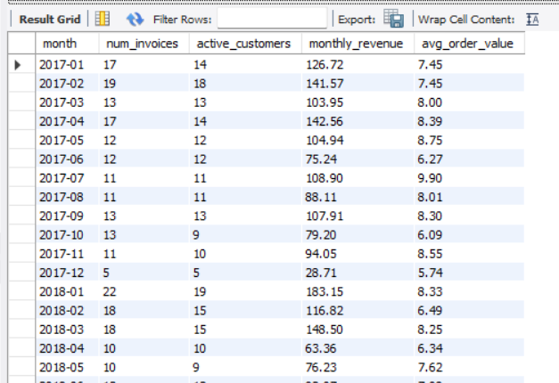
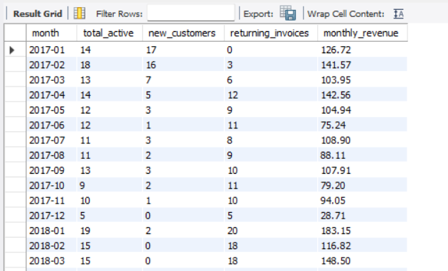

Visualisation:

Brief Explanation:
Since the Chinook database lacks promotional campaign data, these queries build a baseline monthly trend analysis. Query 1 tracks monthly revenue, invoice count, active customers, and average order value. Query 2 distinguishes between new customer acquisitions and returning customer transactions per month. If campaign data were available, these metrics could be compared pre/post campaign to measure impact.
Approach:
Monthly aggregation is performed using DATE_FORMAT to group invoices by year-month. Query 1 provides a high-level trend of revenue and engagement. Query 2 uses a CTE to identify each customer's first purchase date, then classifies each monthly transaction as coming from a new or returning customer. In a real campaign scenario, a campaign table with start/end dates would be joined to compare metrics in campaign vs non-campaign periods.
Insights:
- Monthly revenue fluctuates between $28 and $142, indicating inconsistent sales patterns that promotions could stabilize.
- Most new customer acquisitions occurred in early 2017 (launch period), with acquisitions tapering off suggesting the need for acquisition-focused campaigns.
- Returning customer transactions dominate after the initial months, confirming that retention drives the majority of revenue.
- Months with higher active customer counts correlate with higher revenue indicating that re-engagement campaigns could boost revenue during low-activity months.

Recommendations:
- If campaign data were available, measure impact using: (1) Revenue lift = post-campaign revenue vs baseline, (2) Customer acquisition cost = campaign spend / new customers acquired, (3) Retention rate change = churn rate before vs after campaign.
- Track monthly active customers as the primary leading indicator a drop in this metric is the earliest signal that campaigns or re-engagement efforts are needed.
- Run promotions during historically low-revenue months (e.g., December, June) to smooth revenue fluctuations.
- Create a campaign tracking table with columns: campaign_id, campaign_type, start_date, end_date, budget, channel to enable future campaign ROI analysis.

Q9 How would you approach this problem, if the objective and subjective questions weren't given?
Query:
-- Step 1: Understand table sizes and relationships
SELECT 'album' AS table_name, COUNT(*) AS row_count FROM album
UNION ALL SELECT 'artist', COUNT(*) FROM artist
UNION ALL SELECT 'customer', COUNT(*) FROM customer
UNION ALL SELECT 'employee', COUNT(*) FROM employee
UNION ALL SELECT 'genre', COUNT(*) FROM genre
UNION ALL SELECT 'invoice', COUNT(*) FROM invoice
UNION ALL SELECT 'invoice_line', COUNT(*) FROM invoice_line
UNION ALL SELECT 'media_type', COUNT(*) FROM media_type
UNION ALL SELECT 'playlist', COUNT(*) FROM playlist
UNION ALL SELECT 'playlist_track', COUNT(*) FROM playlist_track
UNION ALL SELECT 'track', COUNT(*) FROM track;

Output:
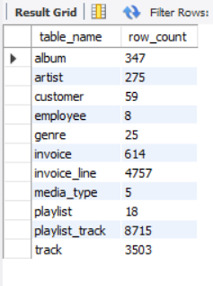

Brief Explanation:
Without predefined questions, the approach would follow a structured exploratory data analysis (EDA) framework starting with data understanding, moving through profiling, and ending with business-driven analysis.
Approach:
Phase 1: Data Understanding: Explore all 11 tables to understand schema, data types, relationships (primary/foreign keys), and row counts. Identify the core transactional flow: customer → invoice → invoice_line → track → album → artist/genre.
Phase 2: Data Quality Assessment: Check for missing values (NULLs), duplicates, and data integrity issues across all tables. Flag fields like composer (978 NULLs) and optional customer fields (company, fax, state).
Phase 3: Revenue Analysis: Start with the business's primary metric revenue. Analyze total revenue, revenue by country, by genre, by artist, and over time (monthly/yearly trends). Identify top performers and underperformers.
Phase 4: Customer Analysis: Profile the customer base by location, purchase frequency, average spend, and lifetime value. Segment customers into behavioral groups (high-value, at-risk, churned).
Phase 5: Product Analysis: Examine the product catalogue which genres, artists, and albums drive the most sales? Are there untapped genres with potential? Analyze product affinity (what gets purchased together).
Phase 6: Actionable Insights: Synthesize findings into business recommendations retention strategies for at-risk customers, marketing priorities for top genres, regional expansion opportunities, and pricing optimization.

Insights:
- A structured EDA approach ensures no important patterns are missed, compared to answering isolated questions.
- Starting with revenue and customer analysis first ensures the most business-critical insights are surfaced early.
- The Chinook schema naturally lends itself to four analytical pillars: Revenue, Customer, Product, and Geographic analysis.
- Without predefined questions, the analyst has more freedom to discover unexpected patterns (e.g., product affinity, seasonal trends) that structured questions might not cover.
Recommendations:
- Always begin with data profiling before any analysis understanding data quality and completeness prevents incorrect conclusions.
- Use a top-down approach: start with high-level KPIs (total revenue, total customers) and progressively drill down into segments and sub-segments.
- Document all assumptions and definitions (e.g., "churn = no purchase in 3 months") early to maintain consistency across analyses.
- Create reusable CTEs and views for frequently used metrics (customer lifetime value, monthly revenue) to enable efficient ad-hoc exploration.

Q10 How can you alter the "Albums" table to add a new column named "ReleaseYear" of type INTEGER to store the release year of each album?
Query:
-- Add ReleaseYear column
ALTER TABLE album ADD COLUMN ReleaseYear INTEGER;
-- Verify the column was added
SELECT * FROM album LIMIT 5;
-- Example: Update a specific album's release year
UPDATE album SET ReleaseYear = 1981 WHERE album_id = 1;
Output:
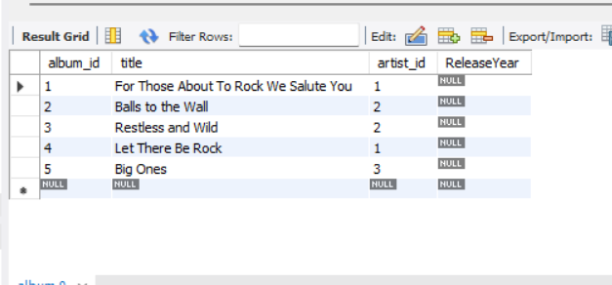

Brief Explanation:
The ALTER TABLE statement with ADD COLUMN is used to add a new column ReleaseYear of type INTEGER to the existing album table. The new column is added with NULL as the default value for all 347 existing rows. Once added, individual rows can be updated using UPDATE statements to populate the release year for each album.
Approach:
The ALTER TABLE ... ADD COLUMN DDL command modifies the table schema without affecting existing data. The INTEGER data type is chosen because release years are whole numbers (e.g., 1981, 2003). The column defaults to NULL since release year data is not currently available in the dataset. A sample UPDATE statement demonstrates how to populate the new column.
Insights:
- Adding a ReleaseYear column enables time-based product analysis such as identifying whether newer or older albums sell better.
- This schema change is non-destructive no existing data is modified or lost.
- With release year data populated, Chinook could analyze trends like "Do customers prefer music from specific decades?" or "Is there a correlation between album age and sales performance?"

Recommendations:
- Populate the ReleaseYear column using reliable music databases (e.g., MusicBrainz, Discogs) to enable decade-wise sales analysis.
- Add an index on ReleaseYear if frequent filtering by year is expected: CREATE INDEX idx_album_year ON album(ReleaseYear);
- Consider adding more metadata columns in the future (e.g., RecordLabel, Rating) to enrich the product catalogue for deeper analysis.

Q11 Chinook is interested in understanding the purchasing behavior of customers based on their geographical location. They want to know the average total amount spent by customers from each country, along with the number of customers and the average number of tracks purchased per customer. Write an SQL query to provide this information.
Query:
SELECT
c.country,
COUNT(DISTINCT c.customer_id) AS num_customers,
ROUND(AVG(customer_totals.total_spent), 2) AS avg_total_spent,
ROUND(AVG(customer_totals.tracks_purchased), 2) AS avg_tracks_per_customer
FROM customer c
JOIN (
SELECT
i.customer_id,
SUM(i.total) AS total_spent,
SUM(il_counts.track_count) AS tracks_purchased
FROM invoice i
JOIN (
SELECT invoice_id, SUM(quantity) AS track_count
FROM invoice_line
GROUP BY invoice_id
) il_counts ON i.invoice_id = il_counts.invoice_id
GROUP BY i.customer_id
) customer_totals ON c.customer_id = customer_totals.customer_id
GROUP BY c.country
ORDER BY avg_total_spent DESC;
Output:
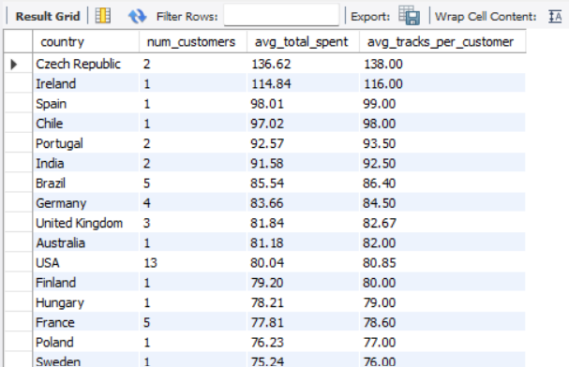

Visualisation:

Brief Explanation:
This analysis evaluates regional purchasing power by calculating the average total amount spent and the average number of tracks purchased per customer in each country. A subquery first aggregates the total tracks and total spend at the invoice level, which is then rolled up to the customer level. The outer query groups these customer-level totals by country to provide a clear picture of average customer value by geographic location.
Approach:
To accurately calculate the average tracks per customer, a double-nested subquery structure is used. The innermost query il_counts aggregates the quantity of tracks per invoice. The middle query customer_totals sums the invoice totals and track counts for each customer. Finally, the outer query joins these totals back to the customer table, grouping by country to compute the overall average spend and average track count per customer for each region, ordered by highest average spend.

Insights:
- Czech Republic leads in customer value: Despite having only 2 customers, they spend the most on average ($136.62) and purchase the highest volume of tracks (138 tracks/customer).
- European markets dominate average spend: Countries like Ireland, Spain, Portugal, and Germany show higher average spend per customer compared to the USA and Canada, suggesting a willingness to buy larger volumes per user in Europe.
- Volume correlates perfectly with spend: Because tracks are uniformly priced (mostly $0.99), the avg_total_spent and avg_tracks_per_customer mirror each other closely across all countries.
- USA has the largest base but lower average spend: The USA has the highest number of customers (13), but ranks 11th in average spend ($80.04), indicating a broad but lower-spending customer base compared to top European countries.

Recommendations:
- Target high-value European markets for premium bundles: Since customers in the Czech Republic, Ireland, and Spain already exhibit high average basket sizes, they are prime targets for premium album bundles or exclusive box sets.
- Drive volume in the USA: The USA has a large user base but lower average spend. Implement "buy more, save more" volume discounts (e.g., "Buy 10 tracks, get 1 free") to increase the average tracks purchased per user.
- Localize marketing in top emerging markets: India and Brazil show strong average spending ($91.58 and $85.54 respectively). Consider localized pricing or genre-specific campaigns (like Latin in Brazil) to acquire more customers in these high-value regions.

