Project Sprint #1

The Solitaire game is described in CS449HomeworkOverview. You should read the description very carefully.

In this assignment, you aim to specify the requirements (i.e., user stories and acceptance criteria) of the target software that allows a human player to play a Solitaire game. These requirements will be fully implemented by the end of sprint 3. The minimum features include choosing the board size and type, starting a new game, making a move, determining if a game is over. The following is a sample GUI layout.

Board size
7
Board Type  - English  - Hexagon  - Diamond | 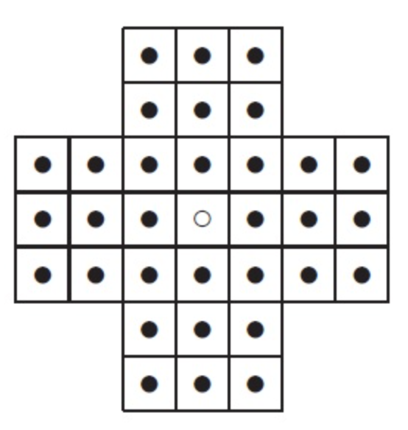 | New Game
Figure 1. Sample GUI layout of the first working program by the end of Sprint 3

Use the following tables to document your user stories and acceptance criteria.

You are required to use the free ChatGPT or another LLM to complete two user stories and two of their respective acceptance criteria. You must ensure that the generated user stories are correct and fix them if not. At the end of the submission, provide screenshots of your LLM prompts and answers, along with the description of errors the LLM made that you had to correct. Points will be deducted if no screenshots/description are provided.

For the other user stories and acceptance criteria, you are not required to use LLM.

- User Stories (3 points)

- User Story Template: As a <role>, I want <goal> [so that <benefit>]

ID | User Story Name | User Story Description | Priority | Estimated effort (hours)
1 | Choose a board size | As a user, I want to choose a board size so that I can change the difficulty of the game. | 3 | 1/2
2 | Choose the board type | As a user, I want to choose the board type so that I can change the difficulty of the game. | 3 | 1/2
3 | Start a new game of the chosen board size and type | As a user, I want to create a board with my chosen board type and size so that I can start the game. | 3 | 1
4 | Make a move in a game | As a user, I want to make a move (“hop a tile”) so that I can eventually win the game. | 1 | 3
5 | A game is over | As a user, I want to know when the game ends so that I can know if I’ve won or not. | 2 | 1 1/2
6 | Start a Time Trial | As a user, I want to time my solving of the game so that I can race against myself. | 5 | 2
7 | Quit the game | As a user, I want to quit an ongoing game so that I can stop playing when I choose to. | 3 | 1
8 | Undo a move | As a player, I want to undo my last move so that I can correct a mistake. | 3 | 4
9 | Get a hint | As a player, I want to request a hint so that I can find a possible next move when I am stuck. | 4 | 3
10 | View available moves | As a player, I want the game to show me which moves are possible so that I know which actions to take. | 2 | 2

- Acceptance Criteria (AC) (12 points): Add/delete rows as needed.

User Story ID and Name | AC  ID | Description of Acceptance Criterion | Status (completed, toDo, inPprogress)
1. Choose a board size | 1.1 | AC 1.1 Display board size options  Given: a new game is started  When: the user chooses to select a board size  Then: the available board size options are displayed | toDo
1. Choose a board size | 1.2 | AC 1.2 Select board size  Given: available board size options are displayed  When: the user selects a board size  Then: the selected board size is applied to a new game | toDo
1. Choose a board size | 1.3 | AC 1.3 Default board size  Given: user has not selected a board size  When: a new game is started  Then: the game uses its default board size | toDo
2. Choose the board type | 2.1 | AC 2.1 Display board type options  Given: a new game is started  When: the user chooses to select a board type  Then: the available board type options are displayed | toDo
2. Choose the board type | 2.2 | AC 2.2 Select board type  Given: available board type options are displayed  When: the user selects a board type  Then: the selected board type is applied to a new game | toDo
 | 2.3 | AC 2.3 Default board type  Given: user has not selected a board type  When: a new game is started  Then: the game uses its default board type | toDo
3. Start a new game of the chosen board size and type | 3.1 | AC 3.1 Start new game  Given: the user has selected a board size and type  When: the user starts a new game  Then: a new game is created with the chosen board size and type | toDo
 | 3.2 | AC 3.2 Reset game state  Given: the user has selected a board size and type  When: the user starts a new game  Then: all board-relevant scores and info are reset to default | toDo
4. Make a move in a game | 4.1 | AC 4.1 Valid move  Given: an active game  When: the user selects a valid puck and a valid end location  Then: the puck applies to move | toDo
 | 4.2 | AC 4.2 Invalid move  Given: an active game  When: the user selects an invalid move  Then: the move is rejected | toDo
 | 4.3 | AC 4.3 Applying moving a puck  Given: the user confirms a valid move  When: the move is completed  Then: the puck is moved to the selected location | toDo
5. A game is over | 5.1 | AC 5.1 Detect a win  Given: the user has completed the game  When: the final required move is made  Then: the game identifies that the user has won | toDo
 | 5.2 | AC 5.2 Detect a non-win  Given: the user has not completed the game  When: The game identifies the game has ended  And the user has not won the game  Then: the game identifies that the user has lost | toDo
 | 5.3 | AC 5.3 Display post-game  Given: the game has ended  When: the game identifies the game has ended  Then: the post-game display message and information is displayed | toDo
 | 5.4 | AC 5.4 Lock the board state  Given: the game has ended  When: the user attempts to make a move  Then: the board does not change (lock the board state) | toDo
6. Start a time trial | 6.1 | AC 6.1 Display game time  Given: the user has started a new game  When: the user confirms a valid move for the first time in the game  Then: the timer starts | toDo
 | 6.2 | AC 6.2 User pauses game  Given: the timer has started  When: the user hits the “pause” button  Then: the timer pauses | toDo
 | 6.3 | AC 6.3 Game window is minimized, pause timer  Given: the timer has started  When: the game window is minimized  Then: the timer pauses | toDo
 | 6.4 | AC 6.4 Game ends, pause timer  Given: the timer has started  When: the game identifies that the user has won  Then: the timer pauses | toDo
7. Quit the game | 7.1 | AC 7.1 User quits game  Given: an active game  When: the user hits the “quit” button  Then: the game ends (U.S. 5, “A game is over”) | toDo
 | 7.2 | AC 7.2 User closes game window  Given: an active game  When: the user closes the game window  Then: the game ends | toDo
8. Undo a move | 8.1 | AC 8.1 Undo available after a move  Given: the player has made at least one move  When: the player selects “Undo”  Then: the most recent move is reversed and the board returns to its previous state | toDo
 | 8.2 | AC 8.2 Restore game state  Given: the player has made a move  When: the player selects “Undo”  Then: the score and move count return to their values before the move | toDo
 | 8.3 | AC 8.3 Undo multiple moves  Given: the player has made multiple moves  When: the player selects “Undo” repeatedly  Then: each selection reverses the most recent remaining move | toDo
 | 8.4 | AC 8.4 No moves to undo  Given: the player has not made any moves that can be undone  When: the player views the game controls  Then: the “Undo” option is unavailable | toDo
9. Get a hint | 9.1 | AC 9.1 Request a hint  Given: the player is in an active game  When: the player selects “Hint”  Then: the game highlights one possible valid move | toDo
 | 9.2 | AC 9.1 Hint does not make move  Given: the game has provided a hint  When: the player views the suggested move  Then: the game does not automatically perform the move | toDo
 | 9.3 | AC 9.3 No available hint  Given: there are no valid moves available  When: the player selects “Hint”  Then: the game informs the player that there are no moves to suggest | toDo
 | 9.4 | AC 9.4 Hint does not change game  Given: the player has requested a hint  When: the hint is displayed  Then: the board state and score remain unchanged | toDo
10. View available moves | 10.1 | AC 10.1 Display available moves  Given: the player is in an active game  When: the player selects “View Available Moves”  Then: the game identifies all currently valid moves | toDo
 | 10.2 | AC 10.2 Identify move details  Given: there are valid moves available  When: the available moves are displayed  Then: each move indicates what piece can be moved and where it can be moved | toDo
 | 10.3 | AC 10.3 Update available moves  Given: the player has changed the board state  When: the player selects “View Available Moves”  Then: the game displays the moves that are valid for the updated board | toDo
 | 10.4 | AC 10.4 No available moves  Given: there are no valid moves remaining  When: the player selects “View Available Moves”  Then: the game informs the player that no moves are available | toDo
 | 10.5 | AC 10.5 Viewing moves does not change game  Given: the player is viewing available moves  When: the moves are displayed  Then: the board state and score remain unchanged | toDo

AI USAGE (ChatGPT, generated 3 user stories and acceptance criteria):

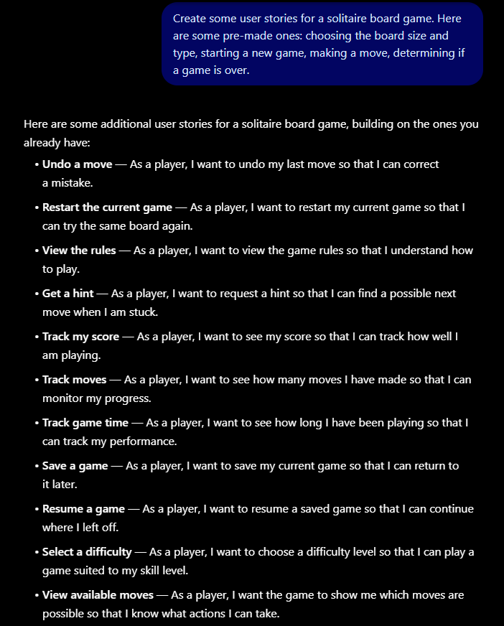

There were no errors here (no possible errors, anyway), so I moved forward with three of them.

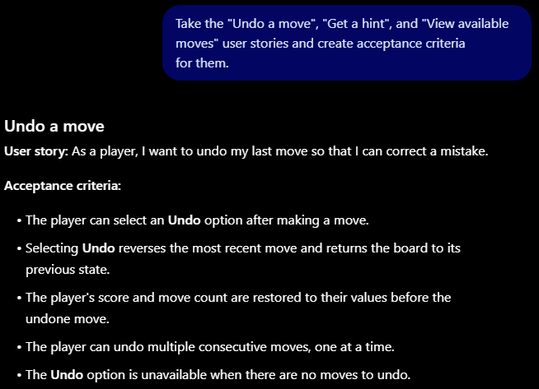
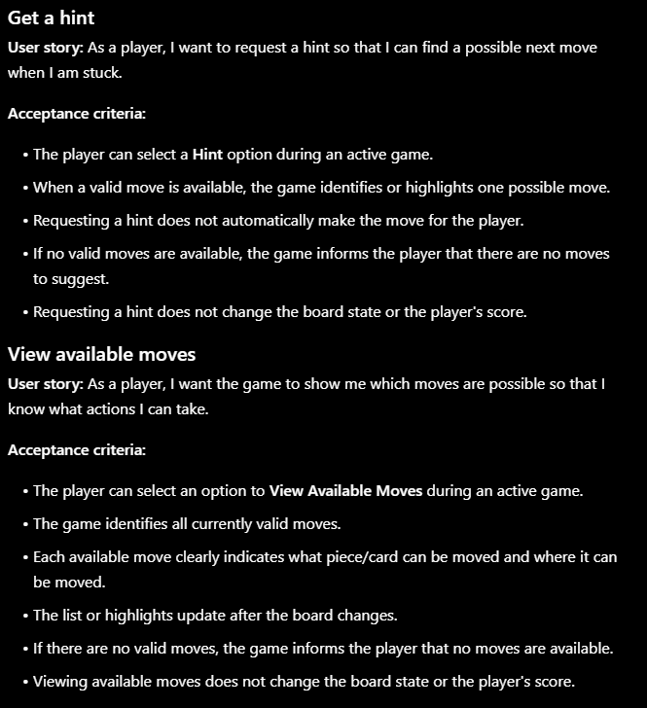

Here, I told the LLM to convert the AC into the Given, When, Then format.
