CPTS 489 Web Application Development
Final Project Report
Home Food Marketplace

Team Members: Yaru Gao
Semester: Spring 2026
Date: 2026-04-20

1. Introduction and Project Overview
Home Food Marketplace is a community-focused web application that connects local home cooks with nearby customers who want affordable home-cooked meals. The system supports two active roles: customers and merchants (cooks). Customers can register, log in, browse restaurants, filter by tags, manage cart and checkout, and track order status. Merchants can create and manage restaurants, assign cuisine tags, maintain menu inventory, and handle incoming orders through a dashboard. The application is built with Express, Sequelize, EJS, and MySQL, with session-based authentication and role-based access control for protected routes.

2. Implementation Documentation (Required)

2.1 Section 1: MVC Implementation Walkthrough
This section covers all use cases through an MVC walkthrough, showing how each one is implemented across routes, controllers, models, and views.

Use Case 1 (UC-G01): User Login

1. The Route
Files: HFM/routes/auth.js
When a user opens /login, the server returns the login form view so credentials can be entered. After the form is submitted, a POST request is sent to /login where the route validates required fields and forwards the request to authentication logic. If credentials are valid, the route initializes session state (userId and role) and redirects the user to the role-appropriate dashboard; otherwise, it re-renders the login page with an error message.

2. The Controller
File: HFM/routes/auth.js | Function: router.post('/login')
The controller is responsible for all business logic. It executes the following steps:
- Reads email and password from req.body and validates both fields are present.
- Calls User.findUser(email, password) to fetch the account and verify bcrypt password.
- If authentication fails, re-renders login with an invalid-credentials error.
- If authentication succeeds, writes userId and role into session state.
- Redirects cook users to /merchant-dashboard and customer users to /customer-dashboard.

3. The Models
This use case reads from and writes to the following model(s):
Model | Operation | What Happens
User | Read | Looks up the account by email and verifies hashed password.

4. The Views
This use case involves the following view(s):

View -- Login Form (file: HFM/views/login.ejs)
This is the page where the user enters email and password. Submitting this form triggers POST /login and starts authentication for UC-G01. The form includes fields for email, password, and visual indication of login status.
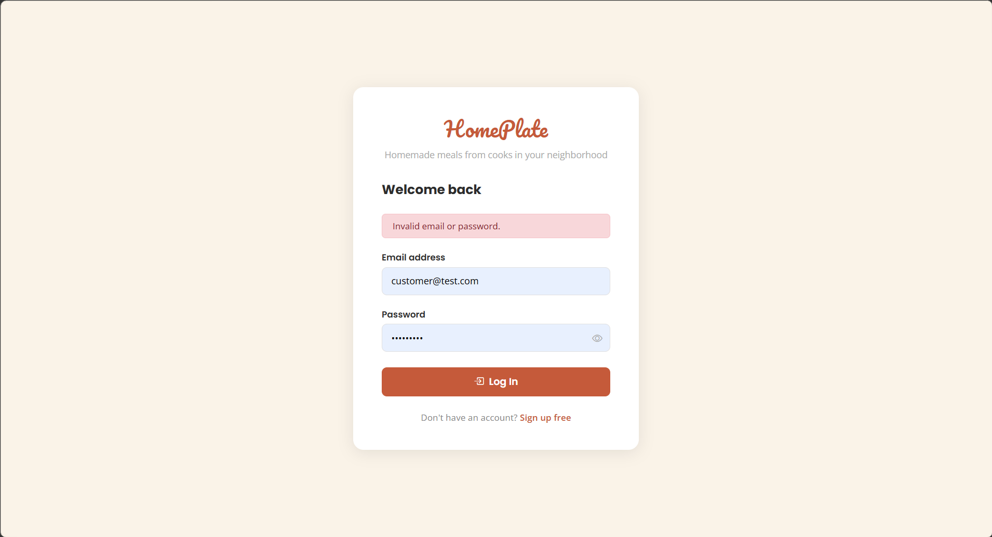

View -- Customer Dashboard After Login (file: HFM/views/customer-dashboard.ejs)
When a customer logs in, they are redirected to their role-specific dashboard. This view confirms login success, displays role-specific navigation, and provides entry points to browse, cart, and order history features.
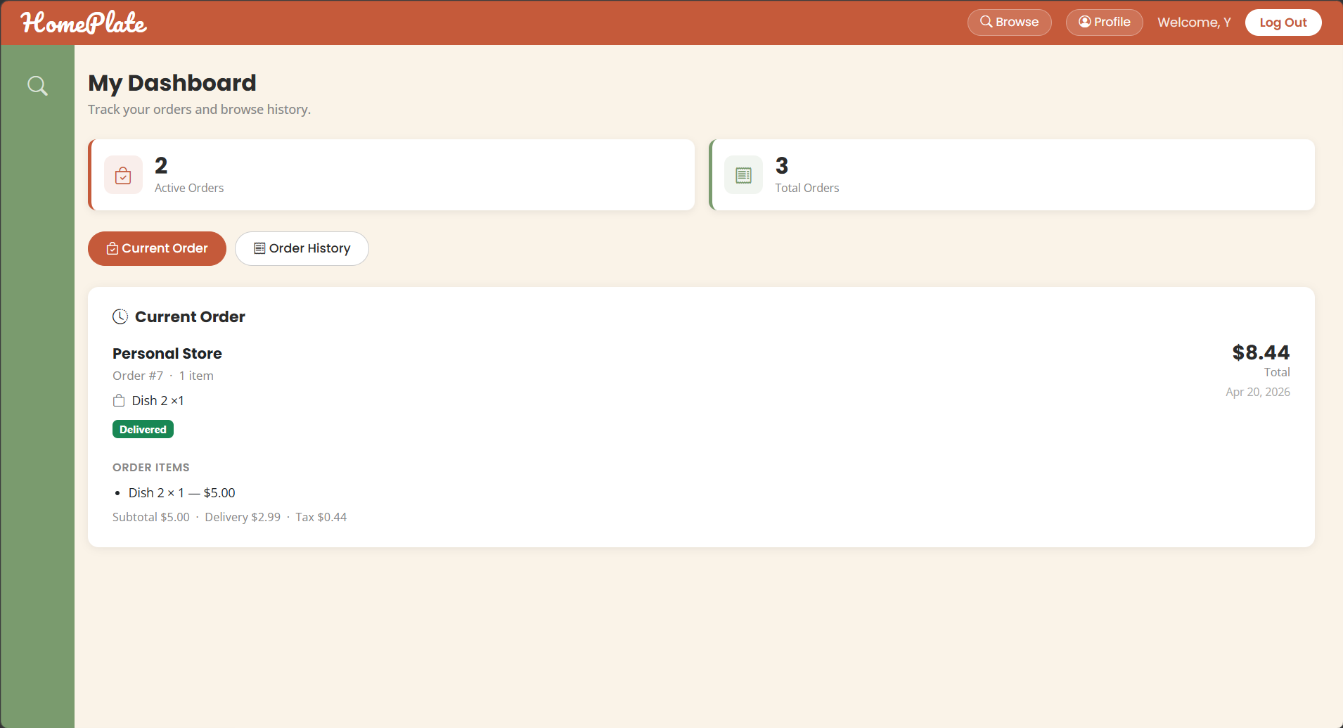

View -- Merchant Dashboard After Login (file: HFM/views/merchant-dashboard.ejs)
When a merchant (cook) logs in, they are redirected to the merchant dashboard. This view displays restaurant selection interface and provides access to menu management, order fulfillment, and reporting features.
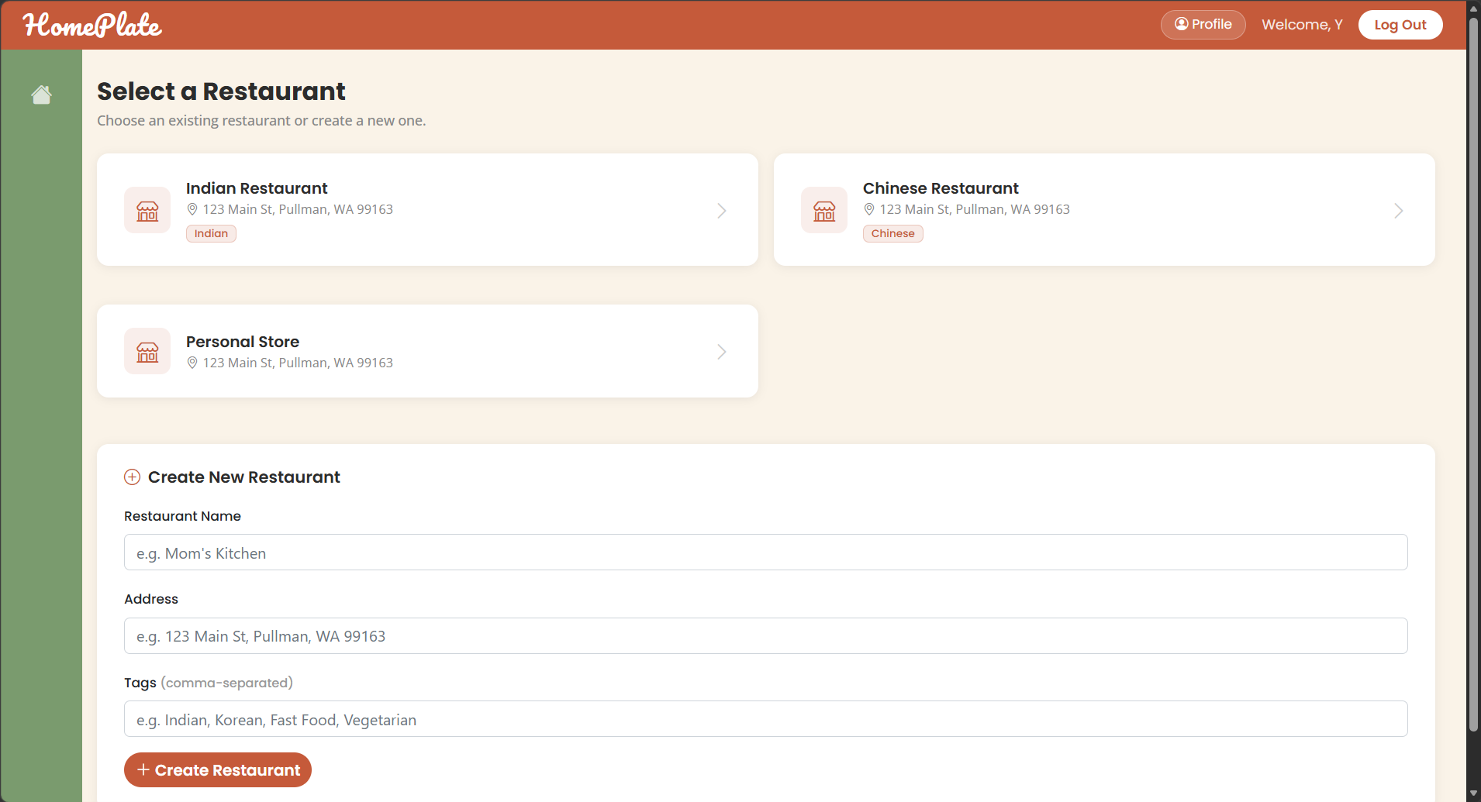

Use Case 2 (UC-G02): User Registration (Sign Up)

1. The Route
Files: HFM/routes/auth.js
The registration flow starts at GET /register, which serves the sign-up form for new users. Submitting the form sends POST /register with identity, credential, and role inputs. The route performs validation (required fields, password rules, confirmation match), selects the correct model for the chosen role, and creates the account. On success, the user is redirected to /login; on failure, the same register view is returned with a clear validation or duplicate-email message.

2. The Controller
File: HFM/routes/auth.js | Function: router.post('/register')
The controller is responsible for all business logic. It executes the following steps:
- Reads registration payload (name, email, password, confirmPassword, role) from req.body.
- Validates required fields, minimum password length, and password confirmation match.
- Normalizes role so only 'customer' or 'cook' is accepted (fallback to customer).
- Selects Merchant or Customer model based on role and creates the account record.
- Handles duplicate-email constraint errors and returns a user-facing registration message.
- On success, redirects to /login for first authentication.

3. The Models
This use case reads from and writes to the following model(s):
Model | Operation | What Happens
Customer | Create | Creates a customer record with role and hashed password when role=customer.
Merchant | Create | Creates a merchant record with role and hashed password when role=cook.

4. The Views
This use case involves the following view(s):

View -- Registration Form (file: HFM/views/register.ejs)
This page captures user identity (first name, last name, email), password (with confirmation), and role selection. The page displays role selection options (Customer or Cook/Merchant) allowing users to define their account type before creation. Submitting the form triggers POST /register and account creation for UC-G02.
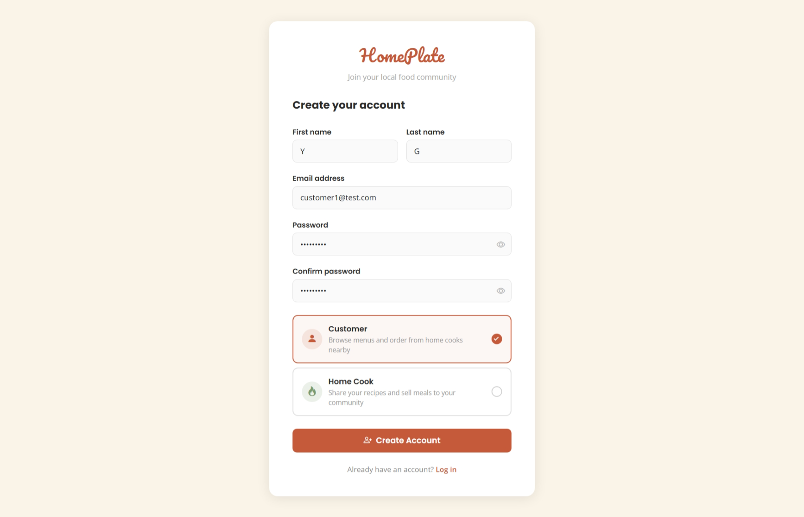

View -- Login Page After Registration Redirect (file: HFM/views/login.ejs)
After successful registration, the user is redirected to the login page to authenticate with their newly created credentials. This view confirms account creation was successful and transitions to the UC-G01 authentication flow. The page may display a success message or transition context if applicable.
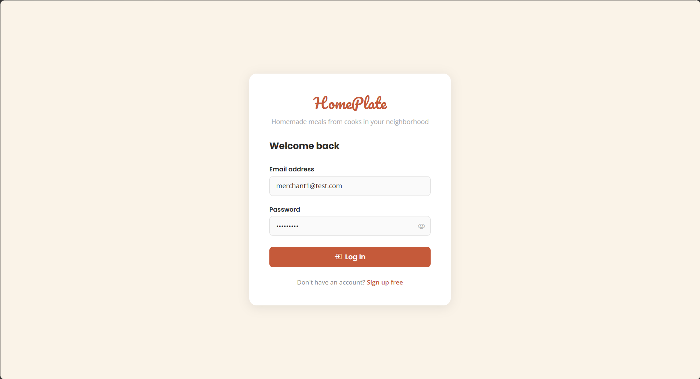

Use Case 3 (UC-C01): Browse and Search Food Listings

1. The Route
Files: HFM/routes/browse.js, HFM/routes/restaurant-detail.js
Customers enter this flow through GET /browse, which reads optional query parameters (keyword and tag) and prepares a filtered restaurant list for rendering. The route also builds supporting browse metadata such as available tags and card-level display fields. When a restaurant is selected, the browser navigates to GET /restaurant-detail?id=<id>, where the server loads the restaurant profile, owner context, and available menu items grouped by category before returning the detail page.

2. The Controller
File: HFM/routes/browse.js, HFM/routes/restaurant-detail.js | Function: router.get('/browse'), router.get('/restaurant-detail')
The controller is responsible for all business logic. It executes the following steps:
- Loads optional session user context for personalized navigation state.
- Builds browse query conditions from q and loads restaurants in reverse creation order.
- Extracts and normalizes all available tags from restaurant records for filter UI.
- Applies tag filter to the result set when tag parameter is provided.
- For each listed restaurant, computes menu count and owner name for card rendering.
- On detail route, loads selected restaurant, owner profile, and available menu items.
- Groups menu items by category and computes cart badge count for the active customer session.

3. The Models
This use case reads from and writes to the following model(s):
Model | Operation | What Happens
Restaurant | Read | Returns restaurant list and detail record for browse and selection.
MenuItem | Read | Counts/lists available items for cards and detail categories.
User | Read | Resolves owner name and current session user context.
Merchant | Read | Loads merchant-specific profile fields for detail page owner block.

4. The Views
This use case involves the following view(s):

View -- Browse Restaurants Page (file: HFM/views/browse.ejs)
This page shows searchable restaurant cards with tag filters. Customers can enter search keywords or select available tags to filter results. Each restaurant card displays name, address, tags, and a thumbnail. Clicking a card navigates to the restaurant detail page. This is the entry action for UC-C01.
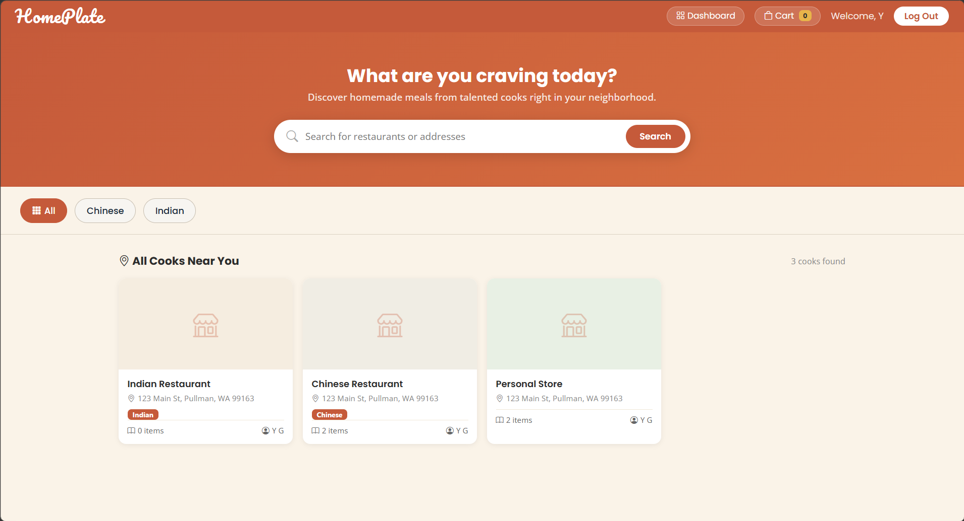

View -- Restaurant Detail with Menu Categories (file: HFM/views/restaurant-detail.ejs)
After selecting a restaurant, the detail page displays the restaurant name, address, owner information, and menu items grouped by category. Each category shows relevant menu items with name, price, description, and "Add to Cart" button. This is the completion view for discovering a specific listing.
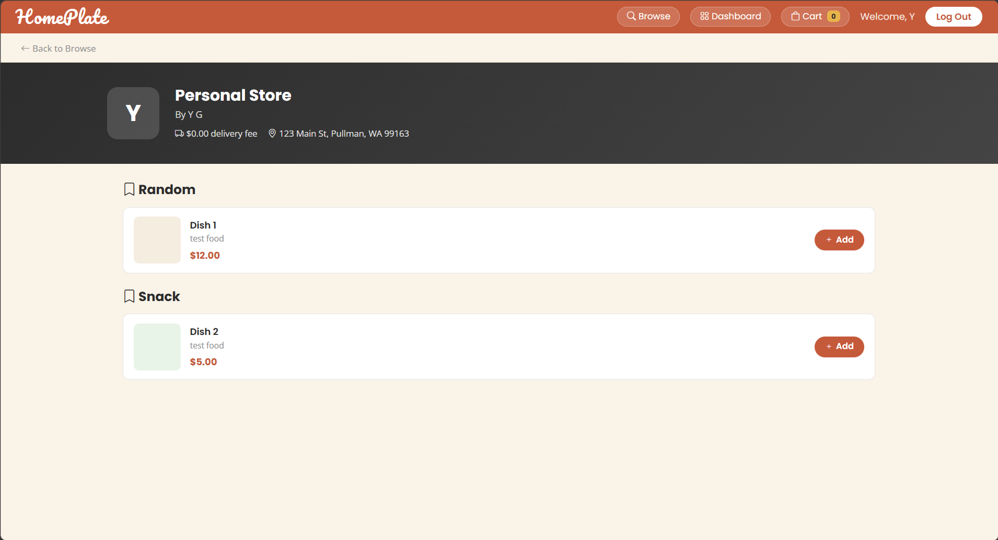

Use Case 4 (UC-C02): Manage Cart

1. The Route
Files: HFM/routes/cart.js
Cart management combines one page route and multiple mutation endpoints. GET /cart loads all pending order groups for the logged-in customer and renders item-level totals. POST /cart/add handles add-to-cart actions by creating or reusing a pending order and then inserting or incrementing the corresponding line item. PUT /cart/item/:id updates quantities, and DELETE /cart/item/:id removes lines. After each mutation, totals are recalculated so the cart always reflects current subtotal, tax, delivery fee, and total.

2. The Controller
File: HFM/routes/cart.js | Function: router.post('/cart/add'), router.put('/cart/item/:id'), router.delete('/cart/item/:id')
The controller is responsible for all business logic. It executes the following steps:
- Enforces login for all cart mutation endpoints via requireLogin middleware.
- On add-item, validates menuItemId/restaurantId, loads menu item and restaurant, then finds or creates a pending order scoped by customer and restaurant.
- Finds existing order line by orderId+menuItemId and either increments quantity or creates a new OrderItem snapshot.
- Recalculates subtotal, tax, delivery fee, and total after each cart mutation via recalcOrder().
- On quantity update, removes the line (and possibly the empty order) when quantity <= 0; otherwise saves the new quantity.
- On delete, removes the line item, deletes empty pending orders, and returns updated cart counters.

3. The Models
This use case reads from and writes to the following model(s):
Model | Operation | What Happens
Order | Read/Create/Update/Delete | Maintains pending cart container and recalculated totals.
OrderItem | Read/Create/Update/Delete | Stores per-item quantities and removes items as needed.
MenuItem | Read | Validates item existence while adding to cart.
Restaurant | Read | Resolves restaurant ownership when creating pending order.

4. The Views
This use case involves the following view(s):

View -- Restaurant Detail with Add-to-Cart (file: HFM/views/restaurant-detail.ejs)
Customers add items to cart from the restaurant detail page by selecting items and clicking "Add to Cart". This initiates cart creation or quantity increment behavior in UC-C02. The page displays a cart badge showing current item count.
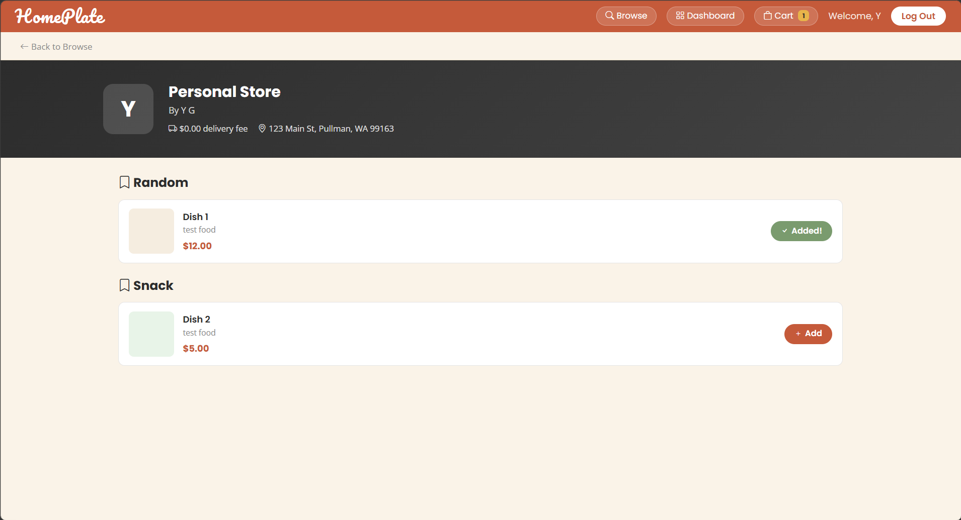

View -- Cart Management Page (file: HFM/views/cart.ejs)
This page shows pending orders grouped by restaurant. For each restaurant group, customers can view items with quantity controls (+/- buttons), remove individual items, and see recalculated totals (subtotal, tax, delivery fee, total). It is the primary management view for UC-C02 with navigation to checkout.
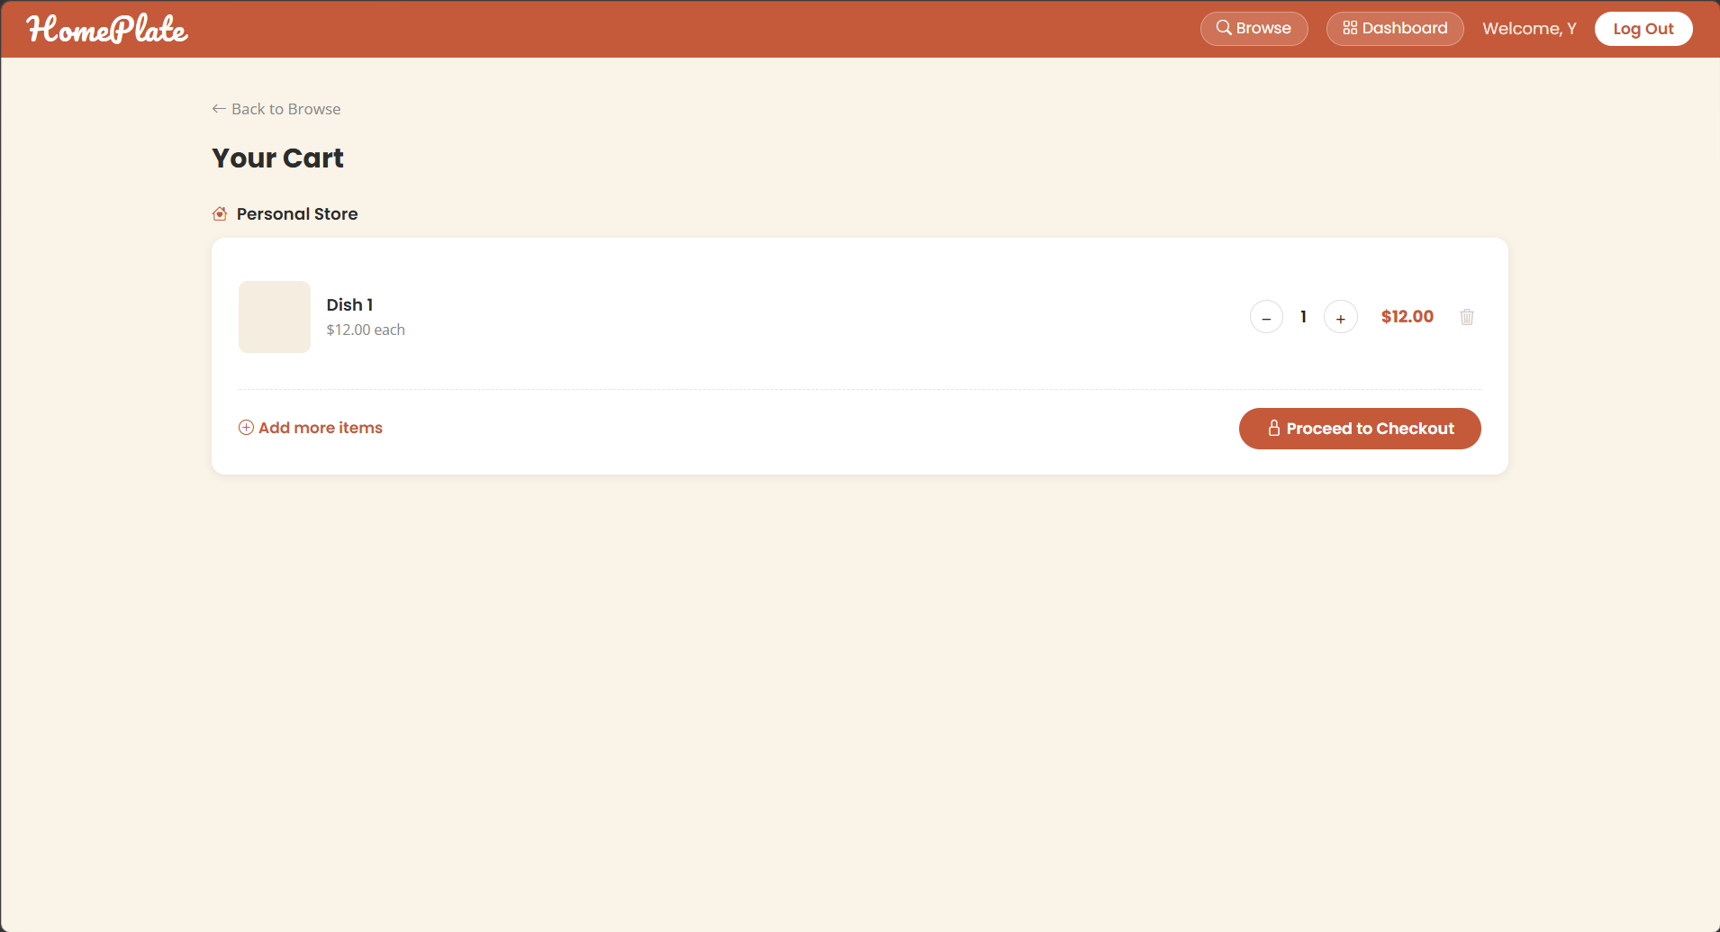

Use Case 5 (UC-C03): Checkout and Place Order

1. The Route
Files: HFM/routes/checkout.js
The checkout page is served by GET /checkout, which resolves the target pending order (either by explicit orderId or latest pending order), loads items, and renders the checkout form. When the customer places the order, POST /checkout validates session ownership and required routing inputs, then executes the placement logic in a transaction. The route verifies stock, writes delivery/fulfillment values, changes order status from pending to placed, and finally redirects to /order-confirmation with the new order id.

2. The Controller
File: HFM/routes/checkout.js | Function: router.get('/checkout'), router.post('/checkout')
The controller is responsible for all business logic. It executes the following steps:
- GET handler validates session and resolves the target pending order by explicit orderId or latest pending order.
- Loads restaurant and order items for page rendering, and redirects back to cart when order is missing or empty.
- POST handler validates session, orderId, and normalized delivery state input.
- Opens a database transaction and lock-checks the pending order ownership (customerId + status=pending).
- Loads order items with lock, verifies non-empty cart, and validates each menu item still exists with sufficient stock.
- Deducts inventory quantities, updates availability flags, and saves each menu item within the same transaction.
- Persists delivery and fulfillment fields to the order, then updates status from pending to placed.
- After commit, schedules simulated auto-delivery and redirects to order confirmation page.

3. The Models
This use case reads from and writes to the following model(s):
Model | Operation | What Happens
Order | Read/Update | Stores delivery details and updates status from pending to placed.
OrderItem | Read | Provides purchased item rows for stock checks and confirmation display.
MenuItem | Read/Update | Validates stock and decrements quantity/availability.
Restaurant | Read | Supplies restaurant context for checkout and confirmation page.
User | Read | Supplies customer context for page rendering.

4. The Views
This use case involves the following view(s):

View -- Checkout Form (file: HFM/views/checkout.ejs)
This page displays the order summary (grouped items with quantities and prices), subtotal/tax/delivery fee/total, and delivery information form fields (street, city, state, zip, fulfillment method selector). The user reviews the order and enters delivery details before submitting. Submitting the form triggers POST /checkout action for UC-C03.

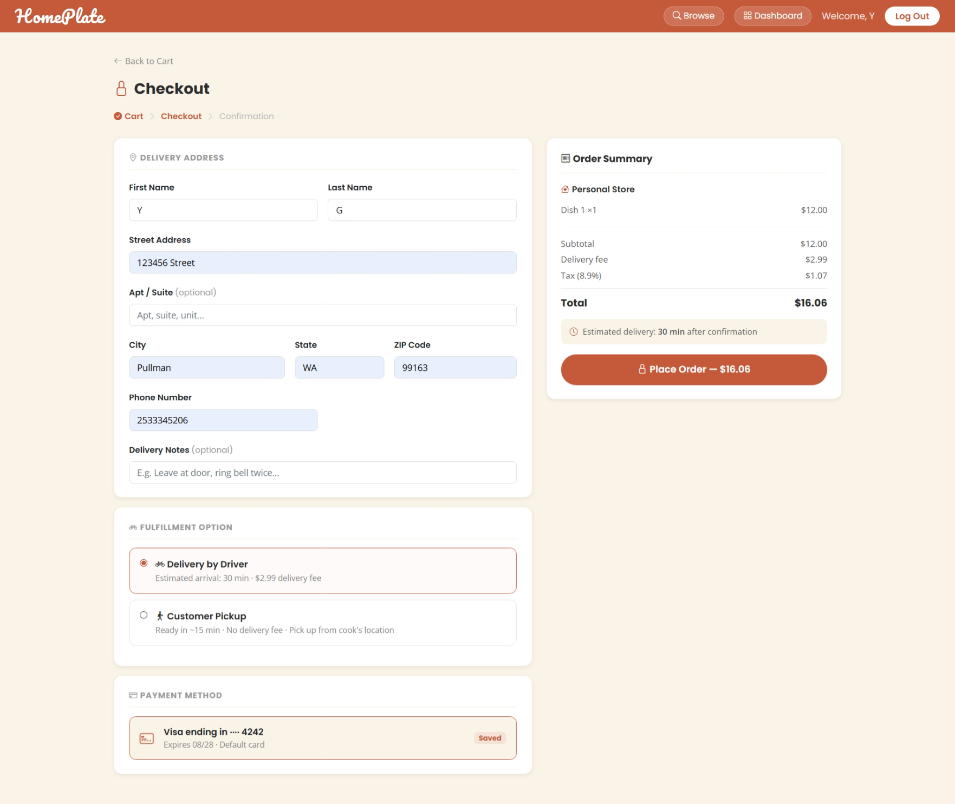

View -- Order Confirmation Page (file: HFM/views/order-confirmation.ejs)
After successful checkout, this confirmation page renders the newly created order with its ID, complete line items with quantities and prices, restaurant name, delivery address, and calculated totals (subtotal, tax, delivery fee, total). This is the final user-facing success view of UC-C03.
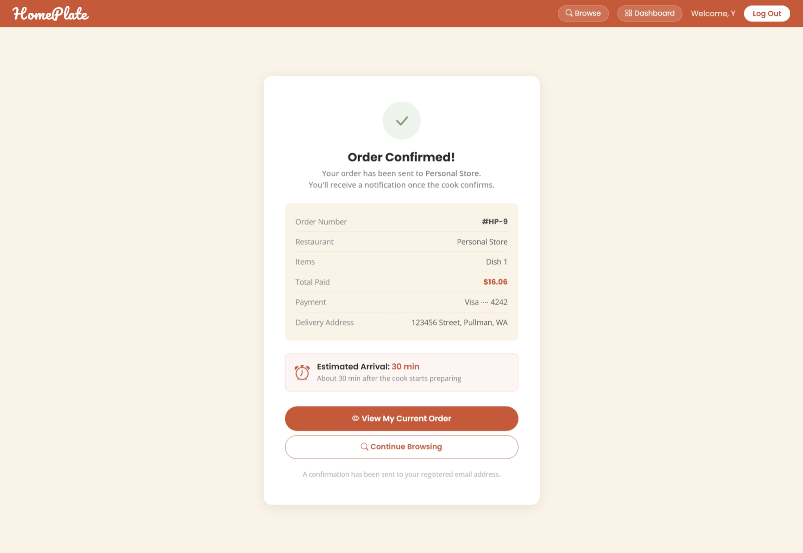

Use Case 6 (UC-C04): View Order History

1. The Route
Files: HFM/routes/customer.js
This use case is routed through customer-only endpoints protected by role checks. GET /customer-dashboard renders the dashboard shell and summary counts. GET /customer-current-order fetches and renders the most recent active (non-pending) order fragment, while GET /customer-order-history-data returns the historical order list fragment with item and restaurant context. Together, these routes provide both current-status visibility and full historical review for customer orders.

2. The Controller
File: HFM/routes/customer.js | Function: router.get('/customer-dashboard'), router.get('/customer-current-order'), router.get('/customer-order-history-data')
The controller is responsible for all business logic. It executes the following steps:
- Applies requireCustomer middleware to enforce authenticated customer-role access.
- Dashboard handler counts active orders (placed/confirmed/ready) and total historical orders (status != pending).
- Current-order handler fetches the latest non-pending order for the customer.
- Loads line items and restaurant context for that current order when present.
- History handler fetches all non-pending orders in descending creation order.
- For each historical order, attaches order items and restaurant details before rendering the fragment view.

3. The Models
This use case reads from and writes to the following model(s):
Model | Operation | What Happens
Order | Read | Retrieves active and historical customer orders by status.
OrderItem | Read | Retrieves line-item detail for each historical order.
Restaurant | Read | Attaches restaurant identity to each order card.
User | Read | Provides customer identity and dashboard context.

4. The Views
This use case involves the following view(s):

View -- Customer Dashboard Hub (file: HFM/views/customer-dashboard.ejs)
The dashboard hosts tabs for current order status and order history. This is the entry point where the customer chooses which order-related view to access. The dashboard displays stat cards showing counts of active orders and total completed orders.
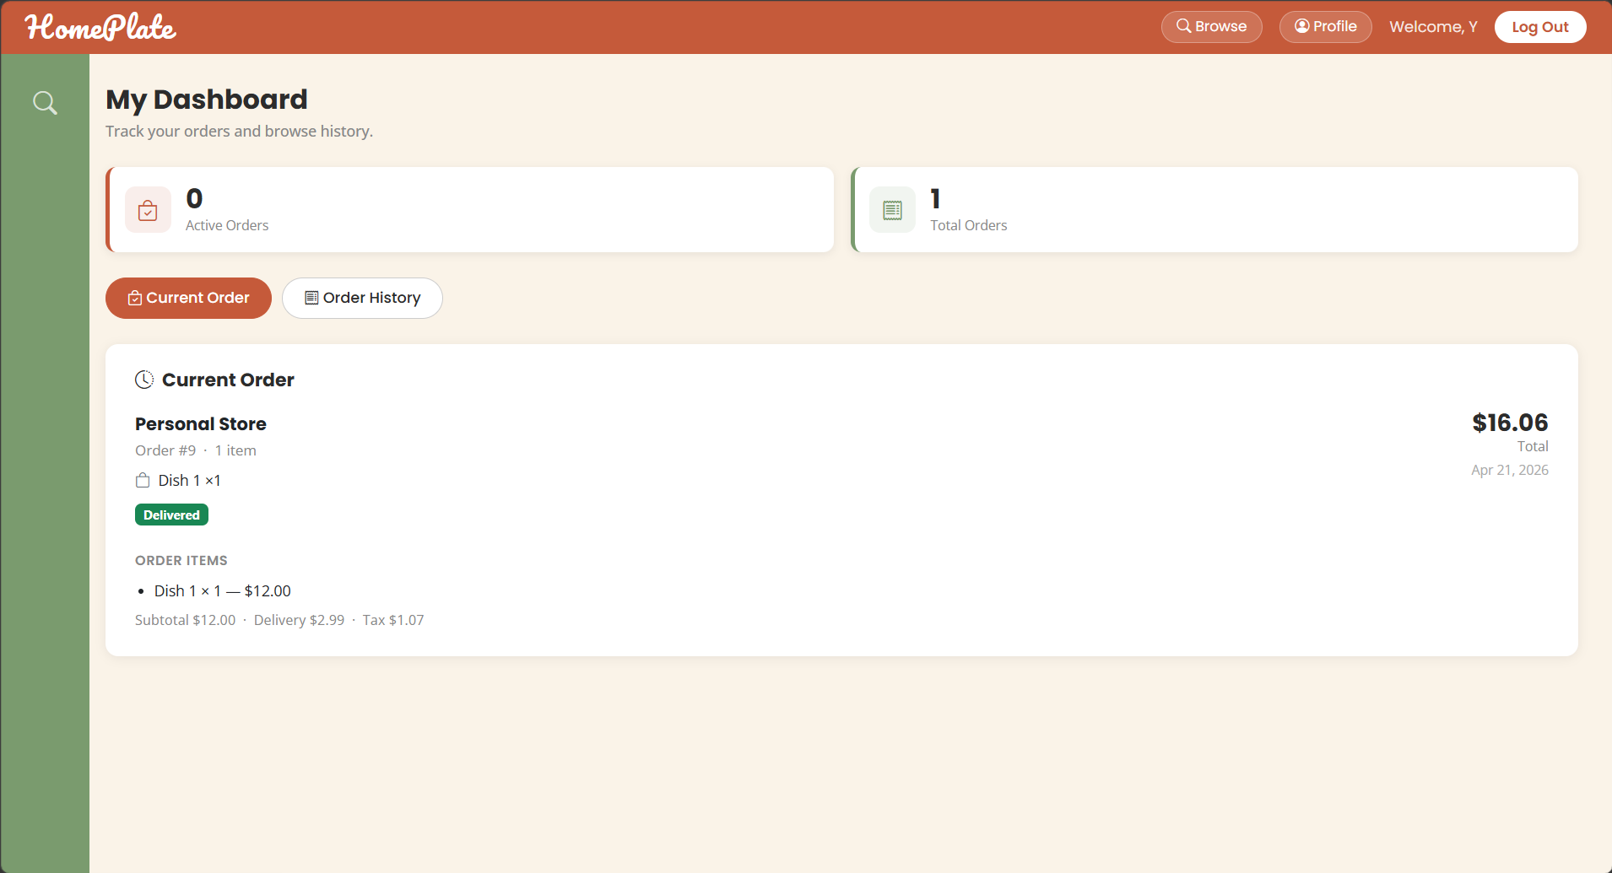

View -- Current Order Status View (file: HFM/views/customer-order-status.ejs)
This view displays the most recent non-pending order (current active order) with its status, restaurant name, order items, and timeline. It provides real-time visibility into the current order being prepared and delivered.


View -- Order History Detail List (file: HFM/views/customer-order-history.ejs)
The history fragment renders all non-pending (completed/historical) orders in reverse chronological order. Each order card displays order ID, restaurant name, order date, status, and totals. Cards are expandable to show line-item details. This is the main historical review view for UC-C04.
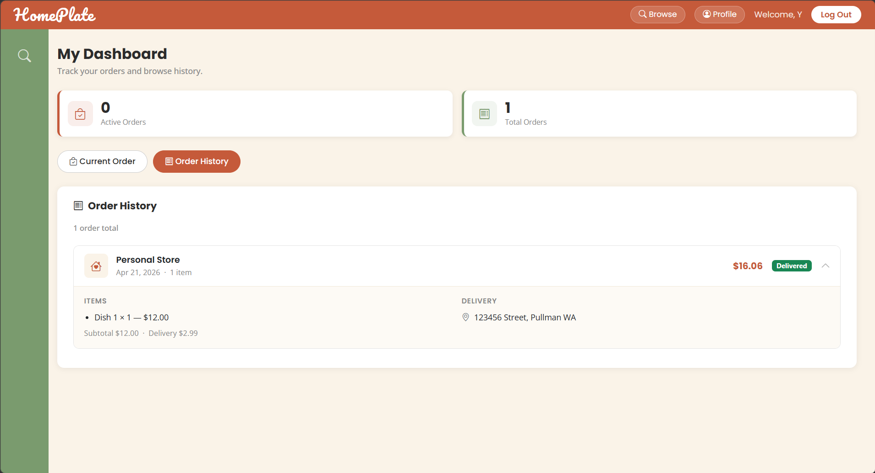

Use Case 7 (UC-C05): Edit User Information

1. The Route
Files: HFM/routes/profile.js
Profile editing starts at GET /profile, which requires authentication and returns the current profile dataset for display/edit mode. Two update routes handle persistence: PUT /profile/personal for identity/contact fields and PUT /profile/address for default address fields. Each update route sanitizes input, applies field-level validation rules, writes changes to the user record, and returns a normalized JSON payload so the front-end can refresh profile state without reloading the full page.

2. The Controller
File: HFM/routes/profile.js | Function: router.get('/profile'), router.put('/profile/personal'), router.put('/profile/address')
The controller is responsible for all business logic. It executes the following steps:
- Validates active session with requireLogin and loads current user profile by session userId.
- Transforms user entity to a stable profile DTO for view/API output.
- Personal-update handler sanitizes first/last name, phone, and date fields with cleanString().
- Enforces required firstName and lastName before committing personal updates.
- Address-update handler sanitizes address fields, normalizes state to uppercase, and persists updates.
- Returns JSON success payloads with normalized profile data for client-side UI refresh.

3. The Models
This use case reads from and writes to the following model(s):
Model | Operation | What Happens
User | Read/Update | Reads current profile and persists personal/address edits.

4. The Views
This use case involves the following view(s):

View -- Profile Information Display (file: HFM/views/profile.ejs)
This state displays current personal information (first name, last name, email, phone, date of birth) and default address in read-only cards. It is the starting point before entering edit mode in UC-C05. Each section has an "Edit" button to toggle into edit mode.
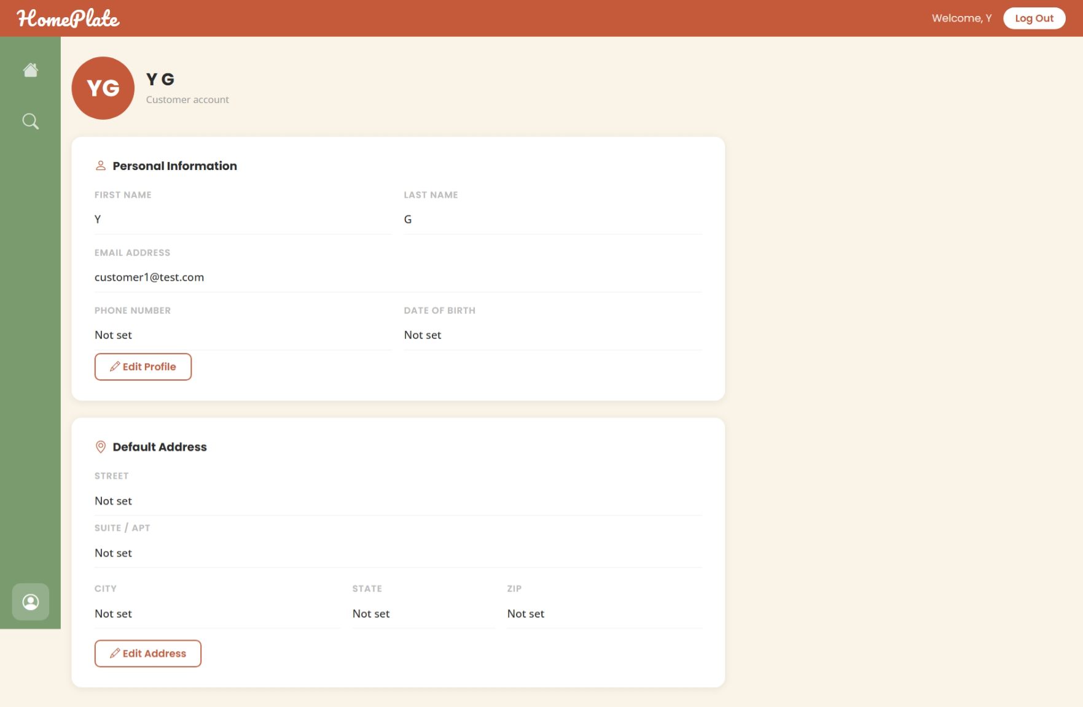

View -- Profile Edit Mode (file: HFM/views/profile.ejs)
When edit mode is enabled by clicking Edit, the same page reveals editable fields and save/cancel actions for both personal and address sections. Submitting updates calls profile PUT endpoints (/profile/personal or /profile/address) and refreshes displayed values after successful update.
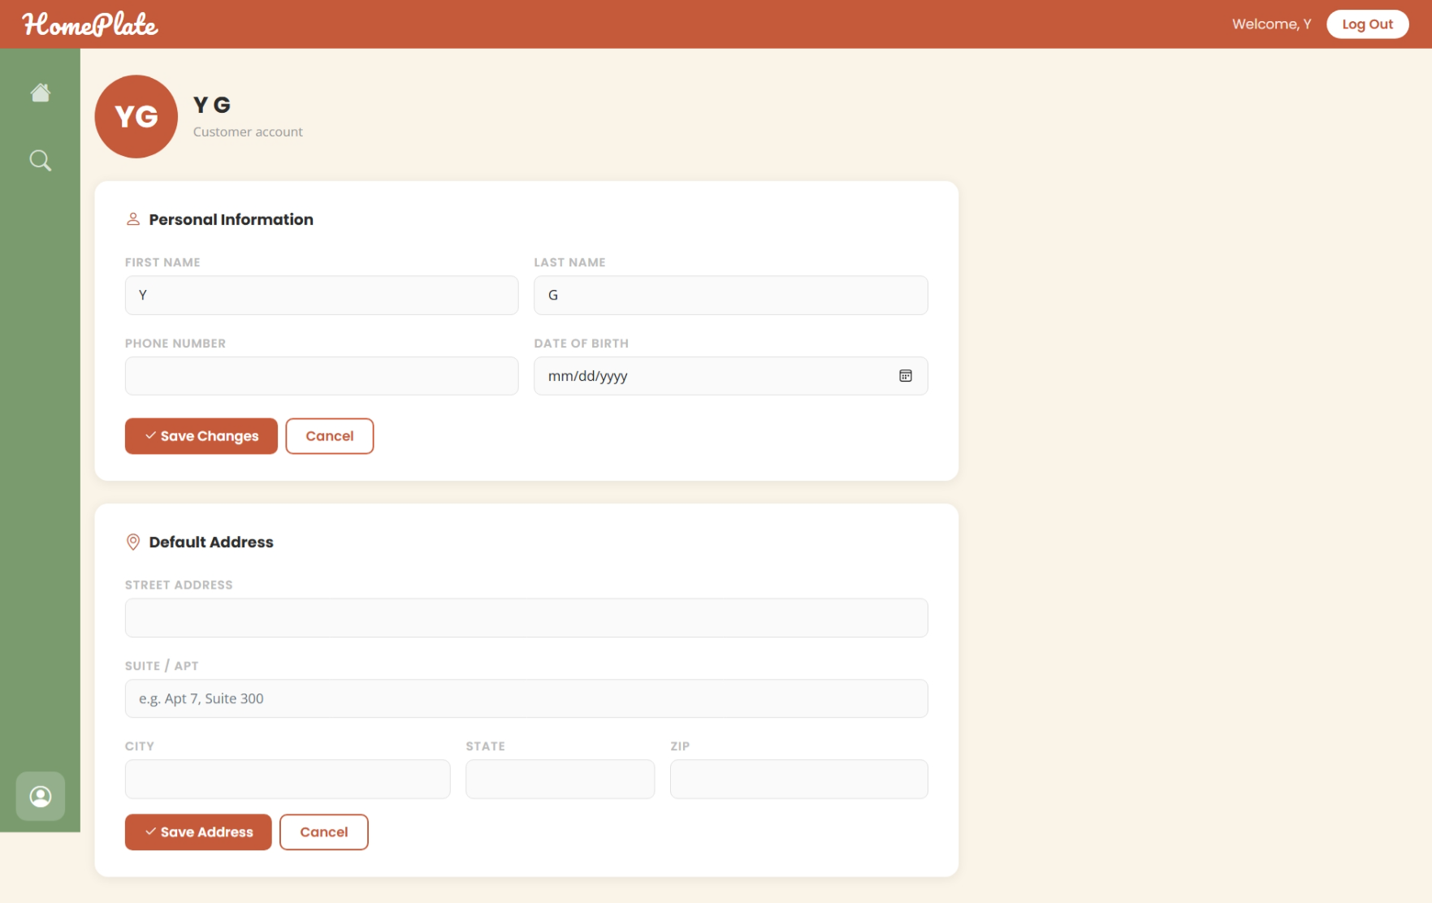

Use Case 8 (UC-M01): Add Menu Item

1. The Route
Files: HFM/routes/menu.js, HFM/routes/merchant.js
Merchants reach menu management from dashboard routes and operate within a selected restaurant context stored in session. The creation action is handled by POST /api/menu, which is protected by cook-role authorization and restaurant selection checks. The route validates required item inputs, creates a restaurant-scoped menu record tied to the current merchant account, and returns JSON used by the UI to refresh the menu list and display the newly added item.

2. The Controller
File: HFM/routes/menu.js, HFM/routes/merchant.js | Function: router.post('/api/menu'), router.get('/merchant-my-menu')
The controller is responsible for all business logic. It executes the following steps:
- Uses requireCook middleware to enforce cook role and selected restaurant context.
- Reads name, price, quantity, category, and description from request payload.
- Validates required name/price fields before attempting persistence.
- Creates a new MenuItem with merchant userId and session restaurantId ownership binding.
- Returns JSON for front-end refresh; merchant menu fragment endpoint reloads current restaurant items.

3. The Models
This use case reads from and writes to the following model(s):
Model | Operation | What Happens
MenuItem | Create/Read | Creates new menu row and reloads menu list fragment.
Restaurant | Read | Confirms selected restaurant scope for item ownership.

4. The Views
This use case involves the following view(s):

View -- Merchant Dashboard - Restaurant and Tab Selection (file: HFM/views/merchant-dashboard.ejs)
Merchant starts at the dashboard where they can select a restaurant to manage. Once a restaurant is selected, tabs appear for My Menu, Current Orders, Completed Orders, and other sections. The merchant clicks the "My Menu" tab to enter the menu management workspace. This is the entry point for UC-M01.
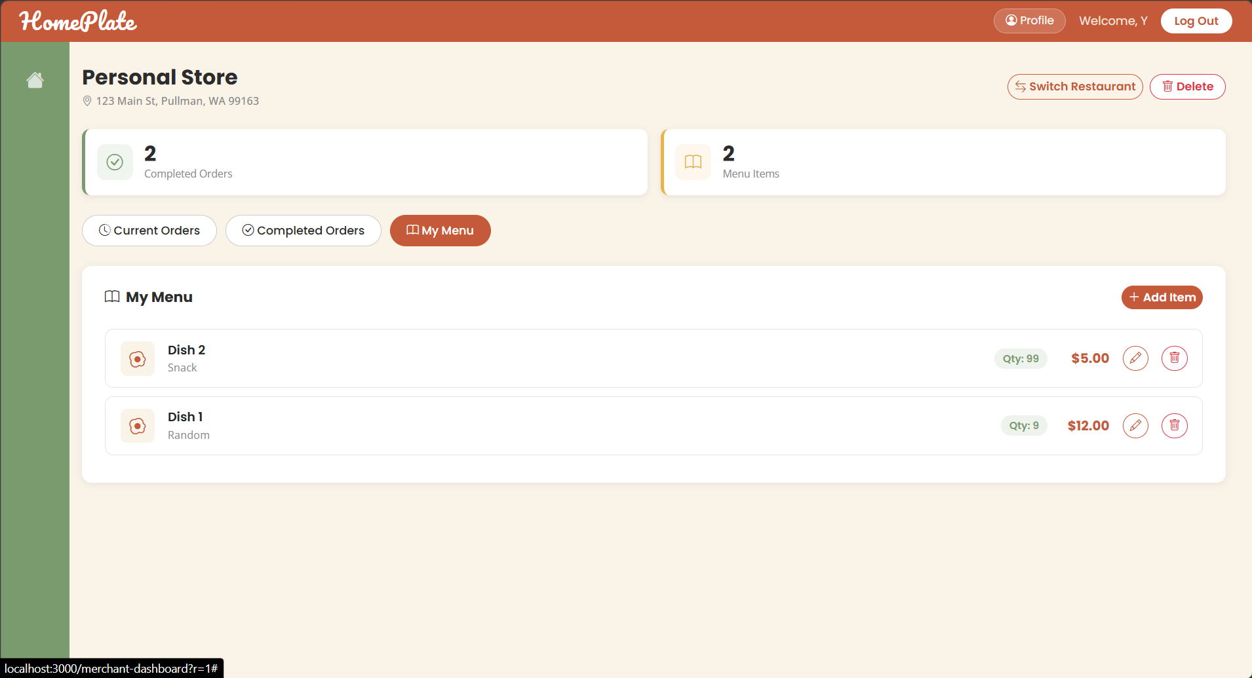

View -- My Menu Item List with Add Control (file: HFM/views/merchant-my-menu.ejs)
The My Menu view displays a list of existing menu items for the selected restaurant in a table or card format, showing name, price, quantity, category, and description. An "Add New Item" button or modal trigger is available. The view supports adding, editing, and deleting items.
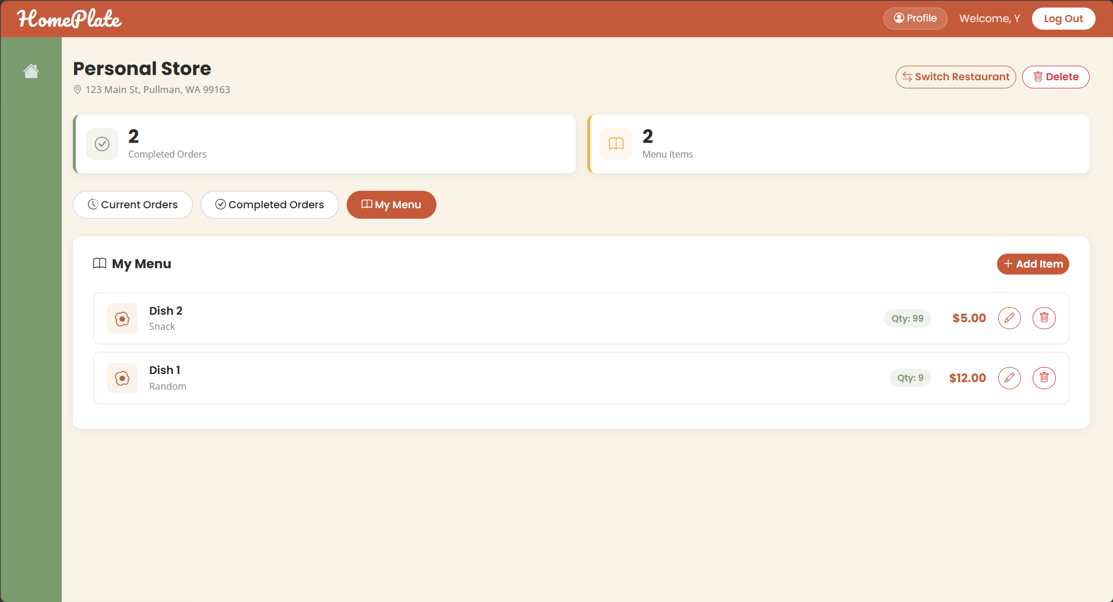

View -- Add Menu Item Modal Form (file: HFM/views/merchant-my-menu.ejs)
The Add Item modal form captures name, price, quantity, category, and description fields for a new menu item. The form includes validation for required fields. Clicking Save triggers POST /api/menu and refreshes the menu list to display the newly created item.
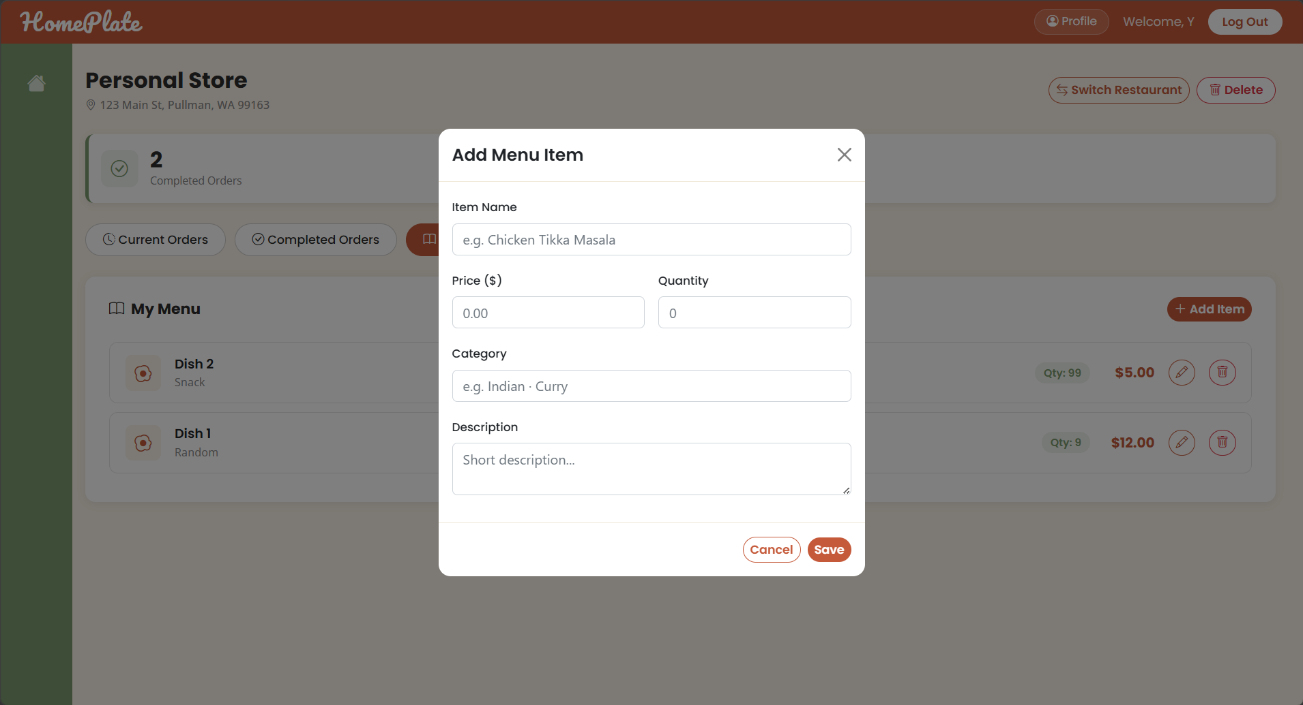

Use Case 9 (UC-M02): Delete Menu Item

1. The Route
Files: HFM/routes/menu.js, HFM/views/merchant-my-menu.ejs
Deleting a menu item is triggered from the merchant menu UI and sent to DELETE /api/menu/:id. The route is protected by cook-role middleware and selected-restaurant context, then performs a scoped lookup using both item id and current restaurant id. If the item exists in scope, it is deleted and a success JSON response is returned; otherwise, the route returns a not-found response to prevent invalid or cross-scope deletion.

2. The Controller
File: HFM/routes/menu.js | Function: router.delete('/api/menu/:id')
The controller is responsible for all business logic. It executes the following steps:
- Applies requireCook authorization and selected restaurant precondition.
- Finds target MenuItem by both id and session restaurantId scope.
- Returns 404 if item is not found in the selected restaurant scope.
- Destroys the scoped menu item and returns success JSON for UI refresh.

3. The Models
This use case reads from and writes to the following model(s):
Model | Operation | What Happens
MenuItem | Read/Delete | Finds scoped item record and permanently removes it.
Restaurant | Read | Provides session scope constraint for safe deletion.

4. The Views
This use case involves the following view(s):

View -- My Menu List with Delete Trigger (file: HFM/views/merchant-my-menu.ejs)
The merchant sees existing menu items in a list/table view. Each item row displays name, price, quantity, category, and description. Each row includes a delete button or icon (trash icon, "Delete" link). Clicking the delete button triggers the DELETE /api/menu/:id action for UC-M02.
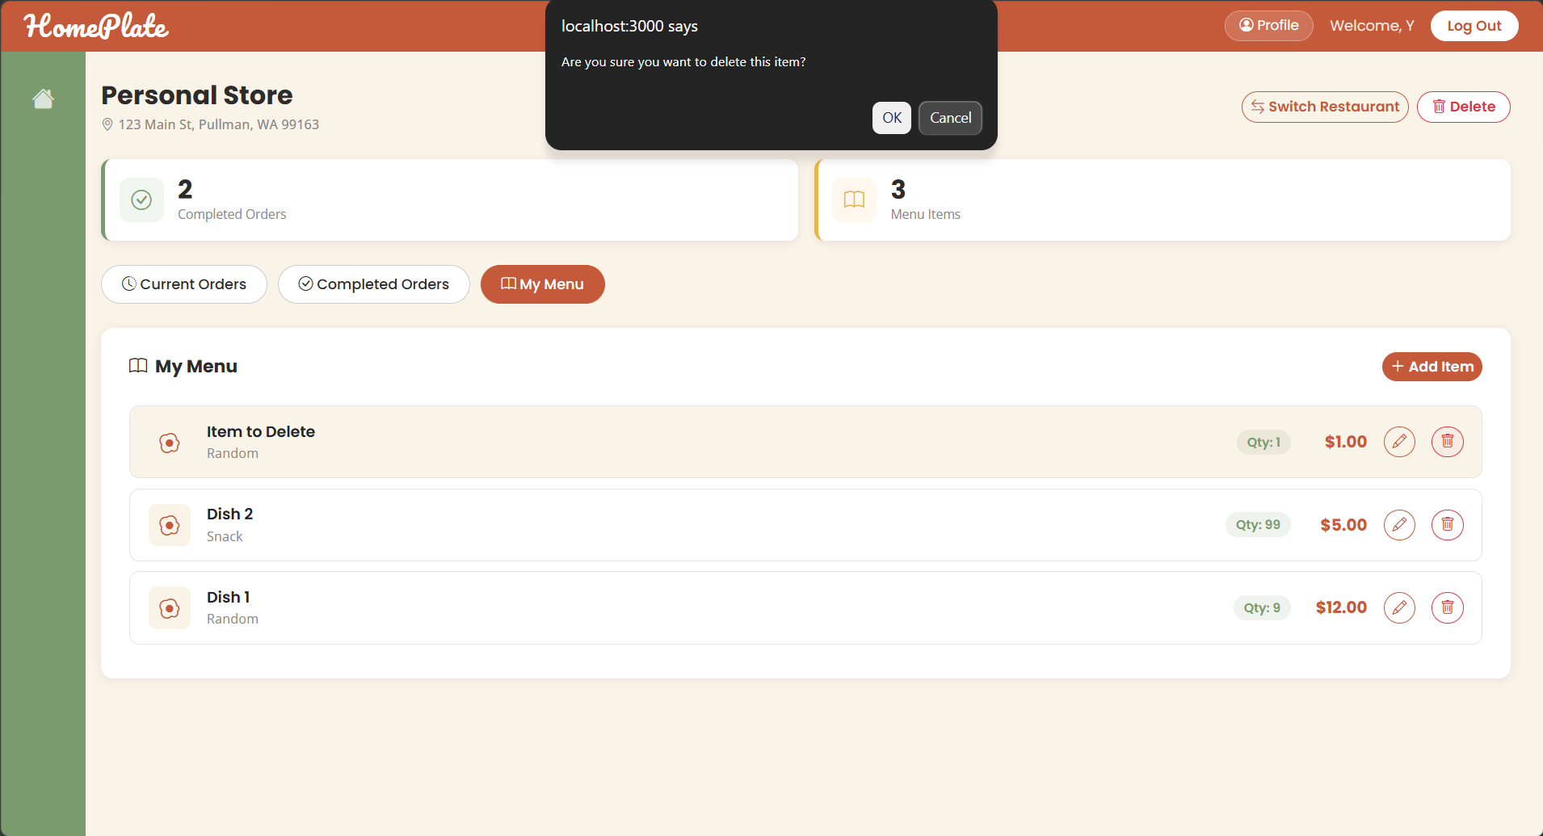

View -- My Menu List After Deletion (file: HFM/views/merchant-my-menu.ejs)
After successful DELETE /api/menu/:id, the menu fragment refreshes automatically via JavaScript. The deleted item no longer appears in the list, and the menu count is recalculated and updated. This confirms delete completion.



Use Case 10 (UC-M03): Edit Item

1. The Route
Files: HFM/routes/menu.js, HFM/views/merchant-my-menu.ejs
Item editing is submitted to PUT /api/menu/:id from the merchant menu interface. The route first enforces cook authorization and current restaurant selection, then loads the target row within that restaurant scope. Incoming editable fields (name, price, quantity, category, description) are conditionally applied, persisted, and returned as JSON so the front-end can re-render the updated item values in place.

2. The Controller
File: HFM/routes/menu.js | Function: router.put('/api/menu/:id')
The controller is responsible for all business logic. It executes the following steps:
- Applies requireCook authorization and selected restaurant precondition.
- Loads the menu record by id + restaurant scope to prevent cross-restaurant updates.
- Maps optional payload fields (name, price, quantity, category, description) to model properties.
- Persists the updated item and returns the updated JSON object to the front-end.

3. The Models
This use case reads from and writes to the following model(s):
Model | Operation | What Happens
MenuItem | Read/Update | Loads selected item and writes edited fields.
Restaurant | Read | Enforces same-restaurant ownership during updates.

4. The Views
This use case involves the following view(s):

View -- My Menu List with Edit Trigger (file: HFM/views/merchant-my-menu.ejs)
The merchant views the menu item list where each row shows name, price, quantity, category, and description. Each row includes an edit button or icon. Clicking edit opens the edit modal prefilled with the item's current values.
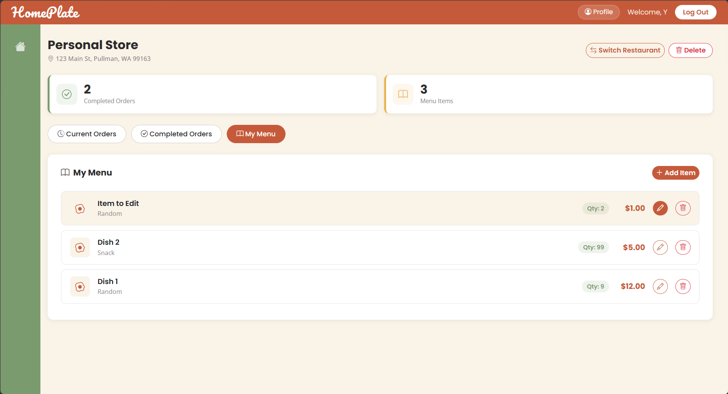

View -- Edit Menu Item Modal Form (Prefilled) (file: HFM/views/merchant-my-menu.ejs)
The edit modal opens with all fields (name, price, quantity, category, description) prefilled with the item's current values. The merchant can modify any field. Clicking Save triggers PUT /api/menu/:id and refreshes the menu list with updated values.
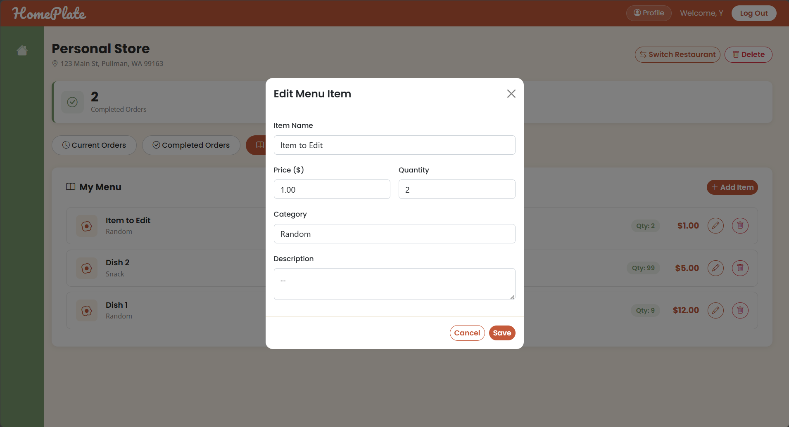

View -- My Menu List After Update (file: HFM/views/merchant-my-menu.ejs)
After PUT /api/menu/:id succeeds, the menu fragment refreshes automatically via JavaScript. The updated item values (name, price, category, quantity) appear in the refreshed list, confirming the update completion.
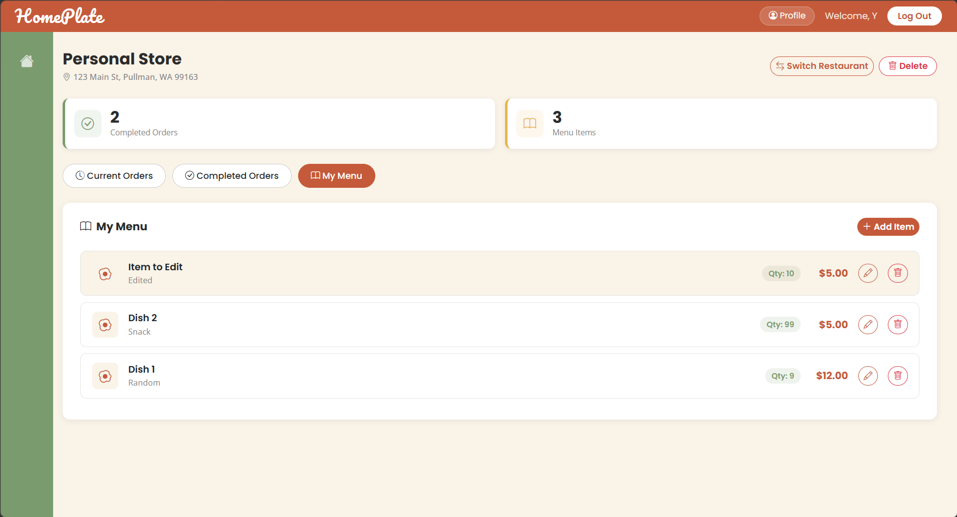

Use Case 11 (UC-M04): View Reports

1. The Route
Files: HFM/views/merchant-reports.html, HFM/routes/merchant.js
Reporting data is exposed through GET /merchant-completed-orders for the selected merchant restaurant. After authorization and restaurant-context checks, the route loads delivered orders in reverse chronological order and enriches each order with its line items. The resulting dataset is rendered as the completed-orders report view used by merchants to inspect historical performance, while advanced aggregated report APIs remain outside the current route implementation.

2. The Controller
File: HFM/routes/merchant.js | Function: router.get('/merchant-completed-orders')
The controller is responsible for all business logic. It executes the following steps:
- Applies requireCook middleware and validates selected restaurant from session context.
- Queries delivered orders for the selected restaurant in descending createdAt order.
- Loads line items for each completed order and merges detail payload for reporting display.
- Renders merchant-completed-orders fragment as the implemented reporting data view.

3. The Models
This use case reads from and writes to the following model(s):
Model | Operation | What Happens
Order | Read | Fetches delivered/completed orders for report-oriented review.
OrderItem | Read | Provides item-level details used in report displays.
Restaurant | Read (Scope) | Ensures report data is restaurant-specific.

4. The Views
This use case involves the following view(s):
View -- Merchant Dashboard - Current Orders (file: merchant-dashboard.ejs)
From the merchant dashboard, the merchant can click the Current Orders tab to open the active order queue. This dashboard view acts as the operational entry point for order fulfillment, where the merchant can switch between Current Orders, Completed Orders, and My Menu while staying in the selected restaurant context.
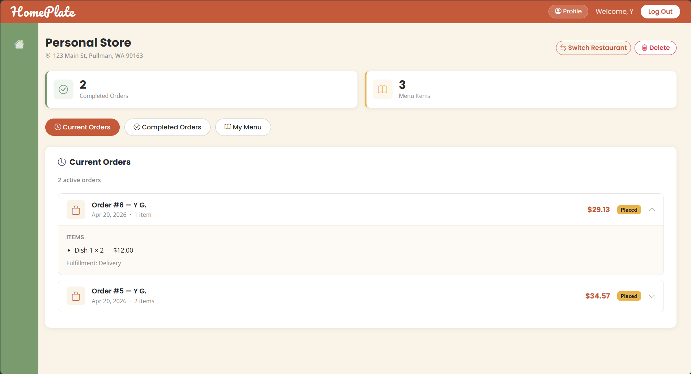

View -- Merchant Dashboard - Completed Orders (file: HFM/views/merchant-dashboard.ejs)
From the merchant dashboard, the merchant can navigate to view completed orders or access reporting features. This implemented view provides delivered-order history and line-item details, which serves as the current reporting data source for UC-M04. Each completed order card displays order ID, completion date, restaurant name, line items with quantities and prices, and total amounts.
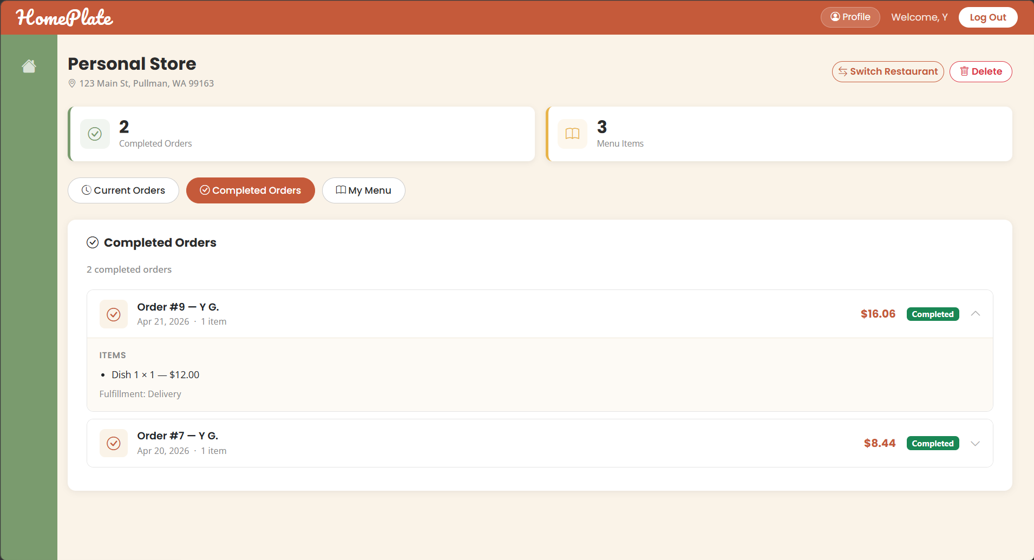

Use Case 12 (UC-M05): Edit Restaurant Information

1. The Route
Files: HFM/routes/merchant.js, HFM/views/merchant-dashboard.ejs
Restaurant management is routed through dashboard and restaurant-management endpoints in merchant routes. GET /merchant-dashboard loads owned restaurants and selected-restaurant state, POST /merchant-restaurant creates a new restaurant with normalized tags, and POST /merchant-restaurant/delete removes a selected restaurant after ownership validation. The delete path performs transactional cleanup of related records so the UI can safely return to restaurant selection state.

2. The Controller
File: HFM/routes/merchant.js | Function: router.get('/merchant-dashboard'), router.post('/merchant-restaurant'), router.post('/merchant-restaurant/delete')
The controller is responsible for all business logic. It executes the following steps:
- Dashboard handler loads all restaurants owned by the logged-in cook and manages selected restaurant state in session.
- Create-restaurant handler validates required fields, normalizes tag list, creates restaurant, and selects it in session.
- Delete-restaurant handler verifies ownership of target restaurant before deletion.
- Executes transactional cascade cleanup: deletes related OrderItem rows, then Orders, then MenuItems, then Restaurant.
- Clears session restaurant selection when deleted restaurant was currently selected, then redirects to restaurant picker state.

3. The Models
This use case reads from and writes to the following model(s):
Model | Operation | What Happens
Restaurant | Create/Read/Delete | Creates stores, lists owned stores, and deletes selected store.
MenuItem | Delete (Cascade) | Removes menu rows when a restaurant is deleted.
Order | Delete (Cascade) | Removes restaurant orders during store deletion flow.
OrderItem | Delete (Cascade) | Removes order-item rows associated with deleted store orders.

4. The Views
This use case involves the following view(s):

View -- Restaurant Picker / Setup View (file: HFM/views/merchant-dashboard.ejs)
This state lets the merchant select an existing restaurant, create a new one with name, address, and tags, or delete a restaurant. The view displays all owned restaurants as selectable cards and includes a form for creating a new restaurant. This is the implemented entry behavior related to UC-M05.


View -- Selected Restaurant Header and Controls (file: HFM/views/merchant-dashboard.ejs)
After selecting a restaurant, the dashboard header renders the active restaurant information (name, address, tags). Management controls are displayed including Switch Restaurant button and Delete Restaurant button. This view reflects current read/manage behavior for restaurant info.
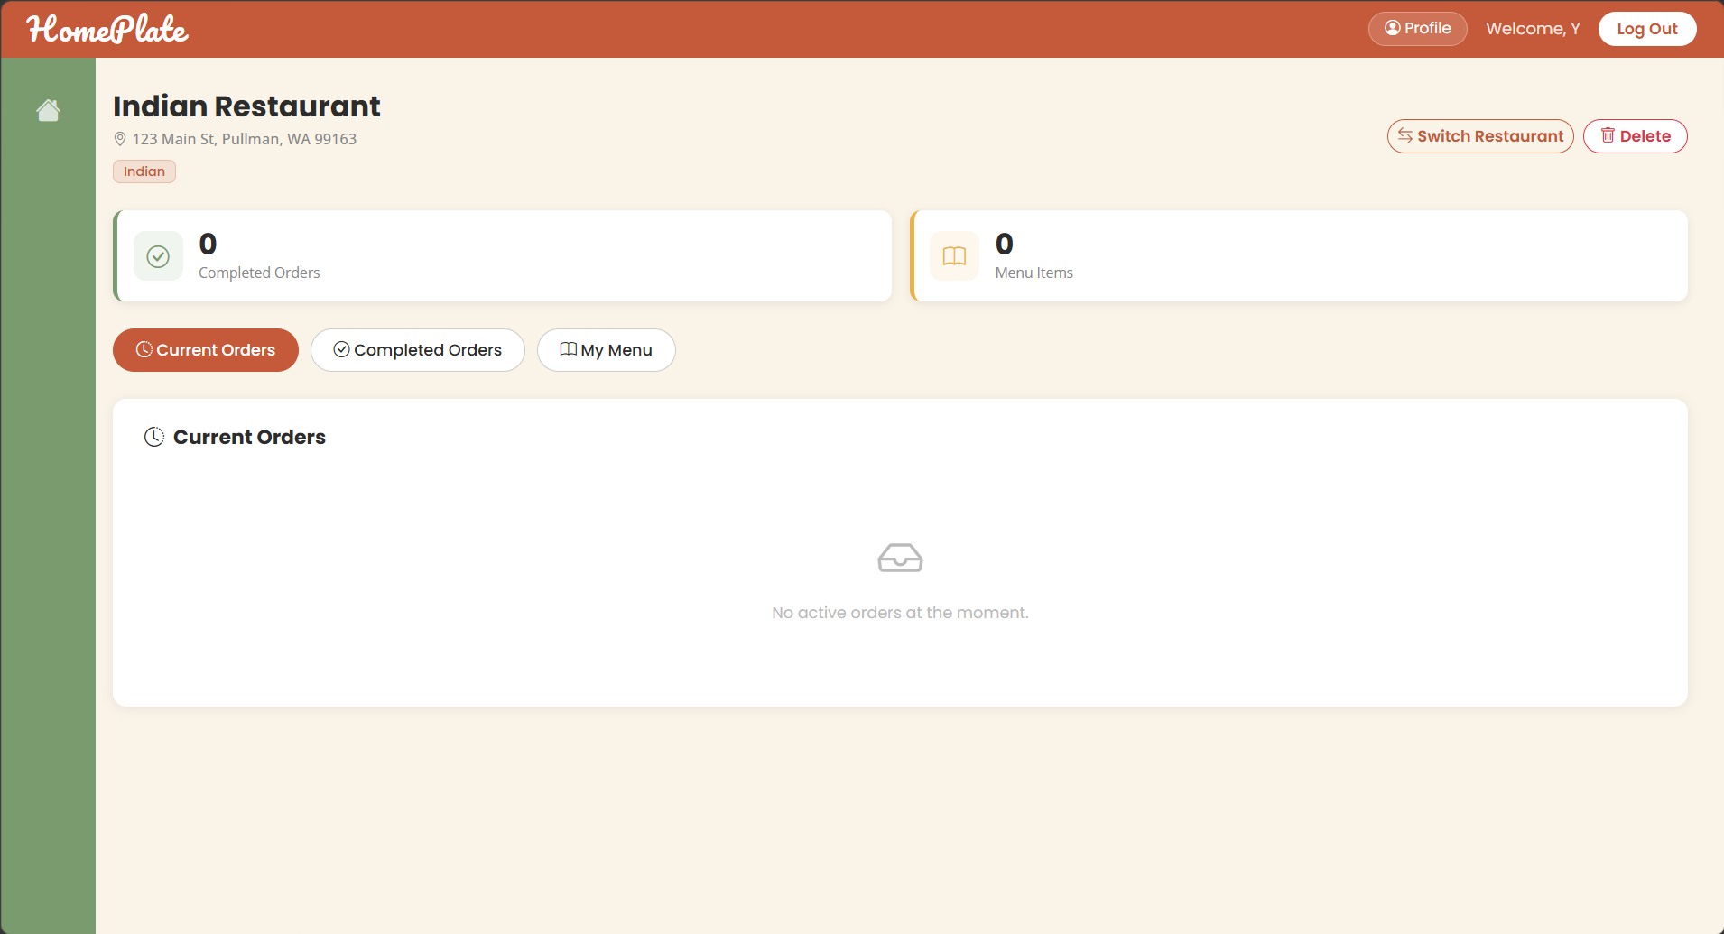

2.2 Section 2: Route / API Table
Routes are grouped by feature area for readability. Each table includes method, path, behavior, and authentication/role requirement.

Core / Utility
Method | Route | Description | Auth Required
GET | / | Render the landing page. | No
GET | /users | Return default users route response. | No

Authentication
Method | Route | Description | Auth Required
GET | /login | Render the login page. | No
POST | /login | Authenticate user and create session. | No
GET | /register | Render the registration page. | No
POST | /register | Create a new customer or cook account. | No
GET | /logout | Destroy current session and redirect to login. | Yes -- Logged-in User

Restaurant Discovery
Method | Route | Description | Auth Required
GET | /browse | Browse/search restaurants and optional tag filter. | No
GET | /restaurant-detail | Render restaurant detail page with available menu items. | No

Cart and Checkout (Customer)
Method | Route | Description | Auth Required
GET | /cart | Render current pending cart groups for session user. | Yes -- Logged-in User (Customer Flow)
POST | /cart/add | Add menu item to cart (create/increment pending order item). | Yes -- Logged-in User (Customer Flow)
PUT | /cart/item/:id | Update cart item quantity and recalculate totals. | Yes -- Logged-in User (Customer Flow)
DELETE | /cart/item/:id | Remove item from cart and delete empty pending order. | Yes -- Logged-in User (Customer Flow)
GET | /checkout | Render checkout page for selected/latest pending order. | Yes -- Logged-in User (Customer Flow)
POST | /checkout | Validate delivery/order, place order, and deduct inventory. | Yes -- Logged-in User (Customer Flow)
GET | /order-confirmation | Render confirmation for a placed order. | Yes -- Logged-in User (Customer Flow)

Customer Dashboard and Order History
Method | Route | Description | Auth Required
GET | /customer-dashboard | Render customer dashboard with active/history counters. | Yes -- Customer
GET | /customer-current-order | Render latest non-pending order status fragment. | Yes -- Customer
GET | /customer-order-history-data | Render customer order-history fragment. | Yes -- Customer

Profile
Method | Route | Description | Auth Required
GET | /profile | Render user profile page. | Yes -- Logged-in User
PUT | /profile/personal | Update personal profile fields. | Yes -- Logged-in User
PUT | /profile/address | Update address profile fields. | Yes -- Logged-in User

Merchant Dashboard
Method | Route | Description | Auth Required
GET | /merchant-dashboard | Render Merchant dashboard and restaurant selector. | Yes -- Merchant (Cook)
POST | /merchant-restaurant | Create a restaurant for the logged-in Merchant. | Yes -- Merchant (Cook)
POST | /merchant-restaurant/delete | Delete a Merchant restaurant and cascade related data. | Yes -- Merchant (Cook)
GET | /merchant-my-menu | Render Merchant menu fragment for selected restaurant. | Yes -- Merchant (Cook)
GET | /merchant-current-orders | Render active current orders fragment for Merchant. | Yes -- Merchant (Cook)
GET | /merchant-completed-orders | Render completed orders fragment for Merchant. | Yes -- Merchant (Cook)

Merchant Menu API
Method | Route | Description | Auth Required
GET | /api/menu | List menu items for selected restaurant. | Yes -- Merchant (Cook)
POST | /api/menu | Create menu item for selected restaurant. | Yes -- Merchant (Cook)
PUT | /api/menu/:id | Update a scoped menu item. | Yes -- Merchant (Cook)
DELETE | /api/menu/:id | Delete a scoped menu item. | Yes -- Merchant (Cook)

2.3 Section 3: Data Model / ER Diagram
This diagram uses the actual database tables in the application. It shows the main tables and their relationships: users, restaurants, menu_items, orders, and order_items.

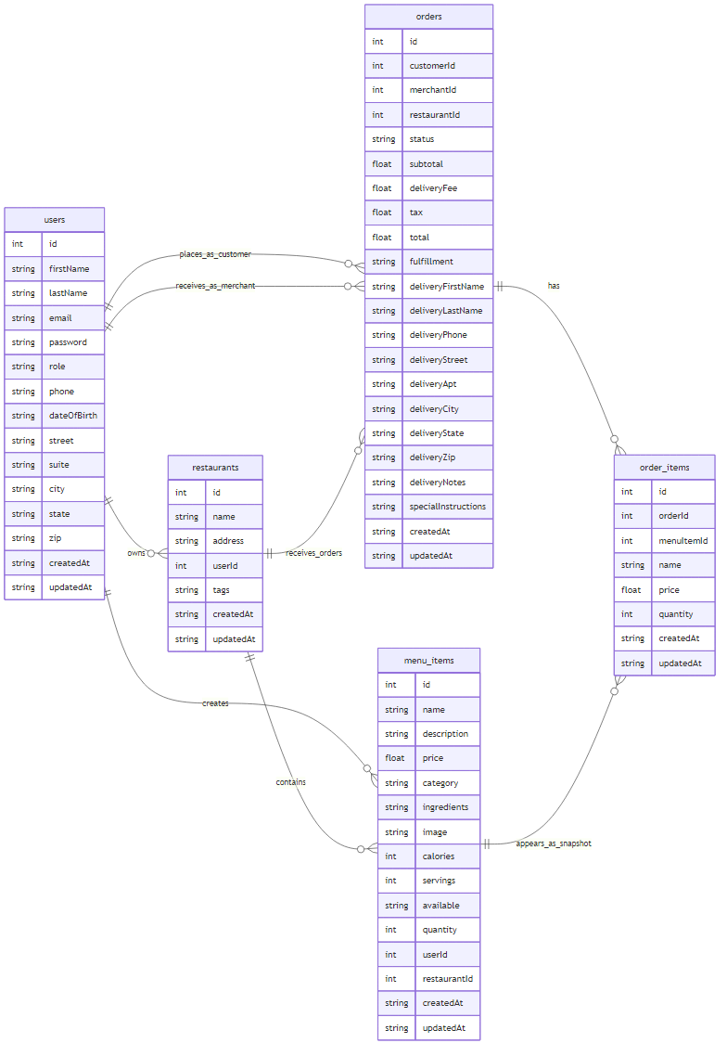
One important detail is that the users table is shared by multiple Sequelize models in the code. It maps to User, Customer, and Merchant. Customer and Merchant are not separate tables. They are different role-based models built on the same users table.
The remaining tables map directly to their corresponding models: restaurants to Restaurant, menu_items to MenuItem, orders to Order, and order_items to OrderItem.

Model Descriptions:

User
Field | Type | Notes
id | INTEGER | Primary key, auto-increment
firstName | STRING(50) | Required
lastName | STRING(50) | Required
email | STRING(255) | Required, unique, login identifier
password | STRING(255) | Required, bcrypt hash
role | ENUM('customer','cook') | Required, default 'customer'
phone | STRING(20) | Optional
dateOfBirth | DATEONLY | Optional
street | STRING(255) | Optional
suite | STRING(100) | Optional
city | STRING(100) | Optional
state | STRING(2) | Optional, 2-letter code
zip | STRING(10) | Optional
createdAt | DATE | Auto-managed by Sequelize timestamp
updatedAt | DATE | Auto-managed by Sequelize timestamp

User is the base identity model and stores shared account/profile fields for all roles. Authentication reads this table by email and compares bcrypt-hashed passwords.

Customer
Field | Type | Notes
id | INTEGER | Primary key, auto-increment (same physical row in users table)
firstName | STRING(50) | Required
lastName | STRING(50) | Required
email | STRING(255) | Required, unique
password | STRING(255) | Required, bcrypt hash
role | ENUM('customer','cook') | Scoped/defaulted to 'customer'
phone | STRING(20) | Optional
dateOfBirth | DATEONLY | Optional
street | STRING(255) | Optional
suite | STRING(100) | Optional
city | STRING(100) | Optional
state | STRING(2) | Optional
zip | STRING(10) | Optional
createdAt | DATE | Auto-managed by Sequelize timestamp
updatedAt | DATE | Auto-managed by Sequelize timestamp

Customer is a role-scoped subclass of User that maps to the same users table. Its default scope enforces role='customer', so it behaves as a filtered view over user accounts.

Merchant
Field | Type | Notes
id | INTEGER | Primary key, auto-increment (same physical row in users table)
firstName | STRING(50) | Required
lastName | STRING(50) | Required
email | STRING(255) | Required, unique
password | STRING(255) | Required, bcrypt hash
role | ENUM('customer','cook') | Scoped/defaulted to 'cook'
phone | STRING(20) | Optional
dateOfBirth | DATEONLY | Optional
kitchenName | STRING(100) | Optional Merchant profile field
cuisine | STRING(50) | Optional
bio | TEXT | Optional
deliveryFee | DECIMAL(5,2) | Optional, default 0.00
availableTimes | STRING(20) | Optional
minimumOrder | DECIMAL(5,2) | Optional, default 0.00
street | STRING(255) | Optional
suite | STRING(100) | Optional
city | STRING(100) | Optional
state | STRING(2) | Optional
zip | STRING(10) | Optional
createdAt | DATE | Auto-managed by Sequelize timestamp
updatedAt | DATE | Auto-managed by Sequelize timestamp

Merchant is a role-scoped subclass of User for cook/Merchant accounts, also stored in users. It adds kitchen/business metadata used by dashboard and listing flows.

Restaurant
Field | Type | Notes
id | INTEGER | Primary key, auto-increment
name | STRING(100) | Required restaurant name
address | STRING(255) | Required display address
userId | INTEGER | Owner user id (Merchant), logical FK -> users.id
tags | TEXT | Optional JSON array stored as string, default []
createdAt | DATE | Auto-managed by Sequelize timestamp
updatedAt | DATE | Auto-managed by Sequelize timestamp

Restaurant represents a Merchant-owned storefront. Tags are serialized JSON for flexible filtering in browse/search views.

MenuItem
Field | Type | Notes
id | INTEGER | Primary key, auto-increment
name | STRING(100) | Required item name
description | TEXT | Optional
price | DECIMAL(10,2) | Required unit price
category | STRING(50) | Optional
ingredients | TEXT | Optional
image | STRING(255) | Optional image path/URL
calories | INTEGER | Optional
servings | INTEGER | Optional, default 1
available | BOOLEAN | Required, default true
quantity | INTEGER | Required stock count, default 0
userId | INTEGER | Merchant owner id, logical FK -> users.id
restaurantId | INTEGER | Restaurant id, logical FK -> restaurants.id
createdAt | DATE | Auto-managed by Sequelize timestamp
updatedAt | DATE | Auto-managed by Sequelize timestamp

MenuItem stores sellable products under a restaurant and merchant owner. Inventory and availability are updated during cart and checkout flows.

Order
Field | Type | Notes
id | INTEGER | Primary key, auto-increment
customerId | INTEGER | Customer id, logical FK -> users.id
merchantId | INTEGER | Merchant id, logical FK -> users.id
restaurantId | INTEGER | Optional logical FK -> restaurants.id
status | ENUM('pending','placed','confirmed','ready','delivered','cancelled') | Required, default 'pending'
subtotal | DECIMAL(10,2) | Required, default 0.00
deliveryFee | DECIMAL(5,2) | Required, default 0.00
tax | DECIMAL(10,2) | Required, default 0.00
total | DECIMAL(10,2) | Required, default 0.00
fulfillment | ENUM('delivery','pickup') | Required, default 'delivery'
deliveryFirstName | STRING(50) | Optional snapshot field
deliveryLastName | STRING(50) | Optional snapshot field
deliveryPhone | STRING(20) | Optional snapshot field
deliveryStreet | STRING(255) | Optional snapshot field
deliveryApt | STRING(100) | Optional snapshot field
deliveryCity | STRING(100) | Optional snapshot field
deliveryState | STRING(2) | Optional snapshot field
deliveryZip | STRING(10) | Optional snapshot field
deliveryNotes | TEXT | Optional
specialInstructions | TEXT | Optional
createdAt | DATE | Auto-managed by Sequelize timestamp
updatedAt | DATE | Auto-managed by Sequelize timestamp

Order is both the cart container (status='pending') and the finalized purchase record. It stores monetary totals and delivery snapshot fields to preserve historical accuracy.

OrderItem
Field | Type | Notes
id | INTEGER | Primary key, auto-increment
orderId | INTEGER | Logical FK -> orders.id
menuItemId | INTEGER | Logical FK -> menu_items.id
name | STRING(100) | Item name snapshot at purchase time
price | DECIMAL(10,2) | Item price snapshot at purchase time
quantity | INTEGER | Required quantity, default 1
createdAt | DATE | Auto-managed by Sequelize timestamp
updatedAt | DATE | Auto-managed by Sequelize timestamp

OrderItem is the line-item table for each order. Name and price are denormalized snapshots so historical orders remain accurate when menu metadata changes later.

Relationship Summary
Relationship | Type | Description
User -> Restaurant | One-to-Many | One Merchant user can own many restaurants via restaurants.userId.
User -> MenuItem | One-to-Many | One Merchant user can create many menu items via menu_items.userId.
Restaurant -> MenuItem | One-to-Many | One restaurant can have many menu items via menu_items.restaurantId.
User(customer) -> Order | One-to-Many | One customer user can place many orders via orders.customerId.
User(Merchant) -> Order | One-to-Many | One Merchant user can receive many orders via orders.merchantId.
Restaurant -> Order | One-to-Many | One restaurant can have many related orders via orders.restaurantId.
Order -> OrderItem | One-to-Many | One order contains many line items via order_items.orderId.
MenuItem -> OrderItem | One-to-Many | One menu item may appear in many order items via order_items.menuItemId.
User -> Customer | Specialization (scope) | Customer model is a role-filtered view of users (role='customer').
User -> Merchant | Specialization (scope) | Merchant model is a role-filtered view of users (role='cook').

Design note: the current codebase uses logical foreign-key relationships in model fields and route logic, but does not define explicit Sequelize association methods (hasMany/belongsTo).

2.4 Section 4: Known Issues and Limitations
This section lists incomplete features and a focused set of unhandled edge cases discovered during code review.

Incomplete Features
- Admin module (all admin-side features) was removed with instructor approval to keep scope aligned with project priorities.
- Delivery driver module (all driver-side features) was removed with instructor approval.
- Profile: Add payment method was not implemented because it is out of scope for the current submission.
- Profile: Delete account was not implemented because it is out of scope and not a hard requirement.
- Profile: Making profile page cusotmer-only or role-specific was not implemented because of time constraints.
- Password recovery flow was not implemented because it is out of scope.
- Customer dashboard: order-status progress tracker was removed with instructor approval.
- Merchant order-state actions (confirm/reject/update status) were removed with instructor approval.
- Merchant storefront open/close status toggle was removed with instructor approval.
- Browse page restaurant sorting was removed with instructor approval.
- Search results filtering by restaurant category attributes (rating, price, distance) was not completed due to time constraints.
- Customer reviews authoring feature was removed with instructor approval.

Bugs
- POST /cart/add does not verify that menuItemId belongs to the submitted restaurantId, so a mismatched item/restaurant combination can be inserted into the same order. Updates to fix this were not implemented due to time constraints.
- Menu create/update endpoints parse numeric fields without strict validation; invalid numeric input can propagate to database write errors and return generic 500 responses instead of clear 4xx validation errors. Updates to fix this were not implemented due to time constraints.

Unhandled Edge Cases
- Checkout state normalization falls back to the first two characters for unknown input (for example, 'InvalidState' becomes 'IN'), which can silently store incorrect addresses. Logics to handle this were not implemented due to time constraints
- Cart quantity update does not validate that quantity is a valid positive integer before assignment, so malformed input can trigger server-side failures instead of a clean 4xx validation response. Rules to handle this were not implemented due to time constraints.
- Customer order-history endpoint loads all non-pending orders with per-order follow-up queries (items and restaurant), which creates an N+1 pattern and can degrade heavily for large histories. Rules to handle this were not implemented due to time constraints.
- Browse page rendering performs per-restaurant count and owner lookups in a loop, creating query amplification that can become slow under larger restaurant datasets. Rules to handle this were not implemented due to time constraints.
- Logout does not handle session-destroy callback errors explicitly, so session termination failures are not surfaced to the user. Rules to handle this were not implemented due to time constraints.

Known Limitations
- Some pricing rules are hardcoded in server logic (for example tax rate and delivery fee in cart recalculation). Refactorings to resolve this were not implemented due to time constraints.
- Restaurant tags are stored as serialized JSON text and tag filtering is applied in application logic, which limits database-level indexing and advanced query flexibility for discovery features. Refactorings to resolve this were not implemented due to time constraints.
- Checkout is scoped to one pending order (effectively one restaurant order at a time), so a single unified checkout across multiple restaurants is not supported. Refactorings to resolve this were not implemented due to time constraints.

