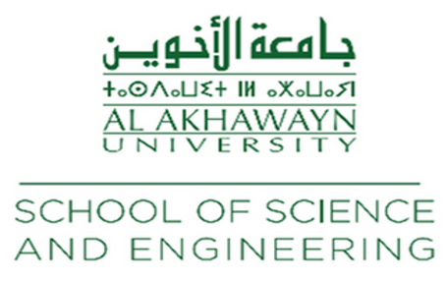

December 2, 2024

To Whom It May Concern,

I am writing to strongly recommend Salma Ennouaimi for admission to the master’s program in Data Science and Artificial Intelligence (DSAI) at ENSIMAG Grenoble. Having had the pleasure of teaching Salma Ennouaimi during the Fall of 2024, I can confidently attest to her exceptional qualities and aptitude for advanced studies.

Salma Ennouaimi was enrolled in my CSC 3329: IoT and Big Data Streaming course at Al Akhawayn University in Ifrane, Morocco. Throughout the semester, she showed outstanding academic abilities coupled with a strong desire for excellence. Salma Ennouaimi was one of the best performing students in my class this semester; she always obtained remarkable marks in all individual and group assignments.

What impressed me most about Salma Ennouaimi was her technical skills and, at the same time, her ability to put theory into practice. She successfully deployed a movement recognition application using Edge Impulse on a TinyML kit in one project. In another one, she created a testbed of temperature and humidity conditions by collecting data from sensors and sending it to a web server. She developed a user-friendly website that allowed real-time access to this data, demonstrating her skills in IoT development, web programming, and data visualization.

I strongly believe that Salma Ennouaimi, with her academic background, skills, and experience, is fully capable of succeeding in such a challenging academic environment as ENSIMAG Grenoble. She showed great interest in data science and artificial intelligence, combined with a strong technical foundation in IoT and big data streaming, makes her an ideal candidate for your program.

Please do not hesitate to contact me if you need any further information or clarification. Thank you for considering Salma Ennouaimi's application, and I appreciate your attention to this recommendation.

Best Regards,

[Dr. Nabil Benamar](https://www.linkedin.com/in/nabil-benamar13375845/)  
Full Professor of Computer Science  
Moulay Ismail University in Meknes &  
Al Akhawayn University in Ifrane  
Email: [N.Benamar@aui.ma](mailto:N.Benamar@aui.ma)