

**Modeling phenomena based on Epidemic diseases**

Sharif University of technology

Winter/spring 2020

Homework3 Yasaman Asgari

**SIS Model**

**Introduction**

There are some happenings which can’t be explained with the model explained in two last home works. So we should describe new models to predict behavior of these systems.SIS models is one of famous models that I want to explain the general behavior and also details. In this model we again have N constant rule which means overall group’s population is constant by the time. There are two special groups: **S**usceptible and **I**nfected that we call them S group and I group in order. These two can turn to each other with special rates- $β$ (S to I), $γ$ (I to S)-.This model can be used for many phenomena such as cold .we have two views: Network based and ODE based!

SIS model

**Mean Field Differential Equation view**

We should write equations which show the proportion of each group at every moment. For simpler mathematics we normalize the population-N- to 1.So:

$$I=1-S$$

And also:

$\frac{dI}{dt}=βIS-γI$

$\frac{dS}{dt}=-βIS+γI$

In this simple example, demography (births and deaths) has been ignored. Despite this lack of susceptible births, the disease can still persist because the recovery of infectious individuals replenishes the susceptible pool. We can, therefore, substitute $I=1-S$ into equation and simplify to get:

$$\frac{dI}{dt}=βI\left(1-I\right)-γI=-βI^{2}+\left(β-γ\right)I=I(-βI+\left(β-γ\right))$$

This can be simplified as below:

$$\frac{dI}{dt}=\left(β-γ\right)(1-\frac{I}{\left(1-\frac{γ}{β}\right)})I$$

Equilibrium solutions are constant solutions to the differential equation. $r=β-γ$ is the intrinsic growth rate .In other words, It is the growth rate that will occur in the absence of any limiting factor. $K=\left(1-\frac{γ}{β}\right)$ is called saturation level or carrying capacity. For this, similar to the popular model of intrinsic growth in a simple society we have two Equilibrium solutions:

$$I=0 , I=\left(1-\frac{γ}{β}\right)$$

Notice that if we start with a population of zero, there is no growth and I population stays at zero. Next, notice that if we start with a I population in the range $0<I_{0}<\left(1-\frac{γ}{β}\right)$ then I population will grow, but start to level off once we get close to a population $\left(1-\frac{γ}{β}\right)$.If we start with a population equals to $\left(1-\frac{γ}{β}\right)$ the I population will stay at $\left(1-\frac{γ}{β}\right)$.Finally, if we start with a population that is greater than $\left(1-\frac{γ}{β}\right)$ then the I population will actually die off until we start nearing a population of K, at which point the population decline will start to slow down.

Now, from a realistic standpoint this should make some sense. Populations can’t just grow forever without bound. Eventually the population and the population growth will start to slow as it comes closer to this threshold. Also, if you start off with a population greater then what an area can sustain there will actually be a die off until we get near to this threshold.

We have three distinct regions.

$$-∞<I_{0}<0 0<I_{0}<K k<I_{0}<∞$$

Which $-∞<I_{0}<0$ has no sense to us. We said that if we start with $I_{0}=ε$ which $ε$ is great smaller than $I_{0}$ the answer will goes to another equilibrium point K. It tells us that $I=0$ is an **unstable equilibrium point** and if we look closely to the behavior of the function we will know that $, I=\left(1-\frac{γ}{β}\right)$ is an **asymptotically equilibrium point**. I’ll try to find answer of the ODE.

$$\frac{dI}{I(-βI+\left(β-γ\right))}=dt => A\frac{dI}{I}+B\frac{dI}{(-βI+\left(β-γ\right))}=dt$$

$A=\frac{1}{β-γ}$ And $B=\frac{β}{β-γ}$.

$$\int{\frac{dI}{dt}}+β\int{\frac{dI}{(-βI+\left(β-γ\right))}}=(β-γ)\int{dt}$$

So:

$$\ln\left(I\right)-\ln\left(\left(β-γ\right)-βI\right)=\left(β-γ\right)t+C$$

With simplifying:

$$\left|\frac{I}{\left(β-γ\right)-βI}\right|=C_{1}exp⁡(\left(β-γ\right)t)$$

For $β>γ$ when t goes to infinity, I population goes near to $\left(1-\frac{γ}{β}\right)$: $\lim_{t→∞}{I(t)}=\left(1-\frac{γ}{β}\right)$

And for $β<γ$ when t goes to infinity, I population goes near to zero: $\lim_{t→∞}{I(t)}=0$

$$I\left(t\right)=\frac{ \left(1-\frac{γ}{β}\right)}{1+(\frac{\left(1-\frac{γ}{β}\right)-I_{0}}{I_{0}})exp⁡(-\left(β-γ\right)t)}$$

This function has a common “S” shape (sigmoid curve) for $I_{0}<\left(1-\frac{γ}{β}\right)$

And also we have:

$$S\left(t\right)=1-\frac{ \left(1-\frac{γ}{β}\right)}{1+(\frac{\left(1-\frac{γ}{β}\right)-I_{0}}{I_{0}})exp⁡(-\left(β-γ\right)t)}$$

But when it achieves the limit?

$$I\left(t\right)=\frac{ \left(1-\frac{γ}{β}\right)}{1+(\frac{\left(1-\frac{γ}{β}\right)-I_{0}}{I_{0}})exp⁡(-\left(β-γ\right)t)}= \left(1-\frac{γ}{β}\right)$$

Then:

$$\left(\frac{\left(1-\frac{γ}{β}\right)-I_{0}}{I_{0}}\right)\exp\left(-\left(β-γ\right)t\right)=0$$

The answer is: when time goes to infinity=))))

But this mathematical view is not sufficient .So I tried to code on python in two methods: 4th degree Runge Kutta and Euler method for more precision and accuracy.

**Effect of $I_{0}$**

* I=0.001, $β$ =0.003 , $γ=0.002$

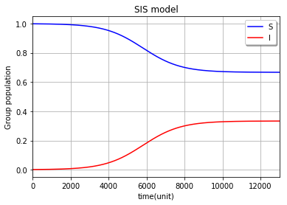

As I’ve spoken above, it has a sigmoid shape and also I’ve chosen I=0.001 to show that any small fluctuation on I can lead to another stable equilibrium point which is around 0.3.For more precision, the limit is $\left(1-\frac{γ}{β}\right)=\left(1-\frac{2}{3}\right)=\frac{1}{3}$. We can stop the code when it goes near this limit.

* I=0.01, $β$ =0.003 , $γ=0.002$

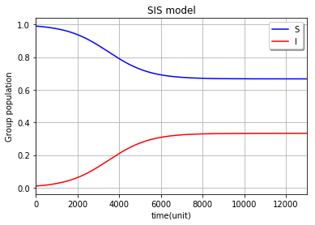

The plot says us that I population upper bound isn’t dependent to $I_{0}$.But it actually influence where the sigmoid begins.

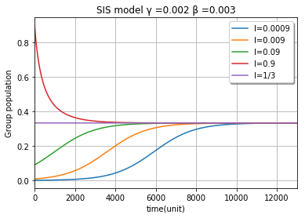

The plot is story-teller. It shows that when $I_{0}<\left(1-\frac{γ}{β}\right)$ we have the sigmoid shape –but it starts from different points- but they all achieve the limit. For $I_{0}=\left(1-\frac{γ}{β}\right)$ the I population is constant because this point is an asymptotically stable equilibrium point.

**Effect of $\frac{γ}{β}$ ratio**

We know that this ratio has a really important effect on the final value of I ($I_{∞}$). $\frac{β}{γ}$ is $R_{0}$ or that reproductive number that tells us when outbreak happens in early stages of disease.

Notice that $γ$ and $β$ don’t have similar dimension because in $\frac{dI}{dt}=βIS-γI$, $βIS$ and $γI$ should have similar dimension. So, we should actually multiple first term by N which is the overall constant. But don’t be afraid we have normalized our society population to 1!

* I=0.2, $β$ =0.001 , $γ=0.002$

Note :When I use Runge Kutta 4th order or even 8th order ,I don’t get any good precision and accuracy .So ,I chose LSODA method which uses Laplace method and also changes the points to best soft curve.

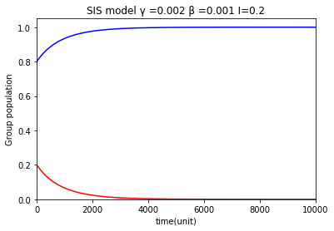

From the proof we have a strong intuition that what happens when $γ>β$.The I population goes to zero and the disease won’t be epidemic. In other words: $$\frac{dI}{dt}=I\left(-βI+\left(β-γ\right)\right)<0$$

And it tells us that the first derivative of I(t) is negative .So, I(t) is a decreasing function and goes near to our unstable equilibrium point.

* I=0.2, $β$ =0.005 , $γ=0.002$

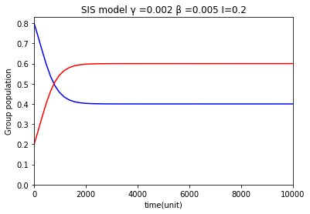

But when $γ<β$ it has the same description for I=0.01, $β$ =0.003 , $γ=0.002$.

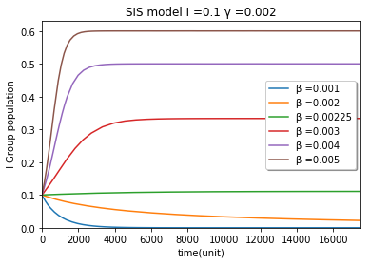

This diagram is gorgeous .I tells us that the time of achieving any stable or unstable equilibrium point depends on the value of $\frac{γ}{β}$.For $γ>β$ the dynamic closing time is influenced by the ratio. When it’s bigger the time is smaller. For $γ<β$, the dynamic closing time is smaller when ratio is bigger.

**Phase diagram**

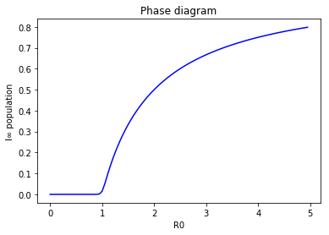

**Comparison with SIR model**

In a short story, I will tell about the similarities and differences. In both models we have a similar phase diagram in which there is a critical point .For values smaller than this point we have nonepidemic phase and for larger values we have outbreak but in SIS it doesn’t mean that the final I is near to 1, it will goes to its equilibrium point. Another difference is the dynamic closing time. In SIR the dynamic is closed when I population goes to zero but in SIS it happens when both S and I are constant over the time.SIS doesn’t give the society members long term immunity ,they can catch the disease also when they are recovered .

**Network based view**

Similar to home work 3 for SIR model I make a 2 dimensional lattice (grid) network with 256 nodes in 8 columns and rows .Each node is connected to up, down, right and left nodes and mean degree is 4.Then I set the attribute “I” for $I_{0}$ number of infected nodes and others “s” as susceptible group. Now we have two probabilities:”infection probability “and “recovery probability” then I make randoms if the random numbers are less than these two probabilities, I change the future state content .Finally, I put the future state in current state. But when we should stop the dynamic?

It’s an important question. We can stop the dynamic when S population remains stable for a range of time. Then I report $I_{∞}$ and $S_{∞}$.

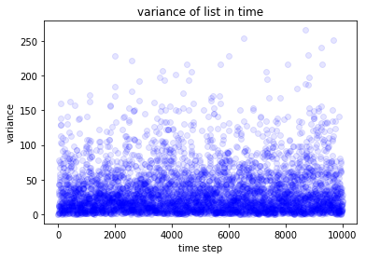

There is actually a problem in this system. It’s really dependent to the random number which random generator generates. If you look above, you’ll observe in time steps the variance of just last 4 I populations changes intensely and sometimes there are probably chaos points in dynamic. So I ran the code for a million steps but it didn’t get stable or something like that. Then I planned to stop the simulation when the variance converges to zero (near zero: I’ve chosen 0.3).

**Effect of $\frac{p}{r}$ ratio**

* **I=1 , p=0.3 , r=0.5**

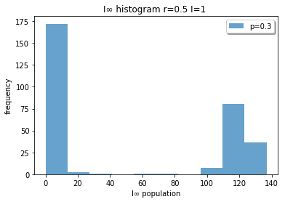

When we look at this graph we understand that we have actually two peaks in graph. When the infected people survive from recovery they give the disease to their neighbors and the overall I will goes to around 120.

* **I=1 , p=0.5, r=0.5**

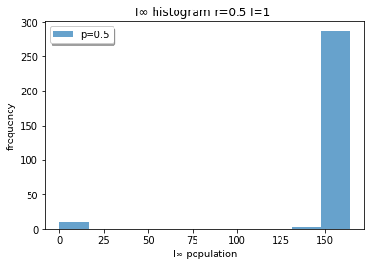

* **I=1 , p=0.7 , r=0.5**

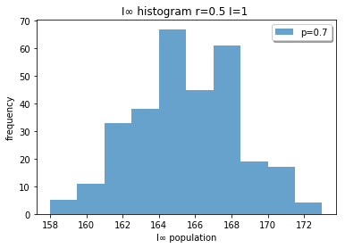

The chance to catch the disease will increase and actually the disease will have an outbreak because frequency of the low I populated happenings has been decreased. The graph below tells us that p and r effect on the average of final I population and also the chance of outbreak.

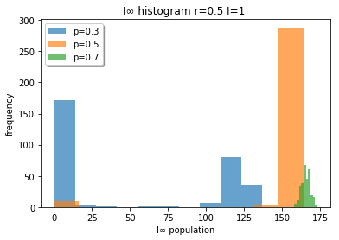

**Effect of $I_{0}$**

* **I=1 , p=0.3 , r=0.5**

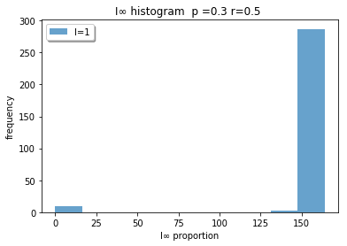

* **I=10 , p=0.3 , r=0.5**

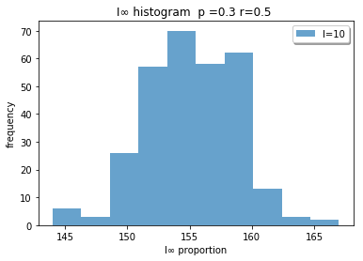

* **I=100 , p=0.3 , r=0.5**

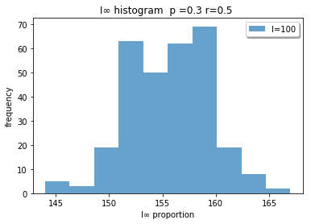

When we look at these three graphs at the same time we can say that the peak and average in any experiment stays near 155 which it tells us that p and r are the parameters which effect the final I population. But when $I_{0}$ increases the chance to recovery will decrease. As shown there are no peak near zero in the $I_{0}=10$ and $I_{0}=100$.

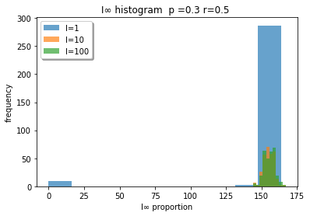

**Phase diagram**

I changed p from zero to 1 in r= 0.5 and $I_{0}=10$. The graph below is the result.

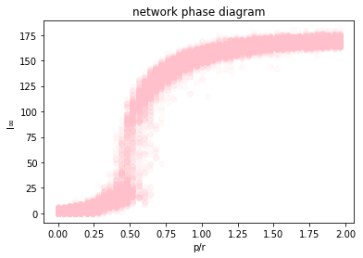

This shape is same as the shape of the phase diagram in mean field view, there is a critical point and nonepidemic and epidemic phases around that. This diagram tells us that we can use the formula of mean field view to stop the dynamic without any calculation or statistics.

**Comparison to SIR**

We can’t compare these two models. The dynamic is different and the time that we stop the simulation is different too. But they are some similarities. Effect of p and r and $I_{0}$ is same. When we talk about the answer of these two models we have distinct point of view. In SIS there is no stable equilibrium point but there is one on SIR-I=0-.

**Plague Data**

To obtain an expression for the epidemic curve, we start by considering equations SIR model), it is possible to remove the variable I from the system by the division of equation by equation (which (after integrating) gives an expression for S in terms of R. Bearing in mind that by deﬁnition S+I +R=1, we can rewrite equation :

$\frac{dR}{dt}=γ(1-S-R)$ After substituting for S from equation S(t)=S(0)e−R(t)R0, this gives

$$\frac{dR}{dt}=γ(1-S(0)e^{-R0R} -R)$$

As it stands, this equation is not solvable. If, however, we assume that R0R is small, we can Taylor expand the exponential term to obtain:

$$\frac{dR}{dt}=γ(1-S(0)+(S(0)R0-1)R-\frac{ S(0){R0}^{2}}{2} R^{2}$$

When we solve it we have:

$$R\left(t\right)=\frac{1}{{{S\left(0\right)R}_{0}}^{2}}(S\left(0\right)R0-1+α\tanh\left(\frac{1}{2}αγt-φ\right))$$

Where

$$α={[{(S\left(0\right)R0-1)}^{2}+2S\left(0\right)I\left(0\right){R0}^{2}]}^{\frac{1}{2}}$$

$$φ =\tanh^{-1}(\frac{1 }{α}\left(S\left(0\right)R0-1\right))$$

To obtain the epidemic curve as a function of time, we need to differentiate equation with respect to time, giving reported cases per unit time

$$\frac{dR}{dt}=\frac{γα^{2}}{2S(0){R0}^{2}}{sech}^{2}\left(\frac{1}{2}αγt-φ\right)$$

I fit this function and also a Gaussian function on this data .The answers are below:

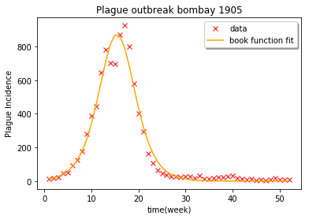

The function derived is $\frac{dR}{dt}=874.11{sech}^{2}\left(0.193t-2.98\right)$ which is near to the book data function:

$$\frac{dR}{dt}=890{sech}^{2}\left(0.2t-3.4\right)$$

The covariance matrix is:

$$\left[\begin{matrix}5.07338470e+02 & 8.53510365e-02 & 1.31622944e+00 \\ 8.53510365e-02 & 3.77522179e-05 & 5.82201978e-04 \\ 1.31622944e+00 & 5.82201978e-04 & 9.49288793e-03\end{matrix}\right]$$

And also found the standard deviation:

$$σ=45.04$$

The second function is the Gaussian:

$$R\left(t\right)=854.9*exp(-\frac{{(x-15.36)}^{2}}{(2{(4.07)}^{2}})$$

The covariance matrix is:

$$\left[\begin{matrix}4.06556474e+02 & 1.42352064e-05 & -1.29276560e+00 \\ 1.42352064e-05 & 1.23313796e-02 & -1.45820609e-07 \\ -1.29276560e+00 & -1.45820609e-07 & 1.23318769e-02\end{matrix}\right]$$

And also found the standard deviation:

$$σ=42.35$$

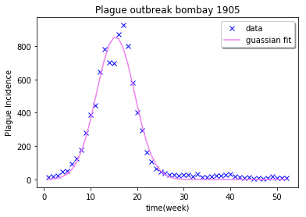

**Covid 19 $R_{0}$ estimation**

Corona virus is now a popular virus which its outbreak is starting and many countries caught it. The virus started to murder people in china and then it went country by country and now the spread out is started in Iran, Italy, and South Korea.

I read two papers about the reproductive number of this virus .One for diamond princess ship which is an international ship with too many cases and also for wuhan –a city in china with our than 80000 cases-.I attached the second with ZIP file .They used Poisson likelihood and also the method of exponential growth rate because this number changes over time actually. They estimated this number in range (2.144, 5.452).But it’s not enough or sufficient .There are many scientists working on this article. But the virus is uncontrollable and acts differently in any country or even city. Other news agencies reported the reproductive number around three (2.72) which is higher than SARS virus or even Ebola and Mers (well-known corona viruses).