

**Modeling phenomena based on Epidemic diseases**

Sharif University of technology

Winter/spring 2020

Homework5 Yasaman Asgari

**Herd immunity, Targeted control, Vaccination**

In this homework we are going to introduce ways to have less infected population when a disease spreads on a society. If there is a way which can reduce the bad effects of spreading diseases, everyone will appreciate to use. Now days by the Covid-19 pandemic all over the world a large group of scientists are looking for the vaccination to lessen deaths and harmful aftereffects on economy.

But there is an important question. Which group of people should be vaccinated to cut down the epidemic as soon as possible? Herd immunity -or group immunity for better sense -is a word used when susceptible are vaccinated or immunized after recovery and the disease is going to be eradicated.

**Methods**

There is a special SIS dynamic for these problems.

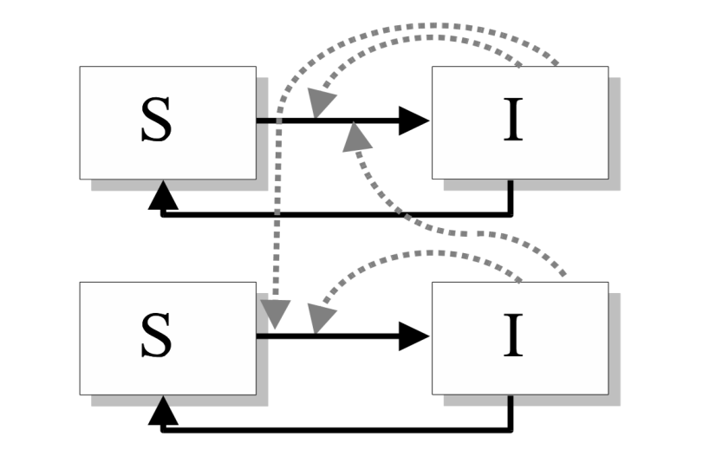

There are two groups in this model: high-risk and low-risk and interactions between them have different rates. $X_{h}$ Is the number of high-Risk susceptible group and $X_{l}$ is the number of low-Risk susceptible group. $Y_{h}$ Is the number of high-Risk infected group and $Y_{l}$ is the number of low-Risk infected group. Now we introduce these 6 parameters: ${ S}_{h}=\frac{X_{h}}{N}$, $S_{l}=\frac{X_{l}}{N}$ and ${ I}_{h}=\frac{Y_{h}}{N}$, $I_{l}=\frac{Y_{l}}{N}$ and also $n_{h}=S_{h}+I_{h}$, $n_{l}=S_{l}+I_{l}$.These are the differential equations by the time:

$\frac{dI_{h}}{dt}=β_{hh}S_{h}I_{h}+β_{hl}S_{h}I_{l}-γI_{h}$

$\frac{dI_{l}}{dt}=β_{ll}S_{l}I_{l}+β_{lh}S_{l}I_{h}-γI_{l}$

$S_{h}=n_{h}-I_{h}$

$S_{l}=n_{l}-I_{l}$

So:

$$\left(\begin{matrix}\frac{dI_{h}}{dt} \\ \frac{dI_{l}}{dt}\end{matrix}\right)=\left(\begin{matrix}β_{hh} & β_{hl} \\ β_{lh} & β_{ll}\end{matrix}\right)\left(good matrix\right)- γ\left(\begin{matrix}I_{h} \\ I_{l}\end{matrix}\right)$$

We also know in matrix $\left(\begin{matrix}β_{hh} & β_{hl} \\ β_{lh} & β_{ll}\end{matrix}\right)$, we should have $β_{hh}+β_{hl}>β_{lh}+β_{ll}$ and we can now define $R_{0}$ for each group based on the constants :

${R_{0}}^{h}=\left(\frac{β_{hh}n_{h}+β_{hl}n_{l}}{γ}\right)$ ${R_{0}}^{l}=\left(\frac{β_{hl}n_{h}+β_{ll}n_{l}}{γ}\right)$

There is a transit phase in which number of infected people is small enough that we can neglect it. So $S_{h}≈n_{h}$ and $S_{l}≈n_{l}$. Now we redefine the equations:

$\frac{dI_{h}}{dt}=β_{hh}n_{h}I_{h}+β_{hl}n_{h}I_{l}-γI_{h}$

$\frac{dI_{l}}{dt}=β_{ll}n_{l}I_{l}+β_{lh}n_{l}I_{h}-γI_{l}$

We can rewrite the equations in linear Algebra’s form:

$$\left(\begin{matrix}\frac{dI_{h}}{dt} \\ \frac{dI_{l}}{dt}\end{matrix}\right)=\left(\begin{matrix}β_{hh}n_{h}-γ_{h} & β_{hl}n_{h} \\ β_{lh}n_{l} & β_{ll}n_{l}-γ_{l}\end{matrix}\right)\left(\begin{matrix}I_{h} \\ I_{l}\end{matrix}\right)$$

By ODE solving methods, we can use the Eigen values and Eigen vectors from linear algebra but actually the biggest Eigen value is enough. So: $I_{h}α\exp\left(λt\right)$ and $I_{l}α\exp\left(λt\right)$

Now it’s time to have the final step: if $ξ$ is the Eigen vector of the Eigen value $λ.$ we should define final fractions of each group.

${I_{h}}^{s}+{I_{l}}^{s}=1$ $\frac{{I_{h}}^{s}}{{I_{l}}^{s}}=\frac{ξ[0]}{ξ[1]}$

**Average Infectiousness period:**

In isolation of each group, Average Infectiousness period (AIP) is $τ=\frac{1}{γ}$.But now for risk groups we should compute the weighted mean. We can say that:

$τ_{h}=\frac{1}{γ_{h}}$ $τ_{l}=\frac{1}{γ_{l}}$

So:

$$τ_{o}={I_{h}}^{s}τ_{h}+{I_{l}}^{s}τ_{l}$$

**Vaccination:**

If we can discharge group of susceptible population by vaccination, $R_{0}$ can be less than 1 .Because dynamic is performed for small amount of susceptible, it can be eradicated sooner. During this homework we actually want to find fraction of each group which their vaccination may be helpful. If the vaccination is done randomly, there is a critical point. From homework 4, we remember that the final number of infected people is $\lim_{t→∞}{I(t)}=1-\frac{1}{R_{0}}$.So critical point for random vaccination is $1-\frac{1}{R_{0}}$.

**Special groups**:

There are two groups introduced in the book: Super-spreaders and super-shedders .There are special because their $β$ matrix have important features.

* **Super-spreaders**

We define super-spreaders as individuals with a very high number of contacts, often due to their occupation. Hence these individuals could generate many secondary cases but are also at a much higher risk of being infected. Therefore, using subscript S to now represent super-spreaders, a suitable transmission matrix would be:

$$β=\left(\begin{matrix}β_{SS} & β_{SR} \\ β_{RS} & β_{RR}\end{matrix}\right)=\left(\begin{matrix}f^{2}β & fβ \\ fβ & β\end{matrix}\right)$$

Where $f>1$ reﬂects greater transmission from and to super-spreaders.

* **Super-shedders**

Therefore, labeling super-shedders with a subscript S and the rest of the population with a subscript R, a suitable transmission matrix would be:

$$β=\left(\begin{matrix}β_{SS} & β_{SR} \\ β_{RS} & β_{RR}\end{matrix}\right)=\left(\begin{matrix}fβ & β \\ fβ & β\end{matrix}\right)$$

Where $f>1$ reﬂects the greater transmission from super-shedders in comparison with the rest of the population. Because super-shedders are assumed to have different epidemiological responses to infection compared to the rest of the population, the $β$ matrix is no longer symmetric.

**Medical treatment and Risk group’s diseases**

Suppose that we have two groups: High-risk and Low-risk and there are only 3600 nurses working in hospitals. Each nurse can increase recovery rate by 0.001( $\frac{1}{contaign dynamic time })$. $β$ Matrix is:

$$β=\left(\begin{matrix}10 & 0.1 \\ 0.1 & 1\end{matrix}\right)$$

$n_{h}=0.2$, $n_{h}=0.8$. $γ$ Matrix is: $γ=\left(\begin{matrix}γ{{+f}_{nurse}}^{H} \\ γ{{+f}_{nurse}}^{L}\end{matrix}\right)$.In this example we can assume:

$γ=1$ $f_{nurse}=0.001N_{nurse}$ $N_{nurse}={N_{nurse}}^{H}+{N_{nurse}}^{L}=3600$

So we can rewrite:

$$γ=\left(\begin{matrix}γ_{h} \\ γ_{l}\end{matrix}\right)=\left(\begin{matrix}1+0.001{N_{nurse}}^{H} \\ 1+0.001(3600-{N_{nurse}}^{H})\end{matrix}\right)$$

By the methods introduced above, we can define:

${R_{0}}^{h}=\left(\frac{β_{hh}n_{h}+β_{hl}n_{l}}{1+0.001{N_{nurse}}^{H}}\right)$ ${R_{0}}^{l}=\left(\frac{β_{hl}n_{h}+β_{ll}n_{l}}{1+0.001(3600-{N_{nurse}}^{H})}\right)$

$$\left(\begin{matrix}\frac{dI_{h}}{dt} \\ \frac{dI_{l}}{dt}\end{matrix}\right)=\left(\begin{matrix}β_{hh}n_{h}-γ_{h} & β_{hl}n_{h} \\ β_{lh}n_{l} & β_{ll}n_{l}-γ_{l}\end{matrix}\right)\left(\begin{matrix}I_{h} \\ I_{l}\end{matrix}\right)$$

We should now change ${N_{nurse}}^{H}$ from 0 to 3600 and figure $R_{0}.$

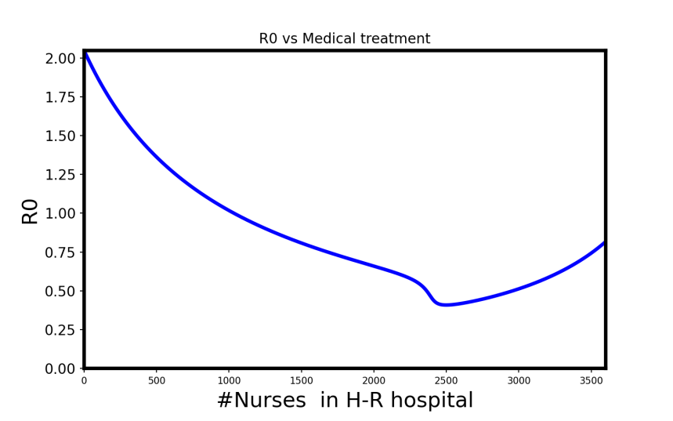

But now we want to eradicate the disease. By the book’s definition we should only choose Number of nurses in high risk group in condition $R_{0}<1$. So:

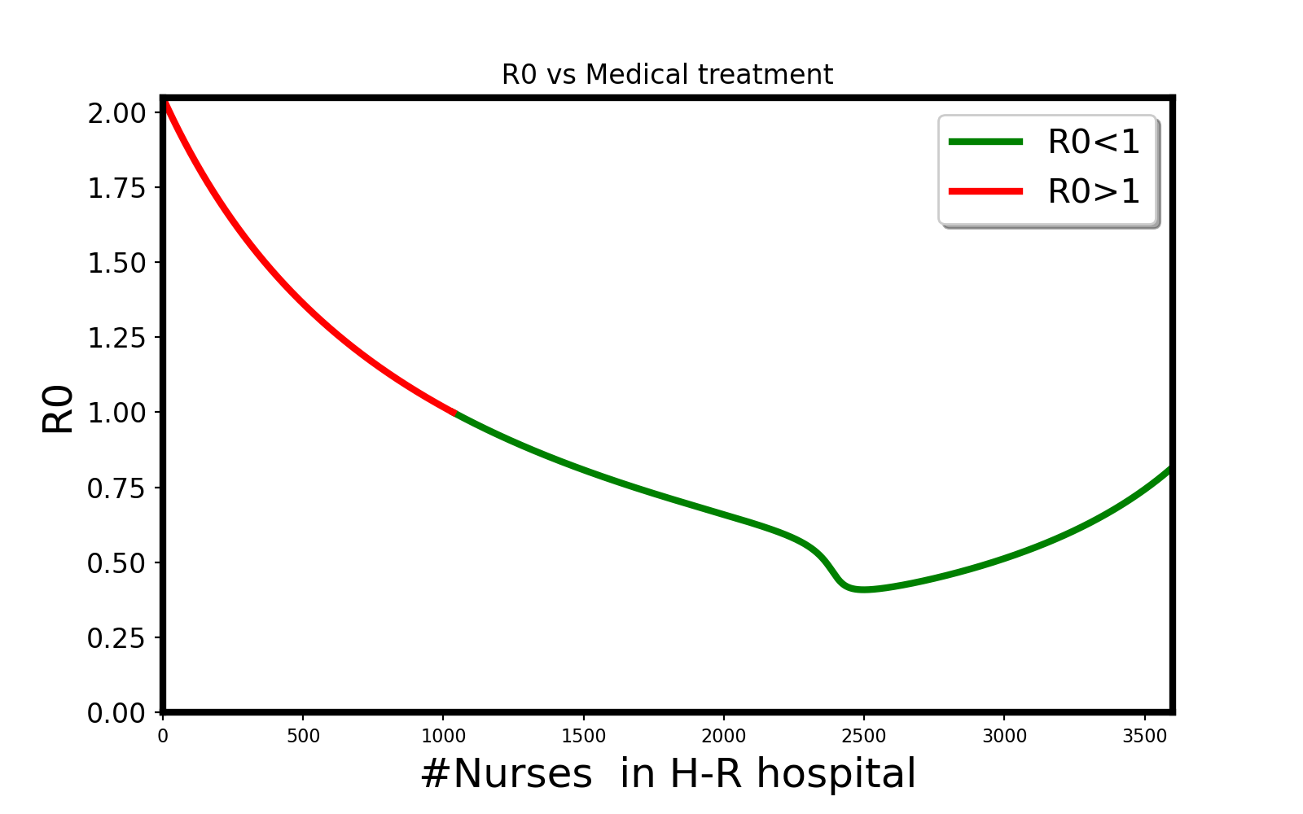

$${N_{nurse}}^{H}=1035$$

$${N_{nurse}}^{L}=2565$$

Now we want to minimize AIP ($τ_{0}$). We should now change ${N_{nurse}}^{H}$ from 0 to 3600 and figure $τ_{0}.$

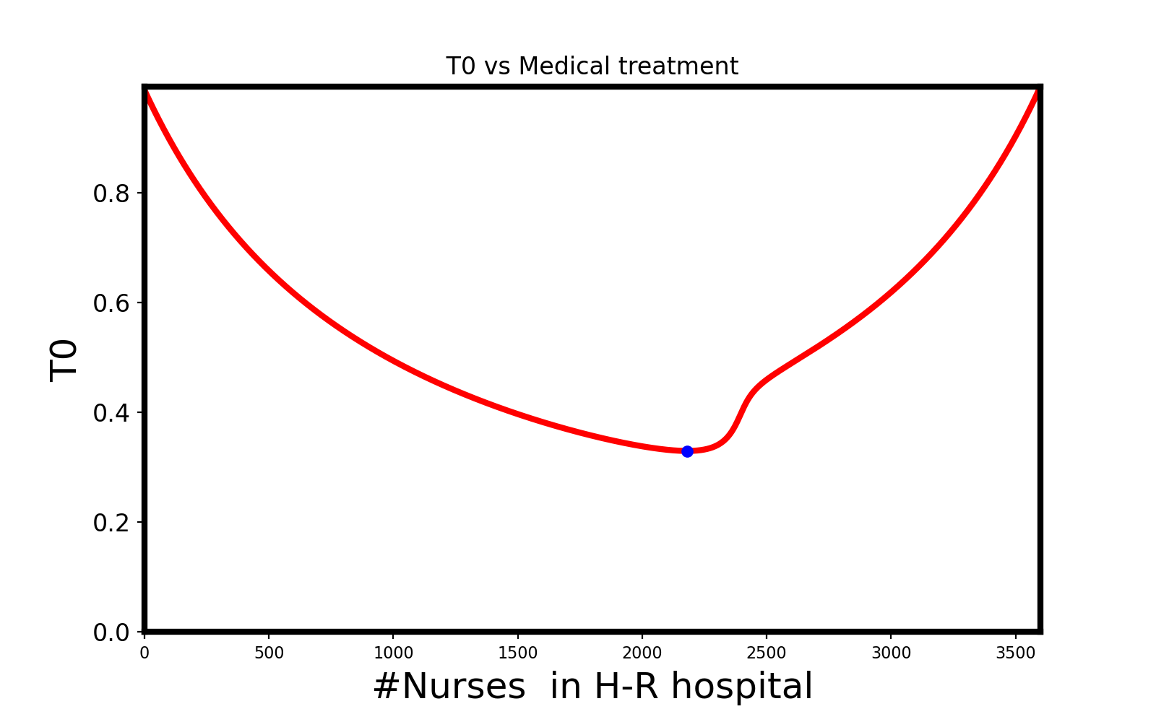

$$τ_{0}=0.33$$

$${N_{nurse}}^{H}=2181$$

$${N_{nurse}}^{L}=1419$$

**Targeted control**

There are two groups of people: High-risk and Low-risk group with the infectiousness matrix:

$$β=\left(\begin{matrix}10 & 1 \\ 1 & 2\end{matrix}\right)$$

And initial conditions: $n_{h}=0.2$, $n_{l}=0.8$ and $γ=1$.We want to vaccinate the groups, But cost of vaccination is different from one group to another.

$$\left(\begin{matrix}\frac{dI_{h}}{dt} \\ \frac{dI_{l}}{dt}\end{matrix}\right)=\left(\begin{matrix}β_{hh}n_{h}-γ_{h} & β_{hl}n_{h} \\ β_{lh}n_{l} & β_{ll}n_{l}-γ_{l}\end{matrix}\right)\left(\begin{matrix}I_{h} \\ I_{l}\end{matrix}\right)$$

First of all we want to make the disease endemic. So we should have $R_{0}<1$.I will change ${n_{vaccinated}}^{h}$ from zero to $n_{h}$ and find ${n_{vaccinated}}^{l}$ which satisfies $R_{0}<1$ and ${n_{vaccinated}}^{l}<n_{h}$. But pay attention that ${R_{0}}^{h}$ and ${R_{0}}^{l}$ are computed by ${n_{eff}}^{l}=n_{l}-{n_{vaccinated}}^{l}$ and ${n_{eff}}^{h}=n_{h}-{n_{vaccinated}}^{h}$.

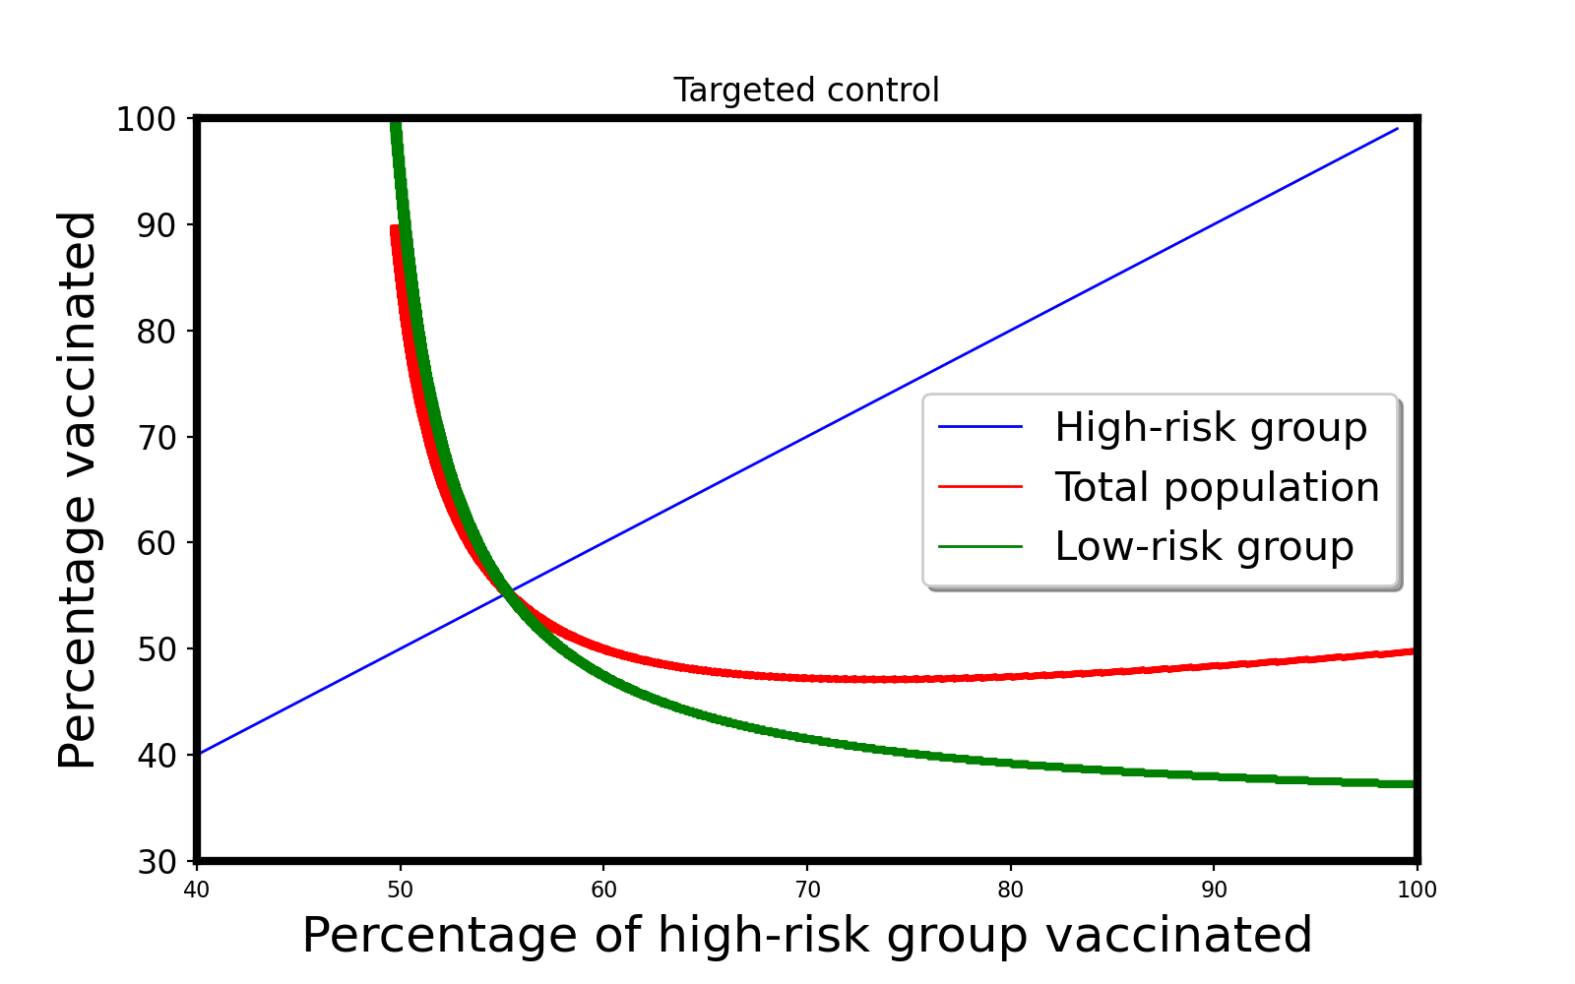

Now we want to pay attention to the cost of vaccination. There are three scenarios:

* Costs are equal.
* Vaccination’s cost of High-risk group is 2X.
* Vaccination’s cost of High-risk group is 1.5X.

All the points in green graph give us situations in which disease will be endemic and $R_{0}<1$.If we want to minimize the cost we should plot the total cost which is defined as:

$${cost}_{tot}={c{ost}^{h}*n_{vaccinated}}^{h}+{c{ost}^{l}*n_{vaccinated}}^{l}$$

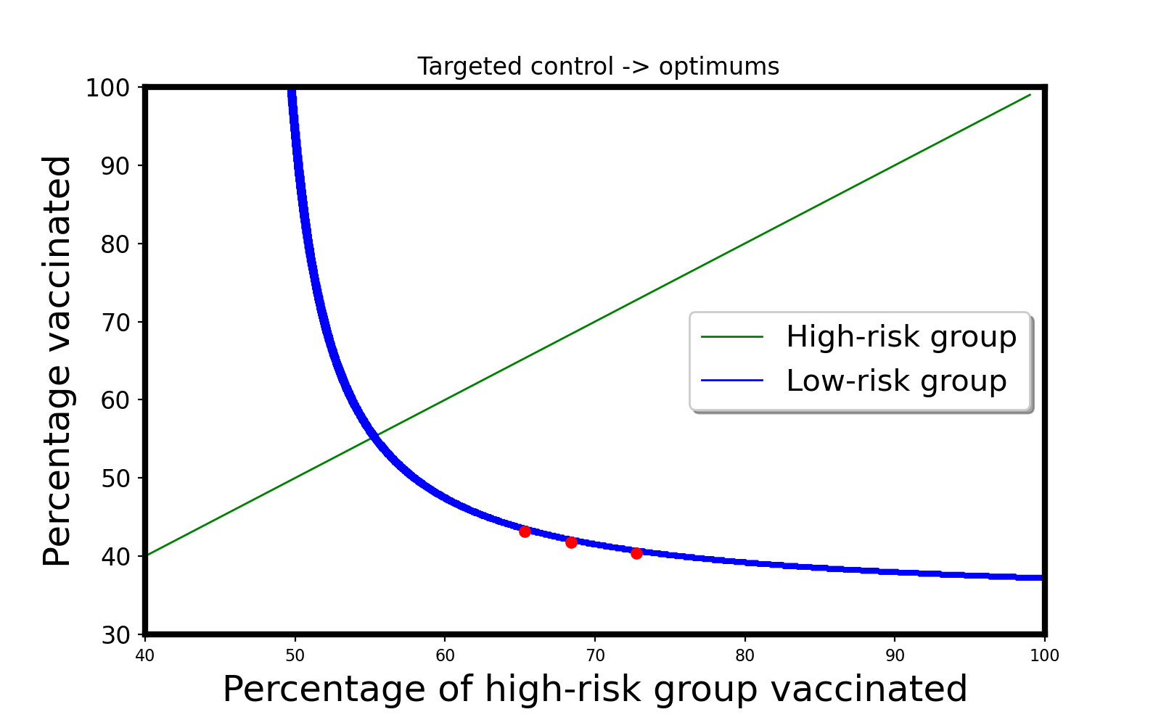

$${p_{vaccinated}}^{h}=72.75 \%$$

$${p_{vaccinated}}^{l}=40.375\%$$

$$Cost :equal$$

$${p_{vaccinated}}^{h}=65.3 \%$$

$${p_{vaccinated}}^{l}=43.12\%$$

$$Cost :2X$$

$${p_{vaccinated}}^{h}=68.4 \%$$

$${p_{vaccinated}}^{l}=41.75\%$$

$$Cost :1.5X$$

**Society Simulation**

Assume that 10 percent of population is Super-shedder and 20 percent is Super –spreader. Others are normal. We want to randomly vaccinate each group and the critical point is $1-\frac{1}{R_{0}}$.So we should compute $R_{0}$.We rename: Super-shedder $→$ 2, Super-spreader $→$ 1 and normal $→$ 3. Differential equations are defined as below:

$\frac{dI_{1}}{dt}=β_{11}S_{1}I_{1}+β_{12}S_{1}I_{2.}+β_{13}S_{1}I_{3.}-γI_{1}$

$\frac{dI_{2}}{dt}=β_{21}S_{2}I_{1}+β_{22}S_{2}I_{2.}+β_{23}S_{2}I_{3.}-γI_{2}$

$\frac{dI_{3}}{dt}=β_{31}S_{3}I_{1}+β_{32}S_{3}I_{2.}+β_{33}S_{3}I_{3.}-γI_{3}$

$S_{1}=n_{1}-I_{1}$

$S_{2}=n_{2}-I_{2}$

$S_{3}=n_{3}-I_{3}$

Initial conditions are:

$$f=1.2 γ=0.1 S_{1}≈n_{1}=0.2 S_{2}≈n_{2}=0.1 { S}_{3}≈n_{2}=0.7 β=1$$

$$\left(\begin{matrix}\frac{dI_{1}}{dt} \\ \frac{dI_{2}}{dt} \\ \frac{dI_{3}}{dt}\end{matrix}\right)=\left(\begin{matrix}β_{11}S_{1}-γ & β_{12}S_{1} & β_{13}S_{1} \\ β_{21}S_{2} & β_{22}S_{2}-γ & β_{23}S_{2} \\ β_{31}S_{3} & β_{32}S_{3} & β_{33}S_{3}-γ\end{matrix}\right)\left(\begin{matrix}I_{1} \\ I_{2} \\ I_{3}\end{matrix}\right)=\left(\begin{matrix}f^{2}βS_{1}-γ & f^{2}βS_{1} & fβS_{1} \\ fβS_{2} & fβS_{2}-γ & βS_{2} \\ fβS_{3} & fβS_{3} & βS_{3}-γ\end{matrix}\right)\left(\begin{matrix}I_{1} \\ I_{2} \\ I_{3}\end{matrix}\right)$$

Now we should find the greatest Eigen Value and Eigen Vector of the matrix:

$$\det\left|\left(\begin{matrix}f^{2}βS_{1}-γ & f^{2}βS_{1} & fβS_{1} \\ fβS_{2} & fβS_{2}-γ & βS_{2} \\ fβS_{3} & fβS_{3} & βS_{3}-γ\end{matrix}\right)-Iλ\right|$$

$=det\left|\begin{matrix}f^{2}βS_{1}-γ-λ & f^{2}βS_{1} & fβS_{1} \\ fβS_{2} & fβS_{2}-γ-λ & βS_{2} \\ fβS_{3} & fβS_{3} & βS_{3}-γ-λ\end{matrix}\right|$

Subtract column 1 from column 2

$=det\left|\begin{matrix}f^{2}βS_{1}-γ-λ & γ+λ & fβS_{1} \\ fβS_{2} & -\left(γ+λ\right) & βS_{2} \\ fβS_{3} & 0 & βS_{3}-γ-λ\end{matrix}\right|$

Add column 2 to column 1

$$=det\left|\begin{matrix}f^{2}βS_{1} & γ+λ & fβS_{1} \\ fβS_{2}-\left(γ+λ\right) & -\left(γ+λ\right) & βS_{2} \\ fβS_{3} & 0 & βS_{3}-γ-λ\end{matrix}\right|$$

$=det\left|\begin{matrix}f^{2}βS_{1} & γ+λ & fβS_{1} \\ fβS_{2}+f^{2}βS_{1}-\left(γ+λ\right) & 0 & βS_{2}+fβS_{1} \\ fβS_{3} & 0 & βS_{3}-γ-λ\end{matrix}\right|$

Add line 1 to line 2

$=det\left|\begin{matrix}0 & γ+λ & fβS_{1} \\ -\left(γ+λ\right) & 0 & βS_{2}+fβS_{1} \\ f\left(γ+λ\right) & 0 & βS_{3}-\left(γ+λ\right)\end{matrix}\right|$

Subtract f*column 3 from column 1

So:

$$\left(γ+λ\right)(\left(βS_{2}+fβS_{1}\right)\left(f\left(γ+λ\right)\right)-\left(-\left(γ+λ\right)\right)\left(βS_{3}-\left(γ+λ\right)\right)=0$$

Then:

$$\left(γ+λ\right)\left(γ+λ\right)(\left(βS_{2}+fβS_{1}\right)f+\left(βS_{3}-\left(γ+λ\right)\right)=0$$

It has two roots:

$\left(γ+λ\right)=0$ $\left(fβS_{2}+f^{2}βS_{1}+βS_{3}-\left(γ+λ\right)\right)=0$

The roots are:

$λ=-γ$ $λ=β( fS_{2}+f^{2}S_{1}+S_{3})-γ$

Now the initial conditions help us to find which one is the biggest Eigen value. But it’s obvious that second one is bigger. However, I have no energy to find the Eigen vectorC:\Program Files (x86)\Microsoft Office\MEDIA\CAGCAT10\j0286034.wmf.Notice that, book tells us that $\left[R_{0}-1\right]γ=λ$ (if $γ$ is equal for all groups).So:

$$\left[R_{0}-1\right]γ=β\left( fS_{2}+f^{2}S_{1}+S_{3}\right)-γ$$

$$R_{0}=1+\frac{β\left( fS_{2}+f^{2}S_{1}+S_{3}\right)-γ}{γ}=\frac{β\left( fS_{2}+f^{2}S_{1}+S_{3}\right)}{γ}$$

So the critical point is: $1-\frac{γ}{β\left( fS_{2}+f^{2}S_{1}+S_{3}\right)}$

By substituting Initial condition we have:

$$R_{0}=1.08$$

But we can work with initial conditions and also coding to find the Eigen Values and Vectors.

Pay attention that we should now compute ${R_{0}}^{1}$, ${R_{0}}^{2}$, ${R_{0}}^{3}$ by assumption of isolation. And find Eigen vector of greatest Eigen value .Then $R_{0}$ is the inner product of these two vectors.

${R_{0}}^{1}=\frac{β_{11}n_{1}+β_{12}n_{2}+β_{13}n_{3}}{γ}$

${R_{0}}^{2}=\frac{β_{21}n_{1}+β_{22}n_{2}+β_{23}n_{3}}{γ}$

1. ${R_{0}}^{3}$ = $\frac{β_{31}n_{1}+β_{32}n_{2}+β_{33}n_{3}}{γ}$

So: ${R_{0}}^{iso}=\left(\begin{matrix}\frac{β_{11}n_{1}+β_{12}n_{2}+β_{13}n_{3}}{γ} \\ \frac{β_{21}n_{1}+β_{22}n_{2}+β_{23}n_{3}}{γ} \\ \frac{β_{31}n_{1}+β_{32}n_{2}+β_{33}n_{3}}{γ}\end{matrix}\right)$

If $ξ$ is the Eigen vector of the Eigen value $λ.$ we should define final fractions of each group.

${I_{1}}^{s}+{I_{2}}^{s}+{I_{3}}^{s}=1$ $m_{1}=\frac{{I_{2}}^{s}}{{I_{1}}^{s}}=\frac{ξ[1]}{ξ[0]}$ $m_{2}=\frac{{I_{3}}^{s}}{{I_{1}}^{s}}=\frac{ξ[2]}{ξ[0]}$

${I_{1}}^{s}+m_{1}{I_{1}}^{s}+m_{2}{I_{1}}^{s}=1→{I_{1}}^{s}=\frac{1}{1+m_{1}+m_{2}}$, ${I_{2}}^{s}=\frac{m_{1}}{1+m_{1}+m_{2}}$, ${I_{3}}^{s}=\frac{m_{2}}{1+m_{1}+m_{2}}$

So: $I^{s}=(\frac{1}{1+m_{1}+m_{2}})\left(\begin{matrix}1 \\ m_{1} \\ m_{2}\end{matrix}\right)$

Then answer is the inner product:

$$R_{0}=: {R_{0}}^{iso}*I^{s}$$

$=\left(\frac{1}{1+m_{1}+m_{2}}\right)((\frac{β_{11}n_{1}+β_{12}n_{2}+β_{13}n_{3}}{γ}+\left(\frac{β_{21}n_{1}+β_{22}n_{2}+β_{23}n_{3}}{γ}\right)m_{1}+m_{2}\left(\frac{β_{31}n_{1}+β_{32}n_{2}+β_{33}n_{3}}{γ}\right))$

And the answer is: $1-\frac{1}{R_{0}}$.

Now by substituting Initial conditions we have:

$$R_{0}=1.08$$

It shows that we have done the calculations perfectly!