
Modeling phenomena based on Epidemic diseases
Sharif University of technology
Winter/spring 2020
Homework1 Yasaman Asgari
SIR model
Introduction
A very simple model that has been introduced is class in the SIR model .It’s a really easy way for describing a society – bacteria, virus and also human– over a time Range. This model divides the population into 3 distinct groups which are mutually independent, Susceptible (if previously unexposed to the disease), Infected (if currently colonized by the disease), and Recovered (if they have successfully cleared the infection). Now we should organize a helpful but simple interaction between these three groups. First of all, we assume that the entire participants in this society are connected with each other and at any moment, it means that any participant can communicate with the other groups and also its team mates. Then we assume that the overall population is constant .in other words No one will go in and outside the society. In order to better describe the model we use the portions (Number of each group divided by N -overall population-) and also (S+I+R =1).
We introduce two important types of interaction .First the interaction between S, I (infection process) and second between I, R (recovery process).So the portions of population will differ from time to time. Rate of these two interactions will definitely influence on S, I, R which the rate of first type is named Infective Rate () and the second is named Recovery Rate ().

Formulating the SIR model
These are the differential equations of the Society.
- 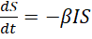
- 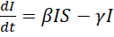
- 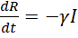

Which the image precisely describes this Model.
S
I
R
I

If we try to find an answer for these coupled differential equations, it will be a little hard. We can’t find an easy answer .We can find the answer of the equation and relation within these groups in absence of time but not really helpful. So we use computer codes to find Numerical solution .I’ve chosen python as my preferred programming language then we use a function in Library "scipy.integrate" which is named "solve_ivp".I defined the function and tried to solve the equation in range (0,20).
As a sample this is the answer of the equation with N=100, S= 98, I=2, R=0,,.
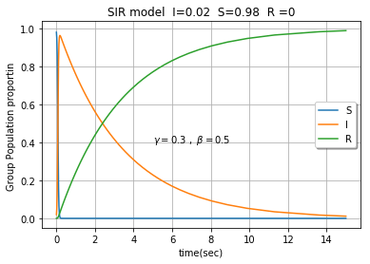
Important Parameters
If we delicately look at these equations we understand that Graphs of the functions are related to specific parameters. At first sight we might mention but by a closer look, we notice that the proportion of is more important because it shows strength of the disease and also relation between the group’s population. Other important parameter is initial proportions of the groups named by I (0), R (0), S (0). They should satisfy conditions S(0) > 0, I(0) > 0, and R(0)=0. There is question. What factors will determine whether an epidemic will occur or if the infection will fail to invade? To answer this, we start by rewriting equation (2) in the form
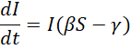
If the initial fraction of susceptible group (S (0)) is bigger than, thenand the infection “dies out” so the “threshold phenomenon” occurs. We know that the Zero Function is an answer of all the Equations and it will cause a” Potato Equilibrium “but just a little difference in the initial proportions will make the Recovered Group approach the bound 1. As we mentioned for an infectious disease with an average infectious period given by, and a transmission rate β, its basic reproductive ratio is determined by .But we pay attention to this parameter in homework2.
First we put the S (0) and constant and change the (S (0) = 0.98, R (0) = 0, I (0) =0.02,).
- =10
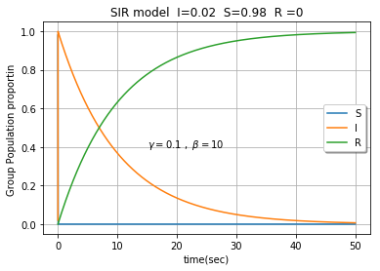

- =0. 1
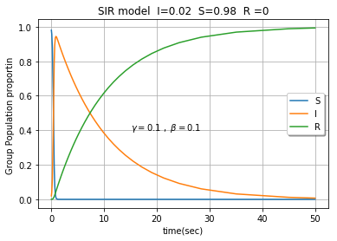
- =0.01
- 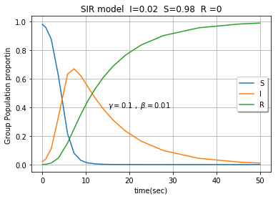

- =0.001
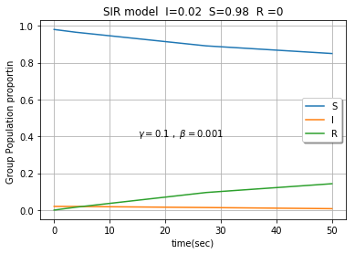
We saw that changing really influence on the behavior of the functions of S, I, R. Now we will change the initial proportions. We set (R (0) = 0, =0.01).
- S (0) = 0.02 ,I (0) =0.98
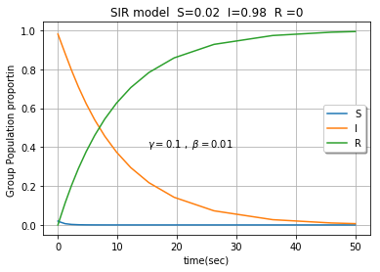
- S (0) = 0.25 ,I (0) =0.75
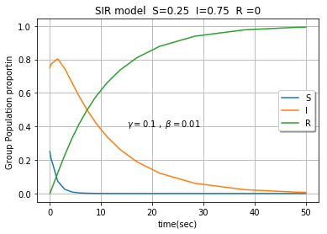
- S (0) = 0. 5 ,I (0) =0.5

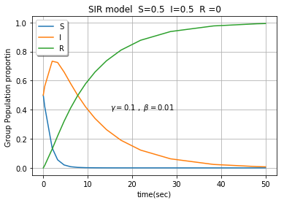

- S (0) = 0.7 5 ,I (0) =0.25
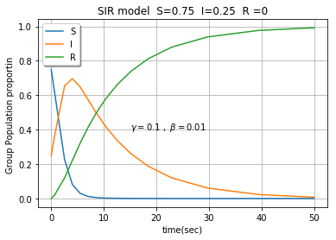
- S (0) = 0.98 ,I (0) =0.02
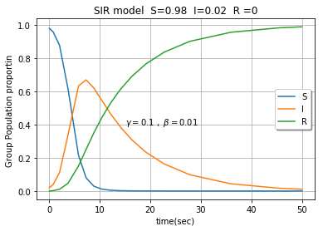

Analyzing Graphs
When we change the we observe that if the infection rate is too higher, S decreases fast but R will not grow highly but after that all S goes to I then R increases until it reaches 1.if the infection rate is lower, we have a peak on the I function then it reduces to zero and R reaches to 1. But if infection rate is too lower than recovery rate, R reaches a constant named which is important in HW2 .

- S (0),I (0)
Increasing S (0) moves the peak of I function to the right, it means that if the I (0) is higher the diseases will be sooner epidemic and then the recovery phase will start.

Examples
- Inﬂuenza
- Chickenpox
- Liar News
- Traditional beliefs

Good luck

