For log in website <https://advokatasist.com/dashboard.php> and app you can use username: [tsvetidream@gmail.com](mailto:tsvetidream@gmail.com), password: 1915 Source code you can download from here <https://files.fm/u/dfb53nas>

1. Name of the package should be change ( with this name it is not possible to be published in google play) (DONE)
2. Notification – explanation: User can add date and time when he/she has court hearing/насрочване, court deadline (message from court)/краен срок (съдебно съобщение) and meeting/среща с клиент and for all of these he/she can set and reminder/напомняне. This is the main goal of the app user to be sure that he/she would not missing some appointments. For this part it will need you to make firebase (server part) to be used for notifications.

When user gets notification from app and clicks on the notification it should open the actual info page. I mean for example if user gets notification for coming meeting when he/she clicks on it to open app on screen for info page for this exact meeting.

Text for notification:

for meeting : "Предстояща среща на ......(date),

for court hearing "Предстоящо съдебно заседание на ......“,

for deadline - message from court : "Изтичащ краен срок на ... „.

Мake it to get notification when it is set remineder/ напомняне and 1 hour before actual taks I mean for example when you are fill in that meeting will be on 18.09.2019 at 15:00h and set reminder for 17.09.2019 at 17:00h. user to receive notification on 17.09.2019 at 17:00h that meeting coming on 18.09.2019 at 15:00 and again on 18.09.2019 at 14:00 to receive same notification. And if user is not set reminder fields are empty again to receive notification one hour later - on 18.09.2019 at 14:00 to receive notification that meeting coming on 18.09.2019 at 15:00h

1. When log in message that appear should be translated “Wellcome …username…” – translation “Добре дошли …..“ **(Done)**
2. Logo should be put to appear as phone icon (I will send it) and name of the app should be change to “Адвокатасист“ **(Done)**
3. Back function does not work how it is supposed to be on most of the screens it backs on a log in page **(Done)**
4. Icons in the header for different screen after opening few screens get mixed and do not appear right icon for the open screen **(Done)**

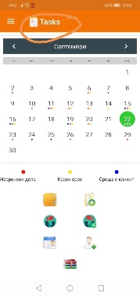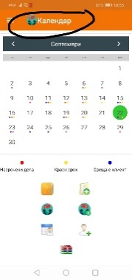“(DONE)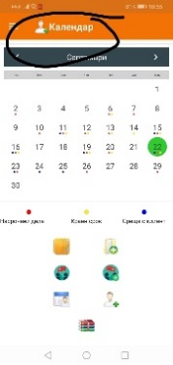

1. List of tasks – Списък Задачи:

* Name in the header is not translated it should be “Списък задачи“(DONE)
* There is missing info that should be shown on this screen (please see calendar for 02.10.2019 on website it should look same way in the app – see the screenshots:

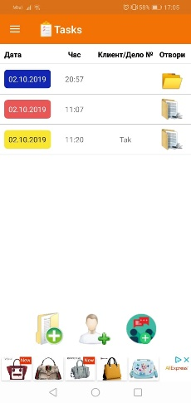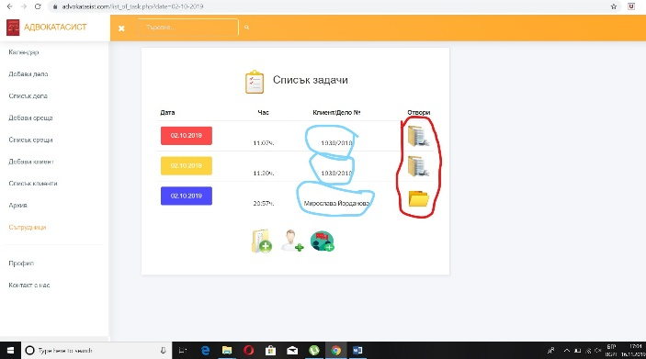

* Icon in app do not works – the two that look same open a case info ( дело ) and the yellow one open a meeting info page (детайли за среща), when user click on them he/she should be able to see same page as he/she opens it from pages case list – “списък дела“ and list of meetings “списък срещи“

1. Add new case/ Добави дело – When you add new client and fill in field for phone keyboard is number and when you fill in mail keyboard become in Latin letters. It would be nice to be same when you add respondent it is much easier for user. Please make clock to be from 00:00 to 24:00 not with am and pm because in BG will do not use am and pm. This is for all clocks in the app same format (DONE)
2. Case info – “Дело“

– I just create case 1611/2019 and when I open it from list of cases I see case info but the court “Съд“ is not the one which I was choose when I added the case.

* I can add client but only from the list. I can`t add new one like in add case page
* Buttons: Добави плащане – add payment, Добави насрещна страна – add respondent, Изпълнено – done, „Успешно“ „Неуспешно“ and Добави към архив - add to archive do not works all that they need is to be connected with api, api works correctly it is checked
* Edit function do not work too
* there is missing fields about judgement when this part is not filled in when the case is added when you open case info this part should looks and work like in the add case. When user add info in judgment part from case info page this new data is saved after user choose „Успешно“ „Неуспешно“ – Please see how it works in website
* 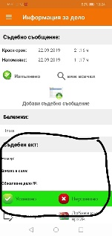 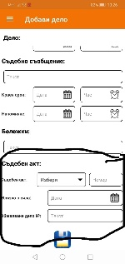
* In page Archive – „Архив“ case info ( дело) pages are same pages that are open from list of cases (списък дела) so they have same problems like above and this is why same buttons do not work and on this screen and the last button is wrong icon should be different one and text next to it should be „Поднови“ – its function is to move the case from archive back to the list of cases page.
* Under calendar there is icon that is for archive page but there is a bug and it open case info page, so this should be fixed and if you want to open archive you should use navigation bar/menu in the left

1. "Списък дела" – List of cases page – on this page is missing the search bar. User should be able to search by writing case number or name of client. Please see how it work in website. Same for Archive – Архив page.(Partially DONE)
2. Add meeting - „Добави среща“ (DONE)

* There is some error because when user add new meeting everything looks fine and after click on save it forward to the list of meetings – „списък срещи“ (how it should be) but in the list name of the client does not show just some letters and when you click on icon to open details for meeting instead of the name of the client you see the same nonsense letters

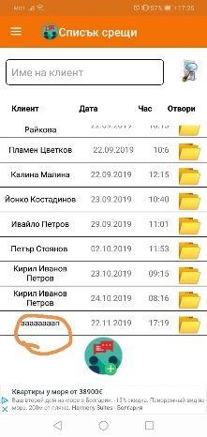

– There is some problem with the clock when you click on edit meeting and edit the time and choose for minutes from 0 to 09 it does not work correct it is only when you edit when you add new meeting it is working correct.

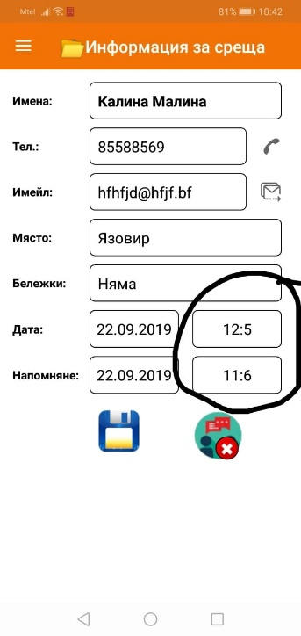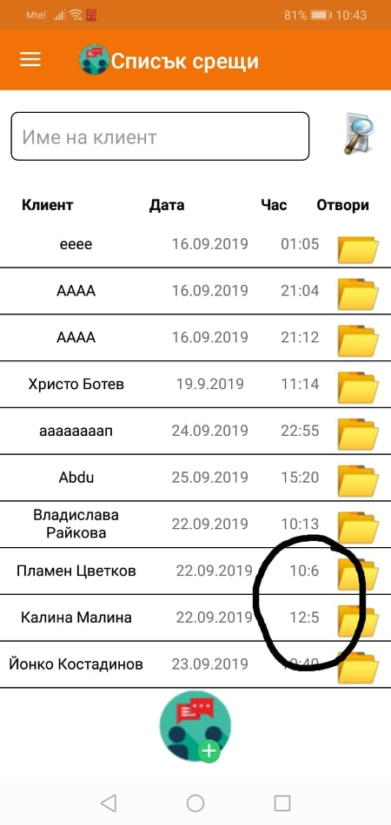

When you click to add new meeting using the icon under the list of meeting it open the last meeting which you were choose before I see this:

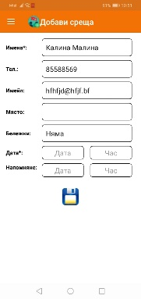

On other screens where have the add meeting button it works correctly. (DONE)

1. List of client - “Списък клиенти“

* On this screen there is an error whit the button add case – „добави дело“. When you choose add case it open page for add case but the info for the client is not transferred. Same when you click add case icon and from client info (клиент) page (DONE)

1. Associates – „Сътрудници“ (explanation for you to understand easier - User can add associate lets say secretary and when he add associate system give him username and password and user provide this username and password to the person and this way this person/assocciate/ secretary can log in and fill in data for the user, to manage his task and so on. Associate do not has access to user profile and can`t add other associates all other functions are available for him. You can see how it works in website)

* When you click to edit an associate and after that click on save it appear message that it is successful but nothing after that just stays on edit screen. After click on save and after message it should forward to associate list page. (DONE)
* Добави сътрудник – add associate (this is button in the end of associate page)– the text in the header of this screen is not translated it should be “Добави сътрудник“. (DONE)
* I can log in as an associate using username and password given from the site but do not see any info. As an associate I should be able to see everything like the main user just without main user profile page and associate`s pages.

1. When you click изход/log out it appear message its translation is: Сигурни ли сте, че искате да излезете от приложението(DONE)
2. Function to change the password/смени парола in user profil does not work it seems everything right but when you try to log in with New password you can’t, old password is still valid so the change is not saved. (DONE)
3. Function for forgotten password/забравена парола do not work **(Done)**
4. Remove adds - “Премахни реклами“ – Remove add is not done, product key and lycense key from google play are not add to the code.
5. Automatic login functionality should be fixed (DONE)
6. When you make new registration in part “Условия за ползване и Декларация за поверителност“ this part should be link to this info in the website <https://advokatasist.com/register.php>

After click on “Регистрация“ it should appear message that telling that to finish registration you should confirm your mail and should check folder spam. There is such message in the web site. (DONE)