**Test 1: Does not allow null in ProductName (non-null column) while adding data (clicking save)**

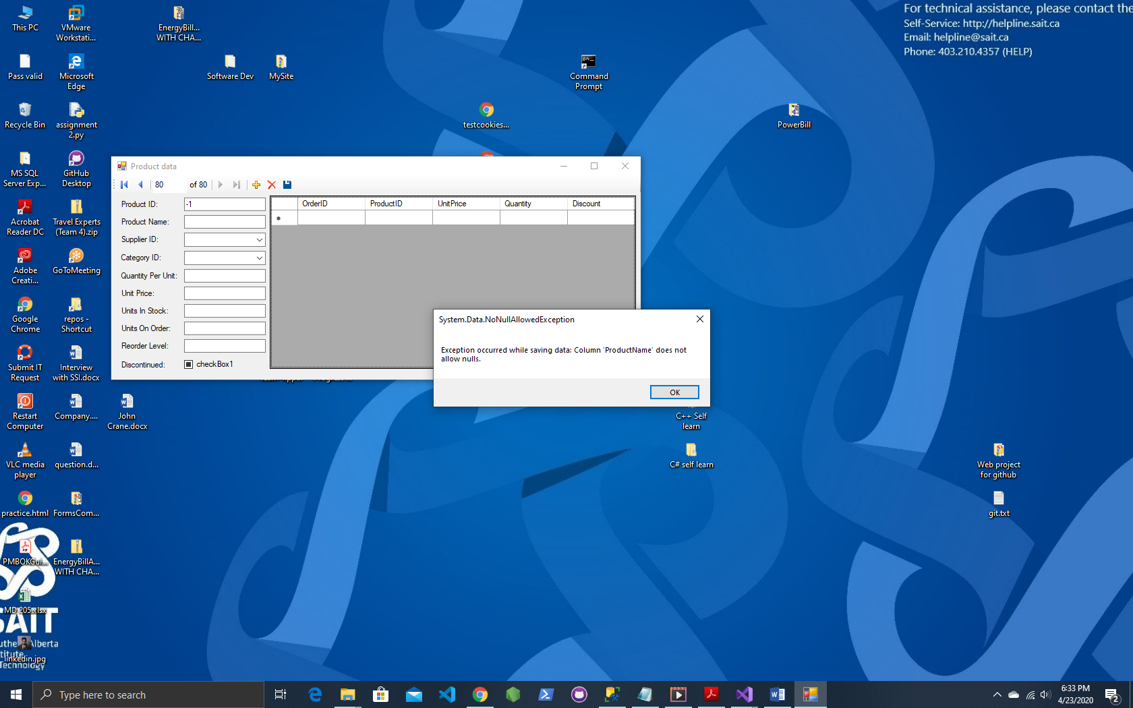

**Test 2: Does not allow null in Discontinued (non-null column), needs to be either checked or unchecked.**

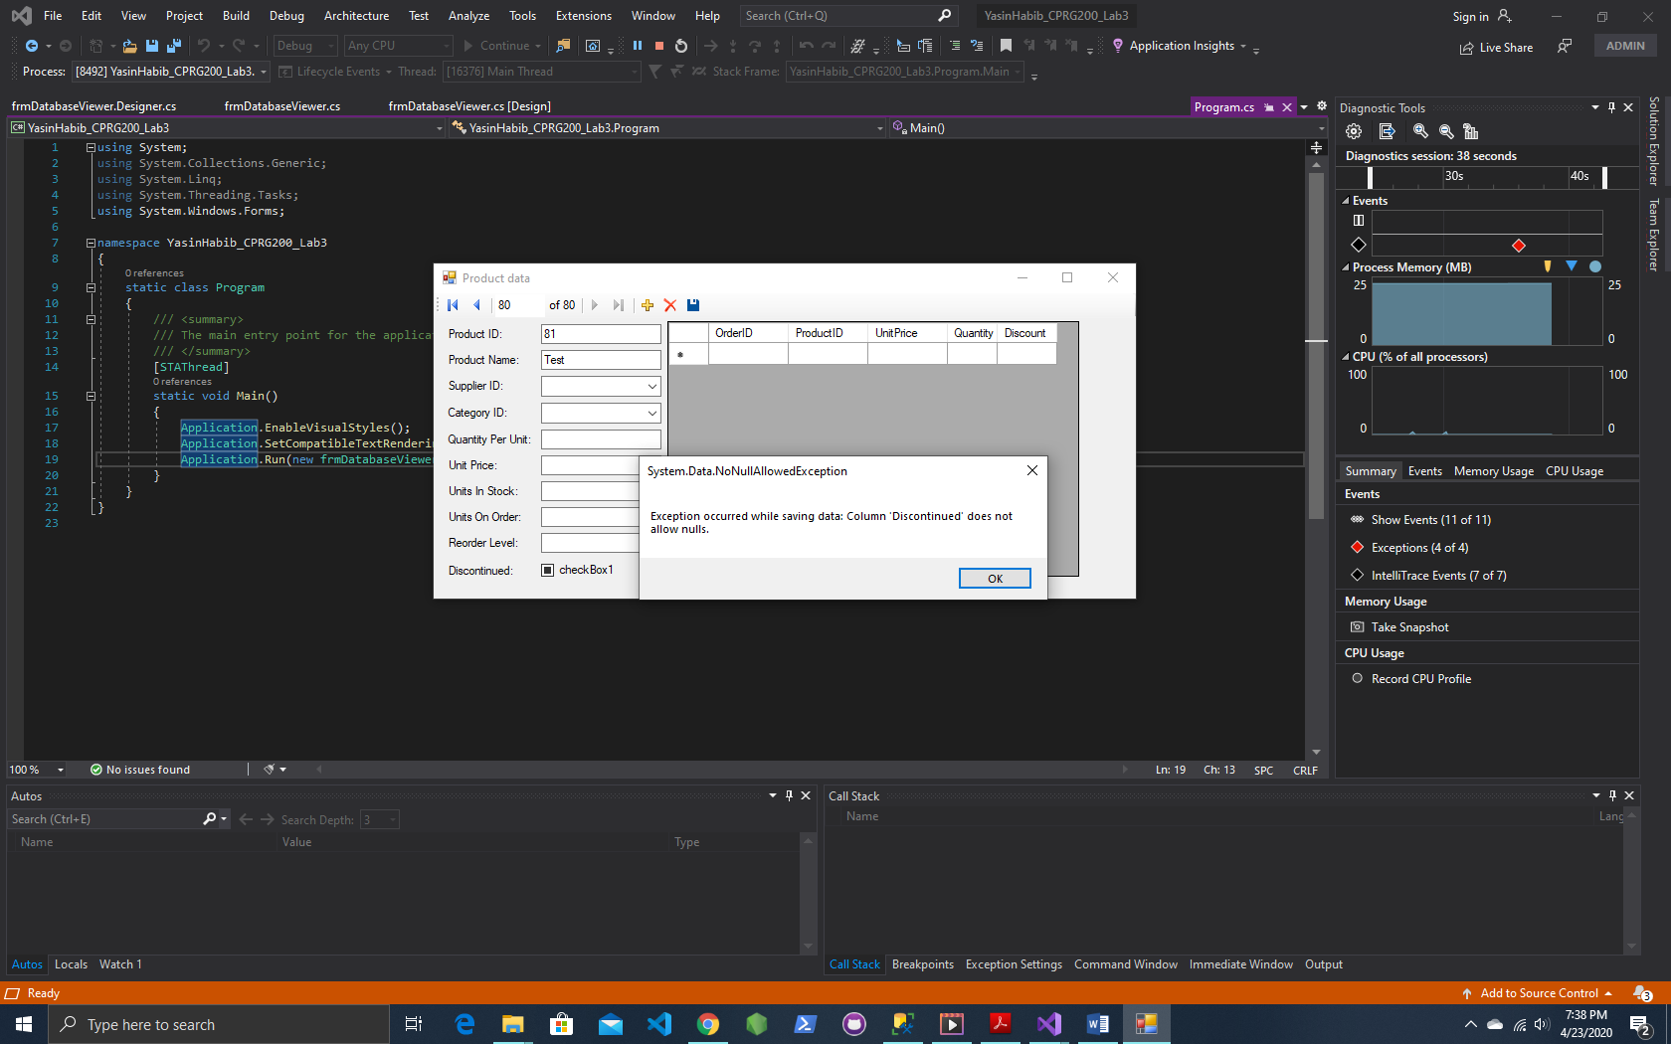

**Test 3: Modified value (unitPrice) from SQL, gives warning message while trying to save.**

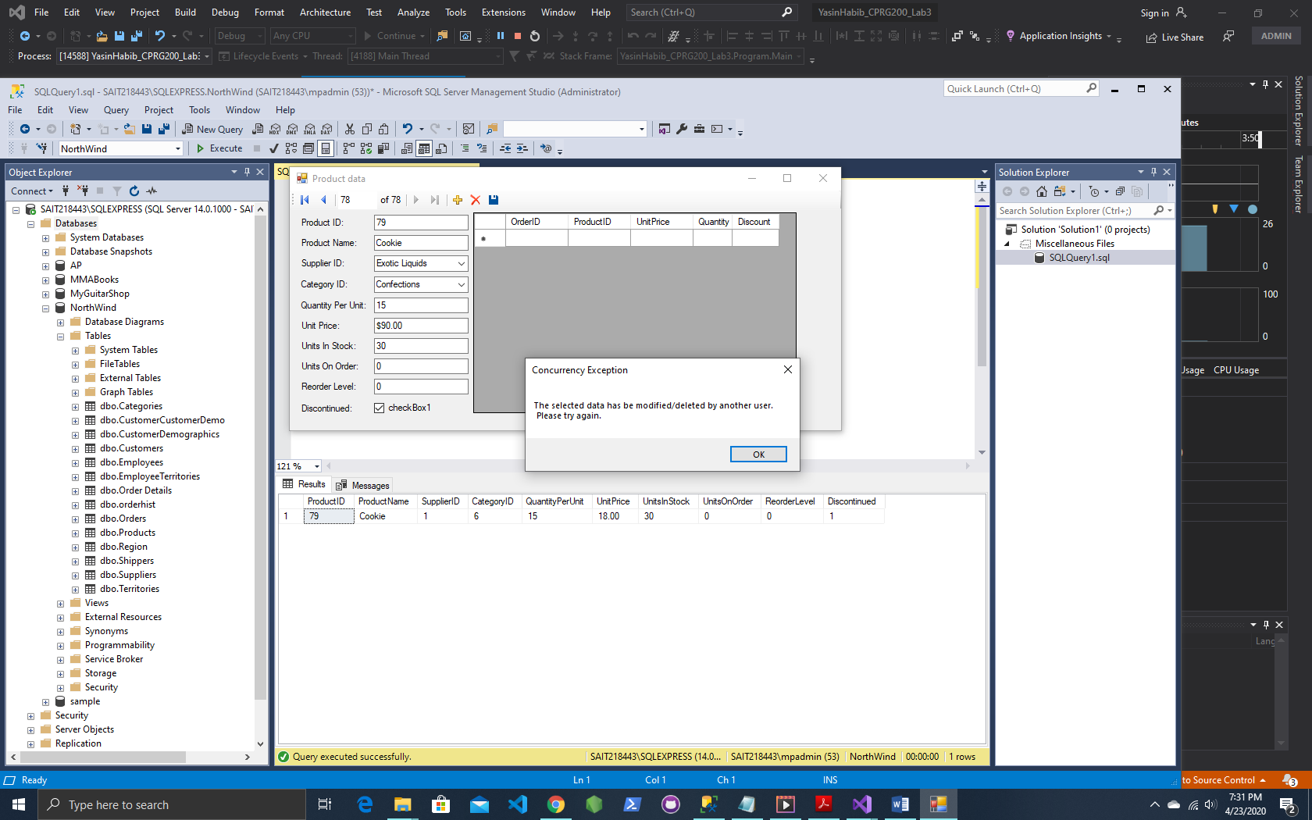

**Test 4: Error handler on delete when another user has deleted data and user on the app tries to make a change and save it.**

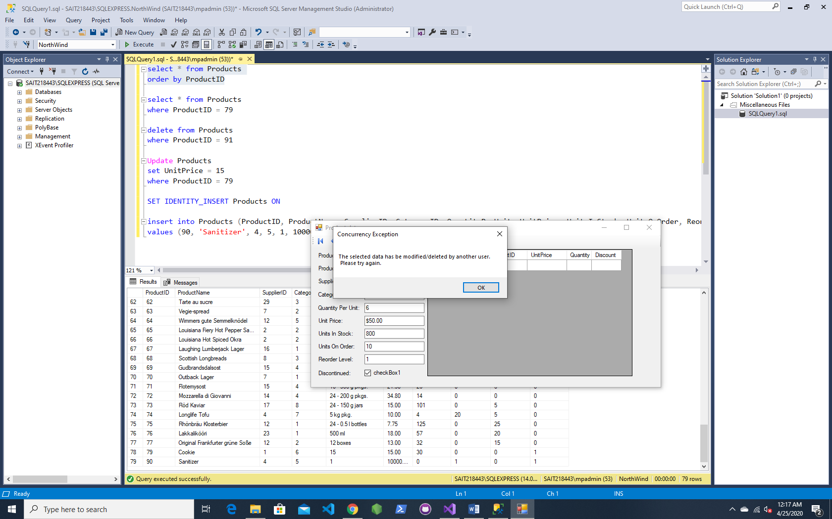

**Test 5: This error occurred while trying to add data (leaving non-null column, null) on the C# app, but instead of pressing save or delete, if the user clicks any other button, it gives an Exception unhandled error on Program.cs.**

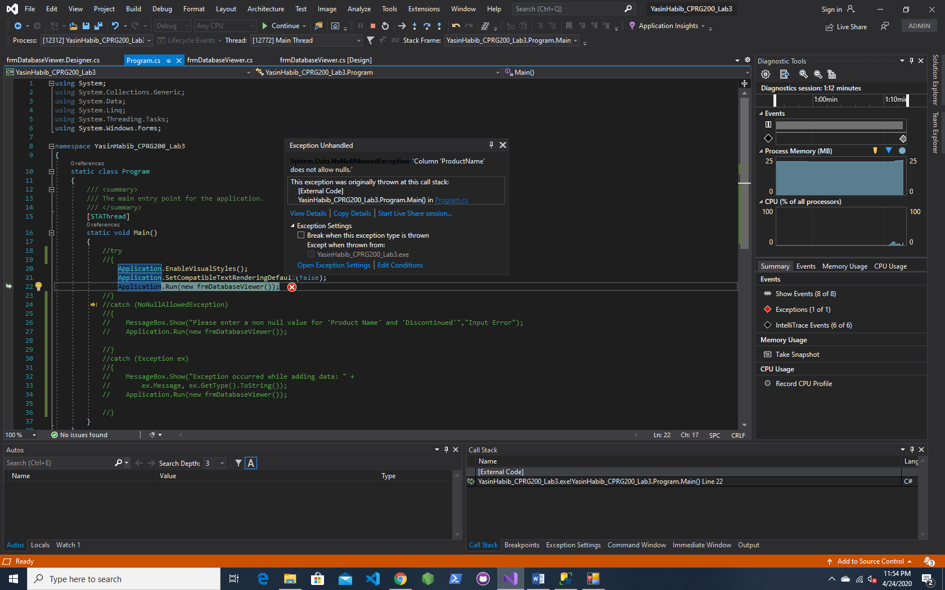

**Fix: Shows an error code, closes the app and relaunches it. (This was a group work as I had to brainstorm some ideas with a classmate who was also having this exception handling error)**

