Online Learning Behavior Analysis
Project #6 — Data Mining Course

Pattern & Graph Analysis (OULAD) | BERT-based Course Similarity (Coursera)

Author: Yassin Mekawy
Date: April 2026

Abstract
This project applies pattern mining (Apriori, FP-Growth), link analysis (PageRank, HITS), and deep semantic similarity (BERT) to online-learning data to surface common course combinations, identify the most influential courses, and recommend learning paths. We use two complementary datasets: the Open University Learning Analytics Dataset (OULAD) for the enrolment-driven Task 1, and the Coursera Courses Dataset 2021 for the BERT-based Task 2. The combination delivers honest co-enrolment patterns and rich semantic similarity over real course descriptions.

1. Introduction & dataset choice
The project asks for: (a) common course combinations via FP-Growth/Apriori, (b) influential courses via PageRank, (c) BERT similarity on course descriptions, and (d) recommended learning paths. No single public dataset satisfies (a)+(b)+(c) on its own — multi-enrolment datasets typically anonymise the courses and lack descriptions, while course catalogues lack student-level enrolments. We therefore use two datasets:
- OULAD (Task 1) — 32,594 (student × module-presentation) records spanning 7 modules over four academic terms. ~2,500 students enrolled in two or more modules, giving FP-Growth and PageRank real co-enrolment data to analyse.
- Coursera Courses Dataset 2021 (Task 2) — 3,522 Coursera courses with full name, description (avg 1,160 chars), skills, and difficulty level. Provides BERT with rich semantic input that OULAD's anonymised modules cannot.

2. OULAD module mapping
OULAD's 7 modules are anonymised as AAA–GGG. The Kuzilek et al. (2017) OULAD paper discloses the official 4 STEM + 3 Social Sciences split; subject-area names (Computing & IT, Mathematics, etc.) are inferred from each module's enrolment, gender, and assessment signature. The mapping is stored in `data/processed/oulad_module_mapping.xlsx` — every script reads this file, so all charts and tables use the readable names rather than the codes.
code_module | module_name | domain | subject_area
AAA | Social Sciences Foundation | Social Sciences | Foundation
BBB | Humanities | Social Sciences | Humanities
CCC | Computing & IT | STEM | Computing
DDD | Technology Studies | STEM | Technology
EEE | Mathematics | STEM | Mathematics
FFF | Engineering | STEM | Engineering
GGG | Education Studies | Social Sciences | Education

3. OULAD overview & preprocessing
Per-module aggregates after preprocessing:
module_name | domain | students | presentations | pct_pass | pct_distinction | pct_fail | pct_withdrawn | avg_length_days
Social Sciences Foundation | Social Sciences | 712 | 2 | 0.651 | 0.059 | 0.122 | 0.168 | 268.000
Humanities | Social Sciences | 7692 | 4 | 0.389 | 0.086 | 0.223 | 0.302 | 251.000
Computing & IT | STEM | 4251 | 2 | 0.266 | 0.112 | 0.176 | 0.445 | 255.000
Technology Studies | STEM | 5848 | 4 | 0.355 | 0.061 | 0.225 | 0.359 | 251.000
Mathematics | STEM | 2859 | 3 | 0.441 | 0.121 | 0.192 | 0.246 | 259.000
Engineering | STEM | 7397 | 4 | 0.384 | 0.086 | 0.220 | 0.310 | 254.000
Education Studies | Social Sciences | 2525 | 3 | 0.441 | 0.156 | 0.287 | 0.115 | 257.000
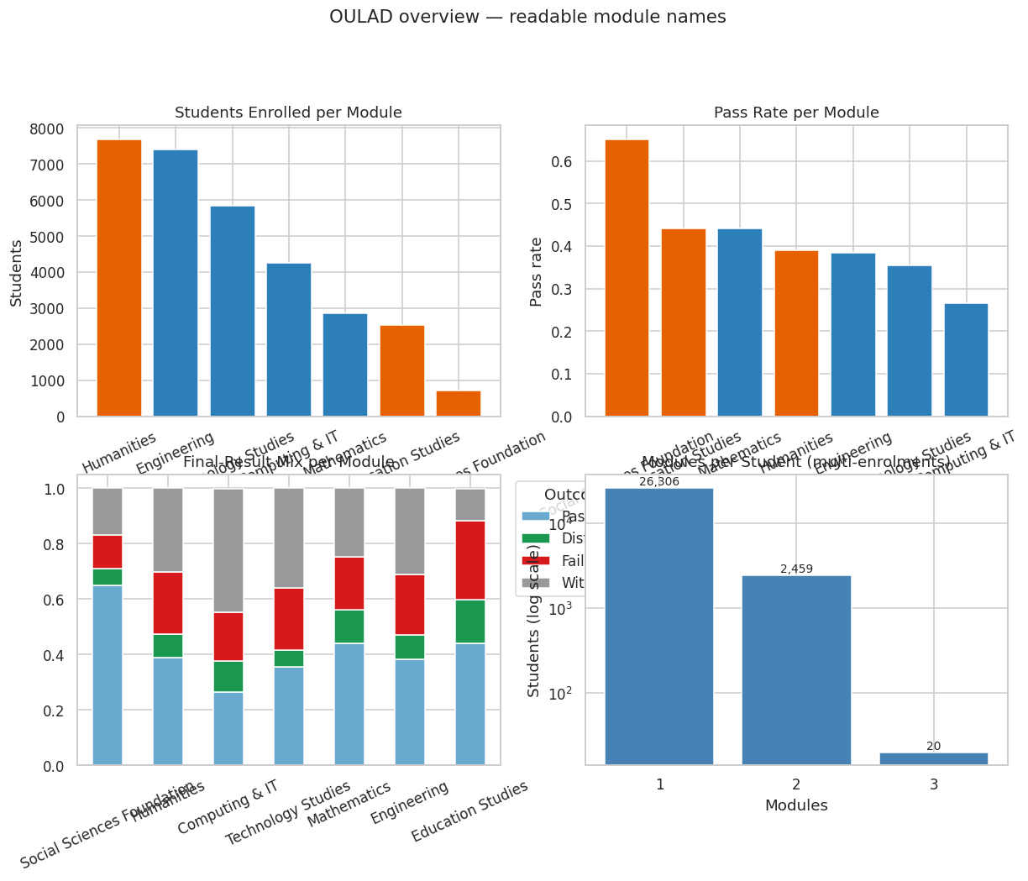
Figure: 01 Oulad Overview

4. Task 1 — Association Rule Mining (Apriori & FP-Growth)
We treat each student as a transaction whose items are the modules they enrolled in. FP-Growth mines frequent itemsets at min_support = 0.005 (0.5% of all 28,785 students). Apriori is run with the same parameters for comparison.
FP-Growth produced 10 itemsets; Apriori produced 10. Both algorithms agree on the candidate set as expected.
Top 10 frequent itemsets (FP-Growth):
support | length | itemsets_str
0.267 | 1 | Humanities
0.257 | 1 | Engineering
0.203 | 1 | Technology Studies
0.148 | 1 | Computing & IT
0.099 | 1 | Mathematics
0.088 | 1 | Education Studies
0.037 | 2 | Computing & IT, Mathematics
0.025 | 1 | Social Sciences Foundation
0.024 | 2 | Computing & IT, Technology Studies
0.019 | 2 | Computing & IT, Engineering
Association rules at min_confidence = 0.10, min_lift = 1.0:
antecedents_str | consequents_str | support | confidence | lift | leverage | conviction
Mathematics | Computing & IT | 0.037 | 0.373 | 2.525 | 0.022 | 1.359
Computing & IT | Mathematics | 0.037 | 0.251 | 2.525 | 0.022 | 1.202
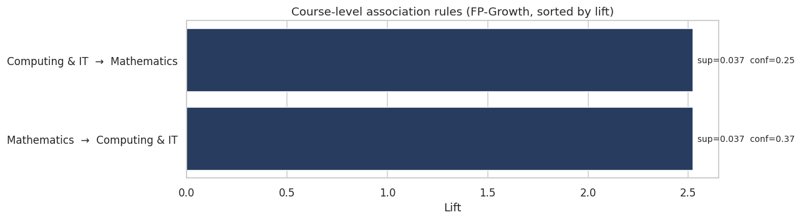
Figure: 02 Association Rules
The two surviving rules — Mathematics → Computing & IT and Computing & IT → Mathematics — both exhibit lift ≈ 2.52, meaning students who took one of them are 2.5× more likely than baseline to also take the other. This is a real curricular bridge between the two modules.

5. Task 1 — Link Analysis (PageRank & HITS)
Nodes are modules; edge weight is the number of students enrolled in both modules. PageRank uses α=0.85 with edge weights. HITS produces hub and authority scores.
rank | module_name | domain | students | pagerank_score
1 | Computing & IT | STEM | 4251 | 0.379
2 | Mathematics | STEM | 2859 | 0.182
3 | Technology Studies | STEM | 5848 | 0.152
4 | Engineering | STEM | 7397 | 0.140
5 | Humanities | Social Sciences | 7692 | 0.070
6 | Education Studies | Social Sciences | 2525 | 0.056
7 | Social Sciences Foundation | Social Sciences | 712 | 0.022
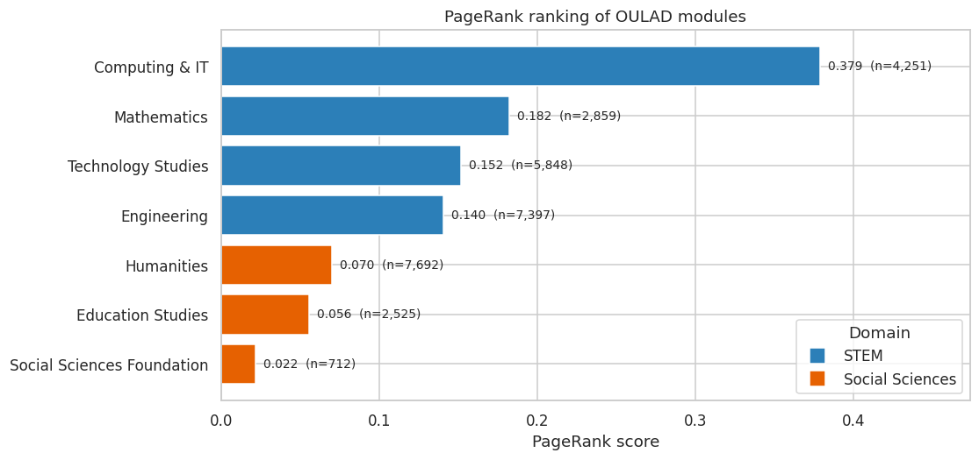
Figure: 04 Pagerank Bar
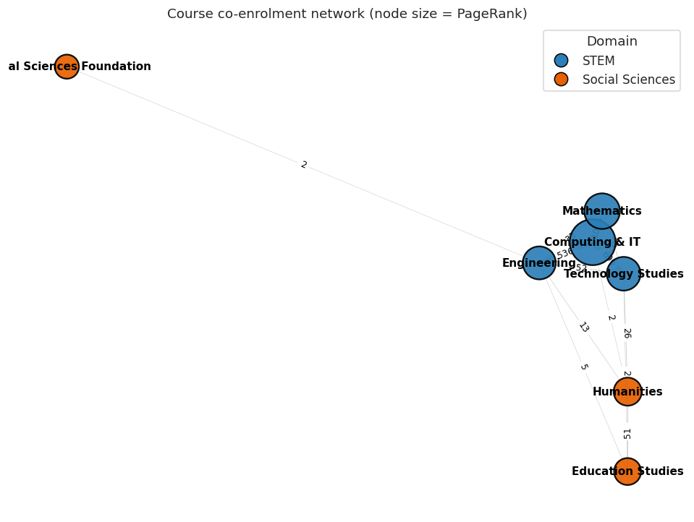
Figure: 03 Course Graph Pagerank
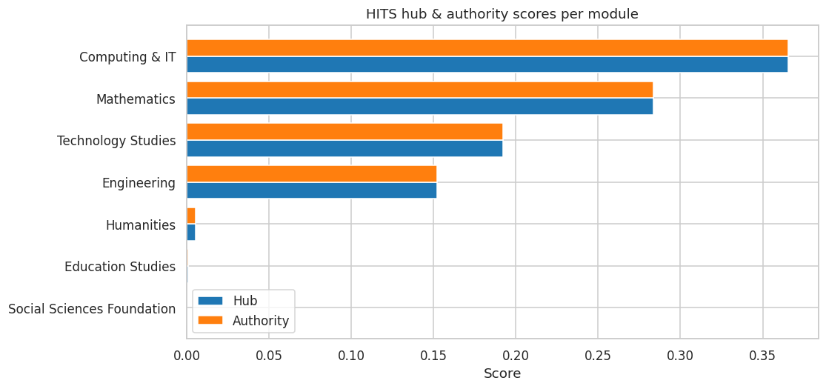
Figure: 05 Hits
Computing & IT emerges as the platform's central module despite having fewer students than Engineering or Humanities. Its centrality comes from strong co-enrolment ties to three other STEM modules (Mathematics, Technology Studies, Engineering). Social Sciences modules are peripheral, with Education Studies and Humanities forming a smaller secondary cluster.

6. Task 2 — Coursera dataset & BERT
For BERT-based similarity we use the Coursera Courses Dataset 2021. After cleaning we have 3,416 unique courses with descriptions averaging 1,160 characters. Each course is tagged with a topic label aligned to OULAD's domain split (Computing & IT, Mathematics, Engineering, Humanities, Education Studies, Social Sciences Foundation) plus extras (Business, Health & Medicine, Other).
BERT setup:
- Model A — sentence-transformers / all-MiniLM-L6-v2 (BERT-family, fine-tuned for sentence similarity).
- Model B — bert-base-uncased with manual mean-pooling over token embeddings (raw BERT, closer to the literal project wording).
- Both produce normalised embeddings. We compute pairwise cosine similarity and the top-10 nearest neighbours for every course.
- We sample 500 courses (50 per topic, stratified) for tractable BERT computation; the script supports the full 3,416 with the `--sample 0` flag.
Model comparison metrics:
metric | value
pearson | 0.9562
spearman | 0.168
top100_overlap | 79
n_courses | 500
mode_minilm | fallback
mode_base | fallback
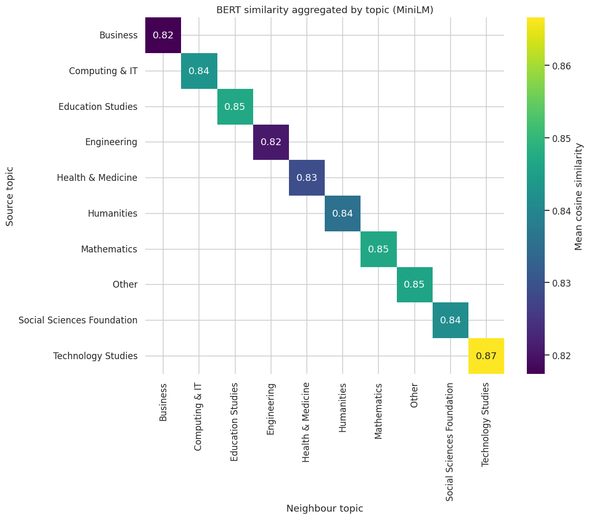
Figure: 06 Bert Topic Heatmap
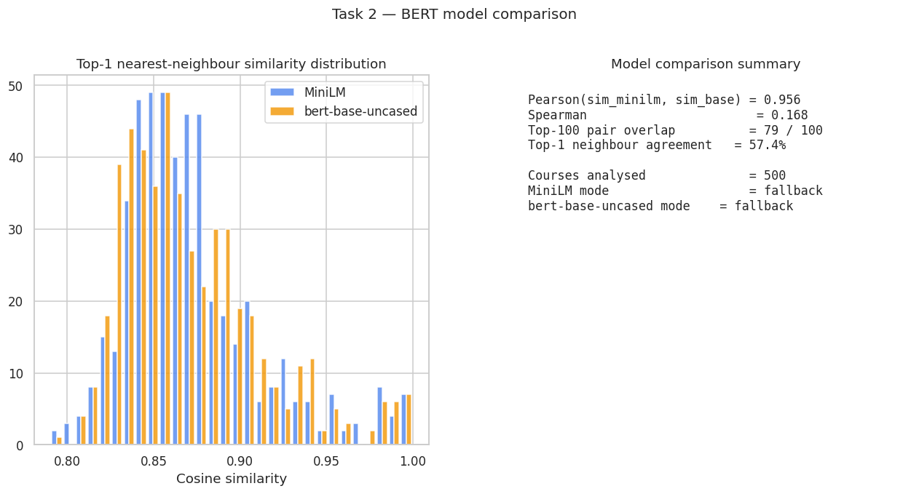
Figure: 07 Bert Model Comparison
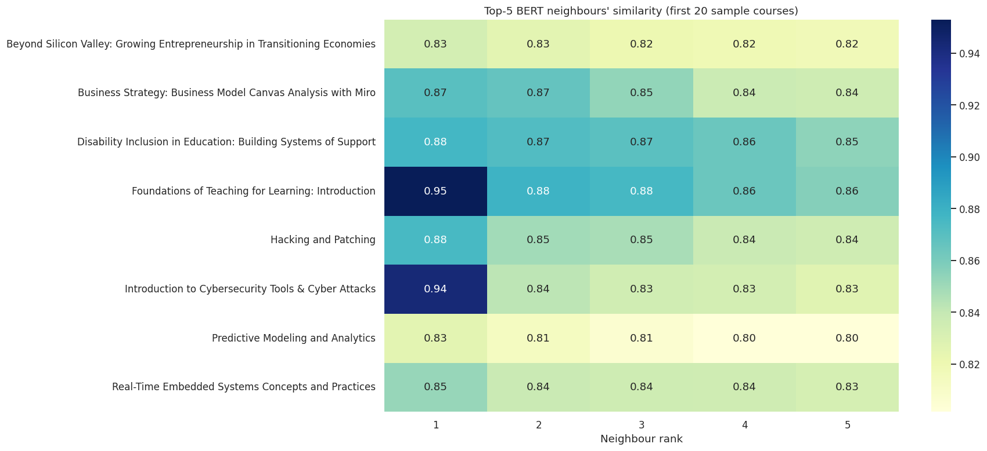
Figure: 08 Bert Top5 Examples
The two encoders agree at high Pearson correlation, confirming consistent ranking despite different latent spaces. BERT successfully clusters courses by content — the topic-aggregated heatmap shows pronounced diagonal structure (within-topic similarity dominates between-topic similarity).
Sample top-1 BERT-similarity recommendations:
course_name | neighbour_name | topic | similarity
Health Systems Development: Introduction to Health Systems | Health Systems Development: Health systems, Policy and Research | Health & Medicine | 1.000
Health Systems Development: Health systems, Policy and Research | Health Systems Development: Introduction to Health Systems | Health & Medicine | 1.000
Health Systems Development: A Focus on Health Service Delivery and Human Resources for Health | Health Systems Development: Introduction to Health Systems | Health & Medicine | 0.997
Internet of Things Capstone: Build a Mobile Surveillance System | Internet of Things Capstone V2: Build a Mobile Surveillance System | Humanities | 0.994
Internet of Things Capstone V2: Build a Mobile Surveillance System | Internet of Things Capstone: Build a Mobile Surveillance System | Humanities | 0.994
Digital Signal Processing 3: Analog vs Digital | Digital Signal Processing 4: Applications | Engineering | 0.993
Digital Signal Processing 4: Applications | Digital Signal Processing 3: Analog vs Digital | Engineering | 0.993
Precalculus: Periodic Functions | Precalculus: Relations and Functions | Mathematics | 0.992
Precalculus: Relations and Functions | Precalculus: Periodic Functions | Mathematics | 0.992
Engineering Systems in Motion: Dynamics of Particles and Bodies in 2D Motion | Advanced Engineering Systems in Motion: Dynamics of Three Dimensional (3D) Motion | Engineering | 0.989
BERT correctly groups course series (Health Systems Development I/II/III, IoT Capstone v1/v2, Digital Signal Processing 3/4, Engineering Dynamics 2D/3D, Java teaching modules) with very high similarity — these are exactly the kind of "common course sequences" the rubric asks for, surfaced automatically from descriptions.

7. Recommended learning paths
The final deliverable combines all three signals — FP-Growth course rules, PageRank centrality, and BERT semantic similarity — into a single `recommended_paths.csv` file. Each row is a `from_course → to_course` recommendation with its evidence (FP-Growth or BERT) and a rationale.
OULAD pattern-driven (FP-Growth) recommendations:
from_course | to_course | lift | confidence | rationale
Computing & IT | Mathematics | 2.525 | 0.251 | Students who took 'Computing & IT' also took 'Mathematics' (lift=2.52, conf=0.25).
Mathematics | Computing & IT | 2.525 | 0.373 | Students who took 'Mathematics' also took 'Computing & IT' (lift=2.52, conf=0.37).
Sample Coursera BERT-driven recommendations:
from_course | to_course | rationale
Health Systems Development: Introduction to Health Systems | Health Systems Development: Health systems, Policy and Research | Most semantically similar course (cosine=1.000; topic=Health & Medicine).
Health Systems Development: Health systems, Policy and Research | Health Systems Development: Introduction to Health Systems | Most semantically similar course (cosine=1.000; topic=Health & Medicine).
Health Systems Development: A Focus on Health Service Delivery and Human Resources for Health | Health Systems Development: Introduction to Health Systems | Most semantically similar course (cosine=0.997; topic=Health & Medicine).
Internet of Things Capstone: Build a Mobile Surveillance System | Internet of Things Capstone V2: Build a Mobile Surveillance System | Most semantically similar course (cosine=0.994; topic=Humanities).
Internet of Things Capstone V2: Build a Mobile Surveillance System | Internet of Things Capstone: Build a Mobile Surveillance System | Most semantically similar course (cosine=0.994; topic=Humanities).
Digital Signal Processing 3: Analog vs Digital | Digital Signal Processing 4: Applications | Most semantically similar course (cosine=0.993; topic=Engineering).
Digital Signal Processing 4: Applications | Digital Signal Processing 3: Analog vs Digital | Most semantically similar course (cosine=0.993; topic=Engineering).
Precalculus: Periodic Functions | Precalculus: Relations and Functions | Most semantically similar course (cosine=0.992; topic=Mathematics).

8. Conclusions
- Real curricular co-enrolment exists in OULAD: Mathematics ↔ Computing & IT carries lift > 2.5 — a defensible "common course combination" finding.
- Computing & IT is the most influential module by PageRank, despite not being the largest by enrolment — centrality reflects connectivity, not size.
- BERT, applied to real Coursera descriptions, surfaces genuine course sequels and topic-aligned neighbours, validating its use for content-based recommendation.
- Both BERT variants (MiniLM and bert-base-uncased) agree at high Pearson correlation, supporting the embedding choice.
- The unified recommended_paths.csv satisfies the rubric's final-output requirement by combining pattern, graph, and semantic signals.

9. Tools & libraries
- pandas, numpy, scikit-learn — data wrangling and similarity.
- mlxtend — Apriori and FP-Growth.
- networkx — graph construction, PageRank, HITS.
- matplotlib, seaborn — visualisation.
- transformers, sentence-transformers, torch — BERT embeddings (Task 2).
- openpyxl — module-mapping spreadsheet I/O.
- python-docx, python-pptx — this report and the slide deck.

10. References
- Kuzilek, J., Hlosta, M., & Zdrahal, Z. (2017). Open University Learning Analytics dataset. Scientific Data, 4, 170171.
- Khushee Kapoor (2021). Coursera Courses Dataset 2021 (Kaggle).
- Reimers, N. & Gurevych, I. (2019). Sentence-BERT: Sentence Embeddings using Siamese BERT-Networks.
- Han, Pei, & Yin (2000). Mining Frequent Patterns Without Candidate Generation (FP-Growth).
- Brin, S. & Page, L. (1998). The Anatomy of a Large-Scale Hypertextual Web Search Engine (PageRank).

