**(DACهدف : کنترل یک متغیر انالوگ در یک سیستم دیجیتال (مدارهای**

A)

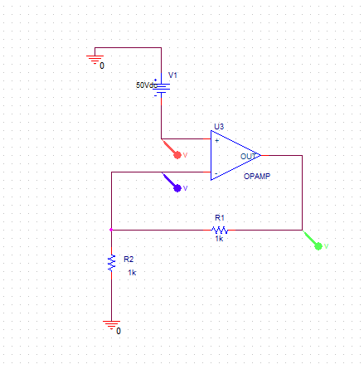

V=50 , r1,r2=1k

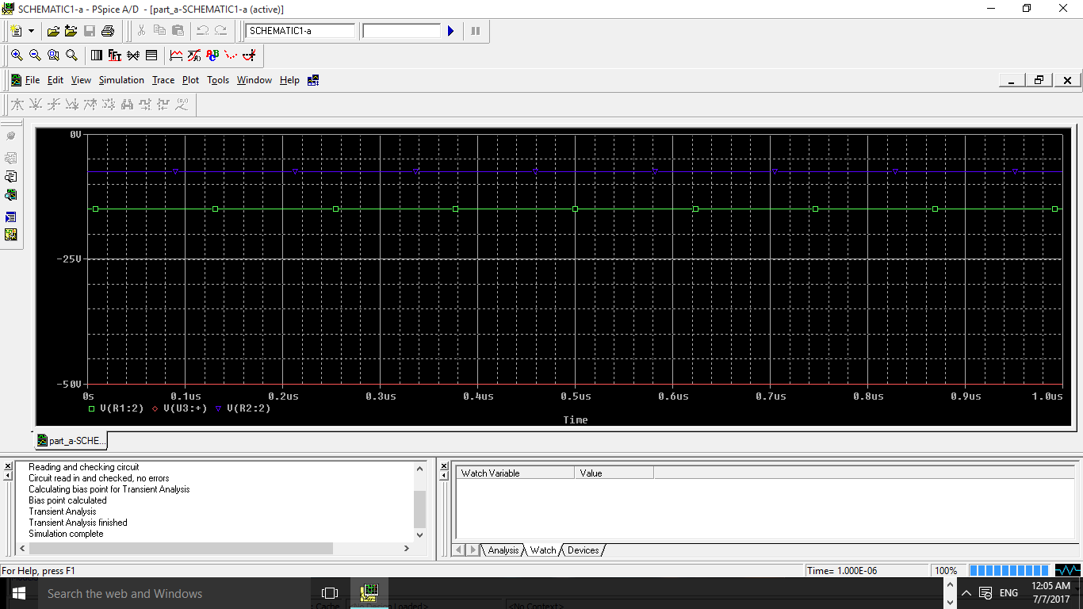

V=50 , r1=1 , r2=1000000k

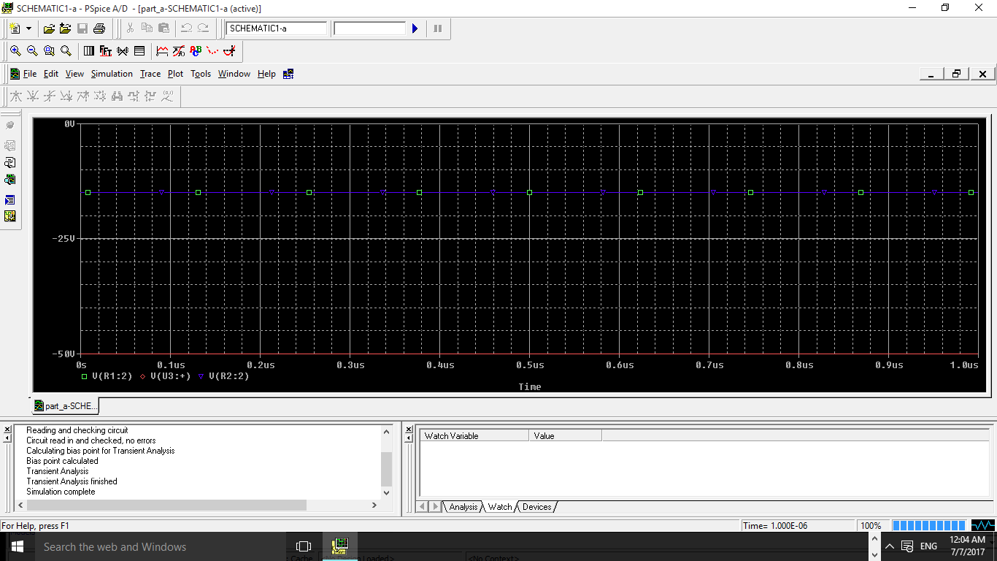

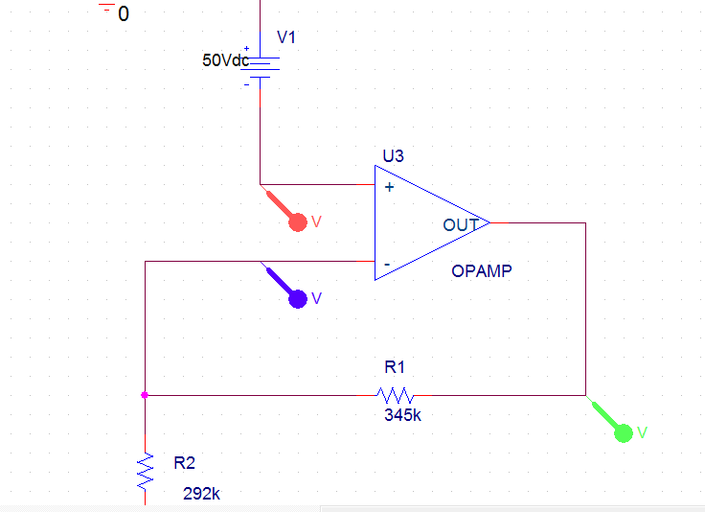

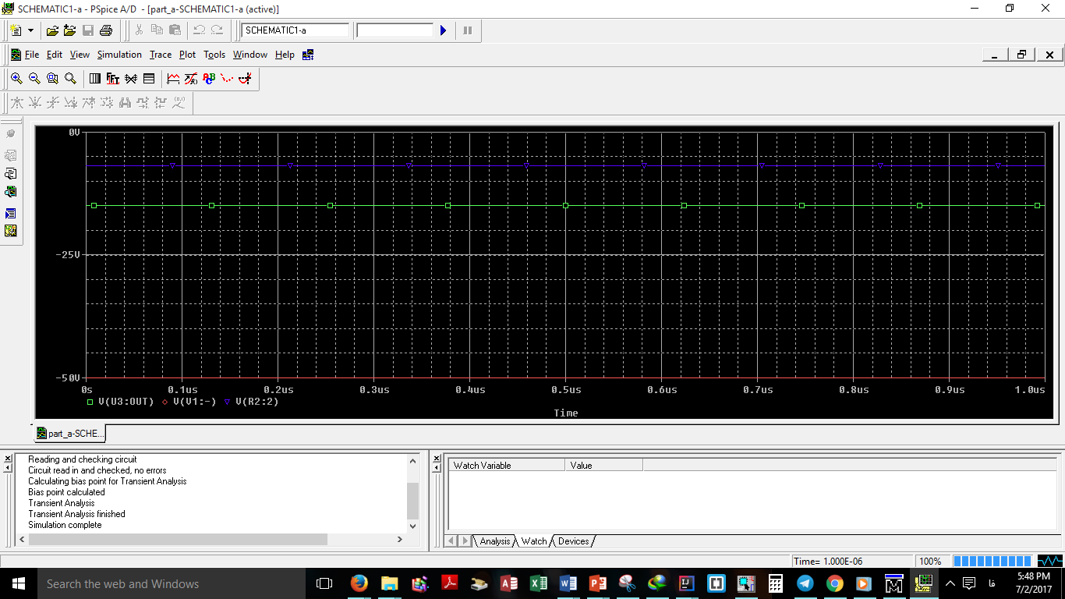

B)



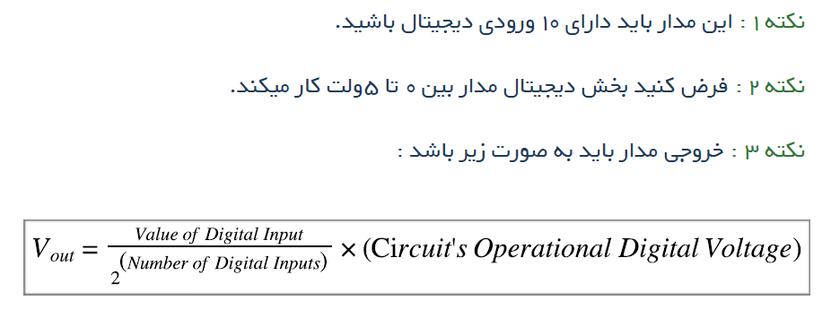

**اولین ایده ای که به ذخن میرسد احتمالا استفاده از خازن خواهد بود .**

**ولی در طراحی مدارات واقعی سعی میشود از خازن استفاده نشود . به دلیل نویز پذیری خیلی بالا و تغییر خاصیت فیزیکی آنها با گذشت زمان .**

 its simply a circuit that will take as input a digital 10-bit number from 0 (0000000000) to 1023(1111111111), and output the relative value on a scale from 0 to 5v.

The maths that describe this process is very simple, an 10 bit converter will divide the 5 volts into 1023 steps, each step having a value of:

**5/1023= 0.0048 V**

Then the output voltage for the converter should be equal to the binary input multiplied by the step value, e.g. for an input of 129 (001000 0001 in binary) the output voltage should be:

**129 X 0.0048 = 0.6192V**

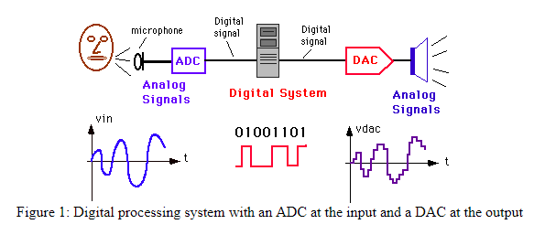

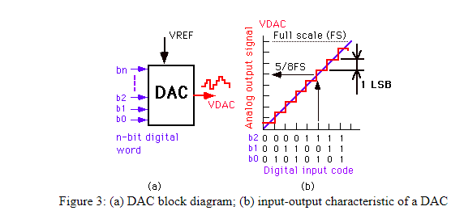

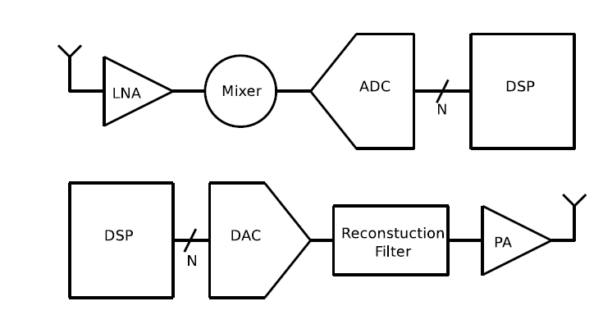A DAC with a resolution of N will need to produce 2N reference voltages. The binary word input D of the DAC can be characterized as:

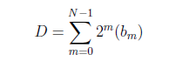

With this reference voltage Vref , the analog

output at any given digital input can be determined by:

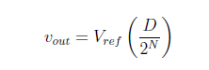

Number of digital input is : 10

**\*The main building block in every DAC is a component that creates an appropriate analog output level by dividing a reference voltage. Elements such as resistors split the reference voltage into smaller voltage or current levels. =>Transistor current sources can also create output currents that are converted to the analog output voltage by the load resistors.**

**Capacitors are also used in some architectures to store charge from the reference voltage and discharge it to the output.**

1.2.1 Resistor String DAC

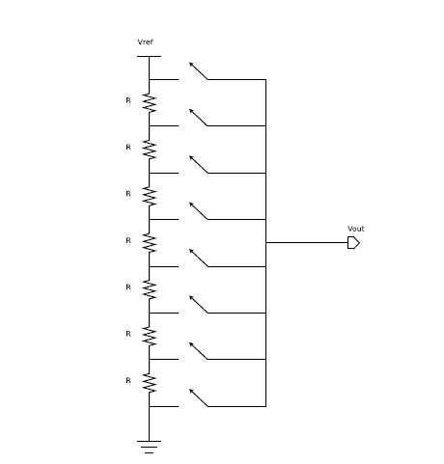

1.2.2 BinaryWeighted Resistor Ladder DAC

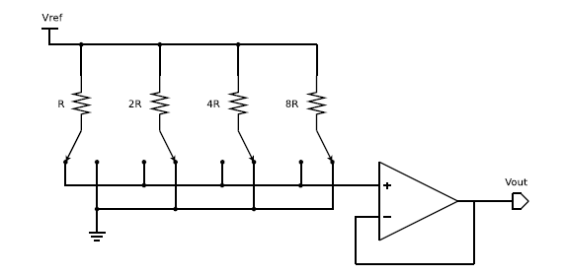

1.2.3 R-2R DAC

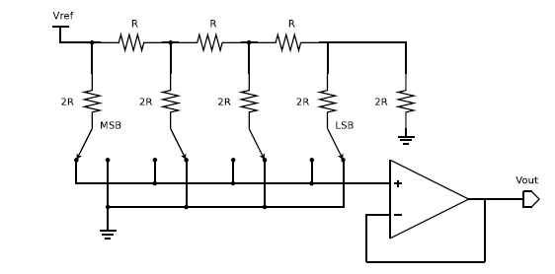

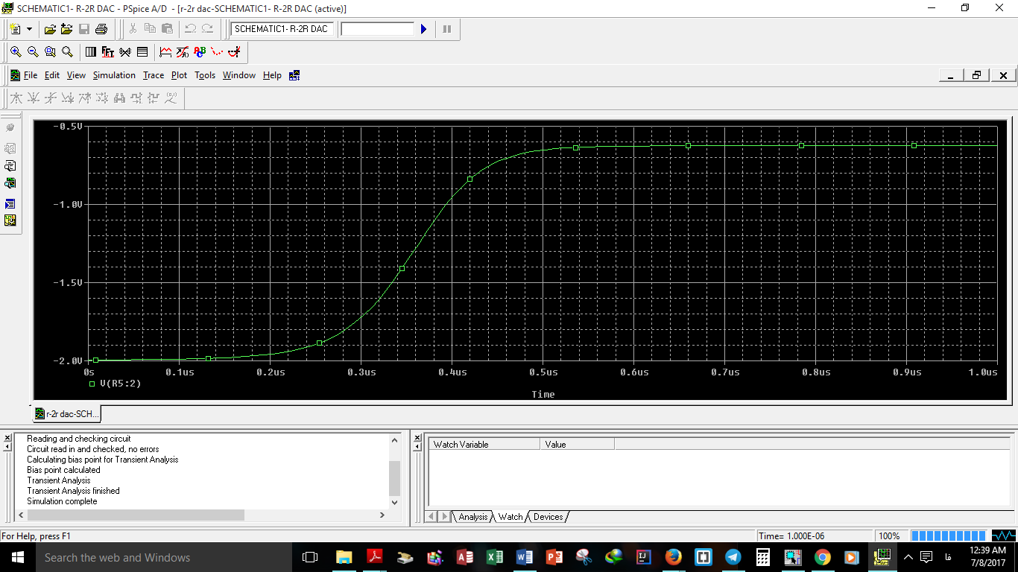



**Vout = 10/1024 * (5-0) =0.048S**

1.2.4 Charge Scaling DAC

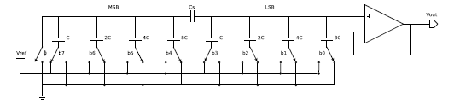

1.2.5 Current Steering

