1)

PI(T) 🡺 F.T 🡺

ABS:

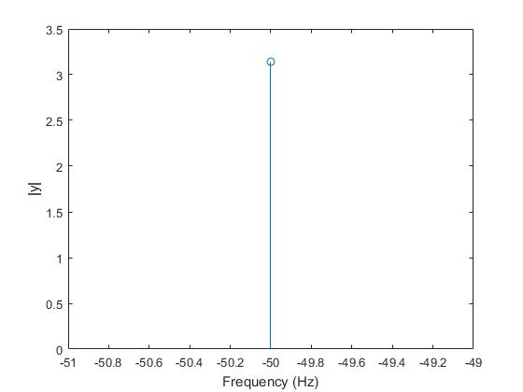

Phase:

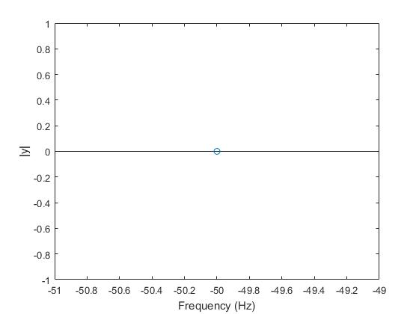

2)

a.

sin(t)/t 🡺 F.T 🡺 0.9752

b.

(𝑡)=1+e^-t^2 🡺 F.T 🡺

Columns 1 through 4

20.9914 + 0.0000i -0.5693 - 0.1672i -0.1025 - 0.0659i -0.0311 - 0.0359i

Columns 5 through 8

-0.0086 - 0.0188i -0.0008 - 0.0059i -0.0008 + 0.0059i -0.0086 + 0.0188i

Columns 9 through 11

-0.0311 + 0.0359i -0.1025 + 0.0659i -0.5693 + 0.1672i

SUM:

19.5668

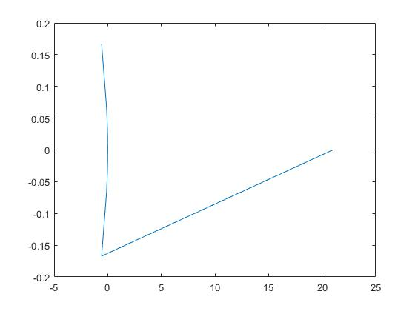

3)

a.

-0.0001 +15.9155i

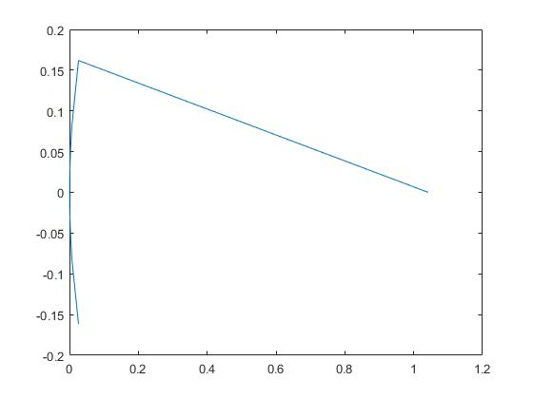

b.

-0.0001 +15.9155i

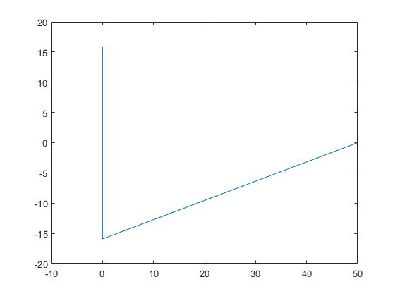

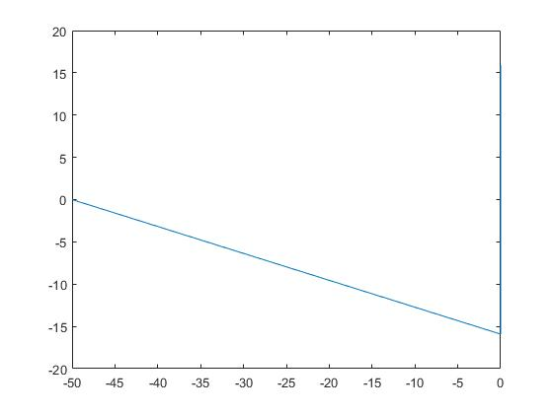

w1=0:0.0001:100;

w2=-100:0.0001:0;

a=ifft(w1);

b=ifft(w2);